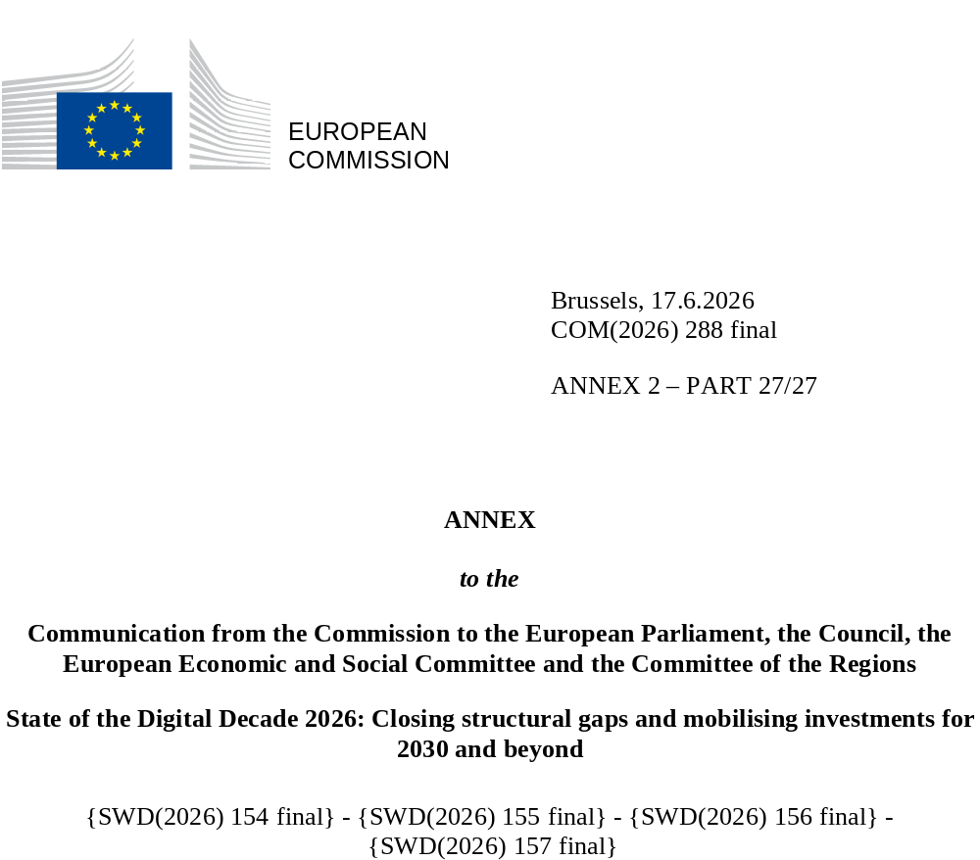

DIGITAL DECADE
SHORT COUNTRY REPORT
2026

Sweden

Executive summary
Sweden is one of the front runners and is above the EU average on almost all indicators. The country has the ambition to become one of the global leaders in the digital field. Sweden remains attractive for start-ups, as the high number of unicorns shows. Sweden has performed and continues to perform particularly well on digital skills, with a population with good ICT skills and a highly skilled workforce. Individuals and business benefit from high-quality fixed and mobile connectivity. Operators have started to roll out 5G stand-alone (SA) networks. The country has improved fixed and mobile connectivity in the most populated areas. However, connecting the very last buildings to the fibre network remains an issue.
The country is actively working on its weaknesses. 5G coverage has increased substantially over the last years and is now close to 100% in many regions. However, to ensure that all rural areas can also fully benefit from increased digitalisation, Sweden needs to continue deploying fibre and 5G SA networks. For several years, Sweden has scored below the EU average on electronic access to health records but is now catching up with the EU average.
While Sweden is among the leaders in the EU and has taken action to increase the uptake of AI; however, more needs to be done to promote the widespread adoption of AI technologies among enterprises. Over the last year, Sweden has updated several of its digital policies. This includes the presentation in May 2025 of a 2025-2030 national strategy on digitalisation 2025-2030 based on five pillars: digital skills, digitalisation of businesses, digitalisation of public services, and digitalisation of welfare and connectivity. In February 2026, Sweden presented an AI strategy in which it announced its ambition to be one of the top ten global leaders in AI. The AI strategy was accompanied by an action plan with a list of initiatives.

Sweden in the Digital Decade
Sweden demonstrates a moderate level of ambition in its contribution to the Digital Decade having set 13 national trajectories (out of 14 possible), 54% of which aligned with the EU 2030 targets. In its national roadmap, Sweden provided 12 trajectory points for 2025 out of 13 analysed. The country is following them moderately well with 58% considered on track. Sweden addressed 67% of the 6 recommendations issued by the Commission in 2025, either by implementing significant policy changes (17%) or making some changes (50%) through new measures.
Sweden submitted an updated Digital Decade national roadmap on 24 February 2026. The roadmap contains 68 measures, of which 27 are new. The total budget is EUR 3.55 billion, with EUR 2.89 billion coming from public budgets (equivalent to approximately 0.49% of Sweden’s GDP in 2025). According to the national roadmap, by the end of 2026, 46% of the measures will come to an end. The total public budget associated to these measures is EUR 1.18 billion, representing 41% of the total public budget outlined in the roadmap.
According to the special Eurobarometer on ‘the Digital Decade’ 2026, 83% of Swedish people consider that digital policy should have a very high/high priority for the EU in shaping our future in Europe. They also think that, in the next ten years, the EU should cooperate with Member States to reinforce cybersecurity and protection from online threats (98%), build and independent European digital infrastructure (broadband, 5G, cloud, semiconductors) (88%) and promote digital education and skills programme/develop shared digital public services (e.g. digital ID, eHealth) (both on 86%).
In addition, 88% of Swedish respondents think that the EU should reduce its dependencies on digital solutions from third countries, and 94% that EU should prioritise investments in digital infrastructure and services that are developed and controlled in Europe. Meanwhile, 73% would be willing to switch to an EU-based digital service provider even if it means slightly higher costs.

Funding for digital and multi-country projects
Sweden allocates 21% of its total recovery and resilience plan to digital (EUR 0.6 billion). In addition, under cohesion policy, EUR 0.2 billion, representing 13% of the country’s total cohesion policy funding, is dedicated to advancing Sweden’s digital transformation.
Sweden is a participating state of the EuroHPC Joint Undertaking (JU) and of the Chips JU.
Digital Decade KPI ⁽¹⁾ | Sweden |  |  |  |  | EU |  |  | Digital Decade target by 2030
Digital Decade KPI ⁽¹⁾ | Last available data (2) | DESI 2026 (year 2025) | Annual progress | National trajectory 2025 (3) | DESI 2026 |  | Annual progress | SE |  | EU
Fixed Very High Capacity Network coverage | 89.7% | 89.8% | 0.1% | - | 85.5% |  | 3.7% | 98.5% |  | 100%
Fibre to the Premises (FTTP) coverage | 85.6% | 85.6% | 0.0% | 98.0% | 74.1% |  | 7.1% | 98.5% |  | -
Basic 5G coverage | 98.6% | 98.7% | 0.1% | 100.0% | 96.8% |  | 2.6% | 100.0% |  | 100%
Edge Nodes (estimate) | - | 226 | - | - | 7451 |  | - | - |  | 10000
SMEs with at least a basic level of digital intensity * | 79.9% | 86.5% | 4.0% | 89.9% | 71.4% |  | 11.0% | 95.0% |  | 90%
Cloud * | 66.0% | 67.6% | 1.2% | 89.0% | 46.7% |  | 9.5% | 94.0% |  | 75%
Artificial Intelligence | 25.1% | 35.0% | 39.7% | 18.0% | 20.0% |  | 48.0% | 39.5% |  | 75%
Data analytics * | 35.0% | 38.6% | 5.1% | 41.5% | 39.9% |  | 9.5% | 56.5% |  | 75%
AI or Cloud or Data analytics * | 73.1% | 76.5% | 2.3% | - | 63.2% |  | 7.5% | - |  | 75%
Unicorns | 41 | 48 | 17.1% | 49 | 324 |  | 10.2% | 64 |  | 500
At least basic digital skills * | 66.4% | 70.0% | 2.6% | 76.8% | 60.4% |  | 4.3% | 89.7% |  | 80%
ICT specialists | 8.6% | 8.9% | 3.5% | 10.2% | 5.0% |  | 2.0% | 12.9% |  | ~10%
e-ID scheme notification |  | Yes
Digital public services for citizens | 85.9 | 84.2 | -2.1% | 87.5 | 84.6 |  | 2.8% | 90.0 |  | 100
Digital public services for businesses | 90.4 | 90.4 | 0.0% | 89.0 | 88.6 |  | 2.7% | 90.5 |  | 100
Access to electronic health records | 77.9 | 86.5 | 10.9% | 76.0 | 86.5 |  | 4.6% | 78.5 |  | 100
(1) Indicators full description, metadata and sources in the DESI 2026 methodological note
(2) Last available data is DESI2025 (reference year 2024) except for indicators marked with a star * for which it is DESI2024 (reference year 2023)
(3) National trajectory value for 2025, if set by the country in its Digital Decade national roadmap

A competitive, sovereign and resilient EU based on technological leadership
Sweden is performing well in connectivity, being above the EU average in fibre and 5G coverage. Coverage of last premises, in particular, in sparsely populated areas will be key to achieving full coverage by 2030. The average support per building for connecting to the fibre network was SEK 80 643 in 2025, which is an increase compared with SEK 36 749 per building in 2022. This indicates that the remaining buildings are becoming increasingly expensive to connect, which Sweden has pointed out in its roadmap. At the same time, the differences in broadband access between urban and rural areas continue to decrease. Sweden is dependent on international fibre-optic submarine cables for connectivity with the rest of the world. On quantum technologies, Sweden is committed to work with European partners to secure existing submarine cable connectivity, and to develop alternative submarine cable routes to enhance resilience, for example Polar Connect. The work on quantum continues based on the flagship project, quantum agenda that was issued in 2024, by the Wallenberg Centremain quantum technology actors in Sweden. Conclusions are the need for Quantum Technology (WACQT), deepening international relations and collaborations, and a continuation of the work done in the quantum flagship WAQCT. During 2025, Sweden has prepared for and organised itself for the integration of quantum flagship activities into the EuroHPC JU.
Sweden has improved on AI use and Swedish businesses are leading in terms of private sector AI uptake. There are reasons, however to continue to strengthen its AI infrastructure and should promote further the integration of its AI ecosystem into the wider EU ecosystem including through Testing and Experimentation Facilities (TEFs) and European Digital Innovation Hubs (EDIHs) and also through the EuroHPC JU, for example through the Swedish AI Factory MIMER which are key support infrastructures for business adoption of AI technologies. However, the country remains just below EU average on data analytics.

Protecting and empowering EU people and society
The population’s level of basic digital skills is well above the EU average. The proportion of ICT specialists is also above the EU average. However, vacancies remain as there is a skills shortage and high competition for the right digital skills, especially for AI use and for SMEs. A further increase in the supply of ICT specialists to the job market should continue to relieve skills shortages in other sectors of the economy.
Sweden has acted to further digitalise its public services. Sweden has lagged behind on access to e-Health records in particular, but has recently improved compared with previous years. The setting up of a government electronic identity will also support access to e-Health records. An important measure as regards the digitalisation of public services is Ena, which is Sweden’s digital infrastructure. It set up is a common infrastructure for exchanging information between public administrations and is coordinated with sector specific infrastructure, for example health and social welfare. Sweden scores below EU average in the latest EU justice scoreboard on digital access to court judgments, and the digitalisation of public judicial services still lags behind as concerns the deployment of the necessary IT solutions which are indispensable for cross-border judicial cooperation as a key reform of digital public services.
Sweden already attracts data processing centres, in particular in the north of the country. To better understand the environmental impact of the energy-consuming data centres, Sweden should collect facts and figures.
The Swedish National Cybersecurity Strategy highlights that the cybersecurity landscape is characterised by ‘inadequate incident management’ and ‘insufficient information sharing between the private and public sectors’. One of the targets already set out in the strategy is ‘strengthened public-private management of cybersecurity incidents’.

Recommendations
- Fixed broadband: Sweden should complete the networks to bridge the urban-rural divide.
- Mobile broadband: Sweden should accelerate 5G roll-out in rural areas. It should also promote the deployment of 5G SA networks while enabling advanced use cases.
- eHealth: Continue efforts to increase the availability of electronic health records.
- AI: Sweden should sustain its efforts to promote the widespread adoption of AI technologies among enterprises, with a particular focus on SMEs. To that end, Sweden should continue to strengthen its AI infrastructure while improving access to critical EU-wide AI infrastructures, including AI factories and Gigafactories, particularly for SMEs, start-ups, and mid-cap businesses. To further accelerate AI adoption across key sectors, Sweden should actively participate in and promote the sectoral flagship initiatives set up under the Apply AI strategy and should continue promoting the integration of its AI ecosystem into the wider EU ecosystem including through TEFs and EDIHs, which are key support infrastructures for business adoption of AI technologies.
- Cybersecurity. Promote national public-private cooperation frameworks for cybersecurity information sharing (for example voluntary information-sharing arrangements as referred to in Article 29 of the NIS2 Directive) and frameworks for national authorities to share information regarding cybersecurity incidents.
- Green: Monitor and quantify the environmental impact of the digital transformation, in particular as regards the impact of data processing.
- Quantum: Sweden should: (i) strengthen its national positioning in the EuroHPC JU governance and align national strategies accordingly; (ii) ensure strong representation there and align the national quantum strategy, national calls and infrastructure plans with the EuroHPC JU’s work programmes, access schemes and infrastructure roadmaps; (iii) shift from mainly research funding to industrial scale-up, with stronger support for quantum software, compilers, middleware, error-correction/error-mitigation tools, and hybrid HPC-QC application stacks; and (iv) align national calls more closely with the EU roadmaps, EuroHPC deployments, the EuroHPC JU work programme, and the Chips JU quantum pilot lines.

