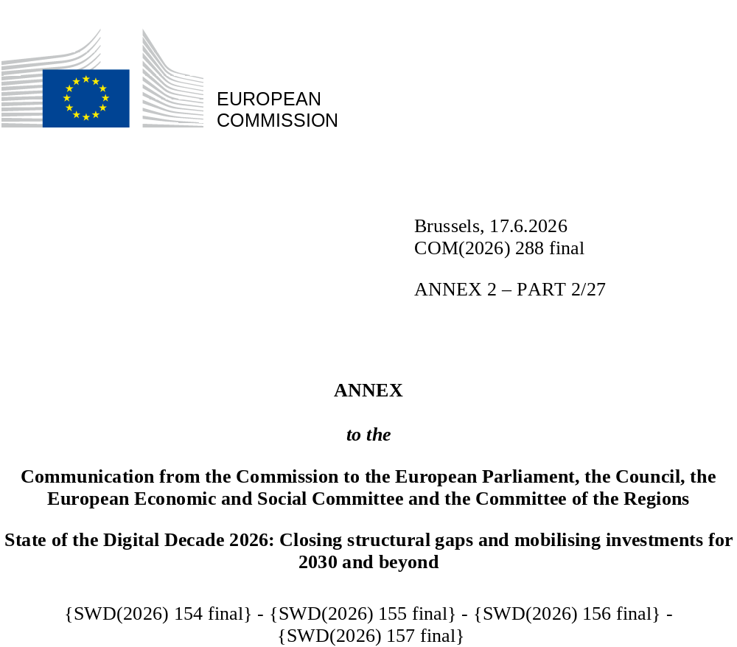

DIGITAL DECADE
SHORT COUNTRY REPORT
2026

Executive summary
Belgium demonstrates strong overall performance in the Digital Decade, combining high connectivity take-up, advanced digitalisation of businesses and very strong digital public services. High internet use among individuals, strong household internet connectivity and a growing level of digital skills reflect a digitally engaged population and provide a favourable environment for digital transformation across the economy. However, structural challenges remain in fibre-to-the-premises deployment, advanced digital skills and ICT specialist shortages, ultrafast broadband uptake and the scale-up of innovative firms.
Some of the structural gaps identified may affect Belgium’s ability to fully translate its strong digital foundations into productivity gains, economic growth and overall competitiveness. Shortages of advanced digital skills and ICT specialists may limit the diffusion of advanced digital technologies across sectors and constrain firms’ capacity to innovate and scale. Likewise, delayed fibre-to-the-premises deployment and moderate uptake of ultrafast broadband may reduce the potential benefits of next-generation connectivity for businesses and public services.
Belgium can nevertheless rely on several strong digital leadership assets. The country hosts one of Europe’s leading semiconductor research ecosystems through Imec and remains highly active in emerging technologies such as artificial intelligence (AI), quantum computing and edge computing infrastructure. Belgium also benefits from a dynamic innovation ecosystem and strong collaboration between research institutions, industry and public authorities, which supports the development and deployment of advanced digital technologies.

Belgium in the Digital Decade
Belgium shows a high level of ambition in its contribution to the Digital Decade, having set 14 national targets (out of 14 possible), 93% of which aligned with the EU’s targets for 2030. In its national roadmap, Belgium provided 12 trajectory points for 2025 (out of 13 analysed). The country is pursuing them moderately well, with 58% considered on track. Belgium addressed 71% of the 7 recommendations issued by the Commission in 2025, either by implementing significant policy changes (14%) or making some changes (57%) through new measures.

Belgium submitted an updated national Digital Decade roadmap in January 2026. The roadmap contains 128 measures, of which 37 are new measures. The total budget is EUR 664 million (mostly coming from public budgets), corresponding to approximately 0.1% of Belgium’s GDP in 2025. According to the national roadmap, by the end of 2026, 24% of the measures will come to an end. The total public budget associated with these measures is EUR 248 million, constituting 37% of the total public budget outlined in the roadmap.
According to the 2026 Digital Decade Eurobarometer, 80% of Belgians consider that digital policy should have a very high or high priority for the EU in shaping our future in Europe. They also think that, in the next ten years, EU bodies should cooperate with Member States to improve cybersecurity and protection from online threats (93%), strengthen the regulation of online platforms (84%) and promote digital education and skills programmes (83%). In addition, 81% of Belgian respondents think that the EU should reduce its dependencies on digital technology from outside the EU, and 86% that the EU should prioritise investment in digital infrastructure and services that are developed and regulated in Europe. Meanwhile, 61% would be willing to switch to an EU-based digital service provider even if it means slightly higher costs.

Funding for digital and multi-country projects
Belgium has allocated 27% of its total recovery and resilience plan (EUR 1.3 billion) to digital technologies. In addition, under cohesion policy, EUR 0.4 million, representing 14% of the country’s total cohesion policy funding, is dedicated to advancing Belgium’s digital transformation.
Belgium hosts the EUROPEUM European digital infrastructure consortium (EDIC). It is also a member of the Local Digital Twins towards the CitiVERSE EDIC. Belgian entities are indirect or associated partners in the Important Projects of Common European Interest on Microelectronics and Communication Technologies (IPCEI-ME/CT) and in the IPCEI on Next-Generation Cloud Infrastructure and Services (IPCEI-CIS). Belgium is a participating state in the EuroHPC Joint Undertaking (JU) and of the Chips JU.
Digital Decade KPI ⁽¹⁾ | Belgium |  |  |  | EU |  | Digital Decade target by 2030
Digital Decade KPI ⁽¹⁾ | Latest available data (2) | DESI 2026 (year 2025) | Annual progress | National trajectory (3) | DESI 2026 | Annual progress | BE | EU
Fixed Very High-Capacity Network (VHCN) coverage | 93.8% | 96.2% | 2.6% | 96.0% | 85.5% | 3.7% | 100.0% | 100%
Fibre to the Premises (FTTP) coverage | 30.7% | 35.5% | 15.7% | 40.0% | 74.1% | 7.1% | 82.0% | -
Basic 5G coverage | 96.9% | 99.9% | 3.2% | 99.5% | 96.8% | 2.6% | 100.0% | 100%
Edge Nodes (estimate, new methodology) | - | 176 | - | 34 | 7451 | - | 164 | 10 000
SMEs with at least a basic level of digital intensity* | 74.5% | 84.4% | 6.4% | 81.9% | 71.4% | 11.0% | 90.0% | 90%
Cloud* | 47.7% | 58.5% | 10.8% | 67.0% | 46.7% | 9.5% | 75.0% | 75%
Artificial Intelligence | 24.7% | 34.5% | 39.8% | 20.0% | 20.0% | 48.0% | 75.0% | 75%
Data analytics* | 44.5% | 52.1% | 8.2% | 53.0% | 39.9% | 9.5% | 75.0% | 75%
AI or Cloud or Data analytics* | 64.2% | 74.5% | 7.7% | - | 63.2% | 7.5% | - | 75%
Unicorns | 7 | 8 | 14.3% | - | 324 | 10.2% | 14 | 500
At least basic digital skills* | 59.4% | 61.2% | 1.5% | 65.6% | 60.4% | 4.3% | 80.0% | 80%
ICT specialists | 5.7% | 5.9% | 3.5% | 7.6% | 5.0% | 2.0% | 10.0% | ~10%
e-ID scheme notification |  | Yes
Digital public services for citizens | 81.4 | 81.6 | 0.2% | 89.0 | 84.6 | 2.8% | 100.0 | 100
Digital public services for businesses | 95.4 | 96 | 0.6% | 96.0 | 88.6 | 2.7% | 100.0 | 100
Access to electronic health records | 100.0 |  |  | 100.0 | 86.5 | 4.6% | 100.0 | 100
⁽¹⁾ Indicators full description, metadata and sources in the DESI 2026 methodological note
⁽²⁾ Last available data is DESI2025 (reference year 2024) except for indicators marked with a star * for which it is DESI2024 (reference year 2023)
⁽³⁾ National trajectory value for 2025, if set by the country in its Digital Decade national roadmap

A competitive, sovereign and resilient EU based on technological leadership
Belgium combines strong technological assets with persistent structural bottlenecks in digital infrastructure. It benefits from a high-performing research and innovation ecosystem and plays a leading role in strategic technologies, notably semiconductors through Imec, while also strengthening its position in quantum computing and edge computing infrastructure. Belgian businesses perform strongly in adopting advanced digital technologies, with high levels of SME digitalisation and adoption by companies of cloud, data analytics and AI. However, these strengths have not yet fully translated into scale-up performance and broader business dynamism for long-term competitiveness, with constraints in growth financing, scaling and diffusion of advanced technologies – including AI – across the wider economy, as well as in translating strong adoption into large-scale deployment and integration across strategic sectors.
Connectivity and cybersecurity remain key constraints on technological competitiveness. Belgium benefits from very high VHCN coverage and near-universal 5G, but FTTP rollout remains the lowest in the EU. Gaps also persist in the deployment and effective use of 5G pioneer bands, especially in the 3.4-3.8 GHz band. Fragmented permitting procedures, regulatory divergence across governance levels, modest gigabit uptake and limited demand for parts of the 5G spectrum continue to reduce the economic impact of connectivity. At the same time, Belgium is well equipped in cybersecurity, with strong institutional capacity, high SME uptake of cybersecurity measures and progress in implementing NIS2. However, uneven SME maturity, shortages of specialised profiles and emerging risks linked to cloud dependencies, supply chains and AI-enabled threats remain weak points.

Protecting and empowering EU people and society
Belgium combines broad digital participation with persistent inclusion and skills gaps. Basic digital skills are slightly above the EU average, internet use is widespread and the use of generative AI is comparatively high, reflecting a digitally engaged population. However, progress in improving basic digital skills remains slower than the EU average and the share of people with above-basic digital skills remains below the EU average. Structural disparities also persist, particularly among women, older people and, especially, individuals with low formal education, while digital safety skills remain below the EU average. Together with continued exposure to hostile or degrading online content, these gaps point to the need for targeted training efforts, particularly for people with low levels of education, older adults and women, alongside stronger digital safety and media literacy skills. More outcome-oriented coordination across education, adult learning, labour-market and local inclusion policies could help improve effectiveness and monitoring of interventions.
Belgium also performs very strongly in digital public services, especially for businesses and in access to electronic health records; this is supported by a mature digital identity ecosystem and continued progress in eHealth. High use of eGovernment and fully operational access to electronic health records are important strengths. At the same time, citizen-facing services remain less advanced than business-oriented ones, and gaps persist in transparency, cross-border performance and the integration of services across life events and governance levels. Fragmentation across federal, regional and local responsibilities therefore remains a structural obstacle to fully seamless, user-centric public digital services.

Recommendations
- Basic digital skills: Strengthen Belgium’s digital skills base, particularly among groups facing persistent digital inclusion barriers, while improving coordination, monitoring and policy effectiveness across governance levels.
- ICT specialists: Increase the supply of ICT specialists by strengthening skills pipelines and better aligning education, training and labour-market needs, including for advanced digital technologies and underrepresented groups.
- Digitalisation of SMEs and advanced technologies take-up: Strengthen the digitalisation of SMEs and the uptake of advanced digital technologies by improving the effectiveness, visibility and coordination of support measures and facilitating the deployment of advanced digital solutions.
- Artificial intelligence: Accelerate the adoption and scaling of AI, particularly by SMEs and in strategic sectors, by strengthening AI infrastructure and ecosystem support, facilitating the deployment of AI solutions and use cases, and improving coordination across governance levels and key stakeholders.
- Fixed and mobile connectivity: Accelerate the rollout and take-up of gigabit-capable connectivity by addressing persistent deployment bottlenecks, supporting fibre and 5G deployment across all regions, fostering the copper networks switch off, promoting effective use of next-generation connectivity infrastructure, and strengthening conditions for investment and adoption.
- Cybersecurity: Strengthen cybersecurity resilience among SMEs and critical sectors, including by supporting preparedness, improving the uptake of cybersecurity measures among less mature organisations, and reinforcing resilience against emerging risks such as AI-enabled threats.
- Green and digital: Translate monitoring of the environmental footprint of digitalisation into coordinated policy action, including through measurable objectives, strengthened reporting and actions to reduce the environmental footprint of digital infrastructures and services.

