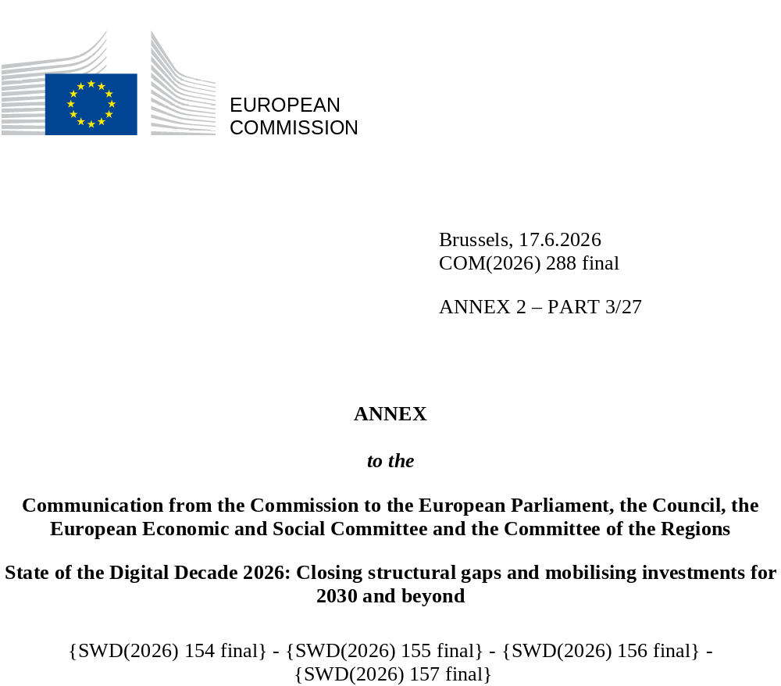

DIGITAL DECADE
SHORT COUNTRY REPORT
2026

Executive summary
Bulgaria continues to make progress in the Digital Decade, supported by strong connectivity infrastructure and gradual improvements in digital public services. However significant gaps remain in digital skills, SME digitalisation and the uptake of advanced technologies. The country benefits from extensive fibre coverage, increasing mobile broadband use and continued policy engagement in digital transformation. It has also expanded investment e-government and eHealth services, while strengthening its participation in European digital initiatives. At the same time, Bulgaria’s overall digital performance is hampered by persistent structural weaknesses, including low levels of digital skills, SME digital intensity that is among the lowest in the EU, and low adoption of cloud computing, artificial intelligence, and data analytics.
Some of the structural gaps identified may affect Bulgaria’s capacity to translate its solid infrastructure foundations into broader digital transformation across the economy and society, fully benefit from digital transformation, and strengthen its competitiveness within the EU digital economy. Structural constraints, including relatively low R&D intensity, fragmented research funding, limited scale-up capacity and relatively little connection between research and business affect Bulgaria’s innovation ecosystem. Limited adoption of advanced digital technologies and low SME digital intensity may constrain productivity growth and the integration of Bulgarian firms into higher-value-added segments of European value chains. Persistent shortages of digital skills and uneven cybersecurity maturity also risk slowing the spread of digital technologies across sectors and regions. Without stronger investment in skills, innovation capacity and technology uptake it will take time to achieve the Digital Decade objectives.
Despite these challenges, Bulgaria contributes to the EU’s digital leadership in several emerging domains. The country is strengthening its participation in European initiatives relating to semiconductors and quantum technologies and continues to develop research capabilities in these areas. Bulgaria’s ICT sector is dynamic and provides a strong foundation for digital innovation. Initiatives supporting start-ups, technology transfer and venture financing aim to gradually strengthen the scale-up ecosystem. Continued integration into EU research and innovation networks will help further develop these capabilities and support Bulgaria’s contribution to Europe’s technological leadership.

Bulgaria in the Digital Decade
Bulgaria shows a moderate level of ambition in its contribution to the Digital Decade having set 12 national targets (out of a possible 14), half of which are aligned with the EU 2030 targets. In its national roadmap, Bulgaria provided 12 trajectory points for 2025 (out of 13 analysed). The country is on track to meet 75% of them. Bulgaria addressed 56% of the nine recommendations issued by the Commission in 2025 by making some changes through new measures. According to the national roadmap, 48% of the measures will have been completed by the end of 2026. The total public budget allocated to these measures is EUR 597 million, which accounts for 27% of the total public budget outlined in the roadmap.
Bulgaria is working hard to meet the Digital Decade objectives. The national Digital Decade roadmap, initially submitted in April 2024, has undergone only minor updates and continues to prioritise the digitalisation of public services, the development of digital skills and the digital transformation of businesses. It includes 60 measures and is largely aligned with the National Recovery and Resilience Plan (RRP) and EU funding programmes. Bulgaria has addressed most recommendations, mainly through clarifications and references to existing measures.
Bulgaria continues to base its strategy on its existing framework, the Digital Transformation of Bulgaria 2024–2030. This year, the authorities are planning to present the National Strategy for the Digital Transformation of the Republic of Bulgaria 2026–2030, which is currently at the stage of development and stakeholder consultation. It is drawing up priorities on business digitalisation and innovation, secure and inclusive digital transformation, modernisation of public administration, digital skills development, interoperable digital services, cybersecurity, and the wider use of data and emerging technologies to support economic and social development. While this strategy is set to provide a forward-looking policy direction and is designed to align Bulgaria’s digital development with the Digital Decade 2030 goals, it is not yet formally integrated into the national Digital Decade roadmap and forms no part of the measures submitted.
According to the 2026 Digital Decade Eurobarometer, 74% of Bulgarians consider that digital policy should be a high/very high priority for the EU in shaping our future in Europe. They also think that, in the next ten years, the EU should cooperate with Member States to reinforce cybersecurity and protection from online threats (88%), promote digital education and skills programmes (84%) and strengthen the regulation of online platforms (81%). In addition, 73% of Bulgarian respondents think that the EU should reduce its dependencies on digital technology from outside the EU, and 80% that the EU should prioritise investment in digital infrastructure and services that are developed and controlled in Europe. Meanwhile, 45% would be willing to switch to an EU-based digital service provider even if that meant slightly higher costs.

Funding for digital and multi-country projects
Bulgaria allocates close to 21% of its total RRP to digital (EUR 1.2 billion). Under cohesion policy, EUR 1.2 billion, 11% of the country’s total cohesion policy funding, is dedicated to advancing Bulgaria’s digital transformation.
Bulgaria is a member of the Alliance for Language Technologies EDIC. It is a participating state of the EuroHPC Joint Undertaking (JU) and the Chips JU.
Digital Decade KPI ⁽¹⁾ | Bulgaria |  |  |  | EU |  | Digital Decade target by 2030
Digital Decade KPI ⁽¹⁾ | Latest available data (2) | DESI 2026 (year 2025) | Annual progress | National trajectory (3) | DESI 2026 | Annual progress | BG | EU
Fixed Very High-Capacity Network (VHCN) coverage | 90.4% | 93.5% | 3.5% | 96.0% | 85.5% | 3.7% | 100% | 100%
Fibre to the Premises (FTTP) coverage | 90.4% | 93.5% | 3.5% | 96.0% | 74.1% | 7.1% | 100% | -
Basic 5G coverage | 81.3% | 94.8% | 16.6% | 96.0% | 96.8% | 2.6% | 100.0% | 100%
Edge Nodes (estimate, new methodology) | - | 112 | - | - | 7451 | - | - | 10 000
SMEs with at least a basic level of digital intensity* | 28.4% | 38.3 % | 16.2% | 51.8% | 71.4% | 11.0% | 60.0% | 90%
Cloud* | 14.2% | 15.7 % | 5.2% | 11.9% | 46.7% | 9.5% | 15.0% | 75%
Artificial Intelligence | 6.5% | 8.6 % | 32.1% | 5.7% | 20.0% | 48.0% | 11.0% | 75%
Data analytics* | 21.9% | 27.1 % | 11.3% | 7.5% | 39.9% | 9.5% | 9.0% | 75%
AI or Cloud or Data analytics* | 29.3% | 34.6 % | 8.6% | - | 63.2% | 7.5% | - | 75%
Unicorns | 0 | 1 |  | - | 324 | 10.2% | - | 500
At least basic digital skills* | 35.5% | 38.3 % | 3.8% | 40.4% | 60.4% | 4.3% | 52.0% | 80%
ICT specialists | 4.6% | 4.8% | 4.3% | 4.4% | 5.0% | 2.0% | 5.0% | ~10%
e-ID scheme notification |  | Yes
Digital public services for citizens | 68.0 | 71.08 | 4.6% | 90.0 | 84.6 | 2.8% | 100.0 | 100
Digital public services for businesses | 94.0 | 94.04 | 0.1% | 95.0 | 88.6 | 2.7% | 100.0 | 100
Access to electronic health records | 87.5 | 89.6 | 2.4% | 85.6 | 86.5 | 4.6% | 100.0 | 100
⁽¹⁾ Indicators full description, metadata and sources in the DESI 2026 methodological note
⁽²⁾ Last available data is DESI2025 (reference year 2024) except for indicators marked with a star * for which it is DESI2024 (reference year 2023)
⁽³⁾ National trajectory value for 2025, if set by the country in its Digital Decade national roadmap

A competitive, sovereign and resilient EU based on technological leadership
Connectivity infrastructure is one of Bulgaria’s strongest digital assets, with very high fibre and very high-capacity network (VHCN) coverage, and significant progress in 5G rollout. However, the main challenge is shifting from deployment to effective use: gigabit uptake remains limited despite high coverage, reflecting affordability constraints and territorial disparities. Progress in the deployment and effective use of 5G networks in the 3.4–3.8 GHz band remains uneven.
There is a major shortfall in the digitalisation of businesses. SMEs lag far behind the EU average in basic digital intensity, and the uptake of cloud solutions, AI and data analytics is still limited. A broad range of support measures has been put in place and progress is visible in some areas, but these measures have not yet translated into large-scale transformation, reflecting challenges in their accessibility, consistency and effective uptake by businesses, particularly SMEs, including through existing support structures. Key barriers include skills shortages, high investment costs, regulatory complexity, cybersecurity concerns and a lack of connection between science and business. In addition, the absence of a comprehensive action plan to implement the national AI strategy limits the coordination and impact of efforts to promote AI uptake. Priorities include strengthening advisory, skills and investment support, improving innovation support instruments, and complementing the national AI strategy with a clear implementation framework.
Bulgaria is strengthening its technological capacities, including in data infrastructure, edge computing and quantum research. However, the innovation ecosystem remains relatively small, with limited private investment and weak commercialisation of research.
Cybersecurity preparedness remains low, particularly among SMEs. Recent progress, including the transposition of the NIS2 Directive and targeted support measures, provides a basis for improvement, but further efforts are needed to ensure effective implementation and wider uptake.

Protecting and empowering EU people and society
Bulgaria’s digital transformation is severely hampered by low levels of digital skills. Digital skills gaps are particularly pronounced among older populations, people with lower levels of education and people living in rural areas. These deficits limit the ability of individuals and businesses to adopt and use digital technologies effectively and are closely linked to the country’s poor performance in SME digitalisation. The evidence suggests that progress will depend on a combination of targeted training efforts, continued attention to teacher preparation and curriculum development, local digital inclusion initiatives, and effective coordination across delivery channels.
At the same time, Bulgaria continues to expand initiatives aimed at improving digital skills and boosting workforce capabilities. EU-funded programmes support upskilling and reskilling, while education and vocational-training reforms aim to increase the supply of ICT specialists and to help reflect the needs of the labour market. Despite these initiatives, shortages of digital talent remain a major constraint and may hinder the adoption of advanced digital technologies.
Digital public services continue to improve, supported by ongoing investment in e-government infrastructure and interoperability frameworks. The availability of electronic services continues to expand, and Bulgaria performs comparatively well in digital public services for businesses. However, the uptake of e-government services, particularly among citizens, remains low compared with the EU average, also in the field of justice, highlighting the need to improve user-friendliness, awareness and trust to derive maximum benefit from public sector digitalisation, including for cross-border services. Notably, In Bulgaria, the digitalisation of public judicial services lags behind as concerns the deployment of the necessary IT solutions which are indispensable for cross-border judicial cooperation as a key reform of digital public services.

Recommendations
- Basic digital skills: Strengthen Bulgaria’s digital skills base, particularly among groups facing persistent digital inclusion barriers, through education, training and local inclusion initiatives, while improving coordination and monitoring across delivery channels.
- ICT specialists: Increase the supply of ICT specialists by strengthening education and training pathways, improving links between education, research and industry, and addressing persistent challenges in the digital talent pipeline.
- Digitalisation of SMEs and take-up of advanced technologies: Strengthen framework conditions for SME digitalisation and innovation, including by improving links between research and business, facilitating investment in digital transformation and enhancing the effectiveness of innovation support ecosystems.
- Artificial intelligence: Accelerate the uptake of AI, cloud computing and data analytics, particularly among SMEs, by strengthening advisory, skills and innovation support, facilitating deployment by businesses, and improving strategic coordination.
- Cybersecurity: Strengthen cybersecurity resilience among SMEs and critical sectors, including by supporting preparedness, improving the uptake of cybersecurity measures among less mature organisations, and reinforcing resilience against emerging risks such as AI-enabled threats.
- Key public services: Improve the uptake, quality and interoperability of digital public services for citizens by accelerating the digitalisation and simplification of priority services, strengthening user-friendliness and accessibility, expanding the use of digital identity, and improving digital justice and cross-border public services.
- e-Health: Expand access to and uptake of digital health services by improving the availability, interoperability and usability of eHealth solutions, addressing barriers to access and use, and strengthening the integration of health data across the healthcare system.
- Fixed and mobile connectivity: Foster demand for gigabit connectivity and strengthen the deployment and resilience of connectivity infrastructure by addressing affordability and digital readiness barriers, accelerating fibre and 5G deployment (including 5G SA and the 3.4–3.8 GHz band), supporting investment-friendly conditions for future network development, and reinforcing the resilience and security of submarine cable infrastructure.

