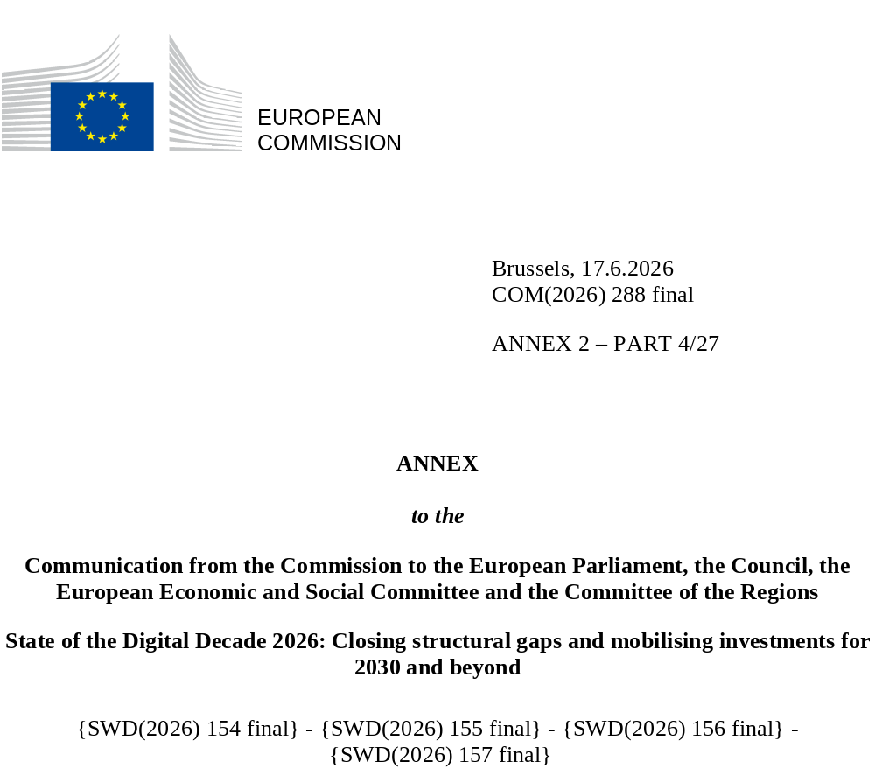

DIGITAL DECADE
SHORT COUNTRY REPORT
2026

Croatia

Executive summary
Overall, Croatia has strong digital assets in connectivity and selected strategic technology areas, notably fast-improving fixed and mobile coverage and growing engagement in quantum communication and semiconductors. However, it is not fully reaping the benefits of digitalisation across the wider economy, as SMEs continue to lag in basic digital intensity and in the uptake of advanced technologies. Persistent gaps in digital skills and weaknesses in the ICT specialist pipeline also remain significant constraints.
The weaknesses identified in the digitalisation of businesses weigh on Croatia’s competitiveness, as low and uneven SME digitalisation limits productivity gains, process modernisation and the diffusion of innovation in an economy dominated by smaller firms. Shortages and mismatches in ICT specialist profiles, together with broader gaps in digital skills, also constrain business transformation and the wider adoption of digital tools across sectors.
Croatia can, however, build on several digital leadership assets. It is strengthening its position in strategic European technology areas through quantum communication infrastructure and the Croatian Competence Centre for Semiconductors. The country is also improving its connectivity base and building capacities linked to cybersecurity and sovereign digital infrastructure. These strengths will provide a basis for stronger digital sovereignty and technological leadership if they are translated into broader digital upgrading across the economy.

Croatia in the Digital Decade
Croatia shows a substantial level of ambition in its contribution to the Digital Decade, having set 13 Croatia demonstrates a substantial level of ambition in its contribution to the Digital Decade, having set 13 national targets out of a possible 14, 77% of which are aligned with the EU 2030 targets. In its national roadmap, Croatia provided 13 trajectory points for 2025 out of 13 analysed. The country is following them moderately well, with 54% considered to be on track. Croatia addressed 88% of the eight recommendations issued by the Commission in 2025 by making some changes through new measures. According to the national roadmap, by the end of 2026, 39% of the measures will come to an end. The total public budget associated with these measures is EUR 106 million, representing 17% of the total public budget outlined in the roadmap.
According to the special Eurobarometer on ‘the Digital Decade’ 2026, 84% of Croatian people consider that digital policy should have a very high/high priority for the EU in shaping the future of Europeans. They also think that, in the next 10 years, the EU should cooperate with Member States to make digital tools more accessible for everyone, especially vulnerable groups, older people and people with disabilities (91%), reinforce cybersecurity and protection from online threats (91%) and promote digital education and skills programmes (88%). In addition, 84% of Croatian respondents think that the EU should reduce its dependencies on digital solutions from non-EU countries, and 87% think that the EU should prioritise investments in digital infrastructure and services that are developed and controlled in Europe. Meanwhile, 73% would be willing to switch to an EU-based digital service provider even if it means slightly higher costs.

Funding for digital and multi-country projects
Croatia allocates 21% of its total recovery and resilience plan to digital (EUR 1.5 billion). In addition, under cohesion policy, EUR 0.9 billion, representing 10% of the country’s total cohesion policy funding, is dedicated to advancing Croatia’s digital transformation.
Croatia is a member of the Alliance for Language Technologies European digital infrastructure consortium (EDIC), the Local Digital Twins towards the CitiVERSE EDIC, of the EUROPEUM EDIC and of the IMPACTS EDIC. Croatian entities are indirect partners in the important project of common European interest (IPCEI) on Next Generation Cloud Infrastructure and Services (IPCEI-CIS). Croatia is a participating state in the EuroHPC Joint Undertaking (JU) and of the Chips JU.
Digital Decade KPI ⁽¹⁾ | Croatia |  |  |  |  | EU |  |  | Digital Decade target by 2030
Digital Decade KPI ⁽¹⁾ | Last available data (2) | DESI 2026 (year 2025) | Annual progress | National trajectory 2025 (3) | DESI 2026 |  | Annual progress | HR |  | EU
Fixed Very High Capacity Network (VHCN) coverage | 78.9% | 82.7% | 4.8% | 73.0% | 85.5% |  | 3.7% | 100.0% |  | 100%
Fibre to the Premises (FTTP) coverage | 75.4% | 77.9% | 3.4% | 71.0% | 74.1% |  | 7.1% | 100.0% |  | -
Basic 5G coverage | 94.2% | 97.8% | 3.8% | 87.9% | 96.8% |  | 2.6% | 99.0% |  | 100%
Edge Nodes (estimate, new methodology) | - | 75 | - | - | 7451 |  | - | - |  | 10000
SMEs with at least a basic level of digital intensity * | 56.0% | 57.1% | 1.0% | 65.0% | 71.4% |  | 11.0% | 90.0% |  | 90%
Cloud * | 40.7% | 43.3% | 3.1% | 53.0% | 46.7% |  | 9.5% | 75.0% |  | 75%
Artificial Intelligence | 11.8% | 15.2% | 29.2% | 14.0% | 20.0% |  | 48.0% | 20.0% |  | 75%
Data analytics * | 51.7% | 41.9% | -10.0% | 22.0% | 39.9% |  | 9.5% | 30.0% |  | 75%
AI or Cloud or Data analytics * | 65.6% | 60.8% | -3.7% | - | 63.2% |  | 7.5% | - |  | 75%
Unicorns | 2 | 2 | 0.0% | 2 | 324 |  | 10.2% | 4 |  | 500
At least basic digital skills * | 59.0% | 63.4% | 3.7% | 69.0% | 60.4% |  | 4.3% | 80.0% |  | 80%
ICT specialists | 5.0% | 4.9% | -2.0% | 4.9% | 5.0% |  | 2.0% | 7.0% |  | ~10%
e-ID scheme notification |  | Yes
Digital public services for citizens | 75.2 | 75.3 | 0.2% | 80.0 | 84.6 |  | 2.8% | 100.0 |  | 100
Digital public services for businesses | 65.3 | 67.6 | 3.5% | 80.0 | 88.6 |  | 2.7% | 100.0 |  | 100
Access to electronic health records | 86.6 | 87.1 | 0.6% | 100.0 | 86.5 |  | 4.6% | 100.0 |  | 100
(1) Indicators full description, metadata and sources in the DESI 2026 methodological note
(2) Last available data is DESI2025 (reference year 2024) except for indicators marked with a star * for which it is DESI2024 (reference year 2023)
(3) National trajectory value for 2025, if set by the country in its Digital Decade national roadmap

A competitive, sovereign and resilient EU based on technological leadership
Croatia is performing increasingly well in connectivity, with progress in VHCN, FTTP and 5G coverage bringing it closer to the EU average. The remaining challenge is concentrated in rural, island and other market-failure areas, where delivery risks have increased, while progress on stand-alone, higher-capacity 5G and the transition from legacy networks remains limited. Croatia is also strengthening its position in strategic technologies, notably through quantum communication and the Croatian Competence Centre for Semiconductors.
On the business side, SMEs with at least a basic level of digital intensity remain a central weakness, with Croatia still below the EU average and progressing too slowly relative to the EU pace. Cloud computing and AI uptake also remain below the EU average, while data analytics and the overall take-up of advanced technologies have weakened. Croatia is strengthening support through vouchers, EDIHs and AI-related instruments, but support remains fragmented and stronger results among larger firms are not yet translating into broad-based digitalisation across business. Access to later-stage financing also remains limited, constraining the scaling and retention of innovative firms. Croatian enterprises also remain below the EU average in cybersecurity measures, limiting trusted digitalisation and business resilience. Relevant green digital initiatives are emerging, but the use of digital technologies for the green transition is not yet sufficiently systematic across sectors and territories.

Protecting and empowering EU people and society
Croatia’s performance in basic digital skills is mixed. The headline result is slightly above the EU average, but remains below the 2030 target and masks deep gaps by age, education and territory, especially among older, less educated and rural populations. The proportion of ICT specialists is around the EU average, but the pipeline remains constrained by weak progression, skills mismatches, retention pressures and insufficient alignment between education and labour market needs.
Digital public services also remain uneven. Services for citizens and access to e-Health records are comparatively stronger, while business-facing and cross-border services remain weaker. Croatia has made progress on interoperability, e-Citizens, the Once-Only Technical System and preparations linked to the European Digital Identity Wallet, but major gaps remain in register integration, practical usability and the interoperability of sectoral services, including in health. Indicators and user experience still point to administrative friction and a weaker contribution of digital public administration to competitiveness than the stronger parts of the system would suggest.

Recommendations
- Uptake of advanced digital technologies by businesses, especially SMEs: Accelerate the uptake of AI and other advanced technologies, especially in SMEs and microenterprises, by strengthening awareness, advisory and investment support for cloud computing, AI, data-driven and, where relevant, edge-enabled solutions; target lagging and low-digital-intensity firms; improve progress across vouchers, financial instruments and EDIH services; and promote secure, trustworthy and, where relevant, European solutions.
- ICT Specialists & Digital skills: Reduce dropout and improve progression into ICT-related pathways, including for women and girls, better aligning STEM, ICT, VET, higher education and lifelong learning with labour market needs. Improve digital skills by expanding accessible training for older people, low-skilled adults, inactive people and rural communities; improve coordination and monitoring across vouchers, adult learning providers and local delivery channels; reinforce media literacy and critical online information skills.
- Connectivity: Strengthen Croatia’s connectivity infrastructure by ensuring continuity and financing for gigabit roll-out in rural, island and other commercially unviable areas, also following terminated broadband projects; and advance higher-capacity 5G, including 3.4-3.8 GHz deployment and, where economically justified, stand-alone 5G use cases in underserved and strategic economic areas.
- Digital public services: Strengthen Croatia’s digital public services by accelerating end-to-end digitalisation and simplifying priority citizen and business services, especially regular business operations; strengthen interoperability and practical application of the once-only principle through better register integration and evidence exchange; improve cross-border usability; and integrate sectoral digital services, also in health, more effectively into wider public digital platforms.
- Scale-ups and innovative firms: Strengthen conditions for scaling and retaining innovative firms by improving later-stage finance for high-growth digital and technology-based firms; improve coherence between start-up, scale-up, innovation, commercialisation and growth-finance support; strengthen pathways from research and innovation to high-growth firms; and support access to European pilot lines and specialised infrastructures in strategic technologies, including semiconductors where relevant.
- Green & Digital: Strengthen the systematic use of digital technologies for the green transition by developing interoperable environmental, climate and ESG data infrastructures; scale up digital solutions for greening in priority sectors and municipalities; and improve monitoring of both the footprint of digital technologies and the emissions-reduction effects of digital solutions.
- Cybersecurity and resilience: Strengthen cybersecurity resilience across enterprises and public institutions by expanding targeted SME support from maturity assessment to implementation follow-up; promote regular risk assessment, security testing, monitoring and secure access practices beyond minimum compliance; accelerate incident-response and resilience capacities, also by developing the Security Operations Centre and national situational awareness; reinforce advisory, training and operational delivery, also through CARNET / NCC-HR; and support the gradual deployment of secure next-generation communication infrastructures, including quantum communication where relevant.

