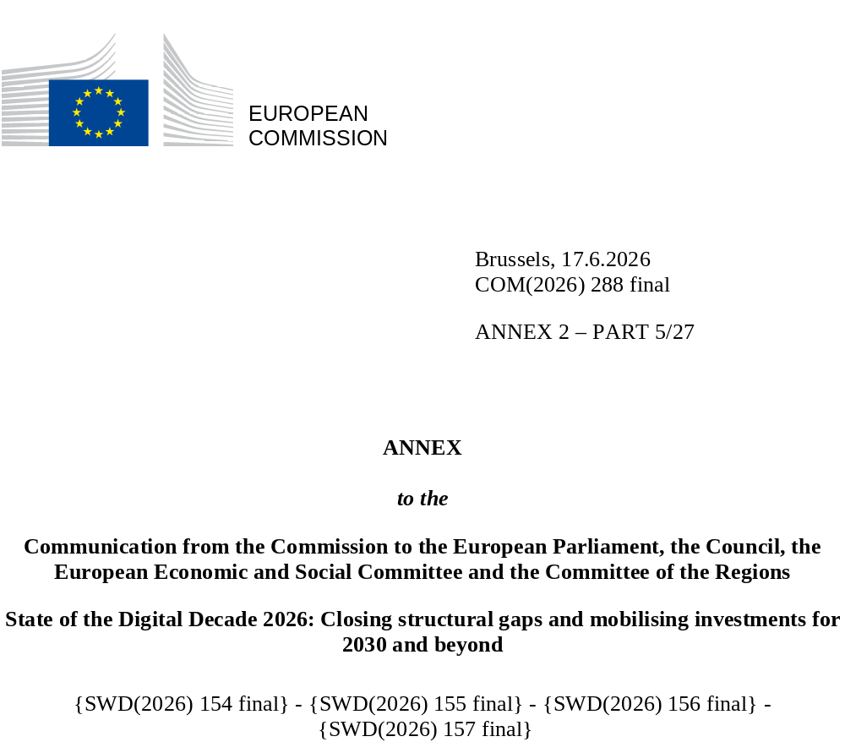

DIGITAL DECADE
SHORT COUNTRY REPORT
2026

Cyprus

Executive summary
Cyprus possesses a strong foundation for its digital transition with its extensive gigabit connectivity coverage across the territory, performing well in all key connectivity indicators. A significant proportion of SMEs in Cyprus have reached at least a basic level of digital intensity, but few have achieved a higher-level of digital intensity. In terms of AI uptake, Cypriot enterprises are lagging behind the EU average overall. At the same time, the share of ICT specialists in employment in the country is around the EU average, but with no signs of progress.
The slow adoption of AI by enterprises in Cyprus may limit their ability to fully harness the transformative potential of this technology across all economic sectors and enhance competitiveness. Additionally, while the share of the population with at least basic digital skills is improving, the current level remains a constraint, limiting access to digital opportunities, public services, and professional development. This skills gap could further hinder participation in the labour market and reduce the broader benefits of a digital economy and society. Online access to public services for people has improved, but it is still below the EU average.
Cyprus demonstrates digital leadership in strategic areas, for example, by participating in a major European project to strengthen digital sovereignty. Cyprus’s Quantum Communication infrastructure (CYQCI) initiative is part of a pan-European project to develop a secure, scalable quantum network connecting the national quantum communication infrastructures of four EU countries. This project will provide ultra-secure communication channels reinforcing Europe’s cybersecurity resilience. In terms of cross-border cybersecurity cooperation, Cyprus is also hosting one of the three EU Cyber Hubs established under the Cyber Solidarity Act. Through its federated and standards-based approach, the project contributes to the broader European vision of interconnected and resilient cross-border security operation centre (SOC) ecosystems. Furthermore, with its dynamic start-up ecosystem, Cyprus has implemented measures to attract and facilitate the relocation of start-ups, reinforcing its position as an emerging start-up ecosystem.

Cyprus in the Digital Decade
Cyprus shows a substantial level of ambition in its contribution to the Digital Decade having set 14 national targets (out of a possible 14), 86% of which are aligned with the EU 2030 targets. In its national roadmap, Cyprus provided 13 trajectory points for 2025 (out of 13 analysed). The country is following them well with 77% considered on track. Cyprus addressed 40% of the five recommendations issued by the Commission in 2025, either by implementing significant policy changes (20%) or making some changes (20%) through new measures. According to the national roadmap, by the end of 2026, 50% of the measures will come to an end. The total public budget associated with these measures is EUR 117 million, representing 16% of the total public budget outlined in the roadmap.
According to the special Eurobarometer on ‘the Digital Decade 2026’, 89% of people in Cyprus consider that digital policy should have a very high/high priority for the EU in shaping Europe’s future. They also think that, in the next 10 years, the EU should cooperate with Member States to: (i) reinforce cybersecurity and protection from online threats (93%); (ii) promote digital education and skills programmes (91%); and (iii) strengthen the regulation of online platforms (e.g. online social media networks, marketplaces, app stores, etc.) (88%). In addition, 76% of Cypriot respondents think that the EU should reduce its dependencies on digital services from third countries, and 85% that the EU should prioritise investments in digital infrastructure and services that are developed and controlled in Europe. Meanwhile, 49% would be willing to switch to an EU-based digital service provider even if it meant slightly higher costs.

Funding for digital and multi-country projects
Cyprus is allocating 30% of its total recovery and resilience plan (RRP) to digital (EUR 0.3 billion). In addition, under cohesion policy, EUR 0.1 billion – representing 12% of the country’s total cohesion policy funding – is also being dedicated to advancing Cyprus’s digital transformation.
Cyprus is a member of the EUROPEUM-EDIC (European Digital Infrastructure Consortium) to deepen cooperation on blockchain services. Cyprus is also a participating state of the EuroHPC Joint Undertaking (JU) and of the Chips JU.
Digital Decade KPI ⁽¹⁾ | Cyprus |  |  |  |  | EU |  |  | Digital Decade target by 2030
Digital Decade KPI ⁽¹⁾ | Last available data (2) | DESI 2026 (year 2025) | Annual progress | National trajectory 2025 (3) | DESI 2026 |  | Annual progress | CY |  | EU
Fixed Very High Capacity Network coverage | 89.1% | 95.5% | 7.2% | 84.0% | 85.5% |  | 3.7% | 100.0% |  | 100%
Fibre to the Premises (FTTP) coverage | 89.1% | 95.5% | 7.2% | 84.0% | 74.1% |  | 7.1% | 100.0% |  | -
Basic 5G coverage | 100.0% | 100.0% | 0.0% | 100.0% | 96.8% |  | 2.6% | 100.0% |  | 100%
Edge Nodes (estimate, new methodology) | - | 14 | - | 2 | 7451 |  | - | 10 |  | 10 000
SMEs with at least a basic level of digital intensity * | 67.3% | 74.4% | 5.1% | 75.6% | 71.4% |  | 11.0% | 90.1% |  | 90%
Cloud * | 45.5% | 48.5% | 3.2% | 54.2% | 46.7% |  | 9.5% | 75.0% |  | 75%
Artificial Intelligence | 7.9% | 9.3% | 17.3% | 11.0% | 20.0% |  | 48.0% | 75.0% |  | 75%
Data analytics * | 33.5% | 42.8% | 13.1% | 37.2% | 39.9% |  | 9.5% | 75.0% |  | 75%
AI or Cloud or Data analytics * | 58.0% | 64.7% | 5.6% | - | 63.2% |  | 7.5% | - |  | 75%
Unicorns | 4 | 4 | 0.0% | 0 | 324 |  | 10.2% | 5 |  | 500
At least basic digital skills * | 49.5% | 55.8% | 6.2% | 55.0% | 60.4% |  | 4.3% | 80.0% |  | 80%
ICT specialists | 5.0% | 4.9% | -2.0% | 6.1% | 5.0% |  | 2.0% | 10.0% |  | ~10%
e-ID scheme notification |  | Yes
Digital public services for citizens | 77.6 | 80.3 | 3.5% | 80.0 | 84.6 |  | 2.8% | 100.0 |  | 100
Digital public services for businesses | 86.0 | 85.9 | -0.1% | 89.3 | 88.6 |  | 2.7% | 100.0 |  | 100
Access to electronic health records | 75.4 | 78.8 | 4.4% | 78.2 | 86.5 |  | 4.6% | 100.0 |  | 100
(1) Indicators full description, metadata and sources in the DESI 2026 methodological note
(2) Last available data is DESI2025 (reference year 2024) except for indicators marked with a star * for which it is DESI2024 (reference year 2023)
(3) National trajectory value for 2025, if set by the country in its Digital Decade national roadmap

A competitive, sovereign and resilient EU based on technological leadership
Cyprus continues to deploy its fixed gigabit network at a rapid pace. A very efficient symmetrical access regime has helped develop the networks, as has – in underserved areas – the implementation of a major investment project funded by the recovery and resilience facility (RRF), with full network deployment scheduled for mid-2026. The country also demonstrates strong performance in 5G coverage. Regarding digital infrastructure, Cyprus is active in all aspects of the security and resilience of submarine cables, which is increasingly important in the current geopolitical environment. It is intensifying its efforts to enhance the submarine ecosystem, having a strategic target to become a regional connectivity hub. On the business side, Cyprus shows promising advancements in digitalisation of SMEs and uptake of cloud and data analytics by businesses, but there is room for improvement in the adoption of artificial intelligence. Policies and initiatives aimed at enhancing these areas could further bolster Cyprus’s digital competitiveness, in particular the implementation of the upcoming new national AI strategy. Continued focus on digital transformation and investment in advanced technologies will be crucial for sustaining and enhancing Cyprus’s position in the digital landscape.

Protecting and empowering EU people and society
Cyprus continues to work towards narrowing the digital skills gap, although it demonstrates a positive trend in digital skills acquisition. Significant disparities based on education level and age, persist, particularly among older adults and those with low formal education. Cyprus is making progress in digital public services but still lags behind EU averages, particularly in cross-border services (including judicial services) and local government digitalisation, as well as in the digitalisation of its justice system. However, Cyprus is actively advancing the practical deployment of artificial intelligence in the public sector through its programme ‘AI-in-Government’ to support the development and implementation of innovative AI-driven solutions in key domains such as meteorology, labour market monitoring, and transport, contributing to improved public service delivery and enhanced decision-making. Cyprus is also developing an integrated national digital health ecosystem and participate in the European cross-border e-health services network. Currently, people have access to their health data through an online portal, but the mobile Health application is under development. Cyprus reached all major preparatory milestones and started the implementation phase in early 2026, but the project’s completion is expected by the end of 2027.

Recommendations
- Adoption of AI by businesses: Swiftly turn the new national AI strategy into concrete support measures for greater AI adoption by businesses, including SMEs, by: (i) developing targeted AI capacity-building initiatives, particularly for traditional, non-ICT sectors; (ii) taking advantage of the sectoral approach outlined in the EU Apply AI Strategy; (iii) addressing cross-cutting challenges, such as enabling an AI-ready workforce and attracting and retaining top AI talent; (iv) promoting access for all types of enterprises (incl. SMEs, start-ups) to the recently created AI Factory Antenna in Cyprus; (v) leveraging the widespread fixed high-speed broadband coverage to accelerate efforts to create a local ecosystem of AI excellence around the AI Factory Antenna.
- Building technological leadership: With a view to the sovereignty of the digital backbone infrastructure of the island and the EU, secure investment to enhance Cyprus’s submarine cable ecosystem, and to participate in the Team Europe strategy on Submarine cable security and resilience for the Mediterranean regional sea basin.
- Cybersecurity: Strengthen Cyprus’s cybersecurity resilience in response to ever-increasing risks, especially to critical infrastructure (in particular submarine cables); further explore the use of an experimental national quantum communication infrastructure to enhance protection of critical assets.
- Digital public services: Accelerate implementation of the digital transformation strategy for the public sector, prioritising seamless and inclusive access to digital services for all citizens, with a focus on weaker areas, such as (i) boosting cross-border digital services, especially for Transport, Health, Business Start-Ups, and Justice; and (ii) supporting central and local authorities in digitalising services. Improve the efficiency of the justice system by leveraging innovative digital technologies to introduce well-functioning digital tools and procedures.
- Basic digital skills: Strengthen and expand targeted initiatives to enhance the digital skills of the population. Provide accessible and tailored training programmes, especially for groups presenting a lower percentage of at least basic digital skills, such as (i) people with no or low formal education and (ii) older people, and targeted awareness raising actions to help ensure inclusive development of digital skills across all population groups.
- E-health: Secure swift implementation of ongoing projects to ensure: (i) people will have access to their e-health records through a mobile application as soon as possible; (ii) timely availability of medical images and hospital discharge reports, (iii) equality of access to electronic health records (EHRs) for all demographic groups (e.g. by providing the legal basis and technical features for authorised persons to access EHRs on behalf of others; an online access service that fully complies with web accessibility guidelines and by promoting the use of e-health solutions also by people with no or low formal education).

