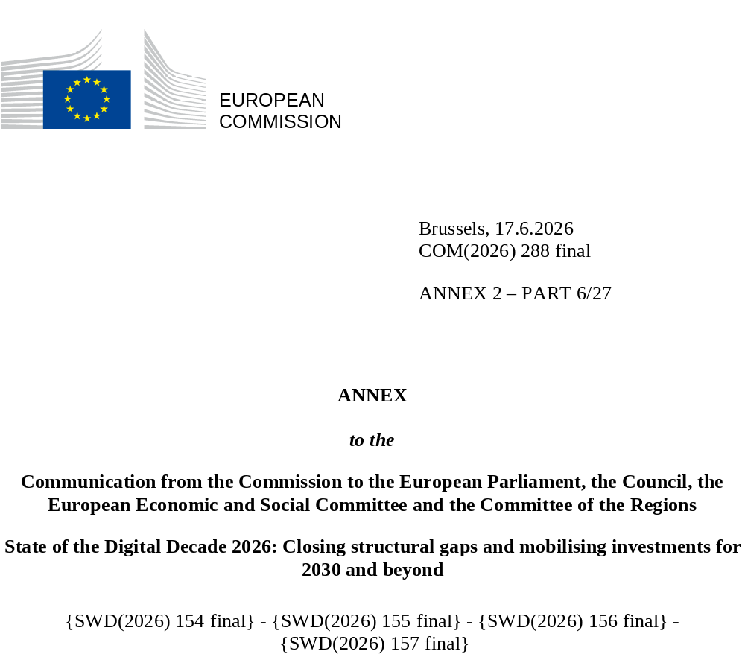

DIGITAL DECADE
SHORT COUNTRY REPORT
2026

Czechia

Executive summary

Overall, Czechia shows solid foundations in basic digital skills and a well-performing eGovernment ecosystem. It also demonstrates strengths in advanced research areas such as AI and quantum technologies. However, important gaps remain in the digitalisation of SMEs, particularly in the uptake of advanced technologies (AI, cloud, data analytics), as well as in the availability of ICT specialists. Structural weaknesses also persist in areas such as interoperability, data use in public administration and the absence of a comprehensive green-digital strategy.
The remaining gaps in SME digitalisation and advanced technology uptake weigh on productivity and competitiveness, limiting the ability of businesses to scale, innovate and integrate into digital value chains. Shortages of ICT specialists further constrain digital transformation across sectors. At the same time, incomplete interoperability and limited data-sharing practices reduce the efficiency gains that could be achieved through fully digital public administration, while gaps in eHealth uptake and integration affect the broader performance of the system.
Czechia can nevertheless rely on several assets for digital leadership. It is developing a structured approach to AI through the National Artificial Intelligence Strategy of the Czech Republic 2030 and related support initiatives (including the advanced tech TWIST programme and EDIHs), while maintaining strong participation in European initiatives such as EuroHPC and quantum research. The innovation ecosystem is supported by incubation and internationalisation programmes, although scaling-up remains a challenge. Continued investment in advanced technologies, combined with stronger links between research and industry, will be key to consolidating this position.
Czechia in the Digital Decade
Czechia shows a low level of ambition in its contribution to the Digital Decade having set 14 national targets (out of 14 possible), 43% of which aligned with the EU 2030 targets. Czechia also set a target of 60% for the combined adoption of technologies by businesses, shy of the 75% at EU level. In its national roadmap, Czechia provided 14 trajectory points for 2025 (out of 14 analysed). The country is following them moderately well with 64% considered on track. Czechia addressed 17% of the 6 recommendations issued by the Commission in 2025 by making some changes through new measures. According to the national roadmap, by the end of 2026, 69% of the measures will come to an end. The total public budget associated to these measures is EUR 988 million, representing 31% of the total public budget outlined in the roadmap.
According to the special Eurobarometer on 'the Digital Decade' 2026, 72% of Czech people consider that digital policy should have a very high/high priority for the EU in shaping our future in Europe. They also think that, in the next ten years, the EU should cooperate with Member States to reinforce cybersecurity and protection from online threats (86%), promote digital education and skills programs (80%) and develop shared digital public services (74%). In addition, 77% of Czech respondents think that the EU should reduce its dependencies on digital from third countries, and 77% that the EU should prioritise investments in digital infrastructure and services that are developed and controlled in Europe. Meanwhile, 45% would be willing to switch to an EU-based digital service provider even if it means slightly higher costs.

Funding for digital and multi-country projects
Czechia allocates 22% of its total recovery and resilience plan to digital (EUR 1.8 billion). In addition, under cohesion policy, EUR 1.8 billion, representing 9% of the country’s total cohesion policy funding, is dedicated to advancing Czechia’s digital transformation.
Czechia is a member of the Alliance for Language Technologies EDIC and of the Local Digital Twins towards the CitiVERSE EDIC. Czechia is directly participating in the IPCEI on Microelectronics and Communication Technologies (IPCEI-ME/CT), supported under National Recovery Plan. Czechia is a participating state of the EuroHPC Joint Undertaking (JU) and of the Chips JU.

Digital Decade KPI ⁽¹⁾ | Czechia |  |  |  | EU |  | Digital Decade target by 2030
Digital Decade KPI ⁽¹⁾ | Last available data (2) | DESI 2026 (year 2025) | Annual progress | National trajectory (3) | DESI 2026 (year 2025) | Annual progress | CZ | EU
Fixed Very High Capacity Network (VHCN) coverage | 53.9% | 54.7% | 1.4% | 68.9% | 85.5% | 3.7% | 95.0% | 100%
Fibre to the Premises (FTTP) coverage | 40.6% | 44.8% | 10.4% | 42.9% | 74.1% | 7.1% | 60.0% | -
Basic 5G coverage | 99.1% | 99.7% | 0.6% | 89.4% | 96.8% | 2.6% | 100.0% | 100%
Edge Nodes (estimate) | - | 295 | - | 37 | 7451 | - | 144 | 10000
SMEs with at least a basic level of digital intensity * | 49.3% | 70.5% | 19.5% | 72.5% | 71.4% | 11.0% | 80.0% | 90%
Cloud * | 35.2% | 42.9% | 10.4% | 47.5% | 46.7% | 9.5% | 60.0% | 75%
Artificial Intelligence | 11.3% | 17.6% | 56.3% | 10.7% | 20.0% | 48.0% | 21.0% | 75%
Data analytics * | 19.5% | 44.6% | 51.3% | 23.9% | 39.9% | 9.5% | 35.0% | 75%
AI or Cloud or Data analytics * | 43.1% | 61.0% | 19.0% | 45.9% | 63.2% | 7.5% | 60.0% | 75%
Unicorns | 3 | 3 | 0.0% | 4 | 324 | 10.2% | 6 | 500
At least basic digital skills * | 69.1% | 70.5% | 1.0% | 67.3% | 60.4% | 4.3% | 80.0% | 80%
ICT specialists | 4.5% | 4.7% | 4.4% | 5.4% | 5.0% | 2.0% | 7.0% | ~10%
e-ID scheme notification |  | Yes
Digital public services for citizens | 81.5 | 87.2 | 7.0% | 100.0 | 84.6 | 2.8% | 100.0 | 100
Digital public services for businesses | 86.3 | 100.0 | 15.9% | 100.0 | 88.6 | 2.7% | 100.0 | 100
Access to e-health records | 77.4 | 77.4 | 0.0% | 62.1 | 86.5 | 4.6% | 100.0 | 100
(1) Indicators full description, metadata and sources in the DESI 2026 methodological note
(2) Last available data is DESI2025 (reference year 2024) expect for indicators marked with a star * for which it is DESI2024 (reference year 2023)
(3) National trajectory value for 2025, if set by the country in its Digital Decade national roadmap

A competitive, sovereign and resilient EU based on technological leadership
Despite maintaining investments in fibre and 5G infrastructure and ongoing reforms to address permitting bottlenecks and support rollout in underserved areas Czechia is below the EU average in connectivity; demand-side factors, including limited perceived benefits and price sensitivity, continue to affect uptake and the business case for deployment, particularly in rural areas.
SME digitalisation is supported through a broad set of programmes under OP TAC, including Digital Enterprise and DEEP TECH calls, which have mobilised significant funding and demonstrated strong demand. These measures increasingly focus on advanced technologies and are aligned with Digital Decade targets. However, structural barriers such as administrative complexity, limited advisory capacity and regulatory constraints affect uptake. While regional innovation ecosystems are supported through EDIHs and testing facilities, further efforts are needed to improve visibility, accessibility and effectiveness of support tools. Czechia also lags behind its trajectory on unicorns, reflecting broader challenges in scaling innovative firms and access to finance.
Protecting and empowering EU people and society
Czechia performs well in basic digital skills, with limited structural gaps across the population. Ongoing education reforms, notably the revision of the Framework Education Programme, strengthen digital competences and computational thinking from an early stage. However, shortages of ICT specialists persist, particularly in advanced fields such as AI, cybersecurity and data analytics, despite upskilling and reskilling efforts. Measures to increase women participation and improve labour market relevance are in place but remain limited in scale.

Digital public services continue to improve, with a strong focus on user-centric design, life-event-based services and the gradual integration of AI tools. Progress on the national digital wallet and interoperability frameworks is ongoing, supported by investments in core infrastructure and governance. However, barriers remain in data sharing, system integration and uneven capacities across administrations. In eHealth, access to digital health records has expanded, but challenges persist in interoperability, uptake by professionals and support for smaller healthcare providers.

Recommendations
- Connectivity: (a) Promote the rollout of fibre infrastructure by supporting the expansion of fibre networks through coordinated funding programmes and regulatory measures at both national and regional levels, ensuring a balanced deployment, including in rural areas; (b) strengthen fibre take-up by supporting, through targeted funding and appropriate regulation, the deployment of the fibre connections to end users. (c) foster the copper networks switch-off with a view to ensuring the take up of fibre, unlock the benefits of the connectivity ecosystem and maximise the socio-economic value of high-speed infrastructure; (d) Improve availability and coverage in the 5G mid-spectrum band (3.4-3.8 GHz) in order to ensure sufficient availability of mid-band spectrum for high-quality public 5G networks.
- Unicorns: Strengthen framework conditions for scaling innovative firms, including start-ups and spin-offs in deep-tech sectors, by improving access to scale-up support and facilitating the commercial uptake of research results through stronger academia-business links.
- ICT specialists: Reinforce the supply of ICT specialists and advanced digital skills, with particular attention to cybersecurity, AI and data-related skills, by further aligning education and reskilling programmes with labour market needs and stepping up efforts to attract women and girls into ICT careers.
- E-Health: Strengthen interoperability and uptake of digital health services by accelerating the adoption of common health data standards across healthcare providers, supporting the digitalisation of smaller healthcare providers, and improving the use and awareness of eHealth services among healthcare professionals and patients.
- Green-Digital nexus: Develop a more coherent green-digital approach, including measures to monitor the environmental footprint of digital infrastructures and to better integrate digitalisation into climate, energy and circular economy policies.

