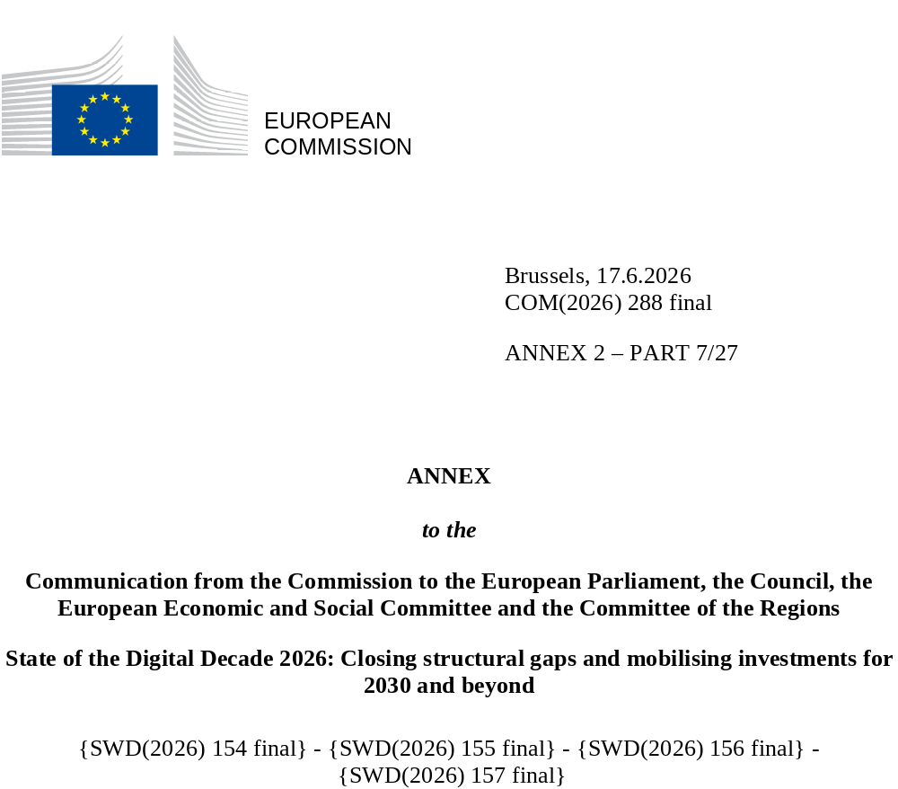

DIGITAL DECADE
SHORT COUNTRY REPORT
2026

Denmark

Executive summary
Denmark has built a very advanced digital ecosystem, supported by a robust infrastructure, an excellent research base, a population with strong digital skills and a long-standing use of digital solutions in both the private and public sectors. However, the next stage of digitalisation is proving to be more challenging, particularly for Small and Medium-Sized Enterprises (SMEs). Although companies are increasingly investing in advanced technologies – such as Artificial Intelligence (AI), cloud-based solutions and data analytics – to transform their internal processes and leverage data, adoption at the deeper level remains uneven because of skills and financial constraints. At the same time, the increasing demand for ICT specialists is putting pressure on the labour market, with smaller companies in particular facing difficulties in attracting and retaining the necessary expertise. These challenges can affect Denmark’s ability to sustain its high levels of productivity and competitiveness, as companies that do not integrate more advanced digital use risk lagging behind on innovation.
Denmark can rely on solid foundations supporting its digital leadership, including advanced digital infrastructure and a strong innovation system. Strengthening the link between research and market deployment will be essential to ensure that Denmark’s innovation base translates into real applications, supporting the scaling up of digital solutions and their diffusion across the economy. This approach is already visible in some strategic sectors, such as quantum technologies, where strong connections are being created between research – including in life sciences and advanced sensing – and industrial capabilities. Recent policy initiatives are also seeking to reinforce this link, including in the recent multi-annual investment plan for Research and Innovation 2026-2029 and the political agreement on knowledge and technology transfer. Moreover, the country now finds itself at a pivotal moment, as recent national elections coincide with the upcoming end of its current digitalisation strategy in 2027, prompting a reassessment of priorities and funding needs. While AI, SMEs, digital skills and ICT development are expected to remain central pillars, policy discussions increasingly reflect the need to balance competitiveness and digital leadership with resilience and technological sovereignty. This is demonstrated by a growing focus on critical digital infrastructures – such as cloud, quantum technologies and connectivity – not only as drivers of innovation, but also as key enablers of strategic autonomy.

Denmark in the Digital Decade
Denmark shows a high level of ambition in its contribution to the Digital Decade, with 10 national targets (out of 14), 90% of which are aligned with the EU 2030 targets. In its national roadmap, it provided 8 trajectory points for 2025 (out of 13 analysed). The country is following these trajectories well, with 88% of them being on track. Denmark has addressed 60% of the 5 recommendations issued by the Commission in 2025 by making some changes through new measures. According to the national roadmap, 51% of the measures are set to expire by the end of 2026. The total public budget associated to these measures is EUR 200 million, representing 24% of the total public budget set out in the roadmap.
According to the special Eurobarometer on the Digital Decade 2026, 88% of Danish people consider that digital policy should have a very high or high priority for the EU. They also think that, over the next 10 years, the EU should cooperate with Member States to reinforce cybersecurity and protection from online threats (98%), build an independent European digital infrastructure (broadband, 5G cloud, semiconductors) (87%) and promote digital education and skills programmes (86%). In addition, 87% of Danes think that the EU should reduce its dependencies on digital from third countries, and 92% think that the EU should prioritise investments in digital infrastructure and services that are developed and controlled in Europe. Meanwhile, 76% would be willing to switch to an EU-based digital service provider even if it means slightly higher costs.

Funding for digital and multi-country projects
Denmark allocates 28% of its total recovery and resilience plan to digital (EUR 0.4 billion). In addition, under cohesion policy, EUR 0.06 billion, representing 14% of the country’s total cohesion policy funding, is dedicated to advancing Denmark’s digital transformation.
Denmark is a member of the ‘Alliance for Language Technologies’ European Digital Infrastructure Consortium. It also participates in the European High-Performance Computing Joint Undertaking (JU) and in the Chips JU.
 | Denmark |  |  |  | EU |  | Digital Decade target by 2030
Digital Decade KPI (1) | Last available data (2) | DESI 2026 (year 2025) | Annual progress | National trajectory 2025 (3) | DESI 2026 | Annual progress | DK | EU
Fixed Very High-Capacity Network (VHCN) coverage | 96.8% | 97.7% | 1.0% | 98.0% | 85.5% | 3.7% | - | 100%
Fibre to the Premises (FTTP) coverage | 87.2% | 90.3% | 3.5% | - | 74.1% | 7.1% | - | -
Basic 5G coverage | 100.0% | 100.0% | 0.0% | 100.0% | 96.8% | 2.6% | 100.0% | 100%
Edge Nodes (estimate, new methodology) | - | 132 | - | - | 7451 | - | - | 10000
SMEs with at least a basic level of digital intensity * | 75.3% | 92.5% | 10.8% | 82.9% | 71.4% | 11.0% | 95.0% | 90%
Cloud * | 66.2% | 67.6% | 1.1% | 71.0% | 46.7% | 9.5% | 77.2% | 75%
Artificial Intelligence | 27.6% | 42.0% | 52.4% | 36.8% | 20.0% | 48.0% | 76.6% | 75%
Data analytics * | 49.5% | 60.0% | 10.1% | 59.4% | 39.9% | 9.5% | 75.0% | 75%
AI or Cloud or Data analytics * | 77.4% | 82.3% | 3.1% | - | 63.2% | 7.5% | - | 75%
Unicorns | 10 | 11 | 10.0% | - | 324 | 10.2% | - | 500
At least basic digital skills * | 69.6% | 81.5% | 8.2% | 73.6% | 60.4% | 4.3% | 80.0% | 80%
ICT specialists | 5.8% | 5.7% | -1.7% | 6.6% | 5.0% | 2.0% | 7.7% | ~10%
e-ID scheme notification |  | Yes
Digital public services for citizens | 79.5 | 82.2 | 3.4% | - | 84.6 | 2.8% | 100.0 | 100
Digital public services for businesses | 87.5 | 89.1 | 1.8% | - | 88.6 | 2.7% | 100.0 | 100
Access to electronic health records | 97.9 | 97.9 | 0.0% | - | 86.5 | 4.6% | 100.0 | 100
(1 Indicators full description, metadata and sources in the DESI 2026 methodological note
(2) Last available data is DESI2025 (reference year 2024) except for indicators marked with a star * for which it is DESI2024 (reference year 2023)
(3) National trajectory value for 2025, if set by the country in its Digital Decade national roadmap

A competitive, sovereign and resilient EU based on technological leadership
Denmark enjoys strong connectivity, with very high broadband coverage, though uptake of fibre and 5G on the demand side remains a work in progress. Overall, most SMEs display a basic level of digital intensity, with widespread use of digital tools supported by initiatives like SME:Digital, which has helped drive early adoption and awareness. However, the programme has received little attention in recent budget planning, limiting its potential to support deeper digitalisation in the future. While companies are showing higher investment and innovation activity, skill shortages continue to weigh on productivity gains. Adoption of advanced technologies, including AI, cloud and data analytics, has increased – especially for AI – but remains uneven, with smaller companies struggling to keep pace with larger competitors because of financial, skills and time constraints. The AI-Boost hub and the broader European Digital Innovation Hub (EDIH) network play a key role in bridging these gaps by providing access to expertise, testing and implementation support. Denmark has a strong pipeline of start-ups and scale-ups, but weaker growth-stage funding makes scaling more difficult. Late-stage financing is heavily dependent on foreign investors, while regulatory and administrative burdens continue to hinder growth. As a result, a strong early-stage innovation ecosystem is not translating into sufficient commercialisation or conversion of research into ready-made businesses. Cybersecurity awareness is high, but maintaining resilience remains an ongoing challenge, given the continuously evolving nature of threats and technologies. A new political agreement was reached to strengthen cyber and information security support to citizens and SMEs, enhance cyber coordination and improve cyber education until 2029. Building on this framework, the key challenge now is to turn increased awareness and institutional support into consistent, widespread implementation of basic cybersecurity practices across SMEs.

Protecting and empowering EU people and society
Denmark remains one of the EU’s strongest countries when it comes to digital skills, thanks to a long-standing model that links mandatory use of digital tools with public service delivery and skills formation. Some gaps linked to education levels remain and the country is now starting to integrate ‘Technology Comprehension’ as an approach across core subjects in primary education and as an elective subject in lower secondary education starting from 2027-2028. Implementation across the country remains to be seen, particularly in lower secondary education, where the subject will remain optional for students. Young people are particularly vulnerable to misleading content online, which has led Denmark to prioritising online safety and protecting children, particularly during its EU Presidency of the Council. At the same time, shortages of ICT specialists and STEM graduates persist, with smaller companies struggling to find the talent they need to be truly competitive. As part of the higher education reform, Denmark is seeking to raise the number of international students to address labour market needs. For example, by expanding English-taught master’s programmes and creating new places in STEM and IT fields. However, its effectiveness will depend on the ability to retain STEM graduates. Digital public services continue to be widely used and trusted, with healthcare representing a key application area. As systems face pressures from an ageing populations and workforce shortages, AI is increasingly being explored and adopted for its potential to improve efficiency, accessibility and service delivery.

Recommendations
- Digitalisation of SMEs and adoption of advanced digital technologies: Accelerate SME digitalisation beyond basic adoption towards the productive use of advanced digital and AI-based solutions. This includes: (i) maintaining and expanding existing SME digitalisation support schemes, while also reducing fragmentation among programmes; (ii) strengthening coordination with innovation infrastructures such as the AI-Boost hub, European Digital Innovation Hubs (EDIHs) and the EU Testing and Experimentation Facilities (TEFs); (iii) fostering stronger collaboration between SMEs, research institutions and innovation intermediaries to improve knowledge diffusion and facilitate the uptake of cutting-edge technologies; and (iv) promoting AI uptake in strategic sectors, supporting the EU’s Apply AI strategy.
- ICT specialists: Address shortages of ICT specialists and strengthen digital skills across the workforce by: (i) increasing the supply of ICT and STEM graduates, including through the effective implementation of higher education reforms and the expansion of relevant study places; (ii) attracting and retaining ICT talent by strengthening pathways from study to employment and facilitating graduates’ integration into the Danish labour market; (iii) scaling advanced digital skills, upskilling and reskilling programmes for both ICT specialists and workers in sectors undergoing digital transformation, ensuring alignment with labour market needs.
- Innovation ecosystems: Strengthen the country’s capacity to turn digital and deep-tech research into scalable commercial innovation, including by effectively implementing and monitoring the recent agreements on technology transfer and on funding for research and innovation. Improve access to scale-up funding for innovative digital companies by addressing the late-stage funding gap and enabling businesses to scale domestically.
- Quantum technologies: Consolidate the country’s quantum leadership by: (i) leveraging existing strengths in life sciences and quantum sensing to develop market-ready applications and grow industrial adoption; (ii) expanding commercialisation support to speed up research-to-market transitions; and (iii) deepening cross-border collaboration to contribute to the building of a European quantum supply chain.
- Cybersecurity: Ensure the effective implementation of the new national cyber and information security strategy and the strengthening of coordination mechanisms across public and private stakeholders. Moreover, further encourage the uptake of cybersecurity measures by SMEs through targeted awareness, training and funding initiatives.

