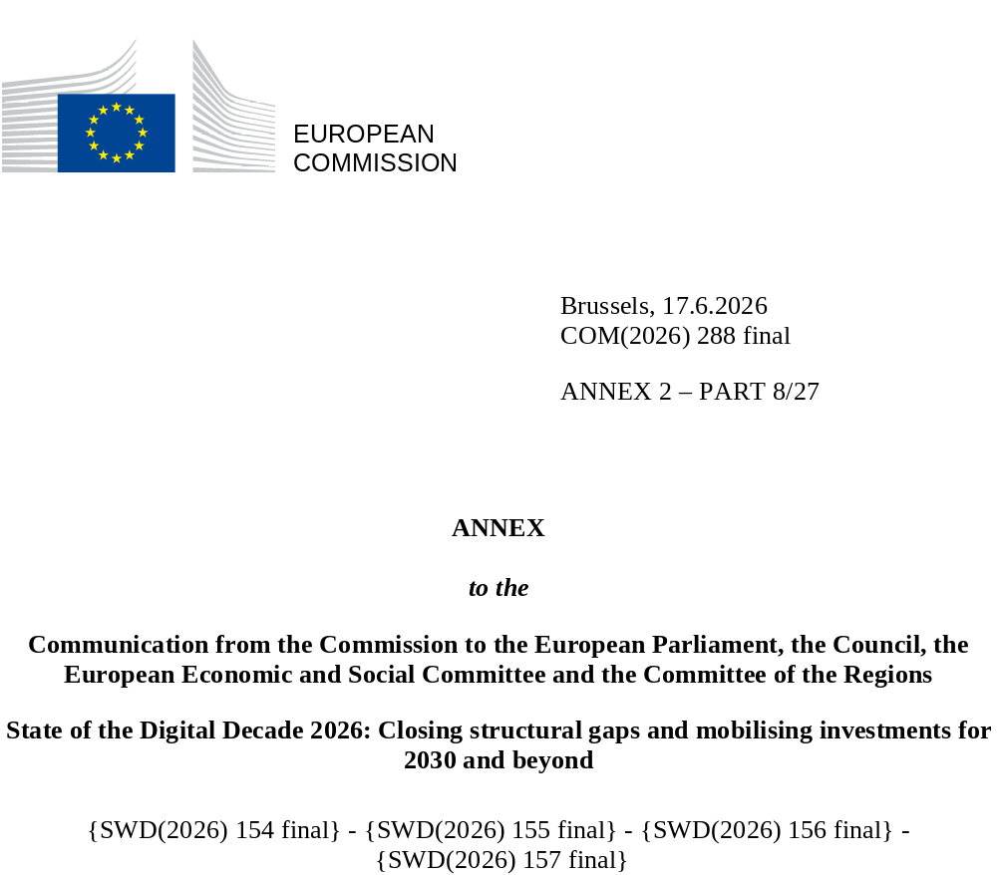

DIGITAL DECADE SHORT COUNTRY REPORT
2026

Estonia

Executive summary
Overall, Estonia has a strong record in digitalisation, with excellent digital public services, strong take-up of advanced technologies and a vibrant tech start-up ecosystem. However, there is still room for improvement when it comes to connectivity and the implementation of cybersecurity measures by businesses. The number of ICT specialists, while currently above the EU average, is still a crucial area of development to meet demand on Estonia’s job market, with a growing emphasis not only on quantity but on the quality of skills and the progression from advanced to top-level expertise. Additionally, while the overall level of basic digital skills in Estonia is above the EU average, it has stagnated over recent years and certain groups, such as older individuals are less digitally skilled than their EU counterparts.
While Estonia has performed well overall in its digital transition, its connectivity weaknesses in the area of very high capacity networks (VHCNs), are having an impact on its competitiveness, as strong digital infrastructure is the foundation for a thriving digital society. Low levels of implementation of cybersecurity measures by businesses also represent a significant risk, especially in the current geo-political environment. Estonia has identified that a shortage in ICT specialists is the key bottleneck to ongoing digitalisation efforts and the adoption of advanced technologies across all sectors in the country. By increasing the supply of ICT specialists on the employment market, combined with stronger and more systematic emphasis on skills development, Estonia could further improve its competitiveness through increased digitalisation.
Estonia is a digital leader in several areas. It is home to one of the most digitised governments in the EU thanks to the early implementation of digital public services. Additionally, Estonia’s public policies have strongly shifted towards the adoption of AI, including by building local AI infrastructure through a Nordic-wide consortium and the adoption of AI in education and throughout the public and private sector with initiatives such as the AI Leap and Eesti.ai. Estonia has also committed to large public investments in its start-up sector, building on one of the existing strengths of the country. In the area of emerging technologies such as semiconductors and quantum computing, Estonia is an active participant in EU-level initiatives while simultaneously cooperating with neighbouring countries.

Estonia in the Digital Decade
Estonia shows a high level of ambition in its contribution to the Digital Decade having set 14 national targets (out of 14 possible), 93% of which aligned with the EU 2030 targets. In its national roadmap, Estonia provided 12 trajectory points for 2025 (out of 13 analysed). The country is following them well with 83% considered on track. Estonia addressed 86% of the 7 recommendations issued by the Commission in 2025, either by implementing significant policy changes (29%) or making some changes (57%) through new measures. According to the national roadmap, by the end of 2026, 0% of the measures will come to an end.
According to the special Eurobarometer on ‘the Digital Decade’ 2026, 71% of Estonian people consider that digital policy should have a very high/high priority for the EU in shaping our future in Europe. They also think that, in the next ten years, the EU should cooperate with Member States to reinforce cybersecurity and protection from online threats (93%), promote digital education and skills programs (88%), and strengthen the regulation of online platforms (e.g. online social networks, marketplaces, app stores, etc.) (80%).
In addition, 69% of Estonian respondents think that the EU should reduce its dependencies on digital from third countries, and 70% that EU should prioritise investments in digital infrastructure and services that are developed and controlled in Europe. Meanwhile, 35% would be willing to switch to an EU-based digital service provider even if it means slightly higher costs.

Funding for digital and Multi-Country Projects
Estonia allocates 24% of its total recovery and resilience plan to digital (EUR 0.2 billion). In addition, under cohesion policy, EUR 0.4 billion, representing 10% of the country’s total cohesion policy funding, is dedicated to advancing Estonia’s digital transformation.
Estonia is a member of the Local Digital Twins towards a CitiVERSE EDIC. Estonia is a participating state of the EuroHPC Joint Undertaking (JU) and of the Chips JU.
Digital Decade KPI ⁽¹⁾ | Estonia |  |  |  |  | EU |  |  | Digital Decade target by 2030
Digital Decade KPI ⁽¹⁾ | Last available data (2) | DESI 2026 (year 2025) | Annual progress | National trajectory 2025 (3) | DESI 2026 |  | Annual progress | EE |  | EU
Fixed Very High Capacity Network coverage | 76.3% | 81.1% | 6.4% | 78.5% | 85.5% |  | 3.7% | 100.0% |  | 100%
Fibre to the Premises (FTTP) coverage | 76.3% | 81.1% | 6.4% | 78.5% | 74.1% |  | 7.1% | 100.0% |  | -
Basic 5G coverage | 91.5% | 100.0% | 9.2% | 95.0% | 96.8% |  | 2.6% | 100.0% |  | 100%
Edge Nodes (estimate, new methodology) | - | 28 | - | 0 | 7451 |  | - | 5 |  | 10000
SMEs with at least a basic level of digital intensity * | 55.9% | 72.1% | 13.6% | 65.0% | 71.4% |  | 11.0% | 90.0% |  | 90%
Cloud * | 52.6% | 56.2% | 3.4% | 58.0% | 46.7% |  | 9.5% | 75.0% |  | 75%
Artificial Intelligence | 13.9% | 23.4% | 68.5% | 20.0% | 20.0% |  | 48.0% | 75.0% |  | 75%
Data analytics * | 25.6% | 56.0% | 48.0% | 35.0% | 39.9% |  | 9.5% | 75.0% |  | 75%
AI or Cloud or Data analytics * | 60.6% | 75.0% | 11.3% | - | 63.2% |  | 7.5% | - |  | 75%
Unicorns | 2 | 2 | 0.0% | - | 324 |  | 10.2% | 5 |  | 500
At least basic digital skills * | 62.6% | 62.5% | -0.1% | 67.0% | 60.4% |  | 4.3% | 80.0% |  | 80%
ICT specialists | 7.2% | 6.8% | -5.6% | 7.5% | 5.0% |  | 2.0% | 10.0% |  | ~10%
e-ID scheme notification |  | Yes
Digital public services for citizens | 96.1 | 97.2 | 1.1% | 100.0 | 84.6 |  | 2.8% | 100.0 |  | 100
Digital public services for businesses | 97.5 | 97.5 | 0.0% | 100.0 | 88.6 |  | 2.7% | 100.0 |  | 100
Access to electronic health records | 100.0 | 100.0 | 0.0% | 100.0 | 86.5 |  | 4.6% | 100.0 |  | 100
(1) Indicators full description, metadata and sources in the DESI 2026 methodological note
(2) Last available data is DESI2025 (reference year 2024) except for indicators marked with a star * for which it is DESI2024 (reference year 2023)
(3) National trajectory value for 2025, if set by the country in its Digital Decade national roadmap

A competitive, sovereign and resilient EU based on technological leadership
Estonia has a mixed performance in connectivity, with its fibre and basic 5G coverage above the EU average after impressive growth over the last two years. However, its VHCN coverage remains below the EU average. To address this, Estonia has implemented support measures to increase its VHCN coverage, specifically targeting rural areas.
On the business side, basic digitalisation in SMEs is above the EU average. Moreover, Estonian businesses have demonstrated impressive take-up of data analytics and cloud computing. Building on an already strong uptake of advanced technologies by businesses, Estonia has embraced the goal of becoming a global leader in AI. The country is aiming to use the technology to grow its economy by 50% by 2035 through the launch of Eesti.ai and other initiatives. However, the Eesti.ai initiative is still in its initial stages and will need additional definition and further implementation to achieve its high goals. In its transition to AI, Estonia is also supported by its historically strong start-up ecosystem which grew significantly in 2025. However, the number of newly formed companies and overall investment in the sector has declined over several years, warranting further support.

Protecting and empowering EU people and society
In Estonia, the overall level of basic digital skills is above the EU average but has stagnated over recent years and among certain groups. For example, older individuals in Estonia have lower digital skills than their EU counterparts. The need for digital skills is all the more crucial given the high degree of digitalisation of public services in Estonia, creating increased barriers to participation in public life especially for vulnerable groups. Further work to ensure the accessibility of public services is crucial in Estonia. While the share of ICT specialists remains above the EU average, Estonia has nevertheless identified the number of ICT specialists as a key factor limiting its digital transition across all sectors.

Recommendations
- ICT specialists: Further implement measures to educate ICT specialists, particularly in critical fields such as AI and cybersecurity, and reverse the decline in ICT specialists in employment, including by (i) providing lifelong learning opportunities, (ii) offering courses specifically targeted at upskilling junior ICT specialists and recent ICT graduates, (iii) decreasing the dropout rate of ICT-related courses, and (iv) renewing efforts to attract more women to the ICT sector.
- AI uptake: Continue implementing measures to position Estonia as a future AI leader by advancing AI adoption in education, the economy and the public sector. This should be done by (i) further developing the AI Leap programme in education, (ii) accelerating the implementation of Eesti.ai and similar initiatives to boost AI uptake across the business sector, (iii) further adopting AI in the public sector to increase usability and reduce the cost of digital public services, and (iv) strengthening local AI infrastructure through initiatives such as the Nordic AI consortium.
- Basic digital skills: Continue implementing measures to increase digital skills throughout society by (i) consolidating the fragmented efforts of the digital skills development system, (ii) expanding access to and the range of free e-learning opportunities, (iii) providing in-person digital training targeted at older adults and rural communities, and (iv) introducing measures aimed at increasing the fact-checking skills of the public.
- Cybersecurity: Step up efforts to support companies, especially SMEs and entities that operate in critical infrastructure to implement cybersecurity measures. Pursue efforts to minimise the impact of online fraud by organising awareness-raising campaigns targeting the general public and particularly vulnerable groups in society.
- Unicorns: Support the Estonian start-up ecosystem by (i) further developing accelerator programmes and start-up incubators to foster the formation of new start-ups, (ii) better leveraging public investment in R&I and addressing obstacles to commercialisation of R&I, and (iii) improving access to finance for scaling up of start-ups.
- Green transition: Follow up on the sustainability initiatives of the Digital Society Development plan 2035, particularly by (i) institutionalising the measurement of the ICT carbon footprint of each public sector institution, and (ii) consolidating ICT management across the public sector.

