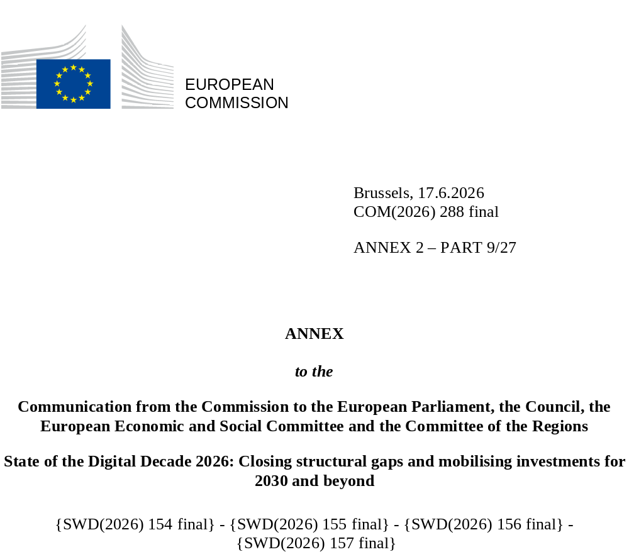

DIGITAL DECADE
SHORT COUNTRY REPORT
2026

Finland

Executive summary
Finland has established itself as a digital frontrunner, with digitally agile enterprises, strong digital skills and leadership in artificial intelligence (AI) and supercomputing. However, Finland has not fully harnessed its digital potential due to persistent connectivity gaps in rural areas, stagnant cloud adoption and a shortage of ICT professionals.
Finland benefits from a range of strong digital leadership assets. It is advancing semiconductor innovation and research, and promoting cross-sector AI adoption, including hosting one of the EU’s first AI factories, LUMI, and strengthening AI education. Finnish businesses are highly digitalised, supported by sustained public and private investments. People in Finland demonstrate strong digital proficiency alongside robust awareness of privacy issues and critical content-evaluation skills, while e-Government services are widely adopted across society.
Addressing persistent connectivity gaps in rural areas remains important to ensuring that all communities can benefit from the digital economy and have equitable access to services such as e-government, remote work, and digital education. At the same time, stagnant cloud adoption may create long-term issues, given that growing demand for high-performance computing will necessitate additional investment. ICT talent shortages threaten Finland’s ability to capitalise on its technological leadership, meaning it could fall behind in AI innovation, data-driven industries and high-performance computing (areas where the country currently excels). If these challenges are not addressed, Finland may struggle to sustain its competitive edge in digitalisation and to fully realise the economic and societal benefits of its advanced digital infrastructure.

Finland in the Digital Decade
Finland shows a high level of ambition in its contribution to the Digital Decade having set 12 national targets (out of 14 possible), 100% of which aligned with the EU 2030 targets. In its national roadmap, Finland provided 10 trajectory points for 2025 (out of 13 analysed). The country is following them well with 80% considered on track. Finland addressed 86% of the 7 recommendations issued by the European Commission in 2025, either by implementing significant policy changes (29%) or making some changes (57%) through new measures. According to the national roadmap, by the end of 2026, 43% of the measures will come to an end. The total public budget associated with these measures is EUR 70 million, representing 13% of the total public budget outlined in the roadmap.
According to the special Eurobarometer on ‘the Digital Decade’ 2026, 83% of Finnish people consider that digital policy should have a very high/high priority for the EU in shaping our future in Europe. They also think that, in the next 10 years, the EU should cooperate with Member States to reinforce cybersecurity and protection from online threats (96%), promote digital education and skills programs (90%), and strengthen the regulation of online platforms (83%).
In addition, 87% of Finnish respondents think that the EU should reduce its dependencies on digital from non-EU countries, and 93% that EU should prioritise investments in digital infrastructure and services that are developed and controlled in Europe. Meanwhile, 68% would be willing to switch to an EU-based digital service provider even if it means slightly higher costs.

Funding for digital and multi-country projects
Finland allocates 29% of its total recovery and resilience plan to digital (EUR 0.5 billion). In addition, under the cohesion policy, EUR 0.4 billion, representing 19% of the country’s total cohesion policy funding, is dedicated to advancing Finland’s digital transformation.
Finland is an observer of the Alliance for Language Technologies European Digital Infrastructure Consortium (EDIC). It is directly participating in the Important Project of Common European Interest on Microelectronics and Communication Technologies (IPCEI-ME/CT). The country is also a participating state of the EuroHPC Joint Undertaking (JU) and of the Chips JU.

Digital Decade KPI ⁽¹⁾ | Finland |  |  |  |  | EU |  |  | Digital Decade target by 2030
Digital Decade KPI ⁽¹⁾ | Last available data (2) | DESI 2026 (year 2025) | Annual progress | National trajectory 2025 (3) | DESI 2026 |  | Annual progress | FI |  | EU
Fixed Very High-Capacity Network (VHCN) coverage | 81.7% | 84.6% | 3.6% | 72.1% | 85.5% |  | 3.7% | 100.0% |  | 100%
Fibre to the Premises (FTTP) coverage | 68.3% | 80.0% | 17.2% | 72.1% | 74.1% |  | 7.1% | 100.0% |  | -
Basic 5G coverage | 99.5% | 100.0% | 0.5% | 99.6% | 96.8% |  | 2.6% | 100.0% |  | 100%
Edge Nodes (estimate, new methodology) | - | 110 | - | - | 7451 |  | - | - |  | 10000
SMEs with at least a basic level of digital intensity * | 85.6% | 94.0% | 4.8% | 91.5% | 71.4% |  | 11.0% | 95.0% |  | 90%
Cloud * | 73.0% | 73.1% | 0.1% | 73.6% | 46.7% |  | 9.5% | 75.0% |  | 75%
Artificial Intelligence | 24.4% | 37.8% | 55.2% | 35.0% | 20.0% |  | 48.0% | 75.0% |  | 75%
Data analytics * | 40.6% | 45.1% | 5.5% | 52.0% | 39.9% |  | 9.5% | 75.0% |  | 75%
AI or Cloud or Data analytics * | 79.5% | 81.0% | 0.9% | - | 63.2% |  | 7.5% | - |  | 75%
Unicorns | 6 | 8 | 33.3% | - | 324 |  | 10.2% | - |  | 500
At least basic digital skills * | 82.0% | 81.0% | -0.6% | 83.4% | 60.4% |  | 4.3% | 87.0% |  | 80%
ICT specialists | 7.8% | 7.8% | 0.0% | 8.3% | 5.0% |  | 2.0% | 10.0% |  | ~10%
e-ID scheme notification |  | Yes
Digital public services for citizens | 96.3 | 97.4 | 1.2% | 92.0 | 84.6 |  | 2.8% | 100.0 |  | 100
Digital public services for businesses | 98.8 | 98.8 | 0.0% | - | 88.6 |  | 2.7% | 100.0 |  | 100
Access to electronic health records | 84.7 | 91.4 | 7.9% | - | 86.5 |  | 4.6% | 100.0 |  | 100
(1) Indicators full description, metadata and sources in the DESI 2026 methodological note
(2) The latest available data is from DESI2025 (reference year 2024) except for indicators marked with a star * for which it is DESI2024 (reference year 2023)
(3) National trajectory value for 2025, if set by the country in its Digital Decade national roadmap

A competitive, sovereign and resilient EU based on technological leadership
Finland’s 2025 digital and technological landscape reflects strong performance in key areas but reveals mixed progress in adoption, infrastructure, and innovation. Digital connectivity shows steady improvement with the decommission of copper, adoption of a 6G roadmap, near-universal 5G coverage and Fibre-to-the-Premises (FTTP) adoption surpassing EU averages. On the other hand, Very High-Capacity Network (VHCN) coverage lags behind, and gaps in rural area coverage (FTTP and VHCN) is a threat to further deepen the digital divide. Finland excels in the digitalisation of small and medium-sized enterprises (SMEs), though growth rates for cloud adoption and data analytics have slowed. AI adoption remains a standout, driven by initiatives like the LUMI AI Factory. Finland’s 2025-2035 Quantum Technology Strategy position the country as a global leader by integrating research, industrial policy, and infrastructure, while expanding commercialisation, quantum-secure communications, and export-driven innovation through Business Finland’s quantum program. By accelerating private-sector growth, cross-border partnerships, and market capture, would allow Finland to full capitalise on its world-class ecosystem. In semiconductors, Finland has strengthened its ecosystem through initiatives such as the VTT Technical Research Centre of Finland’s (VTT) pilot lines (e.g. FAMES and NanoIC), Tampere University’s wide-bandgap (WBG) packaging hub and the Finnish Chips Competence Centre (FiCCC). These efforts bring together academia and industry while also supporting collaboration across the Nordic and Baltic regions. Cybersecurity continues to be a national strength, although reliance on non-European providers and fragmented funding structures risk weakening long-term resilience. Meanwhile, the start-up ecosystem is seeing a decline in the number of new ventures, even as investment – particularly in deep tech – continue to grow.

Protecting and empowering EU people and society
Finland’s digital society in 2025 demonstrates exceptional strength in skills and public services, though persistent gaps exist in the availability of ICT specialists. The level of basic digital skills continues to be significantly above the EU average, standing out due to women outperforming men. However, stagnant skills growth and the urban-rural divide risks eroding Finland’s lead. While ICT education in Finland is expanding, domestic output has been short of industry demand. This makes strategic international recruitment of high-skilled digital talent essential to fill persistent gaps, capitalise on the country’s strong ICT reputation and support businesses driving growth through next-generation technologies. Recently, due to the general economic situation, unemployment of the recently graduated has been rising. Digital public services continue to rank among the best in the EU, with initiatives such as suomi.fi leading the way. Finland is in the process of harmonising the EU Digital Identity (EUDI) Wallet.

Recommendations
- Connectivity: Finland should close the remaining fixed gigabit coverage gap in rural and sparsely populated areas in particular by: (i) maintaining Finnish leadership on mobile networks and on the next-generation roadmap, including through the sustained implementation of the national 6G roadmap published in June 2025 promotion of the deployment of 5G SA networks and of the national project on secure and future-proof communication networks. (ii) it should take advantage of the upcoming expiry rights of use to negotiate pro-investment conditions, (iii) scaling up existing broadband support measures for areas where market failure is evident, complemented by targeted state-aid schemes and community-led initiatives.
- ICT specialists: to meet the fast-growing demand for ICT specialists from Finnish industry and to address persistent gaps in supply, Finland should deploy a coordinated set of training, attraction and retention measures aligned with the country's priority technology domains, in particular by: (i) offering tailored training pathways for ICT specialists already in the workforce, aligned with the demand from the LUMI AI Factory, from the Finnish Chips Competence Centre and from the quantum ecosystem, including by building on the national doctoral-training pilot programme 2024-2027; (ii) reinforcing the attraction and retention of ICT specialists from abroad, and addressing the persistent gender gap in the field (iii) intensifying efforts to increase women’s participation in ICT studies and careers.
- Take-up of technologies: Further promote cooperation between academia, businesses, and other stakeholders, with a view to advancing innovation with the support of digital technologies with a particular emphasis on cloud and data analytics.
- Cybersecurity: Reinforce further efforts in cybersecurity to address evolving threats, particularly for enterprises and public administration. To strengthen digital sovereignty and align with EU strategic priorities, Finland should expand its reliance on European cybersecurity suppliers while addressing current funding gaps and structuring investments more effectively. Ensure the effective operation of the national cybersecurity services for information security threat detection and attack surface mapping, including by securing predictability of public funding for these services. Finalise efforts to ensure imposition of cybersecurity measures necessary to enhance the cyber posture of critical infrastructure.
- Quantum: Accelerate the transition from infrastructure excellence toward a broader industrial and export-oriented base, widening the company landscape beyond the current concentrated core. Reinforce Finland's instruments for attracting foreign investment and supporting commercial scale-up. Enforce the integration of the Finnish ecosystem into European value chains and intensify collaboration and contribute to building a European quantum supply-chain.
- Semiconductors: Continue investing in the development and manufacturing of critical technologies in the areas of digital and deep tech.

