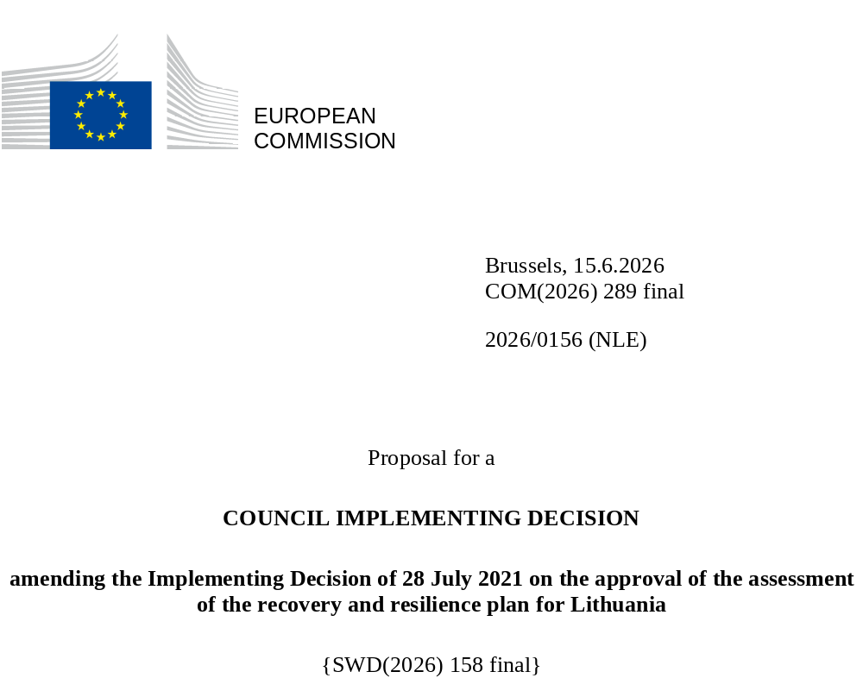

2026/0156 (NLE)
Proposal for a
COUNCIL IMPLEMENTING DECISION
amending the Implementing Decision of 28 July 2021 on the approval of the assessment of the recovery and resilience plan for Lithuania
THE COUNCIL OF THE EUROPEAN UNION,
Having regard to the Treaty on the Functioning of the European Union,
Having regard to Regulation (EU) 2021/241 of the European Parliament and of the Council of 12 February 2021 establishing the Recovery and Resilience Facility, and in particular Article 20(1) thereof,
Having regard to the proposal from the European Commission,
Whereas:
(1) Following the submission of the national recovery and resilience plan (‘RRP’) by Lithuania on 14 May 2021, the Commission proposed its positive assessment to the Council. On 28 July 2021, the Council approved the positive assessment by means of an implementing decision (‘the Council Implementing Decision of 28 July 2021). The Council Implementing Decision of 28 July 2021 was amended by the Council Implementing Decisions of 9 November 2023, 8 October 2024, 20 June 2025 and 17 February 2026.
(2) On 31 May 2026, Lithuania made a reasoned request to the Commission to make a proposal to amend the Council Implementing Decision of 28 July 2021 in accordance with Article 21(1) of Regulation (EU) 2021/241 on the grounds that the RRP is partially no longer achievable because of objective circumstances. On that basis, Lithuania has submitted an amended RRP.
Amendments based on Article 21 of Regulation (EU) 2021/241
(3) The amendments to the RRP submitted by Lithuania because of objective circumstances concern 29 (sub-) measures.
(4) Lithuania has explained that nine (sub-)measures are partially no longer achievable, because of supply chain constraints and unexpected technical difficulties. This concerns (sub)-measures A.1.3.2 (Modernisation of infectious disease cluster centres), B.1.2.1 (Support for the delivery of clean vehicles, and for sustainable mobility), B.1.2.3 (Installation of vehicle charging and alternative fuel filling infrastructure), B.1.3.3 (Supply of construction products and services that speed up the renovation of buildings), B.1.3.4 (Support for renovation of buildings), D.1.4.3 (Apprenticeship and trainings), G.1.2.2 (Increasing the scope and diversity of employment support measures), H.1.1.2 (Support for renovation of buildings (scaled-up), H.1.2 (Support for the purchase of clean inland water vehicle). On this basis, Lithuania has requested that those measures be amended. The Council Implementing Decision of 28 July 2021 should be amended accordingly.
(5) Lithuania has explained that one (sub-)measure has been amended to implement better alternatives in order to achieve its original ambition. This concerns E.1.3.2 (Supporting research and development). On this basis, Lithuania has requested that this (sub-)measure is amended. The Council Implementing Decision of 28 July 2021 should be amended accordingly.
(6) Lithuania has explained that 17 (sub-)measures have been amended to implement a better alternative that allows the administrative burden to be reduced and simplify the Council Implementing Decision, while still achieving the objectives of those measures. This concerns sub-measures A.1.1.11 (Digitalisation of the healthcare sector), B.1.1.2 (Support for the construction of individual storage facilities), B.1.2.2 (Support for the purchase of zero-emission public transport vehicles), B.1.2.4 (Support for the RES fuels sector (biomethane gas, second generation liquid biofuels for transport, and renewable hydrogen)), B.1.4 (Maintaining and increasing GHG absorption capacity), D.1.1.3 (Millennium School programme), D.1.1.5 (Supporting equipment acquisition for STEAM centres and mobile laboratories), E.1.2.3 (Supporting the start-up ecosystem), E.1.3.3 (Encouraging science and business to participate in the EU research and innovation programme Horizon Europe and other international funding programmes), F.1.1.1 (Modernization of human resources management system in the public sector), F.1.4.4 (Tax literate future taxpayers), F.1.6.1. (Delivery of new data analytics tools for the State Tax Inspectorate), F.1.6.2. (Monitoring data quality of the State Tax Inspectorate and of other institutions), F.1.7.2. (Delivery of a prototype eFTI gate), F.1.8 (A single window to pay fines), G.1.2.1 (Optimization and digitalisation of employment service operational processes, ensuring systematic customer orientation), H.1.1.1 (Update of renovation packages and standards). On this basis, Lithuania has requested that those measures be amended. The Council Implementing Decision of 28 July 2021 should be amended accordingly.
(7) Following the decrease in the level of implementation of 13 sub-measures in accordance with Article 21 of Regulation (EU) 2021/241, Lithuania has requested to use the resources freed up by the decrease in the level of their implementation to increase the level of implementation of two sub-measures. This concerns F.1.3.5 (Consolidation of the national development institutions) and H.1.3.2 (Support for the construction of RES plants (solar power)). On this basis, Lithuania has requested that the level of implementation of two sub-measures be increased. The Council Implementing Decision of 28 July 2021 should be amended accordingly.
Corrections of clerical errors
(8) Two clerical errors have been identified in the text of the Council Implementing Decision, affecting two sub-measures under two components. The Council Implementing Decision should be amended to correct these clerical errors that do not reflect the content of the RRP submitted to the Commission on 28 July 2021, as agreed between the Commission and Lithuania. Those clerical errors relate to A.1.2.2 (Human resources and infrastructure capacity for the provision of long-term care services) and C.1.1 (Transformation of public information technology governance) under components A and C. Those corrections do not affect the implementation of the measures concerned.
Commission’s assessment
(9) The Commission has assessed the amended RRP against the assessment criteria laid down in Article 19(3) of Regulation (EU) 2021/241.
Contribution to the REPowerEU objectives
(10) In accordance with Article 19(3), point (da), of, and criterion 2.12 of Annex V to, Regulation (EU) 2021/241, the REPowerEU chapter is expected to effectively contribute to a large extent (rating A) to energy security, the diversification of the Union’s energy supply, an increase in the uptake of renewables and in energy efficiency, an increase of energy storage capacities or the necessary reduction of dependence on fossil fuels before 2030. While the ambition of sub-measures H.1.1.2 (Support for renovation of buildings (scaled-up) and H.1.2 (Support for the purchase of clean inland water vehicle) has been decreased, the ambition of sub-measure H.1.3.2. (Support for the construction of RES plants (solar power)) has been increased following the reallocation of the corresponding freed-up resources. The total estimated cost of the measures under REPowerEU has remained constant, and therefore the assessment remains unchanged.
Contribution to the green transition including biodiversity
(11) In accordance with Article 19(3), point (e), of, and criterion 2.5 of Annex V to, Regulation (EU) 2021/241, the amended RRP contains measures that contribute to a large extent (rating A) to the green transition, including biodiversity, or to addressing the challenges resulting therefrom. The measures supporting climate objectives account for an amount which represents 37.2% of the amended RRP’s total allocation and 99.64% of the total estimated costs of measures in the REPowerEU chapter calculated in accordance with the methodology set out in Annex VI to Regulation (EU) 2021/241. In accordance with Article 17 of Regulation (EU) 2021/241, the amended RRP is consistent with the information included in the National Energy and Climate Plan 2021-2030.
(12) Following the proposed amendments by Lithuania to the RRP, the contribution to climate objectives decreased from 38.2% to 37.2%. The decrease in the contribution to climate objectives mostly reflects the decrease in the level of implementation of measure H.1.2 (Promote the purchase of zero-emission inland waterway transport vehicles) contributing 40% to climate objectives following the reallocation of the corresponding freed-up resources.
Contribution to the digital transition
(13) In accordance with Article 19(3), point (f), of, and criterion 2.6 of Annex V to, Regulation (EU) 2021/241, the amended RRP contains measures that contribute to a large extent (rating A) to the digital transition or to addressing the challenges resulting from it. The measures supporting digital objectives account for an amount which represents 23.42% of the amended RRP’s total allocation calculated in accordance with the methodology set out in Annex VII to that Regulation.
(14) The contribution towards the digital transition of the modified RRP decreases from 23.44% contribution to 23.42%. This decrease is driven mostly by the downscaling of sub-measures D.1.4.3 (Apprenticeship and work-based learning) and G.1.2.2. (Increasing the scope and diversity of employment support measures, contributing to the goals of digital and green transformation and promoting the circular economy - Measures to promote entrepreneurship (digitisation)) which contribute at 40% to digital objectives.
Costing
(15) In accordance with Article 19(3), point (i), of, and criterion 2.9 of Annex V to, Regulation (EU) 2021/241, the justification provided in the amended RRP on the amount of the estimated total cost of the RRP is to a medium extent (rating B) reasonable and plausible, is in line with the principle of cost efficiency and is commensurate to the expected national economic and social impact.
(16) According to the information provided, the assessment of the cost estimates for the revised investments shows that most of the costs are reasonable and plausible even though the evidence shows varying degrees of details and depth of calculations. Furthermore, the changes in the cost estimates for amended measures were justified and proportional and as such the reasonability, plausibility, and the additionality of EU funding where applicable, of these cost estimates were not altered compared to the original RRP. Finally, the amount of the estimated total costs of the RRP is in line with the principle of cost efficiency and commensurate to the expected national economic and social impact.
Any other assessment criteria
(17) The Commission considers that the amendments put forward by Lithuania do not affect the positive assessment of the RRP set out in the Council Implementing Decision of 28 July 2021 on the approval of the assessment of the RRP for Lithuania regarding the relevance, effectiveness, efficiency and coherence of the RRP against the assessment criteria laid down in Article 19(3), points (a), (b), (c), (d), (db), (g), (h), (j) and (k).
Positive assessment
(18) Following the positive assessment by the Commission of the amended RRP, with the finding that the RRP satisfactorily complies with the criteria for assessment set out in Regulation (EU) 2021/241, in accordance with Article 20(2) of and Annex V to that Regulation, the reforms and investment projects necessary for the implementation of the amended RRP, the relevant milestones, targets and indicators, and the amount made available from the Union for the implementation of the amended RRP should be set out.
Financial contribution
(19) The estimated total costs of Lithuania’s amended RRP is EUR 3 849 237 823. As the amount of the estimated total cost of the amended RRP is equal to the updated maximum financial contribution available for Lithuania, the financial contribution determined in accordance with Article 4a of Regulation (EU) 2021/1755 of the European Parliament and of the Council, and with Article 20(4) and Article 21a(6) of Regulation (EU) 2021/241 that is allocated for Lithuania’s amended RRP should be equal to EUR 2 297 565 464. Therefore, the financial contribution made available to Lithuania remains unchanged.
(20) The amount of the financial contribution for Lithuania should be determined in accordance with Article 20 of Regulation (EU) 2021/241. However, pursuant to Commission Implementing Decision of 6 May 2024 on the reduction of the amount of the first instalment of the non-repayable support for Lithuania, adopted in accordance with Article 24(8) of Regulation (EU) 2021/241, the financial contribution has been reduced by EUR 8 733 750 and Lithuania cannot request its disbursement from the Commission.
Loans
(21) The loan support made available to Lithuania amounting to EUR 1 551 672 358 remains unchanged.
(22) The Council Implementing Decision of 28 July 2021 should therefore be amended accordingly. For the sake of clarity, the Annex to the Council Implementing Decision of 28 July 2021 should be replaced entirely.
(23) This Decision should be without prejudice to the outcome of any procedures relating to the award of Union funds under any Union programme other than the Facility or to procedures relating to distortions of the operation of the internal market that may be undertaken, in particular under Articles 107 and 108 of the Treaty. It does not override the requirement for Member States to notify instances of potential State aid to the Commission under Article 108 of the Treaty,
HAS ADOPTED THIS DECISION:
Article 1
Approval of the assessment of the RRP
The assessment of the amended RRP for Lithuania on the basis of the criteria provided for in Article 19(3) of Regulation (EU) 2021/241 is approved.
Article 2
Amendments
The Council Implementing Decision of 28 July 2021 on the approval of the assessment of the recovery and resilience plan for Lithuania is amended as follows:
the Annex is replaced by the text set out in the Annex to this Decision.
Article 3
Addressee
This Decision is addressed to the Republic of Lithuania.
Done at Brussels,
For the Council
The President

OJ L 57, 18.2.2021, p. 17, ELI: https://eur-lex.europa.eu/eli/reg/2021/241/oj.
ST 10477/21 INIT; ST 10477/21 ADD 1.
ST 14637/23 INIT; ST 14637/23 COR 1; ST 14637/23 ADD 1.
ST 13498/24 INIT; ST 13498/24 ADD 1.
ST 9588/25 INIT; ST 9588/25 ADD 1; ST 9588/25 ADD 1 COR.
ST 5756/26 INIT; ST 5756/26 ADD 1 REV 1.

