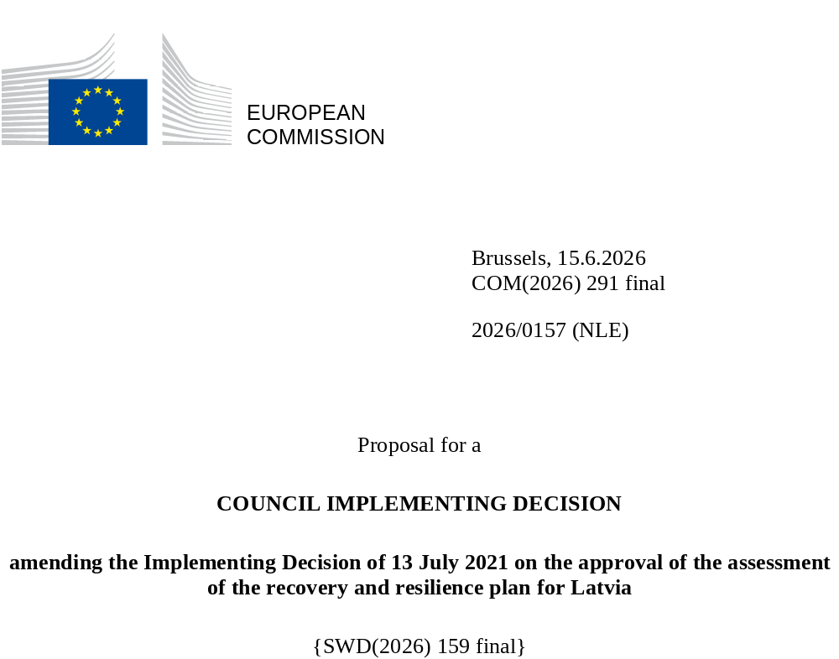

2026/0157 (NLE)
Proposal for a
COUNCIL IMPLEMENTING DECISION
amending the Implementing Decision of 13 July 2021 on the approval of the assessment of the recovery and resilience plan for Latvia
THE COUNCIL OF THE EUROPEAN UNION,
Having regard to the Treaty on the Functioning of the European Union,
Having regard to Regulation (EU) 2021/241 of the European Parliament and of the Council of 12 February 2021 establishing the Recovery and Resilience Facility, and in particular Article 20(1) thereof,
Having regard to the proposal from the European Commission,
Whereas:
(1) Following the submission of the national recovery and resilience plan (‘RRP’) by Latvia on 30 April 2021, the Commission proposed its positive assessment to the Council. On 13 July 2021, the Council approved the positive assessment by means of an implementing decision (‘the Council Implementing Decision of 13 July 2021’). The Council Implementing Decision of 13 July 2021 was amended by the Council Implementing Decisions of 8 December 2023, of 18 February 2025 and of 12 December 2025.
(2) On 27 May 2026, Latvia made a reasoned request to the Commission to make a proposal to amend the Council Implementing Decision of 13 July 2021 in accordance with Article 21(1) of Regulation (EU) 2021/241 on the grounds that the RRP is partially no longer achievable because of objective circumstances. On that basis, Latvia has submitted an amended RRP.
Amendments based on Article 21 of Regulation (EU) 2021/241
(3) The amendments to the RRP submitted by Latvia because of objective circumstances concern 22 measures.
(4) Latvia has explained that two measures are partially no longer achievable, because of unexpected delays in the implementation, including procurement challenges, difficulty with attracting sufficient bidders and supply chain constraints impeding the progress of the measures and rendering the initial planning unfeasible. This concerns measure 2.3.2.3.i (Closing the digital divide for socially vulnerable pupils and educational institutions) under Component 2 (Digital Transformation) and measure 3.1.2.1.i (Measures to promote access to public services and employment for people with functional impairments) under Component 3 (Reduction of Inequality). On this basis, Latvia has requested that those measures be amended. The Council Implementing Decision of 13 July 2021 should be amended accordingly.
(5) Latvia has explained that 18 measures have been amended to implement better alternatives that allow the administrative burden to be reduced and simplify the Council Implementing Decision, while still achieving the objectives of those measures. This concerns measures 1.1.1.r (A sustainable transport system), 1.1.1.i (Improving Riga metropolitan transport infrastructure), 1.2.1.2.i (Increasing energy efficiency in business in the form of a combined financial instrument), 1.2.1.4.i (Improving the energy efficiency of public sector buildings) under Component 1 (Climate Change and Environmental Sustainability); measures 2.1.1.1.i (Administration modernisation and digital transformation of services), 2.1.3.1.i (Data availability, sharing and analysis), 2.3.1.1.i (Delivering digital skills), 2.3.1.2.i (Development of digital skills), 2.3.2.2.i (Development of state and local government digital transformation skills and capabilities), 2.4.1.2.i (Broadband or very high capacity network “last mile” infrastructure development) under Component 2 (Digital Transformation); measures 3.1.1.3.i (Investments in public infrastructure to develop industrial parks in the regions), 3.1.1.4.i (Establishing a financing fund for the construction of low-rent housing), 3.1.1.6.i (Purchase of electric school buses), 3.1.2.3.i (Resilience and continuity of the long-term social care service) under Component 3 (Reduction of Inequality); measures 5.1.1.1.i (Support for a fully-fledged innovation system governance model), 5.1.1.2.i (Support instrument for research and internationalization), 5.2.1.r (Reform of Higher Education and Scientific Excellence and Governance) under Component 5 (Economic transformation and productivity reform); measure 6.1.2.4.i (Creation of infrastructure for the performance of control services in Kundziņsala) under Component 6 (Rule of Law). On this basis, Latvia has requested that those measures be amended. The Council Implementing Decision of 13 July 2021 should be amended accordingly.
(6) Following the decrease in the level of implementation of measures in accordance with Article 21 of Regulation (EU) 2021/241 and related reduction in the underlying costing, Latvia has requested to use the resources freed up by the decrease in the level of their implementation to increase the level of implementation of two measures. This concerns measure 3.1.1.7.i (Loans to real estate developers for the construction of low-rent dwellings) and measure 3.1.2.6.i (Facilitating the availability of technical aids) under Component 3 (Reduction of Inequality). On this basis, Latvia has requested that the level of implementation of two measures be increased. The Council Implementing Decision of 13 July 2021 should be amended accordingly.
Commission’s assessment
(7) The Commission has assessed the amended RRP against the assessment criteria laid down in Article 19(3) of Regulation (EU) 2021/241.
Contribution to the digital transition
(8) In accordance with Article 19(3), point (f), of, and criterion 2.6 of Annex V to, Regulation (EU) 2021/241, the amended RRP contains measures that contribute to a large extent (rating A) to the digital transition or to addressing the challenges resulting from it. The measures supporting digital objectives account for an amount which represents 22.58% of the amended RRP’s total allocation calculated in accordance with the methodology set out in Annex VII to that Regulation.
(9) Following the proposed amendments by Latvia to the RRP, the contribution towards the digital transition decreased slightly from 22.75% previously to 22.58% currently. This slight decrease reflects the reallocation of the freed up resources amounting to EUR 3 010 779 following the decrease in the level of implementation of measure 2.3.2.3.i (Closing the digital divide for socially vulnerable pupils and educational institutions) under Component 2 (Digital Transformation) and contributing 100% to the digital objectives, towards increasing the level of implementation of measure 3.1.1.7.i (Loans to real estate developers for the construction of low-rent dwellings) under Component 3 (Reduction of Inequality) with a 0% contribution to digital objectives. The limited scope of these amendments does not change the overall assessment of this criterion.
Costing
(10) In accordance with Article 19(3), point (i), of, and criterion 2.9 of Annex V to, Regulation (EU) 2021/241, the justification provided in the amended RRP on the amount of the estimated total cost of the RRP is to a medium extent (rating B) reasonable and plausible, is in line with the principle of cost efficiency and is commensurate to the expected national economic and social impact.
(11) According to the information provided, the assessment of the cost estimates for the existing measures whose modifications entailed a new cost assessment show that most of the costs are reasonable and plausible. Furthermore, the changes in the cost estimates for the modified measures were justified, proportional to the removed or revised targets and supported by detailed calculations and evidence, and as such the reasonability and plausibility of these cost estimates were not altered compared to the original RRP. Finally, the amount of the estimated total cost of the RRP is in line with the principle of cost efficiency and commensurate to the expected national economic and social impact.
Any other assessment criteria
(12) The Commission considers that the amendments put forward by Latvia do not affect the positive assessment of the RRP set out in the Council Implementing Decision of 13 July 2021 on the approval of the assessment of the RRP for Latvia regarding the relevance, effectiveness, efficiency and coherence of the RRP against the assessment criteria laid down in Article 19(3), points (a), (b), (c), (d), (da), (db), (e), (g), (h), (j) and (k).
Positive assessment
(13) Following the positive assessment by the Commission of the amended RRP, with the finding that the RRP satisfactorily complies with the criteria for assessment set out in Regulation (EU) 2021/241, in accordance with Article 20(2) of and Annex V to that Regulation, the reforms and investment projects necessary for the implementation of the amended RRP, the relevant milestones, targets and indicators, and the amount made available from the Union for the implementation of the amended RRP should be set out.
Financial contribution
(14) The estimated total costs of Latvia’s amended RRP is EUR 1 969 244 522. As the amount of the estimated total cost of the amended RRP is equal to the updated maximum financial contribution available for Latvia, the financial contribution determined in accordance with Article 4a of Regulation (EU) 2021/1755 of the European Parliament and of the Council, and with Article 20(4) and Article 21a(6) of Regulation (EU) 2021/241 that is allocated for Latvia’s amended RRP should be equal to EUR 1 969 244 522. Therefore, the financial contribution made available to Latvia remains unchanged.
(15) The Council Implementing Decision of 13 July 2021 should therefore be amended accordingly. For the sake of clarity, the Annex to the Council Implementing Decision of 13 July 2021 should be replaced entirely.
(16) This Decision should be without prejudice to the outcome of any procedures relating to the award of Union funds under any Union programme other than the Facility or to procedures relating to distortions of the operation of the internal market that may be undertaken, in particular under Articles 107 and 108 of the Treaty. It does not override the requirement for Member States to notify instances of potential State aid to the Commission under Article 108 of the Treaty,
HAS ADOPTED THIS DECISION:
Article 1
Approval of the assessment of the RRP
The assessment of the amended RRP for Latvia on the basis of the criteria provided for in Article 19(3) of Regulation (EU) 2021/241 is approved.

Article 2
Amendments
The Council Implementing Decision of 13 July 2021 on the approval of the assessment of the recovery and resilience plan for Latvia is amended as follows:
the Annex is replaced by the text set out in the Annex to this Decision.
Article 3
Addressee
This Decision is addressed to the Republic of Latvia.
Done at Brussels,
For the Council
The President

OJ L 57, 18.2.2021, p. 17, ELI: https://eur-lex.europa.eu/eli/reg/2021/241/oj.
See documents ST 10157/21 INIT; ST 10157/21 ADD 1.
See documents ST 15569/23 INIT; ST 15569/23 ADD 1.
See documents ST 5730/25 INIT; ST 5730/25 ADD 1.
See documents ST 15719/25 INIT; ST 15719/25 ADD 1 REV 1 (el, mt) COR 1 (lv).
Regulation (EU) 2021/1755 of the European Parliament and of the Council of 6 October 2021 establishing the Brexit Adjustment Reserve (OJ L 357, 8.10.2021, p. 1, ELI: http://data.europa.eu/eli/reg/2021/1755/oj).

