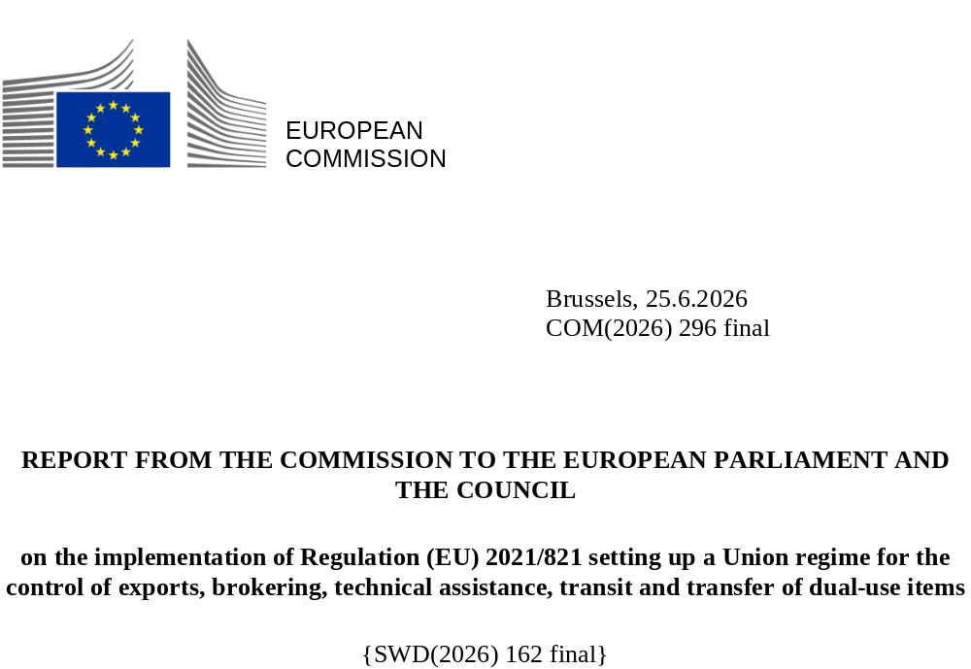

1. Introduction and executive summary

1.1 Introduction
This report provides information on the implementation of EU export controls and the revised Regulation (EU) 2021/821 of 20 May 2021 (‘the Dual-Use Regulation’ or ‘the Regulation’) for the control of exports of dual-use items in 2024, together with the EU aggregated and Member States’ export control data for 2024.
This annual report reflects the EU’s determination under the Regulation to improve information sharing on Member States’ licensing decisions in the area of export controls with the objective of increasing transparency.
As required under the Regulation and to improve the data collection process, on 17 January 2024, the Commission published guidelines agreed with the Member States setting out a methodology for collecting and processing licensing data and other data in view of the preparation of the EU’s annual report on dual-use export controls. Against this background, this report was prepared by the Commission with inputs from Member States in the Dual-Use Coordination Group (DUCG). Due to their volume, the data for 2024 provided by Member States are presented in a consolidated format in the staff working document that accompanies this annual report.

1.2 Executive summary
In 2024, the total value of authorised dual-use trade amounted to EUR 77.6 billion, representing 3% of total extra-EU exports of goods. The types of licences having the highest weighting were global export authorisations (EUR 36.5 billion), individual export authorisations (EUR 24 billion) and EU general export authorisations (EUR 9 billion).
In terms of volume, the 2024 dual-use trade corresponds to 133 470 authorisations and notifications. Most transactions fall under EU general export authorisations (89 388), then national general export authorisations (23 406) and subsequently individual licences (18 549).
In the same year, 487 denials were reported for a value of EUR 0.2 billion, indicating that only a small portion of EU exports were denied (0.01% of the value of total extra-EU exports of goods that year).
The report provides information synthesised from the available data. Given the different practices and types of authorisations in each Member State, it does not provide a precise breakdown of authorised trade by type of item or destination for global export authorisations, which represent 47% of authorised value in 2024. Despite this, it is still useful to consider the trends for the other types of authorisations (individual and general export authorisations), which represent 44% of the authorised value.
In 2024, the highest values of individual and general export authorisations (Figure 1) corresponded to the following items: Nuclear materials, facilities, plants and equipment (22%), Information security and crypto-analysis items and equipment (21%), Equipment for the manufacturing and testing of semiconductor devices or materials (9%), Aerospace engines and gas turbines (except UAV) (8%), Other/non-listed items (8%). Overall, the list of types of items in Figure 1 accounts for 90% of the value of these authorisations.
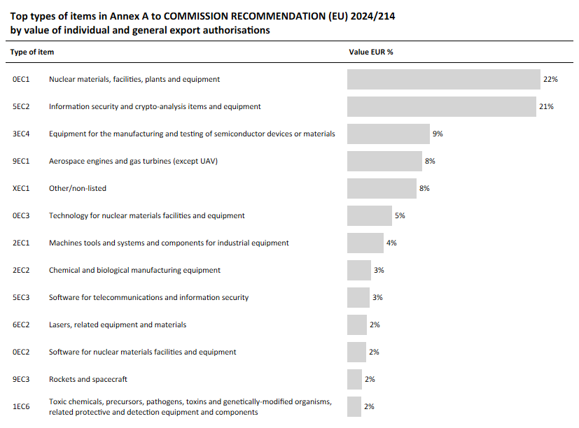
Figure 1: Top types of items by value of individual and general export authorisations
The main destinations for individual and general export authorisations (Figure 2) are China (25%), the United States of America (21%), the United Kingdom (7%), South Korea (7%) and Ukraine (3%). This ranking is influenced by the weighting of EU GEAs, in particular EU001 (EUR 8.6 billion), which account for a large share of the total value authorised under export authorisations. As a result, destinations specified in general export authorisations, and in particular EU GEA EU001, feature prominently in the ranking, while the list does not fully reflect the importance of certain destinations that receive significant volumes of exports under global export authorisations, such as Taiwan, Brazil, Singapore and Israel. Overall, the list of destinations in Figure 2 accounts for 90% of the value of individual and general export authorisations.

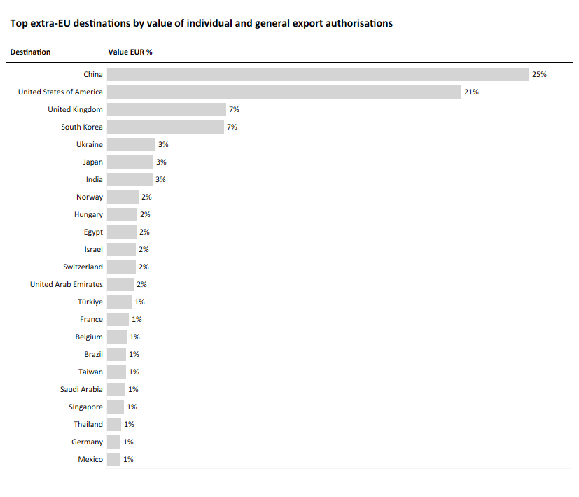
Figure 2: Top extra-EU destinations by value of individual and general export authorisations
In addition, Member States reported a stable number of staff working on the administration and enforcement of the Regulation in 2024 as compared with 2023. It is also noteworthy that the number of reported infringements rose from 192 in 2023 to 270 in 2024. In this context, administrative and criminal penalties or fines imposed (by any relevant national enforcement agency) for the infringement of export control regulations increased from 122 in 2023 to 144 in 2024.
The report pays particular attention to the licensing of cyber-surveillance items as part of the EU’s commitment to effectively addressing the risk of cyber-surveillance items being used in connection with internal repression and/or the commission of serious violations of human rights and international humanitarian law. In 2024, Member States received a total of 320 applications for the export of those items. The highest figure was for the item Telecommunications interception systems (233 applications). In the same period, 293 authorisations and 13 denials were issued. Those figures also show a rather stable number of licences for cyber-surveillance items compared to 2023, whereas the number of denials appeared to be decreasing.

As part of the various activities initiated in 2024, the Commission and the Member States continued to focus on meeting the requirements and mandates under the revised Regulation. This includes continuing the work in the various technical expert groups towards enhanced controls on cyber-surveillance items, the enforcement of export controls, work on emerging technologies and the development of EU capacity-building and training programmes for Member States’ licensing and enforcement authorities.
These actions under the Dual-Use Regulation will also allow the EU to cooperate more effectively with partners in order to promote the global convergence of controls, reduce trade frictions, increase predictability for business, promote EU values and uphold international peace and security.

2. Evolution of the policy & regulatory framework

2.1. Export control policy
2.1.1 Effective implementation of EU export controls under the Dual-Use Regulation
In 2024, the Commission and the Member States continued the implementation of the Regulation in a number of new areas, such as transparency, enforcement and capacity-building. The DUCG played a key role, as described in Section 3 below, and expanded the ‘institutional infrastructure’ for EU export controls through the activities of several expert groups working to develop new policies, guidelines, procedures, etc.
The Regulation also places emphasis on the control of exports of cyber-surveillance items. It addresses the potential risk of such items being exported from the European Union with the intention of being misused in connection with serious violations of human rights or international humanitarian law. It is in this context that on 16 October 2024 the Commission published guidelines on the export of cyber-surveillance items pursuant to Article 5 of the Regulation to provide clarity primarily for exporters on how to conduct due diligence and internal compliance checks prior to exporting cyber-surveillance items.

2.1.2 Export controls under the Commission’s White Paper
The Commission’s White Paper, published on 24 January 2024 proposed short and medium-term actions to improve the coordination of export controls on dual-use items in the EU. Amongst the key measures proposed by the Commission were (1) inclusion in the EU control list (Annex I) of dual-use items that have not been subject to controls in the multilateral regimes due to delays in decision making; (2) a senior-level forum for political coordination on export controls; (3) a mechanism to better coordinate new national control lists; and (4) an early evaluation of the EU’s Dual-Use Regulation. The White Paper was subject to a public consultation which ran from 2 February until 30 April 2024, to which 23 replies were received, informing the Commission’s internal deliberations. Since the publication of the White Paper, the Commission has been actively moving forward on each of those measures. The Council of the European Union responded to the White Paper in its Conclusions adopted in spring 2024.
2.1.3 Export restrictions concerning products destined for Russia
Throughout 2024, the European Union continued to actively tighten dual-use export restrictions in the context of sanctions against Russia, including through the adoption of three packages of sanctions, in particular expanding export restrictions on dual-use ‘advanced technology items’, in light of information from the battlefield, and targeting entities associated with Russia’s military-industrial facilities both in Russia and in non-EU countries. In September 2024, the Commission published guidance for industry which had been developed and agreed by the G7 members and the Commission, to assist industry in better identifying Russia’s sanctions evasion practices, to protect G7 technology from misappropriation, prevent reputational harm and mitigate liability risk while supporting the effectiveness of export controls and sanctions.
In addition, the Commission and the Member States were active participants in the global coalition on Russia sanctions (GECC), whose 39 members have implemented substantially similar export controls in response to Russia’s full-scale invasion of Ukraine in February 2022. The GECC aims to cut Russia and Belarus off from the commodities, technologies and software necessary to sustain their aggression in Ukraine, depriving their defence, aerospace and maritime sectors of key materials.
2.1.4 Cooperation with non-EU countries in 2024
The sixth ministerial meeting of the EU–US Trade and Technology Council (TTC) took place in Leuven on 4-5 April 2024. Both the EU and the US recognised the role of the EU-US TTC in coordinating export controls imposed in response to Russia’s invasion of Ukraine and resolved to further align their respective priorities.
On 8-9 October 2024, the Commission hosted the Fourth Dialogue on Export Control Governance in Brussels under the title ‘Catch-all Controls and Recommendations on Related Internal Compliance Programs for Companies’, organised under the EU’s partner-to-partner (EUP2P) export control programme and involving partner countries and organisations. The Dialogue served to strengthen networking, raise awareness and build capacity among the EUP2P partner countries and relevant stakeholders regarding the implementation and practical application of catch-all export controls and related compliance practices under the EU strategic trade control frameworks.
Finally, the EU and Norway held an EU-Norway Export Control Dialogue on 6 February 2024. The parties discussed the regulatory developments in the field of export controls, shared their views on destinations of concern and discussed the sanctions against Russia. Norway informed the EU of its plans to establish a new department for export control and sanctions (DEKSA) which will be in charge of analysis, licensing and enforcement.
2.2. Updates to the EU control list
The EU control list in Annex I to the Regulation essentially provides a list of dual-use items, including software and technology, which are subject to controls due to their potential use for both civil and military purposes. The list is updated on a regular basis to reflect changes in the multilateral export control regimes i.e. the Wassenaar Arrangement, the Australia Group, the Nuclear Suppliers Group and the Missile Technology Control Regime (MTCR).
On 5 September 2024, the Commission adopted an annual update to Annex I, which entered into force on 8 November 2024, bringing the EU’s Dual-Use Regulation into line with decisions formally taken as part of the multilateral regimes in 2023. The updated list includes new entries in the field of nuclear plants and equipment, as well as additional toxins, chemical precursors and noise reduction equipment.
2.3. National implementation and enforcement measures
The Dual-Use Regulation is binding in its entirety and directly applicable in all Member States. It includes, in its Annex I, a common list of items derived from the multilateral export control regimes that must be subject to controls in all Member States. However, it provides that Member States may take certain national measures to implement specific provisions of the Regulation, and it requires information on such national measures to be published by the Commission in the Official Journal of the European Union. The publication ensures transparency of the applicable rules and reflects the EU’s efforts to support the consistent and effective implementation of controls by exporters throughout the EU.
The Information Note published on 2 October 2024 provided information from Member States about how they make use of the possibilities provided for in the Regulation including the extension of brokering and transit controls, the extension of controls to non-listed items for reasons of public security and human rights considerations, the introduction of national general export authorisations and the application of intra-EU transfer controls for non-listed items.

2.4 Exports from Northern Ireland
Exports of dual-use items from the EU to the United Kingdom became subject to control under the Regulation after the United Kingdom’s departure from the European Union on 1 January 2021. Specific arrangements are set forth in the Northern Ireland (NI) Protocol, which provides that the Regulation applies to the United Kingdom in respect of Northern Ireland, with the UK acting as a competent authority under the Regulation for exports from Northern Ireland to non-EU countries. The Commission has developed a dedicated secure electronic tool to support the exchange of information with the United Kingdom’s competent authority in charge of applying the Regulation in respect of the flow of goods into and from Northern Ireland, which was used throughout 2024. This enables the United Kingdom authorities to access information on denials for essentially identical transactions issued by EU Member States and to hold bilateral consultations with the issuing Member States, as provided for in the Regulation.

3. Activities of the Dual-Use Coordination Group
The Dual-Use Coordination Group (DUCG), chaired by the Commission, brings together experts from the Commission and Member States to examine any issue concerning the application of export controls. In 2024, the DUCG held eight meetings: on 16 January, 14 March, 16 May, 3 July, 12 September, 4 October, 6 November and 11 December.

3.1. Consultations on implementation issues - general information exchange
The Commission and Member States’ representatives in the DUCG exchanged information on export control issues, regarding, in particular:
- the implementation of intangible transfers of technology (ITT);
- national general licences;
- large project authorisations;
- the definition of ‘exporter’;
- the interpretation of Article 16(1) of the Regulation;
- the implementation of transit controls;
- the implementation of technical assistance controls;
- re-export of Union goods onwards from non-EU countries; and
- treatment of goods temporarily brought into the Union.

3.2 Guidelines
Following discussions within the DUCG, the Commission published guidelines for exporters of cyber-surveillance technologies and guidelines for gathering and processing data on export controls.
First, the Commission published guidelines on data gathering and processing for export controls on 17 January 2024. Those guidelines establish detailed procedures for collecting licensing data from national authorities to enhance transparency and information sharing. This enables the EU’s annual export control report to include more detailed statistics on authorisations and denials. By improving public reporting, the guidelines aim to provide exporters, civil society and the public with a clearer picture of EU export control implementation, support dialogue with non-EU countries and promote good reporting practices internationally.
Second, on 16 October 2024, the Commission published guidelines for exporters of cyber-surveillance items with the intention to raise awareness of the risks of such items being misused and to provide exporters with practical tools to assess the possible human rights impacts of such misuse. The guidelines aim to make EU export controls more effective and consistent across Member States by helping exporters conduct due diligence checks through a step-by-step approach to transaction screening. The guidelines strengthen the ‘protect’ pillar of the 2023 European economic security strategy by promoting responsible and secure export practices.
3.3 Technical exchange of information – technical expert groups
Member States’ competent authorities in the DUCG provided technical expertise supporting the updates to the EU control list, and they engaged in discussions on several specific implementation issues, as mentioned above.
Under the Commission’s coordination, the DUCG also took initiatives to address certain technical implementation issues. The specific role of technical expert groups is now recognised in Article 24(3) of the Regulation.
The enforcement coordination mechanism (ECM), set up in accordance with Article 25 of the Regulation, met six times in 2024 to support the exchange of information and direct cooperation between competent authorities and enforcement agencies of the Member States.
Finally, the Capacity Building Technical Expert Group (CB-TEG) held its third and fourth progress meetings on 13 March and 17 May 2024, which were dedicated, respectively, to identifying the priorities for 2024 and to selecting the topic for the annual capacity-building event and setting up teams in charge of its organisation. Subsequently, an EU capacity-building technical seminar on dual-use restrictive measures was held in Budapest on 18 September 2024, hosted by the Hungarian Presidency, back-to-back with the 17th JRC-NNSA licensing seminar on the same topic but with complementary lectures and more extended non-EU attendance.
3.4 Technical support for the preparation of updates to the EU control list and national implementing measures
The DUCG held a technical information session on 14 March 2024 to support the preparation of the proposal for a Commission delegated regulation updating the EU control list. The Commission adopted the delegated act on 5 September 2024.
The DUCG also contributed to the update of the official information notice on national measures published on 2 October 2024 and the revision of the EU compilation of national control lists on 27 September 2024.

3.5 Licensing and implementation data exchange
The DUCG initiated the collection of 2022-2023 licensing data under the 2024 guidelines on data gathering and processing, with a view to supplementing the annual report published on 30 January 2025.
3.6 IT tools for the exchange of information among Member States and for electronic licensing
The Commission, supported by the DUCG, continued to develop the Dual-Use e-System (DUeS) as the IT backbone of the EU dual-use export control network. This platform plays a key role in the effective application of the Regulation.
DUeS functionalities were developed or updated, as follows:
- allowing Member States to share with the Commission licensing data, as mandated in Article 26(3) of the Dual-Use Regulation, in accordance with the guidelines developed with the Member States on data gathering and processing on export controls (transparency guidelines);
- allowing Member States to notify the Commission of the imposition of an authorisation requirement on the basis of a national control list, pursuant to Article 10;
- allowing voluntary exchange of information among Member States on the implementation of Articles 9 and 10, as foreseen in the Commission Recommendation 2025/683 on the coordination of national control list; and
- existing functionalities were updated, in particular with reference to the management of exemptions/authorisations and denials related to the restrictive measures against Russia and Belarus, and with reference to the database of items subject to control pursuant to the Regulation.
2024 was the fourth year of operation of the dual-use eLicensing system, which was used during the reporting period by Latvia, Romania, Italy, Slovenia and Belgium (Walloon authorities). Hungary and Belgium (Brussels Region) expressed an interest in joining the project.
Beyond the EU, and as part of its cooperation with partner countries, the Commission explored the possibility of providing the eLicensing tool to partner countries. Bosnia and Herzegovina, Kyrgyzstan and Serbia expressed interest in using the tool.
The eLicensing project continuously improves the interconnection of the national customs systems via the EU Single Window Environment for Customs. This makes the sharing of information across borders with different customs authorities much easier, reducing the regulatory burden on operators and allowing automatic licensing management. This is done through the certification exchange ‘CERTEX’ platform, managed by DG TAXUD. The interconnection between eLicensing and the national customs systems has been operational since December 2022. The Romanian customs authorities have been part of the system since April 2024.
At the request of the Member States that already used electronic licensing systems, in April 2022 the Commission initiated a new ‘eLicensing bridge’ project to make it possible to connect national licensing systems to customs systems through eLicensing. Finland was part of the pilot project and tested the interconnection in 2024.

4. EU export controls – key data
Article 26 of the Regulation provides that the European Commission’s annual report on the implementation of controls must include relevant information on authorisations, denials and prohibitions, as well as information on the administration and enforcement of such controls.
This Section presents EU aggregated export control data for the reference year 2024. Due to their volume, the underlying data provided by Member States are presented in consolidated form in the staff working document that accompanies this report.
The data have been made available in accordance with specific reporting guidelines (‘the Guidelines’). Under these guidelines, the data collection methodology is designed to remain sustainable over time, allowing Member States to provide relevant information to the Commission in an efficient and cost-effective manner, which is statistically sound and with due consideration to the protection of personal information, commercially sensitive information or protected information on defence, foreign policy or national security.
4.1 Methodological notes
The Regulation primarily applies to the export of over 1 800 dual-use items listed in the EU control list, classified in 10 categories (Figure 3). That is the underlying rationale that led the EU to group the entries in Annex I to the Regulation in ‘types of items’ for the purpose of the EU annual report.
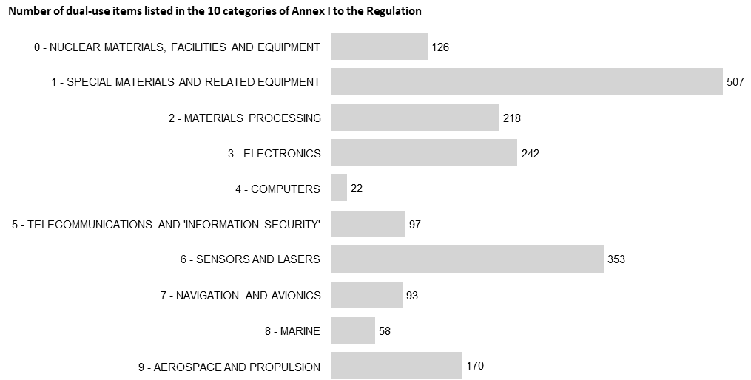
Figure 3: Number of dual-use items listed in the 10 categories of Annex I to the Regulation
To allow for the required level of transparency of public reporting while ensuring efficient and sustainable data collection over time, it was decided that the baseline for determining the types of items would build on the specific classification of dual-use items used in the Regulation at 5-digit level while ensuring that the heading ‘types of items’ provides meaningful information from a security, policy and trade perspective.
Annex A to the Guidelines describes the list of 52 ‘types of items’ used for collecting licensing data and preparing this annual report. Authorisations are broken down by type of item and by relevant destination in line with the requirements of the Regulation, while considering the nature, purpose and characteristics of the different types of authorisations, as well as the varying practices in Member States for granting authorisations and collecting data. Furthermore, it was necessary to adapt the relevant data collection and submission by the Member States to the Commission according to the specific features of the different types of national authorisations and practices. For that reason, figures presented in this report provide a count of Member States that have provided the data underlying each authorisation type. The methodology also acknowledges that authorisations may refer to more than one individual item falling under various types of items.
Concerning cyber-surveillance items, the definition set out in Article 2(20) of the Regulation comprises both the items listed in Annex I as well as non-listed items. Annex B to the Guidelines identifies five items in Annex I to the Regulation which fulfil the definition set out in Article 2(20). The decision as to whether a specific non-listed item meets the requirements of the legal definition is taken on a case-by-case basis by the Member States and the Commission within the Surveillance Technology Expert Group (STEG). Applications and authorisations for non-listed cyber surveillance items also need to be included in the annual report in accordance with Article 26(2) of the Regulation, based on the data provided by the Member States. Applications and authorisations for other listed items can be included in the report, based on the decision of the relevant competent authority.
4.2 Overview of authorisations by type of licence
In 2024, the total value of authorised dual-use trade amounted to EUR 77.6 billion, representing 3% of extra-EU exports of goods (Figure 4) and an increase compared to 2023 (EUR 71 billion). In terms of numbers, that corresponds to 133 470 authorisations and notifications. With respect to the types of authorisations, most transactions fall under EU general export authorisations (89 388), national general export authorisations (23 406) and individual licences (18 549), which mirrors the ranking in 2023. In terms of value, the types of licences having the highest weighting were global export authorisations (EUR 36.5 billion, 47% of total authorised trade), individual export authorisations (EUR 24 billion, 31% of total) and EU general export authorisations (EUR 9 billion, 12% of total).
4.3 Denials and prohibitions
In 2024, 487 denials were reported for a value of EUR 0.2 billion. Those figures show that only a small portion of EU exports were denied (0.01% of total extra-EU exports of goods that year). This represents both a lower number and a lower value of denials compared to 2023 but accounts for the same percentage of extra-EU exports.
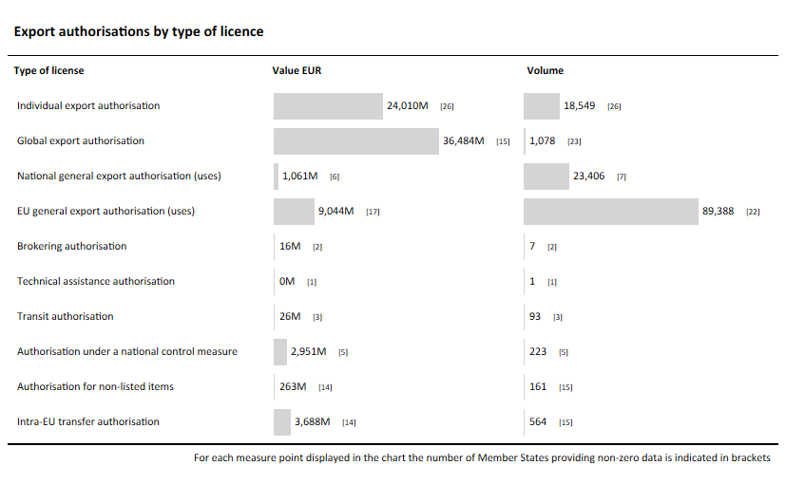Figure 4: Export authorisations by type of licence
4.4 Individual authorisations
Individual authorisations are licences granted to one specific exporter for one end-user or consignee in a non-EU country and covering one or more dual-use items. As specified in the Guidelines, the following items are all considered individual licences for the purpose of this report: individual export authorisations, brokering authorisations, technical assistance authorisations, transit authorisations, intra-EU transfer authorisations, authorisations under a national control measure and authorisations for non-listed items.
The overview of individual authorisations in 2024 by the 10 categories of items in Annex I to the Regulation as well as non-listed items subject to controls (Figure 5) indicates that the highest number of authorisations in terms of market value was granted to Nuclear materials, facilities and equipment (EUR 12.2 billion, 36% of total). Telecommunications and ‘information security’ came second (EUR 6.7 billion, 20% of total), and Aerospace and propulsion third (EUR 4.6 billion, 13% of total). Concerning the volume of individual authorisations, the largest figure was recorded for Materials processing (5 891, 27% of total), followed by Telecommunications and ‘information security’ (4 405, 20% of total) and Special materials and related equipment (4 293, 20% of total).
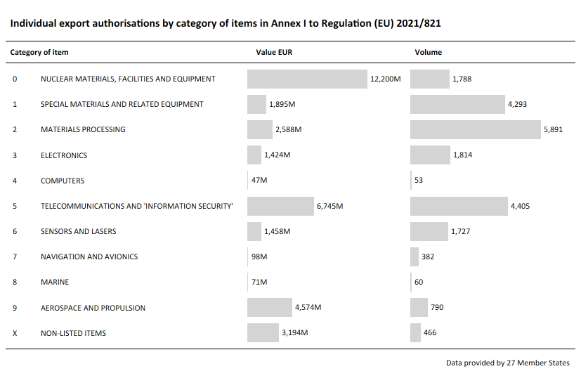
Figure 5: Individual export authorisations by category of items in Annex I to Regulation (EU) 2021/821
Breaking down the value of individual authorisations by type of items (Figures 6.1 and 6.2) shows that the top five items are Nuclear materials, facilities, plants and equipment (EUR 9.2 billion, 27% of total), Information security and crypto-analysis items and equipment (EUR 5.5 billion, 16% of total), Aerospace engines and gas turbines (except UAV) (EUR 3.5 billion, 10% of total), Other/non-listed items (EUR 3.2 billion, 9% of total), and Technology for nuclear materials facilities and equipment (EUR 2.1 billion, 6% of total).
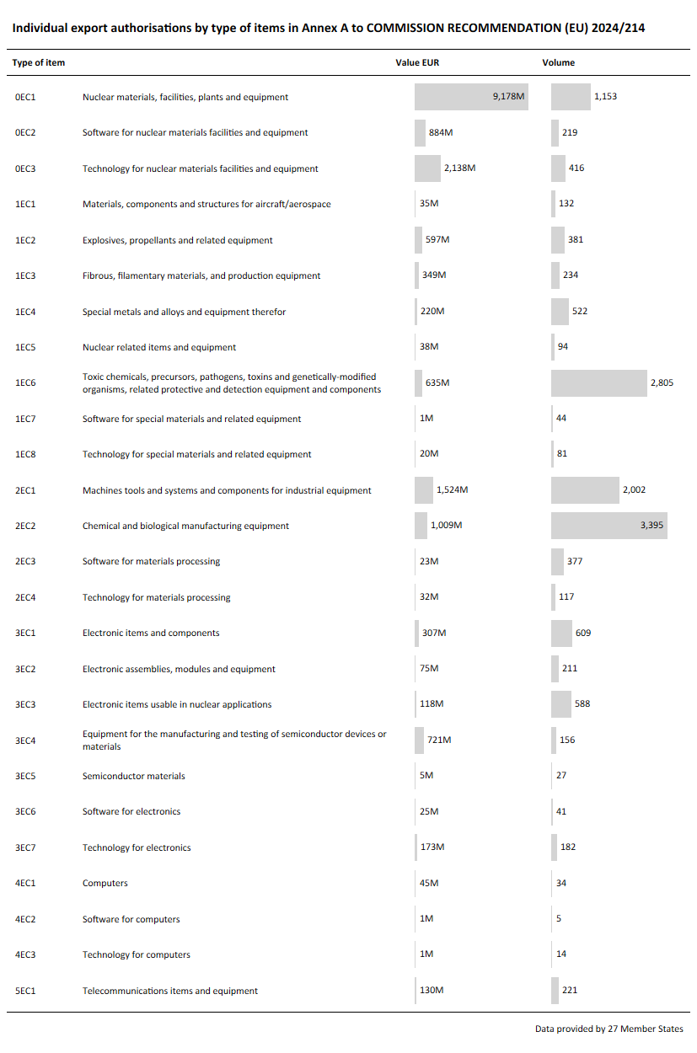
Figure 6.1: Individual export authorisations by type of items (Part 1)
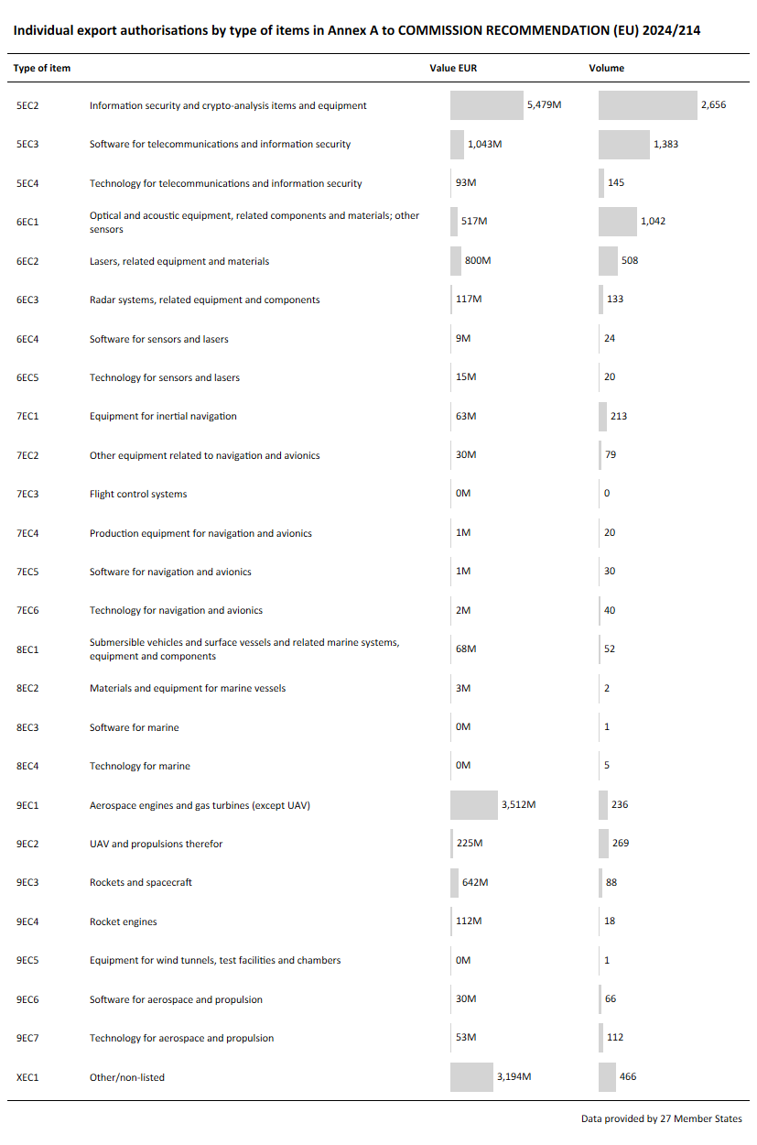
Figure 6.2: Individual export authorisations by type of items (Part 2)
Of the destinations covered by individual authorisations (Figures 7 and 8), China was the top destination by value (EUR 9.6 billion, 36% of total), followed by the United States (EUR 2.7 billion, 10% of total), South Korea (EUR 2.6 billion, 10% of total), the United Kingdom (EUR 1.2 billion, 5% of total) and India (EUR 1 billion, 4% of total). Overall, the top 25 extra-EU destinations account for 94% of individual authorisations by value. With respect to intra-EU transfers, the main destinations were Hungary (EUR 704 million), France (EUR 507 million), Belgium (EUR 458 million), Germany (EUR 324 million) and the Netherlands (EUR 234 million). Compared to extra-EU destinations, intra-EU transfers appear to be limited because most intra-EU dual-use exports do not need to be authorised under the Regulation. Instead, export control authorisations for exports of dual-use items to another EU Member State are only required in specific circumstances under the Regulation, such as for items listed in Annex IV to the Regulation pursuant to Article 11(1) or based on measures taken by a Member State pursuant to Article 11(8) of the Regulation.
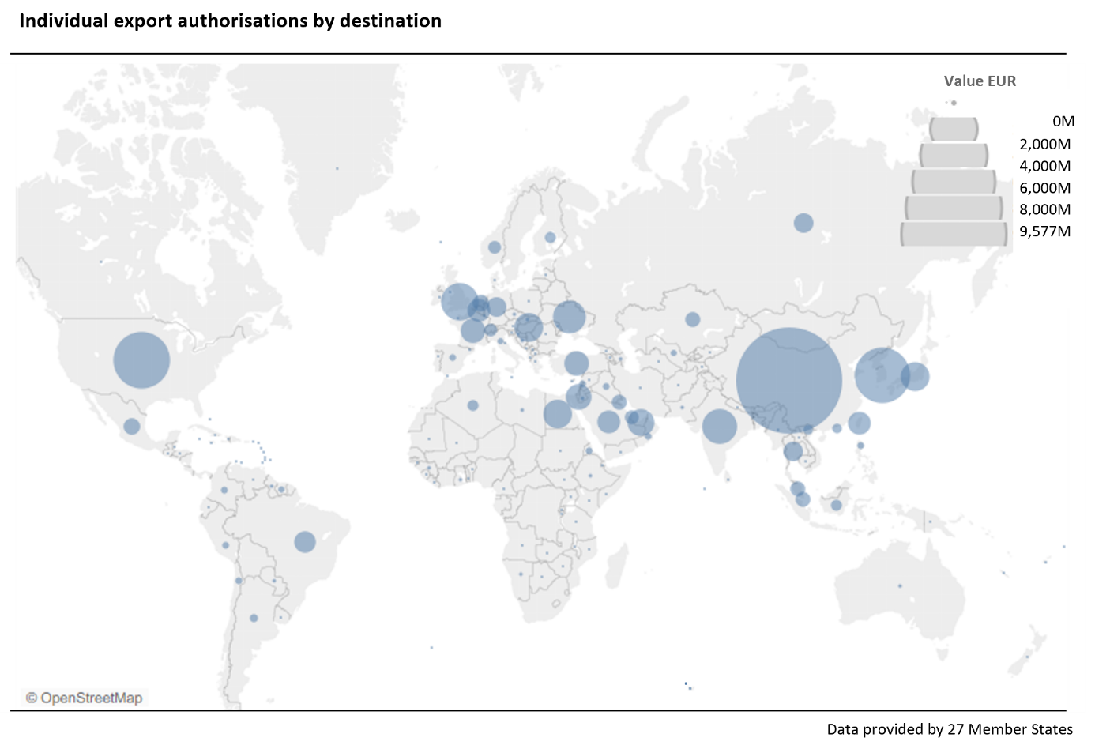
Figure 7: Individual export authorisations by destination
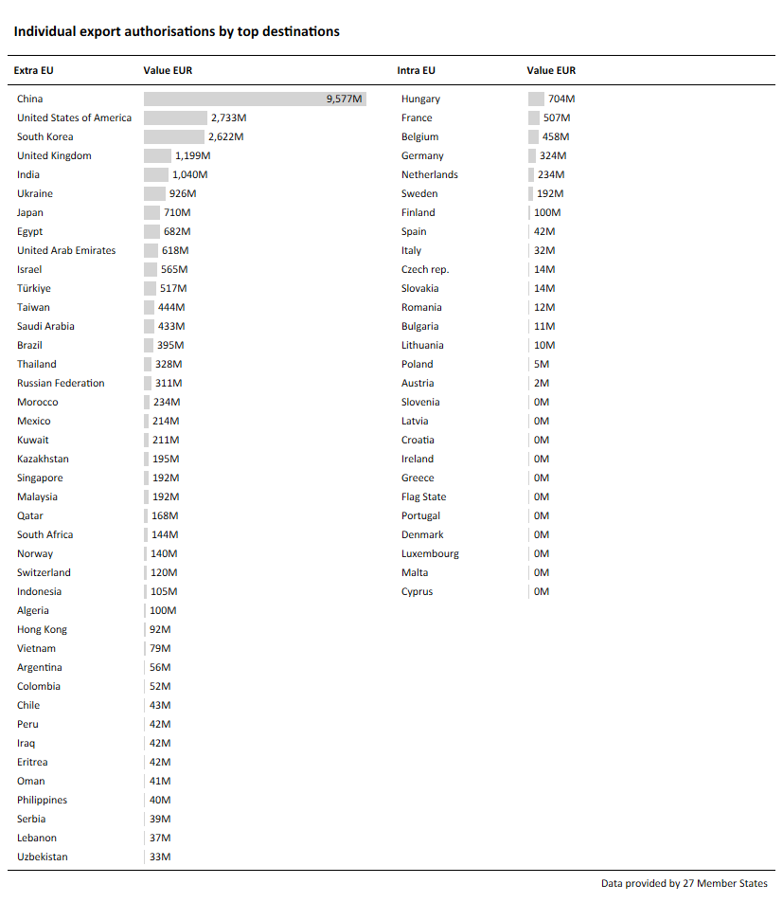
Figure 8: Individual export authorisations by top extra-EU destinations and by intra-EU destinations
4.5 Global export authorisations
Global export authorisations most often contain estimated or open-ended export values and are granted either for one or multiple items for a single destination or for one or multiple items for multiple destinations. As such, global authorisations reduce administrative burden for competent authorities and exporters when handling similar and/or frequent transactions. To safeguard non-proliferation objectives, exporters are required to draft and submit an internal compliance programme in order to qualify for a global authorisation. As the Regulation leaves it up to individual Member States to decide on the concrete configuration of global authorisations, practices vary from one EU country to another.
To provide meaningful information to the public while taking into account the different national practices and the rationale behind global export authorisations, the Guidelines have adapted the relevant data collection and reporting standards. Member States provide licensing data to the Commission accordingly, with a focus on (i) the total value of global export authorisations (EUR 36.5 billion, equivalent to 47% of authorised value in 2024) and (ii) a breakdown of the total volume of global licences by type of items (Figures 10.1 and 10.2) and destinations (Figures 11.1 and 11.2).
By category of items in Annex I to the Regulation (Figure 9), the majority of authorisations were granted for items listed under Telecommunication and ‘information security’ (31% of total), Materials processing (19%) and Sensors and lasers (13%).
The top five types of items covered by global export authorisations (Figures 10.1 and 10.2) are Information security and crypto-analysis items and equipment (19% of total), Optical and acoustic equipment, related components and materials; other sensors (11%), Explosives, propellants and related equipment (10%), Software for telecommunications and information security (8%) and Toxic chemicals, precursors, pathogens, toxins and genetically-modified organisms, related protective and detection equipment and components (8%).
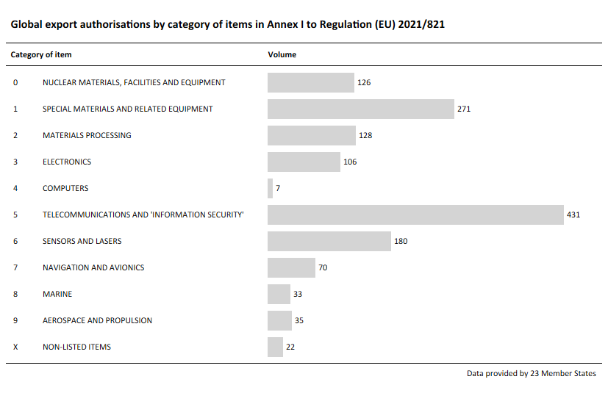Figure 9: Global export authorisations by category of items in Annex I to Regulation (EU) 2021/821
Figure 10.1: Global export authorisations by type of items (Part 1)
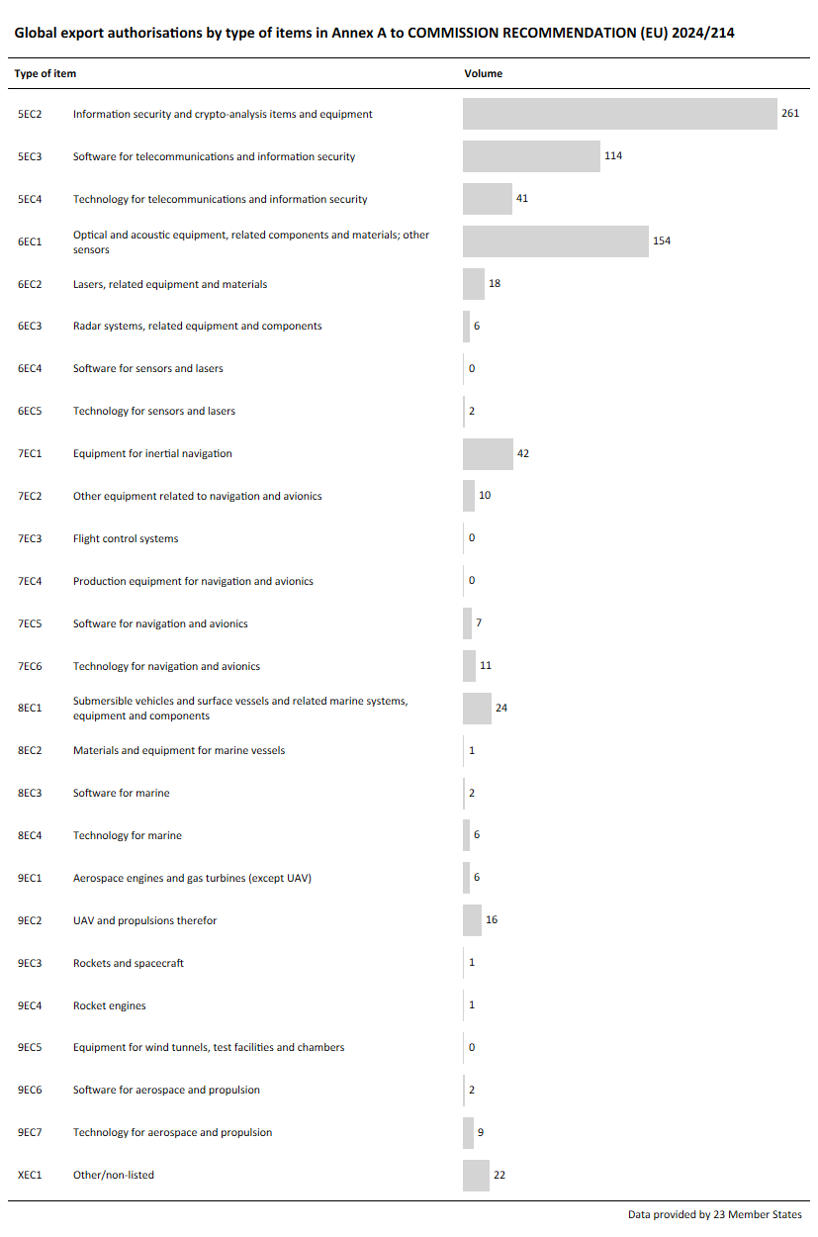
Figure 10.2: Global export authorisations by type of items (Part 2)
Concerning destinations (Figures 11 and 12), the majority of authorisations by volume were granted for exports to China (3%), India (2%), Taiwan (2%), Brazil (2%) and Singapore (2%). Overall, the top 25 destinations account for only 37% of authorisations by volume of global export authorisations, as a global licence often covers multiple destinations.
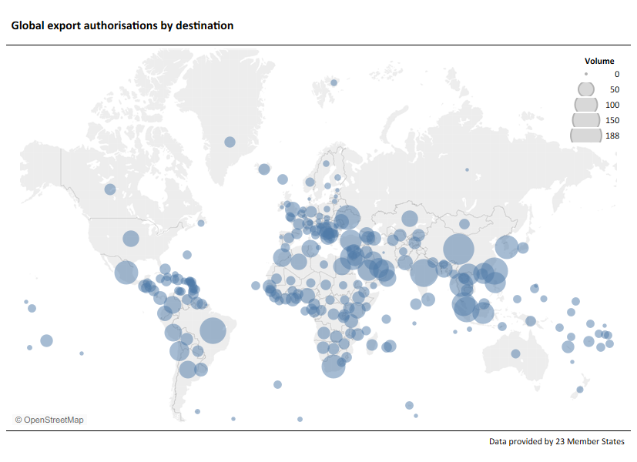Figure 11: Global export authorisations by destination
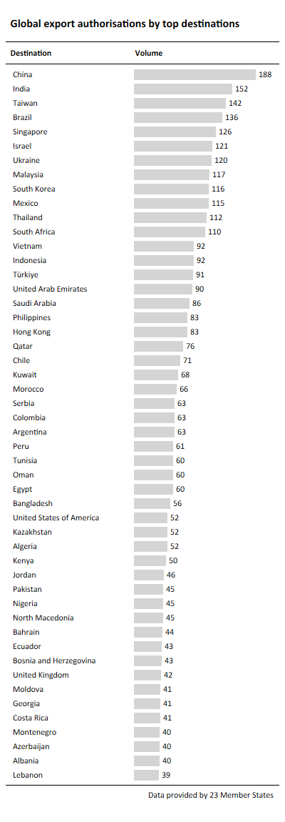
Figure 12: Global export authorisations by top destinations

4.6 National and EU general export authorisations
National and EU general export authorisations (GEAs) are issued to facilitate trade in dual-use items while reducing the administrative burden for exporters and export control authorities alike. EU general export authorisations (EU GEAs) provide the highest level of trade facilitation for dual-use goods. They are granted to EU exporters who comply with the relevant pre-conditions established in the Regulation. The Regulation provides for eight types of EU GEAs.
The vast majority of uses of EU GEAs in 2024 (Figure 13) corresponded to EU001 (99% in terms of value, 99% of volume), for exports to the 10 destinations set out in the authorisation.
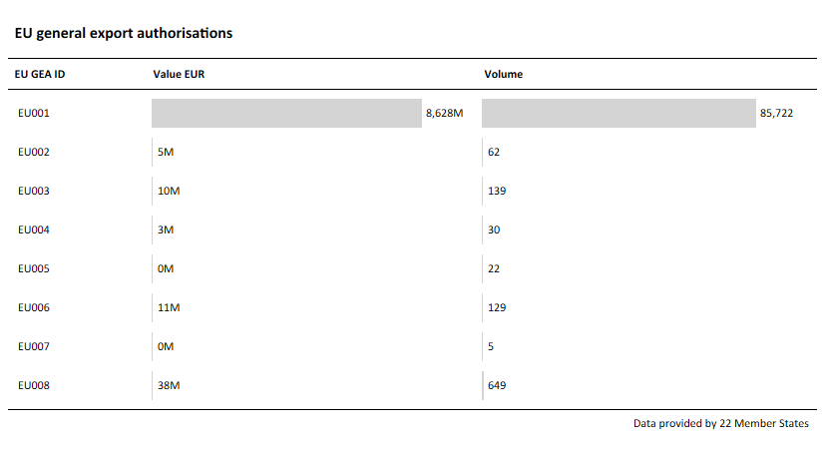
Figure 13: EU general export authorisations
National general export authorisations are granted by the Member States to exporters who notify competent authorities while complying with the relevant pre-conditions established by applicable national laws.
Figure 14 breaks down the value of EU and national GEAs by the categories included in Annex I to the Regulation. The highest values correspond to Telecommunications and ‘information security’ (EUR 3.5 billion, 44% of total), Electronics (EUR 3.3 billion, 42% of total), and Materials processing (EUR 0.3 billion, 4% of total).
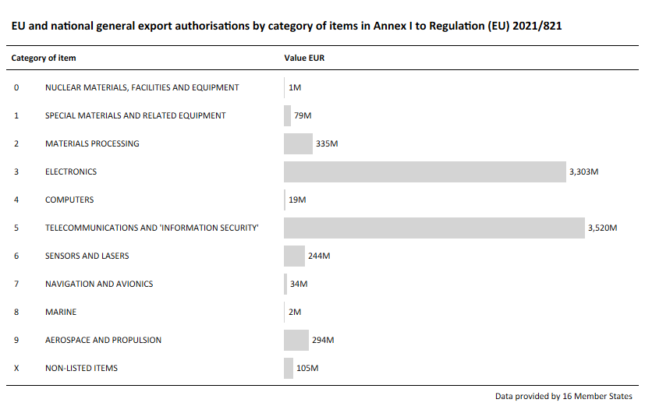
Figure 14: EU and national general export authorisations by category of items in Annex I to Regulation (EU) 2021/821
Breaking down the value of EU and national GEAs by type of items (Figures 15.1 and 15.2) indicates that the top five items are Information security and crypto-analysis items and equipment (EUR 3.5 billion, 44% of total), Equipment for the manufacturing and testing of semiconductor devices or materials (EUR 3.2 billion, 40% of total), Machines tools and systems and components for industrial equipment (EUR 0.2 billion, 2% of total), UAV and propulsions therefor (EUR 0.2 billion, 2% of total) and Lasers, related equipment and materials (EUR 0.1 billion, 2% of total).
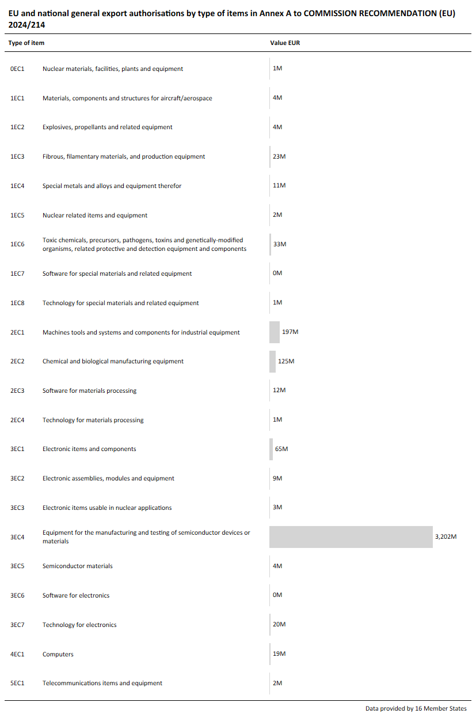
Figure 15.1: EU and national general export authorisations by type of items (Part 1)
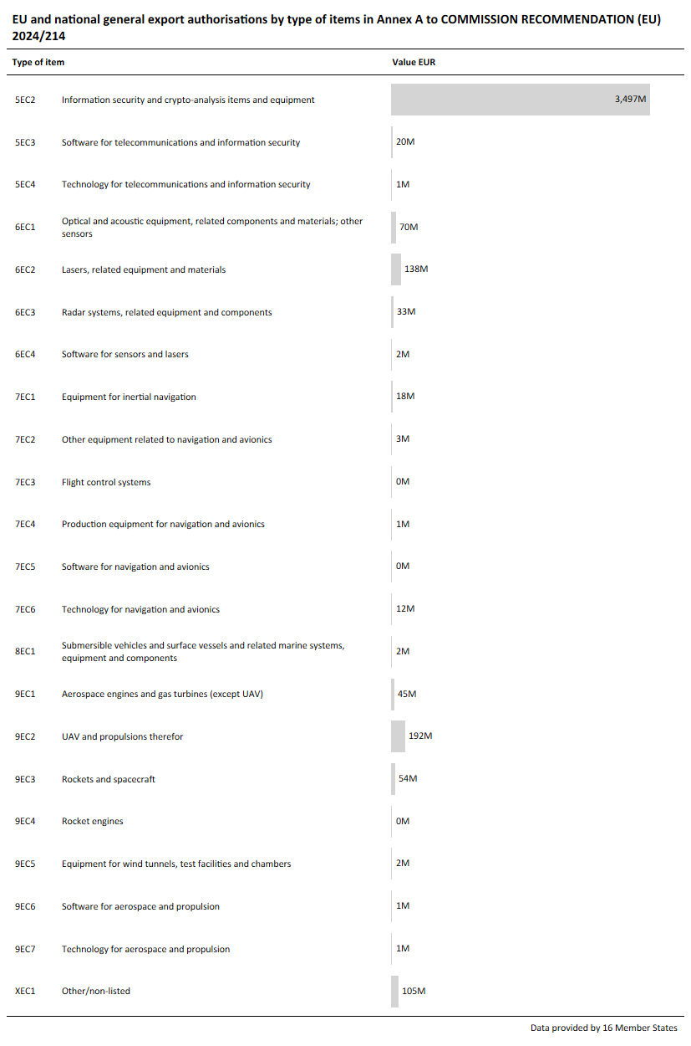
Figure 15.2: EU and national general export authorisations by type of items (Part 2)
Of the destinations authorised under EU and national GEAs, the top five were the United States (EUR 5.3 billion, 55% of total), the United Kingdom (EUR 1.5 billion, 16% of total), Norway (EUR 0.6 billion, 6% of total), Switzerland (EUR 0.6 billion, 6% of total) and Japan (EUR 0.3 billion, 4% of total). This indicates that the large majority of the dual-use exports covered by GEAs are directed towards countries listed in EU GEA EU001, also reflecting the fact that the value of exports authorised under EU GEAs is much higher than under national GEAs (EUR 9 billion versus EUR 1 billion, as per Figure 4).

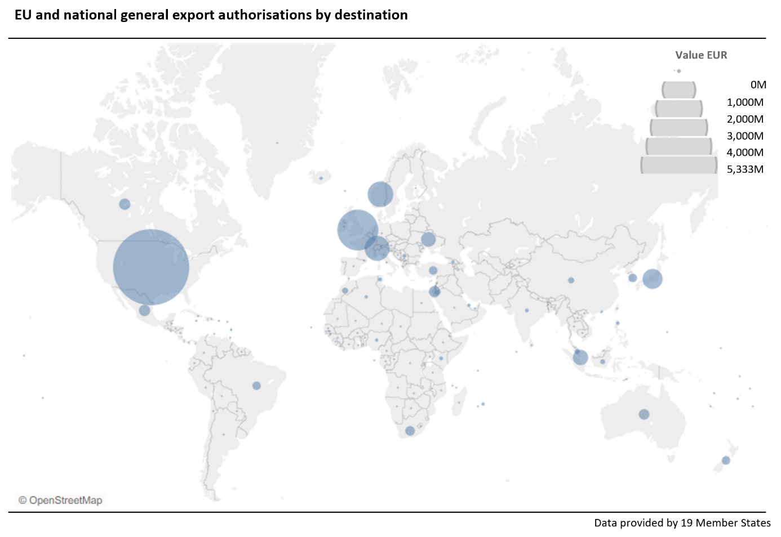Figure 16: EU and national general export authorisations by destination
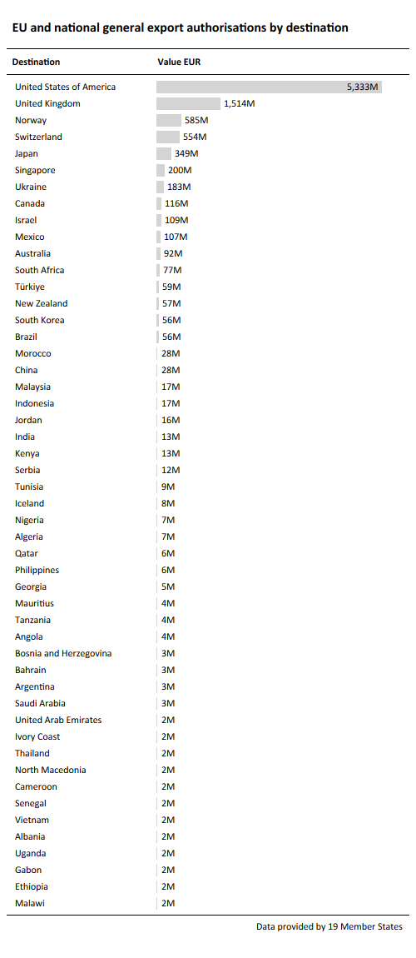
Figure 17: EU and national general export authorisations by top destinations

4.7 Registered users of national and EU general export authorisations
In order to provide information on exporters’ notifications in accordance with the Regulation, the annual report includes data on the number of exporters that have notified or are registered with the competent authority to use EU or national general export authorisations.
In 2024, a total 12 093 exporters were using EU general export authorisations, of which 50% of them were using EU001, and 37% of exporters were using national general export authorisations. With respect to first-use notifications or registrations in 2024, the figures were 1 044 for EU GEAs (45% for EU001) and 644 for national GEAs.
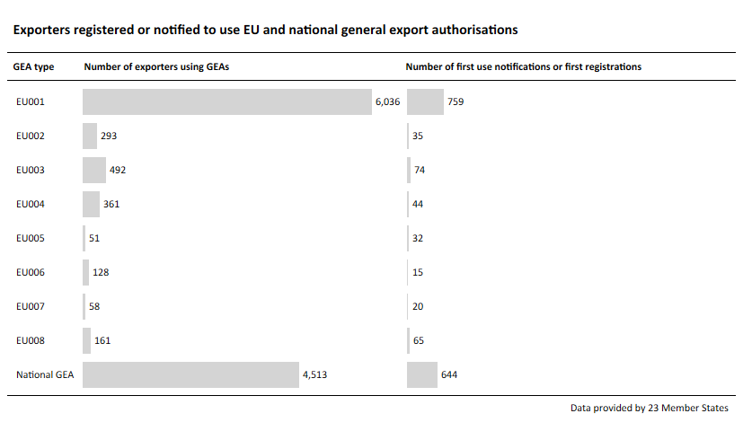
Figure 18: Exporters registered or notified to use EU and national general export authorisations

- Data on dual-use items classified as cyber-surveillance items according to Article 2 (20) of the Regulation
In 2024, Member States received a total of 320 applications (Figure 19) for the export of cyber-surveillance items, mostly in relation to telecommunications interception systems (233 applications), followed by communication monitoring software (46 applications) and intrusion software (18 applications). Figures 20.1 and 20.2 show the 71 destinations of applications for the export of cyber-surveillance items. In 2024, 293 authorisations were issued and 13 denied. This shows a rather stable number of licences for cyber-surveillance items (330 licences issued in 2023), signalling an end to the upward trend observed since 2020. The number of denials for the export of cyber-surveillance items appeared to be decreasing (20 denials in 2023).
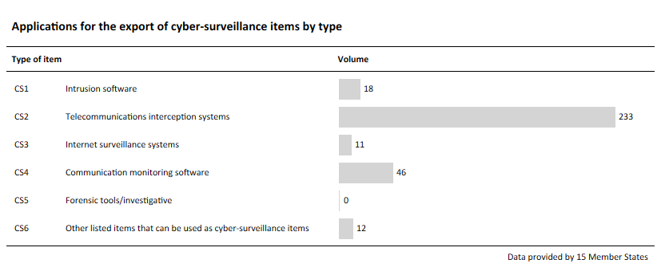
Figure 19: Applications for the exports of cyber-surveillance items

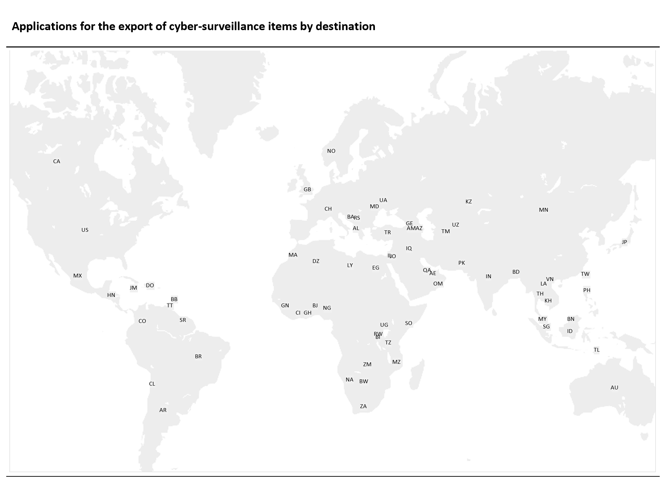
Figure 20.1: Applications for the exports of cyber-surveillance items by destination
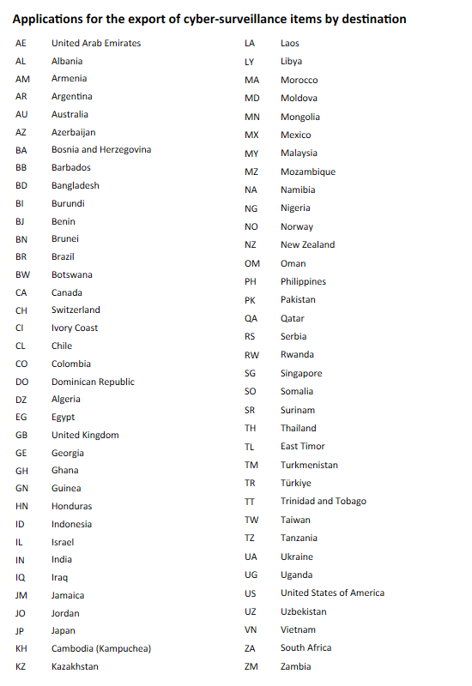
Figure 20.2: Applications for the exports of cyber-surveillance items by destination
- Information on administration and enforcement
Member States communicated the following information on the administration and enforcement of the Regulation in 2024:
- number of staff (full-time equivalent) directly involved in the administration of controls in the EU: 415;
- number of outreach events organised in the reference year: 154;
- number of compliance audits conducted in the year, including those conducted by customs or other agencies: 1 353;
- number of infringements reported: 270;
- number of administrative and criminal penalties or fines imposed (by any relevant national enforcement agency) in case of infringement of export control regulations: 144; and
- use of export control tools:
- Member States using the e-licensing system: 19;
- Member States using classification tools: 4; and
- Member States using other tools or software to support the application of controls: 9.

Regulation (EU) 2021/821 of the European Parliament and of the Council of 20 May 2021 setting up a Union regime for the control of exports, brokering, technical assistance, transit and transfer of dual-use items (recast) – (OJ L 206, 11.6.2021, p. 1): https://eur-lex.europa.eu/eli/reg/2021/821/oj.
Commission Recommendation (EU) 2024/214 of 10 January 2024 on guidelines setting out the methodology for data gathering and processing for the preparation of the annual report on the control of exports, brokering, technical assistance, transit and transfer of dual-use items pursuant to Regulation (EU) 2021/821 of the European Parliament and of the Council (OJ L 2024/214, 17.1.2024): http://data.europa.eu/eli/reco/2024/214/oj.
Some Member States’ competent authorities also publicly report on trade in dual-use items.
This includes voluntary data on the uses of national general export authorisations and EU general export authorisations.
In 2023, 330 licences were issued for cyber-surveillance items.
In 2023, 20 denials were issued for cyber-surveillance items.
Commission Recommendation (EU) 2024/2659 of 11 October 2024 on guidelines on the export of cyber-surveillance items under Article 5 of Regulation (EU) 2021/821 of the European Parliament and of the Council, C/2024/7035 (OJ L 2024/2659, 16.10.2024): http://data.europa.eu/eli/reco/2024/2659/oj.
European Council, Conclusions of the European Council meeting (ST 9439 2024 COR 1).
Council of the EU, Press Release ‘Russia’s war of aggression against Ukraine: EU adopts 15th package of restrictive measures’:https://www.consilium.europa.eu/en/press/press-releases/2024/12/16/russia-s-war-of-aggression-against-ukraine-eu-adopts-15th-package-of-restrictive-measures/.
Preventing Russian Export Control and Sanctions Evasion: Updated Guidance for Industry: https://finance.ec.europa.eu/news/sanctions-vis-vis-russia-commission-publishes-g7-industry-guidance-preventing-sanctions-evasion-2024-09-24_en.
The GECC members are Australia, Canada, the 27 EU Member States, Iceland, Japan, Liechtenstein, New Zealand, Norway, South Korea, Switzerland, United Kingdom, United States and Taiwan.
In June 2021, the EU and the U.S. established the Trade and Technology Council, which met for the first time in Pittsburgh on 29 September 2021 and agreed on an ambitious joint statement, including cooperation on export control. One of its ten working groups is dedicated to export controls, sharing information and working on topics like legislative and regulatory developments, risk assessments and licensing good practices, as well as on approaches to industry compliance and enforcement. Furthermore, this working group aims to promote convergent control approaches on sensitive dual-use technologies and to perform joint industry outreach activities on dual-use export controls.
Press release: ‘EU and US continue strong trade and technology cooperation at a time of global challenges’, 5 April 2024: https://ec.europa.eu/commission/presscorner/detail/en/ip_24_1827.
COMMISSION DELEGATED REGULATION (EU) …/… amending Regulation (EU) 2021/821 of the European Parliament and of the Council as regards the list of dual-use items: https://policy.trade.ec.europa.eu/news/2025-update-eu-control-list-dual-use-items-2025-09-08_en.
https://eur-lex.europa.eu/legal-content/EN/TXT/?uri=OJ:C_202405881.
The UK has been added to EU General Export Authorisation EU001 in the meantime.
OJ L 29, 31.1.2020, p. 7 (‘Withdrawal Agreement’).
Article 5(4) of the NI Protocol and Section 47 of Annex 2 to that Protocol.
This report is also the annual report required under the Regulation on the activities, examinations and consultations of the DUCG.
Commission Recommendation (EU) 2024/214 of 10 January 2024 on guidelines setting out the methodology for data gathering and processing for the preparation of the annual report on the control of exports, brokering, technical assistance, transit and transfer of dual-use items pursuant to Regulation (EU) 2021/821 of the European Parliament and of the Council (OJ L 2024/214, 17.1.2024): http://data.europa.eu/eli/reco/2024/214/oj.
Commission Recommendation (EU) 2024/2659 of 11 October 2024 on guidelines on the export of cyber-surveillance items under Article 5 of Regulation (EU) 2021/821 of the European Parliament and of the Council, C/2024/7035 (OJ L 2024/2659, 16.10.2024): http://data.europa.eu/eli/reco/2024/2659/oj.
United States National Nuclear Security Administration (NNSA).
Information Note – Regulation (EU) 2021/821 of the European Parliament and of the Council setting up a Union regime for the control of exports, brokering, technical assistance, transit and transfer of dual-use items: Information on measures adopted by Member States in conformity with Articles 4, 5, 6, 7, 8, 9, 11, 12, 22 and 23 (PUB/2024/740), OJ C/2024/5881, 2.10.2024: http://data.europa.eu/eli/C/2024/5881/oj.
https://eur-lex.europa.eu/legal-content/EN/TXT/?uri=CELEX%3A32025H0683.
Commission Recommendation (EU) 2024/214 of 10 January 2024 setting out the methodology for data gathering and processing for the preparation of the annual report on the control of exports, brokering, technical assistance, transit and transfer of dual-use items pursuant to Regulation (EU) 2021/821 (‘the Guidelines’).
Cf. Article 26(2) of the Regulation.
E.g. ECCN 0A001: Nuclear reactors.
This includes voluntary data on uses of national general export authorisations and EU general export authorisations. The data in these figures do not cover all 27 EU Member States.
In accordance with the third paragraph of Article 26(2) of the Regulation, Sections 4.2 to 4.7 of this report do not include data relating to cyber-surveillance items. Information on those items is provided in Section 5 below.
This includes voluntary data on uses of national general export authorisations and EU general export authorisations.
Please note that export authorisations with a destination to the Russian Federation correspond to trade taking place under the limited exemptions and derogations under the EU’s Russia sanctions regime. See Council Regulation (EU) No 833/2014 of 31 July 2014 concerning restrictive measures in view of Russia’s war of aggression against Ukraine.
Ibid.
EU001 – Exports to Australia, Canada, Iceland, Japan, New Zealand, Norway, Switzerland, Liechtenstein, the United Kingdom and the United States of America EU002 – Export of certain dual-use items to certain destinations EU003 – Export after repair/replacement EU004 – Temporary export for exhibitions or fairs EU005 – Telecommunications EU006 – Chemicals EU007 – Intra-group technology transfers EU008 – Encryption
In accordance with the provisions for EU general export authorisations in Annex II to the Regulation, [t]he exporter who uses this authorisation shall notify the competent authority of the Member State where the exporter is resident or established of the first use of this authorisation within 30 days from the date when the first export took place or, alternatively, and in accordance with a requirement by the competent authority of the Member State where the exporter is resident or established, prior to the first use of this authorisation. Member States shall notify the Commission of the notification mechanism chosen for this authorisation. The Commission shall publish the information notified to it in the C series of the Official Journal of the European Union.
More information on cyber-surveillance items can be found in the Guidelines of 16 October 2024, as referred to in footnote 7.
Please note that Article 11 of the Regulation also requires licences issued by Member States in the case of intra-EU exports of specific cyber-surveillance items listed in Annex IV to the Regulation.
e-Licensing is a web-based platform to request authorisations for exporting, brokering, technical assistance, transit and transfer of dual-use items, such as software and technology.
Such tools can assist exporters and national authorities in classifying items.

