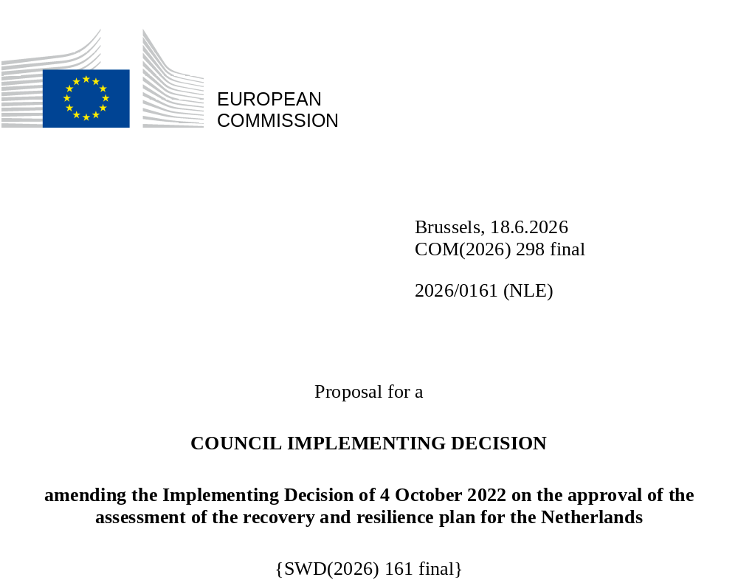

2026/0161 (NLE)
Proposal for a
COUNCIL IMPLEMENTING DECISION
amending the Implementing Decision of 4 October 2022 on the approval of the assessment of the recovery and resilience plan for the Netherlands
THE COUNCIL OF THE EUROPEAN UNION,
Having regard to the Treaty on the Functioning of the European Union,
Having regard to Regulation (EU) 2021/241 of the European Parliament and of the Council of 12 February 2021 establishing the Recovery and Resilience Facility, and in particular Article 20(1) thereof,
Having regard to the proposal from the European Commission,
Whereas:
(1) Following the submission of the national recovery and resilience plan (‘RRP’) by the Netherlands on 8 July 2022, the Commission proposed its positive assessment to the Council. On 4 October 2022, the Council approved the positive assessment by means of an implementing decision (‘the Council Implementing Decision of 4 October 2022’). The Council Implementing Decision of 4 October 2022 was amended by the Council Implementing Decisions of 17 October 2023, 5 November 2024, 13 May 2025 and 20 January 2026.
(2) On 22 May 2026, the Netherlands made a reasoned request to the Commission to make a proposal to amend the Council Implementing Decision of 4 October 2022 in accordance with Article 21(1) of Regulation (EU) 2021/241 on the grounds that the RRP is partially no longer achievable because of objective circumstances. On that basis, the Netherlands has submitted an amended RRP.
Amendments based on Article 21 of Regulation (EU) 2021/241
(3) The amendments to the RRP submitted by the Netherlands because of objective circumstances concern 12 measures.
(4) The Netherlands has explained that one measure is partially no longer achievable, due to the high administrative burden required to verify the implementation of the measure. This concerns C1.1 I1 Offshore wind. On this basis, the Netherlands has requested that this measure be amended. The Council Implementing Decision of 4 October 2022 should be amended accordingly.
(5) The Netherlands has explained that one measure is partially no longer achievable, due to a combination of delays in the supply of equipment, technical challenges and issues originating from grid congestion which has deteriorated, especially in locations of importance to the implementation of the measure. This concerns C1.1 I3 Inland waterway energy transition, project Zero Emission Services (ZES). On this basis, the Netherlands has requested that this measure be amended. The Council Implementing Decision of 4 October 2022 should be amended accordingly.
(6) The Netherlands has explained that one measure is partially no longer achievable, due to delays caused by exceptionally heavy precipitation, preventing works from being carried out. This concerns C1.2 I1 Nature programme. On this basis, the Netherlands has requested that this measure be amended. The Council Implementing Decision of 4 October 2022 should be amended accordingly.
(7) The Netherlands has explained that one measure is partially no longer achievable, due to risk of double funding with another European Union’s funding programme that would affect the same outputs. This concerns C2.2 I2 Safe, smart and sustainable mobility. On this basis, the Netherlands has requested that this measure be removed. The Council Implementing Decision of 4 October 2022 should be amended accordingly.
(8) The Netherlands has explained that two measures are partially no longer achievable, due to persistently elevated financing costs, labour shortages in the construction sector and lower-than expected demand. This concerns C3.1 I1 Unlocking new construction projects and C3.2 I1 Subsidy scheme for sustainability of public sector real estate. On this basis, the Netherlands has requested that this measure be removed. The Council Implementing Decision of 4 October 2022 should be amended accordingly.
(9) The Netherlands has explained that three measures have been amended to implement better alternatives in order to achieve their original ambition. This concerns C4.1 R2 Disability insurance for self-employed persons (renamed Reform C4.1 R2 Providing more certainty for flex workers and additional new Reform C4.1 R5 Abolishment of the old age reserve), C4.1 R3 Reform of the second pillar of the pension system, and C4.1 R4 Tackling bogus self-employment. On this basis, the Netherlands has requested that those measures be amended. The Council Implementing Decision of 4 October 2022 should be amended accordingly.
(10) Following the decrease in the level of implementation of measures in accordance with Article 21 of Regulation (EU) 2021/241, the Netherlands has requested to use the resources freed up by the decrease in the level of their implementation to increase the level of implementation of three measures. This concerns C1.1 I6 AanZET, C2.2 I1 European Rail Traffic Management System (ERTMS), and C3.2 I2 Investment subsidy for sustainable energy and energy savings. On this basis, the Netherlands has requested that the level of implementation of three measures be increased (C1.1 I6, C2.2 I1, C3.2 I2). The Council Implementing Decision of 4 October 2022 should be amended accordingly.
Corrections of clerical errors
(11) One clerical error has been identified in the text of the Council Implementing Decision, affecting one target and one measure under one component. The Council Implementing Decision should be amended to correct this clerical error that does not reflect the content of the RRP submitted to the Commission on 8 July 2022, as agreed between the Commission and the Netherlands. This clerical error relates to target 56 of C2.2 I3 Intelligent roadside stations (iWKS) under component Accelerating the Digital Transformation. This correction does not affect the implementation of the measure concerned.
Commission’s assessment
(12) The Commission has assessed the amended RRP against the assessment criteria laid down in Article 19(3) of Regulation (EU) 2021/241.
Contribution to the green transition including biodiversity
(13) In accordance with Article 19(3), point (e), of, and criterion 2.5 of Annex V to, Regulation (EU) 2021/241, the amended RRP contains measures that contribute to a large extent (rating A) to the green transition, including biodiversity, or to addressing the challenges resulting therefrom. The measures supporting climate objectives account for an amount which represents 56.2% of the amended RRP’s total allocation and 100% of the total estimated costs of measures in the REPowerEU chapter calculated in accordance with the methodology set out in Annex VI to Regulation (EU) 2021/241. In accordance with Article 17 of Regulation (EU) 2021/241, the amended RRP is consistent with the information included in the National Energy and Climate Plan 2021-2030.
(14) The Netherlands has requested a decrease in the level of implementation of certain measures and to use the resources to upscale three measures, namely C1.1 I6 AanZET, C2.2 I1 European Rail Traffic Management System (ERTMS), and C3.2 I2 Investment subsidy for sustainable energy and energy savings. These changes account for a slight positive change in the contribution of the amended RRP to the green transition. The measures in the amended RRP continue to significantly contribute to the green transition.
Contribution to the digital transition
(15) In accordance with Article 19(3), point (f), of, and criterion 2.6 of Annex V to, Regulation (EU) 2021/241, the amended RRP contains measures that contribute to a large extent (rating A) to the digital transition or to addressing the challenges resulting from it. The measures supporting digital objectives account for an amount which represents 28.2% of the amended RRP’s total allocation calculated in accordance with the methodology set out in Annex VII to that Regulation.
(16) The Netherlands has requested a decrease in the level of implementation of certain measures and to use the resources upscale three measures, namely C1.1 I6 AanZET, C2.2 I1 European Rail Traffic Management System (ERTMS), and C3.2 I2 Investment subsidy for sustainable energy and energy savings. These changes account for a slight negative change in the contribution of the amended RRP to the digital transition. The measures in the amended RRP continue to significantly contribute to the digital transition.
Costing
(17) In accordance with Article 19(3), point (i), of, and criterion 2.9 of Annex V to, Regulation (EU) 2021/241, the justification provided in the amended RRP on the amount of the estimated total cost of the RRP is to a medium extent (rating B) reasonable and plausible, is in line with the principle of cost efficiency and is commensurate to the expected national economic and social impact.
(18) The cost information provided by the Netherlands for the amended RRP is detailed and well substantiated. Moreover, the Netherlands submitted separate documents, including more elaborate descriptions of the methodology underlying the cost calculations and explanations of how past projects relate to the cost estimates of the amended measures as documentation, as well as on the additionality of EU funding where applicable. The assessment of the cost estimates and supporting information shows that the majority of the costs of the amended measures are well justified, reasonable and plausible, and do not include costs covered by existing or planned Union financing. Finally, the amount of the estimated total costs of the RRP is in line with the principle of cost efficiency and commensurate to the expected national economic and social impact. Therefore, a B rating is warranted for the amended RRP.
Any other assessment criteria
(19) The Commission considers that the amendments put forward by the Netherlands do not affect the positive assessment of the RRP set out in the Council Implementing Decision of 4 October 2022 on the approval of the assessment of the RRP for the Netherlands regarding the relevance, effectiveness, efficiency and coherence of the RRP against the assessment criteria laid down in Article 19(3), points (a), (b), (c), (d), (da), (db), (g), (h), (j) and (k).
Measures supporting investment operations contributing to the objectives of the Strategic Technologies for Europe Platform (STEP)
(20) In accordance with Article 4(4) of Regulation (EU) 2024/795, the Netherlands considered as a matter of priority projects that have been awarded a Sovereignty Seal pursuant to Article 4(1) of Regulation (EU) 2024/795. However, the Netherlands considered that no project having been awarded a Sovereignty Seal was to be included in the amended RRP given the limited amount of funding per project and the challenges of ensuring feasibility within the timeframe of the RRF. Therefore, the Netherlands prioritised upscaling existing RRP measures.
Positive assessment
(21) Following the positive assessment by the Commission of the amended RRP, with the finding that the RRP satisfactorily complies with the criteria for assessment set out in Regulation (EU) 2021/241, in accordance with Article 20(2) of and Annex V to that Regulation, the reforms and investment projects necessary for the implementation of the amended RRP, the relevant milestones, targets and indicators, and the amount made available from the Union for the implementation of the amended RRP should be set out.
Financial contribution
(22) The estimated total costs of the Netherlands’s amended RRP is EUR 5 443 259 340. As the amount of the estimated total cost of the amended RRP is higher than the updated maximum financial contribution available for the Netherlands, the financial contribution determined in accordance with Article 4a of Regulation (EU) 2021/1755 of the European Parliament and of the Council, and with Article 20(4) and Article 21a(6) of Regulation (EU) 2021/241 that is allocated for the Netherlands’s amended RRP should be equal to EUR 5 441 423 046. Therefore, the financial contribution made available to the Netherlands remains unchanged.
(23) The Council Implementing Decision of 4 October 2022 should therefore be amended accordingly. For the sake of clarity, the Annex to the Council Implementing Decision of 4 October 2022 should be replaced entirely.
(24) This Decision should be without prejudice to the outcome of any procedures relating to the award of Union funds under any Union programme other than the Facility or to procedures relating to distortions of the operation of the internal market that may be undertaken, in particular under Articles 107 and 108 of the Treaty. It does not override the requirement for Member States to notify instances of potential State aid to the Commission under Article 108 of the Treaty,
HAS ADOPTED THIS DECISION:
Article 1
Approval of the assessment of the RRP
The assessment of the amended RRP for the Netherlands on the basis of the criteria provided for in Article 19(3) of Regulation (EU) 2021/241 is approved.
Article 2
Amendments
The Council Implementing Decision of 4 October 2022 on the approval of the assessment of the recovery and resilience plan for the Netherlands is amended as follows:
the Annex is replaced by the text set out in the Annex to this Decision.
Article 3
Addressee
This Decision is addressed to the Kingdom of the Netherlands.
Done at Brussels,
For the Council
The President

OJ L 57, 18.2.2021, p. 17, ELI: https://eur-lex.europa.eu/eli/reg/2021/241/oj.
ST 12275/22 INIT; ST 12275/22 ADD 1.
ST 13613/23 INIT; ST 13613/23 REV 1 (en); ST 13613/23 ADD 1 REV 1.
ST 13789/24 INIT; ST 13789/24 ADD 1 REV 1.
ST 8132/25 INIT; ST 8132/25 ADD 1.
ST 17030/25 INIT; ST 17030/25 ADD1.
Regulation (EU) 2021/1755 of the European Parliament and of the Council of 6 October 2021 establishing the Brexit Adjustment Reserve (OJ L 357, 8.10.2021, p. 1, ELI: http://data.europa.eu/eli/reg/2021/1755/oj).

