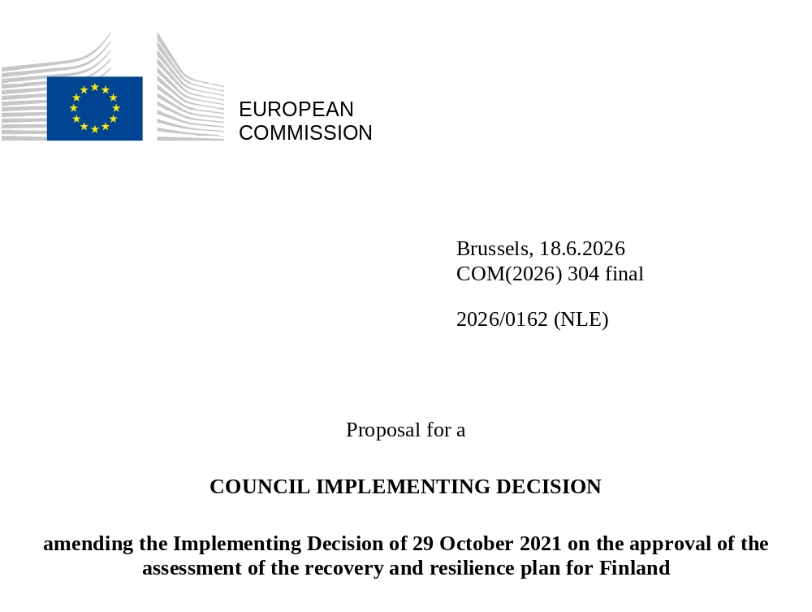

2026/0162 (NLE)
Proposal for a
COUNCIL IMPLEMENTING DECISION
amending the Implementing Decision of 29 October 2021 on the approval of the assessment of the recovery and resilience plan for Finland
THE COUNCIL OF THE EUROPEAN UNION,
Having regard to the Treaty on the Functioning of the European Union,
Having regard to Regulation (EU) 2021/241 of the European Parliament and of the Council of 12 February 2021 establishing the Recovery and Resilience Facility, and in particular Article 20(1) thereof,
Having regard to the proposal from the European Commission,
Whereas:
(1) Following the submission of the national recovery and resilience plan (‘RRP’) by Finland on 27 May 2021, the Commission proposed its positive assessment to the Council. On 29 October 2021, the Council approved the positive assessment by means of an implementing decision (‘the Council Implementing Decision of 29 October 2021). The Council Implementing Decision of 29 October 2021 was amended by Council Implementing Decisions of 14 March 2023, 8 December 2023, 16 July 2024, 18 July 2025 and 20 January 2026.
(2) On 28 May 2026, Finland made a reasoned request to the Commission to make a proposal to amend the Council Implementing Decision of 29 October 2021 in accordance with Article 21(1) of Regulation (EU) 2021/241 on the grounds that the RRP is partially no longer achievable because of objective circumstances. On that basis, Finland has submitted an amended RRP.
Amendments based on Article 21 of Regulation (EU) 2021/241
(3) The amendments to the RRP submitted by Finland because of objective circumstances concern four measures.
(4) Finland has explained that one measure has been amended to implement a better alternative in order to achieve its original ambition. This concerns measure P2C3R1 (Ensuring effective supervision and enforcement of the prevention of money laundering). On this basis, Finland has requested that this measure be amended. The Council Implementing Decision of 29 October 2021 should be amended accordingly.
(5) Finland has explained that three measures have been amended to implement a better alternative that allow the administrative burden to be reduced and simplify the Council Implementing Decision, while still achieving the objectives of the measure. This concerns P4C1I4 (Introducing digital innovations for social welfare and health care services) P4C1I3 (Knowledge base to increase cost-effectiveness of social welfare and health care services) and P4C1I5 (Introducing new digital healthcare information system in Åland). On this basis, Finland has requested that the measure be amended. The Council Implementing Decision of 29 October 2021 should be amended accordingly.
Corrections of clerical errors
(6) Four clerical errors have been identified in the text of the Council Implementing Decision, affecting one milestone, three targets and four measures under three components. The Council Implementing Decision should be amended to correct these clerical errors that do not reflect the content of the RRP submitted to the Commission on 27 May 2021, as agreed between the Commission and Finland. Those clerical errors relate to target 8 of P1C1I2 (Investments in new energy technologies) under component P1C1 (Transformation of the energy system), milestone 12 and the measure description of P1C2R1 (Reform of the Climate Act and low-carbon industrialisation) under component P1C2 (Industrial reforms and investments supporting the green and digital transition), target 85 of P3C1R4 (Employment and labour market – Multi-disciplinary services for young people (Ohjaamo services) under component P3C1 (Employment and labour market and milestone 147 of P5C1I1 (Investments for clean transition) under component P5C1 (REPowerEU). Those corrections do not affect the implementation of the measures concerned.
Commission’s assessment
(7) The Commission has assessed the amended RRP against the assessment criteria laid down in Article 19(3) of Regulation (EU) 2021/241.
(8) The Commission considers that the amendments put forward by Finland do not affect the positive assessment of the RRP set out in the Council Implementing Decision of 29 October 2021 regarding the relevance, effectiveness, efficiency and coherence of the RRP against the assessment criteria laid down in Article 19(3) of Regulation (EU) 2021/241 points (a), (b), (c), (d),(da), (db), (e), (f), (g), (h), (i), (j) and (k).
Positive assessment
(9) Following the positive assessment by the Commission of the amended RRP, with the finding that the RRP satisfactorily complies with the criteria for assessment set out in Regulation (EU) 2021/241, in accordance with Article 20(2) of and Annex V to that Regulation, the reforms and investment projects necessary for the implementation of the amended RRP, the relevant milestones, targets and indicators, and the amount made available from the Union for the implementation of the amended RRP should be set out.
Financial contribution
(10) The estimated total costs of Finland’s amended RRP is EUR 1 949 226 000. As the amount of the estimated total cost of the amended RRP is higher than the updated maximum financial contribution available for Finland, the financial contribution determined in accordance with Article 4a of Regulation (EU) 2021/1755 of the European Parliament and of the Council, and with Article 20(4) and Article 21a(6) of Regulation (EU) 2021/241 that is allocated for Finland’s amended RRP should be equal to EUR 1 949 059 854. Therefore, the financial contribution made available to Finland remains unchanged.
(11) The Council Implementing Decision of 29 October 2021 should therefore be amended accordingly. For the sake of clarity, the Annex to the Council Implementing Decision of 29 October 2021 should be replaced entirely.
(12) This Decision should be without prejudice to the outcome of any procedures relating to the award of Union funds under any Union programme other than the Facility or to procedures relating to distortions of the operation of the internal market that may be undertaken, in particular under Articles 107 and 108 of the Treaty. It does not override the requirement for Member States to notify instances of potential State aid to the Commission under Article 108 of the Treaty,
HAS ADOPTED THIS DECISION:
Article 1
Approval of the assessment of the RRP
The assessment of the amended RRP for Finland on the basis of the criteria provided for in Article 19(3) of Regulation (EU) 2021/241 is approved.
Article 2
Amendments
The Council Implementing Decision of 29 October 2021 on the approval of the assessment of the recovery and resilience plan for Finland is amended as follows:
the Annex is replaced by the text set out in the Annex to this Decision.
Article 3
Addressee
This Decision is addressed to the Republic of Finland.
Done at Brussels,
For the Council
The President

OJ L 57, 18.2.2021, p. 17, ELI: https://EUR-lex.europa.eu/eli/reg/2021/241/oj.
ST 12524/21 INIT; ST 12524/21 ADD 1.
ST 6991/23 INIT; ST 6991/23 ADD 1 COR1.
ST 15836/23 INIT; ST 15836/23 ADD 1.
ST 11535/24 INIT; ST 11535/24 ADD 1.
ST 11030/25 INIT; ST 11030/25 ADD 1.
ST 16877/26 INIT; ST 16877/26 ADD 1.
Regulation (EU) 2021/1755 of the European Parliament and of the Council of 6 October 2021 establishing the Brexit Adjustment Reserve (OJ L 357, 8.10.2021, p. 1, ELI: http://data.europa.eu/eli/reg/2021/1755/oj).

