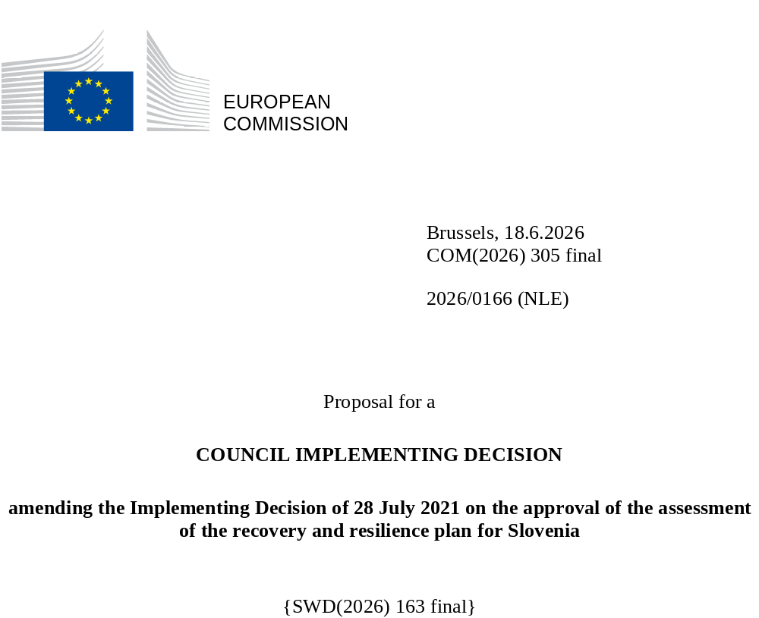

2026/0166 (NLE)
Proposal for a
COUNCIL IMPLEMENTING DECISION
amending the Implementing Decision of 28 July 2021 on the approval of the assessment of the recovery and resilience plan for Slovenia
THE COUNCIL OF THE EUROPEAN UNION,
Having regard to the Treaty on the Functioning of the European Union,
Having regard to Regulation (EU) 2021/241 of the European Parliament and of the Council of 12 February 2021 establishing the Recovery and Resilience Facility, and in particular Article 20(1) thereof,
Having regard to the proposal from the European Commission,
Whereas:
(1) Following the submission of the national recovery and resilience plan (‘RRP’) by Slovenia on 30 April 2021, the Commission proposed its positive assessment to the Council. On 28 July 2021, the Council approved the positive assessment by means of an implementing decision (‘the Council Implementing Decision of 28 July 2021’). The Council Implementing Decision of 28 July 2021 was amended by the Council Implementing Decisions of 17 October 2023, 10 December 2024, 20 June 2025, 12 December 2025 and 27 April 2026.
(2) On 26 May 2026, Slovenia made a reasoned request to the Commission to make a proposal to amend the Council Implementing Decision of 28 July 2021 in accordance with Article 21(1) of Regulation (EU) 2021/241 on the grounds that the RRP is partially no longer achievable because of objective circumstances. On that basis, Slovenia has submitted an amended RRP.
Amendments based on Article 21 of Regulation (EU) 2021/241
(3) The amendments to the RRP submitted by Slovenia because of objective circumstances concern 26 measures.
(4) Slovenia has explained that one measure is partially no longer achievable, because of withdrawals of the applicants from the awarded contracts. This concerns C11-IB (‘The sustainable development of tourist accommodation offers to raise the added value of tourism’). On this basis, Slovenia has requested that this measure be amended. The Council Implementing Decision of 28 July 2021 should be amended accordingly.
(5) Slovenia has explained that one measure is partially no longer achievable, because of delays in the public procurement process outside the responsibility of the Member State. This concerns C14-ID (‘Accessibility of the health system’). On this basis, Slovenia has requested that this measure be amended. The Council Implementing Decision of 28 July 2021 should be amended accordingly.
(6) Slovenia has explained that one measure is partially no longer achievable, because of the lower-than-expected absorption capacity of the recipients of support. This concerns C17-IE (‘Promoting alternative fuels infrastructure in transport (scaled-up)’). On this basis, Slovenia has requested that this measure be amended. The Council Implementing Decision of 28 July 2021 should be amended accordingly.
(7) Slovenia has explained that 21 measures have been amended to implement better alternatives that allow the administrative burden to be reduced and simplify the Council Implementing Decision, while still achieving the objectives of those measures. This concerns C3-IFL (‘Further reducing flood risks and reducing the risk to other climate-related disasters’), C5-IC (‘Increasing wood processing to accelerate the transition to a climate-neutral society’), C7-IG (‘Modernising the digital environment of public administration’), C7-IH (Gigabit infrastructure’), C7-IJ (‘Digitalisation of education and science’), C7-IL (‘The digital transition in agriculture, or food, or forestry’), C7-IM (‘Digitalisation in the field of culture’), C7-IN (‘Digitalisation in the field of justice’), C8-IB (‘Co-financing of research innovation projects in support of green transition and digitalisation’), C8-IC (‘Co-financing of projects to enhance the international mobility of Slovenian researchers and research organisations and to promote the international involvement of Slovenian applicants’), C8-ID (‘Co-financing of investment in RDI demonstration and pilot projects’), C9-IC (‘Support for decarbonisation, productivity, and competitiveness of companies’), C9-ID (‘Providing innovative ecosystems of economic and business infrastructure’), C12-RB (‘Reform of higher education for a green and resilient transition’), C12-RC (‘Revision of vocational education and training programmes (VET)’), C12-IE (’The comprehensive transformation of green and digital education’), C12-IF (‘Pilot projects for higher education reform for a green and resilient transition’), C12-IG (‘Strengthening cooperation between the education system and the labour market’), C12-IHL (‘Further greening education infrastructure in Slovenia’), C15-ICL (‘Ensuring a safe living environment for dependent persons’) and C16-IBL (‘Provision of public rental housing’). On this basis, Slovenia has requested that those measures be amended. The Council Implementing Decision of 28 July 2021 should be amended accordingly.
(8) Following the decrease in the level of implementation of measures in accordance with Article 21 of Regulation (EU) 2021/241, Slovenia has requested to use the resources freed up by the decrease in the level of their implementation to add two new measures. This concerns measures C7-IO (‘Voluntary contribution to the EuroHPC Joint Undertaking for AI Gigafactories or equivalent AI infrastructure’) and C7-IOL (‘Further voluntary contribution to the EuroHPC Joint Undertaking for AI Gigafactories or equivalent AI infrastructure’). On this basis, Slovenia has requested that two new measures be added. The Council Implementing Decision of 28 July 2021 should be amended accordingly.
Commission’s assessment
(9) The Commission has assessed the amended RRP against the assessment criteria laid down in Article 19(3) of Regulation (EU) 2021/241.
Contribution to the REPowerEU objectives
(10) In accordance with Article 19(3), point (da), of, and criterion 2.12 of Annex V to, Regulation (EU) 2021/241, the REPowerEU chapter is expected to effectively contribute to a large extent (rating A) to energy security, the diversification of the Union’s energy supply, an increase in the uptake of renewables and in energy efficiency, an increase of energy storage capacities or the necessary reduction of dependence on fossil fuels before 2030.
(11) Despite Slovenia’s request to decrease the level of implementation of one measure, the REPowerEU chapter is still coherent with Slovenia’s policy framework aimed at reducing greenhouse gas emissions and increasing the share of renewable energy sources. The measures also reinforce those included in the RRP on promoting energy efficiency and zero-emission transport, and on increasing the share of renewables.
Contribution to the green transition including biodiversity
(12) In accordance with Article 19(3), point (e), of, and criterion 2.5 of Annex V to, Regulation (EU) 2021/241, the amended RRP contains measures that contribute to a large extent (rating A) to the green transition, including biodiversity, or to addressing the challenges resulting therefrom. The measures supporting climate objectives account for an amount which represents 43.05% of the amended RRP’s total allocation and 91.69% of the total estimated costs of measures in the REPowerEU chapter calculated in accordance with the methodology set out in Annex VI to Regulation (EU) 2021/241. In accordance with Article 17 of Regulation (EU) 2021/241, the amended RRP is consistent with the information included in the National Energy and Climate Plan 2021-2030.
(13) Despite a reduction of the share of measures supporting climate objectives by 1.64%, the downscaled measures do not impact the overall ambition of the RRP regarding the green transition, including biodiversity. The REPowerEU chapter continues to provide additional support to Slovenia’s green transition, as the reform of the promotion of renewable energy sources in Slovenia and all the investments contribute integrally to accelerating the uptake of renewables. Those reduce the reliance on fossil fuels and air pollution, while increasing energy efficiency and energy savings. The measures in the RRP are still expected to reduce the greenhouse gas emissions, facilitate the uptake of renewable energy, further increase the railway infrastructure capacity, and ensure the reduction of flood risks in Slovenia, thereby contributing to the attainment of the 2030-2050 climate targets, including the objective of EU climate neutrality by 2050. The limited scope of these amendments does not change the overall assessment of this criterion.
Contribution to the digital transition
(14) In accordance with Article 19(3), point (f), of, and criterion 2.6 of Annex V to, Regulation (EU) 2021/241, the amended RRP contains measures that contribute to a large extent (rating A) to the digital transition or to addressing the challenges resulting from it. The measures supporting digital objectives account for an amount which represents 26.48% of the amended RRP’s total allocation calculated in accordance with the methodology set out in Annex VII to that Regulation.
(15) The amendments to Slovenia’s RRP entail an increase in the overall contribution to the digital transition by 2,02%, mainly due to the addition of two new measures focused on AI infrastructure. The amended RRP continues to contribute significantly to the digital transition of the economy and the public sector, including by deploying necessary infrastructure such as building up connectivity, developing cloud and AI infrastructure and improving cybersecurity, by deploying advanced and user-friendly digital solutions and services, and by transforming business processes and closing the digital gap for more traditional companies. The limited scope of these amendments does not change the overall assessment of this criterion.
Costing
(16) In accordance with Article 19(3), point (i), of, and criterion 2.9 of Annex V to, Regulation (EU) 2021/241, the justification provided in the amended RRP on the amount of the estimated total cost of the RRP is to a medium extent (rating B) reasonable and plausible, is in line with the principle of cost efficiency and is commensurate to the expected national economic and social impact.
(17) According to the information provided, the assessment of the cost estimates for the revised investments show that most of the costs are reasonable and plausible. The changes to the plan were not extensive enough to affect the existing rating (B) of the plan. Additional resources were allocated to well-performing measures and to a new measure, consisting of voluntary contribution to the EuroHPC Joint Undertaking for AI Gigafactories or equivalent AI infrastructure. Allocations were reduced in cases where the measures faced risks. Slovenia provided sufficient explanations, which mainly comprise the results of tenders and calls for proposals launched for the purposes of the RRP. The changes in the cost estimates for amended measures were justified and proportional and, as such, the reasonability and plausibility of those cost estimates were not altered compared to the original RRP. Slovenia has provided sufficient information and evidence to demonstrate that the amount of the estimated total cost is not covered by any other existing or planned Union financing. Finally, the amount of the estimated total cost of the RRP is in line with the principle of cost-efficiency and commensurate with the expected national economic and social impact.
Any other assessment criteria
(18) The Commission considers that the amendments put forward by Slovenia do not affect the positive assessment of the RRP set out in the Council Implementing Decision of 28 July 2021 on the approval of the assessment of the RRP for Slovenia regarding the relevance, effectiveness, efficiency and coherence of the RRP against the assessment criteria laid down in Article 19(3), points (a), (b), (c), (d), (db), (g), (h), (j) and (k).
Measures supporting investment operations contributing to the objectives of the Strategic Technologies for Europe Platform (STEP)
(19) In accordance with Article 4(4) of Regulation (EU) 2024/795, Slovenia considered as a matter of priority projects that have been awarded a Sovereignty Seal pursuant to Article 4(1) of Regulation (EU) 2024/795. However, Slovenia considered that no project having been awarded a Sovereignty Seal was to be included in the amended RRP because those projects do not cover the areas that have been upscaled in the amended RRP.
Positive assessment
(20) Following the positive assessment by the Commission of the amended RRP, with the finding that the RRP satisfactorily complies with the criteria for assessment set out in Regulation (EU) 2021/241, in accordance with Article 20(2) of and Annex V to that Regulation, the reforms and investment projects necessary for the implementation of the amended RRP, the relevant milestones, targets and indicators, and the amount made available from the Union for the implementation of the amended RRP should be set out.
Financial contribution
(21) The estimated total costs of Slovenia’s amended RRP is EUR 2 082 352 849. As the amount of the estimated total cost of the amended RRP is higher than the updated maximum financial contribution available for Slovenia, the financial contribution determined in accordance with Article 4a of Regulation (EU) 2021/1755 of the European Parliament and of the Council, and with Article 20(4) and Article 21a(6) of Regulation (EU) 2021/241 that is allocated for Slovenia’s amended RRP should be equal to EUR 1 612 948 340. Therefore, the financial contribution made available to Slovenia remains unchanged.
Loans
(22) The loan support made available to Slovenia amounting to EUR 468 836 849 remains unchanged.
(23) The Council Implementing Decision of 28 July 2021 should therefore be amended accordingly. For the sake of clarity, the Annex to the Council Implementing Decision of 28 July 2021 should be replaced entirely.
(24) This Decision should be without prejudice to the outcome of any procedures relating to the award of Union funds under any Union programme other than the Facility or to procedures relating to distortions of the operation of the internal market that may be undertaken, in particular under Articles 107 and 108 of the Treaty. It does not override the requirement for Member States to notify instances of potential State aid to the Commission under Article 108 of the Treaty,
HAS ADOPTED THIS DECISION:
Article 1
Approval of the assessment of the RRP
The assessment of the amended RRP for Slovenia on the basis of the criteria provided for in Article 19(3) of Regulation (EU) 2021/241 is approved.
Article 2
Amendments
The Council Implementing Decision of 28 July 2021 on the approval of the assessment of the recovery and resilience plan for Slovenia is amended as follows:
the Annex is replaced by the text set out in the Annex to this Decision.
Article 3
Addressee
This Decision is addressed to the Republic of Slovenia.
Done at Brussels,
For the Council
The President

OJ L 57, 18.2.2021, p. 17, ELI: https://eur-lex.europa.eu/eli/reg/2021/241/oj.
See documents ST 10612/21 INIT and ST 10612/21 ADD 1.
See documents ST 13615/23 INIT, ST 13615/23 REV 1 (en) and ST 13615/23 ADD 1 REV 1.
See documents ST 15989/24 INIT, ST 15989/24 ADD 1 and ST 15989/24 COR 1 (ga).
See documents ST 9591/25 INIT and ST 9591/25 ADD 1.
See documents ST 15797/25 INIT, ST 15797/25 ADD 1 and ST 15797/25 COR 1 (lv).
See documents ST 7812/26 INIT and ST 7812/26 ADD 1.
Regulation (EU) 2024/795 of the European Parliament and of the Council of 29 February 2024 establishing the Strategic Technologies for Europe Platform (STEP), and amending Directive 2003/87/EC and Regulations (EU) 2021/1058, (EU) 2021/1056, (EU) 2021/1057, (EU) 2013/1303, (EU) 2014/223, (EU) 2021/1060, (EU) 2021/523, (EU) 2021/695, (EU) 2021/697 and (EU) 2021/241 (OJ L, 2024/795, 29.2.2024, ELI: http://data.europa.eu/eli/reg/2024/795/oj).
Regulation (EU) 2021/1755 of the European Parliament and of the Council of 6 October 2021 establishing the Brexit Adjustment Reserve (OJ L 357, 8.10.2021, p. 1, ELI: https://eur-lex.europa.eu/eli/reg/2021/1755/oj).

