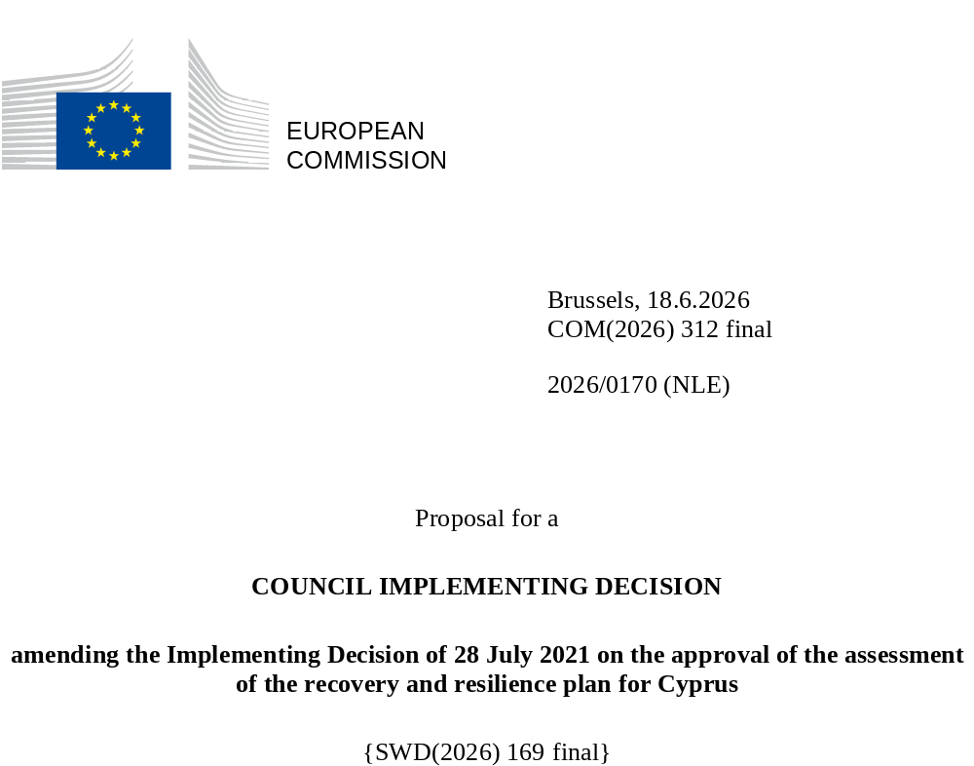

2026/0170 (NLE)
Proposal for a
COUNCIL IMPLEMENTING DECISION
amending the Implementing Decision of 28 July 2021 on the approval of the assessment of the recovery and resilience plan for Cyprus
THE COUNCIL OF THE EUROPEAN UNION,
Having regard to the Treaty on the Functioning of the European Union,
Having regard to Regulation (EU) 2021/241 of the European Parliament and of the Council of 12 February 2021 establishing the Recovery and Resilience Facility, and in particular Article 20(1) thereof,
Having regard to the proposal from the European Commission,
Whereas:
(1) Following the submission of the national recovery and resilience plan (‘RRP’) by Cyprus on 17 May 2021, the Commission proposed its positive assessment to the Council. On 28 July 2021, the Council approved the positive assessment by means of an implementing decision (‘the Council Implementing Decision of 28 July 2021’). The Council Implementing Decision of 28 July 2021 was amended by the Council Implementing Decisions of 8 December 2023, 16 July 2024, 21 January 2025, 20 June 2025 and 12 December 2025.
(2) On 29 May 2026, Cyprus made a reasoned request to the Commission to make a proposal to amend the Council Implementing Decision of 28 July 2021 in accordance with Article 21(1) of Regulation (EU) 2021/241 on the grounds that the RRP is partially no longer achievable because of objective circumstances. On that basis, Cyprus has submitted an amended RRP.
Amendments based on Article 21 of Regulation (EU) 2021/241
(3) The amendments to the RRP submitted by Cyprus because of objective circumstances concern 54 measures.
(4) Cyprus has explained that five measures are partially no longer achievable because of lack of demand. This concerns C2.1I9 fire protection, C2.2I1 Sustainable Urban Mobility Projects (SUMP) and accessibility-enhancing measures, C3.4I6a Regeneration and Revitalisation of Nicosia Inner City, C5.1R4 Digital transformation of school units with the aim of supporting digital skills and skills related to STEM education, and C6.1I6 Scaled-up measure: Thematic research and innovation funding programme on green transition. On this basis, Cyprus has requested that those measures be amended. The Council Implementing Decision of 28 July 2021 should be amended accordingly.
(5) Cyprus has explained that three measures are partially no longer achievable because of unexpected delays in the implementation. This concerns C1.1I5 Construction works and new equipment in Cyprus State Hospitals, C3.4I5 Smart cities and C5.1R2 A new teacher and school evaluation system. On this basis, Cyprus has requested that those measures be amended. The Council Implementing Decision of 28 July 2021 should be amended accordingly.
(6) Cyprus has explained that five measures are partially no longer achievable because of technical issues in the implementation. This concerns C1.1I7 Public warning system for emergency operations, C3.4R9 Digital transformation of courts, C3.5R4 Digital system for the exchange of data and the provision of credit scoring services, C3.5R9 Digitalising tax collection and C4.2I2 Digitalisation of the Cyprus Ports Authority. On this basis, Cyprus has requested that those measures be amended. The Council Implementing Decision of 28 July 2021 should be amended accordingly.
(7) Cyprus has explained that one measure is partially no longer achievable because of force majeure. This concerns C3.1R3 Genetic improvement of the Cyprus sheep and goat population. On this basis, Cyprus has requested that that measure be amended. The Council Implementing Decision of 28 July 2021 should be amended accordingly.
(8) Cyprus has explained that one measure has been amended to implement a manifestly better alternative in order to achieve its original ambition. This concerns C2.1R1 Green taxation. On this basis, Cyprus has requested to amend that measure. As those circumstances justify an amendment of the measures, the Council Implementing Decision of 28 July 2021 should be amended accordingly.
(9) Cyprus has explained that 36 measures have been amended to implement better alternatives that allow the administrative burden to be reduced and simplify the Council Implementing Decision, while still achieving the objectives of those measures. This concerns C1.1R1 National Centre for Clinical Evidence and Quality Improvement; C2.1I1 Energy-saving investments in SMEs and non-profit organisations; C2.2I2 Creation of electro-mobility infrastructure; C2.3I2 Water Treatment Plants; C2.3I4 Smart Water and Sewerage Networks Management; C2.3I5 Anti-flood and water collection measures; C2.3I6 Water security projects; C3.1R1 Move agricultural practices from the 20th century to the 21st century by investing in a national centre for excellence in agri-tech; C3.1I6 Scheme for supporting the production of enterprises in the agricultural sector; C3.1I8 Added value of tourism; C3.1I9 Circular economy in hotels; C3.1I10 Enrichment of tourism; C3.1R4 Circular economy; C3.1I11 Extension of the Cyprus Green Points Network; C3.2R1 National Research and Innovation Policy; C3.3R2 Supporting Fast-Track Business Activation Mechanism; C3.3R4 Incorporation of a National Promotional Agency; C3.4R1 Support the functioning of public administration; C3.4R4 Digitalisation of public procurement; C3.4I3 Economic Policy Modelling Hub; C3.4R7 Urban land consolidation; C3.4I4 E-system for issuing building permits; C3.5R8 Enhancing supervision of Insurance and Pension Funds; C3.5R10 Addressing Aggressive Tax Planning; C3.5I2 Modernisation of Customs and Electronic Payment System; C4.2R1 Digital Services Factory (DSF); C4.2R3 Police procedures digitalisation (Digipol); C4.2I1 Digitalisation of central government ministries/services; C5.1R3 Gradual extension of free compulsory pre-primary education from the age of four; C5.1R5 E-skills Action Plan – Delivery of specific actions; C5.2R2 Flexible work arrangements in the form of telework; C5.2I2 Establishment of Multifunctional Centres and Childcare Centres; C5.2I3 Establishment of home structures for people in need of long-term care; C5.2I4 Child centres in municipalities; C5.2I5 Construction of two model special education schools and C5.2R1 Reform of the Social Insurance System and Restructuring of the Social Insurance Services. On this basis, Cyprus has requested that those measures be amended. The Council Implementing Decision of 28 July 2021 should be amended accordingly.
(10) Following the decrease in the level of implementation of measures in accordance with Article 21 of Regulation (EU) 2021/241, Cyprus has requested to use the resources freed up by the decrease in the level of their implementation to increase the level of implementation of three measures. This concerns C2.1I2 Renewables and individual energy efficiency measures in dwellings and tackling energy poverty in households with vulnerable electricity consumers; C2.2I3 Advance the use of Electric Vehicles (EVs) and C6.1I1 Scaled-up measure: renewables and individual energy efficiency measures in dwellings. On this basis, Cyprus has requested that the level of implementation of four measures be increased. The Council Implementing Decision of 28 July 2021 should be amended accordingly.
Distribution of milestones and targets
(11) The distribution of milestones and targets in instalments should be amended to take into account the amendments to the RRP and the indicative timeline presented by Cyprus.
Commission’s assessment
(12) The Commission has assessed the amended RRP against the assessment criteria laid down in Article 19(3) of Regulation (EU) 2021/241.
Addressing all or a significant subset of challenges identified in country-specific recommendations
(13) In accordance with Article 19(3), point (b), of, and criterion 2.2 of Annex V to, Regulation (EU) 2021/241, the amended RRP is expected to contribute to effectively addressing all or a significant subset of challenges (rating A) identified in the relevant country-specific recommendations addressed to Cyprus, including fiscal aspects thereof, or challenges identified in other relevant documents officially adopted by the Commission in the context of the European Semester.
Contribution to the REPowerEU objectives
(14) In accordance with Article 19(3), point (da), of, and criterion 2.12 of Annex V to, Regulation (EU) 2021/241, the REPowerEU chapter is expected to effectively contribute to a large extent (rating A) to energy security, the diversification of the Union’s energy supply, an increase in the uptake of renewables and in energy efficiency, an increase of energy storage capacities or the necessary reduction of dependence on fossil fuels before 2030.
(15) The overall ambition of the RePowerEU chapter is maintained. While one measure has been slightly downscaled due to lack of demand, another measure promoting renewables has been upscaled, therefore the chapter effectively contributes to a large extent to energy security, the diversification of the Union’s energy supply, an increased uptake of renewables and energy efficiency, and the reduction of dependence on fossil fuels before 2030. Therefore, the amended plan effectively contributes to the objectives of Article 19(3), point (da).
Contribution to the green transition including biodiversity
(16) In accordance with Article 19(3), point (e), of, and criterion 2.5 of Annex V to, Regulation (EU) 2021/241, the amended RRP contains measures that contribute to a large extent (rating A) to the green transition, including biodiversity, or to addressing the challenges resulting therefrom. The measures supporting climate objectives account for an amount which represents 43.30% of the amended RRP’s total allocation and 94.18% of the total estimated costs of measures in the REPowerEU chapter calculated in accordance with the methodology set out in Annex VI to Regulation (EU) 2021/241. In accordance with Article 17 of Regulation (EU) 2021/241, the amended RRP is consistent with the information included in the National Energy and Climate Plan 2021-2030.
(17) In accordance with Article 19(3), point (e), of and Annex V, criterion 2.5, to Regulation (EU) 2021/241, the modified RRP contains measures that contribute to a large extent to the green transition, including biodiversity or to addressing the challenges resulting from it, as well as to the achievement of the Union 2030 climate targets while complying with the objective of EU climate neutrality by 2050. The positive assessment of the contribution to the green transition provided in the Council Implementing Decision of 20 July 2021 remains valid. While one measure on green R&I projects has been slightly downscaled, one measure on EVs has been scaled up, resulting in an increase of 2.79%, the measures amended do not impact the overall ambition of the plan regarding the green transition.
Contribution to the digital transition
(18) In accordance with Article 19(3), point (f), of, and criterion 2.6 of Annex V to, Regulation (EU) 2021/241, the amended RRP contains measures that contribute to a large extent (rating A) to the digital transition or to addressing the challenges resulting from it. The measures supporting digital objectives account for an amount which represents 29.15% of the amended RRP’s total allocation calculated in accordance with the methodology set out in Annex VII to that Regulation. The amendments to the Cyprus’s RRP entail a net decrease in the overall contribution to the digital target of the RRP by 2.93%. However, the measures amended do not impact the overall ambition of the plan regarding the digital transition.
(19) In accordance with Article 19(3), point (f), of and Annex V, criterion 2.6, to Regulation (EU) 2021/241, the modified RRP contains measures that contribute to a large extent to the digital transition or to addressing the challenges resulting from it. The positive assessment of the contribution to the digital transition provided in the Council Implementing Decision of 20 July 2021 remains valid.
Costing
(20) In accordance with Article 19(3), point (i), of and Annex V, criterion 2.9, to Regulation (EU) 2021/241, the justification provided in the amended RRP on the amount of the estimated total cost of the RRP is to a medium extent (rating B) reasonable and plausible, is in line with the principle of cost efficiency and is commensurate to the expected national economic and social impact.
(21) According to the information provided, the assessment of the cost estimates for the existing measure whose modifications entailed a new cost assessment show that most of the costs are reasonable and plausible. The changes in the cost estimates were justified, proportional to the revised targets and supported by detailed calculations and evidence, and as such the reasonability and plausibility of these cost estimates were not altered compared to the original RRP. Finally, the amount of the estimated total cost of the RRP is in line with the principle of cost-efficiency and commensurate to the expected national economic and social impact.
Any other assessment criteria
(22) The Commission considers that the amendments put forward by Cyprus do not affect the positive assessment of the RRP set out in the Council Implementing Decision of 28 July 2021 on the approval of the assessment of the RRP for Cyprus regarding the relevance, effectiveness, efficiency and coherence of the RRP against the assessment criteria laid down in Article 19(3), points [(a), (b), (c), (d), (da), (db), (e), (f), (g), (h), (i), (j) and (k).
Positive assessment
(23) Following the positive assessment by the Commission of the amended RRP, with the finding that the RRP satisfactorily complies with the criteria for assessment set out in Regulation (EU) 2021/241, in accordance with Article 20(2) of and Annex V to that Regulation, the reforms and investment projects necessary for the implementation of the amended RRP, the relevant milestones, targets and indicators, and the amount made available from the Union for the implementation of the amended RRP should be set out.
Financial contribution
(24) The estimated total costs of Cyprus’s amended RRP is EUR 1 022 123 510. As the amount of the estimated total cost of the amended RRP is higher than the updated maximum financial contribution available for Cyprus, the financial contribution determined in accordance with Article 4a of Regulation (EU) 2021/1755 of the European Parliament and of the Council, and with Article 20(4) and Article 21a(6) of Regulation (EU) 2021/241 that is allocated for Cyprus’s amended RRP should be equal to EUR 1 020 223 681. Therefore, the financial contribution made available to Cyprus remains unchanged.
(25) The Council Implementing Decision of 28 July 2021 should therefore be amended accordingly. For the sake of clarity, the Annex to the Council Implementing Decision of 28 July 2021 should be replaced entirely.
(26) This Decision should be without prejudice to the outcome of any procedures relating to the award of Union funds under any Union programme other than the Facility or to procedures relating to distortions of the operation of the internal market that may be undertaken, in particular under Articles 107 and 108 of the Treaty. It does not override the requirement for Member States to notify instances of potential State aid to the Commission under Article 108 of the Treaty,
HAS ADOPTED THIS DECISION:
Article 1
Approval of the assessment of the RRP
The assessment of the amended RRP for Cyprus on the basis of the criteria provided for in Article 19(3) of Regulation (EU) 2021/241 is approved.
Article 2
Amendments
The Council Implementing Decision of 28 July 2021 on the approval of the assessment of the recovery and resilience plan for Cyprus is amended as follows:
the Annex is replaced by the text set out in the Annex to this Decision.
Article 3
Addressee
This Decision is addressed to the Republic of Cyprus.
Done at Brussels,
For the Council
The President

OJ L 57, 18.2.2021, p. 17, ELI: https://eur-lex.europa.eu/eli/reg/2021/241/oj
See documents: ST 10686/21 INIT, ST 10686/21 ADD 1.
See documents: ST 15571/23 INIT, ST 15571/23 ADD 1, ST 15571/23 ADD 1 COR 1.
See documents: ST 11806/24 INIT, ST 11806/24 ADD 1.
See documents: ST 17052/24 INIT, ST17052/24 ADD 1.
See documents: ST 9585/25 INIT, ST 9585/25 ADD 1.
See documents: ST 15743/25 INIT, ST 15743/25 ADD1.
Regulation (EU) 2021/1755 of the European Parliament and of the Council of 6 October 2021 establishing the Brexit Adjustment Reserve (OJ L 357, 8.10.2021, p. 1, ELI: http://data.europa.eu/eli/reg/2021/1755/oj).

