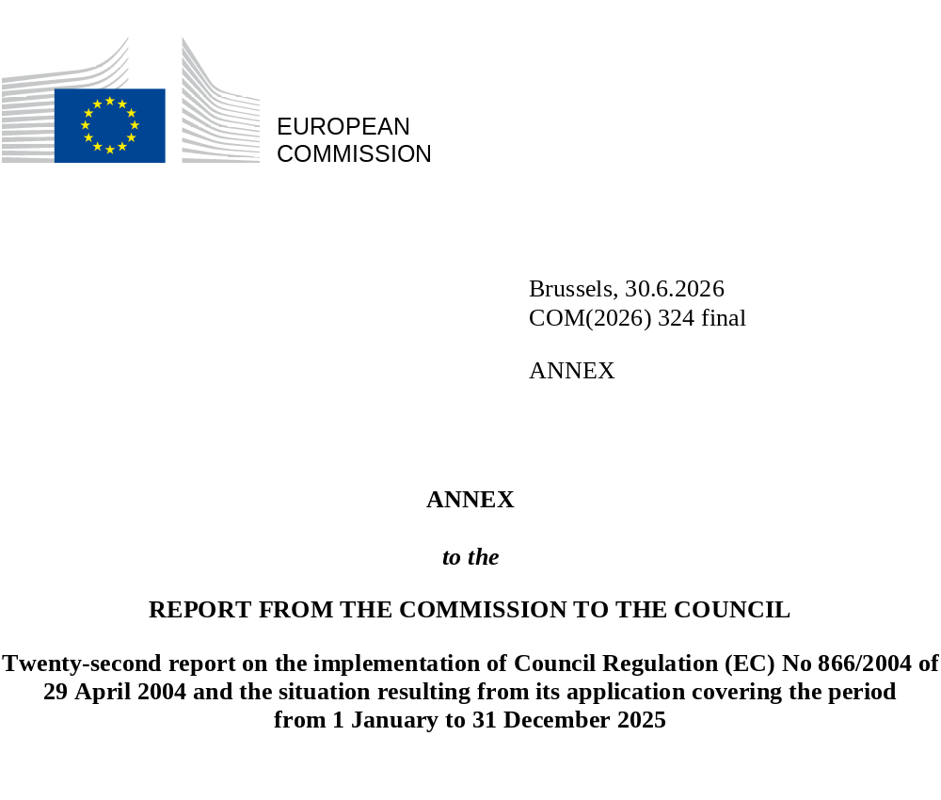

TABLE I:
Overview table summarising the monthly reports for year 2025 of the Turkish Cypriot Chamber of Commerce according to Article 8 of Commission Regulation (EC) No 1480/2004 in EUR
Traded products | January | February | March | April | May | June | July | August | September | October | November | December | Total
ANIMAL OR VEGETABLE FATS AND OILS AND THEIR CLEAVAGE PRODUCTS; PREPARED EDIBLE FATS; ANIMAL OR VEGETABLE WAXES | 33.520.00 | 80,160.00 | 36,720.00 | 88,700.00 | 126,280.00 | 71,000.00 | 96,900.00 | 57,000.00 | 82,060.00 | 133,100.00 | 104,380.00 | 141,640.00 | 1,053,460.00
ARTICLES OF STONE, PLASTER, CEMENT, ASBESTOS, MICA OR SIMILAR MATERIALS; CERAMIC PRODUCTS; GLASS AND GLASSWARE | 108,285.23 | 80,631.66 | 55,295.95 | 203,170.16 | 79,463.50 | 89,772.00 | 98,964.80 | 48,039.23 | 117,105.81 | 61,291.10 | 149,875.88 | 214484.89 | 1,306,380.21
BASE METALS AND ARTICLES OF BASE METAL | 65,478.50 | 46,314.00 | 65,366.50 | 43,450.50 | 86,558.50 | 108,238.00 | 81,522.00 | 47,275.50 | 61,893.00 | 72,945.00 | 49,645.50 | 33,521.00 | 762,208.00
FOOTWEAR, HEADGEAR, UMBRELLAS, SUN UMBRELLAS, WALKING STICKS, SEAT-STICKS, WHIPS, RIDING-CROPS AND PARTS THEREOF; PREPARED FEATHERS AND ARTICLES MADE THEREWITH; ARTIFICIAL FLOWERS; ARTICLES OF HUMAN HAIR | 3.300,00 | 0.00 | 0.00 | 1,650.00 | 3,300.00 | 3,300.00 | 0.00 | 0.00 | 3,300.00 | 330.00 | 0.00 | 0.00 | 15,180.00
LIVE ANIMALS; ANIMAL PRODUCTS | 65,478.50 | 46,314.00 | 65,366.50 | 43,450.50 | 86,558.50 | 108,238.00 | 81,522.00 | 47,275.50 | 61,893.00 | 72,945.00 | 49,645.50 | 33,521.00 | 762,208.00
MACHINERY AND MECHANICAL APPLIANCES; ELECTRICAL EQUIPMENT; PARTS THEREOF; SOUND RECORDERS AND REPRODUCERS, TELEVISION IMAGE AND SOUND RECORDERS AND REPRODUCERS, AND PARTS AND ACCESSORIES OF SUCH ARTICLES | 33,521.41 | 11,325.48 | 7,808.28 | 2,450.00 | 1,755.00 | 1,520.00 | 2,378.00 | 18,461.63 | 0.00 | 13005.9 | 0.00 | 0.00 | 92,225.7
MINERAL PRODUCTS | 0.00 | 0.00 | 0.00 | 0.00 | 0.00 | 0.00 | 2,320.00 | 5,800.00 | 0.00 | 0.00 | 0.00 | 0.00 | 8,120.00
MISCELLANEOUS MANUFACTURED ARTICLES | 589,546.54 | 580,279.67 | 699,963.81 | 674,488.70 | 704,884.84 | 832,062.89 | 949,101.26 | 491,630.67 | 830,665.63 | 743,072.91 | 746,420.95 | 648,289.31 | 8,490,407.18
PLASTICS AND ARTICLES THEREOF; RUBBER AND ARTICLES THEREOF | 168,669.57 | 147,596.78 | 207,176.14 | 264,025.67 | 224,351.47 | 190,251.26 | 242,624.15 | 143,696.31 | 207,135.62 | 243,988.98 | 199,763.50 | 185299.96 | 2,424,579.41
PREPARED FOODSTUFFS; BEVERAGES, SPIRITS AND VINEGAR; TOBACCO AND MANUFACTURED TOBACCO SUBSTITUTES | 0.00 | 0.00 | 0.00 | 0.00 | 0.00 | 0.00 | 0.00 | 0.00 | 0.00 | 0.00 | 0.00 | 0.00 | 0.00
PRODUCTS OF THE CHEMICAL OR ALLIED INDUSTRIES | 557.60 | 3,894.80 | 0.00 | 7,246.80 | 3,930.40 | 7,551.42 | 6,636.00 | 0.00 | 1,169.60 | 4,046.40 | 860.80 | 1,490.00 | 37,383.82
PULP OF WOOD OR OF OTHER FIBROUS CELLULOSIC MATERIAL; RECOVERED (WASTE AND SCRAP) PAPER OR PAPERBOARD; PAPER AND PAPERBOARD AND ARTICLES THEREOF | 20,017.00 | 19,211.00 | 11,107.00 | 21,266.00 | 17,373.00 | 4,117.00 | 18,288.60 | 19,037.50 | 3,194.00 | 21,568.00 | 35,658.00 | 31,581.00 | 222,418.10
RAW HIDES AND SKINS, LEATHER, FURSKINS AND ARTICLES THEREOF; SADDLERY AND HARNESS; TRAVEL GOODS, HANDBAGS AND SIMILAR CONTAINERS; ARTICLES OF ANIMAL GUT (OTHER THAN SILKWORM GUT) | 0.00 | 0.00 | 0.00 | 0.00 | 0.00 | 0.00 | 0.00 | 0.00 | 0.00 | 0.00 | 0.00 | 0.00 | 0.00
TEXTILES AND TEXTILE ARTICLES | 10,139.50 | 4,432.75 | 18,051.60 | 26,319.50 | 7,561.00 | 12,187.00 | 15,423.00 | 5,643.00 | 19,039.50 | 9,087.00 | 24,815.75 | 193583.5 | 346,283.10
VEGETABLE PRODUCTS | 17,000.00 | 5,500.00 | 12,500.00 | 5,000.00 | 22,500.00 | 0.00 | 0.00 | 0.00 | 0.00 | 0.00 | 0.00 | 0.00 | 62,500.00
VEHICLES, AIRCRAFT, VESSELS AND ASSOCIATED TRANSPORT EQUIPMENT | 0.00 | 0.00 | 0.00 | 0.00 | 0.00 | 0.00 | 0.00 | 0.00 | 0.00 | 0.00 | 0.00 | 0.00 | 0.00
WOOD AND ARTICLES OF WOOD; WOOD CHARCOAL; CORK AND ARTICLES OF CORK; MANUFACTURES OF STRAW, OF ESPARTO OR OF OTHER PLAITING MATERIALS; BASKETWARE AND WICKERWORK | 1,097.00 | 0.00 | 1,309.00 | 1,184.00 | 1,910.00 | 1,428.00 | 895.00 | 5,683.00 | 4,812.00 | 2,024.00 | 1,288.00 | 1,927.00 | 23,557.00
TOTAL | 1,117,190.72 | 1,049,166.71 | 1,218,643.68 | 1,392,874.67 | 1,353,444.19 | 1,368,984.32 | 1,596,453.25 | 923,043.76 | 1,408,552.82 | 1,373,684.00 | 1,597,729.78 | 1,597,729.78 | 15,865,325.18
Source: Turkish Cypriot Chamber of Commerce (spread of values of accompanying documents issued in 2025)
TABLE II:
Value of goods crossing the Green Line reported by the authorities of the Republic of Cyprus for 2025 in EUR
 | Total
January | 1,093450.57
February | 1,037889.04
March | 1,048214.50
April | 1,279254.95
May | 1,300590.49
June | 1,169685.05
July | 1,430114.80
August | 814,896.71
September | 1,351179.62
October | 1,305072.75
November | 1,271693.48
December | 1,328627.43
TOTAL | 14,430,669

Source: Table based on data received from Cyprus Customs and Excise Department

TABLE III:
Value of goods which crossed the Green Line and value of goods for which accompanying documents were issued in 2025

Source:
- For the value of goods for which accompanying documents were issued: Turkish Cypriot Chamber of Commerce
- For the value of goods which crossed the Green Line: Cyprus Customs and Excise Department
TABLE IV:
Most traded products in 2025 in EUR

Building / construction materials | 4,731,514.64 | 32.79%
Furniture and parts thereof | 2,752,993.65 | 19.08%
Plastic products | 2,185,030.39 | 15.14%
Scrap/waste | 1,651,758.1 | 11.45%
Mosaics, marbles, granites | 1,083,504.21 | 7.51%
Fresh fish | 718,612 | 4.98%
Mattresses and divans | 691,816.3 | 4.79%
Commercial items | 401,147.72 | 2.78%
Stone and stone filling | 92,858.21 | 0.64%
Aluminium | 42,032.2 | 0.29%
Other | 79,401.97 | 0.55%
Total | 14,430,669.39 | 100.00%

Source: Table based on data received from Cyprus Customs and Excise Department
TABLE V:
Development of accompanying documents issued for the most traded goods in 2025 (highest value)

Source: Graph based on data on issued accompanying documents received from the Turkish Cypriot Chamber of Commerce

TABLE VI

Movement of G/C and T/C persons and vehicles across the crossing points as per Council Regulation no. 866/04
(01/01 – 31/12/2025)
MONTH | MOVEMENTS OF PERSONS |  |  | MOVEMENTS OF VEHICLES
MONTH | GREEK CYPRIOTS | TURKISH CYPRIOTS | TOTAL | GREEK CYPRIOTS | TURKISH CYPRIOTS | TOTAL
01 / 2025 | 86132 | 156707 | 242839 | 53679 | 59858 | 113537
02 / 2025 | 79714 | 164777 | 244491 | 50417 | 65397 | 115814
03 / 2025 | 100554 | 179541 | 280095 | 58538 | 72230 | 130768
04 / 2025 | 110634 | 166268 | 276902 | 67701 | 67244 | 134945
05 / 2025 | 123230 | 174650 | 297880 | 73133 | 73955 | 147088
06 / 2025 | 140815 | 186108 | 326923 | 80736 | 76186 | 156922
07 / 2025 | 130727 | 168588 | 299315 | 80191 | 83680 | 163871
08 / 2025 | 135336 | 160787 | 296123 | 78394 | 64814 | 143208
09 / 2025 | 100880 | 160308 | 261188 | 62516 | 80638 | 143154
10 / 2025 | 132230 | 145765 | 277995 | 79622 | 45425 | 125047
11 / 2025 | 158719 | 164914 | 323633 | 73068 | 28442 | 101510
12 / 2025 | 154164 | 155197 | 309361 | 75791 | 30192 | 105983
TOTAL | 1453135 | 1983610 | 3436745 | 833786 | 748061 | 1581847
Source: Republic of Cyprus Police

