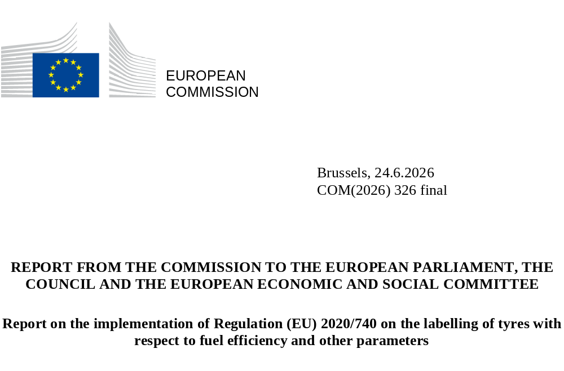

Introduction

Policy and legal context
Tyres are a critical component of every road vehicle. Tyre rolling resistance directly affects the vehicle’s energy consumption. Encouraging the demand for, and the development and production of, more efficient tyres can therefore reduce fuel costs, emissions and imports of fossil fuels – or increase the range of electric vehicles by reducing the electricity needed per driven kilometre. The first formal EU act on efficient tyres was adopted in the wake of the 1973 oil crisis, recommending ‘that the fitting of radial-ply tyres on all vehicles, including heavy goods vehicles, be encouraged’ by Member States ⁽⁾.
Fifty years on, radial tyres have become the default technology, but road transport still accounts for a significant part of total EU final energy consumption (around a quarter), and the vast majority of that energy still comes from oil. Meanwhile, innovation in tyre design and materials has made further efficiency gains possible. Estimates suggest that replacing high rolling resistance tyres with low resistance ones could cut average energy consumption of passenger cars by some 2% ⁽⁾. For heavy duty vehicles, rolling resistance from tyres is far more important, and the potential for efficiency gains greater: rolling resistance influences energy use up to one third in diesel trucks and over half in a more efficient electric ones ⁽⁾.
At the same time, another tyre parameter, wet grip, is critical for safety as it determines a vehicle’s breaking distance. Wet grip and rolling resistance are competing metrics, and for customers deciding on which type of tyre to buy there may be some trade-offs between safety and energy performance. To make well-informed purchasing decisions, customers should therefore have information on both parameters. To this end, the first EU Tyre Labelling Regulation (TLR hereafter) was adopted in 2009 and revised in 2020. Tyre labels provide easy to understand information to stimulate demand for, and competition in the supply of, better tyres.
The TLR’s legal bases are Article 114 and 194 of the Treaty on the Functioning of the European Union. The Regulation’s scope covers tyres for passenger vehicles (C1), vans and light trucks (C2) and heavy trucks and buses (C3) ⁽⁾. The TLR works in tandem with minimum performance requirements set in other legislation. Type-approval legislation, in particular UNECE Regulation 117, establishes the most important minimum performance standards for tyres placed on the EU market in terms of rolling resistance, wet grip, noise, snow grip and ice grip. Relevant minimum performance standards are also set in UNECE Regulations 30 (C1 tyres), 54 (C2, C3 tyres), 172 (re-treaded tyres). While no EU ecodesign legislation has yet been adopted for tyres, tyres are included in the 2025-2030 working plan on ecodesign and energy labelling ⁽⁾.

Main changes in the 2020 revision of the Tyre Labelling Regulation
The key changes introduced by the 2020 revision were to:
- align the label style and format with the more familiar energy label;
- reduce the number of performance classes, from seven (A-G) to five (A-E), for both rolling resistance (energy efficiency) and wet grip (safety) because more stringent UNECE type-approval requirements had banned tyres falling into the worst performing classes on the label;
- require registration of every tyre type in the European Product Registry for Energy Labelling (‘EPREL’) ⁽⁾;
- improve customer awareness of the tyre label by strengthening the requirements for showing the tyre label to consumers;
- empower the Commission to adopt certain changes through delegated acts.

Scope of this report
Article 15 of the TLR requires the Commission to carry out an evaluation of the Regulation and submit a report to the European Parliament, the Council and the European Economic and Social Committee. The report is to assess ‘how effectively this Regulation and the delegated acts adopted pursuant thereto have led end-users to choose higher‐performing tyres, taking into account the impact … on business, fuel consumption, safety, greenhouse gas emissions, consumer awareness and market surveillance activities. The report shall also assess the costs and benefits of mandatory independent third‐party verification of the information provided in the tyre label, taking into account experience gained with regard to the broader framework provided by Regulation (EC) No 661/2009’.
This report focuses on the following topics:
- consumer awareness, understanding and use;
- market evolution;
- delegated acts;
- market surveillance and enforcement;
- third-party verification and testing;
- test machine alignment;
- issues identified as part of the implementation.
Some aspects are analysed as part of the Impact Assessment accompanying the omnibus simplification proposal on energy-efficient product legislation adopted in parallel with, and informed by, this report and the underlying analysis. A separate report on the implementation of the Energy Labelling Regulation (Regulation (EU) 2017/1369) is adopted in parallel to the present report.

Analytical basis
This report builds on several sources of data and input including:
- a survey of consumers and tyre and vehicle dealers ⁽⁾;
- EPREL data for tyre registrations;
- input from stakeholders and authorities, including via the work of various working groups including the Administrative Cooperation Group (AdCo) for tyre labelling ⁽⁾ and the Expert Group on laboratory alignment for the measurement of tyre rolling resistance ⁽⁾;
- the Information and Communication System for Market Surveillance (ICSMS) ⁽⁾;
- other publicly available analyses and resources.

The redesigned tyre label
A 2018 review study ⁽⁾ found that the tyre label had not reached its full potential because end users were not well aware of its existence and it was not being adequately enforced by the MSAs. The study also found that some intrinsic factors were hindering the success of the label, such as a misleading performance class subdivision, inaccurate and incomplete information and lack of trust in what some respondents considered a self-declaration.
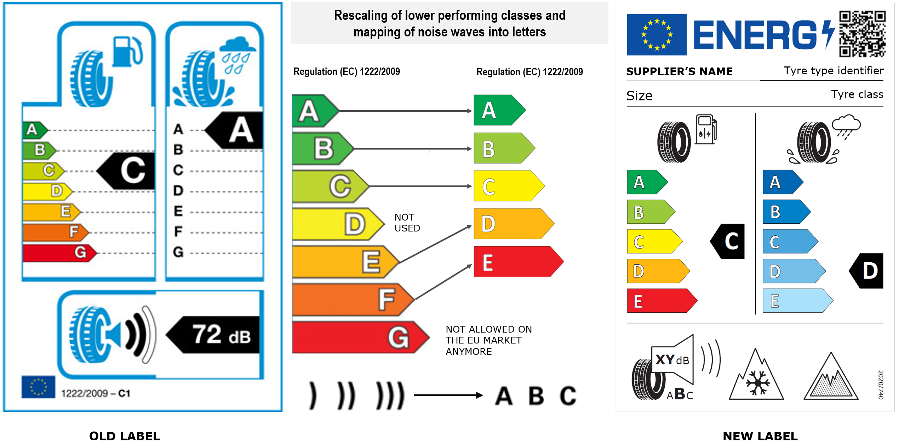

Figure 1. Illustration of the original tyre label (2012) and the revised (new) label (2021).
The updated tyre labelling legislation has applied since 1 May 2021. Figure 1 compares the original and the revised label. The new label includes several new features:
- Rolling resistance. The lowest classes were rescaled to become D and E. This eliminated the empty D class for C1 and C2 tyres ⁽⁾. The same value range was kept for each tyre type;
- Wet grip. Label classes were rescaled, and the empty D class was eliminated. Blue shaded arrows were added to the wet grip scale (recalling water), to distinguish safety aspects from energy.
- External rolling noise. The class indication was aligned with other energy labels using a letter scale. The sound level was expressed in decibels (as for other labelled products) and a pictogram with soundwaves was retained.
- Two new pictograms were added, for tyres type-approved for use in severe snow and severe ice conditions ⁽⁾.

Consumer awareness, use and understanding of the tyre label
Consumer understanding of the tyre label was tested through a consumer survey. The main findings are summarised below:
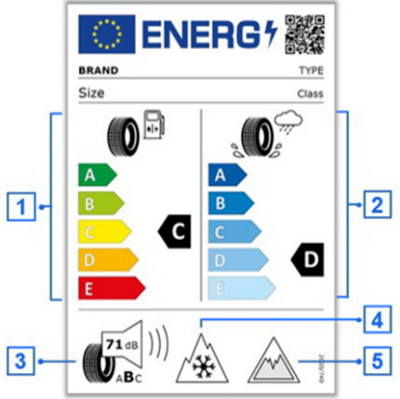
TYPE
Class
Size

BRAND
Size

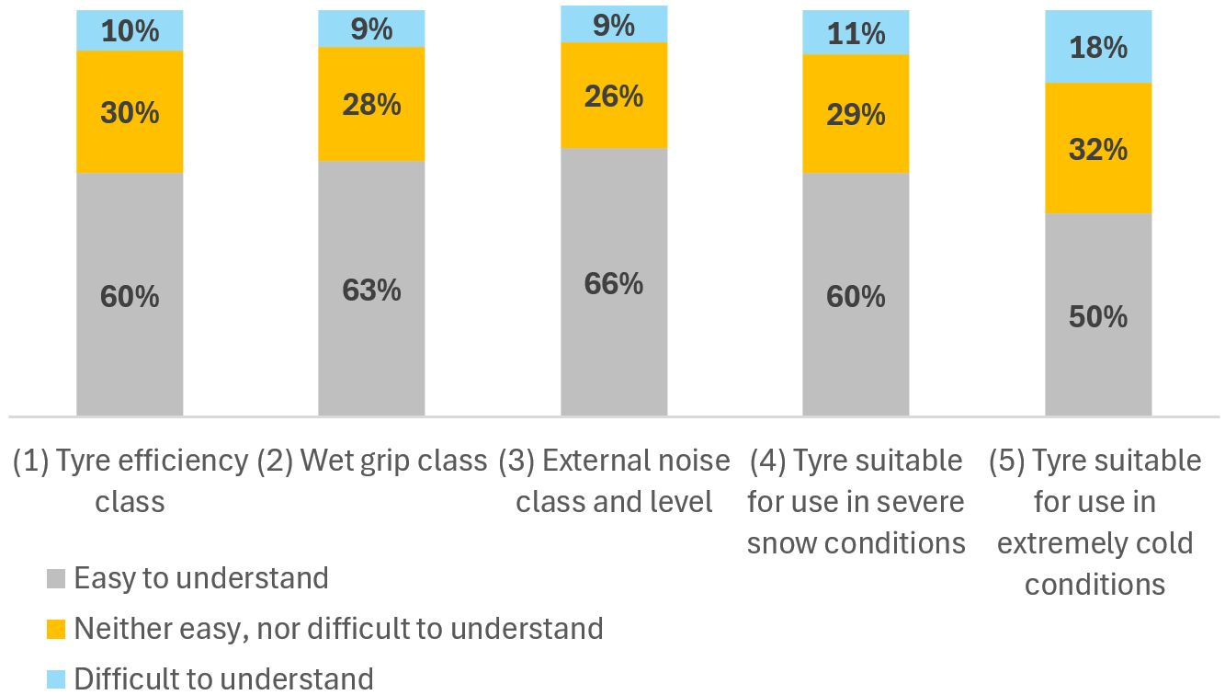
Figure 2. Consumers self-reported understanding of the tyre label elements (baseline = all respondents (n=4 590).
As Figure 2 shows, most consumers find the tyre label easy to understand. Only 9 to 18% report difficulty with any specific element. A large majority, consider all current label elements relevant, particularly wet grip (94%). The majority (78%) felt that the amount of information present on the label is appropriate. Other parameters not currently featured on the label, such as mileage, were rated as equally or more relevant. Noise and microplastic release are viewed as less important or not influencing consumers’ choice ⁽⁾.
The survey confirmed the results of a 2019 study ⁽⁾ and found that the label played a meaningful role in guiding the consumers and professional buyers who checked it. About 80% of both groups stated the label helped them select more efficient or safer tyres.
Tyre dealers and distributors are familiar with the label and generally view it positively. This does not consistently translate into proactive use during sales. Half the interviewed salespeople say that they only discuss the label if the consumer prompts them to do so. One in six discourages customers from relying on the label, pointing out that it is only based on a self-declaration; instead, they base their recommendations on profit margins, discounts, incentives, stock availability or customers’ budget.

Figure 3. Tyre dealers’ and distributors’ perception of the tyre label (baseline = all respondents (n=201).
About half of vehicle dealers see little value in including tyre labels for all available options in vehicle purchase offers, due to low customer interest at the time of sale or because the customer does not have the option to make a selection ⁽⁾. Consequently, these dealers consider the current requirements disproportionately burdensome and suggest that a smaller or simplified version of the label should be allowed for use in purchase offers ⁽⁾.
The EPREL website is recognised as a valuable source of additional information by the consumers, professional buyers, dealers and distributors familiar with it, although actual usage appears limited. However, information on some important parameters is currently missing in the database ⁽⁾. Some dealers noted that EPREL simplifies their work, as it reduces their reliance on suppliers for information. Some dealers have integrated APIs to link their websites directly to EPREL, enabling automatic display of tyre labels and product information sheets in the correct language.

Market evolution
Technological progress has enabled simultaneous improvements in rolling resistance and wet grip, while UNECE parallel legislation has banned tyres that would have been in rolling resistance classes F and G. This trend is continuing and, particularly for C1 tyres, UNECE requirements will not allow any new tyre in class E and most of D class to be placed on the market. As a result, the current scale offers less differentiation for purchase choices and a weaker competitive incentive for manufacturers to innovate. Similarly, for noise, all tyres, already since before the Regulation entered into force, have been in classes A and B.
The TLR requires suppliers to register tyres in EPREL before placing them on the market. By 2025 EPREL had listed almost 230 000 tyre types: 81% C1, 10% C2 and 9% C3. The parameters of those registrations are presented below.

C1 tyres

Rolling resistance
Figure 2 shows the estimated C1 tyre average rolling resistance, based on label classes and date of placing on the market ⁽⁾. The dashed line shows the extrapolated business-as-usual (BaU) case to 2024 based on the models registered in EPREL from 2015 through 2021, with modest progress for new tyre types placed on the market.

Figure 4. C1 tyre rolling resistance.
The average rolling resistance of new tyres placed on the market since 2021 appears to have dramatically improved ⁽⁾. It is estimated that there has been a 5.1% reduction in C1 tyre rolling resistance since 2021 compared to BaU.

Wet grip

Figure 5 shows the estimated average C1 tyre wet grip. Although less pronounced, wet grip performance also appears to have improved compared to BaU for tyres placed on the market after 2021 ⁽⁾.

Figure 5. C1 tyre wet grip.
It is estimated that there has been about a 2.4% improvement in wet grip performance compared to BaU. This results in shorter braking distances on a wet road.

External rolling noise
Figure 6 shows the estimated average external noise, based on the declared value. Noise has increased slightly only until 2018, possibly as a result of the trade-off with wet grip (which improved significantly), and of a trend towards larger aspect ratio tyres in new car models. There is no discernible divergence from BaU.

Figure 6. C1 tyre external rolling noise.

C2 and C3 tyres
Similar trends to those for C1 tyres were found for C2 and C3 tyres. For C3 tyres, an improvement in rolling resistance of about 7.3% was found compared to BaU. Other factors may have contributed to the progress shown by the EPREL data. Increased focus on safety and the wider share of electric vehicles on the roads may have stimulated improvements in rolling resistance ⁽⁾.
Although rolling resistance, wet grip and noise are conversely interrelated parameters, it is possible to improve all three simultaneously. In 2025, several manufacturers offered tyres with A-class for all three parameters.
Share of new models: 5 - 10% > 10%

C1 |  | Rolling Resistance
 | 2015 | A | B | C | D | E
Wet Grip | A | 0.0% | 0.5% | 2.0% | 2.3% | 0.0% | 4.8%
Wet Grip | B | 0.0% | 1.9% | 19.8% | 11.6% | 0.7% | 34.0%
Wet Grip | C | 0.0% | 0.5% | 21.0% | 22.5% | 2.5% | 46.6%
Wet Grip | D | 0.0% | 0.1% | 2.6% | 9.6% | 0.7% | 12.9%
Wet Grip | E | 0.0% | 0.0% | 0.2% | 0.8% | 0.7% | 1.7%
 |  | 0.0% | 3.0% | 45.7% | 46.7% | 4.6%
C1 |  | Rolling Resistance
 | 2020 | A | B | C | D | E
Wet Grip | A | 0.7% | 1.7% | 7.5% | 2.9% | 0.0% | 12.8%
Wet Grip | B | 1.4% | 2.4% | 18.9% | 16.4% | 0.9% | 40.0%
Wet Grip | C | 0.1% | 0.7% | 11.2% | 23.6% | 0.5% | 36.1%
Wet Grip | D | 0.0% | 0.2% | 1.4% | 6.6% | 0.5% | 8.7%
Wet Grip | E | 0.0% | 0.3% | 0.7% | 0.3% | 1.2% | 2.4%
 |  | 2.2% | 5.3% | 39.6% | 49.8% | 3.2%
C1 |  | Rolling Resistance
 | 2024 | A | B | C | D | E
Wet Grip | A | 1.1% | 5.1% | 9.5% | 3.6% | 0.0% | 19.4%
Wet Grip | B | 2.2% | 6.6% | 24.9% | 7.7% | 0.6% | 42.1%
Wet Grip | C | 0.3% | 1.3% | 17.6% | 7.5% | 0.4% | 27.2%
Wet Grip | D | 0.2% | 0.6% | 3.7% | 4.9% | 0.5% | 9.9%
Wet Grip | E | 0.0% | 0.1% | 1.1% | 0.1% | 0.1% | 1.4%
 |  | 3.9% | 13.8% | 56.8% | 23.9% | 1.6%
Figure 7. Evolution of C1 tyre rolling resistance and wet grip.
Figure 7 illustrates how rolling resistance and wet grip have evolved over the last decade. The tables depict the relative proportion of tyre models in 2015, 2020 and 2024 in each combination of the parameters.
Over this period, the models placed on the market shift toward the upper left corner, simultaneously improving rolling resistance and wet grip. The largest segment moves from a combination of D for rolling resistance and C for wet grip in 2015 and 2020 to C and B, respectively, in 2024.

Delegated acts
Article 13 of the TLR empowers the Commission to adopt delegated acts to:
- introduce new information requirements for retreaded tyres;
- include parameters or information requirements for tyre abrasion and mileage;
- adapt other aspects to technological progress.

Retreaded tyres
Retreaded tyres are worn tyres that are remanufactured with a new tread replacing the worn one to give them a second or even third life. Retreading results in a reduction in materials and energy used, and related GHG emissions, close to two thirds. In 2022, three industry organisations, ETRMA, ETRTO, and BIPAVER, submitted a proposal to the Commission ⁽⁾ to label retreaded C3 tyres. The Commission conducted a preliminary technical study and started to prepare the analytical basis for a proposal. Stakeholders have been consulted, and work is ongoing.

Abrasion and mileage
As mentioned in chapter 3, and resulting from two consumer surveys in multiple countries, an indicator of potential useful service life (or ‘mileage’) of tyres would boost customers interest in the tyre label: together with rolling resistance, it is an indicator of economic savings, potentially compensating a higher upfront purchase cost of replacement tyres. No suitable test method for measuring tyre abrasion and mileage was available until recently, thus the Commission have been unable to take action for introducing information requirements (as from Article 13.3).
Work is in progress, in the specially constituted UNECE Tyre Abrasion Task Force (TF-TA) ⁽⁾ to set abrasion testing methods for C1, C2 and C3 tyres. The C1 UNECE abrasion test ⁽⁾ includes two methodologies: an on-road vehicle convoy method, conducted under limited weather and climatic conditions, and an in-door drum method ⁽⁾. The former test covers 8 000 km on open public roads ⁽⁾. Work for C2 and C3 tyres is ongoing, and conclusions are expected in 2027 for C2 tyres but later for C3 tyres.
The Commission has urged TA-TF to develop a metric linked to tyre wear to assess mileage potential ⁽⁾ as the activity has focused, so far, solely on setting abrasion minimum requirements. In the meantime, a threshold limit for C1 tyres has been set in the Euro 7 Regulation.
Table 1. Schedule for mandatory abrasion thresholds according to Euro 7 (Regulation (EU) 2024/1257).
Applicable Requirement | C1 Tyres | C2 Tyres | C3 Tyres
New tyre models from: | 1 July 2028 | 1 April 2030 | 1 April 2032
All tyre models from: | 1 July 2030 | 1 April 2032 | 1 April 2034
Non-compliant models in market until: | 30 June 2032 | 31 March 2034 | 31 March 2036

Other aspects
The labelling of retreaded tyres would require amending multiple TLR annexes. In addition, the TLR also lacks clarity or detailed requirements for some respects (nested labels, public parameters, compliance documentation). This is source of uncertainty for suppliers and both tyres and vehicle dealers and complicates compliance ⁽⁾. Alignment with the legislation on labelled energy-related products, would solve most of the problems.

Market surveillance and enforcement
Regulation (EC) No 765/2008 ⁽⁾ sets out the procedure for compliance verification by national market surveillance authorities (MSAs) for tyre labelling and for cross-border market surveillance. Regulation (EU) 2019/1020 ⁽⁾ on market surveillance and compliance of products amended Regulation (EC) No 765/2008, extending its scope and aligning definitions and accreditation rules for testing facilities.
In addition, the TLR creates certain obligations for suppliers (manufacturers, importers and authorised representatives) and dealers or distributors, including the obligation to cooperate with MSAs and take immediate action in case of non-compliance. Specific requirements are set for internet hosting service providers.
Tyres are complex, safety-critical products. Assessing tyre quality and compliance requires specific skills and expertise. To verify performance, MSAs need specialised, costly equipment and dedicated test grounds or tracks.
Most performance and compliance testing by MSAs is currently done on appliances (fridges, washing machines, light bulbs), and very few have specific expertise and experience on tyres. In many countries, few human and financial resources are allocated to compliance control, so most perform only controls on formal aspects. Moreover, in about half of Member States, labelling and type-approval competences are split between different authorities, with little or no coordination between them, even though the testing equipment and procedures used are the same.
Several Member States do conduct controls, and these show high non-compliance rates. Ireland reported results for 36 tyre models in ICSMS ⁽⁾; it found that only 33% were compliant in 2024 and 51% in 2025. Germany reported results for 60 tyre models tested; it found that 37% were compliant in 2023 and 58% in 2024. National MSAs generally conduct market surveillance using a risk-based approach, meaning that the non-compliance rates found are not necessarily representative of market averages. Data from tests performed by the JRC, however, also show very high non-compliance figures. As regards tyres entering the EU market, customs controls at the EU external borders remained limited and, accordingly, the discovery of non-compliance cases low.
Under the TLR, Member States are obliged to lay down rules on effective, proportionate and dissuasive penalties, as well as establish enforcement mechanisms for infringements of the Regulation, and notify the Commission, by 1 May 2021, of those rules. The list of penalties notified has been published in the Energy Efficient Products portal ⁽⁾.

Type approval vs tyre labelling
Type approval is not performed on every tyre model but only at the level of ‘tyre family’ and using the ‘worst-case’ scenario, for each of the regulated parameters. For example, for rolling resistance, among the tyres with the same tread pattern but different aspect ratios, the one with the lowest load index and largest aspect ratio is considered as the worst-case representative tyre. This means that out of 10 or 20 tyres in the same family and with the same tread design, only one is tested for rolling resistance, another for wet grip and possibly another for noise.
For tyre labelling, every single member of a tyre family is in principle tested, using the same testing method.
This means that compliance control and verification of the class claimed on the label, unless the same as the worst case is indicated, needs a specific testing on the specific tyre and cannot rely on the test results of the type approval for the whole family.

EU support to MSAs
The Energy Efficiency Compliant Products 4 (EEPLIANT4) is an EU co-funded Concerted Action under the LIFE programme, the EU’s funding instrument for the environment and climate action. EEPLIANT4 includes a tyres work package under which TLR compliance checks will be carried out. Only four MSAs are participating: Cyprus, Estonia, the Netherlands, and Portugal, coordinated by PROSAFE ⁽⁾.
Project | Programme | Running time | EU contribution
MSTyr15 | European Commission’s Horizon 2020 | 2016-2019 | €1 854 673
EEPLIANT4 | LIFE | 2024-2029 | €7 999 999
Table 3. EU support for the implementation of the Tyre Labelling Regulation and related market surveillance
The Commission also supports MSA activities through:
- bi-annual meetings and support to MSAs through the Administrative Cooperation (AdCo) Expert Group on Tyres Labelling - Market Surveillance Administrative Cooperation;
- the European Product Compliance Network under the Market Surveillance Regulation (MSR);
- integration between EPREL and ICSMS;
- a ‘safeguard clause’ feature in ICSMS, allowing MSAs to share information on products presenting a risk.
Article 34(4) of the MSR obliges Member States to report in-depth checks on compliance. By autumn 2025, the ICSMS database listed 230 in-depth TLR inspections. Figure 8 shows the results by Member State. Member States not appearing in the table did not report any checks in ICSMS.
Out of the TLR checks reported, 5 found tyres posing a serious risk and 16 a high risk. Correction measures included warnings (14), orders to withdraw the model from the market (2) and a ban (2). Other measures included changes in EPREL (1) and a change to the label (1). Often the correction measure is not reported.
 | 2020 | 2021 | 2022 | 2023 | 2024 | 2025
Spain |  |  |  | 30% | 84% | 68%
Germany |  | 90% | 93% | 37% | 58%
Ireland |  |  |  |  | 33% | 51%
Luxembourg |  |  |  |  | 100%
Croatia |  |  |  |  | 100%
European Union |  |  |  |  | 50%
Portugal |  |  | 0% | 100% | 0%
Denmark |  |  |  |  |  | 0%
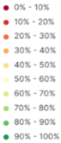Figure 8. Overview of TLR compliance testing, ICSMS. ‘European Union’ refers to the reports by Commission JRC. High percentage (green shading) means models were found to be compliant.

Commission role in market surveillance
Tyre testing is technically demanding and appears not to be a priority for Member States. Insufficient compliance information in EPREL, a large number of models, high testing costs (€1 k to €10 k per unit), difficulty to build expertise, lack of laboratory capacity, different distribution of responsibilities between national bodies in Member States and lack of coordination contribute to insufficient control, high non-compliance rates and – possibly relatedly - distrust by customers and distributors (see the survey findings about perceptions of tyre labels as unreliable due to being based on self-declaration). Figure 1 shows the surprising rates of non-compliance for the tyres tested by JRC in the years 2021-2024.
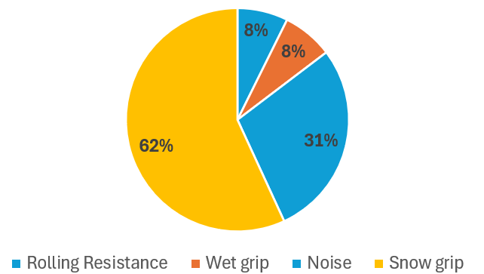
Figure 9: Non-compliance findings by JRC between 2021-2024 (presentation to AdCo meeting, 1 April 2025, Ispra).
Stronger involvement by the Commission would be beneficial. Such a strategy is being implemented for vehicle safety since 2020. Here, while Member States play a central role and conduct surveillance testing, the Commission provides a second layer of control and performs independent tests. The Commission is empowered ⁽⁾ to test vehicles and their parts, impose administrative fines directly on manufacturers and order EU-wide recalls ⁽⁾. Tyre type approval is within the scope of the Commission’s competence, but tyre labelling falls outside it. Currently, EU-level testing campaigns are organised to assess compliance of tyres sold on the EU market, complementing national controls and filling gaps where national capacities may be limited ⁽⁾. A centralised, coordinated approach, also covering labelling, would create synergies and guarantee impartiality, without conflict of interest ⁽⁾. Furthermore, the additional cost of labelling compliance checks would be minimal, as they are based on the same tests required by UNECE Regulation 117.

Possible third-party verification and testing
The Commission has sought to assess the costs and benefits of mandatory independent third-party verification of the information provided in the tyre label, taking into account the experience gained with the broader framework provided by Regulation (EC) No 661/2009.
Third-party verification can help compensate MSA deficiencies in budget, labs, staff, coordination and necessary skills. Using third parties could ensure access to state-of-the-art laboratory equipment and specialised staff. Several labs have already gained experience in the broader type-approval framework provided by Regulation (EU) 2019/2144 and are also already accredited to conduct all TLR testing activities. However, third-party testing and certification fees can be significant. Table shows indicative prices for testing for C1 tyre TLR parameters in laboratories accredited for tyre type-approval legislation.
Table 4. C1 tyre third-party verification testing costs (per tyre)
Test Procedure – Tyre Class C1- | From | To
ECE 117 R. Annex 3 – Noise | €1 100 | €2 000
ECE 117 R. Annex 5 - Wet Grip | €950 | €1 500
ECE 117 R. Annex 6 (CR) – Rolling Resistance | €650 | €1 250
ECE 117 R. Annex 7 3PMSF - Snow Performance | €3 200 | €5 500
Total for the test procedure: | €5 900 | €10 250
Two options exist to mitigate these high third-party verification costs.
- Random ex post testing, paid for by the public sector. This only appears feasible if coordinated at EU level.
- Systematic mandatory ex ante verification by suppliers, for all declared parameter values in the label if they exceed the class equivalent to the ‘worst-case’ as documented in type approval certificates ⁽⁾. This would simply involve disclosure of the test reports that manufacturers are supposed to perform in order to claim a class better than the ‘worst-case’ as documented in the type-approval certificates and which must be uploaded to EPREL.

Test machine alignment
The rolling resistance coefficient (RRC) used to assess the energy efficiency class of a tyre is measured in a laboratory using a specific machine. Major manufacturers carry out their own RRC testing. Some independent test laboratories also have their own machines. Regular calibration, or realignment, of machines is needed to ensure repeatable, consistent measurements. Some non-EU countries rely on a central body to provide this calibration service ⁽⁾. There is no such EU central body. Instead, a ‘virtual reference machine’ and a procedure have been put in place, described in Annex V to the TLR. Every two years, a pool of 11 participating laboratories perform a resource-intense ‘round-robin’ process to align their machines and provide a reference ⁽⁾.
The Commission could develop an alternative to this periodical and burdensome calibration exercise of the pool of different laboratories by establishing a single physical reference laboratory one, possibly with a second row of independent laboratories providing the service to manufacturers worldwide. The cost of such a laboratory could be covered through fees for calibration services. It should be noted that the machines used for RRC testing are the same as those used for type approval. Using the same machines ensures that the labelling measurements are better aligned with the type-approval measurements and reduces double testing.

Issues identified as part of implementation
Some issues related to the TLR have been identified during implementation, most of which could be addressed by amending TLR annexes. The most pertinent ones, along with possible solutions, are outlined below.

Promotional material, catalogues, vehicle offers
The TLR provides no detail on the format, size and modalities for the display of labels in catalogues, online stores or promotional material or vehicle offers. The only stipulation is that the size should be no smaller than 75x100 mm. This lack of detail has led to legal uncertainty on the one hand and to widespread non-conformity on the other. One practical solution, which other energy label delegated acts have provided for in a specific annex, is the option to use a simplified, small-format label, in the form of a ‘class arrow with range’, possibly combined with a ‘nested display mechanism’ for online pages. Figure 10 provides an example of how such an indication might be used for tyres.

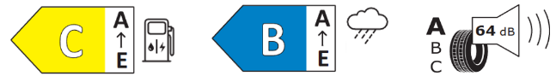
Figure 10. Examples of class arrows as an alternative to displaying the full label (in catalogues, lists, vehicle offers on paper or associated with the ‘nested label mechanism in online sales’).

Insufficient parameters in EPREL to select tyres
Annex III to the TLR lists the data to be uploaded in EPREL: the description is very generic, and some crucial parameters are not mentioned, thus making the publicly available information insufficient for important real-use scenarios ⁽⁾. Most of the missing parameter values may be provided in EPREL but on a voluntary basis. This limits the usability of EPREL for determining for determining choices, e.g. by fleet managers of the freight transport sector ⁽⁾ or, again, selection by vehicle manufacturers for original equipment choice ⁽⁾. Mandatory registration of all parameters relevant for the purchase choice would enable such choices by customers and better exploit the label savings potential, by making full use of digitalisation and EPREL. Moreover, identifying tyres meeting the EU taxonomy criteria is not intuitive. A dedicated filter function may remedy this situation.

Insufficient information to perform compliance checks
Annex VI to the TLR lists the information for the compliance part of EPREL. The list is generic and in practice constitutes a barrier to effective compliance control, particularly in those countries where responsibility for type approval and tyre labelling is separated. Aligning the format of parameters to be provided in EPREL for tyre labelling with that used for energy labelling would address this issue. The lack of clarity also leads to diverging interpretations and a considerable burden on MSAs, which have to request documentation from the supplier, instead of finding it in EPREL. As every single member of a tyre family must in principle be tested unless the class indicated on the label corresponds to the ‘worst case’, the availability of test reports would make it possible to simplify the compliance control activity, reducing costs and the administrative burden on Member States.

Limited separation in performance classes
Tyre performance thresholds are set in the UNECE regulations. These are periodically reviewed and updated. Generally, the updated requirements apply first to new tyre types, type-approved after entry into force of the limits, and later to existing types.
Technological progress has permitted more stringent requirements to be set in type-approval legislation, which has banned tyres belonging to the worst classes. However, the TLR revision did not include any rescaling or adjustment of classes. As a result, all tyres now fit in only three or four rolling resistance and wet grip classes. This reduced range decreases customer interest in the tyre label and reduces the supplier’s incentive to innovate in order to differentiate their products from those of their competitors. Pending a future rescaling, this issue might be mitigated by requiring suppliers to enter in the public part of EPREL the RRC and the wet grip index (WGI) measured or estimated to rate the class, as is already required for noise ⁽⁾, allowing professional buyers and other interested users to differentiate among products within a class using EPREL.

Conclusion
The revised TLR has driven measurable improvements in tyre performance, notably a 5.1% reduction in rolling resistance and 2.4% improvement in wet grip for C1 tyres since 2021, compared to business-as-usual trends. Similar trends were found for C2 and C3 tyres. For the latter, the improvement in rolling resistance has been even 7.3%. The market has thus shifted towards higher-performing tyres, with more models now available that achieve top (A) ratings across all parameters.
However, consumer awareness of and trust in the label remain limited, partly due to inconsistent enforcement and reliance on self-declaration. Market surveillance appeared not a priority for Member States, it requires specialised expertise and tools, is difficult to carry out and, when performed, reveals high non-compliance rates. This highlights the need to strengthen coordination, resources and expertise at both national and EU levels. While third-party verification and testing could mitigate some of the current shortcomings in market surveillance, this would come at significant cost. The current test machine alignment exercise is cumbersome and the biannual exercise burdensome: a single reference laboratory, possibly managed by Commission (JRC), may simplify the process and ensure increased stability, with costs recovered by directly providing alignment services. The machines could be used for testing for both the labelling and R.117 compliance.
EPREL is a valuable tool, but the lack of mandatory requirements to fill in relevant data fields limits its usability for consumers, fleet managers and procurers. Meanwhile, progress on abrasion and mileage labelling is delayed by the absence of standardised test methods, though ongoing work at UNECE may yield solutions by 2027.
Finally, the TLR implementation has revealed additional shortcomings, including the lack of a ‘nested’ label mechanism definition. Crowding of tyre models in the best 3 classes, for rolling resistance and in particular for wet grip and in 2 performance classes for noise emissions undermines customer interest in the tyre label.
The modifications in the omnibus proposal presented in parallel to this report aim to better address some of the different shortcomings whilst also simplifying compliance respect where possible, for suppliers and retailers. At the same time, certain issues (such as those linked to mileage, abrasion, re-treading, testing machine alignment and testing for compliance verification) can only be tackled when additional preparatory work has progressed.

() 76/494/EEC: Council recommendation of 4 May 1976 on the rational use, through better driving habits, of energy consumed by road vehicles, OJ L 140, 28/05/1976 P. 0014 – 0015.
() Zacharof, N., Fontaras, G., Ciuffo, B., Tsiakmakis, S. et al. Review of in use factors affecting the fuel consumption and CO₂ emissions of passenger cars; Joint Research Centre, 2016.
() Hyttinen, Jukka et a. Effect of Ambient and Tyre Temperature on Truck Tyre Rolling Resistance, International Journal of Automotive Technology, Nov. 2022.
() Tyres for off-road, construction, agriculture or for two and three-wheeled vehicles are out of scope as fuel efficiency or safety aspects would not be relevant.
() COM(2025) 187 final.
() https://eprel.ec.europa.eu/.
() Study on consumer understanding of the EU tyre label applied since 1 May 2021.
() List of administrative cooperation groups.
() https://ec.europa.eu/transparency/expert-groups-register/screen/expert-groups/consult?lang=en&groupID=2519.
() ICSMS.
() https://ec.europa.eu/info/law/better-regulation/have-your-say/initiatives/1460-Evaluation-and-potential-revision-of-the-EU-tyre-labelling-scheme_en.
() No empty class had been set for C3 tyres that, anyhow, had no obligation to bear a label sticker.
() No class rating is indicated for snow and ice grip, as the testing method (braking on a snowy or icy path) does not provide sufficiently accurate and repeatable results.
() This not surprising, confirming that the purchase choice is influenced by aspects that can be translated into money savings or increased safety.
() Study assessing consumer understanding of tyre labels, https://data.europa.eu/doi/10.2833/210444.
() With the exception of luxury cars or diplomatic sales, the tyres mounted on the car depend on the tyre batch available when the vehicle is assembled at the factory. Some car retailers may agree to exchange the wheels, if possible and as an exceptional courtesy to the customer.
() E.g. just an indication with a class arrow.
() E.g. currently for C1 tyres, it is not mandatory to indicate which, among the registered tyres, is fabricated according to the vehicle OEM specifications, or, for C3 tyres, which are for the drive, steering or free-rolling axle, or which are for urban or long haul use etc.
() Unlike all other product labelling regulations, the TLR does not require the real value of the parameter determining the class for rolling resistance and wet grip, but only for the noise.
() Weighted percentage values for the mid-point label class are used because the Regulation does not require suppliers to enter the rolling resistance coefficient in EPREL, only the class associated with it.
() Based on weighted percentages of the mid-point label class, because suppliers are not required to enter the wet grip index in EPREL, only the class associated with it.
() For trucks, the formula for calculation of fleet CO₂ emissions according to EURO IV legislation includes the rolling resistance coefficient of original equipment tyres (in diesel trucks tyre rolling resistance contributes 30 to 40% of energy use). In electric trucks the share is higher because of the high electric motor efficiency, keeping the energy efficiency focus unchanged.
() The same method would be used as for new tyres.
() https://wiki.unece.org/pages/viewpage.action?pageId=160694352.
() GRBP 83, (WP.29/GRBP) Working Party on Noise and Tyres (83rd session) | UNECE, is a subsidiary body of the World Forum for Harmonisation of Vehicle Regulations.
() The quicker, more repeatable and less polluting in-door method, similar to the tests used for measuring rolling resistance, saves months to tyre manufacturers introducing new tyre types.
() 25% urban, 25% regional roads and 35% highways, at three temperature levels, between 5 °C and 25 °C. The convoy-based test poses repeatability and affordability challenges for MSAs.
() UNECE Regulation 117 will be amended to include the abrasion thresholds. Data on abrasion levels and tread loss, thus, becomes part of the type-approval documentation. If the declaration by tyre manufacturers, via the type-approval documentation on testing results for abrasion would also include the tread depth loss, rating mileage may become feasible.
() No small-format label is available for use in tyre catalogues, where about 20 rows on each page describe each tyre, or for vehicle offers, where the tyre labels take 10 times the space used for the vehicle description and its options. The lack of indication on which parameters needed to distinguish tyres of the same size are to be entered in EPREL hinders the application of the taxonomy or any DNSH criteria.
() Regulation (EC) No 765/2008 setting out the requirements for accreditation and market surveillance relating to the marketing of products.
() Regulation (EU) 2019/1020 on market surveillance and compliance of products.
() Information and Communication System on Market Surveillance.
() https://energy-efficient-products.ec.europa.eu/national-measures-penalties-and-sanctions-tyres_en.
() https://prosafe.org/, an MSA coordination consortium.
() Article 9 of Regulation (EU) 2018/858.
() A report of activity is available from https://publications.jrc.ec.europa.eu/repository/handle/JRC130606.
() A report describing the activities carried out by the JRC on tyres are available at the following link: https://publications.jrc.ec.europa.eu/repository/handle/JRC135546.
() National authorities may be reluctant to enforce compliance/penalties on manufacturers established in their territory.
() Type approval is at ‘product family’ level, while tyre labelling is at tyre-type level (each family member).
() e.g. USA, Korea and Japan.
() The list of laboratories is published in Commission communication 2012/C 86/03. An update is due in 2026.
() For example, truck tyres tread design differs depending on whether the tyres are to be mounted, i.e. on steering, traction or free-rolling axle (the casing is the same, overall performance may differ significantly).
() Selection of tyres considering “axle position” or “mission profile” is crucial, as related to tread and casing design and, consequently, to rolling resistance, noise or grip performance.
() Although each manufacturer launches a ‘tendering’ mechanism, the vehicle industry has clearly expressed interest in having a complete market overview, for better tuning requirements.
() Such RRC and WGI values are in any case already entered in EPREL, but only for the technical documentation and only by some suppliers.

