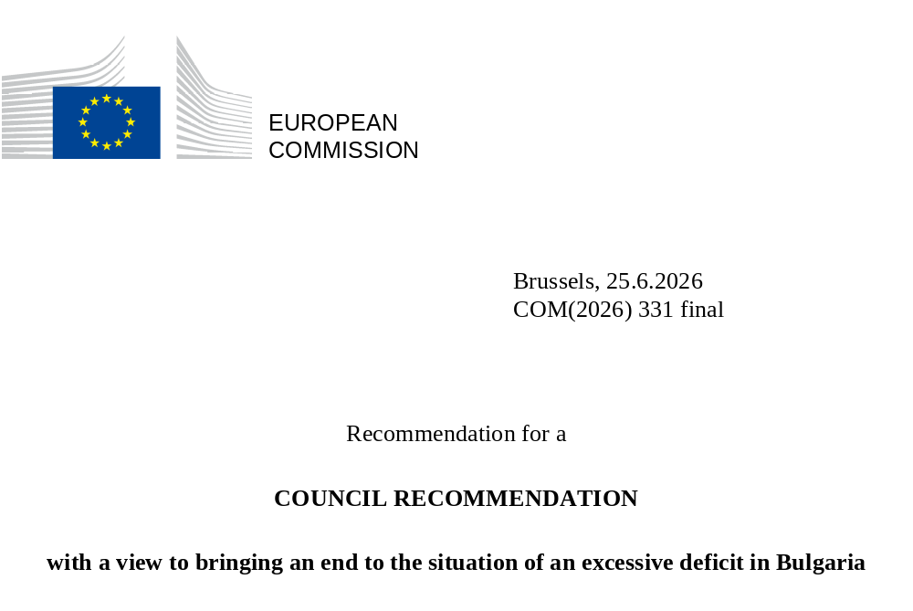

Recommendation for a
COUNCIL RECOMMENDATION
with a view to bringing an end to the situation of an excessive deficit in Bulgaria
THE COUNCIL OF THE EUROPEAN UNION,
Having regard to the Treaty on the Functioning of the European Union (TFEU), and in particular Article 126(7) thereof,
Having regard to the recommendation from the European Commission,
Whereas:

(1) According to Article 126 of the TFEU, Member States shall avoid excessive government deficits.
(2) The Stability and Growth Pact is based on the objective of sound and sustainable government finances as a means of strengthening the conditions for price stability and for strong, sustainable and inclusive growth underpinned by financial stability, thereby supporting the achievement of the Union’s objectives for sustainable growth and employment.
(3) On [date], the Council decided, in accordance with Article 126(6) TFEU, that an excessive deficit existed in Bulgaria due to non-compliance with the deficit criterion ().
(4) Article 126(7) TFEU and Article 3(4) of Council Regulation (EC) No 1467/97 () require the Council to adopt a recommendation addressed to the Member State concerned with a view to bringing the situation of excessive deficit to an end within a given period. In line with Article 3(4) of Council Regulation (EC) 1467/97, that recommendation is also to establish a maximum deadline of six months for effective action to be taken by the Member State concerned to correct the excessive deficit, which can be reduced to three months when warranted by the seriousness of the situation. Furthermore, the Council is to recommend that the Member State implement a corrective net expenditure () path, which ensures that the general government deficit is brought, and maintained, below the reference value of 3% of gross domestic product (GDP) within the deadline set in that recommendation. Where the excessive deficit procedure was opened on the basis of the deficit criterion, the corrective net expenditure path is, according to Article 3(4) of Council Regulation (EC) No 1467/97, to be consistent with a minimum annual structural adjustment of at least 0.5% GDP as a benchmark for the years when the general government deficit is expected to exceed the reference value. The Commission may, during a transition period in 2025, 2026 and 2027, adjust the benchmark to take into account the increase in interest expenditure when setting the proposed corrective net expenditure path for those years, taking into account Recital 23 of Council Regulation (EU) 2024/1264. Where needed, the corrective path is to be based on updated projections produced by the Commission using the methodology for Debt Sustainability Analysis. The concerned Member State may signal to the Commission country-specific issues that it considers relevant for setting the corrective path.
(5) Real GDP in Bulgaria grew by 3.1% in 2025. According to the Commission Spring 2026 Forecast, the economy is expected to grow by 2.5% in 2026, on the back of continued growth in domestic demand components. In 2027, the same drivers are expected to support real GDP growth of 2.2%. The unemployment rate is expected to reach 3.7% in 2026 and 3.9% in 2027. The inflation rate is set to increase from 3.5% in 2025 to 4.2% in 2026 and reach 2.6% in 2027.
(6) According to the data provided by Eurostat on 22 April 2026 (), the general government deficit in Bulgaria stood at 3.5% of GDP in 2025. The Commission Spring 2026 Forecast projects a general government deficit of 4.1% of GDP in 2026 and 4.3% of GDP in 2027, thus remaining above the reference value of 3% of GDP. According to the Commission’s calculations (), these developments correspond to a net expenditure growth rate of 12.3% in 2025 and 5.5% in 2026. The structural deficit is projected at 4.1% in 2026 and is expected to remain at the same level in 2027.
(7) General government debt stood at 29.9% of GDP at end-2025. According to the Commission Spring 2026 Forecast, it is projected to increase to 32.3% of GDP at end-2026 and 35.5% of GDP at end-2027, thus remaining below the 60% of GDP reference value.
(8) The corrective net expenditure path in this recommendation, which establishes maximum growth rates of net expenditure, is consistent with minimum annual structural adjustments, or structural primary adjustments, of at least 0.5% GDP in line with Article 3(4) of Council Regulation (EC) No 1467/97 and Recital 23 of Council Regulation (EU) 2024/1264. Based on the macroeconomic assumptions from the Commission Spring 2026 Forecast, the corrective net expenditure path in this recommendation corresponds to an adjustment in the structural primary balance of 0.3 percentage points in 2026 and of 0.6 percentage points in 2027. For 2028 and 2029, which is beyond the period during which the Commission may take into account the increase in interest expenditure, the corrective path corresponds to an annual adjustment in the structural balance of 0.5 and 0.6 percentage points, respectively. While the corrective net expenditure path in 2026 implies a structural adjustment of less than 0.5 percentage points of GDP, considering that the late formation of the government delayed the adoption of a budget, this is compensated by the higher adjustment in the remaining years.
(9) The corrective net expenditure path in this recommendation supersedes the maximum growth rates for net expenditure set out in point 1 of Council Recommendation of 20 June 2025 endorsing the medium-term fiscal-structural plan of Bulgaria ().
(10) Based on the corrective net expenditure path in this recommendation, and based on the Commission medium-term government debt projection framework and the Commission Spring 2026 Forecast, the general government deficit is projected to decrease from 3.5% of GDP in 2025 to 2.9% by 2029.
(11) Based on the corrective net expenditure path in this recommendation, the Commission medium-term government debt projection framework, and the Commission Spring 2026 Forecast, the general government debt-to-GDP ratio would continue increasing from 29.9% at end-2025 to 38.3% at end-2029, while remaining well below the 60% of GDP reference value.
(12) Abiding by the corrective net expenditure path in this recommendation should secure a lasting correction of the excessive deficit; concrete measures should be geared towards enhancing the quality and composition of the public finances, preserving investment and reinforcing the growth potential of the economy. Reforms of a fiscal and broader economic nature should improve the growth and resilience potential of the economy in a sustainable manner, and support fiscal sustainability.
(13) On 8 July 2025, the Council adopted a recommendation () allowing Bulgaria to deviate from the maximum growth rates of net expenditure recommended by the Council Recommendation C/2025/3700, for the period 2025-2028.
(14) The flexibility provided by the national escape clause should also be considered in the implementation of the excessive deficit procedure, and when assessing if Bulgaria has taken effective action. Therefore, until 2028, the corrective net expenditure path set out in this recommendation is complemented by the flexibility that is allowed by the increase in defence expenditure () under the national escape clause. To ensure that fiscal sustainability is not endangered, this recommendation should set out the maximum flexibility, in line with the Commission Communication of 19 March 2025 and the Council Recommendation of 8 July 2025. For that purpose, the overall maximum flexibility under the excessive deficit procedure should be limited to the flexibility that has not been used during the period preceding the net expenditure path in this recommendation.
(15) Based on the Commission's calculations (), Bulgaria exceeded the cumulative maximum net expenditure growth rate for 2025 recommended by the Council on 20 June 2025, by 2.1% of GDP. This deviation is reduced to 1.4% of GDP when accounting for the flexibility allowed by the Council Recommendation of 8 July 2025, corresponding to a use of the flexibility under the national escape clause of 0.6% of GDP. Therefore, only the part of the increase in defence expenditure as percent of GDP since the reference year 2024 that is above 0.6 percentage points is eligible for granting flexibility in 2026 to 2028. Moreover, the available maximum flexibility in that period should be reduced from 1.5% of GDP to 0.9% of GDP.
(16) In line with Article 8(3) of Regulation (EC) No 1467/97, a Council decision to abrogate the excessive deficit procedure shall only be taken pursuant to Article 126(12) TFEU where the deficit has been brought below the 3% of GDP reference value and is projected by the Commission to remain so in the current and following year.

HEREBY RECOMMENDS:
(1) Bulgaria should ensure that the nominal growth rates of net expenditure do not exceed the maxima established in Annex I.
(2) Bulgaria should thus put an end to the excessive deficit situation by 2029.
(3) The Council establishes the deadline of 15 October 2026 for Bulgaria to take effective action and present the necessary measures together with its 2027 Draft Budgetary Plan, to be submitted to the Commission and the Eurogroup in accordance with Article 6 of Regulation (EU) 473/2013 (). Thereafter, Bulgaria should report on progress made in the implementation of this recommendation at least every six months, in spring in the context of its annual progress report by 30 April, and in autumn in its draft budgetary plan by 15 October, until the excessive deficit has been corrected.
(4) Until 2028, Bulgaria is allowed to exceed the maximum growth rates of net expenditure as set by point 1 of this recommendation, to the extent that the net expenditure in excess of these maximum growth rates is not more than the minimum of:
(a) the part of the increase in defence expenditure in percent of GDP since 2024 that is above 0.6 percentage points of GDP; and
(b) 0.9 percent of GDP.
(5) In the years after 2028, Bulgaria may still be allowed to exceed the maximum growth rates of net expenditure, as set by point 1, to the extent that the net expenditure in excess of these maximum growth rates is related to deliveries of military equipment contracted before end-2028 and remains within the overall limit mentioned in point 4.
(6) In order to ensure a correct recording of the additional expenditure, Bulgaria is to include actual and planned data on total defence expenditure (COFOG division 02), including defence investment (COFOG division 02 P.51) and any expenditure to be financed by SAFE loans that are not covered in COFOG-02:
- for years T-4, T-3, T-2 and T-1 (with year T being the current year), in the reporting to the Commission (Eurostat) in accordance with Council Regulation (EC) No 479/2009 ();
- for years 2021 through year T (current year), in national medium-term fiscal-structural plans and in annual progress reports in accordance with Article 11(1), Article 15 and Article 21(1) of Regulation (EU) 2024/1263;
- for years T (current year) and T+1, in draft budgetary plans in accordance with Regulation (EU) No 473/2013.
This Recommendation is addressed to the Republic of Bulgaria.
ANNEX I
Maximum growth rates of net expenditure
(annual and cumulative growth rates, in nominal terms)
Bulgaria

Years |  | 2026 | 2027 | 2028 | 2029
Growth rates | Yearly | 4.2 | 3.4 | 3.4 | 3.2
Growth rates | Cumulative (*) | 4.2 | 7.7 | 11.4 | 15.0
(*) The cumulative growth rates are calculated by reference to the base year of 2025.

Done at Brussels,
For the Council
The President

() Council Decision of [DATE] on the existence of an excessive deficit in Bulgaria (OJ L, [OJ: please insert in this footnote the reference]).
() Council Regulation (EC) No 1467/97 on speeding up and clarifying the implementation of the excessive deficit procedure (OJ L 209, 2.8.1997, ELI: http://data.europa.eu/eli/reg/1997/1467/2024-04-30) as last amended by Council Regulation (EU) 2024/1264 of 29 April 2024 (OJ L, 2024/1264, 30.4.2024).
() According to Article 2(2) of Regulation (EU) 2024/1263, 'net expenditure' means government expenditure net of interest expenditure, discretionary revenue measures, expenditure on programmes of the Union fully matched by revenue from Union funds, national expenditure on co-financing of programmes funded by the Union, cyclical elements of unemployment benefit expenditure, and one-offs and other temporary measures.
() Eurostat Euro Indicators published on 22 April 2026. See: https://ec.europa.eu/eurostat/en/web/products-euro-indicators/w/2-22042026-ap]
() Fiscal Statistical Tables providing background data relevant for the assessment of the budgetary policies of the Member States, SWD(2026)200 final, Brussels 3.6.2026.
() Council Recommendation of 20 June 2025 endorsing the national medium-term fiscal-structural plan of Bulgaria (OJ C, C/2025/3700, 20.8.2025, ELI: https://eur-lex.europa.eu/eli/C/2025/3700/oj).
() Council Recommendation of 8 July 2025 allowing Bulgaria to deviate from the maximum growth rate of net expenditure as set by the Council under Regulation (EU) 2024/1263 (Activation of the national escape clause), (OJ C, C/2025/3961, 20.8.2025, ELI: https://eur-lex.europa.eu/eli/C/2025/3961/oj)
() Nationally financed defence expenditure as defined in the Classification of the functions of government (COFOG02)
() Commission Staff Working Document SWD(2026)200, 'Fiscal statistical tables providing background data relevant for the assessment of the budgetary policies of the Member States', 3.6.2026.
() Regulation (EU) No 473/2013 of the European Parliament and of the Council of 21 May 2013 on common provisions for monitoring and assessing draft budgetary plans and ensuring the correction of excessive deficit of the Member States in the euro area (OJ L 140, 27.5.2013, ELI: http://data.europa.eu/eli/reg/2013/473/oj).
() Council Regulation (EC) No 479/2009 of 25 May 2009 on the application of the Protocol on the excessive deficit procedure annexed to the Treaty establishing the European Community (OJ L 145, 10.6.2009, p. 1-9, ELI: http://data.europa.eu/eli/reg/2009/479/2014-09-01).

