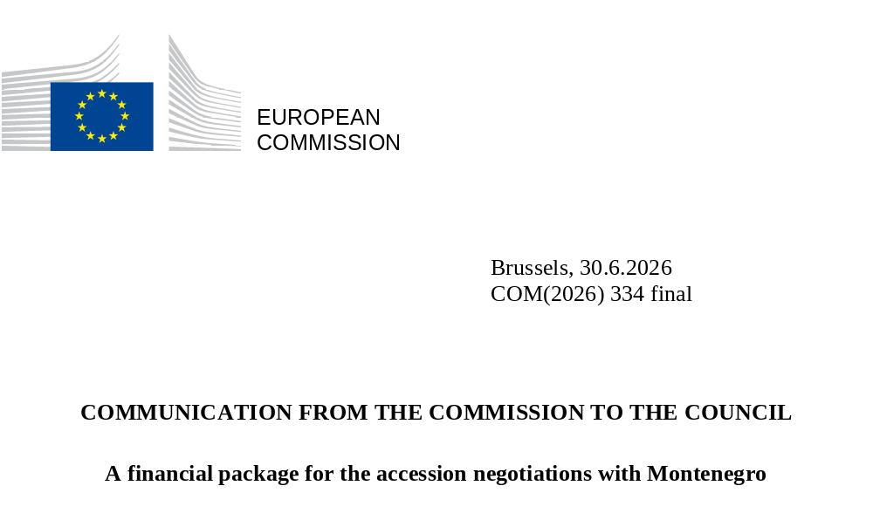

INTRODUCTION
The 2025 Communication on EU enlargement policy indicated that, subject to Montenegro maintaining the pace of progress in preparations for EU membership, the Commission will present, according to established practice, a draft financial package. Since then, the EU and Montenegro have provisionally closed nine additional chapters, bringing the total number of provisionally closed chapters to 16, while work continues to close the remaining ones.
Taking into account the overall progress achieved thus far by Montenegro in the accession negotiations, this Communication provides the main elements of a financial package for Montenegro to allow the Council to debate these issues alongside work on the remaining chapters. Provided that conditions are met, a possible accession could take place at some point after the beginning of next Multiannual financial framework (‘MFF’) 2028-2034. This financial package is therefore based on the Commission proposal for the next Multiannual Financial Framework, taking into account the proposed design of the future internal policies of the Union as well as the new own resources package. On this basis, the Commission will subsequently present to the Council a draft common position for negotiations on financial and budgetary provisions (chapter 33).
This Communication builds on the principles of financial packages for previous enlargement rounds, with adjustments tailored to accommodate Montenegro’s accession within the proposal for the MFF 2028-2034, and presenting benefits both for new and existing Member States. For Montenegro, it ensures continuity, reduces administrative burden and prevents implementation gaps at a critical moment immediately after accession. For existing Member States, it provides clarity about the cost of the accession of Montenegro.

OUTLINE FOR A FINANCIAL PACKAGE
In line with the practice of previous enlargement rounds, the financial package covers the pre-allocated national financial envelope for Montenegro on the one hand, and the increase in ceilings of the MFF Headings without pre-allocated financial envelopes on the other hand. As in the previous enlargements, the financial package ensures full rights and obligations from the day of accession, i.e. the new Member State pays full contributions to the EU budget and it has access to all programmes and funds of the EU budget from the date of accession.
With respect to pre-allocated envelopes in Heading 1 (‘Economic, social and territorial cohesion, agriculture, rural and maritime prosperity and security of the internal policies’), the implementation will take place on the basis of a National and Regional Partnership Plan for each Member State (‘NRP Plan’), which is objective-based in the sense of linking disbursements with the achievement of predefined milestones and targets. To adequately prepare candidate countries for managing internal funds, these countries will also submit plans under the Global Europe instrument (henceforth referred to as 'Global Europe Plan') under the external heading (Heading 3 – ‘Global Europe’), which are also objective-based in the same sense as under Heading 1. Consequently, this financial package is structured primarily around this plan, ensuring continued implementation of support from pre-accession to internal funds, based on the methodology outlined below.
The calculation of amounts increasing the capacity of headings and programmes without specific country allocation for the acceding country (rest of Heading 1 outside of the NRP Plan, Heading 2, Heading 3) applies a key based on a combination of 50% population and 50% GDP relative to an enlarged EU. This is the same methodology as the one used for the fifth enlargement in 2004, and in all successive enlargement rounds.
The proposed approach will ensure predictability and minimise any disruption to implementation following accession without compromising the official status of Montenegro as a new Member State. It caters for the uncertainty related to the entry into force of the Accession Treaty and reduces costs to existing Member States by reusing availabilities for Montenegro’s Global Europe Plan under Heading 3. The proposed figures are based on the Commission proposal for the next Multiannual Financial Framework which is under negotiations with the Council and the European Parliament. Any changes during the MFF proposal may have impacts on the results of funding and approach described here.
Figures provided in this Communication are expressed in current prices.

Heading 1: Economic, social and territorial cohesion, agriculture, rural and maritime prosperity and security
Each Member State will submit one NRP Plan, covering different policy areas such as the common agricultural policy (CAP), cohesion policy, Home affairs and the common fisheries policy. The NRP Plan of Montenegro will include one unallocated component, which will constitute the biggest envelope, dedicated to economic, social and territorial objectives, including fisheries and rural communities, out of which an amount of EUR 17.8 million will be ringfenced for the Common Fisheries Policy. In addition, the NRP Plan will include two ringfenced components – the Common Agricultural Policy (CAP) and Home Affairs (migration, border management and internal security) resources.
Montenegro’s Global Europe Plan will be prepared keeping in mind the requirements under the National and Regional Partnership Plans (‘NRPP’) Regulation. It will comply with the applicable spending targets under Global Europe. At the moment of accession, Montenegro’s plan submitted under Global Europe will become the part of the NRP Plan under the unallocated component to avoid any implementation gaps at a critical juncture of its membership, with revision and adaptation needed to add CAP and Home components. While Montenegro will continue the implementation of the existing plan following its accession, amounts available under the plan will be scaled according to the NRP Plan allocation formula including the relevant caps and all funding paid based on milestones and targets achieved will be paid fully in grants. The resulting costs under Heading 1 will be partially offset by transferring the resources foreseen for the Global Europe Plan of Montenegro under the Heading 3 of the MFF to Heading 1. In line with the deadlines established by the NRPP Regulation, Montenegro will submit a new plan fully in compliance with NRPP rules, including applicable spending targets, covering the remainder of the MFF, enabling it to respond to new needs and opportunities emerging from the early years of membership.
Having joined the Union, Montenegro will be fully integrated under an NRP Plan. Its financial allocation post-2034 is not quantified within this financial package. The financial package presented here is without prejudice to potential financial packages for other candidates at a later time, which will take into account the support levels for candidate countries under Global Europe as well as, according to Article 174 TFEU, the need of reducing disparities between levels of development linked among others to GDP per capita, all the while taking into account their absorption capacity, to ensure consistent support levels for all potential new Member States.
Under the NRPP Regulation proposal, Member States will be able to request loans as part of their plans. Montenegro may also request loans in addition to its pre-allocated financial envelope, within the remaining availabilities at that moment.

NRP Plan: Economic, territorial and social cohesion, including fisheries, and rural communities
The unallocated component of Montenegro’s plan will be calculated on the basis of the criteria outlined in the Annex I to the NRPP Regulation, while applying a maximum cap and safety net of +5% and -20%, respectively, compared to the 2021 – 2027 envelope of the pre-accession aid for the country. Based on these calculations, this will entail EUR 155 million annually, a portion of which will be financed from budgetary availabilities under Heading 3. The precise amount will depend on the final agreement on the next MFF and associated envelopes. There will be no impact on pre-allocated envelopes for existing Member States.

Financial package for Montenegro  (EUR million, current prices) | 2028 | 2029 | 2030 | 2031 | 2032 | 2033 | 2034 | Total
HEADING 1
NRP Plan
of which unallocated funds | 155.0 | 155.0 | 155.0 | 155.0 | 155.0 | 155.0 | 155.0 | 1 085

NRP Plan: Common Agricultural Policy
The future CAP will include income support interventions (direct payments and other types of income support interventions) as well as other interventions.
Similarly to the Union’s approach to previous enlargement rounds, the annual minimum level for the CAP income support interventions should be introduced gradually over a period of ten years with the following schedule of increments:
1st year after accession: 40%
2nd year after accession: 44%
3rd year after accession: 48%
4th year after accession: 52%
Thereafter in 8% increments to reach the support level applicable in the EU-27.
Taking into account also the anticipated absorption capacity of Montenegro, this annual envelope corresponds to the minimum amount that must be planned on CAP interventions, including income support, with the possibility for Montenegro to finance additional CAP interventions out of the unallocated resources set out above.

Financial package for Montenegro  (EUR million, current prices) | 2028 | 2029 | 2030 | 2031 | 2032 | 2033 | 2034 | Total
HEADING 1
NRP Plan
of which CAP | 28.6 | 31.4 | 34.3 | 37.1 | 42.9 | 48.6 | 54.3 | 277

The present methodology is without prejudice to the conditions set with respect to the CAP for potential future financial packages for other candidate countries, in particular for Ukraine.

NRPP: Home Affairs

Montenegro's accession will create a new external border of the EU, giving rise to significant financial needs in the areas of border management, migration, and internal security.
The reference amounts for Home affairs funds will be calculated on the basis of the methodology set out in the Annex to the NRPP Regulation. Given that the most acute investment needs - in particular in border infrastructure and internal security - will be in the run-up to accession and in the immediate post-accession period, the proposal does not include a phase-in of Home affairs funds. However, given that Montenegro's capacity to implement and absorb funds in this area remains constrained, funds will be made available in a flat profile of 70% of full allocation during the MFF 2028-2034. This approach strikes the appropriate balance between the practical limitations of implementation on the one hand, and the need to protect the EU's external border and strengthen internal security from day one of accession on the other. On this basis, additional annual funding of EUR 84.5 million will be required.

Financial package for Montenegro  (EUR million, current prices) | 2028 | 2029 | 2030 | 2031 | 2032 | 2033 | 2034 | Total
HEADING 1
NRP Plan
of which Home | 84.5 | 84.5 | 84.5 | 84.5 | 84.5 | 84.5 | 84.5 | 592

Other items under Heading 1
Heading 1 includes other items without pre-allocated envelopes for each Member State. This includes the EU Facility, Interreg, decentralised agencies, and others.
An Interreg Plan will be established over the period 2028-2034, covering cross-border, transnational, interregional and outermost regions' cooperation. Candidate countries and potential candidates will benefit from cross-border cooperation (CBC) funds under Global Europe, equivalent to the support from Interreg funds being provided to the Member States on the other side of the relevant border. In order to ensure continuation of CBC programmes and to ensure there is no negative effect on the funding foreseen for EU-27, an overall increase in appropriations will be required for Interreg.
The proposal for the next MFF 2028-2034 establishes an EU Facility, composed of different strands, including the Solidarity Actions, Unity Safety Net and Home Affairs actions, and cushion. Montenegro will have access to the EU Facility. While there are no specific country financial envelopes under the EU Facility, an overall increase in appropriations will be required to ensure there is no negative effect on the funding foreseen for EU-27.
Additional annual funding will be required to increase relevant components other than the NRP Plan under Heading 1 in line with the values presented in the table below.

Financial package for Montenegro  (EUR million, current prices) | 2028 | 2029 | 2030 | 2031 | 2032 | 2033 | 2034 | Total
HEADING 1
NRP Plan
of which Interreg | 0.0 | 6.3 | 6.4 | 6.5 | 6.6 | 5.5 | 5.6 | 37
Other | 13.0 | 11.8 | 11.7 | 12.1 | 11.8 | 12.5 | 12.8 | 86

Heading 2: Competitiveness, prosperity and security
It is foreseen that Montenegro will fully participate in the Union’s actions and programmes as from its accession. While there are no specific national financial envelopes under the existing actions and programmes covered by Heading 2, an overall increase in appropriations for EU programmes will be required to ensure there is no negative effect on the funding foreseen for EU-27. Based on the same methodology used to determine the level of increase in the funds available for the internal policies in previous enlargements, additional annual funding will be required for Montenegro’s accession in line with the values presented in the table below.

Financial package for Montenegro  (EUR million, current prices) | 2028 | 2029 | 2030 | 2031 | 2032 | 2033 | 2034 | Total
HEADING 2 | 59.3 | 72.1 | 73.8 | 77.5 | 78.6 | 80.5 | 81.3 | 523

Heading 3: Global Europe
After the MFF revision and the transfer of available resources for Montenegro to Heading 1, Montenegro will no longer be eligible for Global Europe funding under Heading 3. At the same time, other pillars under the Global Europe instrument than the Europe pillar should be proportionately reinforced. Based on the same methodology used to determine the level of increase in the funds available for the internal policies, additional annual funding will be required in line with the values presented in the table below.

Financial package for Montenegro  (EUR million, current prices) | 2028 | 2029 | 2030 | 2031 | 2032 | 2033 | 2034 | Total
HEADING 3 | 16.8 | 17.2 | 17.5 | 21 | 24.5 | 24.9 | 25.4 | 147

Heading 4: Administration
As was the case in previous enlargements, there will be no administrative expenditure specifically earmarked for Montenegro. Additional administrative expenditure will however be necessary due to Montenegro’s accession, for instance for both policy implementation and linguistic needs. Based on the experience of the most recent enlargement, namely the accession of Croatia in 2013, it is estimated that Montenegro’s accession will require additional annual funding to cover the corresponding increase in the Commission’s staffing needs in line with the values presented in the table below.

Financial package for Montenegro  (EUR million, current prices) | 2028 | 2029 | 2030 | 2031 | 2032 | 2033 | 2034 | Total
HEADING 4 | 27.1 | 48.4 | 70.5 | 71.9 | 73.3 | 74.8 | 76.3 | 442

COMPENSATION
The principle agreed in the previous enlargements that no new Member State should find itself in a worse net budgetary position in the first years of accession compared with its situation in the year before accession as a beneficiary of pre-accession funds will be maintained.
The need for temporary budgetary compensation or a cash-flow facility will be assessed in light of the final outcome of the accession negotiations at their concluding stage.
In line with what was agreed for the countries of the previous enlargements, it is provided that the Own Resources Decision should apply fully to Montenegro from the first year of accession.

ADJUSTING THE FINANCIAL FRAMEWORK 2028-2034 TO ACCOMMODATE THE ACCESSION OF MONTENEGRO
An adjustment of the MFF 2028-2034 will be required to accommodate the results of the accession negotiations. Article 11 of the proposed MFF Regulation provides that in the event of new Member States acceding to the Union, the MFF is to be revised accordingly pursuant to the Accession Treaties, to take account of the expenditure requirements resulting from such accession to the Union.
All changes to the ceilings in Headings as well as the possible transfers of resources among headings will require the revision of the MFF.
The Annex to this Communication presents the table setting out the estimated increase in expenditure of the MFF required to take Montenegro’s accession into account. The amounts calculated are based on the Commission proposal for the MFF 2028 – 2034. Where needed, they would need to be amended in order to reflect relevant changes resulting from the outcome of the MFF negotiations.

ANNEX

Financial package for Montenegro  (EUR million, current prices) | 2028 | 2029 | 2030 | 2031 | 2032 | 2033 | 2034 | Total
HEADING 1: Economic, Social and Territorial Cohesion, Agriculture, Rural and Maritime Prosperity and Security | 281.1 | 289.0 | 291.9 | 295.3 | 300.8 | 306.1 | 312.2 | 2 076
NRP Plan | 268.1 | 277.2 | 280.2 | 283.2 | 289.0 | 293.6 | 299.4 | 1 991
of which CAP | 28.6 | 31.4 | 34.3 | 37.1 | 42.9 | 48.6 | 54.3 | 277
of which unallocated funds | 155.0 | 155.0 | 155.0 | 155.0 | 155.0 | 155.0 | 155.0 | 1 085
of which Home | 84.5 | 84.5 | 84.5 | 84.5 | 84.5 | 84.5 | 84.5 | 592
of which Interreg | 0.0 | 6.3 | 6.4 | 6.5 | 6.6 | 5.5 | 5.6 | 37
Other | 13.0 | 11.8 | 11.7 | 12.1 | 11.8 | 12.5 | 12.8 | 86
HEADING 2: Competitiveness, Prosperity and Security | 59.3 | 72.1 | 73.8 | 77.5 | 78.6 | 80.5 | 81.3 | 523
HEADING 3: Global Europe | 16.8 | 17.2 | 17.5 | 21.0 | 24.5 | 24.9 | 25.4 | 147
HEADING 4: Administration | 27.1 | 48.4 | 70.5 | 71.9 | 73.3 | 74.8 | 76.3 | 442
TOTAL HEADINGS 1 – 4 | 384.3 | 426.8 | 453.7 | 465.6 | 477.2 | 486.2 | 495.2 | 3 189
of which transferred from Heading 3 | p.m. | p.m. | p.m. | p.m. | p.m. | p.m. | p.m. | p.m.

COM(2025) 690 final
Commission, ‘Proposal for a Council Regulation laying down the multiannual financial framework for the years 2028 to 2034’ (COM/2025/572 final)
COM/2025/574 final
COM/2025/551 final
The Commission proposal for the regulation establishing Global Europe (COM/2025/551 final) foresees EUR 200 309 000 000 in current prices for the Instrument, of which EUR 43 174 000 000 for the Europe pillar.
For the NRP plan, the minimum ringfenced amount for the common agricultural policy (CAP) will finance interventions corresponding to both current direct payments to farmers and support for rural development. For the current CAP, 80% of planned total CAP amounts concern direct payments, and 20% concern rural development interventions. Phasing in of the 80% will follow the same schedule of increments as applied for enlargements as of 2004 (25%, 30%, 35%, 40% and in 10% increments thereafter). The numbers here presented correspond to the outcome of this approach, e.g. 40% for the first year equal to 20% + 25% of 80%.
The table represents an illustrative example on the basis of Montenegro’s accession in 2028. In case accession takes place at a later point over the course of the MFF, the figures for the headings will be adjusted. For pre-allocated envelopes under Heading 1, the start of the implementation would be delayed, with the first year after accession corresponding to the allocation foreseen for 2028. This would effectively remove the last year from the table. For other items without pre-allocated envelopes, the years indicated correspond to the actual needs for adjustment. If accession takes place in 2029, no adjustment will be made for 2028, effectively removing the years prior to accession from the table.
Reflecting only pillars other than the Europe pillar of the Global Europe instrument that are reinforced.
As a reference, current support provided to Montenegro under this MFF is above EUR 1 billion, including support provided in the form of loans. The actual amount transferred will depend on the final agreement on Global Europe, including the financial envelope and the way that future support will be delivered, the budget and financial programming agreed by the budgetary authorities in the first annual budget procedure and the actual accession date.

