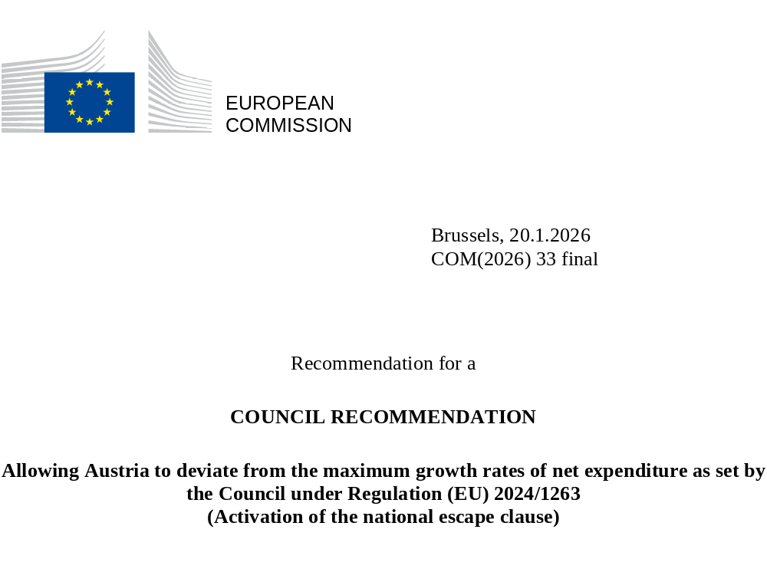

Recommendation for a
COUNCIL RECOMMENDATION
Allowing Austria to deviate from the maximum growth rates of net expenditure as set by the Council under Regulation (EU) 2024/1263
(Activation of the national escape clause)
THE COUNCIL OF THE EUROPEAN UNION,
Having regard to the Treaty on the Functioning of the European Union, and in particular Article 121 thereof,
Having regard to Regulation (EU) 2024/1263 of the European Parliament and of the Council on the effective coordination of economic policies and on multilateral budgetary surveillance and repealing Council Regulation (EC) No 1466/97, and in particular Article 26 thereof,
Having regard to the recommendation from the European Commission,
Whereas:
(1) Regulation (EU) 2024/1263, together with the amended Regulation (EC) No 1467/97 on speeding up and clarifying the implementation of the excessive deficit procedure, and the amended Council Directive 2011/85/EU on requirements for budgetary frameworks of the Member States are the core elements of the reformed EU economic governance framework. The framework aims at ensuring public debt sustainability, and sustainable and inclusive growth through reforms and investments. It promotes national ownership and has a medium-term focus, combined with an effective and coherent enforcement of the rules.
(2) The maximum growth rates of net expenditure as set in a Council recommendation in accordance with Articles 17(1), 19 or 20 of Regulation (EU) 2024/1263 are the single operational reference for the annual fiscal surveillance of each Member State and are at the centre of the new economic governance framework. The maximum growth rates of net expenditure as set by that Council Recommendation establishes a budgetary constraint for four or five years, which is based on an adjustment period of four years that can be extended by an additional period of up to three years.
(3) The framework provides for flexibility in the application of the rules in the event of exceptional circumstances outside the control of Member States that have a major impact on the public finances, in accordance with Article 26 of Regulation (EU) 2024/1263. In the latter case, following a request from a Member State and on a recommendation by the Commission based on its analysis, the Council may within four weeks of the Commission recommendation adopt a recommendation allowing a Member State to deviate from its maximum growth rates of net expenditure as set by the Council, where (i) exceptional circumstances outside the control of the Member State, (ii) have a major impact on the public finances of the Member State concerned, and (iii) provided that such deviation does not endanger fiscal sustainability over the medium term. The Council is to specify a time limit for such deviation.
(4) The Heads of State or Government, meeting in Versailles on 10-11 March 2022, committed to bolster European defence capabilities in light of Russia’s military aggression against Ukraine. These aims were reiterated in the Strategic Compass for Security and Defence. In its Conclusions on European defence of 6 March 2025, the European Council welcomed the intention of the Commission to recommend the activation, in a coordinated manner, of the national escape clause under the Stability and Growth Pact as an immediate measure.
(5) In its Communication of 19 March 2025, the Commission has invited all Member States to make use of the flexibility provided by the national escape clause in a coordinated manner with a view to maximising the impact on the EU’s defence capabilities. This flexibility aims at facilitating the transition to higher levels of defence spending provided that it does not endanger fiscal sustainability over the medium term. That Communication describes that the activation of the national escape clause would allow Member States to deviate from the maximum growth rates of net expenditure as set by the Council when endorsing the medium-term fiscal-structural plans or when establishing the corrective paths under the excessive deficit procedure, to the extent that this deviation is justified by an increase in defence spending relative to the reference year, and that the annual excess through 2028 will not exceed 1.5% of GDP. Increases beyond that amount would be subject to the normal assessments of compliance. Such a maximum is necessary to ensure that fiscal sustainability is not endangered, while allowing all Member States to benefit from the flexibility as they move towards a higher level of defence expenditure. The exact amounts will be determined when outturn data become available, to ensure that the additional flexibility is used only for its intended purpose.
(6) The Council Recommendation of 8 July 2025 endorsed the net expenditure path of Austria. In addition, the Council Recommendation under Article 126(7) adopted on the same day established a corrective path for Austria to correct the excessive deficit, with the same annual and cumulative maximum growth rates of net expenditure. The flexibility provided by the national escape clause will also be considered in the implementation of the excessive deficit procedure, and when assessing if Austria has taken effective action. Therefore, until 2028, the corrective net expenditure path set out in the Council Recommendation under Article 126(7) of 8 July 2025 is complemented by the flexibility that is allowed by the increase in defence expenditure under the national escape clause.
(7) On 11 December 2025, Austria submitted a request to the Council and the Commission, to activate the national escape clause.
(8) In its request, Austria sets out that, in a context of heightened geopolitical tensions, Russia’s continued war of aggression against Ukraine and its threat to European security constitutes an existential challenge for the Union, which requires a significant increase of defence spending. This situation is an exceptional circumstance outside the control of each Member State. Specifically, Austria underlines the purchase of military equipment in 2025 given the deterioration of the geopolitical situation throughout the year. In light of this, Austria is requesting the activation of the national escape clause for the period from 2025 to 2028, in line with the other Member States for which the Council has already activated the national escape clause for defence.
(9) In its request, Austria reports data on total defence expenditure until 2026 (Table 1). In addition, Austria intends to safeguard its long-term defence capabilities also after 2026. Therefore, the increase in defence expenditure has a major impact on the public finances of Austria.

Table 1: Total defence spending in Austria

 | 2021 a | 2022 a | 2023 a | 2024 a | 2025 b | 2026 b
General government total defence expenditure  (% of GDP) | 0.6 | 0.6 | 0.6 | 0.7 | 0.8 | 1.0
Source: a: Eurostat; b: Information provided to the Council and the Commission by Austria.

(10) Austria estimates that the increase in total defence expenditure as a ratio to GDP from 2021 to 2025 has been in the order of 0.2 percentage points and therefore contributes to deteriorating the government balance and increasing government debt.
(11) All else being equal, an increase in expenditure over the period covered by the national escape clause will lead to higher government debt and a higher deficit by the end of that period. Indicative projections run by the Commission and assuming, by 2028, a linear uptake of the full increase in government expenditure allowed by this recommendation suggest that the deficit-to-GDP ratio and debt-to-GDP ratio in 2028 would be 1.2 pps. and 1.7 pps. higher, respectively, than if net expenditure grew in line with the path set by Council Recommendation C/2025/3958. This would likely require an additional fiscal adjustment after the period of activation of the national escape clause in order to meet the requirements of the fiscal framework, including to ensure that the debt ratio is put or remains on a plausibly downward path, or stays at prudent levels below 60% of GDP over the medium term, and that the deficit stays or is brought below 3% of GDP and maintained below the reference value over the medium term. Austria acknowledges that, going forward, structurally higher defence expenditure may require policies to preserve fiscal sustainability and compliance with the fiscal rules over the medium term. The limited projected increase in deficit and debt levels caused by the national escape clause, together with Austria’s commitment to implementing the necessary adjustment to fulfil all the requirements of the fiscal framework in the next plan, ensures that fiscal sustainability is preserved over the medium term.
(12) General government defence expenditure data are compiled and released by the national statistical authorities and Eurostat according to the International Classification of the Functions of Government (COFOG) in the framework of the European System of National Accounts (ESA2010). These data are appropriate to assess the impact of defence spending on government deficit, debt and net expenditure, and related concepts. Eurostat, in close cooperation with the national statistical authorities, are establishing a data collection process. The data collection process needs to be aligned with reporting requirements established by Council Regulation (EU) No 479/2009 .
(13) Moreover, for some of the contracts for military equipment signed during the period of activation of the national escape clause, delivery may occur at a later stage, therefore impacting public finances only after the period of activation of the clause. To cater for this eventuality, the flexibility granted under the national escape clause should also apply to defence expenditure linked to such later delivery, provided that the corresponding contracts were signed during the period of activation of the clause and that this delayed defence expenditure remains within the overall cap mentioned above.
(14) The expenditure financed by loans provided under Council Regulation (EU) 2025/1106 of 27 May 2025 establishing the Security Action for Europe (SAFE) through for the Reinforcement of European Defence Industry Instrument, would automatically benefit from the above flexibility. To this end, Member States would report to Eurostat all defence-related expenditures made under the SAFE Instrument under the categories ‘defence products’ and ‘other products for defence purpose’ as defined in Regulation (EU) 2025/1106.
(15) This recommendation does not modify the definitions of government deficit, debt and net expenditure, and related concepts. Data based on these concepts are to be compiled and reported by Austria in accordance with Regulation (EU) 2024/1263, Council Regulation (EC) No 479/2009 and Regulation (EU) No 549/2013.

HEREBY RECOMMENDS:
1. During the period 2025-2028, Austria is allowed to deviate from and exceed the maximum growth rates of net expenditure as set by Council Recommendation C/2025/3958 to the extent that the net expenditure in excess of these maximum growth rates is not more than:
(i) the increase in defence expenditure in percent of GDP since 2021;
(ii) provided that the deviation in excess of the maximum growth rates of net expenditure does not exceed 1.5 percent of GDP.

2. In the years after 2028, Austria may still deviate from and exceed the maximum growth rates of net expenditure as set by a Council Recommendation in accordance with Articles 17, 19 or 20 of Regulation (EU) 2024/1263, to the extent that the net expenditure in excess of these maximum growth rates is related to deliveries of military equipment contracted before end-2028 and remains within the overall cap mentioned above.

3. In accordance with Article 22(7) of Regulation (EU) 2024/1263, the deviations from the maximum growth rates of net expenditure as set by the Council that are allowed by this Recommendation will not be recorded as debits in the control account of Austria.

4. In order to ensure correct recording of the additional expenditure Austria is to include actual and planned data on total defence expenditure (COFOG division 02), including on defence investment (COFOG division 02 P.51) and any expenditure to be financed by SAFE loans that are not covered in COFOG-02:

(a) for years T-4, T-3, T-2 and T-1 (with year T being the current year) in the reporting to the Commission (Eurostat) in accordance with Council Regulation (EU) No 479/2009;

(b) for years 2021 through year T (current year), in national medium-term fiscal structural plans and in annual progress reports in accordance with Articles 11(1) and 15, and 21(1) of Regulation (EU) 2024/1263;

(c) for years T (current year) and T+1 in draft budgetary plans in accordance with Regulation (EU) No 472/2013 of the European Parliament and of the Council.

This recommendation is addressed to Austria.
Done at Brussels,
For the Council
The President

OJ L, 2024/1263, 30.4.2024, ELI: http://data.europa.eu/eli/reg/2024/1263/oj.
Council Regulation (EC) No 1467/97 of 7 July 1997 on speeding up and clarifying the implementation of the excessive deficit procedure (OJ L 209, 2.8.1997, p. 6, ELI: http://data.europa.eu/eli/reg/1997/1467/2024-04-30).
Council Directive 2011/85/EU of 8 November 2011 on requirements for budgetary frameworks of the Member States (OJ L 306, 23.11.2011, p. 41, ELI: http://data.europa.eu/eli/dir/2011/85/2024-04-30).
Commission Communication (C (2025) 2000 final) of 19 March 2025.
Council Recommendation of 8 July 2025 endorsing the national medium-term fiscal-structural plan of Austria (OJ C, C/2025/3958, 20.8.2025, ELI: http://data.europa.eu/eli/C/2025/3958/oj).
Council Recommendation of 8 July 2025 with a view to bringing an end to the situation of an excessive deficit in Austria. EDP-related documents for Austria can be found at: https://economy-finance.ec.europa.eu/economic-governance-framework/stability-and-growth-pact/corrective-arm-excessive-deficit-procedure/excessive-deficit-procedures-overview/austria_en.
Nationally financed defence expenditure as defined in the Classification of the functions of government (COFOG-02).
Manual on sources and methods for the compilation of COFOG statistics — Classification of the Functions of Government (COFOG) — 2019 edition.
Regulation (EU) No 549/2013 of the European Parliament and of the Council of 21 May 2013 on the European system of national and regional accounts in the European Union (OJ L 174, 26.6.2013, p. 1).
Council Regulation (EC) No 479/2009 of 25 May 2009 on the application of the Protocol on the excessive deficit procedure annexed to the Treaty establishing the European Community (OJ L 145, 10.6.2009, p. 1).
Council Regulation (EU) 2025/1106 of 27 May 2025 establishing the Security Action for Europe (SAFE) through the Reinforcement of the European Defence Industry Instrument (OJ L 2025/1106, 28.5.2025, ELI: http://data.europa.eu/eli/reg/2025/1106/oj).
Regulation (EU) No 472/2013 of the European Parliament and of the Council of 21 May 2013 on the strengthening of economic and budgetary surveillance of Member States in the euro area experiencing or threatened with serious difficulties with respect to their financial stability (OJ L 140, 27.5.2013, p. 1).

