

REPORT FROM THE COMMISSION TO THE EUROPEAN PARLIAMENT AND THE COUNCIL
2019-2024 report on the financial situation of the unemployment insurance scheme for former members of the temporary or contract staff and parliamentary assistants who are unemployed after the termination of their service in a European Union institution

1. Background information 2
1.1 Report structure 2
2. Regulatory Framework 4
2.1 Legal Framework 4
2.2 Description of the scheme 4
3. Financial Position and Cash Balance of the Unemployment Fund 2019-2024 5
3.1 Cash balance: operating results and accumulated balances 2019-2024 6
3.2 Financial position: operating results 2019-2024 7
3.3 Operating Result 2019-2024 8
3.4 Financial position: breakdown of expenditure and revenue 9
4. Analysis of persons insured, beneficiaries and allowances paid 10
4.1 Methodological aspects 10
4.2. Number of persons insured 10
4.3 Number of beneficiaries of unemployment insurance scheme and “unemployment ratio” 11
4.3.1 Number of beneficiaries of unemployment allowances 11
4.3.2 Unemployment ratio of the EU Institutions - end of year 13
4.4 Overview of unemployment allowance and duration 16
4.4.1 Number of monthly unemployment allowances paid 16
4.4.2 Duration of Payment Period 17
4.5 Unemployment distribution per country 18
5. Conclusions 20
5.1 Period 2019 – 2024 20
5.2 Prospects of the Unemployment Fund in the short and medium term 20

Background information
In accordance with the Conditions of Employment of Other Servants (CEOS), the unemployment allowance is intended for former Temporary Agents (TAs), Contract Agents (CAs), or Accredited Parliamentary Assistants (APAs) who find themselves in a situation of involuntary unemployment (excluding, for example, staff who have resigned) following termination of their service with a European Union institution, within the meaning of Article 1a and 1b of the Staff Regulations of Officials of the European Union. This unemployment allowance is complementary to any national unemployment allowance received by the former staff member.
These allowances are financed from the Unemployment Fund (‘the Fund’), which is itself financed by the contributions of staff covered by the CEOS (who are potential beneficiaries) and by their employer’s contributions.
Under Article 28a(11) and Article 96(11) of the CEOS, every 2 years the Commission must present a report on the financial situation of the unemployment insurance scheme. To make it easier to trace the evolution of the Fund, the Commission always makes this bi-annual report with a five-year reference period. The previous report covered the period 2017-2022 and the reference period for the present report is 2019-2024.

Report structure
After a short summary of the key take-aways of the report, Section 2 provides an overview of the legal framework, including the major characteristics of the unemployment scheme as well as the relevant legal references.
Section 3 focuses on the financial aspects of the Fund over the reference period highlighting the evolution of revenue, expenditure as well as the cumulative balance.
Section 4 analyses the demographic aspects of the members and beneficiaries of the scheme and other key characteristics such as duration of payment period and an overview of the residence distribution.
The report concludes with some considerations for the future.
Key take-aways between 2019 and 2024:
 | The reserves of the Fund increased over the reporting period, reaching at the end of 2024 over EUR 106 million, from around EUR 31 million in 2019.
 | The number of members rose to over 36,689 (a 33% increase with respect to 2019). At the same time beneficiaries reduced by 1/3 to 754.
 | The number of unemployment allowances increased for all categories. Average allowances for CAs registered a slight increase, whereas slightly decreased for TAs and APAs.

2. Regulatory Framework

Legal Framework
The conditions governing the unemployment allowance for temporary staff are laid down in Article 28a of the CEOS and Article 5 of the Annex thereto.
The corresponding rules for contract staff are set out in Article 96 of the CEOS.
Technical provisions relating to social security benefits are contained in Articles 135 and 136 of the CEOS.
The update of remuneration and related financial amounts, including the unemployment allowance, is governed by Article 65(1) of the Staff Regulations.
Detailed implementing provisions for the unemployment allowance scheme are established by Commission Regulation (EC) No 780/2009.
The procedural arrangements for granting unemployment allowances to temporary staff are laid down in the Commission Rules of 14 July 1988 implementing Article 28a(10) of the CEOS.

2.2 Description of the scheme
As mentioned in Chapter 1, the unemployment allowance is intended for former Temporary Agents, Contract Agents, or Accredited Parliamentary Assistants who find themselves in a situation of involuntary unemployment following termination of their service with a European Union Institution, within the meaning of Article 1 of the Staff Regulations of Officials of the European Union. This unemployment allowance is complementary to any national unemployment allowance received by the former staff member.
Beneficiaries are entitled to 60% of the last basic salary in the first 12 months, which decreases to 45% in the following 12 months and to 30% in the last 12 months. Only starting from the seventh month, the unemployment allowances have a maximum ceiling.
Since the last report published in early 2024 analysing the situation until 2022, the unemployment contribution of relevant staff was decreased. Indeed, following the conclusions of the last report – which forecasted an increase of the reserves of the Fund - the Commission adjusted the contribution to the unemployment insurance scheme via a Delegated Regulation. The new unemployment contribution rate for temporary and contract staff is 0.51%. In addition, the new contribution of the relevant Institutions is reduced from 1.62% to 1.02%. As the change in the unemployment contribution rate is not part of the temporal scope of this report, i.e. the Delegated Regulation did not enter into force by the end of 2024, its effects will be assessed in the next report covering the period 2021 – 2026.
During the temporal scope of the report, the Fund was financed by the contributions collected by the contract, temporary and APA staff and by their employing Institutions of the European Union, amounting to respectively 0.81% and 1.62% of the basic salary.
Standard allowance and maximum and minimum amounts payable are updated in the same way as remuneration and in line with Article 65 of the Staff Regulations.
Any family allowances due are paid in addition to the unemployment allowance. The contribution to the Joint Sickness Insurance Scheme (JSIS) of the European Union (5.1% of the unemployed person’s reference basic salary) is paid by the unemployment insurance scheme. Any social benefits received at national level (unemployment benefits, family allowances, sickness benefits, childbirth benefits, etc.) are deducted.

3. Financial Position and Cash Balance of the Unemployment Fund 2019-2024
Key facts:
- The financial position of the Fund in 2024 registered aggregate reserves of over EUR 106 million, which consist of EUR 27 million in the current account and over EUR 79 million in the investment account. This represents a 243% growth with respect to 2019.
- Expenditure during the last months of 2024 showed an increase caused by the surge in beneficiaries among the APAs due to the 2024 European Parliament elections. With respect to 2019, there was a 10% increase reaching EUR 29 million in 2024.
- Contribution figures registered a stable increase. With respect to 2019, there was a 65% increase reaching over EUR 48 million in 2024.
- Fund Reserves have yielded over EUR 4 million in 2022 and 2023.
- Institution breakdown: Around 90% of total expenditure and contribution of the Scheme are accounted by the Commission, European Parliament and Agencies. This has remained stable over the reporting period.

This section presents developments in the financial position of the Fund, in particular its revenue and expenditure, as well as the evolution of the reserves of the Fund.
The Fund uses two management instruments for its revenue and expenditure:
- a current account located in Brussels with the PMO, which collects from the contract, temporary and APA staff and their respective Institutions and Agencies the monthly contributions and pays out both the unemployment allowance and the respective JSIS contribution.
- investment accounts located in Luxembourg managed by DG BUDG.

3.1 Cash balance: operating results and accumulated balances 2019-2024
Under cash-based accounting, transactions are recorded only when a cash inflow or outflow occurred during the given analysis period and reports accurately the amount of cash actually transferred/received in a given period. Table 1 gives a summary of revenue and expenditure as entered in the accounts and the resulting current balance.
Table 1 – Unemployment Fund – Cash Balance – Operating Results (2019-2024)
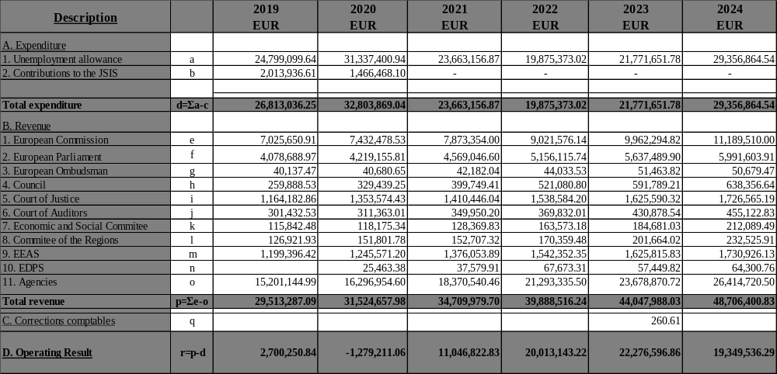

Evolution of Current and Investment Accounts
Besides the current account which provides the day-to-day liquidity and manages the transactions of beneficiaries and the relevant Institutions, on the portfolio the Fund has allocated those funds which are currently not necessary for its obligations, and which are invested under management of DG BUDG.
When analysing the accounts of the Fund, the major evolution occurred during the last 5 years was the transfer of EUR 75 million in 2023 from the current account to the portfolio account. These reserves have initially been invested in fixed-term savings yielding around 3-4% p.a., approximately around EUR 900,000 in 2023 and EUR 3.2 million in 2024.
Table 2 – Unemployment Fund – Cash Balance (Development of cumulative balance 2019-2024)
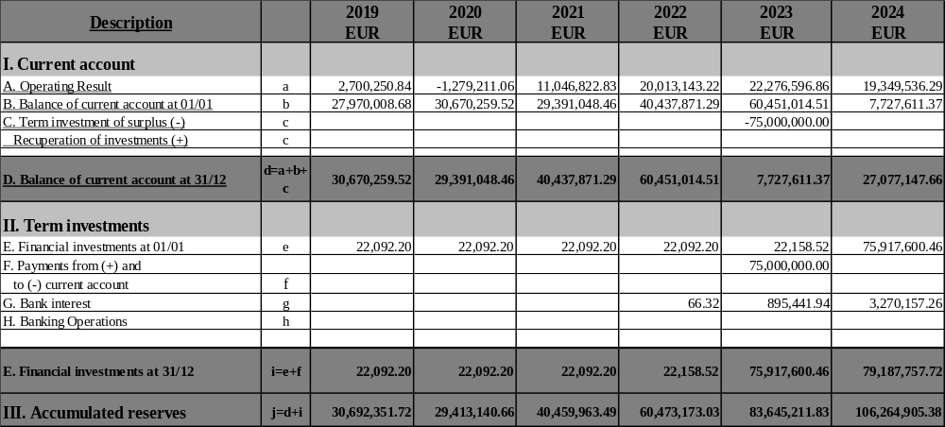
Table 3 shows the accumulated balance of the Fund in a more condensed version. The current account started and ended the reporting period at similar levels around EUR 27 million, whereas the Investments section moved from around EUR 22,000 to over EUR 79 million.
Table 3 – Unemployment Fund - Cumulative Balance (2019 – 2024)
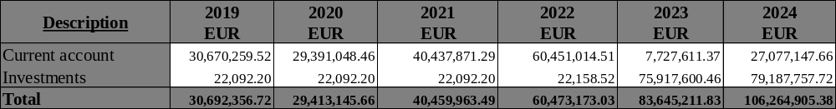

3.2 Financial position: operating results 2019-2024
In accruals accounting, transactions are recorded in the accounts at the moment when the contribution to the Fund or the payment of the unemployment benefit is due. This leads to some discrepancies with the cash-based accounting as some contributions received at the start of year N cover periods of activity at the end of year N-1 or some amounts paid at the start of year N cover periods of unemployment at the end of year N-1.
Table 4 – Unemployment Fund – Financial Situation – Operating Results (2019-2024)
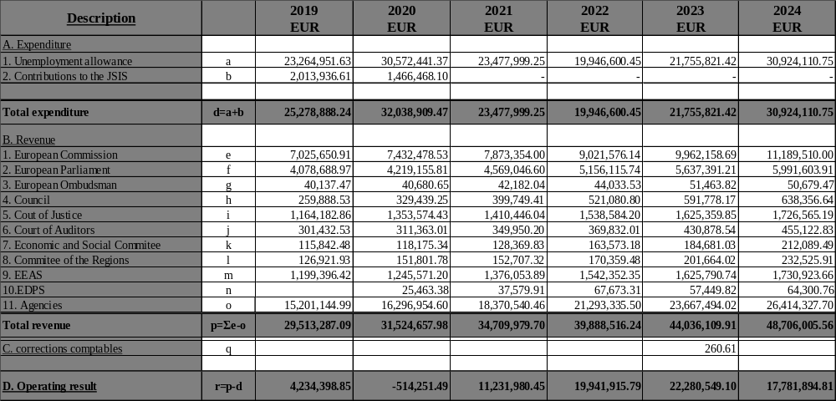

3.3 Operating Result 2019-2024
Over the last years, the operating result of the Fund has presented solid figures and the gains averaged over the reference period around EUR 12 million per year with the last three years hovering around EUR 20 million. Due to these dynamics, the accumulated reserves reached over EUR 106 million at the end of 2024, marking an increase of over 243% with respect to the EUR 30 million of 2019.
The well-known cyclicality in the expenditure, leading to a temporary surge in unemployed APAs, has contributed to the increase in expenditure in 2024. Nevertheless, during that year, a deficit was observed only during the month of October, for a value of EUR 600,000. The current account at the end of 2024 held EUR 27 million, which, combined with around EUR 78 million in the portfolio, provides the scheme a liquidity cushion which stems potential deficits in 2025 caused by the number of unemployed APAs.
When analysing the revenue evolution over the last 5 years, the period 2019-2024 registered an annual average increase of 10%, a slight acceleration to the average of the past report (2017-2022) when around 9% average increase was recorded. In 2024, the total revenue amounted to over EUR 48 million.
The expenditure evolution over the last 5 years, after a decrease in 2021 and 2022, rebounded by nearly 9% in 2023 and by over 34% in 2024 reaching nearly EUR 30 million, a level which is around 10% higher than 2019, but less than the peak of EUR 32 million experienced in 2020.
Fig. 3.3.1 Unemployment Fund Evolution

Source: Table 1, Table 2

3.4 Financial position: breakdown of expenditure and revenue
Table 5 provides a breakdown of expenditure and revenue by institution and for all the agencies both in absolute and relative terms. The evolution of contribution and expenditure of each institution and of the agencies provide a heterogeneous picture.
Table 5 – Unemployment Fund – Financial situation: Breakdown by revenue and expenditure by institution (2019 – 2024)
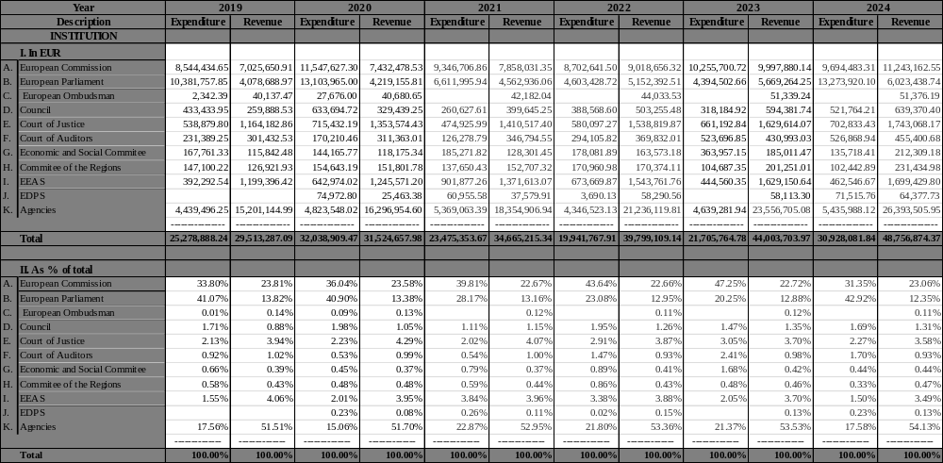

4. Analysis of persons insured, beneficiaries and allowances paid
Key facts:
- The number of contributors in December 2024 was 36,689, a 34% rise with respect to 2019.
- The number of beneficiaries in December 2024 was 754, a contraction of 31% with respect to 2019.
- The aggregate unemployment ratio throughout all Institutions and Agencies contracted over the period from 4% to 2%.
- The unemployment duration slightly increased to an average of 8.8 months in 2024 from 8.5 months in 2019.
- Geographic distribution of beneficiaries: in 2024, 51% of beneficiaries were in Belgium, with 27% residing in Luxembourg, Italy, Spain and France.

4.1 Methodological aspects
When considering the population impacted by the scheme, the population registered in December of each year as members or beneficiaries have been considered in the analysis in the previous and in the current report. This provides a straightforward analytical approach.

4.2. Number of persons insured
Taking into consideration the members of the scheme at year-end, the data shows an ongoing increase of the population over the last years. During the reference period, the population of temporary staff increased by 34%, reaching 36,689 end of 2024.
Table 6 – Number of members of unemployment insurance scheme
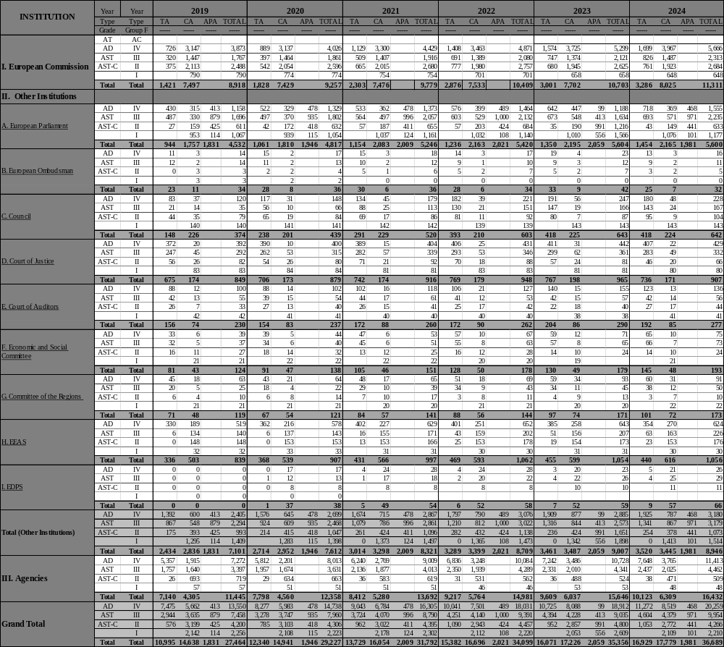
Although all contract categories registered an increase in absolute terms, their respective evolution presented a different pace. Specifically, TAs increased by 54% to 16,929, CAs by 21% to 17,779 and APAs by 8% to 1,981.

4.3 Number of beneficiaries of unemployment insurance scheme and “unemployment ratio”

4.3.1 Number of beneficiaries of unemployment allowances
The number of the beneficiaries at the end of each year over the reference period reduced by over 31% from 1,096 in 2019 to 754 in 2024. The major corrections were reported by TAs, -43%, and CAs, -40%, whereas APAs registered a reduction of -14%.
Table 7 – Number of beneficiaries of the unemployment insurance scheme
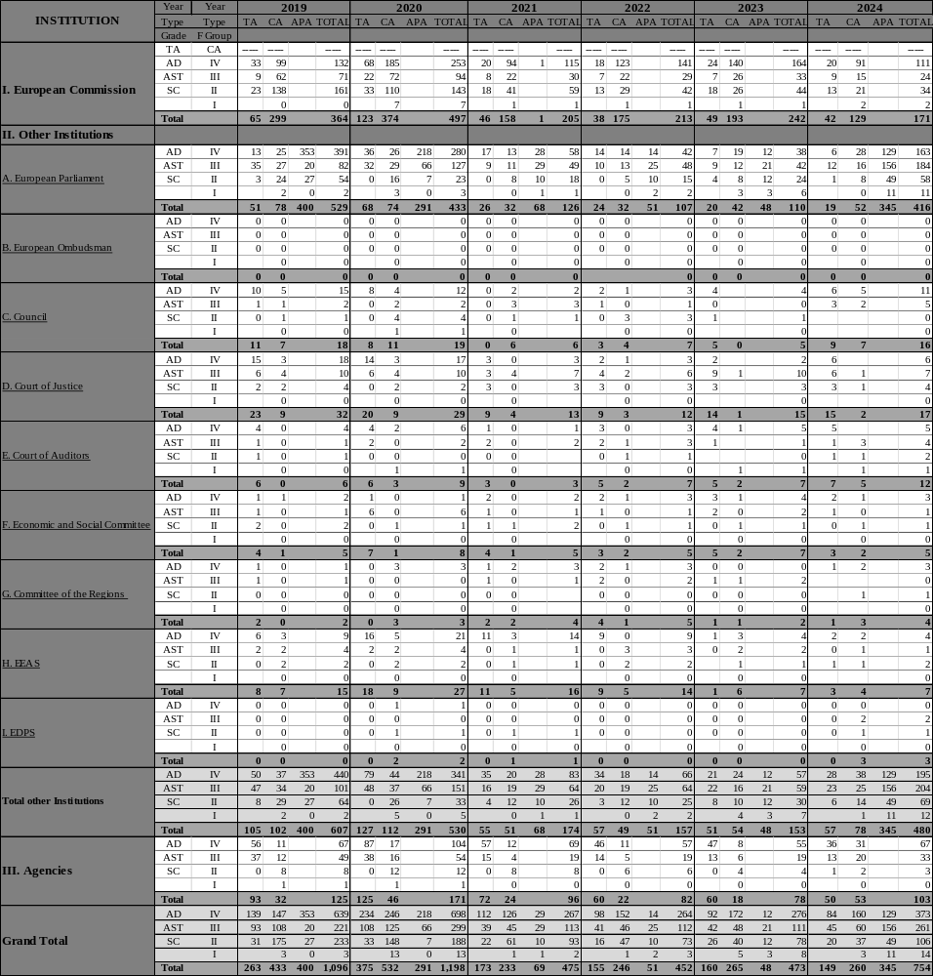
The number of beneficiaries reduced after 2020 for all population types and remained relatively stable until 2023. In 2024, the beneficiaries from the APA category increased to become the largest group, though staying below the level reached in 2019.
Fig. 4.3.1.1 Beneficiaries overview 2019 – 2024 broken down by contract type

Source: Table 7

4.3.2 Unemployment ratio of the EU Institutions
When comparing the beneficiaries with the members of the scheme, it is possible to assess the unemployment ratio. Considering the ongoing increase of members and the corresponding decrease from 2019 to 2024 of beneficiaries, the aggregate unemployment ratio reflects this trend with a correspondent reduction marking nearly a 50% reduction from 3.99% in 2019 to 2.05% in 2024.
Table 8 – Unemployment Ratio – Ratio of beneficiaries of unemployment allowance from the EU insurance scheme to those paying into it, December figures (2019 – 2024)
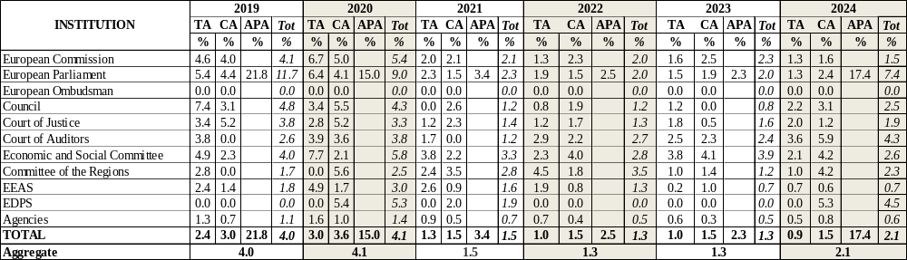
Notably, the cyclical evolution of the APAs show a surge during the year of the European Parliament election and the year after.
Fig. 4.3.2.1 Evolution of unemployment ratio broken down by Institutions and compared to the aggregate scheme

Source: Tables 6, 7, 8
Table 8 B – Comparison active population and beneficiaries
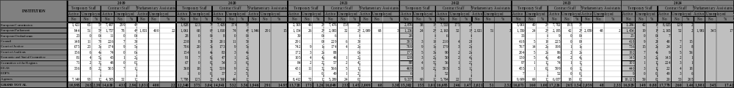

4.4 Overview of unemployment allowance and duration
Pursuant to Articles 28a(4) and 96(4) of the CEOS, the unemployment allowance is paid for a period corresponding to one third of the period of service up to 36 months. In the same Articles, it is stated that the EU pays either the full eligible allowance or, should there be any national schemes to which the beneficiary is entitled to, the EU pays the difference should the national amount be lower than the eligible amount for the EU Institutions.
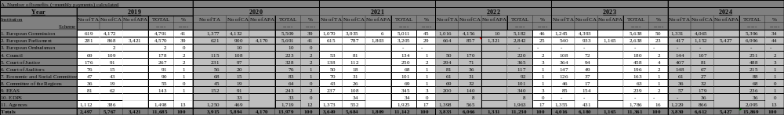
Table 9 – Breakdown number of benefits paid per institution and per contract type

4.4.1 Number of monthly unemployment allowances paid
The number of allowances paid have remained constant around 11,800 between 2019 and 2023, before reaching 15,869 in 2024. Comparing the number of payments to APAs in 2019 to 2024, a 58% increase to 5,427 can be observed. The number of payments to TAs and CAs have experienced a respective increase of 53% and 15% over the reference period, which is opposite the trend of number of beneficiaries in the same period. This finding can be explained that more transactions per beneficiaries are performed, and that the average duration of received benefits increased in 2024.

Table 10 – Number of monthly allowances paid and average allowance per contract type (2019 – 2024)
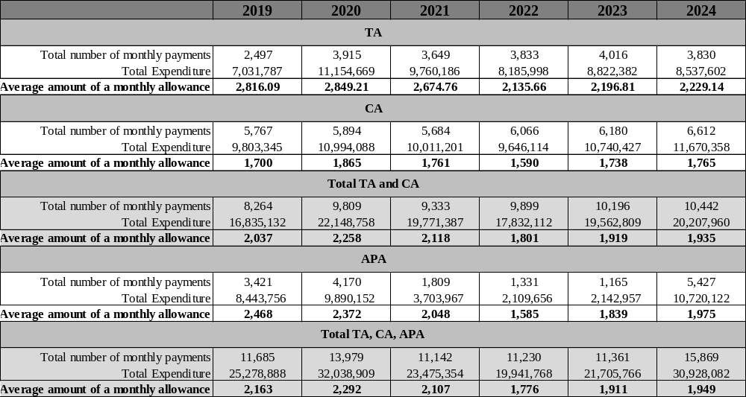

4.4.2 Duration of Payment Period
Over the reference period, the aggregate average duration increased from nearly 8.5 months in 2019 to around 9.0 months in 2024. This trend is the result of durations which increased in the Parliament, Court of Justice, Court of Auditors and Agencies. The Parliament followed a cyclical path due to the impact of the elections.
Table 11 – Duration payment period, in months
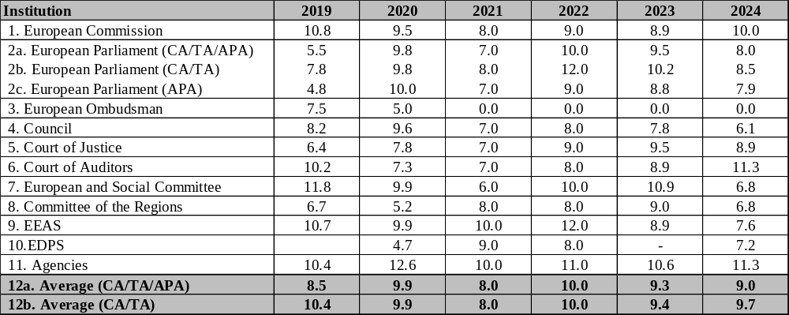
In 2019 and 2024, the duration of unemployment allowance in the Parliament registered a reduction compared to the respective previous years, which is explained by the influx of APA beneficiaries after the elections in June and who started receiving their allowances from August/September. Therefore, the increase in the number of allowances is impacting the last trimester, therefore pushing downwards the overall average duration. In 2024, the shortest average duration was registered in the Council of around 6 months, while the longest was in the Court of Auditors and in the Agencies, both spanning over 11 months.

Fig. 4.4.2.1 Duration comparison in months (2019-2024)

Source: Table 11

4.5 Unemployment distribution per country
Having regard to the principle of complementarity as applied to the unemployment insurance scheme, the country of residence of the recipient of the unemployment allowance is significant, particularly in view of the different eligibility criteria for national unemployment benefit in the different Member States.
Most of beneficiaries of the scheme are in Belgium (51%) as well as, to a minor extent, in Spain, Italy, France and Luxembourg accounting in aggregate terms 27% of the total.
Until the end of the transition period on 31 December 2020, the UK was considered to the be a Member State, allowing former staff to receive unemployment allowance while living in the UK. Pursuant to Article 115 of the Withdrawal Agreement, Articles 28a, 96 and 136 of the CEOS will apply to other servants of the Union of any nationality, including former servants who contributed to the EU unemployment scheme before the end of the transition period if they reside in the UK and are registered with the UK unemployment services.
Table 12 – Country of Residence of beneficiaries of EU unemployment allowances
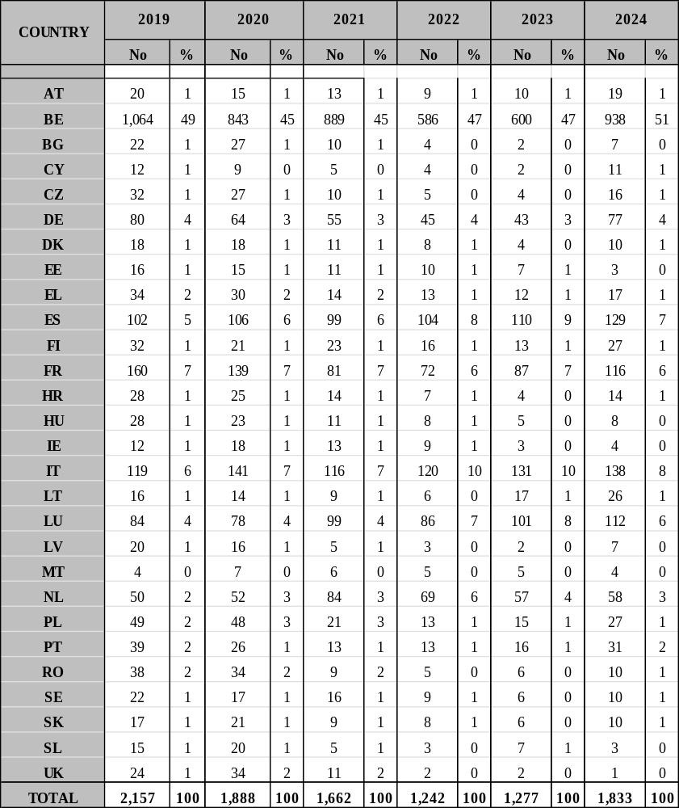

5. Conclusions

5.1 Period 2019 – 2024
The Fund experienced a significant increase of the Reserves, especially during the second half of the reference period, registering positive annual operational results of around EUR 20 million in the last three years.
Consequently, the accumulated reserves in the current account reached EUR 27 million, which added to the EUR 78 million in the investment portfolio makes a grand total of over EUR 106 million at the end of 2024.

5.2 Prospects of the Unemployment Fund in the short and medium term
Based on the observations included in the report, it is expected that the overall balance reaches an equilibrium over that time horizon.
As outlined in Chapter 2.2, following the conclusions of the last report on the unemployment scheme, the Commission adjusted the contribution to the unemployment insurance scheme via a Delegated Regulation. The new unemployment contribution rate for temporary and contract staff is 0.51%. In addition, the new contribution of the relevant Institutions is 1.02%. As the change in the unemployment contribution rate is not part of the temporal scope of this report, i.e. the Delegated Regulation did not enter into force by the end of 2024, its effects will be assessed in the next report covering the period 2021 – 2026.
The Commission will continue regular monitoring of the financial situation of the Fund and will propose adequate measures in function of relevant developments and in the interests of the balance of the scheme.

Council Regulation (EC, Euratom) No 723/2004 of 22 March 2004 amending the Staff Regulations of officials of the European Communities and the Conditions of Employment of other servants of the European Communities, OJ L 124, 27.4.2004, ELI: http://data.europa.eu/eli/reg/2004/723/oj.
Article 28a of the CEOS as amended by Regulation No 1023/2013 of the European Parliament and of the Council of 22 October 2013, OJ L 287, 29.10.2013, ELI: http://data.europa.eu/eli/reg/2013/1023/oj.
Article 96 of the CEOS as amended by Regulation No 1023/2013 of the European Parliament and of the Council of 22 October 2013, OJ L 287, 29.10.2013, ELI: http://data.europa.eu/eli/reg/2013/1023/oj.
Commission Regulation (EC) No 780/2009 of 27 August 2009 laying down provisions for implementing the third subparagraph of Article 28a(2) and the third subparagraph of Article 96(2) of the Conditions of Employment of Other Servants of the European Communities (CEOS), OJ L 226, 28.8.2009, ELI: http://data.europa.eu/eli/reg/2009/780/oj.
Commission Rules of 14 July 1988, common agreement having been recorded by the President of the Court of Justice of the European Communities on 4 July 1989, laying down the detailed arrangements for applying the provisions relating to the grant of the unemployment allowance to members of the temporary staff, implementing Article 28a(10) of the Conditions of Employment of Other Servants of the European Union.
The reform of the Staff Regulations and the CEOS which entered into force on 1 May 2004 amended the legal basis governing eligibility for the unemployment insurance scheme and the rules on the payment of contributions to the scheme that had applied since 1985. A further reform which entered into force in January 2014 has extended the maximum contract length of Contract Agents.
Report from the Commission to the European Parliament and the Council – 2017-2022 report on the financial situation of the unemployment benefit scheme for former members of the temporary or contract staff and accredited parliamentary assistants who are unemployed after the termination of their service in a European Union institution (COM(2024) 54 of 6 February 2024).
Commission Delegated Regulation (EU) 2025/101 of 27 November 2024 adjusting the contributions for the financing of the Special Unemployment Fund set out under Articles 28a and 96 of the Conditions of Employment of Other Servants, OJ L, 2025/101, 31.1.2025, ELI: http://data.europa.eu/eli/reg_del/2025/101/oj.
For information purposes, the JSIS contributions in 2021 amounted to EUR 1,636,067.14 and in 2022 to EUR 1,209,776.99, numbers already included in the unemployment allowance line. The data is no longer presented separately for the last two years because now these contributions are paid at the same time with the other components of the unemployment allowance (more than 15) and do not constitute a separate element, paid through a manual procedure.
Article 127(6) of the Agreement on the withdrawal of the United Kingdom of Great Britain and Northern Ireland from the European Union and the European Atomic Energy Community, OJ L 29, 31.1.2020, pp. 7–187, ELI: http://data.europa.eu/eli/treaty/withd_2020/sign.
Agreement on the withdrawal of the United Kingdom of Great Britain and Northern Ireland from the European Union and the European Atomic Energy Community, OJ L 29, 31.1.2020, pp. 7–187, ELI: http://data.europa.eu/eli/treaty/withd_2020/sign,
Commission Delegated Regulation (EU) 2025/101 of 27 November 2024 adjusting the contributions for the financing of the Special Unemployment Fund set out under Articles 28a and 96 of the Conditions of Employment of Other Servants, OJ L, 2025/101, 31.1.2025, ELI: http://data.europa.eu/eli/reg_del/2025/101/oj.

