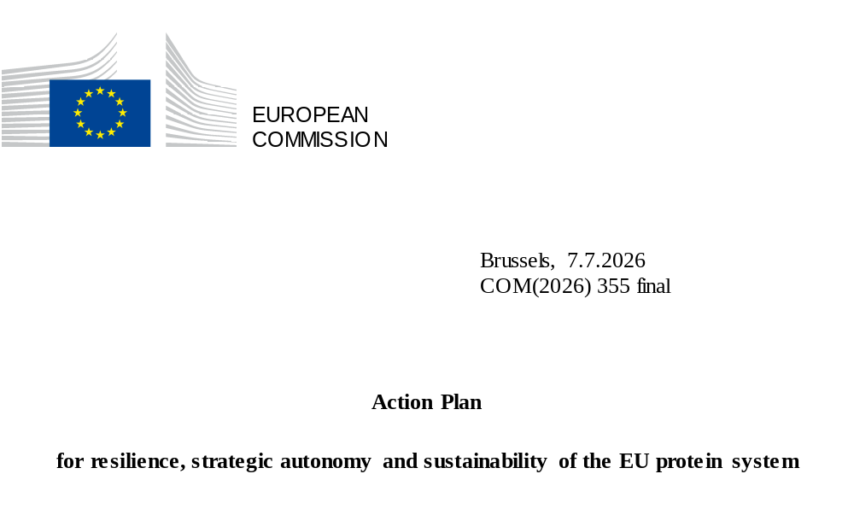

Europe is at a crossroads. In a fast-changing world amid growing uncertainty, bold action is needed to boost our economic competitiveness while strengthening our strategic autonomy. With security and resilience at the centre of the political agenda and growing pressure on Europe’s growth model, key economic dependencies are turning into geopolitical vulnerabilities.
In this context, existing dependencies on imported inputs, such as fertiliser, feed and energy are not only threats for our food security, but central vulnerabilities with an impact on our resilience. Reducing these strategic dependencies is therefore crucial for the EU’s preparedness and security agenda. Collective action is needed by all stakeholders to guarantee that the EU can amplify both its internal and external security().
The EU's high dependence on protein supply for feed from a limited number of origins not only makes our agri-food system vulnerable to global market fluctuations, but also affects capacity to derisk supply chains and restricts progress on the sustainability transition.
As announced in the Vision for Agriculture and Food(), the Commission has developed this comprehensive plan to address these challenges. It integrates policy, research and practical efforts to create a more autonomous and sustainable EU protein system, while diversifying sources of imports. Protein diversification responds to the political call by EU leaders enshrined in the Versailles Declaration() of 2022 to increase EU production of plant-based proteins and by the European Parliament in its 2023 resolution on a European protein strategy().
Scaling up sustainable plant-based protein production in the EU requires finding the right incentives to develop both supply and demand as a key step for the EU to advance on the transformative resilience needed on the continent. A resilient and sustainable protein system will not only contribute to the EU objectives of food security and energy, but will also create new opportunities in rural areas, contribute to the climate neutrality goal by 2050 and accelerate implementation of objectives established in the recent EU bioeconomy strategy() and the fertiliser action plan().
The transition towards a resilient and sustainable protein system requires improved policy coordination aiming at:
- increasing open strategic autonomy by expanding sustainable EU protein supply through incentives for farmers to adopt diversified production systems with reduced fertiliser needs, enabling farmers to cultivate healthy and resilient protein crops;
- improving the resilience, competitiveness and preparedness of the wider EU protein system, including the feed industry, by advancing research and innovation and scaling up investments;
- strengthening EU protein value chains by improving market attractiveness and incentivising demand and promoting local solutions and short supply chains.
Such policy coordination will deliver on the EU’s circularity, climate and energy objectives, which create additional stimulus and business cases for farmers to engage in protein diversification.
This plan sets out the key facts, identifies leverage points and suggests actions across the supply chain to achieve this aim. It complements the livestock strategy adopted on 7 July 2026. While the fisheries and aquaculture sectors are an important source and user of protein in the EU’s food and feed system, they are not covered in this plan.

Plant protein supply in the EU
The EU is home to one of the most competitive and sustainable agricultural production systems in the world. However, this strength is constrained by dependencies on imports of feed with high protein content. Support under the common agricultural policy (CAP) has increased domestic supply of plant protein, both for feed and food use, but the potential to further strengthen is there, albeit with some natural and structural limitations.

An EU production largely based on roughage and cereals with a limited share of protein crops
The EU produces a significant amount of plant protein, but mainly in the form of roughage and cereals, i.e. in the form of low- to medium-protein content products. In the 2025-2026 marketing year, the EU produced about 67 million tonnes of plant protein(), with roughage at around 31 million tonnes of protein and cereals at around 29 million tonnes() (Figure 1)(). Grasslands account for more than half of roughage. The EU’s production of protein-rich plants() stood at 7.2 million tonnes of protein in 2025-2026, having grown significantly over the previous two decades. The production of protein from dry pulses reached 1.3 million tonnes in 2025-2026(). Although this is a small share of the total, their production increased by 53% for the period 2021-2026 compared to the period 2011-2016.
 |  | Plant protein (million tonnes) |  | Share
Roughage |  | 30.6 |  | 45.5%
Cereals |  | 29.4 |  | 43.7%
Oilseeds (excluding soya bean) |  | 5.0 |  | 7.5%
Protein crops | Dry pulses | 2.2 | 1.3 | 3.3% | 1.9%
Protein crops | Soya bean | 2.2 | 0.9 | 3.3% | 1.4%
Total |  | 67.2 |  | 100%
Figure 1: EU plant protein production in marketing year 2025-2026
Source: DG AGRI – Balance Sheets
To note, a shift towards more protein crops with a higher protein content than other arable crops would have only a limited impact on the overall crude plant protein balance, due to their comparatively lower yields. However, increasing the share of protein crops in rotation could reduce greenhouse gas (GHG) emissions by reducing the need for fertilisers, the production and use of which emit GHGs.
The EU’s increased production of protein-rich plants is mainly attributed to support provided through the CAP and to the EU’s agricultural research and innovation programmes as guided by the Commission’s 2018 report(). As highlighted in the fertiliser action plan, the nitrogen-fixing property of protein crops() helps reduce the need for fertilisers, which is a key factor supporting increased production, particularly in a context of escalating costs and tensions on fertiliser supply chains.

EU imports led by soya from the Americas with potential for soya from Ukraine
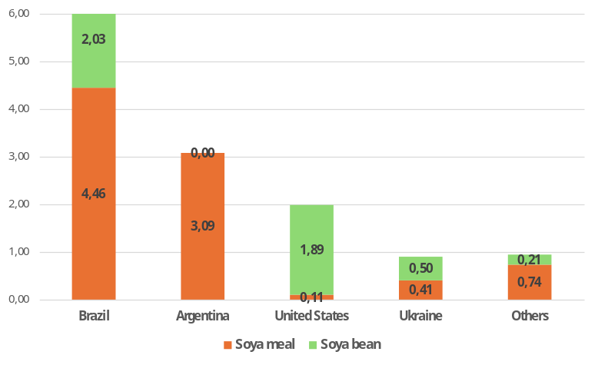
Figure 2: Origin of imported soya protein for marketing year 2024-2025 (in million tonnes of crude protein)
Source: DG AGRI –2024/25
The EU imports protein-rich plants mainly in the form of soya bean and soya meal. They represented about around 13.4 million tonnes of total protein imports in 2024-2025, produced on approximately 13 million hectares in non-EU countries, primarily the US and Brazil, as well as in Argentina for soya meal.
The EU neighbourhood offers tangible opportunities to diversify the EU’s traditional reliance on major soya bean exporters. Ukraine produces 13.5 million tonnes of plant-based protein, 60% of which is exported. This means Ukraine could play a larger role in supplying the EU’s plant-based protein imports. In a prospective accession, this could reduce the EU’s trade deficit from 13.9 million tonnes to 4.7 million tonnes and increase the EU’s self-sufficiency in plant-based protein from 76% to 86%. Moreover, Ukraine has strengthened its role as a strategic partner of the EU by doubling its soya bean production capacity in 2024-2025 compared to 2021-2022, despite disruptions caused by Russia’s war of aggression. The potential for imports from the Western Balkans is smaller given that some traditional producers in those countries have moved from soya bean exporters to import dependence, driven by increased domestic consumption and lower yields.

Protein demand in the EU
Demand for protein in Europe is driven by the needs of the livestock sector for feed, consumer preferences for food and uses linked to emerging needs as regards circularity and bioenergy.

Animal feed
Livestock represents, together with arable crops produced for feed, more than half of total agricultural output (59% in 2024()). In 2025, the value of exports reached EUR 55 billion, creating a EUR 39 billion trade surplus. The livestock sector is also the EU’s largest user of plant protein.
The EU livestock sector uses 74 million tonnes of protein as feed annually(). About 26% is imported but given that the EU also exports the equivalent of 9% of protein in arable crop products or co-products, net reliance on protein imports is 15% of its total feed use (or about 13 million tonnes of protein).
This aggregate figure masks differences by type of feed (Figure 3). Indeed, the EU is largely self-sufficient in low-protein content feed but largely dependent on imports for high-protein feed (oilseeds and protein crops): 74% of those used in the EU are imported. This is mainly driven by soya protein, 94% of which is imported.
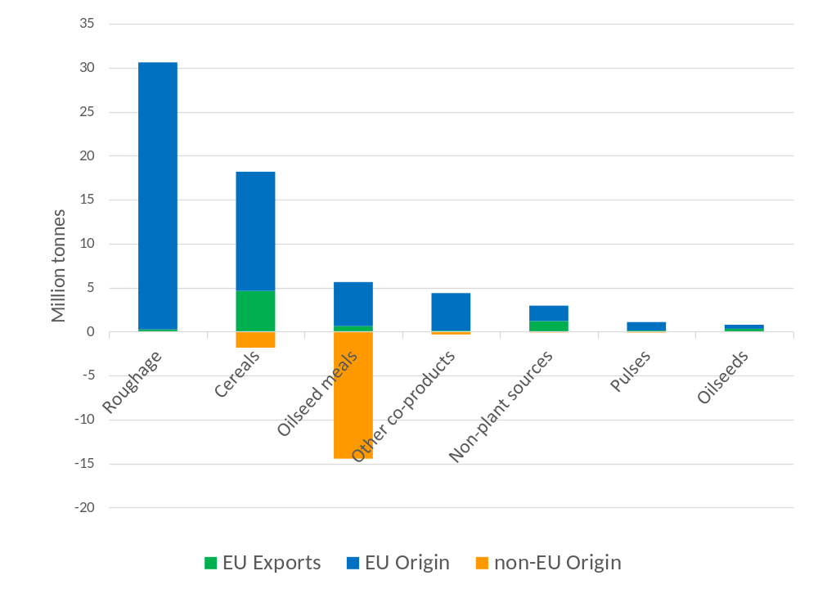
Figure 3: Origin of protein used for feeding EU livestock and exports of those products (in million tonnes of crude protein)
Source: DG AGRI - EU Feed Protein Balance Sheet –2024/25
High-protein plant-based feed() represents a significant share of total feed use, accounting for 31% of total EU feed use of protein (or 23.0 million tonnes of protein)(). It plays a crucial role in several livestock systems, optimising livestock productivity. Replacing it with lower-protein alternatives that are more readily available in the EU would be very challenging, in particular in terms of area needed for cultivation in the EU. In addition, this would require a careful assessment of capacity to substitute feed materials while meeting animal nutritional needs and would depend on the type of livestock (Figure 4). The pig and poultry sectors are the main users of high-protein meals (accounting for 66% of use of compound feed() in the EU), while the dairy and beef sectors account for a lower share (28%).
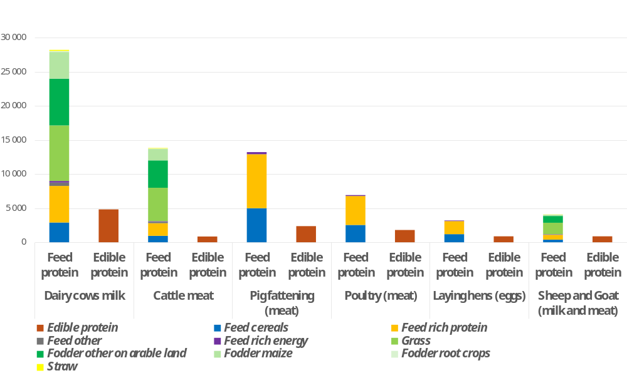
Figure 4: Feed protein use by type of EU livestock and resulting edible protein production by type of EU livestock in 2022 (thousand tonnes of crude protein)
Source: CAPRI model database
Dependence on imported protein feed depends very much on the livestock type and production system. More intensive systems rely on compound feed for a large proportion of their protein, accounting for 25.8 million tonnes of feed protein annually. Compound feed products represent 35% of total protein use by EU livestock. More extensive ruminant systems, relying on grasslands and locally produced feed and forage, are less import-dependent than intensive systems. Certain production systems, such as agroecological, organic, grass-fed, mixed crop-livestock, as well as geographical indications, or those under private standards, actively promote the use of local feed, reduce reliance on imported feed and anchor the production to the territory.
At EU level, the share of on-farm produced feed is on average limited: about 21% of total feed in 2023. It is highest in ruminant livestock farms that also cultivate crops (42% in 2023) and lowest in specialised poultry or pig farms (7%).

Different feeding systems with various degree of dependence
The EU livestock sector is characterised by a variety of feeding strategies. Intensive livestock production enables feeding to be optimised through precision feeding, adding synthetic amino acids to complement low-protein feed, enzymes, or feed additives decreasing methane emissions. However, feed additives (such as vitamins and amino acids) are heavily imported by the EU, particularly from China, which holds an ultra-dominant position on the global market for these substances, and even a quasi-monopoly for some of them. The EU feed, livestock and aquaculture sectors therefore have very limited opportunities to diversify their sourcing, as this document examines later. On the other hand, extensive livestock systems, particularly grass-fed ruminants and organic production, rely significantly less on imported feed, while delivering environmental benefits.
Finally, it should be underlined that the EU is one of the most efficient global producers of animal protein in terms of GHG emissions per unit of output(). Reducing EU animal production in isolation would largely result in replacement of EU animal product consumption with more carbon-intensive imports, increasing the GHG footprint of EU animal product consumption and causing undue disruption to the EU animal product value chain.

Circularity as a driving principle
Overall, plant proteins from a variety of edible and non-edible sources play a significant role in the circular bioeconomy, including when transformed by livestock into food and manure. While several crops used for feed are also processed for non-feed uses in industry, for energy production, or as food, they still can generate high-protein by-products for feed or food. For example, oil from oilseeds or starches from cereals can be separated for human, industrial or energy use, while the remaining co-products, high in protein, can be used for animal feed or food. These co-products from processed crops constitute a major source of protein for EU livestock. They account for around 34% of total livestock protein intake, highlighting the strong interconnection between food, feed, energy and industrial value chains.
Bioenergy policies have a direct effect on the availability of protein for feed as a co-product and on the profitability of EU protein-rich crops. Co-products from EU energy production() account for 47.2% of all oilseed meals and represent 6.3% of the total feed used in the EU. Co-products from the food and beverage industry account for 6% of the protein intake of EU livestock, although former foodstuffs account for only 0.7%, due to technical and regulatory constraints related to feed safety. Safely using protein co-products from food processing for feed could be expanded as it helps to reduce food waste.

Various protein efficiencies by type of livestock
The protein efficiency of livestock production can be assessed through the conversion rate of feed protein to animal protein. The poultry egg sector has the highest protein conversion efficiency, with 3.6 kg of feed protein required to produce 1 kg of animal protein, followed by the pig sector with 5.5 kg feed protein producing 1 kg animal protein and the dairy cow milk sector with 5.8 kg feed protein per 1 kg animal protein. The meat cattle sector uses 15.9 kg feed protein to produce 1 kg animal protein. The growing relative consumption of poultry meat in a context of decline of the other meats could contribute, to some extent, to reducing the EU's dependence on imported feed by improving the overall efficiency of feed protein utilisation.

Food
In the EU, 64% of protein consumed by humans is animal-based (Figure 4). This share rises to 67% in the USA, while in China, plant-based protein accounts for 59% of human protein consumption. Consumption trends over the last decade point to an increased share of animal protein in the diets of Europeans, to the detriment of plant protein().
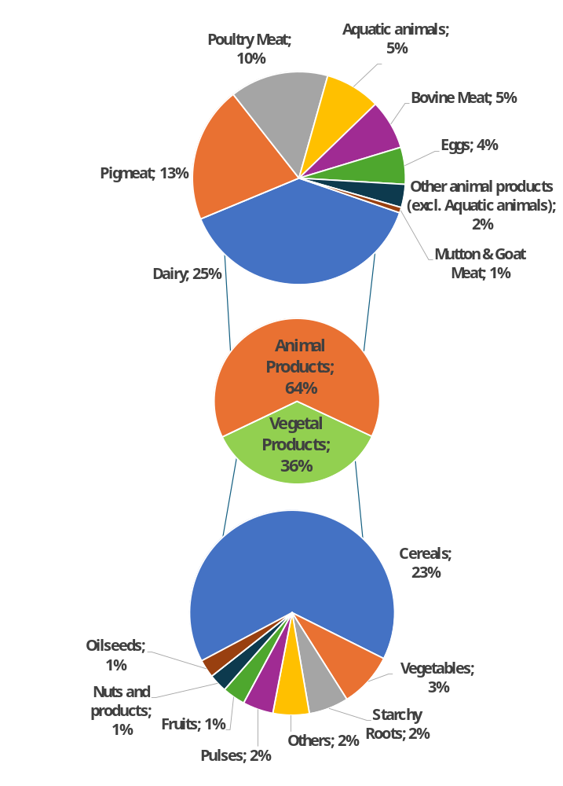
Figure 5 – Share of protein per product in the EU diet
Source: FAO - Food Balances – 2023
Factors influencing current consumption patterns include: (i) cultural traditions and habits; (ii) incomes; (iii) convenience, advertising and marketing; (iv) rising interest in protein-enriched foods; (v) the organisation of supply chains; and (vi) the relative prices of plant versus animal products. Dairy product proteins are likely to experience the largest relative increase in the diets of Europeans, as meat intake (with the exception of poultry) declines. For plant-based protein, the main sources are cereals (23% of human protein intake) and fruit and vegetables (4%). Even though they only account for 2% of protein intake, legumes and pulses are considered an important component of a varied and sustainable diet, and several Member States recommend increasing legume consumption().
As with many foods, a diverse diet provides an important contribution to healthy diets. Diversified diets that include meat from livestock raised on locally adapted feed resources, alongside the consumption of plant proteins from fruits, vegetables and pulses, could play an important role in the transition towards a more resilient and sustainable food system while supporting viable value chains in the EU. In addition to providing adequate nutrition and enabling positive health outcomes, diets that have a high share of plant-based foods help to support environment and climate objectives.

Plant-based and alternative protein sources
Innovation is thriving in the protein domain. The EU has an interest in being a global leader and driving innovation that supports competitive, sustainable and resilient food systems. At the same time, protein production must comply with EU regulations to protect health, climate and the environment. Innovation must be responsible and requires proper assessment as regards its sustainability, as well as social, nutritional and societal considerations. The European Commission’s life sciences strategy recognises that the European agriculture and food sectors are a hub for innovation, with new products and value chains that combine safety, sustainability and social responsibility().
Currently, there is a variety of plant-based and alternative protein sources and innovations on the market for both food and feed use. Some of these products are well established and accepted in Europe, such as plant-based protein food and drinks, or products with protein obtained from fermentation or algae. Algae is also used as feed and has promising market potential. Some alternative protein sources, such as insects, are currently mainly accepted as feed, although they are available on the food market.
Other alternatives for feed such as products based on precision and biomass fermentation or proteins extracted from crops may be subject to specific rules for placing on the market. Several of these alternatives have the potential to create new circular business models for farmers and the feed industry. Fermentation-based technologies are a complementary pathway within the broader protein landscape, with potential implications across agricultural value chains. They may create new opportunities for certain feedstocks, agricultural side streams and feed-related inputs, while contributing to the diversification of protein sources. Their impact on conventional agricultural production is expected to remain limited in the medium term, although more significant effects could emerge over time. The extent to which farmers and rural areas benefit will depend on how value chains are organised, as fermentation-based technologies are expected to coexist with existing agricultural systems and practices. The Commission is finalising a study looking at a number of these questions(). The sources of proteins for feed mentioned above present an area for innovation and contribute to this globally developing market.
Innovative fermentation processes are developing and scaling in other jurisdictions, creating economic benefits and new income streams for farmers outside the EU. Similar benefits could accrue to EU farmers in the form of direct demand for agricultural feedstock and upgrading agricultural side streams. The upcoming Biotech Act II will aim to strengthen the EU’s industrial competitiveness in industrial biotechnology and biomanufacturing, including based on advanced fermentation.
As regards food, plant-based protein food and drinks are expected to have the biggest market potential given the stable regulatory framework and consumer acceptance compared to other alternative proteins. These plant-based alternative products often aim to replicate the taste, texture, and nutritional profile of traditional animal-based products(), although some have undergone a higher degree of processing. Both types of products coexist in the European market and specific rules in the CMO Regulation() on the use of dairy terms and, in the future, meat-related terms() are or will apply to improve transparency and allow consumers to make well-informed choices.
Both plant-based protein products and alternative protein products face several common challenges that will have to be overcome before they can be more widely adopted and integrated into EU diets. While there is the EU regulatory framework on novel foods in place(), public understanding and acceptance are particularly critical in areas like food technology, where innovation may intersect with health, culture, ethical, tradition, social, economic and sustainability considerations, which calls for an enhanced and inclusive dialogue on this matter and better knowledge. Furthermore, affordability, taste, convenience, nutritional aspects and labelling of these products can be additional constraints. Importantly, the sustainability and safety of alternative protein products must be thoroughly assessed, as is the case for conventional food products. For example, the production processes for several types of alternative proteins are energy intensive, in some cases requiring higher energy inputs than the conventional proteins they could potentially replace(). Finally, protein diversification should be pursued while safeguarding the competitiveness and long-term viability of the European livestock sector.
From an economic and social standpoint, increased sales of plant-based protein products create opportunities for farmers and rural communities. Repurposing production and a range of agricultural side streams and co-products for use in plant-based foods and alternative protein production for feed could create new revenue for farmers. Diversifying protein supply creates opportunities for new value chains for both feed and food.

Building a resilient and sustainable protein system in the EU
There are still significant barriers to scaling up sustainable plant-based protein production, despite a number of policy initiatives adopted to date to stimulate development. The broad consultation of stakeholders identified several constraints, including: the lower profitability of protein crops, in particular linked to the availability of dedicated knowledge, skills and inputs; an underdeveloped value chain; infrastructure needs such as storage and processing; investment gaps and the need for closer cooperation among stakeholders to de-risk transition decisions.
Action is required at different levels of governance and by different stakeholders to speed up development of the chain. Success will hinge on the ability to provide an integrated approach and create the right incentives to develop both supply and demand for protein crops.
The EU protein system of the future is built on the following pillars which will in turn make circularity and climate action a business case for farmers:
- increasing open strategic autonomy by expanding sustainable EU protein supply;
- improving the resilience, competitiveness and preparedness of the wider EU protein system;
- strenghthening EU protein value chains by improving market attractiveness, incentivising demand and promoting local solutions.

4.1. Strengthening policy coordination
A coherent transition depends on stronger consistency between the CAP and the EU’s competitiveness, research and innovation, energy, cohesion, environmental, climate, health, public procurement and trade policies, while also ensuring that public policies and private initiatives work together across the entire agri-food chain, from production to consumption.
Several actions are already underway but may need to be accelerated and integrated. In particular, as the EU steps up its environmental and climate ambitions the EU should increase its efforts to promote greater alignment of production standards among trading partners. Developing the protein sector has great potential to deliver on EU environmental and circularity objectives
The next multiannual financial framework (MFF) creates opportunities to stimulate the EU protein crop sector through integrated planning, reduce reliance on imported protein and strengthen the EU’s open strategic autonomy. It requires value chain project development that can combine support for protein crop cultivation under the CAP, better territorial integration and development of infrastructure and processing facilities through the national and regional partnership plans (NRPP)() and finally, scaling up of research and innovation investments through the Horizon Europe research framework programme and the European Competitiveness Fund (ECF)(). Together with risk management instruments that the Commission is developing, also in cooperation with the EIB, this creates unprecedented opportunities for the EU protein crop sector.
Several Member States are already advancing initiatives to promote a more sustainable and resilient protein system. These efforts focus on increasing local protein production and use, diversifying diets, developing alternative proteins, and reinforcing value chains. The Danish action plan for plant-based foods() provides an example of how Member States can bring together tools at different levels of governance to support the value chain for plant-based foods.
With a view to reducing their dependence on imported plant-based protein, Member States are recommended to take action, as further detailed in the subsequent sections, tailored to their needs:
- to promote integration of protein crops in their crop rotation and diversification, based on their environmental and climate benefits;
- to provide coupled income support for the cultivation of protein crops helping the sector to improve its competitiveness;
- to compensate higher risks and production costs for farmers who move to protein crops;
- to integrate protein diversification into their generational renewal strategies and young farmers starter pack measures;
- to support investment, innovation, marketing, storage and risk management for protein crop production;
- to facilitate collective actions, such as promotion measures, joint placing in the market, and greater use of contracts between farmers and other stakeholders in the protein crop value chain;
- to strengthen downstream segments of the protein crop value chain through investments in infrastructure, storage and processing capacity;
- to help farmers in difficulty who produce protein crops, grasses and other herbaceous forage;
- to strengthen the role of grasslands;
- to encourage livestock farmers moving to extensification where appropriate;
- to incentivise farmers combining crop production and livestock;
- to monitor and encourage the use of local feed at farm level or local level, to increase farm-level sufficiency and to reduce dependence on imported high-protein feed;
- to support diversified diets to strengthen system resilience;
- to design taxation policies to contribute to the transition to a resilient food system;
- to issue guidance on a harmonised feed and food protein balance sheets.
Dedicated protein dialogues with Member States will provide a forum to exchange best practices and monitor implementation of the protein plan. The annual food dialogues, bringing together consumers, producers, industry, retailers, public authorities and civil society, provide another opportunity for exchanges and agenda-setting.

4.2. Expanding sustainable EU protein supply
The EU’s capacity to increase its strategic autonomy requires:
- incentives to stimulate protein crop cultivation;
- a toolbox of support measures for farmers;
- strengthening value chains and regional development;
- improving sustainable grassland use and livestock integration;
- enabling farmers to access carbon incentives and nature-credits.
- Incentivising farmers to adopt diversified production systems with reduced fertiliser needs
Sufficient incentives, investment support and risk management tools are needed to achieve protein diversification. It is for the Member States, guided by the above recommendations, to design their plans and strategies for protein diversification and address inherent trade-offs, given the structural constraints in Europe. These policy decisions will have to consider several aspects, including the types of crop, their suitability to agro-climatic conditions in a country, their protein content, ‘dual’-purpose use (food and feed) and ability to be integrated into crop rotation. Certain crops, like soya bean, pulses and legumes, have good potential and realistic chances of scaling up. In addition, legumes in a rotation (including as cover crop) support sustainable farming practices, reducing GHG emissions and enriching soil fertility through nitrogen fixation, thereby reducing the need for fertilisers.
Beyond the crop rotation and diversification requirement under the new farm stewardship, Member States can utilise a range of CAP tools under the CAP post-2027 proposal (). These include coupled income support (CIS) and the agri-environmental and climate actions (AECAs) to improve the attractiveness of protein-rich crops at farm level. CIS, for which maximum financial rates have been proposed to be raised, can support the development of protein crops, while AECAs can support cultivation of legumes, use of manure, and establishment of cover crops, while also promoting organic farming systems that integrate these practices.
The Commission’s proposal anticipates a major new feature with significant potential: transition payments proposed under the CAP post-2027, which can be seen as de-risking instruments. They will help farmers cover investment and adaptation costs associated with introducing protein crops into crop rotations, including new machinery, equipment adjustments, learning costs and temporary increases in production or labour costs, as well as potential losses linked to lower profitability compared with alternative crops.
The Commission will set EU-wide benchmark that will allow improvement in the EU’s overall protein strategic autonomy to be monitored. The market observatory for cereals, oilseeds and protein crops will strengthen its effort to facilitate market monitoring and transparency in the protein system.
Member States will be encouraged through CAP recommendations to include measures in their NRP plans that incentivise production of legumes, as well as rapeseed and sunflower, supported by appropriate advice, and monitor the progress achieved.
The next generation of farmers plays a key role in speeding up the transition, thanks to their entrepreneurial spirit, access to innovation and longer planning horizon. By supporting their modernisation, diversification and innovation, the strategy for generational renewal in agriculture aligns with development of the protein crop sector, contributing to the resilience, sustainability, and competitiveness of the agri-food system. The Commission recommends that the Member States integrate protein diversification into their generational renewal strategies and young farmers starter pack measures, to provide sufficient incentives and business opportunities to young farmers.
The rollout of risk management instruments and financial instruments will further help farmers to adopt protein crops in their farming business, as developed in the livestock strategy.
- Toolbox for enabling farmers to cultivate sustainable, healthy and resilient protein crops
In the Vision for Agriculture and Food, the Commission highlighted that farmers need the right toolbox to be able to produce sustainably, given notably the pressures from climate change and animal and plant health diseases. This is even more relevant for protein crops, to improve the yields, quality and produce climate-adapted varieties. New genomic techniques (NGTs) have a significant potential to tackle cultivation challenges and bring more climate-adapted solutions onto the market.
Breeding programmes for protein crops should therefore focus on developing varieties that combine higher and more stable yields, improved tolerance to climate-related stresses (such as drought and extreme weather events), increased pest and disease resistance, and better nutritional quality, while preserving genetic diversity().
Beyond the availability of suitable varieties, plant health risks and weed control remain key barriers to protein crop adoption. To address this, the Commission proposed in a Food and Feed Omnibus() simplifying regulatory procedures for plant protection products, accelerating access to biocontrol pesticides, and making renewal processes more efficient. The Commission has also targeted Horizon Europe investment into plant protection, which needs to continue to respond to existing and emerging diseases.
Knowledge sharing is key in supporting the wider uptake of protein crops. Cooperatives, EU CAP Networks and Horizon Europe-funded thematic and advisory networks() play an important role through joint action. Farm advisory services are also essential in supporting farmers’ uptake of new practices and raising awareness.
Access to modern machinery adapted to legumes and other protein crops is essential for precise sowing and harvesting, helping to improve yield reliability and product quality. CAP investment support plays an important role. As these crops are often grown on relatively small areas, cooperatives can facilitate access to specialised equipment by sharing investment costs among farmers.
- Strengthening value chains and regional capacities to improve market attractiveness
Better value chain integration and demand generation are key ‘pull’ factors to deliver change.
The CAP post-2027 proposal strengthens the value chain by establishing a dedicated protein crop sector, mandating recognition of producer and interbranch organisations, thereby facilitating collective actions, such as promotion measures, joint placing in the market, and requiring Member States to implement protein crop sectoral interventions to support investment, innovation, marketing, storage and risk management.
It is important that quality is reflected in the price and that farmers are renumerated fairly. Amendments to the Common Market Organisation(), currently being examined by the co-legislators, designed to strengthen trust across the food and feed chain will facilitate greater use of contracts between farmers and other stakeholders in the protein crop value chain to reduce risks when switching to those crops by improving price predictability, securing outlets and clarifying demand.
In addition to CAP income support, integrated planning and financing under the NRPP offers opportunities to help develop value chains through investments that will strengthen the infrastructure, storage and processing capacity needed to link supply to demand. The ECF, which will support businesses and projects along the entire investment journey through different forms of support (grants, repayable support, blended finance), may also play a role. For example, expanding processing capacity for protein crops in the EU would diversify market outlets and support a more territorial livestock distribution with less environmental impact. The European Competitiveness Fund could support investments in feed, food and biorefinery infrastructure, strengthening resilient EU value chains based on locally sourced protein.
Reducing reliance on imported high-protein feed implies preserving the industrial and energy applications of oilseeds, the EU’s main domestic source of high-quality feed protein. Advancing biomass use as set out in the bioeconomy strategy will further expand market opportunities.
The Commission has already begun to engage with stakeholders to prepare for the new opportunities arising from the future MFF. This work will continue.
Regional development matters greatly to address structural challenges in rural areas and regions, such as services, labour shortages, water scarcity and more. The integrated planning under the NRPP can address these concerns.
- Improving sustainable grassland use and livestock integration
The CAP post-2027 maintains strong support for fodder within a more territorial approach to grassland and livestock management, extending CIS to grasses and forage. Through AECAs, Member States can promote extensive systems, sustainable grazing and greater use of grass in feed. The role of grasslands should be strengthened, as they contribute to carbon stock, reduce dependence on imported feed and help address land abandonment, loss of cultural heritage and growing natural hazards, specifically wildfire. In addition to grazing, there is scope to expand the use of protein extracted from grass for monogastric animals.
- Enabling farmers to access carbon incentives and nature-credits
To provide economic incentives for reducing fertiliser use, as highlighted in the fertiliser action plan, a certification method is being developed under the Carbon Removals and Carbon Farming Regulation (CRCF)(), to recognise carbon removals from converting cropland to grassland, improve grassland management, and reduce N₂O emissions through legume use. This unified framework will allow protein crop farmers to access carbon incentive schemes. Furthermore, the announced review of the CRCF framework’s additionality and scope presents an opportunity to create a broader range of business cases for farmers to engage in carbon farming.
In line with the Roadmap towards nature credits(), nature credit approaches could also help reward sustainable protein systems that contribute to maintaining, restoring or improving ecosystems, habitats or biodiversity, including grazing-based livestock systems on permanent grassland and biodiversity-friendly legume-based systems, such as diversified rotations, intercropping or low-input production combined with landscape features.

4.3. Advancing research and innovation to strengthen protein systems
- Investing in crop innovation and seeds to boost production and resilience
The Union Research Framework Programmes for R&I, Horizon 2020 and Horizon Europe have invested over EUR 190 million to support R&I in protein crops, including breeding, intercropping, valorising ecosystem services, on-farm processing, value chains, and feed production to strengthen the EU’s self-sufficiency. Under the EU mission ‘A Soil Deal for Europe’, projects also explore protein crops’ role in improving soil health through Living Labs. The EU Partnership on Animal Health and Welfare also addresses the topic through animal feeding and feed additives. The EU Agroecology Partnership tackles crop diversification and the potential of mixed systems. The EU partnership Biodiversa+ has also addressed the topic from a different approach supporting the development of perennial grain cropping systems().
Targeted R&I investment is needed to boost protein crop production and use. Priorities include, among others: plant breeding and seed development; reducing fertilisers; protecting sustainable crops; diversifying; and developing value chains, alongside research on grazing systems and feed formulations based on local proteins. R&I is also needed on the processability, sensory quality, nutrition, digestibility and allergenicity of EU-grown protein crops. Given variability across varieties and growing conditions, standardised quality, risk assessment, and grading methods are essential to support marketing and wider use. Suitable processing technologies and infrastructures for food and feed, including on-farm, are also necessary to create value.
Investments in developing technologies to better valorise biomass, by including residues and by-products in feed, also need to continue in cooperation with the private sector.
- Strengthening collaboration and knowledge transfer across actors
Collaboration across the value chain is key to scaling innovation. Initiatives such as EIP-AGRI (European Innovation Partnership on agricultural productivity and sustainability), and the EU CAP network support knowledge exchange, collaborative projects and best practices, while linking R&I with extension services ensures effective transfer to farmers. Through multi-stakeholder projects, thematic activities and networking initiatives, these platforms will continue to promote best practices on protein crops and disseminate relevant results from projects implemented at Member State level. Their activities will also contribute to dedicated protein dialogues with Member States and contribute to the annual food dialogues. Cohesion policy for R&I provides another tool to support innovation and several regions have identified relevant priorities in their Smart Specialisation Strategies()
A comprehensive R&I approach for protein needs to deepen scientific knowledge and filling the gaps while ensuring effective integration across disciplines(). Further research and innovation funding is needed to boost the competitiveness, sustainability and resilience of plant and alternative proteins, building on the future ECF and the next Horizon Europe. The upcoming new Strategic Approach to R&I for agriculture, forests, rural areas and food systems will form the basis for guiding future investments to develop new knowledge, practices and tools for the protein sectors. In the long term, further work in areas such as plant protection, breeding and the bio-based bioeconomy, involving both research organisations and the private sector across all these areas, will further strengthen the uptake of results.

4.4. Improving the resilience, competitiveness and preparedness of the EU protein system
The resilience and competitiveness of the EU protein system are strongly linked to efficiencies in feed and breeding and innovation in which the EU is a technological leader:
- making livestock systems more efficient;
- optimising feeding strategies;
- incentivising regional and local feed;
- diversifying imports while aligning sustainability standards;
- supporting domestic production of feed inputs and additives;
- ensuring preparedness and contingency.
- Adapting livestock systems to prioritise local resources
The potential for feed demand optimisation lies in better matching livestock production with regional and local feed production. Building on the current CAP, the CAP post-2027 gives Member States options to further support diversification of livestock production, including extensification, and measures to encourage greater use of regionally and locally produced plant proteins, through instruments such as area-based income support, particularly for mixed crop–livestock systems, and increased CIS for farmers who combine crop and livestock production. In areas affected by nitrate pollution, the Commission has proposed that Member States be required to support farmers in extensifying their livestock system or diversifying their activities and, under the new AECA, they will also provide support for extensification of livestock systems, for example through voluntary management commitments or through the new transition payment. This will allow marginal lands to be better used for ruminants, while for monogastrics, there are opportunities to better use co-products from food in compliance with relevant provisions of Union law concerning animal feed, animal by-products and Transmissible Spongiform Encephalopathy (TSE), and biofuels processing, which help to reduce feed-related GHG emissions and land use change competition.
As developed in the livestock strategy, optimising herd composition and business models in line with the natural resources available at regional level and diversifying the income of impacted livestock producers in value added processing, will also help to reduce the EU’s dependence on imported plant-based protein.
- Local feed production
Reducing the EU’s dependence on imports must be accompanied by efforts to lower the costs of European feed production. Replacing imported protein feed with European, regional or local alternatives may increase costs for livestock producers if they are more expensive than imports. While public support can help develop resilient feed value chains, these costs must be absorbed without undermining competitiveness. The livestock strategy sets out the pathway which would allow for clear consumer identification, through voluntary labelling and short supply chains, to support this transition.
Upstream of animal producers, expanding regional processing and storage capacity is key to increasing local feed use. Investment instruments available under the CAP can already support farmers and producer organisations in developing such regional processing and storage infrastructure, such as drying units, biorefineries or logistics platforms. The future ECF may further contribute to this objective by boosting investments aimed at improving competitiveness and resilience.
To give direction to policies and monitor progress, Member States are recommended to monitor the use of local feed(). Furthermore, the Commission will consider developing voluntary labels or optional reserved terms on the origin of feed used for producing the product.
- Optimising feeding strategies across livestock types
Ruminants can be fed on grass and help maintain grasslands, while monogastrics can make use of leftovers and co-products from food and agricultural processing that would otherwise go to waste. Feeding strategies are designed to meet changing nutrient requirements matching genetic improvement and animal health and welfare requirements. However, there is no single solution that would apply to all production systems, all livestock and all regions. Nevertheless, optimising feeding strategies could reduce the EU’s dependence on imported plant-based proteins, while creating value chains for EU-grown proteins and improving sustainability.
As no single approach fits all systems or regions, feed manufacturers play a key role in balancing animals’ nutritional requirements, ingredient availability, affordability and sustainability. They formulate compound feed from a wide range of local and imported feed materials and additives while adapting to environmental, regulatory and market constraints in order to support optimal livestock performance. This role is particularly important given that compound feed represents a significant share of total livestock feed demand, and feed costs are the main economic input in livestock production.
With a view to promoting a circular bioeconomy, using former foodstuffs, by-products and co-products from food production as animal feed supports circular bioeconomy goals by reducing waste, preserving nutrients, and delivering economic and environmental benefits. EU policy encourages Member States to prioritise safe use in animal nutrition over lower-value options such as biofuels, composting, biogas, incineration or landfill, provided all relevant feed-safety and other legal requirements are met. Circular feed may also involve considering new sources of nutrients for use in animal nutrition, such as protein derived from insects.
- Diversifying imports while aligning sustainability standards
While this plan presents practical steps to boost EU production towards greater autonomy, in the meantime, diversifying imports helps reduce dependence risks. The existing (and future) FTAs that the EU is concluding with various trade partners provide ground for both import and export diversification. Reliance on feed protein imports from non-EU countries is likely to remain in the future. Given the zero-duty treatment for soya beans and soya meal, as well as the limited number of supply origins for these products, the various FTAs that the EU has concluded with non-EU countries help consolidating this arrangement and help diversify the supply of soya bean to the EU. The EU will use its agro-food diplomacy to further diversify supply chains and open new supply corridors.
The EU’s neighbour and accession candidate Ukraine could help reduce the EU’s protein deficit and make it more agile, with cooperation focused on aligning production standards, particularly for soya bean. The EU will work with Ukraine on areas for cooperation that benefit both parties, such as on soya bean production, while ensuring a level playing field and fair competition.
In terms of better alignment of production standards, several steps have already been taken.
In its Vision for Agriculture and Food, the Commission committed to ensuring that hazardous pesticides banned in the EU are not reintroduced through imports. To complement earlier initiatives (), the Commission has put forward a Food and Feed Omnibus proposal and will carry out an impact assessment on the possibility of aligning production standards for imported products.
Protein production may have significant implications for land use. The European legislative framework, including the EU Deforestation Regulation (EUDR)() and Indirect Land Use Change (ILUC)() address these concerns. However, they may also entail impacts in the value chain, for both farmers and traders, requiring specific attention.
- Developing domestic production of feed inputs and additives
Shifts in protein sources and animal diets require appropriate feed additives. Using amino acids in feed diets is nowadays the most cost-effective solution to reduce the EU’s high dependence on soya bean imports, while reducing nitrogen emissions and supporting animal health and welfare. Reduced market access to essential amino acids (especially lysine and methionine) would result in higher imports of soya bean from non-EU countries and more nitrogen released in the environment. Likewise, supplementing feed with sufficient quantities of vitamins is a prerequisite for animal health and welfare, and optimising performances in any existing animal farming system. Deficiency in a single vitamin may be sufficient to affect zootechnical performances, thus impacting on the competitiveness of EU livestock and potentially undermining EU food autonomy.
The EU has a significant degree of dependence on non-EU countries, particularly from East Asia, for almost all the vitamins and amino acids it needs to feed animals.
The EU’s reliance on imported vitamins and amino acids therefore poses critical supply risks. The Commission will work with the Member States to address these weaknesses by protecting and supporting its industrial capacities through competitiveness and trade tools, while working on exploring the potential to reshore production through the following measures:
- Launching a study to assess the extent of EU dependencies and the potential to mitigate them.
- Explore possibilities under the future ECF to scale up projects and provide incentives to EU operators to make full use of the existing production capacity for feed additives/vitamins, ensure continued operation and/or invest in new capacities.
- Continuing to simplify feed additive rules to allow innovation and market availability in the context of the Food and Feed Omnibus.
- Improving monitoring of vulnerabilities and identifying critical risks related to feed inputs/additives and developing relevant preparedness options. Following the Niinistö report(), the Commission adopted the European preparedness union strategy() with the objective, among others, of strengthening the resilience of vital societal functions, such as food security.
- In this context, the Commission will continue to focus in particular on dependencies on food and feed additives within the European Food Security Crisis preparedness and response Mechanism and will reflect on different tools, such as those related to critical materials in terms of market transparency, stockpiling, joint procurement or other instruments, to increase resilience to external shocks and to stabilise both availability and affordability.

4.5. Strengthening EU protein value chains by improving market attractiveness and incentivising demand and promoting local solutions
- Supporting diversified diets
- Utilising different tools at national and EU level to stimulate demand
- Ensuring responsibility and cooperation across the value chain
- Supporting diversified diets to strengthen system resilience
The EU’s agri-food system offers people a wealth of safe and high-quality food choices. There is room for a variety of diets following individuals’ needs and preferences, which include different sources of plant-based proteins and sustainably produced animal products. Making domestic plant-based proteins more widely available and affordable would increase consumer choice and accessibility. In turn, varied and more balanced diets would help build viable value chains for plant-based and territorially integrated animal products, improve public health outcomes and contribute to the EU’s climate and environment objectives().
Consumer food choices are shaped by food environments, largely driven by price and private actors, but influenced by public policies. National policy tools such as taxation, education, dietary guidelines and information on health, climate, environmental and social impacts can support healthier and diverse diets. Additional levers for public and private actors include pricing, availability, public catering, product composition and consumer information, including labelling and advertising, as referenced in the Commission´s safe hearts plan.
- Mobilising different EU and national tools to stimulate demand
In addition to national policies, EU policy plays an important role. In line with the Commission report on marketing standards for dried legumes and soya beans, the CAP post-2027 proposal allows standards for protein crops to be introduced, to better inform consumers about product origin. These standards can promote plant-based consumption and support EU campaigns highlighting the health and sustainability benefits of pulses.
The Commission will raise awareness about opportunities for legumes and pulses in its annual promotion work programme and will integrate those products into the upcoming ‘Buy European’ campaign.
Public food procurement can drive resilience and sustainability by supporting new supply chains, securing demand for sustainable products, and shaping consumption patterns. The Vision for Agriculture and Food announces a proposal to strengthen the role of public procurement. It mentions that public procurement should pursue a “best value” approach to reward quality and sustainability efforts. Local production of plant-based products, particularly pulses, is well aligned with these objectives and is expected to benefit from this approach.
The EU school scheme() (which supports the distribution of milk, fruit and vegetables to millions of school children) can further support sustainable and resilient consumption by raising children’s awareness through educational measures of the benefits of pulses and familiarising them with their taste.
- Aligning pricing and taxation to reflect sustainability and resilience costs
Prices strongly influence consumer choices and can drive the shift to diverse diets. This includes retailer pricing initiatives aligned with the true cost of sustainable and resilient food, supported by labelling practices. Besides pricing, retailers and food industries play an important role by offering options for diversified diets and promoting more sustainable options.
By designing appropriate taxation policies, Member States may advance in contributing to the transition to a resilient food system.
Although shifting to more protein crop products in food and feed is not directly eligible for sustainability agreements under Article 210a of the CMO Regulation, farmers and other stakeholders in the chain could consider including, in sustainability agreements, initiatives pursuing eligible sustainability objectives, such as reducing losses and nitrogen use, improving biodiversity, and other related goals.

4.6. Circularity as a business case
- Biofuels
Domestic production of crops with high protein content does not only reduce the dependence on protein imports but also contributes to valuable co-products that can be used as food and feed, as well as for the production of biofuels, contributing to the resilience of the EU in both the food and feed and the energy sector. The Commission will assess in the review of the renewables energy framework post 2030 how production of home-grown sustainable biofuels, protein crops and feedstocks can be increased in order to support the Union’s strategic autonomy and resilience, reflecting these goals in the overall policy framework.
- Embracing the bioeconomy
Integrating a bioeconomy perspective is key to sustainable resource use and unlocking the full potential of EU protein sources in line with the efficient use of biomass principle for high-value applications according to the objectives in the bioeconomy strategy. To identify areas in which use of resources could be improved, the bioeconomy strategy promotes improved monitoring of biomass flows to increase transparency across sectors that use biomass as food, feed, fertiliser, energy and other industrial uses. Initiatives such as the Circular Bio-based Europe Joint Undertaking and its working group on primary producers also play a key role in advancing the bioeconomy.
The Commission will work on developing biomass balance sheets to improve data gaps on the availability of co-products, and will provide support to Member States to draw up harmonised feed and food protein balance sheets.

5. Conclusions
The EU protein system’s strong reliance on imported high-protein feed reflects a set of interconnected challenges, including underdeveloped protein crop value chains, imported vitamins and amino acids, insufficient competitiveness, limited land availability, environmental pressures, the dependence of certain livestock systems on imported feed, consumption patterns and barriers to the uptake of alternative proteins.
To address these challenges, the pathway combines coordinated and systemic actions across supply, and feed and food demand. It strengthens EU production by incentivising protein crops through CAP tools, and developing resilient value chains supported by processing infrastructure, greater use of contracts and targeted investments. At the same time, it promotes diversification of imports, and more efficient and locally based livestock systems, including extensification based on grassland, optimised feeding strategies relying on locally-sourced feed, supported by infrastructure, market incentives and domestic production of feed inputs.
In parallel, the pathway stimulates demand through more diversified diets, improved food environments, public procurement, labelling and awareness measures, while advancing research and innovation on crops, alternative proteins and bioeconomy and circular solutions. These actions are underpinned by stronger policy coordination, alignment with environmental objectives and enhanced monitoring and dialogue, ensuring a whole-system transition toward a more resilient, sustainable and competitive EU protein system.
With their entrepreneurial and adaptive attitude, young farmers, who are often at the forefront of adopting new technologies, sustainable practices and diversified business models, have a pivotal role to play in seizing opportunities linked to the transition to a sustainable and resilient system of protein supply and demand.
Through a supportive policy environment, alongside dedicated innovation, the EU can speed up uptake of sustainable practices and move towards the following benchmarks by 2035 to ensure that the share of protein from oilseeds and protein crops originating from the EU and used as feed in the EU, which was 25.8% in 2025, will reach 35% in 2035.

ANNEX: Key actions
- Developing protein crop value chains in Europe and strengthening the position of farmers
Id | Actions
1.1 | Monitor the use of local feed.
1.2 | Set an EU-wide benchmark to monitor the EU’s overall protein strategic autonomy.
1.3 | Implement marketing standards for protein crops on origin labelling.
1.4 | Improve the uptake of sustainability criteria for public procurement of food, food services and vending machines.

- Improving knowledge of EU protein self-sufficiency
Id | Actions
2.1 | Establish EU protein dialogues with Member States on implementing the EU protein plan.
2.2 | Launch a study to assess the extent of EU dependencies and potential to mitigate them.
2.3 | Issue guidance on a harmonised national feed and food protein balance sheet.

- Incentivising the EU protein value chain
Id | Actions
3.1 | Explore pathways to invest in storage and processing facilities to develop resilient feed value chains based on locally produced high-protein feed materials under the national and regional partnership plans and the ECF.
3.2 | Facilitate the development of voluntary labels or optional reserved terms that certify that livestock products are produced exclusively using EU, national, regional or local feed in collaboration with the key stakeholders in the supply chain.
3.3 | Raise awareness of funding opportunities for EU promotion campaigns highlighting the health and sustainability benefits of pulses.
3.4 | Raise awareness on pulses in educational establishments via the School Scheme to make children familiar with their taste and appearance and aware of their nutritional benefits.
3.5 | Member States to consider advancing taxation policies that improve consumer access to resilient and affordable food.

- Improving the competitiveness of EU protein crops and alternative protein
Id | Actions
4.1 | Develop a certification methodology for agriculture and agroforestry on mineral soils, including practices that reduce direct and indirect N₂O emissions from managed agricultural soils by using protein crops, in the context of the Carbon Removals and Carbon Farming Regulation.
4.2 | Strategic Approach to R&I for agriculture, forests, rural areas and food systems.  Fund research and innovation to foster the competitiveness, sustainability and resilience of protein crops and alternative proteins.
4.3 | Share knowledge and exchange best practices on local feed autonomy and protein crop production, processing and valorisation through the EU CAP network.

- Harnessing partnership in the European neighbourhood
Id | Actions
5.1 | Advance cooperation with Ukraine as a candidate for EU membership to diversify the supply of protein crops while aligning production standards, including Global Gateway.

() European Commission, Strategic Foresight Report Resilience 2.0: Empowering the EU to thrive amid turbulence and uncertainty, COM(2025) 484 final.
() European Commission, A Vision for Agriculture and Food Shaping together an attractive farming and agri-food sector for future generations, COM(2025) 75 final.
() Council of the European Union, Agriculture and Fisheries Council on Proteins: supply, production and sustainability, 14 July 2025; European Council, The Versailles declaration, 10 and 11 March 2022.
() European Parliament, Resolution of 19 October 2023 on a European protein strategy (2023/2015(INI))
() European Commission, A Strategic Framework for a Competitive and Sustainable EU Bioeconomy, COM(2025) 960 final.
() European Commission, Fertiliser Action Plan: Partnership for ensuring the availability, affordability and strategic autonomy in home-grown EU fertilisers, COM(2026) 310 final.
() Commission estimates based on the EU cereals and oilseeds balance sheets and EU feed balance sheet.
() Roughage is grass, silage maize, fodder legumes and dried fodder.
() Statistics in this document are further detailed in factsheets available here: Reducing the plant protein deficit of the EU - Agriculture and rural development.
() Protein-rich plants are defined as arable crops with a protein content of more than 15%, i.e. oilseeds and protein crops.
() Dry pulses are field peas, broad beans, lupins and other protein crops.
() European Commission, Report on the development of plant proteins in the European Union (COM(2018) 757 final.
() In this report, protein crops refer to legumes (including soya bean). Note that soya bean is sometimes considered as an oilseed but not in this report.
() This corresponds to primary income generated by both output coming from animal production (45%) and from arable crop production used as feed (14%).
() The main sources of feed protein are roughage (41%), cereals (21%), soya bean meal (19%) and other oilseed meals (9%), the remaining 10% being various other sources.
() High-protein feed has a protein content above 30%, such as most types of oilseed meals.
() In contrast, 94% of low- and medium-protein content feed used in the EU is of EU origin, and the EU is a clear net exporter of this type of products.
() Compound feed is animal feed made by mixing at least two feed materials, with or without additives.
() FAO Global Livestock Environmental Assessment Model (GLEAM) foodandagricultureorganization.shinyapps.io/GLEAMV3_Public/.
() I.e. oilseed meals obtained from soya bean, rapeseed and sunflower seed crushed in the EU for the production of oils used for energy purposes.
() From 2010 to 2023, the average per-person consumption of animal protein in the EU increased by 6%, while the average consumption of plant-based protein decreased by 4% (FAO - Food Balances).
() European Commission, Legumes and Pulses - Knowledge for policy, 18 December 2025; European Commission, Food-Based Dietary Guidelines recommendations for legumes - Knowledge for policy, 7 November 2025.
() European Commission, Choose Europe for life sciences A strategy to position the EU as the world’s most attractive place for life sciences by 2030, COM(2025) 525 final.
() European Commission, Study on biomass and precision fermentation, to be finalised during the second semester of 2026.
() FAO, The Plants That Feed the World: baseline data and metrics to inform strategies for the conservation and use of plant genetic resources for food and agriculture, 2023.
() Regulation (EU) No 1308/2013 of the European Parliament and of the Council of 17 December 2013 establishing a common organisation of the markets in agricultural products (OJ L 347, 20.12.2013, p. 671).
() European Commission, Proposal for a Regulation of the European Parliament and of the Council as regards the strengthening of the position of farmers in the food supply chain (COM(2024) 577 final). The addition of a list of terms to be reserved for meat products only is currently being examined by the co-legislator.
() Regulation (EU) 2015/2283 of the European Parliament and of the Council of 25 November 2015 on novel foods, amending Regulation (EU) No 1169/2011 of the European parliament and of the Council and repealing Regulation (EC) No 258/97 of the European Parliament and of the Council and Commission Regulation (EC) No 1852/2001.
() European Parliament: European Parliamentary Research Service, Alternative protein sources for food and feed Service, April 2024.
() National and Regional Partnership Plans are new planning instrument proposed by the Commission for the next MFF.
() European Commission, European Competitiveness Fund - Factsheet, 22 June 2026.
() Ministry of Food, Agriculture and Fisheries of Denmark, Danish Action Plan on Plant-Based Foods, October 2023.
() European Commission, Proposal for a Regulation of the European Parliament and of the Council establishing the conditions for the implementation of the Union support to the Common Agriculture Policy for the period from 2028 to 2034 (COM(2025)560 final); Proposal for a Regulation of the European Parliament and of the Council amending Regulation (EU) No 1308/2013 (COM(2025)553 final).
() Standing Committee on Agricultural Research, R&I for alternative protein sources towards strategic autonomy and sustainability in EU protein production, 6 May 2026.
() European Commission, Proposal for a Regulation of the European Parliament and of the Council as regards the simplification and strengthening of food and feed safety requirements (COM(2025)1030 final).
() More information is available on thematic networks and advisory networks.
() European Commission, Proposal for a Regulation of the European Parliament and of the Council as regards the strengthening of the position of farmers in the food supply chain (COM(2024) 577 final).
() Regulation (EU) 2024/3012 of the European Parliament and of the Council of 27 November 2024 establishing a Union certification framework for permanent carbon removals, carbon farming and carbon storage in products (OJ L, 2024/3012, 6.12.2024).
() European Commission, Roadmap towards Nature Credits, COM(2025) 374 final.
() More information is available on Biodiversa+.
() The S3 Partnerships and Interregional Innovation Investments (I3) instrument are already strengthening regional collaboration, technology transfer, and industrial scaling across Europe. The S3 Partnerships bring together regions interested in new value chains. Two examples are “High Tech Farming” and “Ingredients for the Bioeconomy (I4BE)”. The I3 Instrument supports interregional collaborations, helping regions turn research and pilot projects into real economic opportunities, such as the development of a new transnational value chain in biofertilizers and bioeconomy solutions.
() Standing Committee on Agricultural Research, R&I for alternative protein sources towards strategic autonomy and sustainability in EU protein production, 6 May 2026.
() European Environment Agency, Protein diversification in Europe: risks and opportunities for sustainable food systems, 22 June 2026.
() Commission Regulation (EU) 2023/334 of 2 February 2023 has lowered the Maximum Residue Levels for the neonicotinoid substances clothianidin and thiamethoxam to the limit of analytical determination to protect bees and pollinators.
() Regulation (EU) 2023/1115 of the European Parliament and of the Council of 31 May 2023 on the making available on the Union market and the export from the Union of certain commodities and products associated with deforestation and forest degradation (OJ L 150, 9.6.2023, pp. 206–247).
() Directive (EU) 2018/2001 of the European Parliament and of the Council of 11 December 2018 on the promotion of the use of energy from renewable sources (OJ L 328, 21.12.2018, pp. 82–209).
() Special Adviser Niinistö, Report: Safer Together – Strengthening Europe’s Civilian and Military Preparedness and Readiness, 30 October 2024.
() European Commission, European Preparedness Union Strategy, JOIN(2025) 130 final.
() European Commission: Joint Research Centre, Closing the EU protein gap – drivers, synergies and trade-offs, 2024.
() Articles 22 to 25 and Annex V CMO Regulation.

