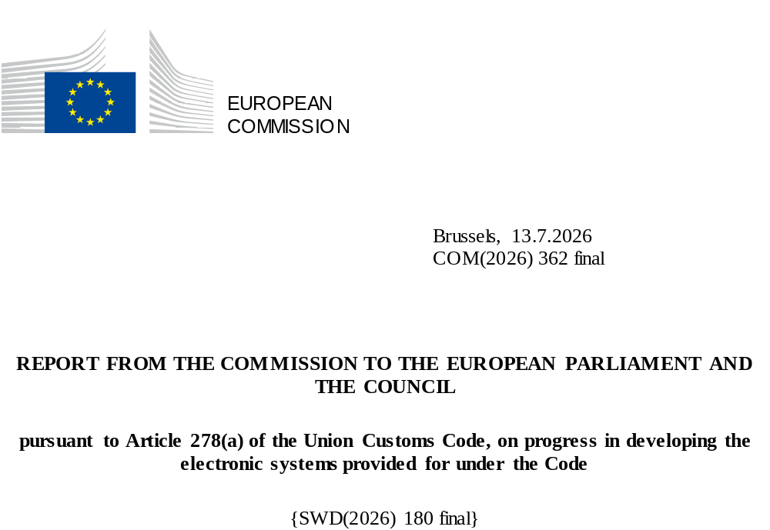

Table of Contents

1. Introduction 2
2. Executive summary 4
3. Content of the Report 5
4. Responsibilities for the UCC digital implementation 6
5. Global overview of progress with the UCC electronic systems 7
5.1 Projects completed before 2025 7
5.2 projects PROGRESS in 2025 7
5.3 Risks AND mitigating MEASURES 17

Introduction
This document constitutes the annual progress report on the digital implementation of the Union Customs Code (UCC) for the year 2025 and is the seventh and last report established by the Commission in accordance with Article 278(a) of the UCC on the progress in developing the electronic systems.
The UCC entered into force on 1 May 2016 and, following its amendment in 2019, it establishes the deadlines of 2020, 2022 and 2025 for the progressive completion of the projects in terms of the digital transition and implementation of the UCC. During the transitional period, the existing electronic and paper-based systems could be used for the completion of customs formalities (the so-called ‘transitional measures’) until the new or upgraded electronic systems envisaged under the UCC are operational.
In this context, the UCC Work Programme (UCC WP) and the Implementing Regulation on the Technical Arrangements for the electronic systems (IRTA) are to be read in conjunction with the UCC and its delegated and implementing acts.
The UCC WP is the legal instrument to steer the gradual and complex three-dimensional transition process towards a fully digital customs environment, taking into account interdependencies between the systems and the situation of the actual development. It is the instrument used to steer the stakeholders in the projects (Member States, Commission, economic operators) towards a common and feasible implementation of the projects by 31 December 2025 as the final end date of the digital transition. The IRTA defines the technical arrangements for each of the systems in terms of components, responsibilities, data access and technical transition.
This report draws on the UCC WP, adopted by the Commission on 15 December 2023, as the baseline for reporting progress. The programme and project governance aspects are defined in the Multi-Annual Strategic Plan for Customs (MASP-C). The report covers the progress accomplished over the years to achieve a fully digital customs in the European Union in 2025, marking the last year of the implementation of the UCC.
Whilst the UCC establishes the legal basis for a fully digital, harmonised customs framework across the European Union and its external borders, its full and uniform implementation across all customs domains and across all Member States represents a pre-requisite of the well-functioning Customs Union and provides the foundation for the next phase of the Customs Reform. It is therefore essential that all Member States complete their share of the implementation of the current UCC to ensure that economic operators and traders get the full benefit before moving into the EU Customs Reform. The Commission adopted on 17 May 2023 a proposal for a comprehensive reform of the Customs Union, including a new UCC, which marks a significant transformation of the EU customs framework. On 26 March 2026, the European Parliament and the Council reached a political agreement in trilogue on the Commission’s proposal for the most ambitious reform of EU customs rules since 1968. The draft text is now expected to be reviewed by legal and linguistic experts and then approved by the Council and the European Parliament for publication in the Official Journal of the European Union by November 2026
The Customs Reform is structured around three main pillars:
- smarter risk management and customs controls through the creation of an EU Customs Authority and EU Customs Data Hub: it will digitalise and simplify procedures, reduce costs and red tape, promote a more uniform approach at the external border, and better protect the Single Market through stronger, data-driven risk management and enforcement;
- a stronger parthnership with business: a new partnership with trade operators based on transparent processes that will allow compliant trade flows to operate without formal customs interaction and will alleviate the related administrative burden;
- a modern framework for e-commerce: a tailor-made e-commerce customs regime, which will make online platforms the key actors in ensuring that goods sold online directly to consumers in the EU comply with all customs obligations.
Customs play a vital role in maintaining the safety of the Single Market and its citizens. With the Customs Reform, European customs will be equipped to adapt to the fast-changing landscape of international trade. In this context, the reform introduces several targeted measures to address the rapid growth in e-commerce. Meanwhile, as a temporary solution, the Commission and Member States agreed in November 2025, to remove the duty exemption that had been in place so far for parcels valued below €150 and to introduce a €3 duty on these parcels, starting 1st July 2026. The removal of the threshold aims to level the playing field between e-commerce sales and traditional retail, restoring fairness while maintaining choice for consumers. Furthermore, with the agreement in trilogue of 26 March, a handling fee on low value goods imported into the EU is being introduced, to compensate for the increasing costs for customs authorities. The fee will be introduced no later than 1 November 2026. Once the EU Customs Data Hub is fully operational, normal customs duties will apply.
It should be noted that, at this stage with all the political focus on the Customs Reform and e-commerce, there is a risk that the delays in the digital implementation of the UCC are overlooked as simple technical delays, while the systemic consequences of these delays could be serious for the EU. Malfunctioning or only partially deployed export/import systems could lead to congestion at major exit or entry points, creating protests, supervision failures and supply chain delays. Moreover, misaligned data could lead to the release of high-risk goods (dual-use, sanctioned goods, undervalued imports) to circulate before full risk analysis, including by limiting the Commission’s capacity to detect issues, and devise a reaction strategy in time.
The timely completion of the UCC digital programme is a strong priority in order to materialise the benefits introduced for traders in the UCC, for instance through further harmonisation of processes, digalisation by design, underpinned by an internationally aligned and integrated EU Customs Data Model, and far-reaching simplifications for trusted traders. The completion of the UCC digital implementation is in that sense crucial to support and feed into the Customs Reform and the development of the future EU Customs Data Hub, as to ensure that the significant simplifications promised by the Customs Reform would be built on a strong base of harmonisation and digitalisation.

Executive summary
The implementation of the UCC has reached its final and decisive year. Since the adoption of the UCC Work Programme in 2014, the collective effort of the Commission, Member States and economic operators has been instrumental in progressing towards a fully digital customs environment. By early 2025, 70% of the digital work programme had been completed. Throughout 2025, the implementation process has been marked by significant progress and several major milestones across both trans-European and national systems have been achieved, reflected in a steady shift towards a largely “green” implementation landscape across Member States. This report demonstrates that the UCC digital implementation has been almost completed by the end of 2025, as visually represented in Figure 1. The projects marked in green are finished; the projects marked in orange indicate the areas where less than 90% of the Member States are ready, and the ones marked in yellow indicate where between 90% and 99% of the Member States are ready.

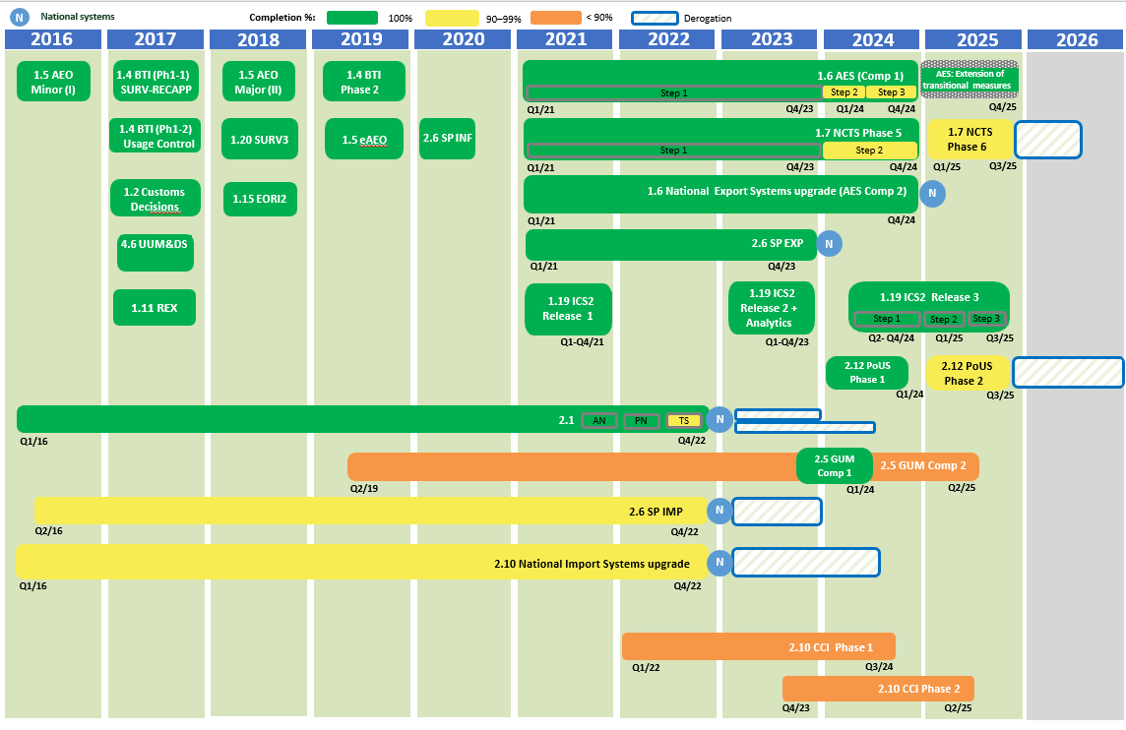
Figure 1 – Planning Overview

To this day, the Union Customs Code (UCC) digital implementation has been mostly completed, with the substantial majority of UCC systems now deployed and Member States working in a fully integrated UCC digital environment. 96% of all the national systems and 100% of all the centralised trans-European systems are deployed by the end of 2025. The remaining challenges are limited, and country and project specific. They no longer concern the overall architecture of the UCC but relate to residual delays or transitional issues in a small number of Member States. The project for Centralised Clearance at Import is the most critical one. Other projects requiring specific follow up in some Member States are: the deployment of the national system on Temporary Storage, and the National Import System, as well as the deployment of the national component for Guarantee management, the Automated Export System (non-core), the New Computerised Transit System – Phase 5 (non-core) and Phase 6 (under derogation till 31 May 2026) and the Proof of Union Status – Phase 2 (under derogation till 1 March 2027).
They remaining activities concern mainly the completion of final upgrades by some Member States, testing or pre-deployment system validations, transition of economic operators of recently deployed systems, and interconnections between systems. In this context, the Commission has adopted three derogation decisions in 2025 to provide legal certainty and business continuity, primarily to support the transition of economic operators for the submission of EU border security requirements in combination with transit (ICS2 - Release 3 and NCTS – Phase 6) and for the submission of the customs goods manifest as a proof of union status (PoUS – Phase 2). They remain limited in scope and timeline extension, and detailed monitoring mechanisms have been put in place to closely follow up on progress until full completion.
In addition, the Commission decided in 2025 to pursue legal actions against fourteen Member States in total for failing to meet their obligations under the UCC and its implementing acts. These concern two main types of non-compliance: the first relates to the deployment of customs digital systems (i.e. Temporary Storage for Air transport, National Import System, the Automated Export System, including ensuring operational readiness and migration of economic operators’ systems, affecting ten Member States in total and the second concerns the transmission of the full set of 57 standardised customs data elements in the required format via the Surveillance system, which is essential for the collection, monitoring, and risk management of EU customs data, affecting thirteen Member States in total.
The Commission’s activities in view of a combination of planning, coordination, support to specific Member States, monitoring and enforcement has proven effective.
By the end of 2025, most of the concerned Member States managed to address the delays appropriately. With a limited set of residual deployments extending into 2026 and, in a few specific cases, into 2027, the remaining gaps are clearly identified, time-bound and under close follow-up. They are either covered by derogation decisions and/or subject to reinforced monitoring and, where necessary, subject to enhanced enforcement measures. At the same time, however, the difficulties faced by Member States in implementing critical projects, most notably national systems and components have underlined the fragility of a joint adventure of a complex digital transformation, engaging the Commission, the 27 Member States and thousands of economic operators towards a commonly agreed scope and completion date. It requires integration of new systems to existing ones and interoperability between different domains such as export followed by transit. The complexity becomes even more critical when requiring interoperability with other digital non-customs transformation programmes such as the European Maritime Single Window environment.
Looking back at the overall experiences in the digital transformation and implementation of the UCC Work Programme over a period of 10 years, there was a clear pattern identified. Member States highlighted that the most significant difficulties they encountered for achieving a successful completion were: (1) governance structures enabling timely decision-making, (2) sustaining the engagement of stakeholders, and (3) defining and maintaining a clear scope.
Overall, the end-2025 deadline marked the formal closure of the UCC digital implementation. With the core digital framework under the UCC being now operational at EU level, a major achievement has been reported which will reinforce the control of the EU external borders and of trade flows at a time of major geopolitical and geoeconomic turbulences. The Customs Union is now in a position to move from transition and delivery to consolidation and stabilisation, with the UCC providing a solid and credible foundation for the forthcoming Customs Reform.

Content of the Report
The projects listed in the UCC WP can be divided into three categories of systems based on the definitions provided for in the IRTA:
- Central trans-European systems to be developed or upgraded by the Commission (often also requiring developments or upgrades of the national systems by the Member States);
- Decentralised trans-European systems that have to be developed or upgraded by the Commission but have a major national component to be implemented by the Member States;
- National systems that have to be developed or upgraded exclusively by the Member States.
This report starts with explaining the method for the creation of the report and the sources used (section 2) and then shortly covers the responsibilites for the UCC electronic systems (section 4). Furthermore, it contains the global overview of the different projects and their progress (section 5) and also highlights the risks and the mitigating measures (section 6).
This report is accompanied by a Commission’s Staff Working Document, published alongside this report, which contains detailed information on the planning and progress of the different projects as reported by the Member States by the end of June 2025. This work was supported by an external contractor. The latest updates from the Member States were mainly covered in the report.
The report and Staff Working Document are drawn up on the basis of information collected from the following sources:
(1) national project plans that the Member States are required to provide twice a year (January and June), and a further update was requested towards the end of 2025.
The information gathered for each project includes specific dates, the status, and the progress for each of the milestones set in the UCC WP;
(2) survey circulated to the Member States.
The information captured the assessment of risk, delays, and reasons for any such delays, as well as the mitigating measures planned and/or taken in relation to the projects. Moreover, continuing with the approach taken in 2023, the Member States also provided information on the lessons learnt during the development of the projects and on the possible additional support needed;
(3) bilateral high-level meetings with the Member States.
During the bilateral meetings a full and accurate understanding of the status of each of the UCC projects is obtained from the Member States, including the issues they were encountering, and ideas are generated for improving problematic situations.
(4) outputs from the trans-European coordination and monitoring programmes.
This report also contains an analysis based on more detailed information provided by the Project Managers in the Commission’s Directorate-General for Taxation and Customs Union (DG TAXUD) and reported by the Member States in the framework of the Coordination Programmes in place since 2020 for the trans-European systems.

Responsibilities for the UCC digital implementation
Dependent on the architecture agreed by the Member States and the Commission for each of the systems (centralised, decentralised or national), there is a role sharing defined as regards to the responsibilities for the development, deployment, operation, and maintenance of the systems related to the UCC digital implementation. This is laid down in the IRTA, which describes what components those systems consist of, and what their nature is – national (developed at national level) or common (developed at EU level). In terms of architecture, the central systems and decentralised systems are of a trans-European nature and contain common components by default, sometimes in combination with national components, whilst the national systems only consist of national components.
In accordance with Article 103 of the IRTA, the common components shall be developed, tested, deployed, and managed by the Commission and may be tested by the Member States. The national components shall be developed, tested, deployed, and managed by the Member States.
The Member States shall ensure that the national components are interoperable with the common components. The Commission shall design and maintain the common specifications for the decentralised systems in close cooperation with the Member States. The Member States shall develop, operate, and maintain interfaces to provide the functionality for the decentralised systems necessary for the exchange of information with Economic Operators and other persons through national components and interfaces, along with other Member States through common components.

Global overview of progress with the UCC electronic systems
The UCC WP contains seventeen projects leading to the deployment of the required electronic systems including fourteen trans-European projects for which the Commission and the Member States are responsible (resulting in central and decentralised systems) and three national projects falling under the sole responsibility of the Member States (resulting in national systems).

Projects completed before 2025
The Commission has delivered all the digital projects under its responsibility. The Member States have further progressed on the systems and components. As defined in the previous reports, this has led to the successful deployment of the following twelve new systems or upgrades:
- UCC Registered Exporter System – REX (new): Deployed in 2017;
- UCC Customs Decisions – CDS (new): Deployed in 2017;
- UCC Direct Trader Access to the European Information Systems – UUM&DS (Uniform User Management & Digital Signature) (new): Deployed in 2017;
- UCC Economic Operator Registration and Identification System 2 – EORI2 (upgrade): Deployed in 2018;
- UCC Surveillance 3 – SURV3 (upgrade): Deployed in 2018;
- UCC Binding Tariff Information – BTI (upgrade): Deployed in 2019;
- UCC Authorised Economic Operators – AEO (upgrade): Deployed in 2019;
- UCC Information Sheets for Special Procedures – INF (new): Deployed in 2020;
- UCC Import Control System 2 – Release 1 & 2 – ICS2 - Release 1 & 2 (upgrade): Deployed in 2021 and 2023, respectively.
- UCC Guarantie Management – component 1 – GUM C1 deployed in 2024
- UCC Proof of Union Status phase 1– PoUS deployed in 2024
- UCC New Computerised Transit System phase 5– NCTS P5 deployed in 2024

projects PROGRESS in 2025
This report aims to highlight the accomplishments, progress and challenges encountered in the implementation of the ongoing projects in 2025 by the Commission and the Member States.

5.2.1 Trans-European projects
The trans-European projects follow a particular structure, which may entail a central system or a combination of central and national components. As stated in Article 278(3) of the UCC, they are required to be completed no later than 31 December 2025. A concise description and progress for each project is presented below. For more details, please refer to section 3 and 4 of the Commission Staff Working Document accompanying this report.
- UCC Guarantee Management – GUM (new): aims to ensure the effective and efficient management of various types of guarantees across the EU, focusing on improving processing speed, traceability, and monitoring of guarantees between customs offices. Guarantee management is done on two levels. In essence, the so-called GUM central component (Component 1) is used for the management of authorizations for comprehensive guarantees (including the registration of the reference amount, split per customs procedure and per Member State concerned), whilst the registration and management of comprehensive guarantees and the monitoring of the related reference amounts is done on national level in a UCC-compliant guarantee management component (Component 2) developed nationally, which also includes the registration and management of other types of guarantees.
Progress: GUM – Component 1 that centrally manages guarantees that can be used across multiple Member States, became operational on 11 March 2024 within the Customs Decisions System. In view of the interconnection between the two components, conformance testing activities remain available until Member States implement their GUM – Component 2 systems.
Concerning the national component, GUM – Component 2, Member States were expected to establish operational connections with the central component between 11 March 2024 and 2 June 2025. Ten Member States ensured the timely deployment of their national component.
By the end of 2025, 21 Member States deployed GUM – C2, meaning a completion rate of 78%. The remaining 6 Member States (DK, FR, GR, HR, CY and IT) plan to be ready early 2026.
- UCC Import Control System 2 – ICS2 (upgrade): aims to strengthen the Safety and Security of the supply chain by improving data quality, filing, availability and sharing of advanced cargo information.
Progress: The ICS2 – Release 3 extends the scope from air transport to maritime and inland waterways, road, and rail traffic. Whilst Releases 1 and 2 are fully implemented as part of the ICS2 project, work continued for Release 3. Economic operators are to use the ICS2 – Release 3 in three steps: maritime and inland waterways carriers by 4 December 2024 (step 1), maritime and inland waterways traffic by 1 April 2025 (step 2) and road and rail carriers, including goods in postal consignments transported by these means of transport, by 1 September 2025 (step 3).
As it concerns a central system, conformance testing activities for this release are exclusively carried out by economic operators. Mid 2025, there were worrying signs by some Member States as regards the readiness of the economic operators for step 3 of the ICS2 - Release 3.
The need to integrate ICS2 with the smart border systems, the large number of economic operators that have difficulties obtaining a registration from a Member State for connection to the IT systems, the complexity of the rollout of the ICS2 system and the resources necessary for the interoperability with national systems, and interfaces, for both Member States and economic operators, as well as the specific and complex nature of the transportation mechanisms affected by this rollout, which includes multi-modal forms, have been proven to disproportionately affect some Member States and economic operators more than others. To ensure legal certainty, business continuity and a smooth transition to fulfilling the requirements of ICS2 Release 3, step 3, the Commission granted a derogation requested by certain Member States and the United Kingdom in respect of Northern Ireland pursuant to Regulation (EU) No 952/2013 of the European Parliament and of the Council for Release 3 of the Import Control System 2 (IE, GR, ES, FR, IT, LT, HU, FI and the UK in respect of XI) until 31 December 2025.
By the end of 2025, the ICS2 is used in all Members States by the given deadline, meaning a completion rate of 100%, marking another major milestone accomplished in 2025.
- UCC Proof of Union Status – PoUS (new): aims to store, manage, and retrieve all proofs to demonstrate that traders provide the Union status of their goods. Due to dependencies with the UCC Customs Goods Manifest (CGM) and the European Maritime Single Window environment (EMSWe), the project will be completed in two different phases to minimise risks and inconsistencies.
Progress: PoUS – Phase 1 started operations on 1 March 2024 as planned.
Regarding PoUS – Phase 2, the technical specifications were completed by the Commission in 2023 and the conformance testing activities were concluded in 2025. The Commission ensured the central system was operational on 15 August 2025, in line with the deadline referred to in the UCC WP. A few Member States decided to use their national system and to connect it to the central one (hybrid mode). The Commission’s and Member States’ customs departments ensured a timely delivery of the project by the legal deadline. Member States’ maritime departments were supposed to implement the interconnection between the PoUS and the European Maritime Single Window environment (EMSWe) to allow facilitation to traders and enable them to submit all data (including customs manifest data) through a new single maritime portal at national level. To this end, both deployment dates in the EU legislation were aligned.
However, as a result of the late implementation of the EMSWe, the maritime transporters were to face important hurdles if they were to use the PoUS without having the national maritime single windows under EMSWe in place. The Commission therefore granted a derogation pursuant to Regulation (EU) No 952/2013 of the European Parliament and of the Council for the PoUS - Phase 2 to certain Member States (BE, BG, CY, DE, DK, EE, IE, FI, FR, HR, IT, LV, NL, PL, PT, SE and SI) until 1 March 2027.
- UCC Centralised Clearance for Import – The new Trans-European CCI system ensure the digitalisation of the centralised clearence process at European level as defined in the Union Customs Code (UCC). It allows trusted traders to submit a customs declaration at the supervising customs office in the member state of their establishment, for goods physically presented to a customs office in any other member state, enabling customs declaration processing and physical release of goods in digital, efficient, predictable and coordinated way among the customs offices located in different Member States. The CCI system is being implemented in two phases.
CCI – Phase 1, enables an automated processing of standard and simplified declaration including pre-lodged customs declaration, as well supplementary declaration with a periodic or general nature for placing goods under release for free circulation, customs warehousing, inward processing and end use.
CCI – Phase 2, builds upon Phase 1 by extending the scope to all remaining CCI scenarios, including more complex declaration types and process flows. It aims to complete the digital integration and functionality of centralised clearance for imports across the EU. Both phases are interrelated and some Member States have opted to implement both phases simultaneously to streamline national efforts.
Progress: For CCI – Phase 1, the system entered its first phase implementation on 1 July 2024 with the readiness of the common components and some of the national components. By 2 June 2025, the system was available for use by European businesses in 10 Members States (BG, EE, ES, LU, LT, LV, PL, RO, HR, and IT). By October 2025, 2 more MS joined the CCI system (BE and SE).
As illustrated in Figure 2, by the end of 2025, a total of 17 Member States (BE, BG, HR, CY, EE, FI, IE, IT, LV, LT, LU, MT, PL, RO, SI, ES, SE) had deployed their CCI P1 system, meaning a completion rate of 63%. The remaining 10 Member States (AT, CZ, DE, DK, FR, GR, HU, NL, PT, SK) are scheduled for deployment throughout 2026.

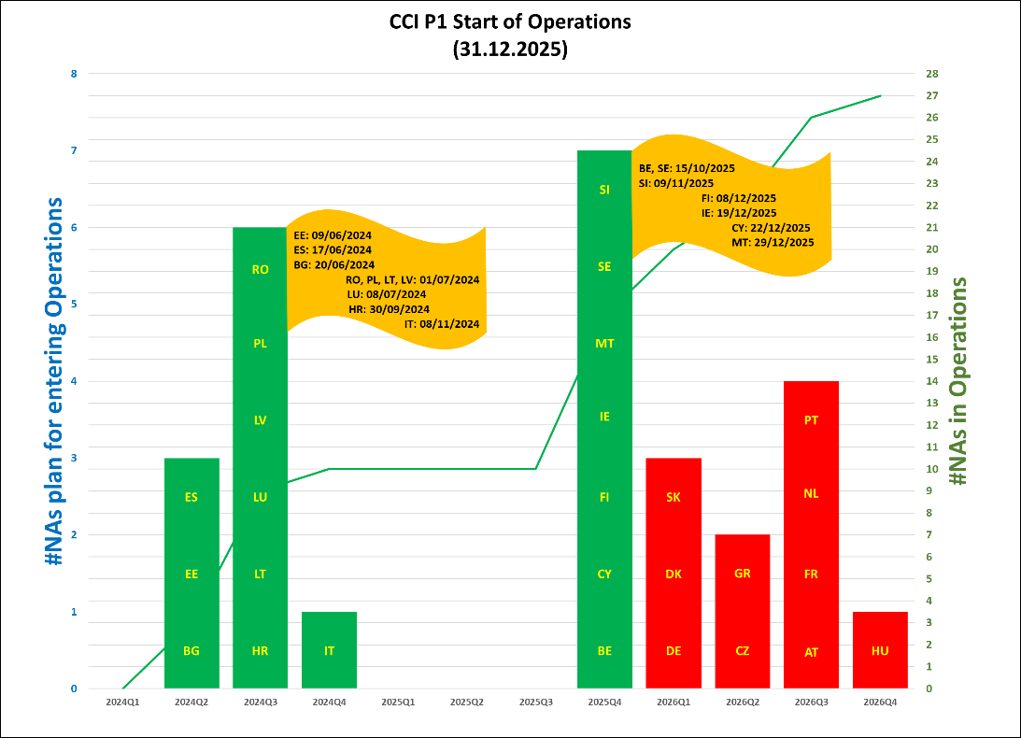
Figure 2: CCI P1 Member States in operations (situation on 31 December 2025)

As regards to CCI – Phase 2, the Commission finalised the technical specifications in 2022. To assist the Member States and traders in implementing all CCI scenarios and processes, the Commission developed a full scope technical specifications package consolidating the specifications for both phases, along with a guide. The assessment mid 2025 showed that whilst most Member States were progressing in the developments, a substantial number of Members States did not meet the final deployment milestone on 2 June 2025.
By the end of 2025, as illustrated in Figure 3, there was on overall level of full CCI completion of 44% (12 MS). Based on the updated NPPs, the majority of the remaining Member States envisage completing their conformance test activities in the first quarters of 2026 and plan the deploy the CCI full scope subsequently, with DE, DK, SK, GR and CZ to come in the first half of 2026 and AT, FR, NL, PT and HU in the second half.
The Commission will continue with its quarterly monitoring programme till CCI is completed.
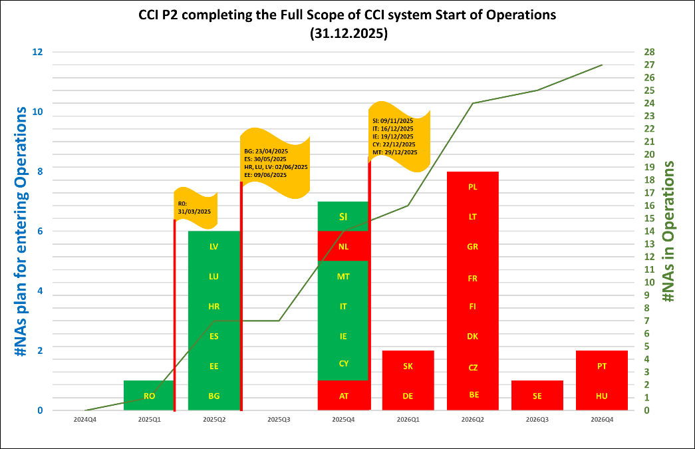
Figure 3: CCI P2 Member States in operations (situation on 31 December 2025).

- UCC New Computerised Transit System – NCTS (upgrade): aims to align the existing Union and common transit system to the UCC legal provisions, including the UCC data requirements and the interfaces with other systems.
Progress: The NCTS - Phase 5 system became operational on 2 December 2024 and the transitional measures were ended on 21 January 2025. All Member States are currently successfully operating in NCTS – Phase 5. Some Member States are still to finalise the non-core functionalities.
The New Computerised Transit System (NCTS) continues to evolve as part of the wider modernisation of customs processes across the EU and Common Transit Convention (CTC) countries. While all Member States completed the rollout of NCTS Phase 5 on 21 January 2025 and in total 41 countries apply Union/common transit and NCTS, the attention has now shifted to the next phase of NCTS.
For NCTS – Phase 6 offers two options, and it is up to the Member States to decide which option they implement:
- Opt-out option means when ENS particulars are not included in the transit declaration, and ENS is lodged directly to ICS2;
- Opt-in option means when ENS particulars are included in the transit declaration and NCTS – Phase 6 is connected to the ICS2 to ensure that ICS2 requirements regarding ENS business processes (risk analysis, control recommendations, decisions etc.) are also fulfilled.
The timeline of the NCTS – Phase 6 was synchronised with that of ICS2. In the first half of 2025, the Member States indicated to be progressing well, though several reported a medium to high risk level for the timely deployment by 1 September 2025.
As Member States did not manage to properly address the risk of delays throughout 2025, it resulted in a situation of non-readiness of the NCTS – Phase 6 by 1 September 2025. For the Member States making use of the opt-out option, the minimal transitional changes were dealt with at technical level. For the opt-in option, the delays were having impact on other Member States and on the economic operators as they would not be able to benefit from streamlined filing of transit and safety and security data. To avoid extra burden on the economic operators (including those of neighbouring countries such as Ukraine and Türkiye), the Commission granted a derogation to six Member States pursuant to Regulation (EU) No 952/2013 of the European Parliament and of the Council for the use of Phase 6 of the New Computerised Transit System until 1 June 2026. These derogations foresee that rail and road operators may connect to ICS2 until the end of 2025, and that connection to the transit system (NCTS Phase 6) interfacing with ICS2 may take place until 31 May 2026. This additional time extension was justified, in recognition of the more complex development and testing required for this interconnection. The derogation entails legal requirements for the Member States to report progress to the Commission.
By the end of 2025, six MS received a formal derogation (BG, HR, LV, PL, RO, SK) and a total of sixteen Member States (AT, BG, CY, CZ, DE, EE, ES, FI, IE, IT, LT, LU, LV, MT, PT, SI) deployed the NCTS – Phase 6. Taken into consideration the derogations granted, this means a compliance rate of 74%. DK, FR, HU, SE schedule deployment of their system before 1 March 2026. The remaining seven Member States (BE, GR, HR, NL, PL, RO and SK) intend to deploy their system at the latest by 1 June 2026, in line with the derogation extension.
- UCC Automated Export System – AES (upgrade): aims to implement the UCC requirements for export and exit of goods, as well as the UCC Simplifications offered to trade.
Progress: According to the 2023 UCC WP, Member States can deploy AES in three steps: core functionalities by 1 December 2023, interface with Excise by 13 February 2024, and non-core functionalities by 2 December 2024. The transitional period for economic operators was extended till 14 December 2025. However, as stated in the previous report, the full development of the national components by Member States was not feasible, as some Member States were not able to meet the deadline of 2 December 2024 nor the end of the transitional period of 11 February 2025 and requested an extension of the transitional measures. In this context, the legal amendment to the Implementing Regulation for Technical Arrangements (IRTA), voted on 7 February 2025 in the Customs Code Committee and adopted on 13 March 2025, included the extension of the transitional period till 14 December 2025.
As illustrated in Figure 4, twelve Member States started operations with core functionalities on 1 December 2023 and during 2024 and 2025 other Member States joined. However, the situation became critical again in the second half of 2025 due to the late deployment of some Member States (HU, PT, MT, FR, GR) resulting in leaving a medium to very tight window to the economic operators for transitioning to the new AES. In some countries, such as France, this was entailing a big risk of long queues of trucks at the exit points of the EU. Through enhanced monitoring and support provided by the Commission and the engagement of the Member States and the economic operators, the AES went live across the EU on 15 December 2025. This achievement of 100% completion rate of the AES deployment with its core functionalities was a major milestone contributing to digital implementation of the UCC.
Some Member States face further delays with the deployment of the non-core functionalities.

Regarding the AES – Component 2, most Member States have deployed the component in 2025.
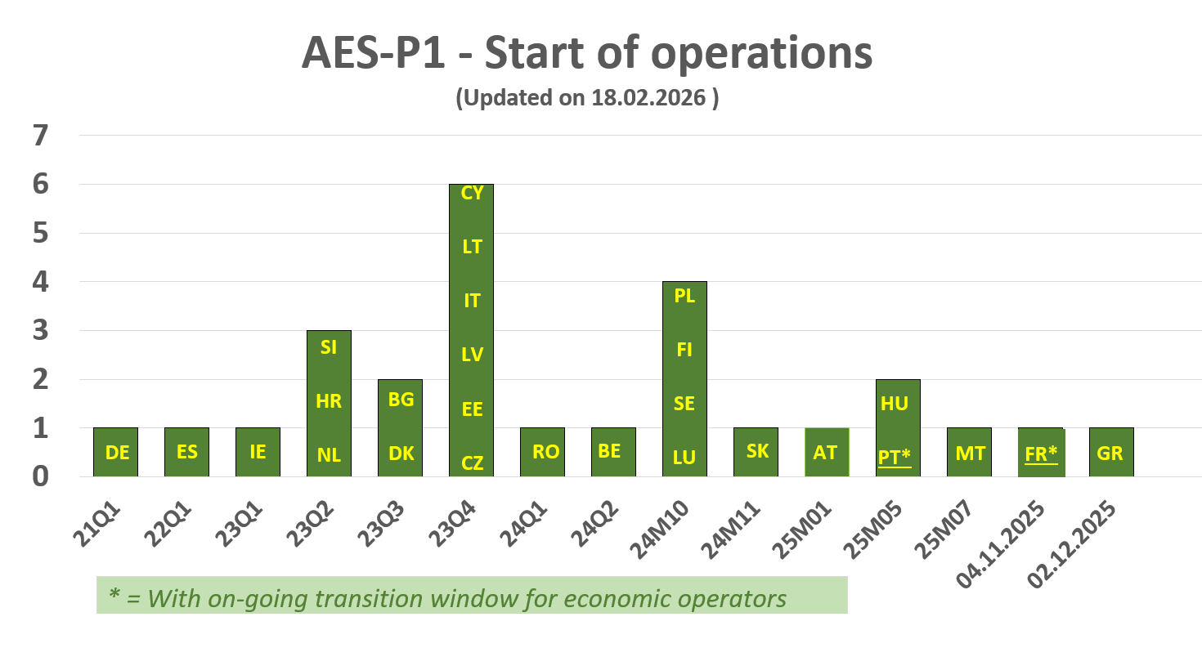
Figure 4: AES Member States entry into operations

To summarise the status of the trans-European projects listed above, the Commission remained on track to meet the legal deadlines agreed upon in the context of the UCC and UCC WP. As regards the Member States’ deployments of the national components of these trans-European systems, serious risks for delays were identified during 2025, particularly for CCI , NCTS - Phase 6, ICS2 Step 3 rail and road, PoUS and AES (see section 5.3). By the end of 2025, the system related to the PoUS – Phase 2 project was deployed, AES entered into operations with the core functionalities in all Member States and ICS2 was operational for all modes of transport. Beyond 2025, there is a situation of non-compliance for the pending deployments of CCI and AES non-core functionalities in certain Member States.

5.2.2 National projects
The Member States were due to complete the upgrade of their systems for the three fully national projects by 31 December 2022, in accordance with Article 278(2) of the UCC. However, twenty-two Member States could not meet this deadline and following their request, were granted a derogation, extending the deployment deadline to 31 December 2023.

Last year’s report reflected some further delays mainly for the National Import System and the system for Temporary Storage. The progress for each national project in 2025 is presented below and illustrated in Figure 5. For more details, refer to section 3 of the Commission Staff Working Document accompanying this report.
- UCC Notification of Arrival, Presentation Notification, and Temporary Storage (AN, PN, and TS) (upgrade): aims to automate the national entry processes and harmonise data exchange between trade and customs across the Member States.
Progress: The timely delivery of national systems was identified as being at risk in previous reports, but substantial progress was made during 2025. During 2025, some Member States were still facing delays with deployment of the system for Temporary Storage and/or with the transition of their economic operators. As these cases went well beyond the legal deadline, the Commission launched an infringement procedure for failing to fully comply with the legal obligation to deploy Temporary Storage – Air transport against eight Member States (AT, BE, CY, DK, GR, PT, RO, SK).
At the end of 2025, most of the late Member States did manage to deploy their system. This can be summarised as a completion rate of 98%. As illustrated in Figure 5, for the Notification of Arrival and the Presentation Notification, all Member States completed the implementation. For the Temporary Storage, three Member States were facing further delays and indicated a deployment date beyond 2025. In the case of AT, full implementation is envisaged by April 2026, whilst GR and SK plan implementation in 2027. As the Commission cannot accept any lateness, the infringements proceedings are continuing.
- UCC National Import Systems – NIS (upgrade): aims to implement all process and data requirements that relate to the imports of goods as outlined in the UCC.
Progress: Several Member States reported risks in the timely delivery of the project since 2022, the initial deadline for Member States’ deployment of NIS. In the first half of 2025, some Member States were still facing delays with the deployment of NIS and/or with the transition of their economic operators. Therefore, the Commission initiated an infringement procedure in the first half of 2025 for failing to fully comply with the legal obligation to deploy NIS against eight Member States (AT, CZ, CY, DK, GR, FR, PT, RO). During 2025, most Member States (AT, CY, DK, MT, PL, SK) took action to address the delays and completed the project in 2025.
By the end of 2025, all Member States except one deployed the system, meaning a completion rate of 96%. In the case of CZ, full deployment is envisaged in Q2 2026. In a few Member States certain upgrades are still pending to have a fully UCC and EUCDM compliant implementation.
- UCC Special Procedures – SP (upgrade): aims to harmonise Special Procedures (i.e., customs warehousing, end-use, temporary admission and inward/outward processing).
Progress: As illustrated in Figure 5, most Member States were due to have SP IMP – Component 2, meaning a completion rate of 96% with AT and CZ, being the last Member States to deploy their system in Q2-3 2026. As for SP EXP – Component 1, most Member States had deployed the system by 2 December 2024 despite the interdependencies with the AES system. The remaining Member States (AT, FR, GR, HU, MT and PT) deployed the system by the end of 2025, meaning a completion rate of 100%, whilst for some Member States the transition of the economic operators was still ongoing.
To summarise, significant efforts were made by Member States in 2025, and the national systems are now operational, while only a limited number of critical delays persist beyond 2025 bringing few Member States in a situation of non-compliance.
 | AN | PN | TS | NIS | SP IMP
UCC WP Deadline | 31/12/2022  with extension to 31/12/2023^{[1]} |  |  | 31/12/2022  with extension to 31/12/2023^{[2]}
AT | 01/07/2023 | 16/05/2023 | 15/04/2026 | 14/12/2025 | 01/09/2026
BE | 30/06/2023 | 05/07/2023 | 29/11/2023 | 28/08/2024* | 28/08/2024
BG | 01/03/2023 | 10/11/2023 | 10/11/2023 | 10/11/2023 | 10/11/2023
CY | 30/10/2024 | 30/10/2024 | 30/10/2024 | 19/05/2025 | 19/05/2025
CZ | 05/12/2023 | 05/12/2023 | 05/12/2023 | 18/05/2026 | 18/05/2026
DE | N/A | 06/03/2021 | 06/03/2021 | 06/03/2021 | 06/03/2021
DK | 06/11/2023 | 06/11/2023 | 07/06/2025 | 07/06/2025* | 07/06/2025
EE | 01/10/2023 | 15/03/2021 | 01/07/2021 | 01/07/2021 | 01/07/2021
ES | 01/03/2023 | 01/01/2024 | 01/01/2024 | 05/09/2023 | 05/09/2023
FI | 31/03/2023 | 31/03/2021 | 31/12/2022 | 31/12/2022 | 31/12/2022
FR | 30/06/2023 | 06/03/2024 | 06/03/2024 | 30/11/2024* | 30/11/2024
GR | 31/12/2023 | 31/12/2023 | 31/12/2027 | 06/08/2024* | 06/08/2024
HR | 01/07/2023 | 01/03/2023 | 17/04/2023 | 01/01/2023 | 01/01/2023
HU | 02/04/2024 | 02/04/2024 | 02/04/2024 | 01/11/2023 | 01/11/2023
IE | 01/07/2023 | 23/11/2020 | 23/11/2020 | 05/10/2021 | 23/11/2020
IT | 13/12/2022 | 13/12/2022 | 13/12/2022 | 01/07/2021 | 01/7/2021
LT | 01/03/2023 | 28/02/2023 | 31/10/2023 | 31/12//2023 | 31/12/2023
LU | 01/03/2023 | 10/01/2023 | 10/01/2023 | 02/05/2023 | 02/05/2023
LV | 24/09/2017 | 24/09/2017 | 24/09/2017 | 04/06/2018 | 04/06/2018
MT | 24/03/2025 | 24/03/2025 | 24/03/2025 | 24/03/2025 | 24/03/2025
NL | 30/06/2023 | 01/12/2023 | 01/12/2023 | 01/04/2022 | 01/04/2022
PL | 01/07/2023 | 20/04/2025 | 20/04/2025* | 20/04/2025* | 01/07/2021
PT | 30/09/2025 | 30/09/2025 | 30/09/2025 | 01/10/2025 | 30/09/2025
RO | 01/05/2024 | 30/09/2024 | 30/08/2025 | 30/08/2025 | 30/08/2025
SE | 01/03/2023 | 27/09/2023 | 02/12/2025 | 15/03/2022 | 23/02/2023
SI | 01/03/2023 | 01/03/2023 | 01/03/2024 | 01/01/2022 | 01/01/2022
SK | 01/03/2023 | 01/10/2023 | 31/03/2027* | 30/09/2025* | 11/06/2016
Completion rate by 2025 | 100% | 100% | 89% | 96% | 93%
Legend
 | Deployment completed by 31/12/2025
 | System not deployed by 31/12/2025
 | No dates provided in National Project Plans or deployment not applicable

Figure 5: National entry/import systems deployment planning

^{[1]} Until 31/12/2023 for the Member States that were granted a derogation.
^{[2]} Until 31/12/2023 for the Member States that were granted a derogation or until 01/07/2024, where Article 2(4a) of Commission Delegated Regulation (EU) 2015/2446 applies.
* The national system was upgraded on time but requires a further alignment to the UCC and EU Customs Data Model and/or the transition of the economic operators is still ongoing.

5.2.3 Surveillance Data
In this year’s report, we would like to highlight the remaining challenges concerning the transmission of the required data to the Surveillance 3 system (SURV3). The Commission’s Surveillance System plays a crucial role in the current geo-economical and geo-political climate. Its primary goal is to create a comprehensive surveillance framework that monitors trade flows, protects the Union’s financial interests, and shields its internal market from unfair or irregular practices. This system provides the analytical foundation for detecting trade anomalies, preventing fraud, and ensuring fair competition for EU industries. As regards the Surveillance 3 system, which serves as the technical backbone of the EU’s customs data monitoring architecture as it collects and processes trade data from the customs declarations submitted to the Member States’ customs administrations, the quality and availability of data reported through NIS are vital.
As a substantial number of Member States continued submitting most of their import data using old systems. This number decreases to two Member States (AT, FR) when considering export data.
In the light of the above, the Commission launched in 2025 infringement procedures against thirteen Member States (AT, BE, CY, CZ, DK, FR, IE, IT, MT, PT, RO, SI, SK) for failing to fully comply with the SURV3 data transmission obligations, particularly regarding data completeness and format conformity.
Whilst 5 Member States (BE, IT, MT, RO, SI) managed to take appropriate action in the course of 2025, a total of eight Member States (AT, CY, CZ, DK, FR, IE, PT, SK) was still not submitting the full set of import data to SURV3 by the end of 2025. This can be summarised as a completion rate of 70%.

5.2.4. State of play for enlargement countries
The EU Enlargement countries and other countries such as the contracting parties to the Common Transit Convention (CTC) need to take into account of the transition towards the upgraded electronic systems of the UCC and the new digital approaches set up by the Customs Reform proposal.
The Commission does not systematically monitor the progress towards full electronic systems of these countries as part of the reporting obligation under Article 278a of the UCC. However, as part of the enlargement strategy including the Association Agreements with the EU, the development of a digital strategy and of the digital landscape supporting their alignment with EU customs legislation is a key element in the regular assessments carried out by the EU.
The candidate countries will need to progressively connect to or put in place the UCC systems in the path towards joining the EU customs territory. Depending on the planned date of accession, they may also be required to meet the functionalities of the future EU Customs Data Hub proposed in the Customs Reform package.
In the future, in preparation for the Enlargement involving candidate countries, several key activities will need to occur regularly. These include reporting on the digital implementation and taking part in conformance testing to ensure interoperability between their national systems and those of the Member States and of the EU. Additionally, the EU will need to regularly assess the performance of the systems.

Risks AND mitigating MEASURES
Role sharing has been defined and agreed with all stakeholders from the outset, and should be respected throughout the project lifecycles. With the Commission successfully achieving a 100% completion rate for the deployment of the central systems and components under its responsibility, and the Member States having reached a very important degree of implementation as well by the overall 2025 deadline for the digital transition, the risks and mitigating measures remain only relevant for a small part of the overall digital implementation.
As explained also in the previous reports, the underlying reasons reported by the Member States for the delays are multifaceted and largely recurring. They include shortages of financial and human resources, competing national IT priorities and interdependencies with other projects. In addition, Member States have highlighted the inability of some national IT infrastructures to cope with the technical requirements, capacity issues of contractors, and dependencies with external stakeholders. Other contributing factors include extended conformance testing, readiness levels of economic operators, lengthy public procurement procedures, governance challenges, and the complexity of integrating new systems into existing IT landscapes.
The Member States outlined in the survey also the various mitigating actions identified and put in place to address the delays encountered. These actions include optimising the allocation of resources, adopting agile methodologies, implementing integrated systems solutions, and strengthening coordination with contractors to improve the efficiency and enhancing collaboration. Other Member States set up actions to improve organisational structures, streamline processes, and refine planning to improve project management and decision-making. These measures were referred to for both national and trans-European projects.
As regards the national projects, an overall completion rate of 96% has been achieved at the end of 2025 for the national deployments of the national entry and import systems. Besides the few late Member States, some other Member States are still providing the old and the new system to their economic operators and/or are still preparing for some minor upgrades of their national systems to have 100% compliance with the UCC and the EU CDM. The full completion is vital in view of the impact on the trans-European systems such as CCI, and on the data submission to the Surveillance system. For the Surveillance System to work properly, it is imperative that all Member States transition to the new data formats as soon as possible. This will enhance data availability, improve data quality, and strengthen the system's ability to monitor trade flows and protect the EU's financial interests.
The Commission has launched legal enforcement measures in 2025 to Member States facing delays with the deployment of their national entry/import systems and/or with the submission of the required data to Surveillance and will take further legal actions in 2026 in addition to the continuous support and monitoring actions.
As regards the trans-European decentralised systems with national components, the situation is very positive for some projects but critical for some other, as described below.
The risks reported in the 2024 Report have been well-addressed by the Member States as regards the NCTS – Phase 5 deployment, leading to a successful closure of the transition period on 21 January 2025. Also for the Release 3 of ICS2, a successful closure of the transition of the economic operators in road and rail transport took place on 31 December 2025. This is thanks to the efforts of the Member States and economic operators, whilst the Commission continued as well providing support to the Member States and economic operators in their development activities for ICS2 – Release 3 through various means. This included organising dedicated webinars, offering assistance through FAQs, monitoring and coordinating plenary meetings to ensure alignment of project plans with Commission’s IT delivery milestones. Lastly, communication campaigns, online training sessions, and documentation were provided accessible in the public CIRCABC library and the Europa website.
Concerning the implementation of the AES, the previous report stated that a few Member States planned actual operations date throughout 2025, beyond the initial deadlines in the UCC WP. Upon their request and to avoid disruptions in trade flows, the Commission extended the period allowing for the continuation of the transitional measures for export and exit till 14 December 2025. The Commission also continued with the ‘National Administration Coordination Programme’ to support the Member States in developing and deploying their national components. Activities include a dedicated helpdesk, virtual meetings to mitigate Member State’s development delays, updated information dissemination to the trade community, and regular reporting to the ECCG and CPG. Additionally, the Commission issues quarterly consolidated progress reports on the transition to the new systems since Q1 2021, providing KPIs for early alert detection. E-learning modules, guidance documents and other information material has been made available to the Member States and the economic operators. By 15 December 2025, all Member States managed to get their system deployed as regards the core functionalities, with PT, FR and GR as last Member States. This demonstrates that the mitigating measures agreed at the end of 2024 with the change of the transition date and the enhanced monitoring of the progress have revealed to be the right way forward. What remains to be done for a few Member States is related to the implementation of the non-core functionalities, which will be further monitored throughout 2026 as to ensure the economic operators can profit from all the simplifications offered by the UCC, such as the Centralised Clearance at Export (CCE).
For the PoUS – Phase 2 project, its central operation depends on national deployments. The project is on schedule from a central customs perspective, however, there are important delays in the availability of the National Maritime Single Windows by Member States’ maritime authorities as set out in the communication from the Commission of 22.10.2024 presenting the 2024 update of the Multi-Annual Implementation Plan for the establishment of a European Maritime Single Window environment (C/2024/6300). In line with the derogation decision granted, the Member States are required to report on the progress in providing the interface between the PoUS system as referred to in Implementing Decision (EU) 2023/2879 and the Maritime National Single Window as provided for in Regulation (EU) 2019/1239, every four months from 15 August 2025, by the 15th day following the fourth month. The Commission has reached out to the customs administrations in the meetings of the Electronic Customs Coordination Group (ECCG) and Customs Business Group (CBG) to work in close collaboration with the maritime authorities to bring in their expertise for the implementation.
Further deployments were expected in 2025 for NCTS - Phase 6 as rail and road transport operators were expected to comply with the new EU customs security requirements from 1 September 2025. As for the reasons explained in section 3.7.2, 4.2 and 4.5.2, this date has been extended to 1 June 2026 for NCTS – Phase 6. In line with the derogation decision granted for NCTS – Phase 6, the Member States are required to report monthly to the European Commission on progress made in developing the interconnection provided for in Commission Implementing Decision (EU) 2023/2879. NCTS – Phase 6 is a major step toward a more harmonised, data-driven transit environment across Europe — but the transition is uneven. Some traders will benefit quickly from streamlined filings, while others must continue handling separate transit and security declarations. During the transition, for multimodal or multi-country shipments, filing rules may vary between the country of departure, transit, and destination. Forward looking, it is expected that by mid 2026 the transition is finished and all Member States will be in NCTS – Phase 6. Meanwhile the Member States and economic operators should prepare for and ensure technical readiness for NCTS – Phase 6 to be well positioned to move goods smoothly through the evolving transit landscape. The Commission will monitor very closely the progress.
As regards the situation of the CCI system, seventeen Member States missed the deployment date for CCI – Phase 1 of 1 July 2024 set in the UCC WP whilst for CCI – Phase 2, nineteen Member States missed the deadline of 2 June 2025. The delays of Member States combined with the different approaches to the incremental system development and deployment for CCI (see Figure 6 below on the Operational Planning) creates a disbalance between the CCI scope implementation in the Member States and the requirements from the economic operators from the CCI full implementation​.

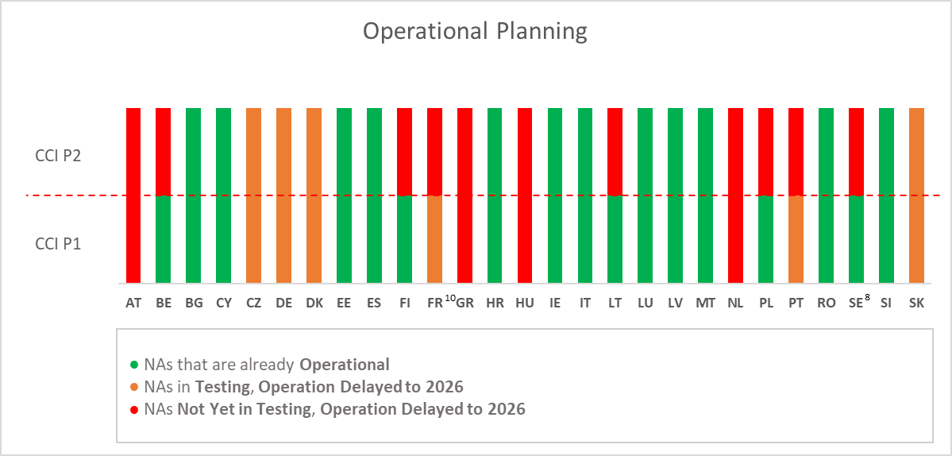
Figure 6: Operational Planning per Member States’ National Administrations (NAs)

The Commission continued its activities to closely monitor the progress of the national components’ development by the Member States for the CCI project and established a quarterly consolidated progress report as of Q1 2024. Furthermore, the Commission’s dedicated CCI business team continued its efforts to address Member States’ questions on import and the simplifications at import such as centralised clearance. In addition, CCI Customs Business Group meetings were organised to coordinate amongst others the activities related to the applications for a CCI authorisation, as well as regular technical meetings on a weekly and bi-weekly basis, and feedback sessions on conformance testing.
E-learning modules and communication materials were published on the Europa website to support the transition to and the implementation of the new systems. The Commission also issued administrative letters to the Member States facing delays in the implementation of the CCI project beyond the legal deadline.
Delays experienced by the Member States impact the progress of the trans-European systems in their totality which, in turn, have an impact on the activities of the Commission. This requires continuous investment in resources devoted to conformance testing, coordination, and support activities for the trans-European projects as well as extended maintenance of central components during transition periods. It also entails further assistance to Member States and and monitoring of progress.
To sum up, throughout 2025 the Commission has also taken a number of measures, complementary to the ones identified and carried out at national level by the Member States.
Firstly, the Comission has enhanced supervision and monitoring of the UCC digital programme by increasing the frequency of progress reports and organising bilateral meetings and missions at Director level with each of the Member States. The implementation of the UCC WP has also been put consistently on the agenda of the meetings and missions conducted by the Director-General and in plenary high-level meetings with the Directors-General of the Member States as in the Customs Policy Group and with the CIO’s of the Member States in the CIO Network. The Member States were encouraged to follow up closely the progress for the remaining projects and to take mitigating measures with a view of completing the UCC digital programme by the end of 2025.
The Commission continued using a Multi-Annual Strategic Plan – Customs (MASP-C) dashboard based on the MASP-C Revision 2023 and the UCC WP 2023 to monitor the progress, project milestones, and identify delays at an early stage. The dashboard is presented on a quarterly basis to the Member States in the ECCG which is meeting jointly with the trade community.
Secondly, the Commission has continued its reinforced assistance to the Member States for trans-European systems by adopting an agile and iterative approach to developing and deploying the UCC electronic systems. This method, which includes prototyping, swift issue resolution, and a balanced workload for both the Commission and the Member States, enhances system quality and facilitates tangible progress. This approach has been well-received by the Member States and traders.
Furthermore, the Commission has established a collaborative mechanism among stakeholders from the outset of the projects to enhance preparatory activities, prevent decision-making difficulties, and ensure transparency through regular project updates.
The Commission also continued coordinating and monitoring programmes for each of the ongoing projects related to the trans-European systems ICS2, NCTS, CCI and AES.
Thirdly, the Commission sought Member States’s input through surveys and other means on their constraints and the needed support to mitigate the risks. The Member States expressed that the bilateral meetings at Director level and technical dialogue with DG TAXUD had been highly beneficial. The Commission continued with the exercise to gather the lessons learnt and best practices for the development of the digital projects. To that end, the survey conducted in 2025 provided this information and the outcomes were added to section 1 of the Commission Staff Working Document accompanying this report. Furthermore, several Member States shared their national experiences and practices in the UCC digital transformation during the high-level Customs Policy Group meeting in July and December 2025 and the CIO Network meeting in November 2025.
Fourthly, in accordance with EU’s enforcement strategy, the Commission has also engaged in formal correspondence with the Member States facing delays in implementing digital systems. The Commission decided to pursue legal action against Member States for failing to comply with their obligations under UCC and the UCC WP. Infringement procedures against 14 Member States (AT, BE, CZ, CY, DK, FR, GR, IE, IT, MT, SK, SI, PT, RO) were opened in May, June and July of 2025 for failing to meet their obligations to deploy the system for Temporary Storage for Air transport (TS Air), the National Import System (NIS), the Automated Export System (AES) and for failing to meet their obligations on customs data transmission to the Surveillance system (SURV3).
Looking back at the overall experiences of the digital transition and implementation of the UCC over a period of 10 years, the Member States’ feedback was asked during a dedicated CIO meeting on the greatest challenges during the UCC digital implementation. The responses showed a clear pattern: the three most significant difficulties were, by a considerable margin, (1) governance structures enabling timely decision-making, (2) sustaining the engagement of stakeholders, and (3) defining and maintaining a clear scope. The complexity of national governance arrangements has, in certain cases, created a diffusion of responsibility. In large-scale digital transformation programmes such as the UCC, diffuse accountability translates directly into delivery risk. The Commission’s experience has shown that delivery accelerates only when clear high-level ownership, steering and central coordination are established at national level, progress has been markedly faster and more predictable.

Regulation (EU) No 952/2013 of the European Parliament and of the Council of 9 October 2013 laying down the Union Customs Code, OJ L 269, 10.10.2013, p. 1–101.
Report from the Commission to the European Parliament and the Council: 2019: https://eur-lex.europa.eu/legal-content/EN/ALL/?uri=CELEX%3A52019SC0434; 2020: https://eur-lex.europa.eu/legal-content/EN/TXT/?uri=CELEX%3A52020SC0339; 2021: https://eur-lex.europa.eu/legal-content/EN/TXT/?uri=CELEX%3A52021SC0382; 2022: https://eur-lex.europa.eu/legal-content/EN/TXT/?uri=CELEX%3A52023SC0029; 2023: https://eur-lex.europa.eu/legal-content/EN/TXT/?uri=COM:2024:395:FIN; 2024: https://eur-lex.europa.eu/legal-content/EN/TXT/?uri=celex:52025DC0579.
Regulation (EU) 2019/632 of the European Parliament and of the Council of 17 April 2019 amending Regulation (EU) No 952/2013 to prolong the transitional use of means other than the electronic data-processing techniques provided for in the Union Customs Code, OJ L 111, 25.4.2019, p. 54–58.
Commission Implementing Decision (EU) 2023/2879 of 15 December 2023 establishing the work programme relating to the development and deployment of the electronic systems provided for in the Union Customs Code, OJ L_202302879, 22.12.2023, p.1-17, https://eur-lex.europa.eu/legal-content/EN/TXT/PDF/?uri=OJ:L_202302879.
Commission Implementing Regulation (EU) 2025/512 of 13 March 2025 on technical arrangements for developing, maintaining and employing electronic systems for the exchange and storage of information under Regulation (EU) No 952/2013 of the European Parliament and of the Council, OJ L 2025/512, 20.3.2025, p. 1–45, https://eur-lex.europa.eu/eli/reg_impl/2025/512/oj/eng.
Proposal for a REGULATION OF THE EUROPEAN PARLIAMENT AND OF THE COUNCIL establishing the Union Customs Code and the European Union Customs Authority and repealing Regulation (EU) No 952/2013 (COM/2023/258 final).
Commission Implementing Regulation (EU) 2025/512 of 13 March 2025 on technical arrangements for developing, maintaining and employing electronic systems for the exchange and storage of information under Regulation (EU) No 952/2013 of the European Parliament and of the Council, OJ L 2025/512, 20.3.2025, p. 1–45, https://eur-lex.europa.eu/eli/reg_impl/2025/512/oj/eng
Commission Staff Working Document Accompanying the Report from the Commission to the European Parliament and the Council pursuant to Article 278(a) of the Union Customs Code, on progress in developing the electronic systems provided for under the Code, SWD(2026) 180 final.
However, challenges remain concerning the data transmission by Member States.
Based on the latest National Project Planning-information, HR has deployed their national GUM components on 1 March 2026, others (IT, CY, DK, FR) would follow in the period till 1 July 2026, and GR would deploy in December 2026.
SK has deployed on 14/02/2026 and DK on 19 March 2026.
SK has deployed the full CCI system (Phase 1 and 2) on 14 February 2026, DK on 19 March 2026 and CZ on 18 May 2026.
As referred to in the 2023 UCC WP, the transition period from NCTS – Phase 5 to NCTS – Phase 6 needs to occur between 1 March 2025 and 1 September 2025, during the same period that ICS2 – Release 2 transitions to ICS2 – Release 3, allowing for the synchronisation between both systems.
This timeline excludes the Export Component of the national Special Procedures system, for which the activity and planning is interlinked with the AES.
Commission Implementing Decision (EU) 2023/235 of 1 February 2023 granting a derogation requested by certain Member States pursuant to Regulation (EU) No 952/2013 of the European Parliament and of the Council to use means other than electronic data-processing techniques for the exchange and storage of information for the notification of arrival of a sea-going vessel or of an aircraft (OJ L 32, 3.2.2023, p. 220-222). Commission Implementing Decision (EU) 2023/234 of 1 February 2023 granting a derogation requested by certain Member States pursuant to Regulation (EU) No 952/2013 of the European Parliament and of the Council to use means other than electronic data-processing techniques for the exchange and storage of information for the Presentation Notification related to goods brought into the customs territory of the Union (OJ L 32, 3.2.2023, p. 217-219). Commission Implementing Decision (EU) 2023/236 of 1 February 2023 granting a derogation requested by certain Member States pursuant to Regulation (EU) No 952/2013 of the European Parliament and of the Council to use means other than electronic data-processing techniques for the exchange and storage of information for the Temporary Storage declaration related to non-Union goods presented to customs (OJ L 32, 3.2.2023, p. 223-225). Commission Implementing Decision (EU) 2023/237 of 1 February 2023 granting a derogation requested by certain Member States to use means other than electronic data-processing techniques for the exchange and storage of information related to the customs declaration for goods brought into the customs territory of the Union laid down in Articles 158, 162, 163, 166, 167, 170 to 174, 201, 240, 250, 254 and 256 of Regulation (EU) No 952/2013 of the European Parliament and of the Council laying down the Union Customs Code (OJ L 32, 3.2.2023, p. 226-228).
For the implementation of the Temporary Storage related to maritime transport, the completion it 96% and for other modes than air or maritime, the completion rate is 89%.
AT deployed the system on 15 April 2026.
CZ deployed the NIS, including SP IMP, on 18 May 2026.
FR, DK, SK have been submitting the SURV3 data by end of Q1 2026 and AT, IE, PT and CZ planned to be compliant by Q2 2026.
In the 2023 UCC WP, the end of the deployment window for the core functionalities of the system is envisaged for 01/12/2023, the development of a harmonised interface with the EMCS for 13/02/2024, and the remaining functionalities for 02/12/2024. By 02/12/2024, all Member States and traders should use the AES system with the transition ending on 11/02/2025.
In the 2023 UCC WP, the end of the deployment window is envisaged for 01/07/2024.
Letters of formal notice (LFN) were sent to Czechia (INFR(2025)2017), Denmark (INFR(2025)2018), Greece (INFR(2025)2019), Austria (INFR(2025)2015), Romania (INFR(2025)2020), and Slovakia (INFR(2025)2021) for failing to deploy the electronic systems for Temporary Storage for air transport and, in some cases, the National Import System, by the 31 December 2023 deadline. Additionally, Denmark (INFR(2025)2011), France (INFR(2025)2012), Cyprus (INFR(2025)2010), Austria (INFR(2025)2007), Portugal (INFR(2025)2013), and Romania (INFR(2025)2014) were sent LFN for failing to transmit complete customs data to the Commission through SURV3. https://ec.europa.eu/commission/presscorner/detail/en/inf_25_982#_blank
Infringement procedures were initiated against Portugal (INFR(2025)2064) and Belgium (INFR(2025)2016) for non-deployment of the Temporary Storage system for air transport, and in Portugal's case, also for the National Import System. Additionally, Letter of formal notice (LFN) was sent to Belgium (INFR(2025)2009) for failing to transmit complete customs data to the Commission through the SURV3 system. https://ec.europa.eu/commission/presscorner/detail/en/inf_25_1241
The Commission issued letters of formal notice (LFN) to France (INFR(2025)2060) and Cyprus (INFR(2025)2061) for non-deployment of the Temporary Storage and National Import System, and in France's case, also for the Automated Export System. Furthermore, Czechia (INFR(2025)2054), Ireland (INFR(2025)2055), Italy (INFR(2025)2056), Malta (INFR(2025)2057), Slovenia (INFR(2025)2059), and Slovakia (INFR(2025)2058) were cited for failing to transmit complete customs data to the Commission through the SURV3 system https://ec.europa.eu/commission/presscorner/detail/en/inf_25_1628

