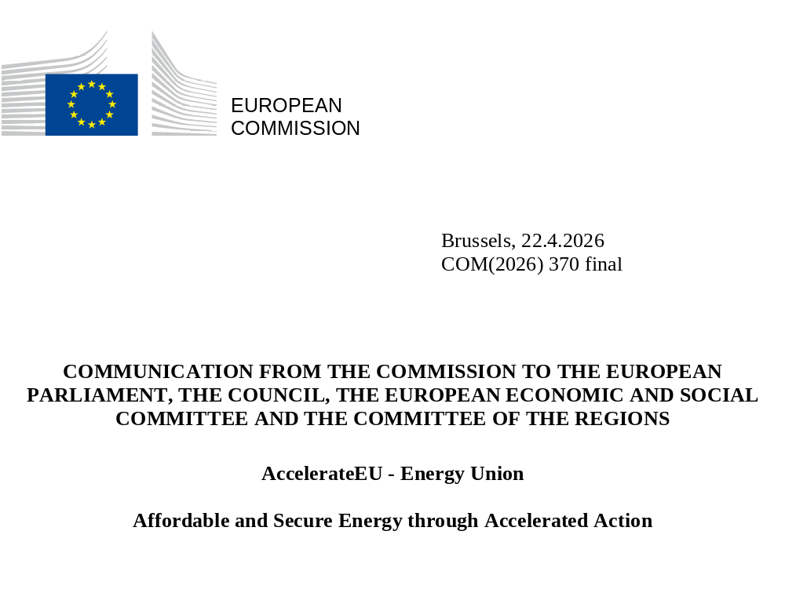

Introduction
For the second time in less than five years, the dangers of Europe’s dependency on fossil fuel imports are becoming abundantly clear. Over half (57%) of the energy consumed in Europe is imported fossil fuels. This creates a vulnerability that comes at a price. In 2025, the EU imported around EUR 340 billion worth of fossil fuels. Since the beginning of the conflict in the Middle East in March 2026 and the closure of the Strait of Hormuz, we have spent an additional EUR 24 billion on fossil fuels imports. Moreover, the possible effects on GDP growth and inflation are significant. The situation in the Middle East remains volatile and it is unclear how long it will last, but one thing is certain: its impacts will continue being felt for at least several months and go well beyond the energy sector, with economic, employment and social impacts.
Rising prices are the immediate consequence of the conflict. There is no immediate threat to the security of supply, although stocks of some fuels are tight. The EU is in the process of reducing the share of fossil fuels in electricity production, but gas and oil continue to dominate in heating, industry and transport and are a key input to industrial value chains (e.g. chemicals, plastics and fertilisers). This leaves European households and businesses, notably SMEs and energy-intensive industries, and their workers, exposed to global price spikes. The current situation calls for timely, targeted and temporary measures to protect the most vulnerable consumers, to accelerate our shift to the clean energy transition and electrification and to safeguard the competitiveness of European industry.
Over recent years, the EU has massively accelerated the energy transition towards an efficient, flexible and interconnected system that is based on homegrown, clean and abundant energy sources. Many Member States are already reaping the benefits of swift progress on the energy transition, showing that this goal is achievable and delivers clear benefits to people and businesses. For example, Member States that have a high share of clean energy (notably renewables and nuclear) in their electricity mix, together with a flexible electricity system that counts with sufficient grid capacity and storage, generally have electricity prices below the EU average and are currently less impacted by the ongoing energy crisis.
This is a strong reminder of the need to accelerate electrification, the roll out of additional domestic clean energy production and the energy transition. The choices we make today determine whether we face the next crisis from a position of vulnerability or strength. The transition to a clean, abundant, homegrown, secure, water-resilient and affordable energy system has never been solely a climate and environmental necessity – it is also a socio-economic, competitiveness and security imperative. These policy goals mutually reinforce and complement each other and can be achieved by making full use of all available clean technologies while ensuring technological neutrality. That is why short-term relief measures must not detract from – but on the contrary, double down on – the longer-term goals to increase domestic clean energy production, achieve a decarbonised and resilient EU energy system and strengthen European manufacturing capacity to avoid creating new strategic dependencies.
Reaching these goals will require strong commitment, intensified coordination and increased investment, but the benefits of accelerating the clean energy transition clearly outweigh its costs. Every delayed investment in the energy transition risks creating greater costs to society.
The current crisis has a very strong global dimension. To mitigate the impact of the tension on global markets, the EU can draw on its significant weight as a buyer and on the value of its single market, a source of strength and solidarity especially in times of crisis.
This plan is one part of the Commission's dynamic response, which will evolve as the situation develops. The Commission will keep these measures under close review and consider further measures if the situation deteriorates. It consists of five key areas of action that aim to support Member States in providing and channelling short-term relief to consumers, especially those most immediately affected. It also sets out ways to move faster down the path to achieve a more resilient energy system in the medium and long term:
- greater coordination between Member States and with international partners;
- supporting Member States to protect consumers, including industry, from price shocks, and simultaneously helping them in the energy transition;
- accelerating the shift to homegrown clean energy and electrification;
- stepping up our energy system; and
- boosting investment by mobilising both public and private funding for the energy transition.

Immediate action to produce rapid benefits
  - The benefits of greater EU coordination
Enhanced coordination at EU level has shown clear benefits. Joint actions under the REPowerEU Plan following the aggression in Ukraine played a central part in enabling the EU to reduce its gas demand by 18% (between August 2022 and March 2023), easing immediate pressures and supporting longer-term stability. The EU Energy Platform helped aggregate 90 billion cubic metres of European gas demand. It connected EU industrial buyers with international suppliers – with 77 billion cubic metres matched.
The first areas for strengthened EU-level coordination include gas storage filling and the use of flexibilities in filling rules, oil stock releases, national emergency measures and ensuring the availability of jet fuel and diesel, including through the optimisation of oil refinery production capacities.
Jet fuel shortages may have a significant impact on air transport, such as flight cancellations, especially in view of the busy summer aviation season. Given that air transport operates across national borders, it requires European coordination to preserve the effective functioning of the single market and secure continued supply across the EU. Exploring alternative supplies and imported fuel types should be considered.
Increased diesel prices and bunker fuel costs are driving up freight rates and have put road transport operators, the short-sea and inland shipping sectors, as well as fishery and agriculture, under severe pressure.
The availability and operational capacity of Europe’s oil refining sector must be maximised to meet the current demand, especially for jet fuels, since approximately 40% of our jet fuel consumption is imported and about half of all imports pass through the Strait of Hormuz. Refining capacities are geographically concentrated in some regions in the EU and alternative supplies of refined oil products are limited, making coordinated monitoring and potential collective action necessary to maximise existing European refinery output, including through the coordinated and timely release of emergency stocks.
Coordinating actions is also key for strengthening military fuel infrastructure, in particular for importing, processing, storing and distributing jet fuel supplies.
Finally, the EU’s external action towards reducing fossil fuel dependency globally can further contribute to reducing the EU’s vulnerability to energy price shocks, foster EU’s energy security, resilience and promote Europe’s clean tech competitiveness. Coordination and cooperation with Energy Community Contracting Parties in particular will support the resilience of our interconnected energy markets.
In view of their impact on the external relations of the EU, the actions proposed in this Communication will be carried out in cooperation with the European External Action Service, within the exercise of its functions.
Immediate action from the Commission to step up EU-level coordination:
- [April 2026 onwards] The Commission will facilitate the coordination of national action on gas storage filling (e.g. by closely monitoring and coordinating with Member States the timing of purchases by market players to avoid price spikes due to increased simultaneous purchasing) and on possible oil stock releases, including of jet fuel and diesel (for which the Commission will provide scenario analyses and coordinate the timing and volumes per region and for the EU). This will be done in the Gas Coordination Group and in the Oil Coordination Group, respectively.
- [April 2026 onwards] Member States are encouraged to make use of flexibility in gas storage filling (up to 10%). The Commission stands ready to assess a further increase of the permitted deviation threshold (up to an additional 5%) under the updated EU Gas Storage Regulation.
- [April 2026 onwards] The Commission will facilitate coordinated EU outreach to oil and gas suppliers and partner countries with similar energy import profiles to improve the functioning and transparency of global energy markets, including by fully mobilising the EU Energy and Raw Materials Platform to engage with industry. The Commission will seek to step up international cooperation to increase supply from third countries and through the EU network of trade agreements.
- [May 2026] The Commission will map the existing refining capacities in Europe, assess needs and work on measures to ensure full use of and sufficient domestic refining capacity for resilient supplies of the entire spectrum of oil products during this crisis, as well as to increase domestic EU production of sustainable biofuels.
- [May 2026 onwards] The Commission will create a Fuel Observatory, mapping the supply of relevant transport fuels (produced in the EU, imported and exported) and the available stocks in the EU including, to the extent that information is available to the Commission, military fuel stocks and refining capacities. As an initial priority, the Commission will coordinate with Member States, fuel suppliers and the aviation sector (airports and airlines) on the sourcing of alternative jet fuel supply and will propose measures to optimise its distribution among Member States to ensure availability across all regions and airports. The Commission will assess the need for reviewing EU rules on strategic stocks to include specific jet fuel requirements.
- [May 2026 onwards] The Commission will issue guidance clarifying existing flexibilities in the EU legislative framework for aviation, notably in relation to rules on airport slots, anti-tankering, public service obligations and the use of other imported fuels, to address the consequences of potential fuel shortages on air transport operations, ensuring that the proper functioning of the single market is preserved and essential air connectivity secured. If the situation worsens and existing flexibilities no longer suffice, the Commission will propose temporary changes to the applicable EU legislative framework, where justified.
- [2026] The Commission will start the process to revise the Oil Stocks Directive to address weaknesses identified in the current crisis and consider, amongst others, whether specific stock requirements are needed for different oil products.
  - Protecting consumers and industry from price shocks
Households and industry are expecting measures from Member States and the EU that protect them from unexpectedly large price hikes. Household budgets are tightening as rising energy costs reduce people's disposable income. This is already visible today when people fuel their cars. Moreover, since about two thirds of the natural gas consumed in the EU is used in buildings and industry, gas price spikes will also result in challenges for many consumers once these price increases are reflected in their energy bills and, eventually, other parts of the economy such as food prices. Currently, many households may still benefit from the conditions set in the gas and electricity contracts that they concluded before the start of the conflict in the Middle East. This might change when their individual supply contracts expire. All consumers in a vulnerable situation are particularly exposed to this risk.
With persisting and recurring pressure on fossil fuel imports and energy prices remaining volatile, immediate support is needed, but it must be targeted, timely and temporary, and tied to long-term solutions (see examples in Annex II). Such support should preserve incentives to reduce energy demand and be consistent with Member States’ commitments under the EU fiscal framework.
The EU's legislative framework and Commission policy initiatives, including the Citizens Energy Package, already provide a range of measures available to Member States that they could consider, bringing immediate relief to consumers. For example, these include targeted income support schemes; energy vouchers such as for replacing gas boilers; social tariffs; reducing excise duties on electricity for vulnerable households and energy-intensive industries; VAT reductions for the installation of heat pumps, solar photovoltaic and related small-scale batteries; tax incentives supporting the shift to electric vehicles; incentivising and easing the participation of consumers in energy communities and energy self-production; and encouraging consumers to compare and switch their energy suppliers or contracts. In addition, to support vulnerable consumers, Member States may already introduce, under the existing EU legislative framework, temporary or full bans on disconnection from energy supply. Fighting energy and transport poverty is also a priority for the upcoming Anti-Poverty Strategy.
Targeted financial incentives such as targeted tax credits, accelerated depreciation or social leasing schemes can also support investment and increase the rate of deployment of clean technologies while contributing to the scaling up of European manufacturing capacity. This includes sectors such as electric vehicles, residential or industrial heat pumps, solar panels or battery storage systems.
Saving energy and replacing oil and gas consumption with homegrown clean energy have proven efficient in tackling high energy prices and reducing Europe’s dependence on imported fossil fuels. In the short term, Member States can achieve significant benefits in multiple sectors by combining action on electrification, efficiency improvements and accelerated deployment of clean energy technologies, including for instance innovative sustainable bio-based solutions (see examples in Annex II). The EU Emissions Trading System (ETS) has also been a key tool to achieve a higher degree of energy security and independence, as without the ETS Europe would now consume 100 bcm more gas, making us more vulnerable.
In households and buildings, supporting adaptations that deliver rapid impact, such as improving insulation, replacing windows or replacing inefficient appliances, can deliver immediate and long-lasting energy savings and cost relief. Replacing gas and oil boilers with heat pumps could halve final energy consumption in buildings and lower energy bills over time. An annual increase of the rate of heat pump deployed from around 2.4 million units today to around 4 million units by 2030 would not only bring reliefs for consumers but would also support Member States in progressing to reduce the average primary energy use of the residential building stock by at least 16% by 2030. The Commission encourages Member States to make use of the European Investment Bank’s ETS2 Frontloading Facility to accelerate the deployment of decarbonisation measures in the housing and mobility sectors, particularly benefiting low- and middle-income households and SMEs.
Since most oil consumption is in the transport sector, Member States’ actions should be coordinated and targeted towards maintaining freight flows and connectivity for passengers, while promoting the shift to e-mobility and other clean mobility solutions across all modes as a structural pathway to lower our dependence on oil in transport. These may include incentives for consumers to acquire electric vehicles (e.g. switching corporate fleets to clean transport solutions, such as electric heavy-duty vehicles or electric passenger ferries), or the provision of onshore power supply at ports. For businesses – especially small, medium-sized and energy-intensive businesses – targeted support mechanisms may include financing schemes, vouchers or leasing models to stimulate investment in energy efficiency and clean technologies.
Member States can consider using their allocations from the Social Climate Fund to finance such measures for vulnerable groups, including in both the transport and buildings sectors.
For air and waterborne transport and fisheries, the initiated transition to sustainable aviation fuels (SAF) and sustainable maritime fuels (SMF) should be accelerated, supported by the swift implementation of incentives for their production and use in the EU. For other sectors, such as agriculture, fisheries and mobility logistics, increased access to sustainable biofuels for existing combustion engine vehicles can secure their uninterrupted contribution to the supply chain, notably for food.

Immediate action from the Commission to support Member States in protecting consumers and industry:
- [May 2026] The Commission will present, at the forthcoming informal meeting of the EU Energy Ministers in Cyprus on 13 May 2026, a catalogue of replicable measures to produce energy savings and system efficiency gains, as well as measures to substitute fossil fuels by homegrown clean energy, that Member States can rapidly deploy to reduce oil and gas consumption in the short term. The catalogue will be based on an assessment of the most efficient measures taken since 2022 and will include examples of concrete action successfully implemented on the ground with large-scale replication potential across the EU, and their impacts.
- [April 2026 onwards] The Commission will set up a digital repository to compile and share non-confidential information on Member States’ national emergency measures, help coordinate between neighbouring Member States and facilitate the sharing and promotion of good practices.
- [April 2026] The Commission will adopt a State aid temporary framework outlining provisions for Member States to develop and implement targeted temporary emergency measures to support some of the economic sectors most exposed to price spikes.
- [April 2026 onwards] The Commission will provide continuous assistance to Member States in the design of targeted, timely and temporary measures (including price intervention, income support schemes and tax incentives), aimed at supporting in particular SMEs, energy-intensive industries and households, while preserving the incentive to save energy and encouraging fossil fuel reduction. Member States should provide an assessment of the respective expected impacts, including their fiscal cost and avoid the fragmentation of the single market. The Commission will provide guiding principles and facilitate the development of templates in this regard. Member States can also take measures on the taxation of windfall profits to ensure social fairness; the Commission will respect Member States’ decisions and assist and provide best practices on national measures as well as assess their impact on the single market. The Commission stands ready to support any Member States that need, in the short term, to apply energy tax rates below the current EU minimum levels, while avoiding increasing fossil fuel demand and exacerbating imbalances of supply and demand.
- [April 2026] The Commission will continue facilitating the implementation of consumer empowerment and protection across Member States through guidance on protecting vulnerable customers from disconnections, fast-tracking and simplifying energy supplier and energy contract switching, participation in energy communities and self-consumption, improving supplier risk management and on protecting consumers during the energy transition.
- [May 2026 onwards] The Commission will promote and help develop, including through the Energy Transition Investment Council and the Energy Efficiency Financing Coalition, social leasing schemes for clean and efficient technologies which Member States are encouraged to use to support the rapid uptake of, e.g. e-vehicles, residential heat pumps and small-scale batteries. The Commission stands ready to assist Member States in establishing financial incentives, such as targeted tax credits, for the rapid deployment of clean energy technologies such as electric vehicles, industrial and household heat pumps, behind-the-meter batteries and industrial thermal storage, while ensuring compliance with commitments under fiscal rules.
- [April 2026] The Commission has triggered the crisis support mechanism provided under the European Maritime, Fisheries and Aquaculture Fund allowing Member States to compensate operators in the fisheries, aquaculture and processing sector for increased operating costs and income forgone stemming directly from the situation in the Middle East.

immediate action to produce lasting benefits
  - Accelerating the shift to homegrown clean energy and electrification
By taking immediate action to generate strong results in the medium-term, Member States can replace significant volumes of oil and gas by accelerating the shift to clean, homegrown and abundant energy, including through electrification, deployment of solar thermal and geothermal energies as well as other renewable energy, nuclear, biomethane, sustainable biofuels and hydrogen.
For example, the capacity of renewable electricity deployed per year should increase to 100 GW/year, including through new large-scale renewable energy projects and accelerated solar deployment, which can deliver rapid results. To deliver at pace, it is therefore critical to streamline national permitting regimes in line with the requirements set in EU legislation. Beyond transposition efforts, frontloading implementation can deliver concrete results. By the end of 2026, the length of permitting procedures should decrease across Europe to maximum two years and each Member State should unlock the potential of renewable acceleration areas by establishing at least one.
Another key lever is to maximise existing renewable energy assets. The rapid repowering and upgrade of wind farms including offshore wind farms, supported by dedicated streamlined permitting regimes for repowering, and the modernisation of other renewable plants such as hydropower plants, can quickly deliver much needed additional relief by increasing available generation capacity.
Nuclear energy is an important component of decarbonisation, industrial competitiveness, and security of supply strategies. Almost half of the Member States have nuclear energy in their national energy mix. The updated National Energy and Climate Plans indicate that installed nuclear capacity is anticipated to increase. Nuclear power plants supply clean power, suitable for enhancing system integration and providing flexibility facilitating further roll-out of other clean technologies. These benefits accrue to the whole EU energy system. New small modular reactors or avoiding the premature retirement of existing nuclear capacity can help reducing the need for fossil fuel use, including in district heating and industrial processes. As assessed in the PINC Strategy, there is also unlocked potential regarding existing nuclear power plants.
The current crisis is also a call for accelerating electrification to end exposure to fossil fuel price shocks and import dependencies. In 2024, 71% of the EU’s electricity generation came from clean energy sources, bringing cheap energy to the system. Nevertheless, electricity represents less than a quarter of the final energy consumption. To ensure energy affordability and industrial competitiveness by bringing the benefits of clean energy and renewables to consumers and improve system efficiency, more energy demand (transport, buildings, industry, etc.) needs to switch from fossil fuels to electricity.
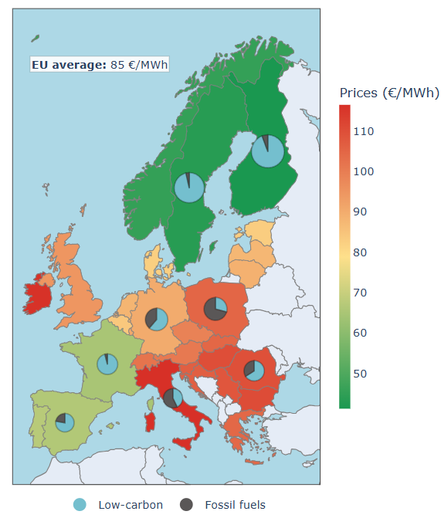 | 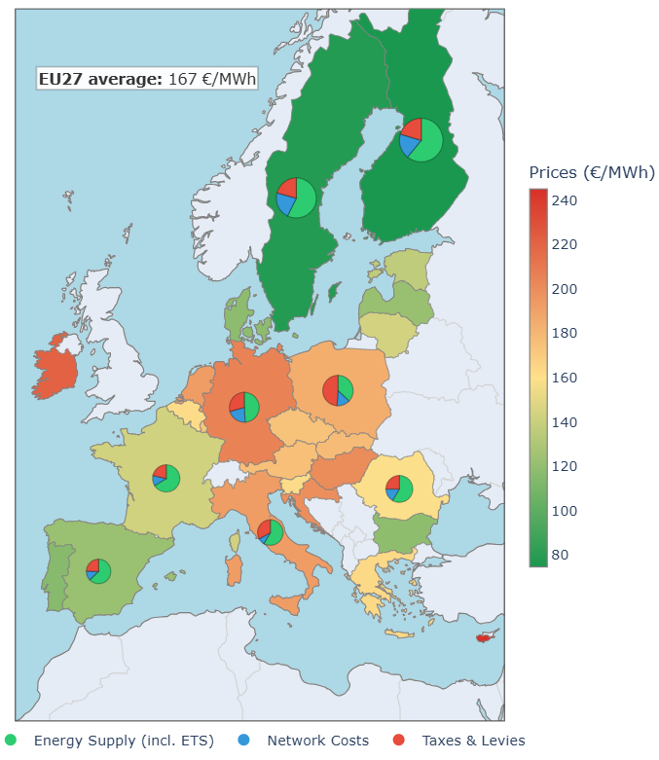
Figure 1. Correlation between clean energy mixes and electricity affordability (wholesale 2025 – left; industrial retail S1 2025 – right) [Source: DG ENER]
Electrification shall also boost domestic EU manufacturing of clean technologies, e.g. residential and industrial heat pumps. Industry estimates indicate that more than two thirds of the heat pumps installed in Europe are produced in Europe. With clarity on potential demand, manufacturers will have a greater incentive to ramp up capacity in the EU and invest in skills development.
Doubling the installed commercial and residential heat pump capacity would reduce the fossil fuel consumption by 200 TWh. In addition, district heating and cooling systems are efficient drivers for accelerating the electrification. They have the potential to provide the demand-side flexibility increasingly needed in the electricity system, through large heat pumps, electric boilers and thermal storage and facilitate waste heat recovery. An ambitious heat network expansion can deliver significant natural gas savings.
Another area essential to increase the electrification of the economy is transport. Beyond incentives to promote the growth of sales of electric vehicles, sufficient recharging infrastructure is essential for their uptake. While recharging infrastructure for cars and vans has grown significantly faster over the last five years than the electric car fleet, the recharging infrastructure for trucks is lacking.
Increasing the share of solar thermal energy not only in buildings but also in district heating and cooling systems, through the repowering of existing solar thermal installations and by starting new projects, including for thermal storage, could produce significant energy savings. This is particularly relevant for industry, especially in the food and beverage sector, the chemicals sector (especially for process heat requirements up to around 400 °C) and agriculture, such as for greenhouses.
Geothermal energy can also replace natural gas in district heating and cooling networks and, in some cases, contribute to electricity generation. It is therefore important to support the swift deployment of new geothermal projects and explore the potential to repower existing installations. Industrial heat pumps can deliver process heat typically up to around 200 °C or upgrade low-temperature heat, enabling increased waste heat recovery in industry and district heating and cooling systems.
Biogas and biomethane can also play a more strategic role in replacing imported fossil fuels, particularly in sectors where electrification is more difficult. Biomethane production in existing plants could be increased by about 10% to 30%. On-farm and cooperative biomethane projects can reduce fossil fuel dependency while providing additional income for farmers and creating local value, particularly in rural areas, by converting waste, residues and manure into energy and fertilisers. Finally, circular solutions for biogas, biomethane and recycled nutrients can strengthen resilience, help competitiveness and reduce exposure to global price shocks.
Lastly, since the ramp up of hydrogen remains slow, the EU should support the acceleration of the industry’s switch to decarbonised fuels, while ensuring a level playing field for all electricity users and minimising the cost of electricity.
Immediate action from the Commission to support Member States:
- [Q2 2026] The Commission will take action on electrification, heating and cooling and geothermal energy. The Commission will, inter alia, set an electrification target, propose action to lower the electricity-fossil fuels price ratio and measures to accelerate the uptake of electrification solutions, such as through a market-based instrument on heat pumps, and address barriers in the industrial, transport and building sectors as well as cross-sectoral barriers to the electrification of the economy. This includes phasing out fossil fuel subsidies, which undermine the relative competitiveness of electricity vis-à-vis other energy carriers.
- [May 2026 onwards] On geothermal energy, the Commission will support Member States and stakeholders in gathering detailed geological data and create an EU-level database. The Commission will also explore supporting the establishment of geothermal derisking schemes and insurance schemes together with public financiers, including national promotional banks, to derisk investment and further mobilise private capital. Under the Global Gateway initiative, the Commission is committed to promote, inter alia, international cooperation on geothermal energy projects where relevant.
- [May 2026 onwards] On solar thermal, together with the Energy Efficiency Financing Coalition, the Commission will help develop public support schemes for the uptake of large-scale solar thermal projects.
- [2026 onwards] On biomethane, the Commission will continue supporting initiatives to advance the production of gaseous molecules of non-fossil origin, including sustainable biogas and biomethane in line with REPowerEUincluding on-farm and cooperative biogas and biomethane projects￼ taking careful consideration to the scaling up of existing plants, reducing permitting bottlenecks and improving the transport of sustainable feedstock across regions.
- [Q2 2026] After an assessment and given the slower than expected ramp up of the hydrogen market, the Commission will propose a targeted review of the production criteria for renewable hydrogen, while safeguarding existing investments. This will support industrial decarbonisation and accelerate the development of hydrogen-based Sustainable Aviation electro-Fuels (eSAF) and Sustainable Maritime electro-Fuels (eSMF). The Commission will further clarify the methodologies applicable for processes relying on both renewable hydrogen and biomass as a feedstock with a view to facilitate the production of eSAF while safeguarding a level playing field and maintaining ambitious sustainability criteria, including additionality, accurate lifecycle emissions accounting and the avoidance of double counting. By 30 June 2026, the Commission will launch a public consultation on a draft methodology outlining criteria for the potential introduction of alternative approaches for recognising low-carbon electricity from nuclear power plants.
- [By summer 2026] The Commission will map European capacities to complement oil and gas as feedstocks for chemicals, ceramics, glass, plastics and fertilisers with circular and bio-based materials and will work with industry to identify and address barriers to their deployment in the short term.
  - Stepping up our energy system
As this crisis shows, upgrading and fundamentally transforming our energy system is no longer a matter of ambition, but an absolute necessity for resilience. To fully reap the benefits, it is indispensable for Member States to swiftly and completely implement the EU energy acquis and for co-legislators to accelerate negotiations on the EU grids package. This will bring forward the delivery of projects, including projects of common interest (PCIs) and projects of mutual interest (PMIs), while defining a flexible approach to domestic congestion income arising from internal bidding zones that takes into account national circumstances. Grids are needed to let power flow at the lowest price from where it is produced to where it is consumed. Stepping up the deployment of cross-border electricity infrastructure is necessary to achieve the EU’s indicative target of at least 15% electricity interconnection by 2030, thereby ensuring a genuine Energy Union.
The Energy Highways initiative targets eight priority corridors, addressing the most urgent energy infrastructure needs that require further swift support and commitment, so that bottlenecks that hinder progress can be addressed. These need to be fast-tracked. Where need arises, additional Energy Highways may be considered in the future. Action to make more efficient and flexible use of grids, including through digitalisation and to improve grid productivity will also bring costs down significantly and help double down on the process to electrify multiple sectors, including heating and cooling.
Interconnectivity, smart grids, access to grids and grid productivity are also prerequisites for many service providers, alongside smart meters, which help consumers lower their energy bills or react to price signals by adjusting demand. The widespread deployment of smart meters is essential to unlock demand response at scale and enable consumers to participate in flexibility markets, reducing peak demand and price volatility. This is supported by assets such as batteries, electric vehicles and heat pumps, as well as by processes such as management systems and vehicle-to-grid solutions and AI-driven automation. To increase system flexibility and help lowering regional and domestic energy prices, each Member State should deploy smart meters to cover at least 50% of their final consumers by 2031. This goes hand in hand with price structures that encourage the use of flexibility services and storage to better integrate and benefit from clean energy.
To build a resilient energy system fed by clean homegrown energy sources, the availability of electricity and thermal storage capacities as well as flexibility, including batteries and pumped hydro, are key. The EU currently has a storage capacity of 55 GW and needs to expand this capacity significantly to reach 200 GW by 2030, with batteries playing an important role in such growth. To this end, political support for such projects already in the planning phase is essential.
Immediate action:
- [By July 2026] The Commission calls on and will support the co-legislators in concluding their negotiations on the grids package by the summer. This is indispensable to accelerate the roll-out of much needed renewable energy projects and storage, including large-scale batteries, and to upgrade grid infrastructure thereby helping lower energy prices and import dependencies.
- [Q2-Q3 2026] The Commission will continue working with Member States to fast track the implementation of the Energy Highways initiative. Building on the progress already made on the Bornholm Energy Island, the Commission will reinforce political engagement, dedicate resources and mobilise all available tools to strengthen investment frameworks and overcome barriers, including by addressing the remaining bottlenecks that hinder the rapid roll-out of such projects.
- [May 2026 onwards]: The Commission will support Member States and stakeholders (for example in the Energy Union Task Force and regional High-Level Groups) to identify electricity generation plants, including wind farms, that are close to end-of-life cycle and installations that could be repowered to help expedite the increase of electricity supply in the coming months. They will also assess how to further scale up renewable energy deployment.
- [May 2026] The Commission will assist Member States, by providing support via the Technical Support Instrument through an Energy Regulation Academy, in implementing key reforms in the electricity sector.
- [May 2026] The Commission will adopt a legal proposal on network charges and taxation. The aim will be to facilitate the transition to a more electrified, more efficient and more resilient energy system that can drive down electricity bills for all consumers. The proposal will provide incentives to make an optimal and cost-effective use of the grid infrastructure, incentivise system-friendly consumption, clarify the framework to allow national regulatory authorities to make targeted reductions to network charges including for energy-intensive industries and allow Member States to remove restrictions to reducing energy taxes for specific users, such as energy-intensive industries and vulnerable households, while ensuring that electricity is taxed less than gas.
- [2026-2027] The Commission will ensure strict monitoring of the implementation of relevant EU legislation using all available tools, including infringements, for example on permitting, storage, flexibility and maximisation of cross-zonal capacity, to speed up the roll-out of clean energy. To accelerate progress, it will fast-track the assessment of key provisions, provide pragmatic guidance on implementation, including via Commission recommendations, and support Member States to ensure harmonised and consistent application across the EU.
  - Boosting investment
The EU’s response to the current energy crisis relies on boosting investment. We must mobilise public funds –at EU and national levels– to catalyse and scale up private investment. Anticipating and accelerating investment in the energy transition and in circular solutions today will break the cycle of fossil fuel dependency once and for all.
Significant resources are being deployed at EU level for the energy transition, including during the final stretch of the Recovery and Resilience Facility (EUR 219 billion). Recovery and Resilience Plans already include numerous reforms and investments that are helping Member States upgrade their energy systems. These are to be completed by 31 August 2026 in line with the deadlines set in its legal architecture. The CEF Alternative Fuels Infrastructure Facility has, since 2021, committed over EUR 2 billion for projects deploying relevant charging and refueling infrastructure for alternative fuels for all transport modes. CEF-Energy will support cross-border energy infrastructure projects and cross-border renewable energy projects with 5.84 billion between 2021 – 2027.
Cohesion policy also provides significant support for the energy transition. The recent mid-term review of the Cohesion Policy Funds has reallocated around EUR 1.2 billion to energy priorities, which can now contribute to responding to the current crisis.
Consistent EU support to research and innovation in clean energy technologies has mobilised both public and private funding for the transition, including in scaling up innovative technologies, thereby producing solutions that are now tested, reliable and already deployed on the market. For those in the process of reaching scale, continued coordinated action and support at EU and Member State level is needed to avoid fragmentation of public funding and accelerate deployment.
However, public money alone cannot cover the significant investment needs (estimated at EUR 660 billion a year until 2030) for the energy transition. To mobilise private investment - including by institutional investors such as insurance companies and pension funds who manage over EUR 12 trillion in the EU, with potential to channel further investments for critical energy transition projects – the Commission adopted a Clean Energy Investment Strategy in March 2026.
The State aid framework will also enable Member States to support strategic investments in energy infrastructure and clean technologies while preserving a level playing field within the internal market.
Immediate action:
- [Q2 – Q3 2026] The Commission will organise a Clean Energy Investment Summit bringing together the financial services industry, including major institutional investors, industrial leaders, project developers and public financiers to accelerate private financing. The Summit will target immediate, high-impact solutions such as storage including batteries, electric vehicle recharging infrastructure, electrification, or sustainable aviation and maritime fuels.
- [April 2026 onwards] The Commission will coordinate an EU exercise (AccelerateEU investment chapter) to empower and assist Member States, including via Member State expert groups, to make maximum use of available EU funding (e.g. from cohesion policy funds) and reallocate EU funds where feasible and in line with Member States’ and regions’ preferences to energy-related investments that can deliver quick impact and alleviate the effects of rising energy prices, for example by:
A) Scaling-up existing measures to reduce energy consumption, roll out of clean energy (e.g. heat pumps, solar PV, insulation, wind or batteries), circular solutions and invest in stronger and safer critical energy infrastructure, as well as to promote the roll-out of recharging infrastructure and the production of sustainable aviation and maritime fuels.
B) Introducing add-ons to existing measures or expanding their scope, e.g. measures to tackle energy poverty, as add-on to existing energy efficiency measures; expand the scope of PV solar to agrivoltaics; expand the scope of accelerated and simplified permitting.
C) Accelerate the delivery of relevant measures in the Recovery and Resilience Plans, by making good use of the indicators provided in the Commission Communication ‘NextGenerationEU - the road to 2026’, including the possibility to inject capital in national promotional banks and institutions.
- [April 2026 onwards]: The Commission will assess whether further action is needed to simplify rules to accelerate the deployment of EU funds to invest in the energy transition.
- [By July 2026] The Commission will adopt a legislative proposal to update and modernise the EU Emissions Trading System. The Commission will consult Member States on the update of the ETS benchmarks soon. This will complement already proposed changes to the Market Stability Reserve to boost its firepower. As part of the review, the Commission will also increase the financial support available to industry for their clean energy transition through the Industrial Decarbonisation Bank, mobilising EUR 100 billion of funding. To ensure early deployment, this will include an Investment Booster financed by 400 million EU ETS allowances allowing for speed and solidarity, aiming to enhance investment certainty to step up decarbonisation investment by EU energy-intensive industries. In this context, to ensure solidarity, lower-income Member States will have guaranteed access to the ETS Investment Booster support. In addition, the Commission will also consider extending the ETS SAF support in terms of volume and duration for aviation and will explore an analogous mechanism for EU-produced SMF.
- [April 2026 onwards]: The Commission will assist Member States who wish to explore the use of revenues from the EU ETS for targeted measures that mobilise and accelerate investments in electrification –such as in transport or heating–, industrial decarbonisation, in circular downstream applications and investments that help reduce electricity prices including through increased renewable electricity capacity, provided the investments contribute to households’ electrification and industrial decarbonisation. The Commission continues to encourage Member States exploring such ETS revenue allocations.
- [April 2026 onwards]: The Commission will work with the European Energy Financing Coalition to develop standardised financial products for clean heating and renovation and develop and promote new energy service business models that provide direct support for SMEs to roll out energy efficiency and electrification solutions.
- [April 2026 onwards]: The Commission will continue supporting Member States in the eSAF Early Movers Coalition in the organisation of the announced EUR 2 billion double-sided auction on eSAF and encourage further participation by Member States.

Eurostat, 2024.
Eurostat.
First 52 days. Comparison against before the start of the Middle East crisis assuming that the EU still imports the same volumes. Before the crisis, the EU would have paid roughly EUR 51 bn over the same time frame rather than EUR 75 bn. Commission calculation based on data from Bloomberg, Kpler, LSEG / Refinitiv.
Energy is a primary driver of volatility in headline inflation, acting through both direct impacts (fuel, electricity) and indirect effects (production and transportation costs).
Eurostat, compared to pre-crisis levels.
Via the AggregateEU mechanism established between 2023-2025.
Such as Jet A.
Commission calculation based on data from Kpler and Eurostat.
Four main regional hubs: North-West Europe, Nordics-Baltics, Mediterranean and Central and Eastern Europe.
Including, e.g. through the implementation of the Global Gateway strategy, the Trans-Mediterranean Renewable Energy and Clean Tech initiative.
The Energy Community may also take part in the Oil Coordination Group and Gas Coordination Group meetings through its Secretariat and, where relevant subject to the specific discussion points, via the Energy Community Contracting Parties. The EU Energy and Raw Materials Platform remains open to companies from the Energy Community Contracting Parties.
https://energy.ec.europa.eu/topics/energy-security/eu-energy-and-raw-materials-platform_en.
On average, Europeans currently pay about EUR 1.8-2.2 per litre for petrol and EUR 2.0-2.4 for diesel, as opposed to an average of EUR 1.5-1.6 per litre for petrol in 2025 and EUR 1.6-1.8 per litre for diesel in 2025, source: The European Commission Weekly Oil Bulletin.
Citizens Energy Package (COM/2026/115).
In line with the Council conclusions of 10 October 2025 on tax incentives to support clean technologies and industry.
Latest available data show that EU-funded energy efficiency investments are already strengthening the Union’s energy resilience. By the end of 2023, annual energy savings achieved through EU funds amounted to 81.9 TWh; source COM(2026) 118 final, page 17. See also ODYSEE project for further information.
Commission calculations.
Compared to 2020. Energy Performance of Buildings Directive (EU) 2024/1275 (‘EPBD’)
Commission Proposal for a Regulation on clean corporate vehicles (COM(2025) 994 final)
ReFuelEU Aviation and FuelEU Maritime regulations.
Sustainable Transport Investment Plan (STIP)
Complementing other incentive models such as grants, guarantees, loans or energy-as-a-service models, that are more frequently used for technologies such as small-scale batteries and heat pumps.
Commission implementing decision establishing the situation in the Middle East as of 28 February 2026 as the occurrence of an exceptional event causing a significant disruption of markets
In accordance with the Clean Industrial Deal (COM(2025) 85 final). This renewable capacity deployment rate refers to direct current capacity, equivalent to around 85 GW in alternating current capacity used in standard statistical reporting practice.
Solar generation is one of the most affordable electricity generation sources and has very large deployment potential, such as in , residential buildings including in balconies, roads and large-scale commercial,
Since 2021, the EU has installed around 260 GW of renewable capacity (204 GW solar PV and 57 GW wind energy ), leading to savings of gas for generation equivalent to approximately 15 bcm in 2025 (or about 5% of the EU annual imports).
All Member States should have already transposed and implemented all permitting requirements for renewables and related infrastructure under EU energy legislation, and particularly the Renewable Energy Directive (including Renewable Energy Acceleration Areas, overriding public interest in favour of renewable projects, and shorter permitting deadlines for the repowering of existing ones). Member States are at the time of publication of this Communication still in the process of adopting and notifying national transposition measures to the Commission.
In accordance with the Renewable Energy Directive, including shorter deadlines for renewable acceleration areas, while lead-times for very complex projects such as some offshore projects may be longer.
EU-wide assessment of the final updated national energy and climate plans, COM(2025) 274 final.
Commission Communication on a Strategy for the development and deployment of Small Modular Reactors (SMRs) in Europe, COM/2026/117 final.
Commission Communication on Nuclear Illustrative Programme presented under Article 40 of the Euratom Treaty – Final (after the opinion of the EESC), COM/2026/120 final.
According to national plans, if Member States extended the lifetimes of existing reactors to 70 or even 80 years, and all new build projects got delivered on time, the installed capacity could reach to 144 GWe in 2050.
Electrification rate of 23.4% in 2024. The Clean Industrial Deal and the Affordable Energy Action Plan introduced a key performance indicator on the share of electricity in final energy consumption, setting 32% by 2030 as reference.
https://ec.europa.eu/eurostat/web/interactive-publications/energy-2026.
Eurostat
European Heat Pump Association (EHPA), Heat pumps made in Europe.
This saving would amount to approximately 8% of the current energy consumption for space heating in buildings.
Mathiesen et al. (2023), Heat matters: The missing link in REPowerEU
In addition, depot conversion for full zero-emission bus fleets and truck fleets remains a considerable investment challenge for many cities and operators.
Ember estimates that next-generation geothermal technologies could deliver up to 301 TWh annually in the EU, equivalent to around 42% of current coal and gas generation. Geothermal energy in Europe, February 2026, Ember
Including heavy-duty vehicles.
Roadmap towards ending Russian energy imports, COM(2025) 440 final
As an instrument designed to tackle the adverse consequences of the COVID-19 crisis in the Union, supported by extraordinary and temporary additional means, the RRF was created with very strict time limits that cannot be derogated from, as they are set in the EURI Regulation, the RRF Regulation and the Own Resources Decision.
Banks and insurance firms are incentivised to scale up their investments under the legislative programme frameworks, which make it easier to invest in equity in areas that are key to Europe’s long-term competitiveness and economic security, including the energy sector.
18 decisions were adopted under CISAF supporting clean tech and budget by 14 April 2026, approving 19 State aid measures for a total budget of EUR 32.76 bn. Of those, 4 measures totalling a budget of EUR 20.22 bn were approved under section 4.1 on renewable energy. One measure (budget of EUR 608.5 million) was approved under section 5 on industrial decarbonisation. Finally, 14 measures were approved under section 6.1 on manufacturing capacity in clean technologies (budget of around EUR 11.93 bn). In addition, in the same period, the Commission approved 7 aid measures for industrial decarbonisation under the Climate, Environmental Protection and Energy State aid guidelines (CEEAG) for a total budget of EUR 6.8 billion.
Support for industrial investments can be designed in accordance with Section 4.5 of the Clean Industrial Deal State Aid Framework (CISAF), but only if 100% of ETS revenues is used for investments in decarbonisation, as required by Article 10(3) of Directive 2003/87/EC establishing a scheme for greenhouse gas emission allowance trading within the Community.

