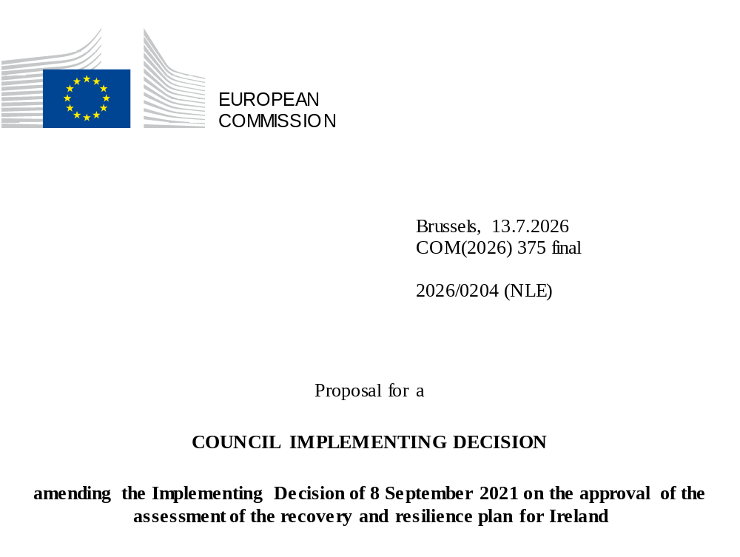

2026/0204 (NLE)
Proposal for a
COUNCIL IMPLEMENTING DECISION
amending the Implementing Decision of 8 September 2021 on the approval of the assessment of the recovery and resilience plan for Ireland
THE COUNCIL OF THE EUROPEAN UNION,
Having regard to the Treaty on the Functioning of the European Union,
Having regard to Regulation (EU) 2021/241 of the European Parliament and of the Council of 12 February 2021 establishing the Recovery and Resilience Facility, and in particular Article 20(1) thereof,
Having regard to the proposal from the European Commission,
Whereas:
(1) Following the submission of the national recovery and resilience plan (‘RRP’) by Ireland on 28 May 2021, the Commission proposed its positive assessment to the Council. On 8 September 2021, the Council approved the positive assessment by means of an implementing decision (‘the Council Implementing Decision of 8 September 2021’). The Council Implementing Decision of 8 September 2021 was amended by the Council Implementing Decisions of 14 July 2023, 8 December 2023, 21 June 2024, 11 March 2025, 8 July 2025, and 20 January 2026.
(2) On 29 May 2026, Ireland made a reasoned request to the Commission to make a proposal to amend the Council Implementing Decision of 8 September 2021 in accordance with Article 21(1) of Regulation (EU) 2021/241 on the grounds that the RRP is partially no longer achievable because of objective circumstances. On that basis, Ireland has submitted an amended RRP.
Amendments based on Article 21 of Regulation (EU) 2021/241
(3) The amendments to the RRP submitted by Ireland because of objective circumstances concern 13 measures.
(4) Ireland has explained that 13 measures have been amended to implement better alternatives that allow the administrative burden to be reduced and simplify the Council Implementing Decision, while still achieving the objectives of those measures. This concerns measures C1-I3 (Public Sector Retrofit Pathfinder Project), C1-I4 (Enable future electrification through targeted investment in Cork commuter rail), C1-I5 (National Grand Challenge Programme), C1-I6 (Enhanced rehabilitation of bog areas), C1-I7 (River basin management plan – Enhanced ambition programme), C2-I2 (Digital transformation of Irish enterprise), C2-I4 (Online response option for the census), C3-R5 (Anti-Money Laundering), C5-I1 (Upscaling a Biomethane Industry in Ireland), C5-I2 (Drogheda Charging Infrastructure), C5-I3 (SEAI/HSE Pilot Energy & Decarbonisation Pathfinder), C5-I4 (Expanded School Sector Pathfinder Decarbonisation and Retrofit Programme), C5-I5 (Retrofit of public building). On this basis, Ireland has requested that those measures be amended. The Council Implementing Decision of 8 September 2021 should be amended accordingly.
Corrections of clerical errors
(5) One clerical error has been identified in the text of the Council Implementing Decision, affecting one milestone and one measure under one component. The Council Implementing Decision should be amended to correct these clerical errors that do not reflect the content of the RRP submitted to the Commission on 28 May 2021, as agreed between the Commission and Ireland. This clerical error relates to milestone 4 of 1.2.1 Accelerate the Decarbonisation of the Enterprise Sector - Carbon Reduction Fund, under component 1 (Advancing the Green Transition). This correction does not affect the implementation of the measures concerned.
Commission’s assessment
(6) The Commission has assessed the amended RRP against the assessment criteria laid down in Article 19(3) of Regulation (EU) 2021/241.
(7) The Commission considers that the amendments put forward by Ireland do not affect the positive assessment of the RRP set out in the Council Implementing Decision of 8 September 2021 regarding the relevance, effectiveness, efficiency and coherence of the RRP against the assessment criteria laid down in Article 19(3) of Regulation (EU) 2021/241 points (a), (b), (c), (d),(da), (db), (e), (f), (g), (h), (i), (j) and (k).
Positive assessment
(8) Following the positive assessment by the Commission of the amended RRP, with the finding that the RRP satisfactorily complies with the criteria for assessment set out in Regulation (EU) 2021/241, in accordance with Article 20(2) of and Annex V to that Regulation, the reforms and investment projects necessary for the implementation of the amended RRP, the relevant milestones, targets and indicators, and the amount made available from the Union for the implementation of the amended RRP should be set out.
Financial contribution
(9) The estimated total costs of Ireland’s amended RRP is EUR 1 153 797 007. As the amount of the estimated total cost of the amended RRP is equal to the updated maximum financial contribution available for Ireland, the financial contribution determined in accordance with Article 4a of Regulation (EU) 2021/1755 of the European Parliament and of the Council, and with Article 20(4) and Article 21a(6) of Regulation (EU) 2021/241 that is allocated for Ireland’s amended RRP should be equal to EUR 1 153 797 007. Therefore, the financial contribution made available to Ireland remains unchanged.
(10) The Council Implementing Decision of 8 September 2021 should therefore be amended accordingly. For the sake of clarity, the Annex to the Council Implementing Decision of 8 September 2021 should be replaced entirely.
(11) This Decision should be without prejudice to the outcome of any procedures relating to the award of Union funds under any Union programme other than the Facility or to procedures relating to distortions of the operation of the internal market that may be undertaken, in particular under Articles 107 and 108 of the Treaty. It does not override the requirement for Member States to notify instances of potential State aid to the Commission under Article 108 of the Treaty,
HAS ADOPTED THIS DECISION:
Article 1
Approval of the assessment of the RRP
The assessment of the amended RRP for Ireland on the basis of the criteria provided for in Article 19(3) of Regulation (EU) 2021/241 is approved.
Article 2
Amendments
The Council Implementing Decision of 8 September 2021 on the approval of the assessment of the recovery and resilience plan for Ireland is amended as follows:
the Annex is replaced by the text set out in the Annex to this Decision.
Article 3
Addressee
This Decision is addressed to Ireland.
Done at Brussels,
For the Council
The President

OJ L 57, 18.2.2021, p. 17, ELI: https://eur-lex.europa.eu/eli/reg/2021/241/oj.
ST 11046/21 INIT; ST 11046/21 ADD 1.
ST 11336/23 INIT.
ST 15965/23 INIT; ST 15965/23 ADD 1.
ST 10262/24 INIT; ST 10262/24 ADD 1; ST 10262/24 ADD 1 COR 1.
ST 6318/25 INIT; ST 6318/25 ADD 1.
ST 10528/25 INIT; ST 10528/25 ADD 1.
ST 17019/25; ST 17019/25 ADD 1.
Regulation (EU) 2021/1755 of the European Parliament and of the Council of 6 October 2021 establishing the Brexit Adjustment Reserve (OJ L 357, 8.10.2021, p. 1, ELI: http://data.europa.eu/eli/reg/2021/1755/oj).

