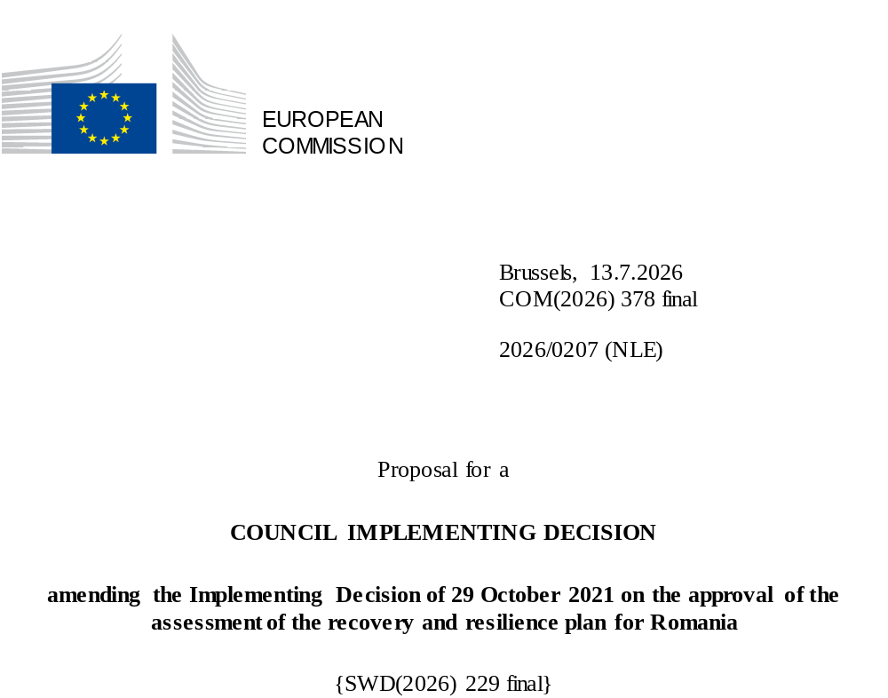

2026/0207 (NLE)
Proposal for a
COUNCIL IMPLEMENTING DECISION
amending the Implementing Decision of 29 October 2021 on the approval of the assessment of the recovery and resilience plan for Romania
THE COUNCIL OF THE EUROPEAN UNION,
Having regard to the Treaty on the Functioning of the European Union,
Having regard to Regulation (EU) 2021/241 of the European Parliament and of the Council of 12 February 2021 establishing the Recovery and Resilience Facility, and in particular Article 20(1) thereof,
Having regard to the proposal from the European Commission,
Whereas:
(1) Following the submission of the national recovery and resilience plan (‘RRP’) by Romania on 31 May 2021, the Commission proposed its positive assessment to the Council. On 29 October 2021, the Council approved the positive assessment by means of an implementing decision (‘the Council Implementing Decision of 29 October 2021’). The Council Implementing Decision of 29 October 2021 was amended by the Council Implementing Decisions of 8 December 2023 and of 13 November 2025.
(2) On 24 June 2026, Romania made a reasoned request to the Commission to make a proposal to amend the Council Implementing Decision of 29 October 2021 in accordance with Article 21(1) of Regulation (EU) 2021/241 on the grounds that the RRP is partially no longer achievable because of objective circumstances. On that basis, Romania has submitted an amended RRP.
Amendments based on Article 21 of Regulation (EU) 2021/241
(3) The amendments to the RRP submitted by Romania because of objective circumstances concern 94 measures.
(4) Romania has explained that three measures are no longer achievable, due to the withdrawal of the relevant projects by the contractors, due to move and merge with an existing measure in the grants and to unforeseen delays in implementation arising from circumstances beyond its control. This concerns C6.I4, C16.I4a and C8.I7. On this basis, Romania has requested that those measures be removed. The Council Implementing Decision of 29 October 2021 should be amended accordingly.
(5) Romania has explained that 23 measures are partially no longer achievable, because of unforeseen circumstances or significant implementation delays beyond its control, including contractor performance issues and other impediments to the progress of the measures, which have rendered the initial planning unfeasible. This includes measures that are partially no longer achievable in their current form due to lack of, or insufficient demand. This concerns C2.I1, C2.I4, C3.I2, C4.I1, C4.I2, C5.I1, C5.I1a, C7.I3, C7.I8, C7.I17, C10.I2, C10.I4, C10.I3, C10.I1, C11.I2, C12.I3, C12.I1, C13.I4, C13.I1, C13.I2, C14.R3, C14.R9, C16.I8. On this basis, Romania has requested that those measures be amended. The Council Implementing Decision of 29 October 2021 should be amended accordingly.
(6) Romania has explained that 68 measures have been amended to implement a better alternative that allows the administrative burden to be reduced and simplify the Council Implementing Decision, while still achieving the objectives of those measures. This concerns C1.I1, C1.I2, C1.I5, C1.R2, C2.I2, C2.I3, C2.I5, C2.R2, C3.I1, C3.I1a, C3.I3, C3.R1, C4.R1, C4.I3, C4.I3a, C4.R2, C5.I4, C5.R1, C6.I2, C6.R1, C6.R4, C7.I5, C7.I6, C8.I1, C8.I2, C8.I3, C8.I4, C8.I5, C8.I10, C8.R1, C9.I1, C9.I2, C9.I3, C9.I4, C9.I5.a, C9.R1, C9.R2.a, C9.R4, C9.R5, C10.R5, C11.I1, C11.I4, C12.I2, C12.R3, C12.I4, C13.R2, C14.R1, C14.R7, C15.I10, C15.I11, C15.I10.2a, C15.I16, C15.I18, C15.I13, C15.I2, C15.I4, C15.I6, C15.I8, C15.I9, C15.R4, C15.I17, C15.I1, C15.I1a, C16.R1, C16.I5, C16.I7, C16.I9, C16.I10. On this basis, Romania has requested that those measures be amended. The Council Implementing Decision of 29 October 2021 should be amended accordingly.
(7) Following the removal and decrease in the level of implementation of measures in accordance with Article 21 of Regulation (EU) 2021/241, Romania has requested to use the resources freed up by the removal of measures and decrease in the level of their implementation to add four new measures and increase the level of implementation of two measures. This concerns C4.I1a, C4.I5, C6.I2a and C16.I7a, and C8.I11 and C16.I4 respectively. On this basis, Romania has requested that the level of implementation of two measures be increased and that four new measures be added. The Council Implementing Decision of 29 October 2021 should be amended accordingly.
Distribution of milestones and targets
(8) The distribution of milestones and targets in instalments should be amended to take into account the amendments to the RRP and the indicative timeline presented by Romania.
Commission’s assessment
(9) The Commission has assessed the amended RRP against the assessment criteria laid down in Article 19(3) of Regulation (EU) 2021/241.
Contribution to the REPowerEU objectives
(10) In accordance with Article 19(3), point (da), of, and criterion 2.12 of Annex V to, Regulation (EU) 2021/241, the REPowerEU chapter is expected to effectively contribute to a large extent (rating A) to energy security, the diversification of the Union’s energy supply, an increase in the uptake of renewables and in energy efficiency, an increase of energy storage capacities or the necessary reduction of dependence on fossil fuels before 2030.
(11) As some measures under the REPowerEU chapter have been downscaled, investments C16.I9 and C16.I10 were added, which were until now included in the RRP as C6.I4a and C6.I5a. The measures align with the REPowerEU objectives supporting electricity storage (Article 21c (3) (e)), decarbonising industry (Article 21c 3(b)), and incentivising reduction of energy demand (Article 21c (3) (d)).
(12) In accordance with Article 19(3), point (db), of and Annex V, criterion 2.13, to Regulation (EU) 2021/241, the new composition of measures included in the REPowerEU chapter are expected to a large extent (rating A) to have a cross-border or multi-country dimension or effect.
Contribution to the green transition including biodiversity
(13) In accordance with Article 19(3), point (e), of, and criterion 2.5 of Annex V to, Regulation (EU) 2021/241, the amended RRP contains measures that contribute to a large extent (rating A) to the green transition, including biodiversity, or to addressing the challenges resulting therefrom. The measures supporting climate objectives account for an amount which represents 39,1% of the amended RRP’s total allocation and 91,5% of the total estimated costs of measures in the REPowerEU chapter calculated in accordance with the methodology set out in Annex VI to Regulation (EU) 2021/241. In accordance with Article 17 of Regulation (EU) 2021/241, the amended RRP is consistent with the information included in the National Energy and Climate Plan 2021-2030.
(14) The amendments to the measures contributing to the green transition concern 20 measures, namely C2.I1, C3.I2, C4.I1, C4.I1a, C4.I2, C5.I1, C5.I1a, C6.I4, C10.I1, C10.I2, C10.I3, C12.I1, C12.I3, C13.I1, C13.I2, C15.I17, C16.I4, C16.I4a, C16.I7, C16.I8. Overall, due to the differing climate-tagging content of the increased measure and the decreased measures, the amendments to Romania’s RRP entail a net decrease in the overall contribution to the climate target of the RRP from 40,6 % to 39,1 %. The measures related to the green transition, including biodiversity, in the modified RRP, including the REPowerEU chapter, have a lasting impact as the measures aim at structural changes to reduce Romania’s overall reliance on fossil fuels and at increasing energy savings by shifting to green technologies, in particular those related to renewable energy sources, and by promoting sustainable practices across various sectors. As a result, the measures also contribute to achieving the 2030-2050 targets and the objective of the EU climate neutrality by 2050. The limited scope of those amendments does not change the overall assessment of this criterion.
Contribution to the digital transition
(15) In accordance with Article 19(3), point (f), of, and criterion 2.6 of Annex V to, Regulation (EU) 2021/241, the amended RRP contains measures that contribute to a large extent (rating A) to the digital transition or to addressing the challenges resulting from it. The measures supporting digital objectives account for an amount which represents 24,0% of the amended RRP’s total allocation calculated in accordance with the methodology set out in Annex VII to that Regulation.
(16) The amendments to the measures contributing to the digital transition concern the decrease in allocation for 10 measures, namely C2.I4, C4.I3, C4.I3a, C7.I3, C7.I8, C8.I7, C10.I2, C10.I4, C12.I3, C16.I5. Overall, due to the differing digital-tagging content of the increased measure and the decreased measures, the amendments to Romania’s RRP entail a net increase in the overall contribution to the digital target of the RRP from 21,3 % to 24,0 %. The limited scope of these amendments does not change the overall assessment of this criterion.
Costing
(17) In accordance with Article 19(3), point (i), of, and criterion 2.9 of Annex V to, Regulation (EU) 2021/241, the justification provided in the amended RRP on the amount of the estimated total cost of the RRP is to a medium extent (rating B) reasonable and plausible, is in line with the principle of cost efficiency and is commensurate to the expected national economic and social impact.
(18) According to the information provided, the assessment of the cost estimates for the new measures and for the existing measures whose modifications entailed a new cost assessment show that most of the costs are reasonable and plausible. Only in a few cases, details on the methodology and assumptions used to make the cost estimates were limited, partly due to the novelty of the measures. This precludes an A rating for this assessment criterion. Furthermore, the changes in the cost estimates for the other modified measures were justified, proportional to the new revised targets and supported by detailed calculations and evidence, and as such the reasonability and plausibility of these cost estimates were not altered compared to the original RRP. Finally, the estimated total cost of the RRP is in line with the principle of cost-efficiency and commensurate with the expected national economic and social impact.
Any other assessment criteria
(19) The Commission considers that the amendments put forward by Romania do not affect the positive assessment of the RRP set out in the Council Implementing Decision of 29 October 2021 on the approval of the assessment of the RRP for Romania regarding the relevance, effectiveness, efficiency and coherence of the RRP against the assessment criteria laid down in Article 19(3), points (a), (b), (d), (db), (g), (h), (j) and (k).
Positive assessment
(20) Following the positive assessment by the Commission of the amended RRP, with the finding that the RRP satisfactorily complies with the criteria for assessment set out in Regulation (EU) 2021/241, in accordance with Article 20(2) of and Annex V to that Regulation, the reforms and investment projects necessary for the implementation of the amended RRP, the relevant milestones, targets and indicators, and the amount made available from the Union for the implementation of the amended RRP should be set out.
Financial contribution
(21) The estimated total costs of Romania’s amended RRP is EUR 20 106 860 700. As the amount of the estimated total cost of the amended RRP is higher than the updated maximum financial contribution available for Romania, the financial contribution determined in accordance with Article 4a of Regulation (EU) 2021/1755 of the European Parliament and of the Council, and with Article 20(4) and Article 21a(6) of Regulation (EU) 2021/241 that is allocated for Romania’s amended RRP should be equal to EUR 13 566 055 514. Therefore, the financial contribution made available to Romania remains unchanged.
Loans
(22) In order to support additional reforms and investments, a total loan support of EUR 7 844 472 079 was made available to Romania by means of Council Implementing Decision of 29 October 2021. Following the removal of C6.I4 and C16.I4a and the decrease in the level of implementation of C3.I2, C4.I1, C4.I2, C5.I1, C6.I4, C6.C10.I2, C10.I4, C11.I2, C12.I3, C16.I5 under Article 21 of Regulation 2021/241, Romania has not requested to use the freed up loan resources to support new measures or to increase the level of implementation of existing measures within the RRP. The amount of the estimated total costs of the RRP is lower than the combined financial contribution available for Romania and the loan support that had been made available to Romania by means of Council Implementing Decision of 29 October 2021. Therefore, the total loan support made available to Romania should be reduced to EUR 6 540 805 186.
(23) The amount of the loan should be set out in this decision in accordance with Article 20(5), point (h) of Regulation (EU) 2021/241. However, pursuant to Commission Implementing Decision of 18 December 2024 on the reduction of the amount of the second instalment of the loan support for Romania, adopted in accordance with Article 24(8) of Regulation (EU) 2021/241, the loan has been reduced by EUR 10 772 581 and Romania cannot request its disbursement from the Commission.
(24) The Council Implementing Decision of 29 October 2021 should therefore be amended accordingly. For the sake of clarity, the Annex to the Council Implementing Decision of 29 October 2021 should be replaced entirely.
(25) This Decision should be without prejudice to the outcome of any procedures relating to the award of Union funds under any Union programme other than the Facility or to procedures relating to distortions of the operation of the internal market that may be undertaken, in particular under Articles 107 and 108 of the Treaty. It does not override the requirement for Member States to notify instances of potential State aid to the Commission under Article 108 of the Treaty,
HAS ADOPTED THIS DECISION:
Article 1
Approval of the assessment of the RRP
The assessment of the amended RRP for Romania on the basis of the criteria provided for in Article 19(3) of Regulation (EU) 2021/241 is approved.
Article 2
Amendments
The Council Implementing Decision of 29 October 2021 on the approval of the assessment of the recovery and resilience plan for Romania is amended as follows:
(1) in Article 3, paragraph 1 is replaced by the following:
“1. The Union shall make available to Romania a loan amounting to a maximum of EUR 6 540 805 186.”;
(2) the Annex is replaced by the text set out in the Annex to this Decision.
Article 3
Addressee
This Decision is addressed to Romania.
Done at Brussels,
For the Council
The President

OJ L 57, 18.2.2021, p. 17, ELI: https://eur-lex.europa.eu/eli/reg/2021/241/oj.
ST 12319/21 INIT; ST 12319/21 ADD 1.
ST 15833/23 INIT; ST 15833/23 ADD 1.
ST 14452/25 INIT; ST 14452/25 ADD 1.
Regulation (EU) 2021/1755 of the European Parliament and of the Council of 6 October 2021 establishing the Brexit Adjustment Reserve (OJ L 357, 8.10.2021, p. 1, ELI: http://data.europa.eu/eli/reg/2021/1755/oj).

