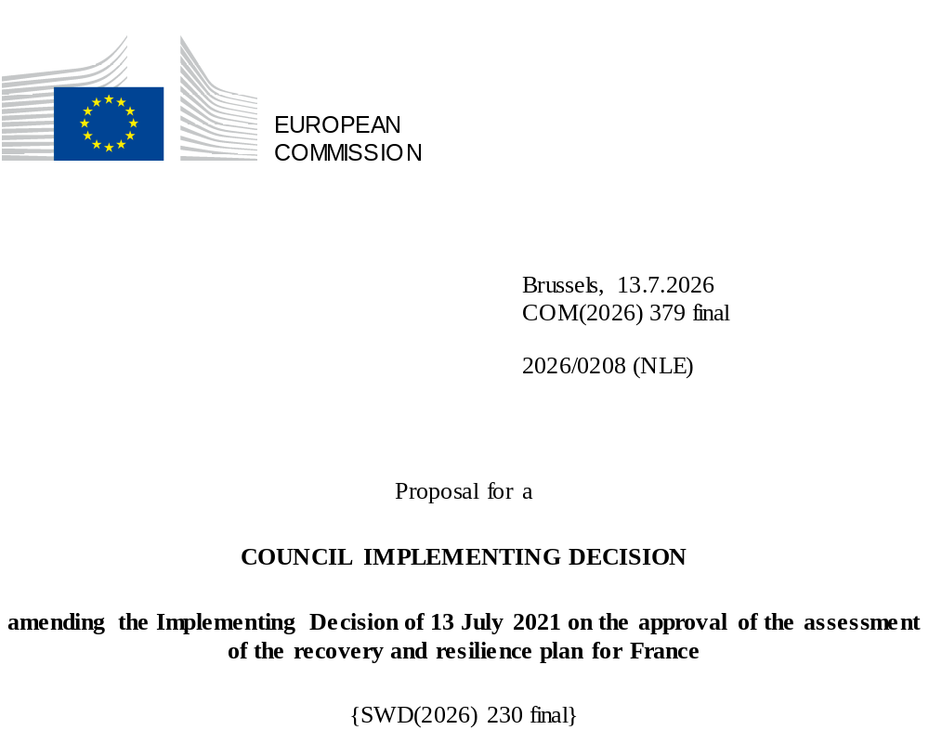

2026/0208 (NLE)
Proposal for a
COUNCIL IMPLEMENTING DECISION
amending the Implementing Decision of 13 July 2021 on the approval of the assessment of the recovery and resilience plan for France
THE COUNCIL OF THE EUROPEAN UNION,
Having regard to the Treaty on the Functioning of the European Union,
Having regard to Regulation (EU) 2021/241 of the European Parliament and of the Council of 12 February 2021 establishing the Recovery and Resilience Facility, and in particular Article 20(1) thereof,
Having regard to the proposal from the European Commission,
Whereas:
(1) Following the submission of the national recovery and resilience plan (‘RRP’) by France on 28 April 2021, the Commission proposed its positive assessment to the Council. On 13 July 2021, the Council approved the positive assessment by means of an implementing decision (‘the Council Implementing Decision of 13 July 2021’). The Council Implementing Decision of 13 July 2021 was amended by the Council Implementing Decisions of 14 July 2023 and 12 December 2025.
(2) On 29 May 2026, France made a reasoned request to the Commission to make a proposal to amend the Council Implementing Decision of 13 July 2021 in accordance with Article 21(1) of Regulation (EU) 2021/241 on the grounds that the RRP is partially no longer achievable because of objective circumstances. On that basis, France has submitted an amended RRP.
Amendments based on Article 21 of Regulation (EU) 2021/241
(3) The amendments to the RRP submitted by France because of objective circumstances concern 17 measures.
(4) France has explained that one measure is partially no longer achievable, because issues encountered in the collection of supporting evidence would create a disproportionate administrative burden in relation to the costing of the target. The proposed amendment also aims to rationalise and simplify the implementation of the plan. This concerns target 7-16 of measure C7.I1 (Digital upgrade of companies). On this basis, France has requested that this measure be amended. The Council Implementing Decision of 13 July 2021 should be amended accordingly.
(5) France has explained that one measure is partially no longer achievable, because of administrative burden anticipated to justify part of the target and possible difficulties in collecting necessary evidence. The proposed amendment also aims to rationalise and simplify the implementation of the plan. This concerns target 8-25 of measure C8.I18 (Modernising and digitalising professional training). On this basis, France has requested that this measure be amended. The Council Implementing Decision of 13 July 2021 should be amended accordingly.
(6) France has explained that one measure is partially no longer achievable, because of technical difficulties to implement the investment within the RRF eligibility period and possible difficulties in collecting necessary evidence. The proposed amendment also aims to rationalise and simplify the implementation of the plan. This concerns target 9-12 of investment C9.I3 (Renovation of medico-social establishments). On this basis, France has requested that this measure be amended. The Council Implementing Decision of 13 July 2021 should be amended accordingly.
(7) France has explained that one measure is partially no longer achievable because, due to industrial issues, one project's implementation timeline has been postponed beyond the RRF eligibility period. This concerns milestone 10-8 of measure C10.I2 (IPCEI Hydrogen). On this basis, France has requested that this measure be amended. The Council Implementing Decision of 13 July 2021 should be amended accordingly.
(8) France has explained that four measures have been amended to implement better alternatives in order to achieve their original ambition. This concerns milestone 2-3a of reform C2.R2 (Law on circular economy), milestone 7-2 of reform C7.R1 (3DS Law), milestone 7-4 of C7.R2 (Organic law experimentation), and target 8-5 of C8.R3 (Reform of health and security at work). On this basis, France has requested that those measures be amended. The Council Implementing Decision of 13 July 2021 should be amended accordingly.
(9) France has explained that five measures have been amended to implement better alternatives that allow the administrative burden to be reduced and simplify the Council Implementing Decision, while still achieving the objectives of those measures. This concerns target 3-20 of investment C3.I3 (Daily mobility), target 4-12 of investment C4.I3 (Support plan to the aeronautics sector), milestone 7-14a of reform C7.R5 (Assessment of the quality of public spending), milestone 7-23 of investment C7.I6 (Applications of the Ministry of Interior) and target 7-30 of investment C7.I11 (Culture). On this basis, France has requested that those measures be amended. The Council Implementing Decision of 13 July 2021 should be amended accordingly.
(10) France has explained that three measures are partially no longer achievable due to unforeseen technical difficulties. This concerns target 3-14 of investment C3.I1 (Support to railway), milestone 10-5 of investment C10.I1 (Fossil-free industry), and target 10-12 of investment C10.I4 (Energy renovation of private housing, including energy sieves). On this basis, France has requested that those measures be amended. The Council Implementing Decision of 13 July 2021 should be amended accordingly.
(11) Following the decrease in the level of implementation of measures in accordance with Article 21 of Regulation (EU) 2021/241, France has requested to use the resources freed up by the removal of target 7-16 of measure C7.I1 (Digital upgrade of companies), target 8-25 of measure C8.I18 (Modernising and digitalising professional training), target 9-12 of investment C9.I3 (Renovation of medico-social establishments) and milestone 10-8 of measure C10.I2 (IPCEI Hydrogen), and by the decrease in the level of their implementation of target 3-14 of investment C3.I1 (Support to railway), milestone 7-23 of investment C7.I6 (Applications of the Ministry of Interior), target 7-30 of investment C7.I11 (Culture), milestone 10-5 of measure C10.I1 (Fossil-free industry), target 10-12 of investment C10.I4 (Energy renovation of private housing, including energy sieves) to increase the level of implementation of one measure. This concerns target 10-13 of measure C10.I5 (Support to demand for clean vehicles). On this basis, France has requested that the level of implementation of one measure be increased. The Council Implementing Decision of 13 July 2021 should be amended accordingly.
Commission’s assessment
(12) The Commission has assessed the amended RRP against the assessment criteria laid down in Article 19(3) of Regulation (EU) 2021/241.
Contribution to the REPowerEU objectives
(13) In accordance with Article 19(3), point (da), of, and criterion 2.12 of Annex V to, Regulation (EU) 2021/241, the REPowerEU chapter is expected to effectively contribute to a large extent (rating A) to energy security, the diversification of the Union’s energy supply, an increase in the uptake of renewables and in energy efficiency, an increase of energy storage capacities or the necessary reduction of dependence on fossil fuels before 2030.
(14) The removal of milestone 10-8 of investment C10.I2 (IPCEI Hydrogen) and the decrease in the level of implementation of milestone 10-5 of investment C10.I1 (Fossil-free industry) and target 10-12 of investment C10.I4 (Energy renovation of private housing, including energy sieves) is counterbalanced by the scale-up of target 10-13 of investment C10.I5 (Support to demand for clean vehicles). The changes introduced in the measures through the revision of the RRP do not affect the assessment carried out of the REPowerEU, which remains the same.
Contribution to the green transition including biodiversity
(15) In accordance with Article 19(3), point (e), of, and criterion 2.5 of Annex V to, Regulation (EU) 2021/241, the amended RRP contains measures that contribute to a large extent (rating A) to the green transition, including biodiversity, or to addressing the challenges resulting therefrom. The measures supporting climate objectives account for an amount which represents 48,43% of the amended RRP’s total allocation and 94,12% of the total estimated costs of measures in the REPowerEU chapter calculated in accordance with the methodology set out in Annex VI to Regulation (EU) 2021/241. In accordance with Article 17 of Regulation (EU) 2021/241, the amended RRP is consistent with the information included in the National Energy and Climate Plan 2021-2030.
(16) The amended RRP does not materially alter its ambition towards the green transition, given that the total allocation for measures supporting the climate objectives have only decreased by 0,54 percentage points compared with the amended assessment of 12 December 2025. This decrease is the result of the scale down of several measures, namely target 3-14 of investment C3.I1 (Support to railway), target 7-30 of investment C7.I11 (Culture), milestone 10-5 of investment C10.I1 (Fossil-free industry), target 10-12 of investment C10.I4 (Energy renovation of private housing, including energy sieves), and the removal of milestone 10-8 of investment C10.I2 (IPCEI Hydrogen) which is compensated by the scale up of target 10-13 of investment C10.I5 (Support to demand for clean vehicles). The limited scope of those amendments does not change the overall assessment of this criterion.
Contribution to the digital transition
(17) In accordance with Article 19(3), point (f), of, and criterion 2.6 of Annex V to, Regulation (EU) 2021/241, the amended RRP contains measures that contribute to a large extent (rating A) to the digital transition or to addressing the challenges resulting from it. The measures supporting digital objectives account for an amount which represents 21% of the amended RRP’s total allocation calculated in accordance with the methodology set out in Annex VII to that Regulation.
(18) The amended RRP does not materially alter its ambition towards the digital transition, given that the total allocation for measures supporting the digital transition has decreased by only 0,5 percentage points compared with the amended assessment of 12 December 2025. This decrease is due to the removal of target 7-16 of investment C7.I1 (Digital upgrade of companies) and target 8-25 of investment C8.I18 (Modernising and digitalising professional training), and the decrease in the level of ambition of target 7-23 of investment C7.I6 (Applications of the Ministry of Interior) and target 7-30 of investment C7.I11 (Culture). The limited scope of those amendments does not change the overall assessment of this criterion.
Costing
(19) In accordance with Article 19(3), point (i), of, and criterion 2.9 of Annex V to, Regulation (EU) 2021/241, the justification provided in the amended RRP on the amount of the estimated total cost of the RRP is to a medium extent (rating B) reasonable and plausible, is in line with the principle of cost efficiency and is commensurate to the expected national economic and social impact.
(20) For the measures that were downscaled in the amended RRP, the decrease in estimated cost was either proportional to the decrease in the relevant milestones and targets or based on good-quality methodologies and supporting documentation with evidence that the cost modifications were justified, reasonable and plausible. Finally, the amount of the estimated total cost of the RRP is in line with the principle of cost efficiency and commensurate with the expected national economic and social impact.
Any other assessment criteria
(21) The Commission considers that the amendments put forward by France do not affect the positive assessment of the RRP set out in the Council Implementing Decision of 13 July 2021 on the approval of the assessment of the RRP for France regarding the relevance, effectiveness, efficiency and coherence of the RRP against the assessment criteria laid down in Article 19(3), points (a), (b), (c), (d), (db), (g), (h), (j) and (k), of Regulation (EU) 2021/241.
Positive assessment
(22) Following the positive assessment by the Commission of the amended RRP, with the finding that the RRP satisfactorily complies with the criteria for assessment set out in Regulation (EU) 2021/241, in accordance with Article 20(2) of and Annex V to that Regulation, the reforms and investment projects necessary for the implementation of the amended RRP, the relevant milestones, targets and indicators, and the amount made available from the Union for the implementation of the amended RRP should be set out.
Financial contribution
(23) The estimated total costs of France’s amended RRP is EUR 40 310 303 896. As the amount of the estimated total cost of the amended RRP is higher than the updated maximum financial contribution available for France, the financial contribution determined in accordance with Article 4a of Regulation (EU) 2021/1755 of the European Parliament and of the Council, and with Article 20(4) and Article 21a(6) of Regulation (EU) 2021/241 that is allocated for France’s amended RRP should be equal to EUR 40 269 973 178. Therefore, the financial contribution made available to France remains unchanged.
(24) The Council Implementing Decision of 13 July 2021 should therefore be amended accordingly. For the sake of clarity, the Annex to the Council Implementing Decision of 13 July 2021 should be replaced entirely.
(25) This Decision should be without prejudice to the outcome of any procedures relating to the award of Union funds under any Union programme other than the Facility or to procedures relating to distortions of the operation of the internal market that may be undertaken, in particular under Articles 107 and 108 of the Treaty. It does not override the requirement for Member States to notify instances of potential State aid to the Commission under Article 108 of the Treaty,
HAS ADOPTED THIS DECISION:
Article 1
Approval of the assessment of the RRP
The assessment of the amended RRP for France on the basis of the criteria provided for in Article 19(3) of Regulation (EU) 2021/241 is approved.
Article 2
Amendments
The Council Implementing Decision of 13 July 2021 on the approval of the assessment of the recovery and resilience plan for France is amended as follows:
the Annex is replaced by the text set out in the Annex to this Decision.
Article 3
Addressee
This Decision is addressed to the French Republic.
Done at Brussels,
For the Council
The President

OJ L 57, 18.2.2021, p. 17, ELI: https://eur-lex.europa.eu/eli/reg/2021/241/oj.
ST 10162/21 INIT; ST 10162/21 ADD 1.
ST 11150/23 INIT; ST 11150/23 ADD 1 REV 2 and corrigendum ST 14651/24.
ST 15759/25 INIT; ST 15759/25 ADD 1.
Regulation (EU) 2021/1755 of the European Parliament and of the Council of 6 October 2021 establishing the Brexit Adjustment Reserve (OJ L 357, 8.10.2021, p. 1, ELI: http://data.europa.eu/eli/reg/2021/1755/oj).

