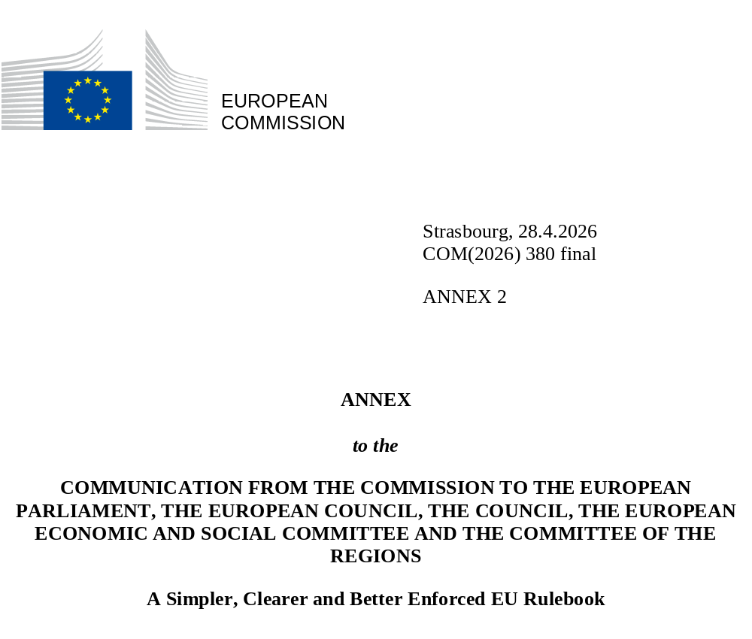

ANNEX II
Single market focus areas for enforcement
Unjustified barriers to the single market, diverging national rules and uneven trading conditions across Member States deter businesses from achieving their full potential, undermining Europe’s competitiveness. This is why the Commission is stepping up its work on enforcing the single market rulebook, targeting several single market focus areas for enforcement.
The Commission has selected the below focus areas based on identified or suspected implementation shortcomings, the enforceability of the identified issues, and the expected benefits for businesses and the functioning of the single market. The Commission will proactively investigate and pursue these focus areas for all Member States, if necessary, through infringement procedures.
Free movement of goods
- Product labelling
Rules on labelling allow the consumer to use a product safely and give information on product identification, origin and environmental impact. The EU has exhaustively harmonised these rules in many areas such as toys, cosmetics, machinery, construction and health products. Additional or divergent rules in Member States can lead to fragmentation of the single market and hamper the seamless distribution of products across the EU, raising costs for consumers.
Issue: National labelling requirements must be notified to the Commission as draft technical regulations prior to their adoption. There has been a proliferation of labelling requirements in recent years, and this requires a closer assessment of the compatibility of such measures with, as applicable, harmonised EU provisions or the principle of free movement of goods. The Commission’s proactive enforcement action will focus on issues in particularly problematic areas such as the labelling for textiles or the labelling for waste sorting.
Expected benefits of focused enforcement: Full compliance with EU rules on labelling requirements across all Member States will lower compliance costs for businesses.
- Circular economy, packaging and waste
EU rules on waste and packaging aim for a more circular economy throughout the EU and minimise the quantities of packaging and waste generated. They lower the use of primary raw materials and contribute to a sustainable and competitive economy. All packaging on the EU market should be recyclable in an economically viable way by 2030, safely increasing the use of recycled plastics in packaging and decreasing the use of virgin materials.
Issue: Several Member States apply the Directives incorrectly and have not reached the waste recycling targets for municipal waste and packaging waste, which is critical to the availability of secondary raw materials for incorporation in new products.
Expected benefits of focused enforcement: Achieving these targets will foster the single market for secondary raw material, enhance circularity and EU competitiveness by reducing the EU’s dependence on imports from third countries. Increased recycling also reduces landfilling, further supporting resource efficiency, circularity and strategic autonomy within the EU.
- Empowering consumers through electricity demand response
High energy prices undermine the competitiveness of businesses and increase people’s cost of living. EU rules on demand response, flexibility and aggregation, and smart meters under the Electricity Directive play an important role for delivering a fully functional, competitive and environmentally sustainable EU internal electricity market. These rules make it possible for domestic and industrial consumers to adjust or reduce their electricity usage in response to higher prices, reduce spikes in wholesale prices and lower electricity system costs.
Issue: Several Member States are late in fully and correctly transposing the requirements of the Electricity Directive on demand response, flexibility and aggregation, as well as the roll-out of smart meters.
Expected benefits of focused enforcement: By adapting electricity consumption in response to market signals, there will be fewer spikes in electricity wholesale prices and lower electricity prices and network charges for households and businesses.
Free movement of people and services
- Posting of workers
EU rules on the posting of workers regulate situations where an employee is sent by their employer to carry out their work for a limited period in the territory of an EU Member State other than where they normally work. Implementing these rules ensures the protection of posted workers, safeguards the freedom to provide services, creates a level-playing field for service providers and helps combating social dumping and fraud. It also requires that the administrative requirements imposed by Member States – to ensure effective monitoring of compliance with the obligations set out in the Enforcement Directive and the Posting of Workers Directive – are justified and proportionate in accordance with the Union law.
Issue: There has been considerable progress to ensure the correct transposition of the Enforcement Directive on the Posting of Workers. While the Commission already pursues infringement procedures, continued action is needed to guarantee respect for an appropriate level of protection of the rights of posted workers, the exercise of the freedom to provide services, and promote fair competition between service providers, thus supporting the functioning of the single market.
Expected benefits of focused enforcement: The Commission will continue its efforts to ensure the correct transposition of the Enforcement Directive. The enforcement of the posting rules will also include strengthening the mandate of the European Labour Authority.
- Construction and installation services related to the green transition
The construction sector represents around 11% of the EU GDP and is essential to supply housing and to renovate Europe’s ageing building stock. Deploying renewable energy equipment and improving the energy efficiency of buildings is economically important and crucial for a successful green transition. Both the increased demand for housing and the green and digital transition are substantially increasing demand for specialised and highly skilled service jobs in the construction sector. The Services Directive aims to ensure that national rules are proportionate and facilitate the cross-border movement of services.
Issue: Many national certification or authorisation schemes for construction and installation services of energy efficiency and renewable installations and, more generally, national regulation of construction services do not fully comply with the Services Directive. These shortcomings are a major cause of the fragmentation in the single market for construction. While labour and skills shortages in the construction sector are now three times higher than they were a decade ago, only 1% of construction services are provided cross-border within the EU. This contributes to high costs, adding to the crisis of affordability in housing.
Expected benefits of focused enforcement: A 10% reduction of barriers in construction services would increase EU gross value added by 0.5%. Reducing obstacles for construction and installation service providers will facilitate cross-border business activities, the entry into new markets and the scaling up, in particular for SMEs.
- Interoperable European railway systems
The 4th railway package provides for common European standards for train vehicles, infrastructure and train operation. The 2024 TEN-T Regulation provides for European train control and signalling systems by 2030. These rules are crucial for smooth and affordable cross-border railway services across Europe, both for passengers and freight.
Issue: Member States have not yet removed all national technical and safety rules on train vehicles, infrastructure and train operation that have been superseded by European specifications or standards under the 4th railway package. There are also delays in achieving the 2030 target for common train control and signalling systems, which risks a bad application of 2024 TEN-T Regulation.
Expected benefits of focused enforcement: Full compliance with EU rules will mean a safer and more interoperable European railway network, opening both the passenger and freight rail markets to more competition, improving the service offer and reducing their prices. This will help both citizens using rail transport and businesses that use freight transport, especially those who wish to reduce the carbon footprint of their transport. European standardisation (standardised and reuseable engineering, harmonised operational rules) will allow for economies of scale foreseeable investment cost will and attract new rail market entrants.
- Multimodal travel information services
EU rules require Member States to ensure the access to data such as aviation, rail or public transport timetables and fares using common EU standards. The information is necessary for multimodal journey planners for European travellers. It is also a pre-requisite for the development of new services such as online ticketing for multimodal travel.
Issue: For many Member States, datasets on aviation, rail or public transport are not accessible via their national access point and/or in the right standard for data exchange, resulting in bad application of EU rules.
Expected benefits of focused enforcement: Access to multimodal data enables increased digitalisation of transport systems, which is a key driving force in the Single European Transport Area and the Single European Railway Area, to improve connectivity across modes and networks. Multimodal travel will increase destination accessibility and territorial cohesion by better connecting regions, including peripheral and rural areas, to core economic centres. Service providers will be able to develop more integrated, user-friendly, and competitive travel solutions.
- Late payments
Most goods and services are supplied within the single market on a deferred payment basis whereby the supplier gives its client time to pay the invoice. Specific rules exist as regards commercial transactions for the supply of goods or services by undertakings to public authorities. These rules aim to ensure the proper functioning of the single market and protect SMEs from the negative impact of late payments on their cash flow.
Issue: Still today, across the EU, Member States still apply the Directive incorrectly and many payments in commercial transactions between economic operators and public authorities are made later than agreed. Delays negatively affect liquidity and complicate the financial management of undertakings. It also affects their competitiveness and profitability when the creditor needs to obtain external financing because of late payment. 73% of SMEs report suffering from late payments, hampering their growth and investment potential and threatens their survival.
Expected benefits of focused enforcement: Ensuring the respect of EU rules on timely payments by public authorities will ensure a more reliable and secure environment for economic operators and specifically SMEs.
Freedom of establishment and free movement of capital
- Digitalisation of company law and cross-border mobility of companies
EU rules make it possible to set up new companies and to register new branches online. The EU also arranges for harmonised procedures for cross-border mergers, divisions and conversions. In the area of taxation, the EU provides for tax neutral treatment in case of company restructuring and dividend payments streams in group companies.
Issue: Commission assessment points to possible shortcomings in the transposition of the Directives on company law digitalisation and on cross-border mobility by several Member States. In the area of taxation, Member States tax dividend and payment streams as well as mergers, divisions and acquisitions differently, meaning an incorrect application of the Parent Subsidiary Directive and the Tax Merger Directive. Tax incentives for employment, research and development face in certain instances also unjustified territorial restrictions.
Expected benefits of focused enforcement: Ensuring full and correct transposition of EU rules on company law digitalisation and on cross-border company mobility into national law and their effective implementation in practice will streamline online business establishment, enabling a more efficient setting up of new companies and registration of new branches within the EU. This will reduce administrative costs and ensure efficient cross-border restructuring with full legal certainty. Less fragmentation of company taxation rules will increase competitiveness and investment for mid-sized and larger companies operating across the single market. Ensuring wider access to tax incentives by companies will drive investments to innovation, boosting competitiveness and employment.
- Bank consolidation
A resilient, diversified and strong banking sector benefits the overall economy and is vital for the Savings and Investments Union, as it supports more efficient capital allocation, strengthens cross-border activities and improves access to financial products at competitive prices. Consolidation in the sector enables banks to achieve scale, diversify risks and operate more efficiently across Member States, it contributes to a more resilient, stable and predictable banking environment, allowing banks to compete in international markets.
Issue: Bank consolidation is market driven. Mergers and acquisitions in the banking sector need to be assessed in a fair, transparent and proportionate manner, without undue impediments. A close monitoring from the Commission will preserve the EU’s system of prudential supervision within the single market and influence market changes in due time. Additionally, several Member States are late to transpose EU rules aiming to create a more uniform regulatory environment for banking activities in the EU.
Expected benefits of focused enforcement: Bank consolidation benefits the overall economy and is supportive of the Savings and Investments Union, contributing to efficient capital allocation and access to financial products at optimal prices.
- Savings and investment
The Commission supports measures to create better opportunities for citizens who wish to invest, which is a key pillar of the Savings and Investments Union Strategy. In particular, Savings and Investment Accounts, based on user-friendly platforms to invest and which may be coupled with simplified tax compliance procedures and advantageous tax treatment, have already shown significant potential in several Member States for channeling more savings towards investments.
Issue: There are measures in several Member States, that make for example, financial and tax incentives conditional upon investments into national markets or products. This conditionality may raise questions as to its justification and may in certain cases ultimately create cross-border discrimination. This can unduly complicate the provision of investment services and the offer of Savings and Investment Accounts by providers on a pan-European basis and lead to limitations on investment opportunities for citizens and hamper the free movement of capital.
Expected benefits of focused enforcement: Capital market-based investments have greater potential to outpace inflation and offer higher returns than other types of savings, notably bank deposits. Removing barriers negatively affecting citizens will increase retail participation in capital markets which will in turn foster more liquid capital markets which can better serve the financing needs of EU companies.

The identified focus areas relate to issues with a serious impact on the functioning of the single market and a detrimental effect on European businesses. The Commission has identified these areas based on information collected from sources including implementation dialogues, complaints by members of the public, and systemic issues identified through the SOLVIT centres operating across the EU to tackle individual cross-border problems.
Directive (EU) 2015/1535 of the European Parliament and of the Council of 9 September 2015 laying down a procedure for the provision of information in the field of technical regulations and of rules on Information Society services.
Articles 34 and 36 TFEU.
Directive 2008/98/EC of the European Parliament and of the Council of 19 November 2008 on waste and repealing certain Directive; Directive (EU) 2018/852 of the European Parliament and of the Council of 30 May 2018 amending Directive 94/62/EC on packaging and packaging waste.
Directive (EU) 2019/944 of the European Parliament and of the Council of 5 June 2019 on common rules for the internal market for electricity and amending Directive 2012/27/EU.
Directive 2014/67/EU of the European Parliament and of the Council of 15 May 2014 on the enforcement of Directive 96/71/EC concerning the posting of workers in the framework of the provision of services and amending Regulation (EU) No 1024/2012 on administrative cooperation through the Internal Market Information System (‘the IMI Regulation’).
In addition to the enforcement actions, the Commission will continue working with the co-legislators to facilitate the adoption of the proposal for a public interface connected to the Internal Market Information System for the declaration of posting of workers (also known as the e-Declaration).
COM(2025) 991 - Communication from the Commission to the European Parliament, the Council, the European Economic and Social Committee and the Committee of the Regions - The European Strategy for Housing Construction: a more competitive and productive construction industry.
Directive 2006/123/EC of the European Parliament and of the Council of 12 December 2006 on services in the internal market.
European Centre for the Development of Vocational Training (CEDEFOP) Skills Forecast.
Directive (EU) 2016/798 of the European Parliament and of the Council of 11 May 2016 on railway safety and Directive (EU) 2016/797 of the European Parliament and of the Council of 11 May 2016 on the interoperability of the rail system within the European Union.
Regulation (EU) 2024/1679 of the European Parliament and of the Council of 13 June 2024 on Union guidelines for the development of the trans-European transport network.
Commission Delegated Regulation (EU) 2017/1926 of 31 May 2017 supplementing Directive 2010/40/EU of the European Parliament and of the Council with regard to the provision of EU-wide multimodal travel information services.
Directive 2011/7/EU of the European Parliament and of the Council of 16 February 2011 on combating late payment in commercial transactions.
Directive (EU) 2019/1151 of the European Parliament and of the Council of 20 June 2019 amending Directive (EU) 2017/1132 as regards the use of digital tools and processes in company law.
Directive (EU) 2019/2121 of the European Parliament and of the Council of 27 November 2019 amending Directive (EU) 2017/1132 as regards cross-border conversions, mergers and divisions.
Council Directive 2011/96/EU on the common system of taxation applicable in the case of parent companies and subsidiaries of different Member States and Council Directive 2009/133/EC of 19 October 2009 on the common system of taxation applicable to mergers, divisions, partial divisions, transfers of assets and exchanges of shares concerning companies of different Member States and to the transfer of the registered office of an SE or SCE between Member States.
Directive (EU) 2024/1619 amending Directive 2013/36/EU as regards supervisory powers, sanctions, third-country branches, and environmental, social and governance risks.
Commission Recommendation on Increasing the Availability of Savings and Investment Accounts with Simplified and Advantageous Tax Treatment - C/2025/6800 final.

