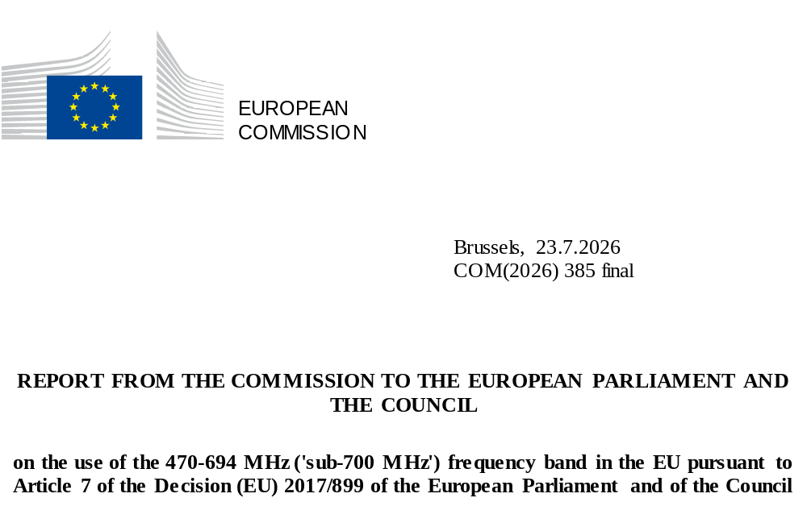

1. INTRODUCTION
Decision (EU) 2017/899 of (the UHF Decision) establishes the regulatory framework for the use of the 470-694 MHz (sub-700 MHz) band across the EU. The UH Ultra High Frequency (UHF) band is a valuable part of the radio spectrum thanks to its favourable propagation characteristics, offering both wide-area coverage and strong indoor signal penetration. As technological and market conditions evolve, so does the demand for this spectrum. To ensure the efficient use of the sub-700 MHz band and in view of EU spectrum policy needs, the Commission is required to reassess in due time the appropriateness of existing spectrum allocations.
The UHF Decision provides long-term investment predictability and stimulates innovation by safeguarding (under Article 4) the availability of the sub-700 MHz band for Digital Terrestrial Television (DTT) and Programme Making and Special Events (PMSE) services until at least 2030 in all Member States. This protection is provided while respecting the principle of technological neutrality. Furthermore, the UHF Decision allows alternative uses of the band within a Member State, provided those uses are compatible with national broadcasting requirements and ensure the continued provision of broadcasting services in neighbouring Member States.
Under Article 7 of the UHF Decision, the Commission is required - in cooperation with the Member States - to report to the European Parliament and the Council on developments in the use of the sub-700 MHz frequency band with a view to ensuring efficient spectrum use. The purpose of this report is therefore to examine the use of the sub-700 MHz frequency band in the EU, taking into account: (i) social, economic, cultural and international aspects; (ii) technological developments; (iii) changes in consumer behaviour; and (iv) connectivity requirements to foster growth and innovation in the EU. The report takes due account of the relevant deliverables from the Radio Spectrum Policy Group (RSPG), namely the 2023 RSPG Opinion and a 2025 RSPG Report, as well as of the 2024 Commission study on the use of the sub-700 MHz band in the EU.

2. ALLOCATIONS IN THE 470-694 MHz BAND AND INTERNATIONAL DEVELOPMENTS
For decades, the sub-700 MHz band has been allocated on a primary basis to broadcasting, including in the International Telecommunication Union (ITU) Region 1, which includes all EU Member States. It is the primary band for terrestrial broadcasting in the EU.
In a number of countries in ITU Region 1, including 24 EU Member States, this band is allocated on a secondary basis to the land mobile service for audio Programme Making and Special Events (PMSE) applications, such as wireless microphones and in-ear monitoring systems. Terrestrial television has shared spectrum with PMSE applications for decades, thanks to: (i) the inherent availability of ‘white spots’ (geographical areas of unused spectrum), (ii) well-established sharing conditions and (iii) PMSE equipment availability. PMSE use must not cause harmful interference to broadcasting or claim protection from harmful interference caused by broadcasting.
In addition, portions of the sub-700 band are also allocated within the EU to other radiocommunication services, namely radioastronomy on a secondary basis (608-614 MHz) and radiolocation on a secondary basis (470-494 MHz). The latter use is limited to wind profiler radars only in certain EU Member States (see Figure 1).
Figure 1: Allocations in the sub-700 MHz band in ITU Region 1
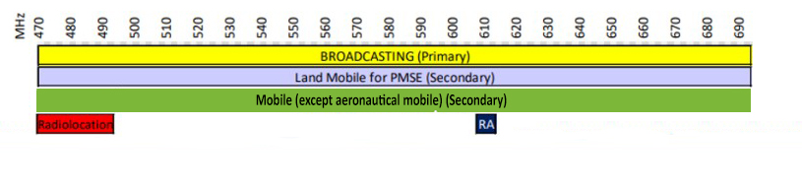
At the 2023 World Radiocommunication Conference (WRC-23), a secondary allocation to mobile services (except aeronautical mobile) was introduced across the entire 470-694 MHz band in 43 CEPT countries, including all EU Member States except Italy and Spain.
In certain countries of ITU Region 1 outside the EU, portions of the sub-700 MHz band are also allocated to: (i) the aeronautical radionavigation service on a primary basis (646-862 MHz); and (ii) on a secondary basis to the fixed service (470-582 MHz) or the fixed and mobile (excluding aeronautical mobile) service (582-790 MHz). At WRC-23, a primary allocation to the mobile service (excluding aeronautical mobile) was introduced in the 614-694 MHz frequency range for 11 Arab countries. In addition, a secondary allocation to the mobile service (excluding aeronautical mobile) was introduced in the 614-694 MHz frequency range for eight African countries.
The usage of the sub-700 frequency band in ITU Region 2 (the Americas) and ITU Region 3 (Asia-Pacific) has traditionally been very similar to ITU Region 1 due to a primary allocation to broadcasting. However, allocations vary (some were introduced only at WRC-23), particularly due to mobile allocations and IMT identifications within the band.
Generally, mobile and fixed allocations in the 470-512 MHz and 614-698 MHz frequency bands are secondary in ITU Region 2. However, certain countries have primary allocations for both the 470-512 MHz band and the 614-698 MHz (600 MHz) bands for mobile services. In most of these countries (and also some others), the 600 MHz band, or portions of it, is identified for IMT. The United States, Canada and Mexico already use the 600 MHz band for mobile broadband (4G/5G), whereas in most Caribbean and Latin American countries the band is still used for terrestrial broadcasting, with a future potential for mobile broadband. Throughout Region 2, the 608-614 MHz frequency band has an exclusive primary allocation to radio astronomy.
In ITU Region 3, the entire sub-700 MHz band has an additional primary allocation to the fixed and mobile service, while the 585-610 MHz range has an additional primary allocation to the radionavigation service. A number of countries have an IMT identification either within the 600 MHz band (or portions of it) or within the sub-700 MHz band (or portions of it). China uses the 600 MHz band for 5G (covering rural areas), and India, Australia, New Zealand and South Korea are moving towards mobile use of the band. However, most other countries - particularly in Southeast and East Asia - continue to use the band mainly for terrestrial broadcasting.

3. USE OF THE 470-694 MHz BAND IN THE EU
Digital Terrestrial Television (DTT)
In the EU, the sub-700 MHz band has traditionally been used for free-to-air (FTA) terrestrial television broadcasting, which has more recently switched over from analogue format to DTT.
The digital switchover process began on 17 June 2006 and was completed on 17 June 2015, in accordance with the ITU’s Geneva 2006 (GE06) Agreement. The transition from analogue to digital terrestrial TV has significantly increased the efficiency of spectrum use, enabling more services to be transmitted within the same bandwidth. With analogue TV, one television service was transmitted per frequency. In DTT, multiple services can be carried on a single frequency. This is achieved through a multiplex, enabled by the DVB-T standard. A multiplex combines several services (channels) into a single digital stream transmitted within an 8 MHz channel (in the EU).
The extent to which the sub-700 MHz band is used for DTT varies significantly across the Member States. A Commission study used a targeted questionnaire to collect viewpoints from national regulators in the Member States on the current use of the band for DTT and its planned future use. Furthermore, replies to a 2024 RSPG questionnaire and a subsequent RSPG report provided updated viewpoints from the Member States on the use of the sub-700 MHz band.
On the basis of evidence from the replies to the RSPG questionnaire, a focused assessment of developments in 10 selected Member States - namely Croatia, Finland, France, Germany, Italy, Portugal, Slovenia, Spain, Sweden and the Netherlands - is presented below to illustrate the significant differences in the use of the sub-700 MHz band across the EU.
The share of households using DTT to access linear television varies widely across the EU, ranging from very low levels in countries such as the Netherlands, Germany and Slovenia to very high levels in Italy and Spain. In addition, the proportion of households that are solely dependent on DTT differs across Member States. The number of multiplexes (8 MHz channels) indicates how much capacity is available to carry television services on the DTT platform and is further analysed below. Taken together, these measures show that the use of DTT differs significantly across Member States.
Table 1: Usage of the sub-700 MHz band in the EU (Source: RSPG questionnaire, 2024)
Country | Maximum number of 8 MHz channels per coverage area | Percentage of households actually using only DTT for accessing linear TV | Percentage of households solely dependent on DTT
Croatia | 5 | 45% | 45%
Finland | 7 | 42% | 30%
France | 8 | 18.4% | 18.4%
Germany | 7 | 6% | 6%
Italy | 14 | 92.1% | 75%
Portugal | 2 | 8.3% | 5.8%
Slovenia | 2 | 0.3% | 0.3%
Spain | 11 | 99.5%
Sweden | 6* | 10% | 10%
Netherlands | 5 | 3% | unknown, very low
* In Sweden, the number of multiplexes was reduced from six to two as of 1 January 2025, with only four public service channels and two private ones being retained. According to information presented at a RSPG workshop in April 2025, a likely scenario is that Sweden’s DTT service may eventually be reduced to a single multiplex carrying only the two main national public channels and then be completely phased out in the short term.

Figure 2 presents the maximum number of multiplexes (8 MHz channels) per coverage area in each country, which reflects the available DTT capacity within a given geographical area and gives an idea of the overall national density of multiplex deployment.
Figure 2: Maximum number of 8 MHz channels received per coverage area (Source: RSPG Report)
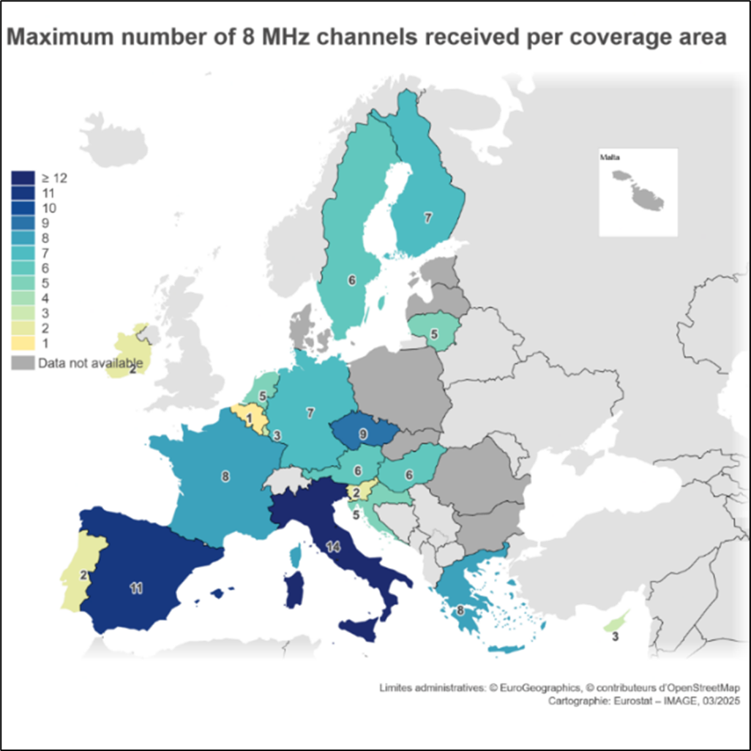
The EBU (European Broadcasting Union) and BNE (Broadcast Networks Europe) estimate that 40-42% of European TV households receive DTT on at least one TV set in the household. According to the EBU-BNE database, approximately 183.5 million households across the EU27 have at least one television set, of which around 74.8 million receive DTT.
Figure 3 shows the portion of households that actually use DTT broadcasting to access linear TV. As mentioned above, the percentage of households that choose to access linear TV through DTT varies among EU countries, ranging from a low of 3% to a high of 92%.
Figure 3: Percentage of households that actually use DTT broadcasting to access linear TV per EU Member State in 2024-2025 (source: RSPG Opinion)
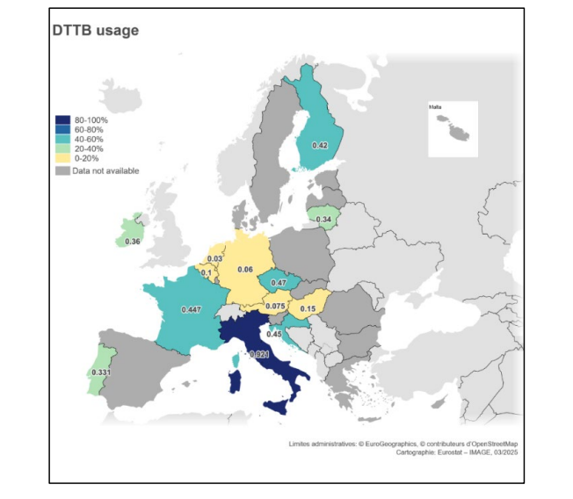
Figure 4 shows DTT penetration across EU Member States in 2025. The results vary considerably: some countries display very low levels of DTT usage, while others reach penetration levels above 70%.
Figure 4: DTT penetration in EU Member States in 2025 (source: EBU-BNE DPM database)
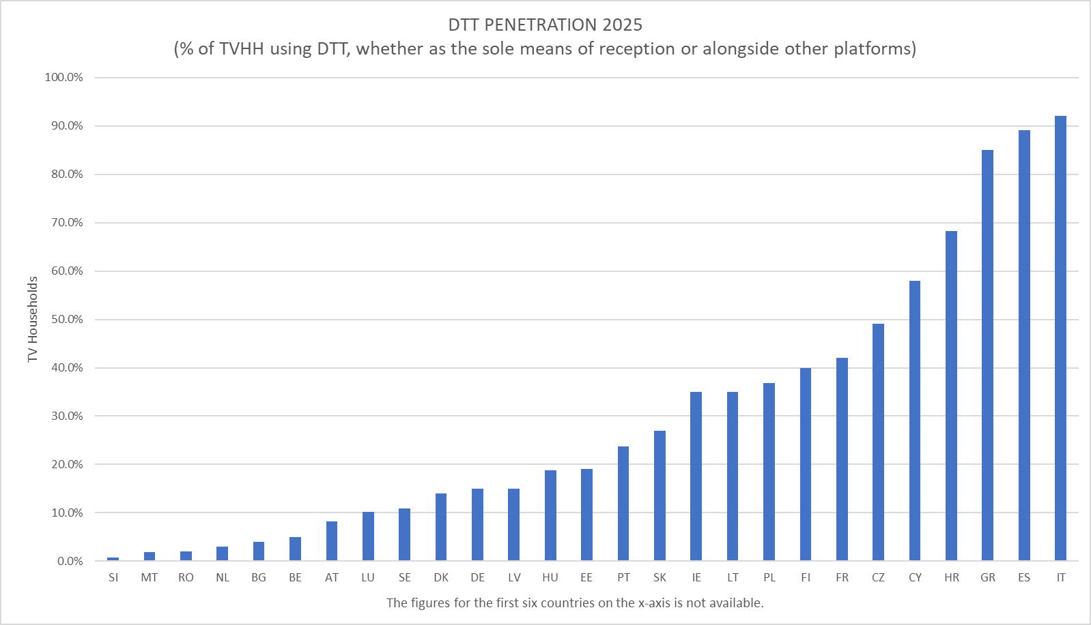

Figure 5 provides an overview of the expiration year of DTT licences across 21 EU Member States (for which data are available). Most of the Member States have licences that expire around or beyond 2030, and several Member States are considering renewing them.
Figure 5: Expiration year of DTT licences23
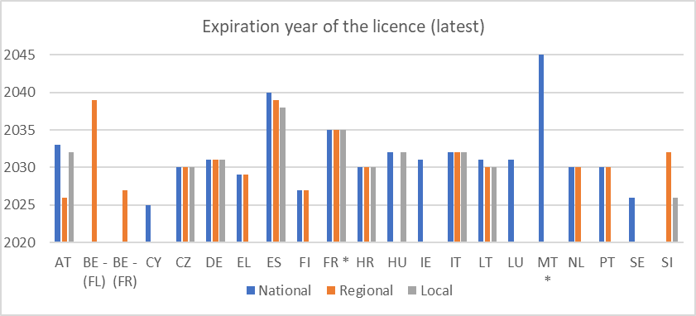
*Note: FR - possible further extension of up to five years for national licences granted in 2025, MT - licence is valid indefinitely.

PMSE (Programme Making and Special Events) and other secondary services
As regards audio PMSE, which typically operates in white spaces of the band, the current trend in usage depends on national circumstances and special events. Peak-demand events can occur several times per year (in some cases up to 24 times per year) and may last from a few days to a few weeks. These large-scale events are normally limited to a specific location and do not require large amounts of spectrum to be used across a wider area. There are also regular PMSE use cases like TV studios.
According to PMSE stakeholders, demand for audio PMSE devices continues to increase, while the existing spectrum range available for PMSE (approximately 110-220+ MHz) is becoming constrained. Furthermore, most Member States indicate a requirement to use the entire sub-700 MHz band for audio PMSE23. According to the EBU and stakeholders in the PMSE sector, alternative (higher) frequency bands are less relevant because of technical, operational and regulatory constraints, such as: (i) limited capacity or availability, (ii) less favourable propagation characteristics, (iii) higher power consumption, and (iv) limited industry support.
Wind profiler radars in the radiolocation service, i.e. radars which assess wind speed and direction, are another secondary user of the sub-700 MHz band in four Member States (Austria, Denmark, Estonia and Germany). As regards radio astronomy (also a secondary user) within the 608-614 MHz range, the ITU Radio Regulations require Member States to take all practical arrangements to protect it, whenever they deploy other radio services which may interfere with radio astronomy.

4. TECHNOLOGICAL DEVELOPMENTS
DTT
Since the late 1990s, digital terrestrial broadcasting has evolved significantly through successive generations of transmission standards, from DVB-T (1997) to DVB-T2 (2009) and of video compression standards, from MPEG-2 (1996) to AVC/H.264 (2003), HEVC/H.265 (2013) and most recently VVC/H.266 (2020). These advances have delivered substantial improvements in capacity, spectral efficiency and video quality.
The transition from DVB-T (as of 1997) to DVB-T2 (as of 2009) has significantly increased DTT capacity within the same radio spectrum, leading to a significant improvement in the efficiency of spectrum use. DVB-T2, the advanced version of the DVB standard, provides approximately 50-100% higher spectral efficiency than DVB-T (ITU-R, 2021). A typical DVB-T2 multiplex (~40 Mbps) can carry around 13 standard-definition (SD) channels ~3 Mbps each) and 5 high-definition (HD) channels (~8 Mbps each using MPEG-4), compared with roughly 8 SD channels and 3 HD channels on a DVB-T multiplex (~24 Mbps).
Alongside improvements in transmission efficiency, video compression technologies have also evolved, further increasing the capacity of the DVB platform. Successive standards - from MPEG-2 (1996) to MPEG-4 (1999), AVC/H.264 (2003) and HEVC/H.265 (as of 2013) - have progressively reduced the bit rate required per video stream, thus enhancing the capacity and efficiency of DTT spectrum use. The shift from MPEG-2 to MPEG-4 has reduced bit rates by up to 50%, while HEVC/H.265 achieves an additional 42-50% reduction (EBU, 2016). VVC/ H.266 is expected to deliver another similar improvement gain equivalent to a 50% reduction over HEVC (Fraunhofer HHI, 2022). These advances allow more services - or higher-quality formats - to be delivered within the same spectrum. Advances in video compression have enabled HD services to be introduced without increasing spectrum needs compared to SD services.
Across the Member States, approximately 60% of national multiplexes are already using the most advanced transmission standard (DVB-T2), with around 40% of national multiplexes using the most advanced encoding standard (HEVC).
Figure 6 shows DTT deployment in CEPT in 2025, based on data from the EBU-BNE database. For the EU specifically, the data indicate that 11 Member States operate DVB-T, 5 operate a mixed system of DVB-T and DVB-T2, and 11 have fully migrated to DVB-T2. With regard to video compression, 12 countries use H.264, 9 use a combination of H.264 and HEVC, 2 use HEVC only, 3 use both MPEG-2 and H.264, and 1 uses MPEG-2. In general, countries still operating DVB-T tend to use H.264 or the older MPEG-2 compression, while countries that have adopted DVB-T2 typically rely on HEVC and/or H.264.
Figure 6: DTT deployment in CEPT-46 countries
(Source: Kenneth Wenzel U Media, EBU-BNE DPM database)
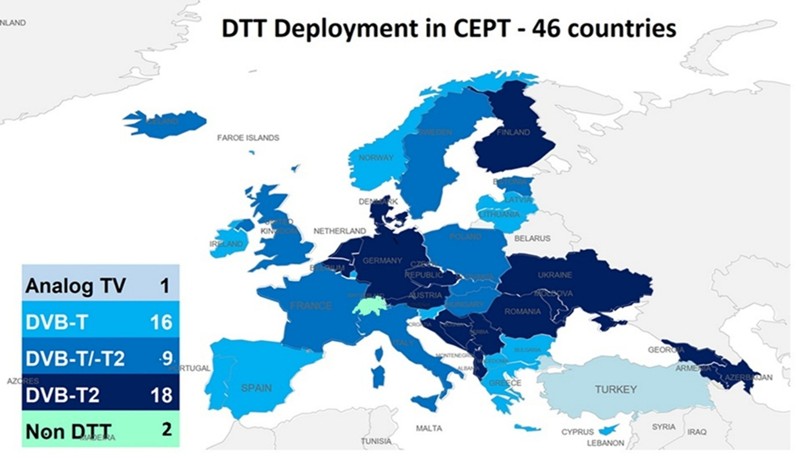
Interactive and hybrid broadcast broadband technologies aim to enhance content delivery beyond traditional DTT. Standards such as HbbTV (Hybrid Broadcast Broadband TV) and DVB-I (Digital Video Broadcasting – Internet) rely on the availability of an internet connection and integrate broadcast and broadband, enabling on-demand and catch-up services alongside linear television. DVB-I represents the intersection of linear broadcast television and internet media streaming, enabling viewers to access linear channels over IP with the same experience as traditional broadcast television. Standardised by ETSI in 2020, mass market availability is expected by the end of this decade. Meanwhile, DVB-HB (Home Broadcast) uses the broadcast signal to distribute content across IP-enabled devices within the home. It allows viewers to access both linear free-to-view and on-demand content with a single interface.
Single Frequency Networks (SFNs) enable multiple transmitters to simultaneously operate on the same frequency, reducing the need for spectrum for DTT services by around 25%, albeit with added complexity and constraints on local or regional content. There is no requirement to obtain additional reception equipment or retune if network topologies are changed to include more SFNs, assuming no changes are made to the transmission or compression technologies. At least 12 Member States are using SFNs in their DTT networks29.
5G Broadcast
5G Broadcast is a broadcast technology from the mobile telephony technical ecosystem, standardised by 3GPP, which uses 5G technology to deliver live video content to multiple users on a smartphone or tablet, without an internet connection, i.e. without consuming data from a user data plan. It is emerging as a potential complement or successor to DTT, particularly for mobile and hybrid environments. The introduction of 5G Broadcast also allows the simultaneous operation of DVB on the same frequency and thus a seamless transition from DVB to 5G Broadcast. 5G Broadcast can enable cross-border coordination with neighbouring countries that have DVB-based DTT networks, based on the specifications of the Geneva 2006 Agreement (the ‘envelope’ concept).
Stakeholders consider that the existing high-power, high-tower (HPHT) infrastructure could provide sufficient outdoor coverage for 5G Broadcast, with some densification required particularly for indoor reception. According to a BNE report, 5G Broadcast offers the advantages of: (i) universal (free-to-air) reception without a mobile data subscription (SIM-free); (ii) high reliability; (iii) high energy and cost efficiency; (iv) a future-proof service portfolio (including public warning, enhanced event experience, geolocation and even drone management); and (v) integration in the mobile ecosystem. Several broadcasters also suggest that 5G Broadcast could enable new, dynamic use cases alongside traditional broadcasting.
Various trials were conducted across a number of Member States between 2017 and 2025 (24 trials in 18 countries across Europe). According to the BNE’s innovation roadmap for the sub-700 MHz band, supporting innovation in this band would require making 5G chipsets with 5G Broadcast capability mandatory in mobile devices and vehicles.
According to the TDF report on the deployment of 5G Broadcast television in France, a series of measures have been taken to support the deployment of the technology since the beginning of 2024. In particular, broadcast operators from several European countries have been cooperating within the 5G Broadcast Strategic Task Force (5BSTF) to align their approaches. The 5BSTF has outlined a possible application scenario involving a white-label mobile application that would allow users to access broadcast content directly on their devices. From a technical perspective, the 600 MHz band is considered the core band for 5G Broadcast deployment in Europe. By contrast, the use of frequencies below the 600 MHz band would require significant hardware changes in mobile devices.
In parallel, chipset and terminal manufacturers have cooperated with broadcast operators to ensure full compatibility of new terminals and to enable a potential launch as early as 2028. In addition, an experiment conducted during the 2024 Olympic and Paralympic Games enabled large-scale, end-to-end technical validation of the technology on commercial terminals, supported by dedicated software.
The RSPG Report also confirms that most Member States have been exploring and trialling 5G Broadcast. However, deployment is still hindered by device compatibility, investment costs and untested business models. Broadcasting stakeholders remain cautious about the return on investment required for rolling out 5G Broadcast infrastructure, despite some optimism about its long-term potential. By contrast, they are nearly unanimous in their doubts about the economic viability of 5G Broadcast. Many argue that if the technology has to be deployed via a low-power low-tower (LPLT) network architecture, the associated increase in deployment costs would make it even less feasible.
PMSE
PMSE equipment requires high audio quality and low latency during live performances. High latency or latency jitter can cause serious performance issues. Recent developments in PMSE technology aim to improve spectral efficiency or to explore new frequency bands and technologies. While digital systems demonstrate higher latency than analogue systems, advances in digital technology have reduced latency to around 2-3 milliseconds (ms), although this may still be too high for in-ear monitors.
Cognitive PMSE (C-PMSE) uses databases of locally available frequencies to manage dense spectrum environments, but it does not significantly increase efficiency. The system relies on a database and listen-before-talk mechanisms to identify available spectrum channels and avoid interference, enabling more automated PMSE planning and greater operational flexibility during events.
5G is a promising enabling technology also for some PMSE applications, with early trials showing that certain network configurations may be close to meeting the requirements for some of the most demanding PMSE use cases. However, even if further development is possible to meet latency and reliability requirements, there are additional issues such as ensuring ease of access to 5G networks (e.g. slices) and dedicated spectrum for PMSE users. Moreover, PMSE professionals argue that technologies such as those developed by 3GPP or cognitive PMSE fall short in real-world production environments.
Existing (analogue and digital) PMSE systems are narrowband (~200 kHz), with different users occupying separate frequencies. The newer Wireless Multichannel Audio System (WMAS) uses wideband channels (up to 20 MHz) shared among users. WMAS is expected tobe approximately 50% more efficient than traditional narrowband systems (ETSI, 2017). The innovation demonstrated by WMAS shows promise. However, it is unlikely to be applicable in all use cases and equipment is not yet widely commercially available.
Looking further ahead, artificial intelligence (AI) could enhance the efficiency of dynamic spectrum access and spectrum sharing for PMSE applications in the sub-700 MHz band and possibly in other bands. AI-enabled approaches, such as real-time spectrum sensing, predictive interference avoidance and automated frequency coordination, has the potential to improve the ability of PMSE users to identify and access available spectrum more adaptively and efficiently in increasingly congested environments.
The use of alternative frequency bands for PMSE will not be suitable for all applications, as many of these bands have less favourable propagation characteristics. Moreover, operating in alternative bands requires the development and acquisition of new equipment, which involves significant investment and requires migration time. The suggested alternative bands for PMSE range from 29.7 MHz up to 470 MHz and from 694 MHz up to 2900 MHz. The UK, for example, has successfully opened a complementary spectrum resource for PMSE in the 960-1164 MHz frequency band, which is supported by professional audio PMSE equipment.
Nevertheless, PMSE stakeholders remain strongly in favour of retaining the 470-694 MHz band and are generally reluctant to migrate to other frequency ranges.
Innovation roadmap
In October 2022, BNE presented the ‘European Cultural Band: An Innovation Roadmap for the 470-694 MHz Band’. The roadmap (Figure 7) outlines a pathway for enhancing user experience by improving video and audio quality (e.g. UHD, UHD2, HDR, NGA) and deploying more efficient compression standards such as HEVC and VVC. It also foresees seamless access to linear and on-demand content through the use of HbbTV and DVB-I, as well as the development of mobile reception capabilities via 5G Broadcast. For audio PMSE, the roadmap anticipates increasing demand in cultural and media production and foresees innovation through the introduction of advanced technologies such as cognitive PMSE (C-PMSE) and the wireless multichannel Wireless Multichannel Audio System (WMAS).
Figure 7: An innovation roadmap for the lower UHF band (Source: BNE)
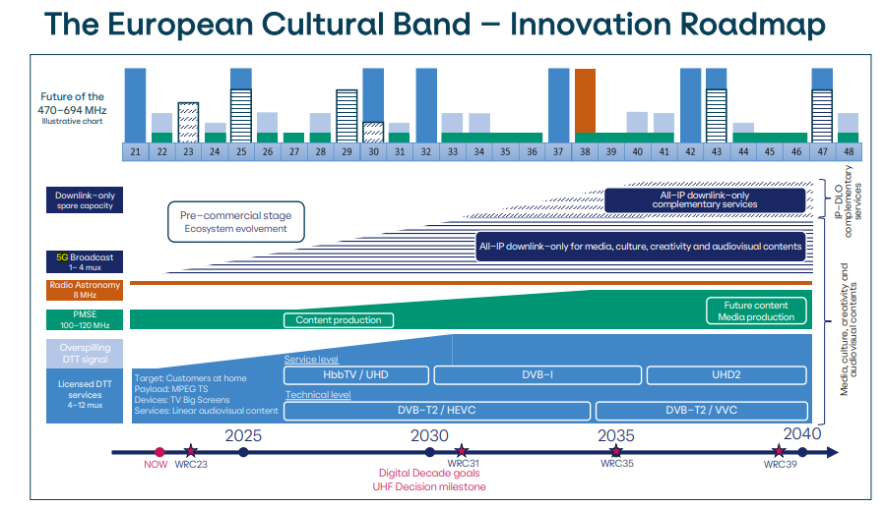

5. ECONOMIC DEVELOPMENTS
Audiovisual market structure and size
The audiovisual industry is the biggest source of revenue and jobs in the European media sector. In recent years, it has grown to include not only cinema and broadcasting, but also video on demand (VoD). The value of the EU audiovisual market was estimated at EUR 119 billion in 2024. With an approximate market share of 22%, it ranks second globally behind the United States (49%), while China ranks third with a 12% share. The global market grew at a CAGR (compound annual growth rate) of 4.59% over the 2019-2024 period, while in the EU it grew by 5.8% compared to 2023. Future projections estimate steady but slower growth of 3% per year (without accounting for inflation). As Figure 8 illustrates, the share of audiovisual in the EU economy has slightly decreased in recent years, from 0.64% in 2019 to 0.59% in 2023.
Figure 8: Share of the audiovisual market in gross national product
(Source: European Audiovisual Observatory, Key Trends 2025, 2025)
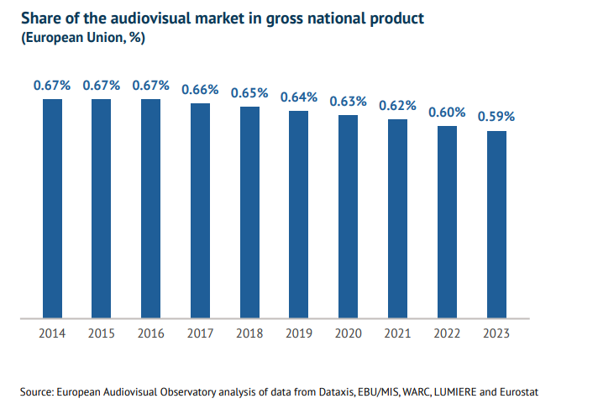
TV distribution platforms
Audiovisual content in the EU is delivered by various methods and associated delivery platforms. Linear TV is delivered through DTT, satellite and cable networks, as well as via streaming over broadband connections (IPTV). Non-linear TV, i.e. viewing content at a time chosen by the viewer rather than at the time of broadcast, is delivered primarily over broadband internet connections. Catch-up TV enables viewers to access programmes that have been broadcast recently, while over-the-top (OTT) services provide catalogues of content produced or licensed by online streaming service providers (e.g. Netflix, Disney+, Amazon). Non-linear television is commonly referred to as video on demand (VoD) and may be provided free of charge, via a subscription model (SVoD) or on a transactional pay-per-view basis (TVoD).
European TV channels are delivered through a combination of terrestrial and non-terrestrial networks. DTT accounts for around 30% of all TV channels in Europe, while the remaining 70% are distributed via cable, satellite, IPTV or other platforms. According to data from December 2024, 2 902 TV channels were carried on DTT, compared with 6 634 channels available through other platforms.
Figure 9 shows the evolution of TV distribution platforms in Europe from 2005 to 2025, based on the BNE-EBU database. Terrestrial analogue television declined steadily until the switchover to DTT. DTT reached a peak of 46% in 2013, and then remained relatively stable, with a gradual decrease to around 40% in 2024. Cable shows a slight downward trend, falling from about 35% in 2006 to around 23% in 2024. Satellite remains at around 22%, with only small fluctuations over time. Finally, IPTV has grown significantly, from almost 0% in 2006 to nearly 29% in 2024.
Figure 9: Penetration of TV distribution platforms (Source: EBU-BNE DPM database)
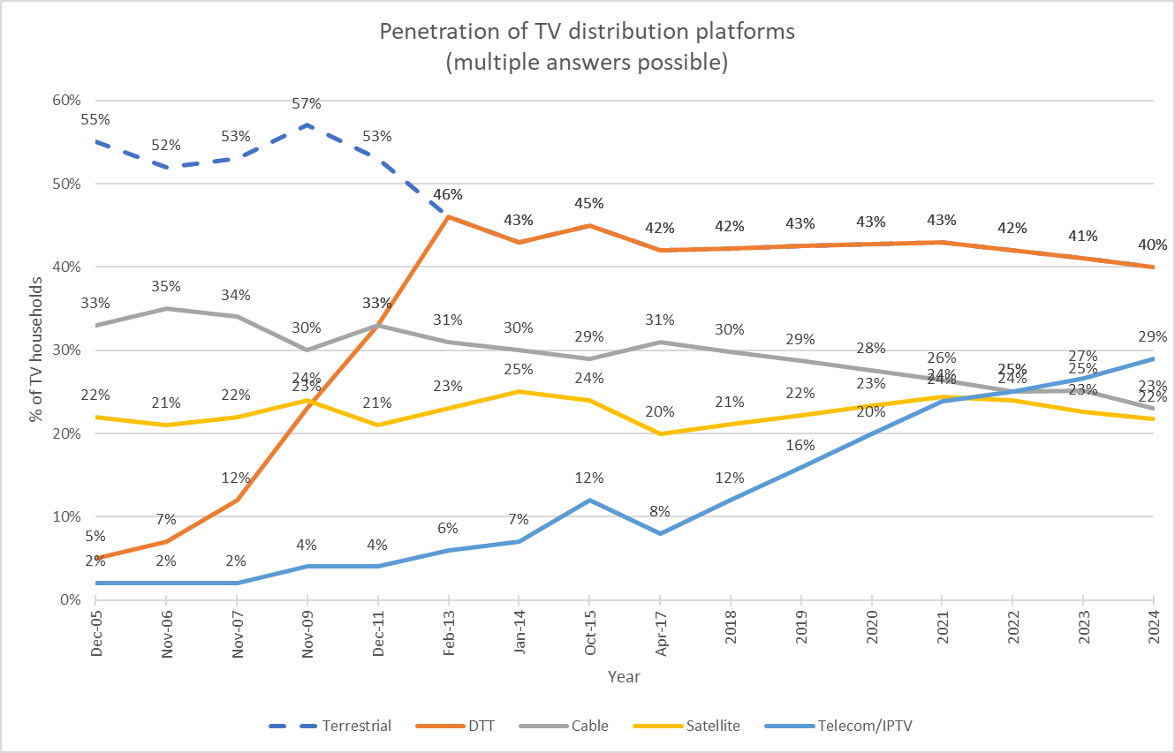
In this context, recent data from the RSPG Report show how these platforms are used across the EU. The report highlights the diversity of platforms used across the EU for the distribution of audiovisual content, with the share of households accessing linear TV through DTT varying significantly among Member States. Figure 10 illustrates this diversity: DTT remains dominant in countries such as Spain and Italy, whereas its use is minimal in countries such as Sweden and Slovenia.

Figure 10: Use of various platforms in the EU for audiovisual content distribution in 2025 (based on available input from national administrations) (Source: RSPG Report)

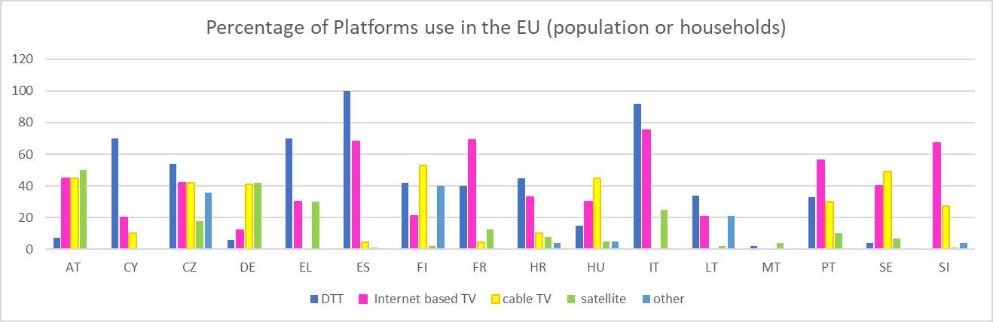
Complementing this perspective, data from the European Audiovisual Observatory illustrate the distribution of primary TV reception platforms across EU Member States in 2024, expressed as a percentage of TV households and broken down by cable, satellite, DTT and IPTV.
Figure 11: Distribution of primary TV reception platforms in the EU (2024)
(Source: European Audiovisual Observatory on Dataxis data – Yearbook 2025)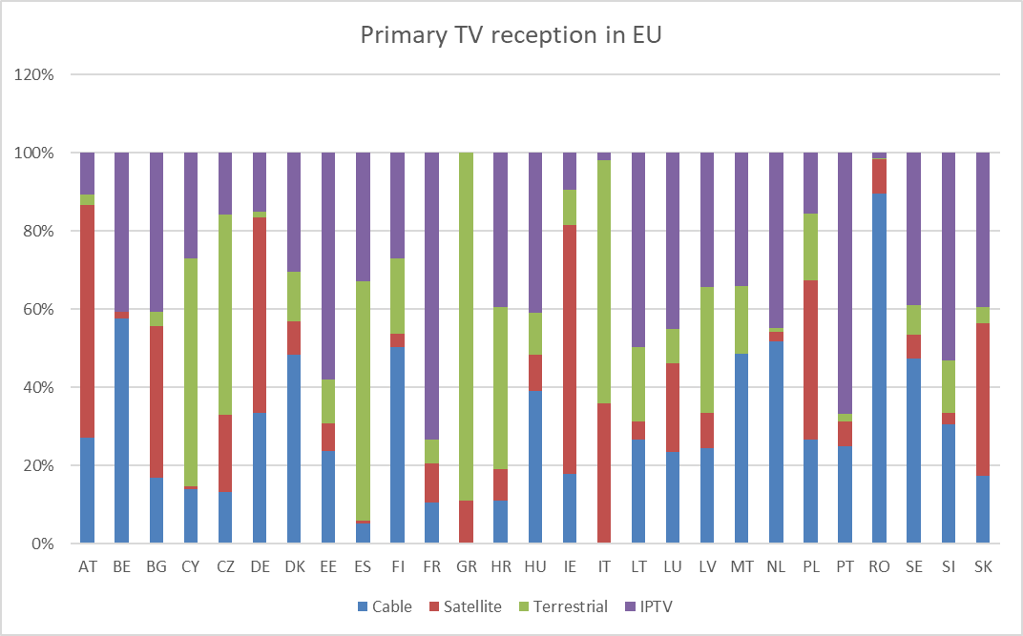
Figure 11: Distribution of primary TV reception platforms in the EU (2024)
(Source: European Audiovisual Observatory on Dataxis data – Yearbook 2025)Figure 11 highlights differences at Member State level, whereas Figure 12 presents the aggregated EU-wide distribution of primary TV reception by platform. In 2024, primary TV reception in the EU was relatively evenly distributed across platforms, with IPTV emerging as the most common primary reception method, accounting for around 31% of TV households. Cable and satellite followed closely, representing approximately 25% and 24% respectively, while terrestrial television (DTT) remained the primary platform for about 21% of households.
Figure 12: Primary TV reception by platform in the EU (2024)
(Source: European Audiovisual Observatory on Dataxis data – Yearbook 2025)
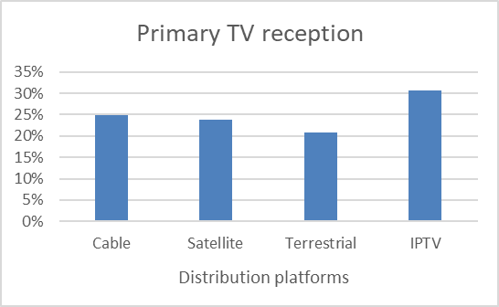
Evolution of the economic impact of DTT and linear broadcasting
DTT is designed primarily for the provision of linear TV services, i.e. watching a programme as it is transmitted (‘live’). Its low cost for consumers means that it is a common option for accessing content. The delivery of FTA broadcasting services in the sub-700 MHz band contributes to the EU economy directly through the economic impact of transmission providers and television channels, as well as indirectly through the economic impact on the wider ecosystem of programme making and ancillary services.
As shown in Figure 13, the revenues of broadcasters increased in nominal terms, but their share of the audiovisual market fell to 53% in 2025, compared to 75% in 2018. On the other hand, SVoD (subscription video on demand) revenues continue to grow and were expected to reach 17% of audiovisual revenues by 2025.
Figure 13: Key revenue trends within the audiovisual market 2018- 2025
(Source: The European Media Industry Outlook, EC 2025) 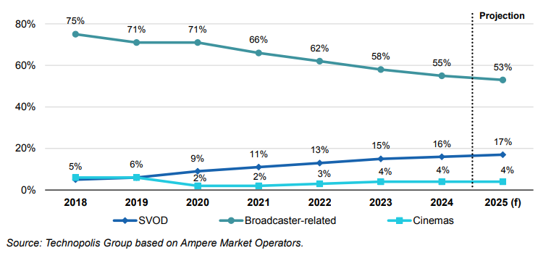
This shift in market shares is also reflected in how broadcasters are adapting their business models. Broadcasters are strengthening their online presence. The increase in their revenues, although modest, comes from advertising in their video-on-demand (VoD) services (AVoD), which is expected to reach 30% by 2028, and from subscriptions in cases where their VoD services follow a subscription-based model (SVoD). Overall, these developments indicate a convergence in revenue models: broadcasters are losing revenue from linear advertising but expanding into streaming, while pure streamers -previously based solely on subscriptions - are increasingly relying on advertising.

Figure 14: Detailed revenue trends in the audiovisual market in the EU 2018-2026 (EUR million ) (Source: The European Media Industry Outlook, EC 2025)
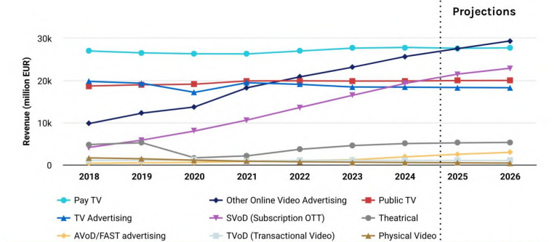

This overall shift in revenue patterns is reflected in the advertising market. In Europe, total advertising expenditures for TV, newspapers and magazines, radio, cinema and outdoor spaces decreased from EUR 62.45 billion in 2018 to EUR 55.9 billion in 2022, while expenditure for online advertising increased from EUR 49.7 billion to EUR 87 billion. Overall, the entire growth of the advertising market came from online advertising. Figure 15 illustrates how the share of advertising expenditures by medium evolved between 2018 and 2022.
Figure 15: Advertising expenditures by medium
(Source: European Audiovisual Observatory, Yearbook 2023-2024, 2024)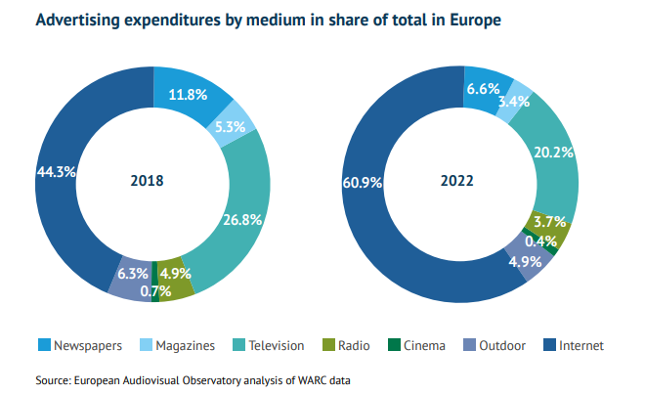

Pay-TV subscription trends and revenues
Trends in pay-TV subscriptions provide additional insight into the evolving role of different delivery platforms. Figure 16 shows a clear shift in pay-TV subscriptions from traditional platforms towards IP-based services. While cable and satellite subscriptions are declining, IPTV and OTT services are growing steadily, with IPTV becoming the leading pay-TV platform. Pay-TV delivered over DTT remains marginal and continues to decrease.
Figure 16: Number of pay-TV subscriptions by platform
(Source: European Audiovisual Observatory on Dataxis data – Yearbook 2025)
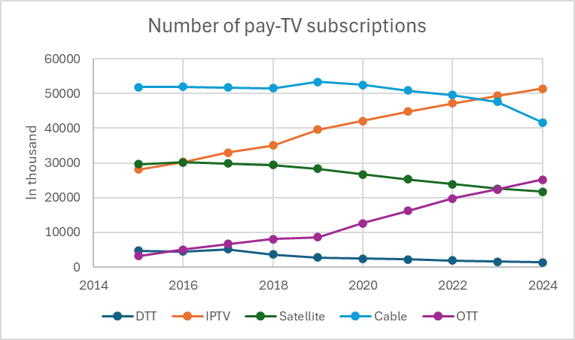
These subscription trends are mirrored in pay-TV revenues. As shown in Figure 17, revenues from IPTV have increased steadily and now represent the largest share of pay-TV revenues, while cable and satellite revenues show a sustained decline. OTT revenues, although still smaller in absolute terms, have grown rapidly. By contrast, pay-TV revenues delivered over DTT remain marginal and continue to decrease.
Figure 17: Pay-TV revenues by platform
(Source: European Audiovisual Observatory on Dataxis data – Yearbook 2025)
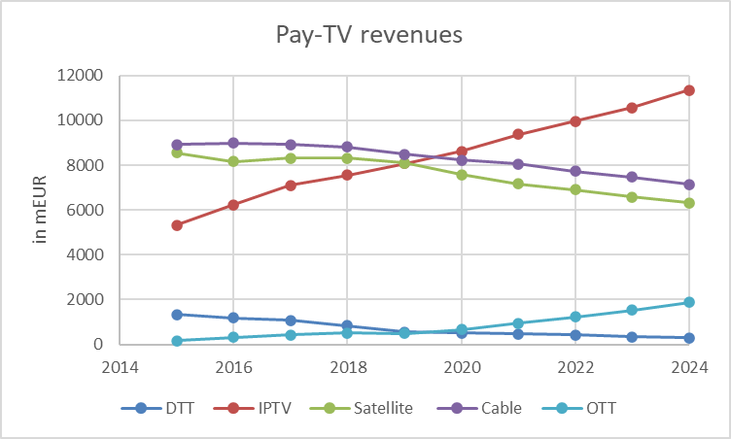

Investment and consumer cost of the digital switchover
The scale of infrastructure upgrades and network replanning linked to the evolution of DTT technology generates investment costs, which are subject to several factors, most notably the size and scale of the DTT transmission network. The transition from DVB-T to DVB-T2 (approximately 60% of national multiplexes across the Member States) requires modification of DTT transmission equipment. Estimates produced for a previous European Commission study predicted that as of 2016, transition to DVB-T2 and MPEG4 would cost a total of between EUR 585 million and EUR 856 million for the EU-27 and the UK, while the transition to DVB-T2 and HEVC would cost a total of between EUR 439 million and EUR 635 million.
In addition to transmission equipment upgrades, costs are generated also for consumers, who need new DVB-T2 capable TV receivers. The previous Commission study estimated the (forced) upgrade cost of TV receivers, i.e. those that were not replaced through the standard television replacement cycle in the EU-27 and the UK as shown in Table 2. It was assumed that consumers replace their television sets on average every seven years and that any publicised switchover date could accelerate this (by an assumed 20%), whereas any publicised government support scheme could delay this (by an assumed 20%). The cost was found to fall over time through a combination of cheaper receivers (assuming a 5% price reduction per year) and a smaller proportion of receivers not having been replaced through the normal replacement cycle.
Table 2: Estimated costs for DVB-T2 receiver replacement across the EU-27 and the UK
Year | 2018 | 2019 | 2020 | 2021 | 2022
Cost (€ million), Eurobarometer Penetration Figures
-20% Acceleration | 1564 | 1316 | 1108 | 932 | 784
Neutral | 1418 | 1155 | 940 | 766 | 623
20% Acceleration | 1281 | 1008 | 794 | 625 | 492

The same study found that 75% of the costs would be incurred in three Member States (Spain, France, Italy). The neutral replacement scenario yields the results shown in Table 3, showing that ~74% of the cost will still be incurred in three EU Member States: Spain (~EUR 120 million in 2022), France (~EUR 130 million in 2022) and Italy (~EUR 170 million in 2022).
Table 3: Estimated costs for DVB-T2 receiver replacement across EU-27
Year | 2018 | 2020 | 2022
Cost (€ million), Eurobarometer Penetration Figures
Neutral | 1306 | 865 | 573
The cost per household seems quite modest at EUR 6.68 in 2018, EUR 4.43 in 2020 and EUR 2.93 in 2022, assuming 195.4 million households within the 27 EU Member States (Eurostat, 2021). However, this per-household average does not reflect the actual cost for those users who may need to spend several hundred euros to replace their television set.
There is limited publicly available information on the cost of deploying SFNs within a broadcast network, often because they are adopted at the same time as other improvements. However, studies comparing the operational expenditure of SFNs and equivalent Multi- Frequency Networks (MFNs) -based on gains in spectral efficiency - indicate that achieving a 25% increase in spectral efficiency (an optimistic estimate for a national SFN) results in transmission costs that are approximately double those of the MFN approach (Bettancourt & Peha, 2015).
Detailed analysis of the cost that might be associated with a 5G Broadcast network has not been published. However, the 2025 report ‘5G Broadcast: Horizons for Europe’ underlines that multicast, one-to-many delivery is more cost-efficient than unicast for mass audiences and live events. As video accounted for around 60% of mobile network traffic in 2022 and is expected to rise to 72% by 2030 (Arthur D. Little, 2023), 5G Broadcast could offload up to 35% of mobile video traffic, reducing network load and limiting the need for further investment or additional spectrum.
A 2019 EBU analysis based on unicast 5G content delivery (thus not applicable to 5G Broadcast) compared estimated transmission and deployment costs for content distribution under several scenarios within a ‘normalised’ European country. It found that continuation of DTT would involve ongoing annual costs of EUR 0.28 per person, increasing to EUR 7.32 per person for content shared over DTT and 5G, and EUR 15.05 per person for content carried exclusively over 5G. The significant increase in costs is due to the higher dimensioning required for 5G networks when carrying 100% of media traffic.
While PMSE stakeholders underline the growing need for bandwidth due to the increasing number of events and content productions (also across borders), they also point out that usage of new bands other than UHF would give rise to additional costs in terms of fostering an ecosystem of standardised equipment. A key benefit associated with the (often licence-exempt) use of the sub-700 MHz band across Europe is that PMSE users can travel widely with standardised equipment, with minimal retuning and administration required in different areas.
Energy efficiency
DTT stakeholders stress that DTT is the most energy-efficient distribution technology for linear television, with minimal carbon impact. It also has low access costs for users. Technological innovation (5G broadcasting, UHD) is seen as important to support DTT as a vital digital infrastructure. The LOCAT Study (2021) confirms this assessment, showing that DTT consumes only a small fraction of the electricity required by OTT streaming and managed IPTV services. As shown in Figure 18, across the countries analysed, DTT uses only a few watt-hours per device viewing hour (e.g. 14 Wh in the EU-28), while OTT consumption is several times higher (up to 109 Wh in the EU-28). Managed IPTV generally records the highest energy use among all platforms.
Figure 18: Energy efficiency of different platforms
(Source: Quantitative study of the greenhouse gas emissions of delivering TV content, The LoCaT Project)
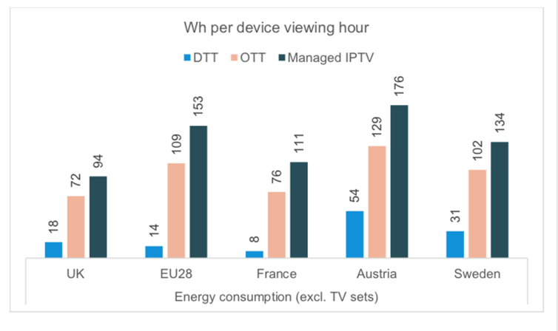
Investment opportunity for alternative uses
Mobile communications (IMT)
According to GSMA’s response to the 2024 RSPG questionnaire, mobile data traffic in European cellular networks is expected to increase by a factor of between two and seven by the end of the decade, depending on the country. Ericsson’s Mobility Report indicates that mobile network data traffic will continue to grow, albeit at a declining year-on-year rate, with an averageCAGR of around 17% projected until 2030. In Western Europe, monthly mobile data traffic per active smartphone is projected to grow at a CAGR of around 13% between 2024 and 2030, rising from 22 GB in 2024 to 47 GB in 2030 per month. This represents growth by a factor of 2.1 by the end of the decade. Arthur D. Little’s report estimates a CAGR of 25% on average for mobile uses (excluding FWA but including mobile-only households), resulting in a growth factor of 4.75 on average for the EU. Traffic is expected to continue to grow in mobile networks also beyond 2030, while 6G and new use cases would increase the annual growth rate. FWA and IoT will further add to network capacity demands.
In the RSPG questionnaire, mobile stakeholders advocated for the primary allocation of the sub-700 MHz band to IMT, arguing that mobile services require greater capacity potential in this band and that it is well suited to support future 5G and 6G expansion. They further contended that reallocating the band to IMT would represent the most efficient use of this scarce spectrum resource. Low-band spectrum is also regarded as crucial for promoting digital inclusion, in particular by improving coverage in rural areas. Beyond 2030, the introduction of 6G is expected to enable new wide-area applications that will further stimulate mobile traffic growth. These include immersive communication (e.g. Extended Reality), massive IoT deployments, hyper-reliable and low-latency services, ubiquitous connectivity, AI-enabled communications and integrated sensing and communication (ISAC). These applications require ubiquitous, reliable wide-area connectivity and will therefore particularly benefit from the coverage characteristics of low-band spectrum.
A GSMA report provides quantitative support for the importance of additional sub-1 GHz spectrum:each additional 50 MHz of sub-1 GHz spectrum is associated with a 7 percentage-point increase in 4G coverage and an 11 percentage-point increase in 5G coverage in rural areas, while rural users already spend more than twice as much time connected to low bands as urban users on both 4G and 5G networks.
GSMA’s analysis further indicates that the main low-frequency bands currently used around the world for 5G are 600 MHz and 700 MHz, while the 800 MHz and 900 MHz bands are still largely used for previous generations. Countries deploying 5G in the 600/700 MHz bands have achieved higher coverage, better availability and improved indoor performance. Low-band 5G is projected to contribute approximately USD 130 billion to global GDP in 2030, with around half of this impact driven by massive Internet of Things (mIoT) i.e. the large-scale deployment of connected low-power devices such as smart meters, environmental sensors and asset-tracking devices. For Europe, the estimated contribution is approximately USD 26 billion. Furthermore, using the UHF band for mobile services could deliver significant infrastructure efficiencies, potentially reducing base-station requirements by up to 33%, as fewer sites would be needed to provide the same level of coverage and performance, particularly in rural areas. This would also support EU environmental sustainability objectives.
Public Protection and Disaster Relief (PPDR)
In the RSPG Report, PPDR users emphasise the importance of rural coverage, highlighting the need for additional spectrum in the 470-694 MHz band to support PPDR systems. They note that existing PPDR frequency allocations are no longer sufficient to meet evolving operational requirements, citing limitations in the number of simultaneous voice channels and constraints on video and data transmission.
In this context, PPDR stakeholders indicate a spectrum requirement of up to 60 MHz to support secure broadband services, including mission-critical live video streaming, and underline that a primary allocation of that spectrum to PPDR would facilitate pan-European cooperation and long-term technology investment.
Defence/military uses
Defence stakeholders have signalled interest in access to parts of the 470-694 MHz band to support secure and mission-critical military communications. They have identified pressing requirements for reliable communications, including access to white spaces or specific sub-bands, in order to address current and future operational needs.
According to the RSPG Report, military spectrum requirements are estimated to range between 48 MHz and 100 MHz, with several national use cases indicating the need for access to portions of the band up to 2030 and beyond. In particular, access to the lower part of the band (470-512 MHz) has been highlighted, as many existing military radio devices are configurable up to 512 MHz, enabling immediate operational deployment. Such access could also help alleviate congestion in the primary military VHF/UHF bands (230-400 MHz).

6. EVOLUTION OF CONSUMER BEHAVIOUR
Audience behaviour across the EU reflects mixed consumption of traditional and digital audiovisual services. Although DTT provides linear TV broadcasting, historically the cornerstone of media consumption in the EU, data show that viewing trends have shifted in recent years and vary significantly across Member States and demographic groups.
Figure 19 illustrates a steady decline in the number of DTT households between 2015 and 2024, reflecting a shift in consumer behaviour. Overall, the evolution shown in the figure suggests that DTT continues to play an important role for a significant number of households, but its relative importance in household television reception has been diminishing over time, mirroring wider trends towards platform diversification.
Figure 19: Evolution of DTT households in the EU (2015–2024)
(Source: European Audiovisual Observatory on Dataxis data – Yearbook 2025)
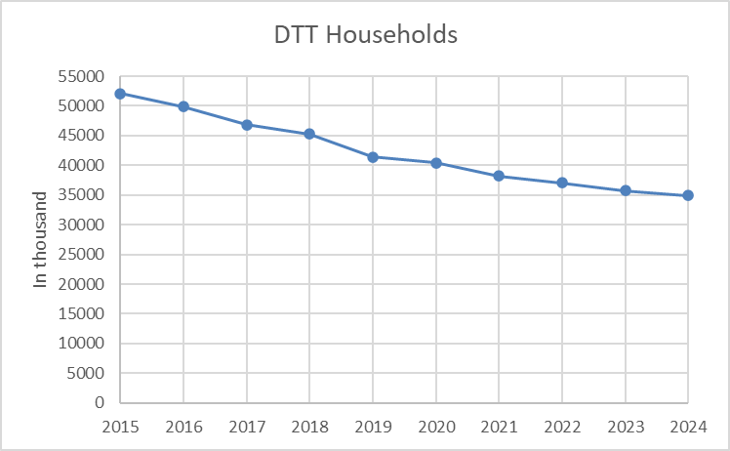

Alongside DTT, audiences across the EU continue to engage with both traditional and digital forms of audiovisual content. According to Figure 20, watching traditional TV at the time of broadcast remains the most frequent mode of consumption with 58% of Europeans watching at least weekly, (comprising 32% who watch at least once a day and 26% who watch at least once a week), unchanged from previous years. Subscription-based streaming services closely follow with 50% of Europeans using them at least weekly (comprising 25% who use them at least once a day and 25% who use them at least once a week), which reflects how streamers are catching up with broadcasters. By comparison, online services provided by traditional TV channels (BVoD) are used by 41% of Europeans at least weekly. Regarding cinema attendance, 15% of Europeans report going at least weekly (mostly in big cities), while the majority (49%) go once a month or a few times a year.
Figure 20: Frequency of use of audiovisual services
(Source: Study on audiences, consumer behaviour and preferences relating to the consumption of media content, EC 2025)
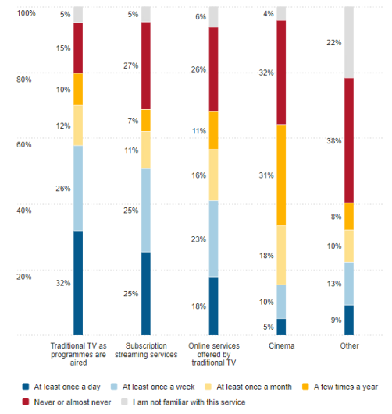
Figure 21 shows that average daily TV viewing time per person in the EU was broadly stable between 2015 and 2019, before reaching a temporary peak during the COVID-19 period (2020–2021) and subsequently declining.

Figure 21: Average daily TV viewing time per person in the EU (Source: European Audiovisual Observatory on Eurodata TV Worldwide until 2020; Dataxis and press as of 2021 – Yearbook 2025)
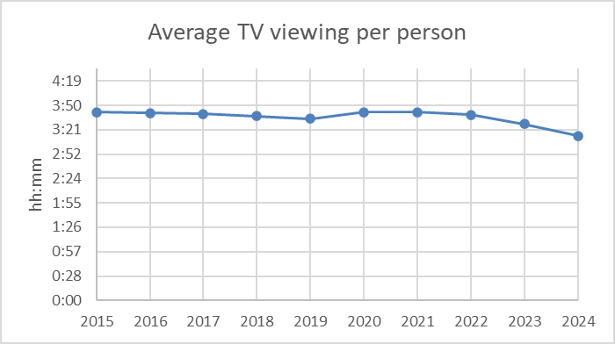
While linear TV remains the medium where people spent most time overall, followed by social media, YouTube has emerged as a major driver of audiovisual content consumption. YouTube is now almost as significant as the combined total for SVoD in the EU, underscoring its central role in reshaping audiovisual consumption patterns (see Figure 22).
Figure 22: Viewing time of different media services in the EU
(Source: Study on audiences, consumer behaviour and preferences relating to the consumption of media content, EC 2025)
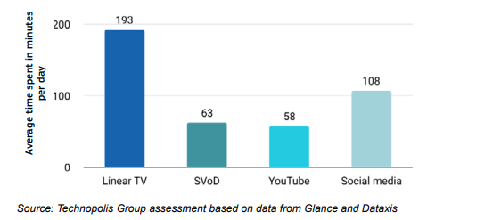
At the same time, audiovisual consumption patterns differ sharply across age groups. Young people’s audiovisual consumption patterns are characterised by a shift towards on-demand, digital-first viewing and away from traditional broadcasting. Subscription streaming services are central to young people’s audiovisual habits. Around one third use these platforms daily (vs 25% of the general population), while traditional TV is far less used, with only 15% watching daily (vs 32% of the general population).
Evidence from the EBU further confirms this generational divide (Figure 23). The average daily viewing time across all audiences is still around three hours, whereby seniors (60+) watch about five hours per day, showing stable habits and strong attachment to broadcasting. In contrast, younger viewers (aged under 35) - especially 14-25 year olds - watch just over one hour daily and are shifting rapidly toward digital, on-demand and mobile platforms. The temporary rise in 2020 due to COVID-19 was followed by a continued decline, confirming a long-term shift.
Figure 23: Daily average TV viewing time
(Source: Audience Trends Television 2025, Media Intelligence Service, EBU)
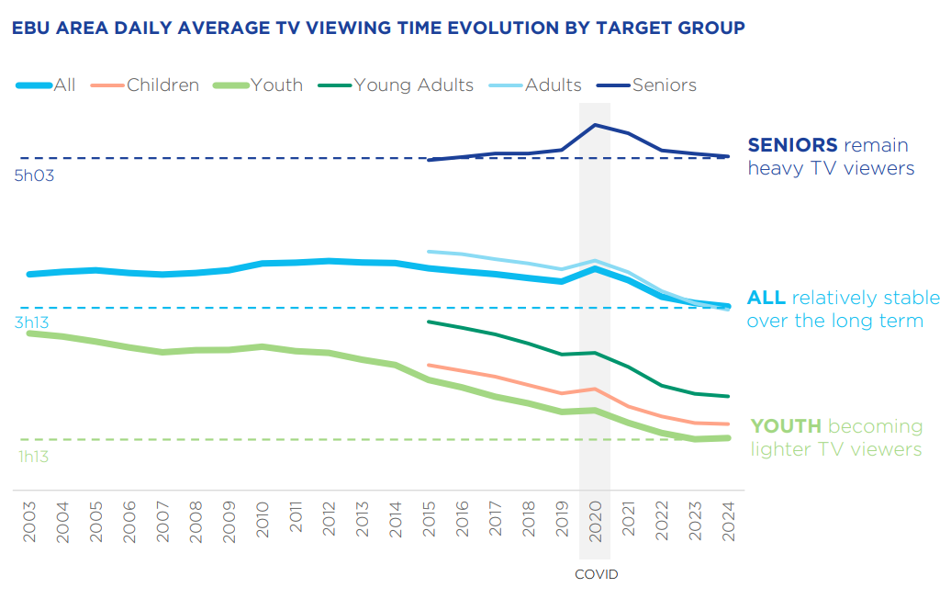

7. SOCIAL AND CULTURAL DEVELOPMENTS
The broadcasting sector considers the sub-700 MHz band to be Europe’s ‘cultural band’, set in the long-term to promote: (i) universality and accessibility of media content; (ii) local and sustainable media production; and (iii) the diversity and richness of national and regional cultural values. Self-sustained public media are considered a key enabler of social, cultural and democratic developments. While cultural and media policies are decided by Member States, Article 167(4) TFEU requires the EU to take into account cultural aspects and, in particular, to respect and promote the diversity of its cultures.
The UHF Decision (recital 11) stresses the need for regulatory predictability with regard to the availability of sufficient spectrum to ensure an environment for investment, so that EU and national audiovisual (AV) objectives such as social cohesion, media pluralism and cultural diversity can be met. The Lamy Report to the Commission emphasised the core principles of pluralism and cultural diversity that underpin Europe’s AV model.
Terrestrial broadcasting has traditionally played a key role in the delivery of public service media. The digital switchover of terrestrial broadcasting increased the capacity of DTT networks and facilitated the introduction of a greater number of free-to-air (FTA) public and commercial TV services, alongside pay-DTT. The low cost of DTT for consumers means that it remains a common method of accessing Public Service Media (PSM) broadcasting, which has been an essential source of social interpretation for news and events. Accessibility requirements for PSM channels are set to ensure continued access to programmes for socially vulnerable people and people with disabilities, particularly for those with hearing and visual impairments, thereby contributing to a diverse and trustworthy information landscape based on reliable public-interest content.
The Commission study assessed the availability of alternative PSM platforms in 16 Member States. Content from public service broadcasters is available on DTT in all analysed Member States, but not consistently on each alternative platform. DTT provides FTA services in almost all cases, except in Belgium (Wallonia only) and Austria. In many Member States, legal or licensing requirements ensure that DTT reaches a large portion of the population. Alternative platforms cannot guarantee this coverage: cable and IPTV networks are often unavailable in rural areas due to high deployment costs. Existing alternatives to FTA DTT are accessible only to subscribers, either as part of a paid package, via a ‘free-to-view’ access card, or through an internet or mobile subscription. These subscription-based alternatives could present a financial hurdle for people who cannot afford, or do not wish to pay for, commercial packages.
DTT plays a particularly important role in local and regional broadcasting: nearly 49% of all local and regional channels use DTT, compared with only 21% of national channels. Three out of four TV channels available on digital terrestrial networks have generalist programming. Public service media are generally given priority access to DTT networks, and their services are predominantly generalist channels with a broad programming offering. By contrast, the programming content of TV channels available across all distribution platforms tends to be more thematic.
Figure 24 illustrates which countries provide FTA content at national, regional and local levels. It shows that dependence on DTT is very high in most EU countries and increases from the national to the regional and local levels. This indicates that audiences rely heavily on DTT to access content of local and regional interest, including local news, cultural programming and community-relevant content.

Figure 24: Free-to-air (FTA) DTTB at national, regional and local level across EU countries (Source: RSPG Report)
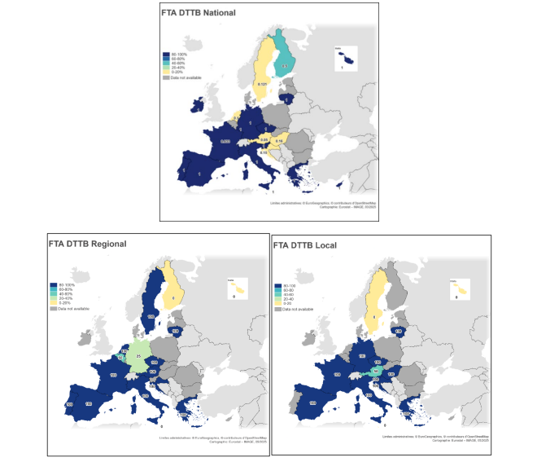

8. CONCLUSIONS
The 470-694 MHz frequency band is still the most strategic and essential portion of terrestrial spectrum for the European Union. At international level, the sub-700 MHz band in ITU Region 1 is governed by the ITU RR and the Geneva 2006 Agreement (GE06), the latter setting the frequency plan and the cross-border coordination procedures. The band is also included in the provisional agenda for WRC-31, which should review the allocation of the band and consider possible regulatory measures.
The sub-700 MHz band continues to underpin both digital terrestrial broadcasting and audio PMSE applications, which play vital roles in supporting cultural diversity, media pluralism and live content production. At the same time, alternative media platforms to DTT (satellite and cable/fibre-based) increasingly provide access to versatile TV and video content, also in support of public policy objectives. The emerging competition for the band - in particular from mobile communications (IMT), PPDR and defence - requires monitoring of spectrum usage and scrutiny of spectrum needs and highlights the importance of maintaining a flexible and forward-looking spectrum regulatory framework that can respond to evolving market trends underpinned by technological enablers and societal demand.
Current and planned DTT and PMSE usage of the band varies considerably across the Member States, and reflects differences in national market needs, technology deployment and audience behaviour. ,DTT remains widely used and essential for PSM in several Member States, while in some others its role has diminished in favour of alternative platforms such as cable, IPTV and satellite. One Member State has already plans for vacating DTT from the band beyond 2027. These variations make a uniform EU-wide solution for the long-term use of the band impractical at this stage. On EU average, DTT usage has been tangibly declining in the recent years with the estimated number of DTT households falling from around 52.1 million in 2015 to 34.9 million in 2024 (an overall decline of approximately 33%). A more convergent solution could hence be more likely in the mid term.
For the time being, evolving EU-level spectrum policy should therefore take into account national needs and enable both, continued access for terrestrial broadcasting and audio PMSE, and new uses such as mobile communications or PPDR, while ensuring coexistence between both, also across borders. EU policy should promote co-existing scenarios for the long-term use of the sub-700 MHz band across the Member States and allow for different speeds in potentially repurposing the sub-700 MHz spectrum for alternative use cases. This approach necessitates EU-level coordination and a future-proof legal framework, and it will largely depend on a bold regulatory mindset and the availability of appropriate technical solutions.
In this regard, the RSPG Opinion emphasises that any future EU regulatory action should, to the extent feasible: (i) facilitate the implementation of various scenarios among Member States; (ii) promote the pursuit of compatible uses; and (iii) focus on the means to achieve them. In the same vein, the RSPG Report underlines the need for a flexible, forward-looking framework that recognises the continued importance of DTT and audio PMSE in some Member States, while also addressing the demand for other uses, such as mobile broadband, in other Member States.
From a spectrum management perspective, an overarching EU policy objective should continue to be ensuring the effective and efficient use of the 470-694 MHz band within a coordinated and differentiated approach respecting the diversity of national circumstances, while preserving the flexibility needed to respond to future technological developments, evolving connectivity requirements and emerging spectrum demands.Striking the challenging balance on a path of transition seems feasible at EU level but relies heavily on intensive cooperation and preparatory work by Member States and the Commission for the post-2030 period.

APPENDIX
List of abbreviations
Abbreviation | Explanation
5BSTF | 5G Broadcast Strategic Task Force
AI | Artificial Intelligence
AV | Audiovisual
AVC | Advanced Video Coding
BVoD | Broadcaster video on demand refers to video-on-demand services created by traditional television broadcasters.
BNE | Broadcast Networks Europe
BWA | Broadband wireless access
CAGR | Compound annual growth rate
Catch-up TV | On-demand access to programmes that were recently broadcast live, available for a limited period after transmission.
CEPT | European Conference of Postal and Telecommunications Administrations
DSL | Digital subscriber line
DPM | DTTB promotion and monitoring
DTT | Digital terrestrial television
DTTB | Digital Terrestrial Television Broadcasting
DVB-HB | Digital video broadcasting - home broadcasting
DVB-I | Digital video broadcasting - internet
DVB-T | Digital video broadcasting - terrestrial
DVB-T2 | Digital video broadcasting - terrestrial (2nd generation)
EBU | European Broadcasting Union
EC | European Commission
ETSI | European Telecommunications Standards Institute
EU | European Union
FTA | Free-to-air
GE06 | Geneva 2006 Agreement
HbbTV | Hybrid broadcast broadband TV
HD | High definition
HDR | High Dynamic Range technology enabling improved contrast, brightness and colour reproduction
HDTV | High definition television
HEVC | High efficiency video coding
HPHT | High-power high-tower
IMT | International mobile telecommunications
IoT | Internet of Things
IPTV | Internet protocol television. Any TV service delivered over an internet protocol network including the public internet.
ITU | International Telecommunication Union
Linear TV | Scheduled television content delivered via broadcast (digital terrestrial television, satellite, cable) or via the internet
MENA | Middle East and North Africa
MMDS | Multichannel multipoint distribution service
MPEG2 | Video encoding standard MPEG2 was the second of several standards developed by the Moving Pictures Expert Group.
MPEG4 | Video encoding standard MPEG4 was the fourth of several standards developed by the Moving Pictures Expert Group.
MFN | Multi-Frequency Network
MS | Member State
NGA | Next Generation Audio
OTT | Over-the-top. Includes all IPTV services delivered over the open, public internet on a best-efforts basis, with no guarantees on service quality, bit rate or reliability.
PMSE | Programme making and special events
PPDR | Public protection and Disaster Relief
PSM | Public Service Media
RA | Radioastronomy
RSPG | Radio Spectrum Policy Group
RSPG Report | Refers to RSPG25-33
SD | Standard definition
SFN | Single Frequency Network
SVOD | Subscription video on demand (subscription-based)
TDF | Télédiffusion de France
TVOD | Transactional video on demand (pay per view)
UHD | Ultra high definition (4K)
UHD 2 | Ultra high definition 2 (8K)
UHF | Ultra High frequency (~300 MHz to ~3GHz)
Video streaming | Online delivery of video content that users can watch instantly without downloading.
VOD | Video on demand. Refers to services that allow users to choose and watch video content whenever they want, rather than following a broadcast schedule.
VSP | Video sharing platforms. These are online platforms where users upload, share and view audiovisual content, typically short or medium-length videos.
VVC/ H.266 | Versatile Video Coding
WMAS | Wireless multichannel audio systems
WRC | World Radio Conference

Decision (EU) 2017/899 of the European Parliament and of the Council of 17 May 2017 on the use of the 470-790 MHz frequency band in the Union, OJ L 138, 25.5.2017, p. 131, ELI: http://data.europa.eu/eli/dec/2017/899/oj.
RSPG Opinion, Strategy on the future use of the frequency band 470-694 MHz beyond 2030 in the EU (RSPG23-035).
RSPG Report, Assessment of future usage of the frequency band 470-694 MHz within the EU (RSPG25-33).
The final report of the Commission study can be found under the following link: https://op.europa.eu/publication-detail/-/publication/d77a592e-4f54-11ed-92ed-01aa75ed71a1.
With the exception of the 608-614 MHz sub-band in ITU Region 2.
For regulatory purposes, the ITU Radio Regulations divide the world into three geographical regions. ITU Region 1 comprises Europe, Africa and the Middle East.
All EU Member States except Cyprus, Greece and Slovenia ( see footnote No 5.296 of the 2024 ITU Radio Regulations).
Germany, Austria, Denmark, Estonia (and also Liechtenstein, Serbia and Switzerland) in the order in which they appear in footnote No. 5.291A of the 2024 ITU Radio Regulations.
Armenia, Azerbaijan, Belarus, the Russian Federation, Georgia, Kazakhstan, Uzbekistan, Kyrgyzstan, Tajikistan, Turkmenistan and Ukraine.
Saudi Arabia, Cameroon, Côte 'd'Ivoire, Egypt, Ethiopia, Israel, Libya, the Syrian Arab Republic, Chad, and Yemen.
Saudi Arabia, Cameroon, Egypt, United Arab Emirates, Israel, Jordan, Libya, Oman, Qatar, the Syrian Arab Republic, and Sudan.
Saudi Arabia, Bahrain, Egypt, the United Arab Emirates, Iraq, Jordan, Kuwait, Oman, Palestine*, Qatar and the Syrian Arab Republic. (* The designation of Palestine shall not be construed as recognition of a State of Palestine and is without prejudice to the individual positions of the Member States on this issue.)
Gambia, Mauritania, Namibia, Nigeria, Senegal, Somalia, Tanzania and Chad.
International Mobile Telecommunications (IMT) is the International Telecommunication Union’s (ITU) framework for global mobile broadband systems, setting standards for different generations like 3G (IMT-2000), 4G (IMT-Advanced), 5G (IMT-2020) and 6G (IMT-2030) to ensure seamless global connectivity and services.
Bahamas, Barbados, Canada, Chile, Cuba, the United States, Guyana, Jamaica, Mexico and Panama.
Bahamas, Barbados, Belize, Canada, Colombia, El Salvador, the United States, Guatemala, Jamaica and Mexico.
In accordance with the 2024 ITU Radio Regulations (RR) (. see footnote No 5.308 A), mobile service stations in the IMT system within the 600 MHz frequency band are subject to agreement under Article 9.21 of the ITU RR and shall not cause harmful interference to, or claim protection from, the broadcasting service of neighbouring countries.
The Geneva 2006 (GE06) Agreement is an international treaty adopted at the Regional Radiocommunication Conference (RRC-06) held in Geneva from 15 May to 16 June 2006 under the auspices of the International Telecommunication Union. It established the frequency plans for digital terrestrial broadcasting (bands 174-230 MHz and 470-862 MHz) in ITU Region 1 and set the transition period from analogue to digital broadcasting.
Commission Study on the use of the sub-700 MHz band in the European Union, 2022. Its final report can be found under the following link: https://op.europa.eu/publication-detail/-/publication/d77a592e-4f54-11ed-92ed-01aa75ed71a1.
RSPG Report, Assessment of future usage of the frequency band 470-694 MHz within the EU (RSPG25-33).
Source: RSPG Report.
TV households using DTT, whether as the sole means of reception or alongside other platforms.
Source: RSPG Report.
10 out of 21 responding Member States. Source: RSPG Report.
Source: Commission Study, p. 198.
Source: RSPG Report.
See footnote No 5.149 of the 2024 ITU RR.
ITU-R, 2021. Report ITU-R BT.2302-1 Spectrum requirements for terrestrial television broadcasting in the UHF frequency band in ITU Region 1 and the Islamic Republic of Iran.
Source: Commission study.
ETSI TS 103 770 V1.1.1, Digital Video Broadcasting (DVB); Service Discovery and Programme Metadata for DVB-I.
3GPP stands for 3rd Generation Partnership Project, which is an international collaboration of telecommunications standard development organisations. Its specifications cover cellular telecommunications technologies, including radio access, core network and service capabilities, which provide a complete system description for mobile telecommunications.
https://broadcast-networks.eu/wp-content/uploads/South-180-5G-Broadcast-Horizons-for-Europe-0311.pdf.
Rather than relying solely on 5G Broadcast, many anticipate a hybrid solution that combines 5G Broadcast with wireless broadband, enabling seamless switching between linear TV and non-linear applications.
BNE: An innovation roadmap for the lower UHF band: https://broadcast-networks.eu/wp-content/uploads/Broadcast-Networks-Europe-European-Cultural-Band-Innovation-Roadmap-for-the-470-694-MHz-Band.pdf?utm_source=chatgpt.com.
Déployer la TV en 5G Broadcast en France : modalités techniques, économiques et réglementaires, 2025.
France, Germany, Poland, Italy, Belgium and the Czech Republic
A white-label application is a pre-built application developed by a third-party provider that businesses can customise and brand as their own.
For example, audio echo, loss of synchronisation between performers and sound systems, disrupted backstage communication, etc.
Source: RSPG Report.
ETSI TR 103 450 V1.1.1 (2017-07).
See: https://broadcast-networks.eu/wp-content/uploads/BNE-innovation-roadmap-infographic.pdfBroadcast-Networks-Europe-European-Cultural-Band-Innovation-Roadmap-for-the-470-694-MHz-Band.pdf
The European Media Industry Outlook, EC 2025.
European Audiovisual Observatory, Yearbook 2023-2024, 2024, https://rm.coe.int/yearbook-key-trends-2023-2024-en/1680aef0c0.
EAO, Key Trends 2025, 2025, https://rm.coe.int/key-trends-2025-en/1680b4e91d.
OTT refers to services delivered over the public internet without being managed or controlled by the network operator.
Audiovisual media services in Europe - 2024 data, European Audiovisual Observatory (EAO), 2025.
‘Other’ in Figure 10 refers to platforms mentioned by Member States: Croatia (OTT service), Hungary (streaming providers, including both subscription-based and ad-supported services), Lithuania (IPTV) and Slovenia (MMDS (multichannel multipoint distribution service) and BWA (broadband wireless access), used as additional wireless technologies for TV distribution in areas with limited fixed-network coverage).
Primary reception network refers to the main TV delivery platform a household uses, even if that household has access to more than one platform.
European Audiovisual Observatory, Yearbook 2023-2024.
Source: Commission study.
Estimates are based on 2016 assumptions and should be regarded as indicative, as they do not reflect inflation or the fact that a number of Member States have since completed their transition to DVB-T2.
LS Telcom, VVA, 2016: Study on the Economic and Social Impact of Repurposing the 700 MHz band for Wireless Broadband Services in the European Union. The estimates represent costs as of 2016; as such, inflation and transitions within Member States to DVB-T2 would affect the costs if incurred today.
Neutral refers to the baseline scenario used in the study. It assumes that consumers replace their TV sets according to the normal replacement cycle (on average once every seven years).
Report 5G Broadcast: Horizons for Europe, South 180 for BNE, 2025.
EBU, 2019. Technical Review: Cost analysis of orchestrated 5G networks for broadcasting. https://tech.ebu.ch/docs/techreview/EBU_Tech_Review_2019_Lombardo_Cost_analysis_of_orchestrated_5G_networks_for_broadcasting.pdf?utm_source=chatgpt.com. The study considered the cases where (a) DTT continues as is, (b) content is carried exclusively over 5G mobile networks, and (c) content is shared between existing DTT infrastructure and 5G mobile networks, albeit with a majority share (75% of traffic) carried over DTT. The study took into account only the total cost of each of these models, rather than the apportionment of costs. It is therefore difficult to extrapolate costs for any particular party.
Quantitative study of the GHG emissions of delivering TV content
Managed IPTV refers to IPTV services that are delivered and controlled by a telecom operator over a dedicated, managed network, rather than over the open internet.
Ericsson Mobility Report, 2025.
The evolution of data growth in Europe, Arthur D. Little’s Telecom, 2023
RSPG Report, 6G Strategic vision (RSPG25-006)
Spectrum and Rural Connectivity, GSMA Intelligence, 2026.
Socio-Economic Benefits of 5G, The importance of low-band spectrum, GSMA 2023.
mIoT applications will play a key role in digital transformation across sectors such as manufacturing, transport, smart cities and agriculture.
Vision 2030: Low-Band Spectrum for 5G, Coleago Consulting and the GSMA, 2022.
Real-time video that must be highly reliable, low latency and always available, even during emergencies.
Only primary terrestrial reception is considered.
Broadcaster’s VoD.
Commission Staff Working Document SWD (2025)261, ‘European Media Industry Outlook’.
Age definitions: children 4-14, youth 15-24, young adults 25-34, adults 35-59, seniors 60+. Definitions may vary slightly by country.
Report on the results of the work of the High Level Group on the future use of the UHF band by P. Lamy, 2014.
PSM counts as any media – whether TV and radio or digital media – that is owned or funded by the public and is therefore accountable to them (Public Media Alliance).

