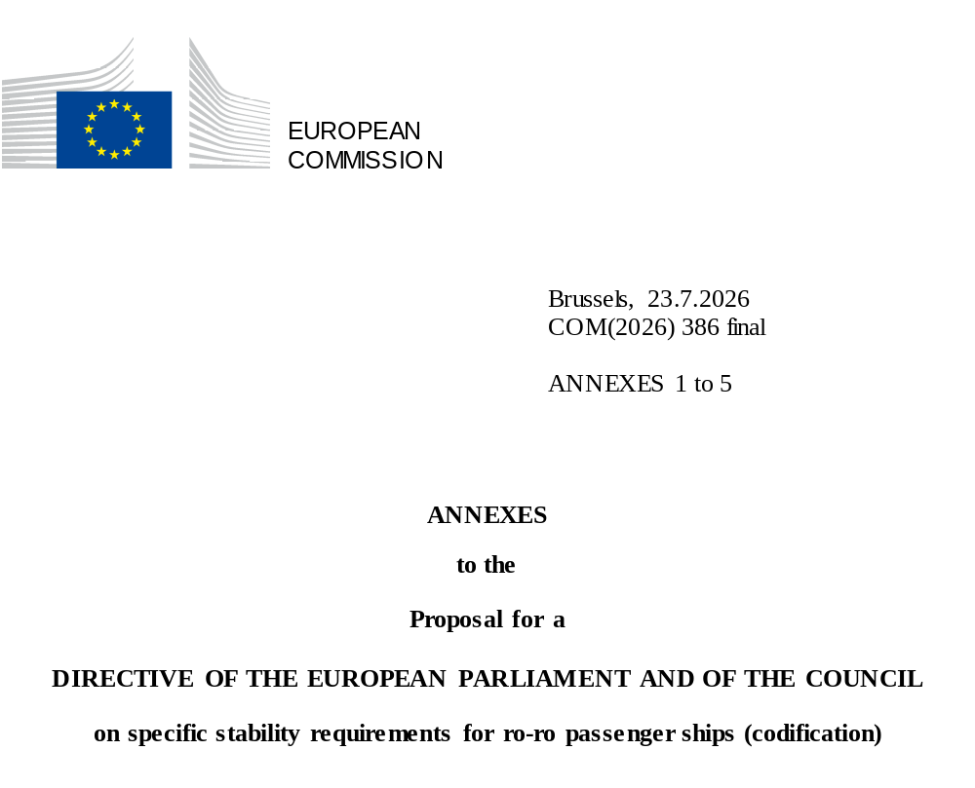

ê 2003/25/EC
ANNEX I
SPECIFIC STABILITY REQUIREMENTS FOR RO-RO PASSENGER SHIPS
as referred to in Article 6

ê 2023/946 Art. 1.11 and Annex I.1(a)

Section A

ê 2023/946 Art. 1.11 and Annex I.1(b) (adapted)
For the purposes of Ö this Õ section , references to the SOLAS Convention regulations shall be construed as references to those regulations as they applied under SOLAS 90.

ê 2023/946 Art. 1.11 and Annex I.1(c) (adapted)
1. In addition to the requirements of Ö SOLAS Õ Regulation II-1/B/8 relating to watertight subdivision and stability in damaged condition, the requirements of this section shall be complied with.

ê 2003/25/EC (adapted)
1.1. The provisions of Ö SOLAS Õ Regulation II-1/B/8.2.3 shall be complied with when taking into account the effect of a hypothetical amount of sea water which is assumed to have accumulated on the first deck above the design waterline of the ro-ro cargo space or the special cargo space as defined in Ö SOLAS Õ Regulation II-2/3 assumed to be damaged ( ‘the damaged ro-ro deck’). The other requirements of Ö SOLAS Õ Regulation II-1/B/8 need not be complied with in the application of the stability standard Ö laid down Õ in this Annex. The amount of assumed accumulated sea water shall be calculated on the basis of a water surface having a fixed height above:
(a) the lowest point of the deck edge of the damaged compartment of the ro-ro deck; or
(b) Ö the still water surface at all heel and trim angles, Õ when the deck edge of the damaged compartment is submerged ;
as follows:
0,5 m if the residual freeboard is 0,3 m or less;
0,0 m if the residual freeboard is 2,0 m or more;
intermediate values to be determined by linear interpolation, if the residual freeboard is 0,3 m or more but less than 2,0 m,
where the residual freeboard is the minimum distance between the damaged ro-ro deck and the final waterline at the location of the damage in the damage case being considered without taking into account the effect of the volume of assumed accumulated water on the damaged ro-ro deck.
1.2. When a high-efficiency drainage system is installed, the administration of flag State may allow a reduction in the height of the water surface.
1.3. For ships in geographically defined restricted areas of operation, the administration of flag State may reduce the height of the water surface prescribed in accordance with point 1.1 by substituting such height of the water surface by the following:
1.3.1. 0,0 m if the significant wave height defining the area concerned is 1,5 m or less;
1.3.2. the value determined in accordance with point 1.1 if the significant wave height defining the area concerned is 4,0 m or above;
1.3.3. intermediate values to be determined by linear interpolation if the significant wave height defining the area concerned is 1,5 m or more but less than 4,0 m,
provided that the following conditions are fulfilled:
1.3.4. the administration Ö of flag State Õ is satisfied that the defined area is represented by the significant wave height which is not exceeded with a probability of more than 10 %; and
1.3.5. the area of operation and, if applicable, the part of the year for which a certain value of the significant wave height has been established are entered on the certificates.
1.4. As an alternative to the requirements of points 1.1 or 1.3, the administration Ö of flag State Õ may exempt application of the requirements of points 1.1 or 1.3 and accept proof, established by model tests carried out for an individual ship in accordance with the model test method, which appears in the Appendix, justifying that the ship will not capsize with the assumed extent of damage as provided Ö for Õ in Ö SOLAS Õ Regulation II-1/B/8.4 in the worst location being considered under point 1.1, in an irregular seaway, and
1.5. reference to acceptance of the results of the model test as an equivalence to compliance with points 1.1 or 1.3 and the value of the significant wave height used in the model tests shall be entered on the ship's certificates.
1.6. The information supplied to the master in accordance with Ö SOLAS Õ Regulations II-1/B/8.7.1 and II-1/B/8.7.2, as developed for compliance with Ö SOLAS Õ Regulations II-1/B/8.2.3 to II-1/B/8.2.3.4, shall apply unchanged for ro-ro passenger ships approved according to these requirements.
2. For Ö the purposes of Õ assessing the effect of the volume of the assumed accumulated sea water on the damaged ro-ro deck in point 1, the following provisions shall Ö apply Õ :
2.1. a transverse or longitudinal bulkhead shall be considered intact if all parts of it lie inboard of vertical surfaces on both sides of the ship, which are situated at a distance from the shell plating equal to one-fifth of the breadth of the ship, as defined in Ö SOLAS Õ Regulation II-1/2, and measured at right angles to the centreline at the level of the deepest subdivision load line;
2.2. in cases where the ship's hull is structurally partly widened for compliance with the provisions of this Annex, the resulting increase of the value of one fifth of the breadth of it Ö shall Õ be used throughout, but shall not govern the location of existing bulkhead penetrations, piping systems, etc., which were acceptable prior to the widening;

ê 2005/12/EC Art. 1.1(a) (adapted)
2.3. the tightness of transverse or longitudinal bulkheads which are taken into account as effective to confine the assumed accumulated sea water in the compartment concerned in the damaged ro-ro deck shall be commensurate with the drainage system, and shall withstand hydrostatic pressure in accordance with the results of the damage calculation. Such bulkheads shall be at least 4 m in height unless the height of water is less than 0,5 m. In such cases the height of the bulkhead may be calculated in accordance with the following:
B_{h} = 8h_{w}
where B_{h} is the bulkhead height and h_{w} is the height of water.
In any event, the minimum height of the bulkhead Ö shall Õ be not less than 2,2 m. However, in Ö the Õ case of a ship with hanging car decks, the minimum height of the bulkhead shall be not less than the height to the underside of the hanging deck when in its lowered position;

ê 2003/25/EC (adapted)
2.4. for special arrangements such as full-width hanging decks and wide side casings, other bulkhead heights may be accepted on the basis of detailed model tests;
2.5. the effect of the volume of the assumed accumulated sea water need not be taken into account for any compartment of the damaged ro-ro deck, provided that such a compartment has on each side of the deck freeing ports evenly distributed along the sides of the compartment complying with the following:
2.5.1. A ≥ 0,3 l
where A is the total area of freeing ports on each side of the deck in m² and l is the length of the compartment in m;
2.5.2. the ship shall maintain a residual freeboard of at least 1,0 m in the worst damage condition without taking into account the effect of the assumed volume of water on the damaged ro-ro deck;
2.5.3. such freeing ports shall be located within Ö a Õ height of 0,6 m above the damaged ro-ro deck, and the lower edge of the ports shall be within 2 cm above the damaged ro-ro deck;
2.5.4. such freeing ports shall be fitted with closing devices or flaps to prevent water entering the ro-ro deck whilst allowing water which may accumulate on the ro-ro deck to drain.
2.6. When a bulkhead above the ro-ro deck is assumed damaged, both compartments bordering the bulkhead shall be assumed flooded to the same height of water surface as calculated in points 1.1 or 1.3.
3. When determining significant wave height, the wave heights given on the maps or list of sea areas established by Member States in Ö accordance Õ with Article 5 of this Directive shall be used.

ê 2023/946 Art. 1.11 and Annex I.1(d)
3.1. For ships which are to be operated only for a shorter period within the meaning of Article 8 the Port States included in the route shall agree on the applicable significant wave height.

ê 2003/25/EC
4. Model tests shall be conducted in accordance with the Appendix.

ê 2023/946 Art. 1.11 and Annex I.1(e)

Section B
The requirements of Chapter II-1, Part B, of SOLAS 2020 shall be complied with. However, by way of derogation from Regulation II-1/B/6.2.3 of SOLAS 2020, the required subdivision index R shall be determined as follows:
Persons on board (N) | Subdivision Index (R)
N < 1000 | R = 0,000088 * N +0,7488
1000 ≤ N ≤ 1350 | R = 0,0369 * ln (N +89,048) +0,579
Where:
N | = | total number of persons on board.

ê 2005/12/EC Art. 1.1(b) and Annex I (adapted)
Appendix

Model test method

1. Objectives
This revised model test method is a revision of the method Ö set out Õ in the Appendix to the Annex to Resolution 14 of the 1995 SOLAS Conference. Since the entry into force of the Stockholm Agreement, a number of model tests Ö have Õ been carried out in accordance with the test method previously in force. During these tests, a number of refinements in the procedures have been identified. This Ö revised Õ model test method aims to include these refinements and, together with the appended guidance notes, provide a more robust procedure for the assessment of survivability of a damaged ro-ro passenger ship in a seaway. In the tests provided for in Section A, point 1.4 , the ship Ö shall Õ be capable of withstanding a seaway as defined in point 4 in the worst-damage-case scenario.

2. Definitions
L_{BP} | is the length between perpendiculars;
H_{S} | is the significant wave height;
B | is the moulded breadth of the ship;
T_{P} | is the peak period;
T_{Z} | is the zero crossing period.

3. Ship model
3.1. The model Ö shall Õ copy the actual ship for both outer configuration and internal arrangement, in particular all damaged spaces having an effect on the process of flooding and shipping of water. Intact draught, trim, heel and limiting operational KG corresponding to the worst damage case Ö shall Õ be used. Furthermore, the test case(s) to be considered Ö shall Õ represent the worst damage case(s) defined in accordance with SOLAS Regulation II-1/8.2.3.2 with regard to the total area under the positive GZ curve and the centreline of the damage opening Ö shall Õ be located within the following range:
3.1.1. ± 35 % L_{BP} from midship;
3.1.2. an additional test Ö shall Õ be required for the worst damage within ± 10 % L_{BP} from midship if the damage case referred to in point 3.1 is outside of ± 10 % L_{BP} from midship.
3.2. The model Ö shall Õ comply with the following Ö requirements Õ :
3.2.1. L_{BP} Ö shall Õ be at least 3 m or a length corresponding to a model scale of 1:40, whichever is greater, and the vertical extent up to at least three superstructure standard heights above the bulkhead (freeboard) deck;
3.2.2. hull thickness of flooded spaces Ö shall Õ not exceed 4 mm;
3.2.3. in both intact and damaged conditions, the model Ö shall Õ satisfy the correct displacement and draught marks (T_{A}, T_{M}, T_{F}, port and starboard) with a maximum tolerance in any one draught mark of + 2 mm. Draught marks forward and aft Ö shall Õ be located as near FP and AP as practicable;
3.2.4. all damaged compartments and ro-ro spaces Ö shall Õ be modelled with the correct surface and volume permeabilities (actual values and distributions) ensuring that floodwater mass and mass distribution are correctly represented;
3.2.5. the characteristics of motion of the actual ship Ö shall Õ be modelled properly, paying particular attention to the intact GM tolerance and radii of gyration in roll and pitch motion. Both radii Ö shall Õ be measured in air and be in the range of 0,35B to 0,4B for roll motion, and 0,2L_{OA} to 0,25L_{OA} for pitch motion;
3.2.6. main design features, such as watertight bulkheads Ö and Õ air escapes, above and below the bulkhead deck that can result in asymmetric flooding Ö shall Õ be modelled properly as far as practicable to represent the real situation. Ventilating and cross-flooding arrangements Ö shall Õ be constructed to a minimum cross section of 500 mm²;
3.2.7. the shape of the damage opening Ö shall Õ be as follows:
1. trapezoidal profile with side at 15o slope to the vertical and the width at the design waterline defined according to SOLAS Regulation II-1/8.4.1;
2. isosceles triangular profile in the horizontal plane with the height equal to B/5 according to SOLAS Regulation II-1/8.4.2. If side casings are fitted within B/5, the damaged length in way of the side casings Ö shall Õ not be less than 25 mm;
3. notwithstanding the provisions of points 3.2.7.1 and 3.2.7.2 , all compartments taken as damaged in calculating the worst damage case(s) referred to in point 3.1 Ö shall Õ be flooded in the model tests.
3.3. The model in the flooded equilibrium condition Ö shall Õ be heeled by an additional angle corresponding to that induced by the heeling moment M_{h} = max (M_{pass}; M_{launch})-M_{wind}, but in no case Ö shall Õ the final heel be less than 1o towards damage. M_{pass}, M_{launch} and M_{wind} are as specified in SOLAS Regulation II-1/8.2.3.4. For existing Ö ro-ro passenger Õ ships this angle may be taken as 1o.

4. Procedure for experiments
4.1. The model Ö shall Õ be tested in a long-crested irregular seaway defined by the JONSWAP spectrum with significant wave height H_{S}, a peak enhancement factor γ = 3,3 and a peak period. H_{S} is the significant wave height for the area of operation, which is not exceeded by a probability of more than 10 % on a yearly basis, but limited to a maximum of 4 m.
Furthermore,
4.1.1. the basin width Ö shall Õ be sufficient to avoid contact or other interaction with the sides of the basin and is recommended not to be less than L_{BP} + 2 m;
4.1.2. the basin depth Ö shall Õ be sufficient for proper wave modelling but Ö shall Õ not be less than 1 m;
4.1.3. for a representative wave realisation to be used, measurements should be performed prior to the test at three different locations within the drift range;
4.1.4. the wave probe closer to the wave maker Ö shall Õ be located at the position where the model is placed when the test starts;
4.1.5. variation in H_{S} and T_{P} Ö shall Õ be within ± 5 % for the three locations;
4.1.6. during the tests, for approval purposes, a tolerance of + 2,5 % in H_{S}, ± 2,5 % in T_{P} and ± 5 % in T_{Z} Ö shall Õ be allowed with reference to the probe closer to the wave maker.
4.2. The model Ö shall Õ be free to drift and placed in beam seas (90o heading) with the damage hole facing the oncoming waves, with no mooring system permanently attached to the model used. To maintain a beam sea heading of approximately 90o during the model test the following requirements Ö shall Õ be satisfied:
4.2.1. heading control lines, intended for minor adjustment, Ö shall Õ be located at the centre line of the stem and stern, in a symmetrical fashion and at a level between the position of KG and the damaged waterline;
4.2.2. the carriage speed Ö shall Õ be equal to the actual drift speed of the model with speed adjustment made when necessary.
4.3. At least 10 experiments Ö shall Õ be carried out. The test period for each experiment Ö shall Õ be of a duration such that a stationary state is reached, but not less than 30 Ö minutes Õ in full-scale. A different wave realisation train Ö shall Õ be used for each experiment.

5. Survival criteria
The model Ö shall Õ be considered as surviving if a stationary state is reached for the successive test runs as required in point 4.3. The model Ö shall Õ be considered as capsized if angles of roll of more than 30º to the vertical axis or steady (average) heel greater than 20º for a period longer than three minutes full-scale occur, even if a stationary state is reached.

6. Test documentation
6.1. The model test programme Ö shall Õ be approved by the administration in advance.
6.2. Tests Ö shall Õ be documented by means of a report and a video or other visual records containing all relevant information on the model and the test results, which are to be approved by the administration. These Ö shall Õ include, as a minimum, the theoretical and measured wave spectra and statistics (H_{S}, T_{P}, T_{Z}) of the wave elevation at the three different locations in the basin for a representative realisation, andÖ, Õ for the tests with the model, the time series of main statistics of the measured wave elevation close to the wave maker and records of model roll, heave and pitch motions, and of the drift speed.
_____________

ê 2003/25/EC
ANNEX II
INDICATIVE GUIDELINES TO NATIONAL ADMINISTRATIONS
as referred to in Article 6(3)

PART I

APPLICATION

ê 2023/946 Art. 1.11 and Annex I.2 (adapted)
In Ö accordance Õ with Article 6(3) of this Directive, these guidelines shall be used by the national administrations of Member States in the application of the specific stability requirements Ö laid down Õ in section A of Annex I, in so far as this is practicable and compatible with the design of the ship in question. The point numbers appearing below correspond to those in section A of Annex I.

ê 2003/25/EC (adapted)

Point 1
As a first step, all ro-ro passenger ships referred to in Article 3(1) of this Directive Ö shall Õ comply with Ö SOLAS Regulation II-1/B/8 Õ as it applies to all passenger ships constructed on or after 29 April 1990. It is the application of this requirement that defines the residual freeboard f_{r}, necessary for the calculations required in point 1.1.

Point 1.1
1. This point addresses the application of a hypothetical amount of water accumulated on the bulkhead (ro-ro) deck. The water is assumed to have entered the deck via a damage opening. This point requires that the ship, in addition to complying with the full requirements of Ö SOLAS Regulation II-1/B/8, Õ further complies with that part of the SOLAS 90 criteria Ö laid down Õ in points 2.3 to 2.3.4 of Ö SOLAS Õ Regulation II-1/B/8 with the defined amount of water on deck. For Ö that Õ calculation, no other requirements of Ö SOLAS Õ Regulation II-1/B/8 need be taken into account. For example, the ship does not, for Ö the Õ calculation, need to comply with the requirements for the angles of equilibrium or non-submergence of the margin line.
2. The accumulated water is added as a liquid load with one common surface inside all compartments which are assumed flooded on the car deck. The height (h_{w}) of water on deck is dependent on the residual freeboard after damage, and is measured in way of the damage (see figure 1). The residual freeboard is the minimum distance between the damaged ro-ro deck and the final waterline (after equalisation measures if any have been taken) in way of the assumed damage after examining all possible damage scenarios in determining the compliance with Ö SOLAS Regulation II-1/B/8 Õ as required in point 1 of Annex I. No account Ö shall Õ be taken of the effect of the hypothetical volume of water assumed to have accumulated on the damaged ro-ro deck when calculating f_{r}.
3. If f_{r} is 2,0 m or more, no water is assumed to accumulate on the ro-ro deck. If f_{r} is 0,3 m or less, then height h_{w} is assumed to be 0,5 m. Intermediate heights of water are obtained by linear interpolation (see figure 2).

Point 1.2
Means for drainage of water can only be considered as effective if Ö such Õ means are of a capacity to prevent large amounts of water from accumulating on the deck, Ö that is to say Õ many thousands of tonnes per hour which is far beyond the capacities fitted at the time of the adoption of these regulations. Such high efficiency drainage systems may be developed and approved in the future (based on guidelines to be developed by Ö IMO Õ )

Point 1.3
1. The amount of assumed accumulated water on deck may, in addition to any reduction in accordance with point 1.1, be reduced for operations in geographically defined restricted areas. These areas are designated in accordance with the significant wave height defining the area in Ö accordance Õ with Article 5 of this Directive.
2. If the significant wave height in the area concerned is 1,5 m or less then no additional water is assumed to accumulate on the damaged ro-ro deck. If the significant wave height in the area concerned is 4,0 m or more then the height of the assumed accumulated water shall be the value calculated in accordance with point 1.1. Intermediate values to be determined by linear interpolation (see figure 3).
3. The height h_{w} is kept constant, therefore the amount of added water is variable as it is dependent upon the heeling angle and whether at any particular heeling angle the deck edge is immersed or not (see figure 4). It should be noted that the assumed permeability of the car deck spaces Ö shall Õ be taken as 90 % (MSC/Circ.649 refers), whereas other assumed flooded spaces permeabilities Ö shall Õ be those prescribed in the SOLAS Convention.
4. If the calculations to demonstrate compliance with this Directive relate to a significant wave height less than 4,0 m, that restricting significant wave height Ö shall Õ be recorded on the vessel's passenger ship safety certificate.

Points 1.4 and 1.5
As an alternative to complying with the new stability requirements in point 1.1 or point 1.3, an administration may accept proof of compliance via model tests. The model test requirements are detailed in the Appendix to Annex I. Guidance notes on the model tests are contained in part II of this Annex.

Point 1.6
Limiting operational curve(s) (KG or GM) Ö conventionally derived from SOLAS Regulation II-1/B/8 Õ may not remain applicable in cases where ‘water on deck’ is assumed under the terms of this Directive and it may be necessary to determine revised limiting curve(s) which take into account the effects of this added water. To this effect sufficient calculations corresponding to an adequate number of operational draughts and trims Ö shall Õ be carried out.
Note: Revised limiting operational KG/GM Curves may be derived by iteration, whereby the minimum excess GM resulting from damage stability calculations with water on deck is added to the input KG (or deducted from the GM) used to determine the damaged freeboards , upon which the quantities of water on deck are based, this process being repeated until the excess GM becomes negligible.
It is anticipated that operators would begin such an iteration with the maximum KG/minimum GM which could reasonably be sustained in service and would seek to manipulate the resulting deck bulkhead arrangement to minimise the excess GM derived from damage stability calculations with water on deck.

Point 2.1
As for conventional SOLAS damage requirements, bulkheads inboard of the B/5 line are considered intact in the event of side collision damage.

Point 2.2
If side structural sponsons are fitted to enable compliance with Ö SOLAS Õ Regulation II-1/B/8, and as a consequence there is an increase in the breadth of the ship and hence the vessel's B/5 distance from the ship's side, such modification shall not cause the relocation of any existing structural parts or any existing penetrations of the main transverse watertight bulkheads below the bulkhead deck (see figure 5).

Point 2.3
1. Transverse or longitudinal bulkheads/barriers which are fitted and taken into account to confine the movement of assumed accumulated water on the damaged ro-ro deck need not be strictly ‘watertight’. Small amounts of leakage may be permitted subject to the drainage provisions being capable of preventing an accumulation of water on the ‘other side’ of the bulkhead/barrier. In such cases where scuppers become inoperative as a result of a loss of positive difference of water levels other means of passive drainage Ö shall Õ be provided.
2. The height (B_{h}) of transverse and longitudinal bulkheads/barriers shall be not less than (8 × h_{w}) metres, where h_{w} is the height of the accumulated water as calculated by application of the residual freeboard and significant wave height (as referred to in points 1.1 and 1.3). However, in no case is the height of the bulkhead/barrier to be less than the greater of:
(a) 2,2 metres; or
(b) the height between the bulkhead deck and the lower point of the underside structure of the intermediate or hanging car decks, when these are in their lowered position. It should be noted that any gaps between the top edge of the bulkhead and the underside of the plating Ö shall Õ be ‘plated-in’ in the transverse or longitudinal direction as appropriate (see figure 6).
Bulkheads/barriers with a height less than that specified above may be accepted if model tests are carried out in accordance with part II of this Annex to confirm that the alternative design ensures appropriate standard of survivability. Care needs to be taken when fixing the height of the bulkhead/barrier such that the height shall also be sufficient to prevent progressive flooding within the required stability range. This range is not to be prejudiced by model tests.
Note: The range may be reduced to 10 degrees provided Ö that Õ the corresponding area under the curve is increased (as referred to in MSC 64/22).

Point 2.5.1
The area ‘A’ relates to permanent openings. It should be noted that the ‘freeing ports’ option is not suitable for ships which require the buoyancy of the whole or part of the superstructure in order to meet the criteria. The requirement is that the freeing ports shall be fitted with closing flaps to prevent water entering, but allowing water to drain.
These flaps Ö shall Õ not rely on active means. They Ö shall Õ be self-operating and it Ö shall Õ be shown that they do not restrict outflow to a significant degree. Any significant efficiency reduction Ö shall Õ be compensated by the fitting of additional openings so that the required area is maintained.

Point 2.5.2
For the freeing ports to be considered effective, the minimum distance from the lower edge of the freeing port to the damaged waterline shall be at least 1,0 m. The calculation of the minimum distance shall not take into account the effect of any additional water on deck (see figure 7).

Point 2.5.3
Freeing ports Ö shall Õ be sited as low as possible in the side bulwark or shell plating. The lower edge of the freeing port opening Ö shall Õ be no higher than 2 cm above the bulkhead deck and the upper edge of the opening no higher than 0,6 m (see figure 8).
Note: Spaces to which point 2.5 applies, Ö that is to say Õ . those spaces fitted with freeing ports or similar openings, shall not be included as intact spaces in the derivation of the intact and damage stability curves.

Point 2.6
1. The statutory extent of damage Ö shall Õ be applied along the length of the ship. Depending on the subdivision standard, the damage may not affect any bulkhead or may only affect a bulkhead below the bulkhead deck or only Ö a Õ bulkhead above the bulkhead deck or various combinations.
2. All transverse and longitudinal bulkheads/barriers which constrain the assumed accumulated amount of water Ö shall Õ be in place and secured at all times when the ship is at sea.
3. In cases where the transverse bulkhead/barrier is damaged, the accumulated water on deck shall have a common surface level on both sides of the damaged bulkhead/barrier at the height h_{w} (see figure 9).

ê 2005/12/EC Art. 1.2 and Annex II (adapted)

PART II

MODEL TESTING
The purpose of these guidelines is to ensure uniformity in the methods employed in the construction and verification of the model as well as in the undertaking and analyses of the model tests.
The contents of points 1 and 2 of the Appendix to Annex I are considered self-explanatory.

Point 3 — Ship model
3.1. The material of which the model is made is not important in itself, provided that the model both in the intact and damaged condition is sufficiently rigid to ensure that its hydrostatic properties are the same as those of the actual ship and also that the flexural response of the hull in waves is negligible.
It is also important to ensure that the damaged compartments are modelled as accurately as practicably possible to ensure that the correct volume of flood water is represented.
Since ingress of water (even small amounts) into the intact parts of the model will affect its behaviour, measures Ö shall Õ be taken to ensure that this ingress does not occur.
In model tests involving worst SOLAS damages near the ship ends, it has been observed that progressive flooding was not possible because of the tendency of the water on deck to accumulate near the damage opening and hence flow out. As such models were able to survive very high sea states, while they capsized in lesser sea states with less onerous SOLAS damages, away from the ends, the limit Ö of Õ ± 35 % was introduced to prevent this.
Extensive research carried out for the purpose of developing appropriate criteria for new vessels has clearly shown that, in addition to the GM and freeboard being important parameters in the survivability of passenger ships, the area under the residual stability curve is also another major factor. Consequently, in choosing the worst SOLAS damage for compliance with the requirement of point 3.1 the worst damage Ö shall Õ be taken as that which gives the least area under the residual stability curve.
3.2. Model particulars
3.2.1. In recognising that scale effects play an important role in the behaviour of the model during tests, it is important to ensure that these effects are minimised as much as practically possible. The model Ö shall Õ be as large as possible since details of damaged compartments are Ö more easily Õ constructed in larger models and the scale effects are reduced. It is therefore required that the model length is not less than that corresponding to 1:40 scale or 3 m, whichever is greater.
It has been found during tests that the vertical extent of the model can affect the results when tested dynamically. It is therefore required that the ship is modelled to at least three super structure standard heights above the bulkhead (freeboard) deck so that the large waves of the wave train do not break over the model.
3.2.2. The model in way of the assumed damages Ö shall Õ be as thin as practically possible to ensure that the amount of flood water and its centre of gravity is adequately represented. The hull thickness Ö shall Õ not exceed 4 mm. It is recognised that it may not be possible for the model hull and the elements of primary and secondary subdivision in way of the damage to be constructed with sufficient detail and due to these constructional limitations, it may not be possible to calculate accurately the assumed permeability of the space.
3.2.3. It is important that not only the draughts in the intact condition are verified, but also that the draughts of the damaged model are accurately measured for correlation with those derived from damage stability calculation. For practical reasons, a tolerance of + 2 mm in any draught is accepted.
3.2.4. After measuring the damaged draughts, it may be found necessary to make adjustments to the permeability of the damaged compartment by either introducing intact volumes or by adding weights. However, it is also important to ensure that the centre of gravity of the flood water is accurately represented. In this case, any adjustments made Ö shall Õ err on the side of safety.
If the model is required to be fitted with barriers on deck and the barriers are less than the bulkhead height indicated below, the model Ö shall Õ be fitted with CCTV so that any ‘splashing over’ and any accumulation of water on the undamaged area of the deck can be monitored. In this case, a video recording of the event Ö shall Õ form part of the test records.
The height of transverse or longitudinal bulkheads which are taken into account as effective to confine the assumed accumulated sea water in the compartment concerned in the damaged ro-ro deck Ö shall Õ be at least 4 m in height unless the height of water is less than 0,5 m. In such cases, the height of the bulkhead may be calculated in accordance with the following:
B_{h} = 8h_{w}
where B_{h} is the bulkhead height and h_{w} is the height of water.
In any event, the minimum height of the bulkhead Ö shall Õ be not less than 2,2 m. However, in the case of a ship with hanging car decks, the minimum height of the bulkhead Ö shall Õ be not less than the height to the underside of the hanging car deck when in its lowered position.
3.2.5. In order to ensure that the model motion characteristics represent those of the actual ship it is important that the model is both inclined and rolled in the intact condition so that the intact GM and the mass distribution are verified. The mass distribution Ö shall Õ be measured in air. The transverse radius of gyration of the actual ship Ö shall Õ be in the range 0,35B to 0,4B and the longitudinal radius of gyration Ö shall Õ be in the range 0,2L to 0,25L.
Note: While inclining and rolling the model in the damaged condition may be accepted as a check for the purpose of verifying the residual stability curve, such tests Ö shall Õ not be accepted in lieu of the intact tests.
3.2.6. It is assumed that the ventilators of the damage compartment of the actual ship are adequate for unhindered flooding and movement of the flood water. However, in trying to scale down the ventilating arrangements of the actual ship undesirable scale effects may be introduced in the model. In order to ensure that no such effects occur it is recommended to construct the ventilating arrangements to a larger scale than that of the model, ensuring that this does not affect the flow of water on the car deck.
3.2.7. It is deemed appropriate to consider a damage shape representative of a cross section of the striking ship in the bow region. The 15° angle is based on a study of the cross section at a distance of B/5 from the bow for a representative selection of vessels of different types and sizes.
The isosceles triangular profile of the prismatic damage shape is that corresponding to the load waterline.
Additionally, in cases where side casings of width less than B/5 are fitted, and in order to avoid any possible scale effects, the damage length in way of the side casings Ö shall Õ not be less than 25 mm.
3.3. In the original model test method of Resolution 14 of the 1995 SOLAS Conference, the effect of heeling induced by the maximum moment deriving from any of passenger crowding, launching of survival craft, wind and turning was not considered even though this effect was part of SOLAS. Results from an investigation have shown, however, that it would be prudent to take these effects into account and to retain the minimum of 1° heel towards the damage for practical purposes. It Ö should Õ be noted that heeling due to turning was considered not to be relevant.
3.4. In cases where there is a margin in GM in the actual loading conditions compared to the GM limiting curve (derived from SOLAS 90), the administration may accept that this margin is taken advantage of in the model test. In such cases, the GM limiting curve Ö shall Õ be adjusted. This adjustment can be done as follows:
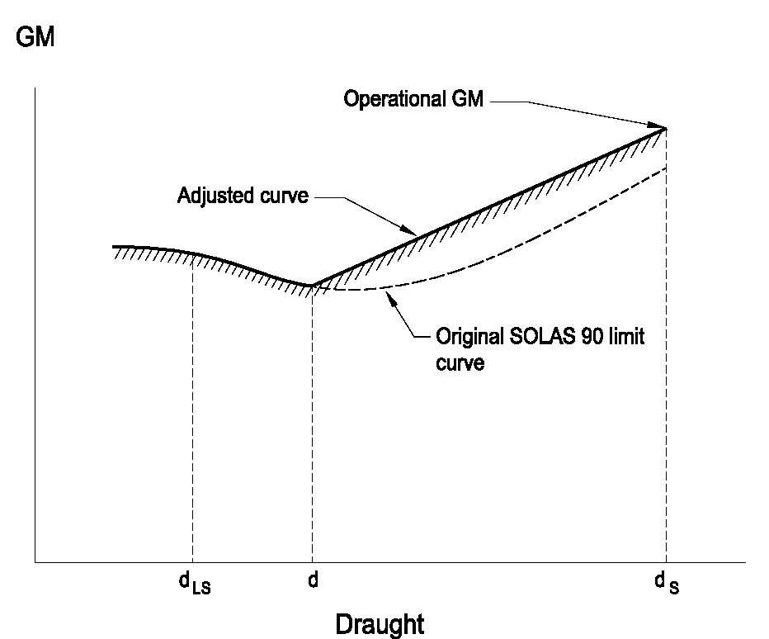
d = d_{S}-0,6 (d_{S}-d_{LS})
where d_{S} is the subdivision draught and d_{LS} is the lightship draught.
The adjusted curve is a straight line between the GM used in the model test at the subdivision draught and the intersection of the original SOLAS 90 curve and draught d.

Point 4 — Procedure for experiments
4.1. Wave spectra
The JONSWAP spectrum Ö shall Õ be used as this describes fetch- and duration- limited seas which correspond to the majority of conditions worldwide. In this respect it is important that not only the peak period of the wave train is verified but also that the zero crossing period is correct.
It is required that for every test run the wave spectrum is recorded and documented. Measurements for this recording Ö shall Õ be taken at the probe closest to the wave making machine.
It is also required that the model is instrumented so that its motions (roll, heave and pitch) as well as its attitude (heel, sinkage and trim) are monitored and recorded throughout the test.
It has been found that it is not practical to set absolute limits for significant wave heights, peak periods and zero crossing periods of the model wave spectra. An acceptable margin has therefore been introduced.
4.2. To avoid interference of the mooring system with the ship dynamics, the towing carriage (to which the mooring system is attached) Ö shall Õ follow the model at its actual drifting speed. In a sea state with irregular waves the drift speed will not be constant; a constant carriage speed would result in low frequency, large amplitude drift oscillations, which may affect the model behaviour.
4.3. A sufficient number of tests in different wave trains is necessary to ensure statistical reliability, Ö that is to say Õ the objective is to determine with a high degree of confidence that an unsafe ship will capsize in the selected conditions. A minimum number of 10 runs is considered to provide a reasonable level of reliability.

Point 5 — Survival criteria
The contents of this point are considered self-explanatory.

Point 6 — Test approval
The following documents Ö shall Õ be part of the report to the administration:
(a) damage stability calculations for worst SOLAS and mid-ship damage (if different);
(b) general arrangement drawing of the model together with details of construction and instrumentation;
(c) inclining experiment and measurements of radii of gyration;
(d) nominal and measured wave spectra (at the three different locations for a representative realisation and for the tests with the model from the probe closest to the wave maker);
(e) representative record of model motions, attitude and drift;
(f) relevant video recordings.
Note:
All tests Ö shall Õ be witnessed by the administration.
_____________

ê 2023/946 Art. 1.12 and Annex II (adapted)
ANNEX III

NOTIFICATION DETAILS
Data to be notified in accordance with Article 6(2):
I. General data:
(1) applicable stability requirements: section A or section B of Annex I;
(2) ship’s identification number (IMO number, Call sign);
(3) main particulars;
(4) general arrangement plan;
(5) number of persons on board;
(6) GT;
(7) is the ship double-ended: Yes/No;
(8) does the ship have long lower holds: Yes/No.
II. Specific data – for ro-ro passenger ships subject to the probabilistic requirements Ö laid down Õ in the SOLAS Convention:
(1) d_{l}, d_{p}, d_{s};
(2) R – required index;
(3) layout plan (watertight integrity plan) for the sub-compartments with all internal and external opening points including their connected sub-compartments, and particulars used in measuring the spaces, such as general arrangement plan and tank plan; the subdivision limits, longitudinal, transverse and vertical, Ö shall Õ be included Ö Õ ;
(4) attained subdivision index A with a summary table for all contributions for all damaged zones Ö Õ with a separate column with the attainable subdivision index (w*p*v);
(5) for 1 and 2 Zone damage cases, the percentage of damage cases that were not investigated (Ö that is to say Õ cases not included in the factor (w*p*v)), that s = 0, s = 1 and 0<s< 1;
(6) for 1 and 2 Zone damage cases, the percentage of damage cases involving ro-ro spaces that were not investigated ( Ö that is to say Õ i cases not included in the factor (w*p*v)), that s = 0, s = 1 and 0<s< 1;
(7) for each damage which contributes to the attained subdivision index A, identification of flooded spaces, contribution value and factor «s» Ö Õ ;
(8) particulars of non-contributing damages (s = 0 and p > 0) for ro-ro passenger ships fitted with long lower hold, including full details of the calculated factors Ö Õ .
III. Specific data – for ro-ro passenger ships applying section A of Annex I:
(1) method of compliance:
- model tests;
- calculations.
Please indicate whether the water on deck calculations have been avoided due to, for example, the residual freeboard being higher than 2.0 m in all damage cases: Yes/No;
(2) significant wave height pursuant to Ö this Directive ] Õ .
_____________

é
ANNEX IV
Part A
Repealed Directive
with list of the successive amendments thereto
(referred to in Article 13)
Directive 2003/25/EC of the European Parliament and of the Council
(OJ L 123, 17.5.2003, p. 22, ELI: http://data.europa.eu/eli/dir/2003/25/oj)
Commission Directive 2005/12/EC
(OJ L 48, 19.2.2005, p. 19, ELI: http://data.europa.eu/eli/dir/2005/12/oj)
 | Regulation (EC) No 1137/2008 of the European Parliament and of the Council  (OJ L 311, 21.11.2008, p. 1, ELI: http://data.europa.eu/eli/reg/2008/1137/oj) |  | only Annex, point 9.10
 | Regulation (EU) 2019/1243 of the European Parliament and of the Council  (OJ L 198, 25.7.2019, p. 241, ELI: http://data.europa.eu/eli/reg/2019/1243/oj) |  | only Annex, point IX.4
Directive (EU) 2023/946 of the European Parliament and of the Council
(OJ L 128, 15.5.2023, p. 1, ELI: http://data.europa.eu/eli/dir/2023/946/oj)
Part B
Time-limits for transposition into national law
(referred to in Article 13)
Directive | Time-limit for transposition
2003/25/EC | 17 November 2004
2005/12/EC | 11 March 2006
(EU) 2023/946 | 5 December 2024
_____________

ANNEX V

Correlation Table
Directive 2003/25/EC | This Directive
Article 1 | Article 1
Article 2, introductory wording | Article 2, introductory wording
Article 2, point (a) | Article 2, point (6)
Article 2, point (b) | Article 2, point (7)
Article 2, point (c) | Article 2, point (8)
Article 2, point (d) | Article 2, point (9)
Article 2, point (e) | Article 2, point (1)
Article 2, point (ea) | Article 2, point (2)
Article 2, point (eb) | Article 2, point (3)
Article 2, point (ec) | Article 2, point (4)
Article 2, point (f) | Article 2, point (10)
Article 2, point (g) | Article 2, point (5)
Article 2, point (h) | Article 2, point (11)
Article 2, point (i) | Article 2, point (12)
Article 2, point (j) | Article 2, point (13)
Article 2, point (k) | Article 2, point (14)
Article 2, point (l) | Article 2, point (15)
Article 2, point (m) | Article 2, point (16)
Article 2, point (n) | Article 2, point (17)
Articles 3 to 6 | Articles 3 to 6
Article 8 | Article 7
Article 9 | Article 8
Article 10 | Article 9
Article 10a | Article 10
Article 12 | Article 11
Article 13 | -
Article 13a | Article 12
- | Article 13
Articles 14 and 15 | Articles 14 and 15
Annex I | Annex I
Annex II | Annex II
Annex III | Annex III
– | Annex IV
– | Annex V
_____________

This documentation Ö shall Õ be submitted to administrations in accordance with point 2.2 of the Appendix to IMO Resolution MSC.429(98).
This documentation Ö shall Õ be submitted to administrations in accordance with point 2.3.1 of the Appendix to IMO Resolution MSC.429(98).
This documentation Ö shall Õ be submitted to administrations in accordance with point 2.3.1 of the Appendix to IMO Resolution MSC.429(98).
This documentation Ö shall Õ be submitted to administrations in accordance with point 2.3.1 of the Appendix to IMO Resolution MSC.429(98).

