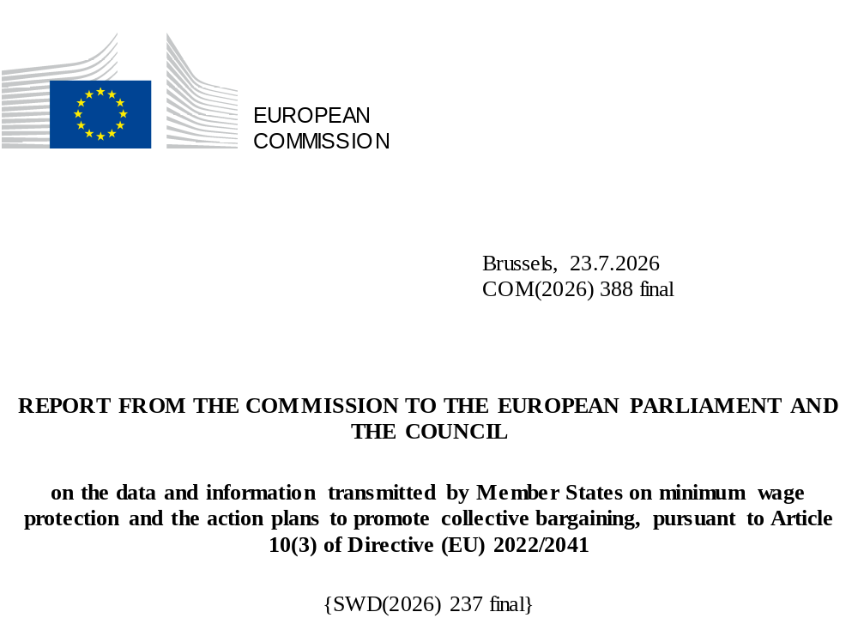

Table of Contents
INTRODUCTION 3
PART I: DATA AND INFORMATION ON MINIMUM WAGE PROTECTION 4
PART II: ACTION PLANS TO PROMOTE COLLECTIVE BARGAINING 10
CONCLUSION 13

INTRODUCTION
Directive (EU) 2022/2041() (the “Minimum Wage Directive” or the “Directive”) establishes a framework for the adequacy of statutory minimum wages, promoting collective bargaining on wage-setting and enhancing effective access of workers to minimum wage protection. It constitutes one of the key deliverables of the European Pillar of Social Rights (), in particular Principle 6 on wages.
The Directive requires all Member States to regularly report data and information on minimum wage protection (Article 10(2)). Specific reporting obligations depend on the minimum wage protection system that exists in a Member State. It also requires the establishment of action plans to promote collective bargaining by those Member States in which the collective bargaining coverage rate is below the threshold of 80% (Article 4(2)).
In addition, Article 10(3) of the Directive requires the Commission to analyse the data and information transmitted by Member States as well as their action plans, and to report to the European Parliament and the Council on this matter every second year.
This is the first periodic report prepared in accordance with Article 10(3). It consists of two parts:
- Part I on the data and information on minimum wage protection transmitted by Member States in accordance with Article 10(2) of the Directive, which covers the years 2021, 2022 and 2023. As the Directive allows Member States a significant amount of discretion in their reporting, this data and information may differ from the minimum wage statistics published by Eurostat ().

- Part II on the action plans to promote collective bargaining established by Member States with a collective bargaining coverage rate below 80%, pursuant to Article 4(2) of the Directive.
This report is based on data and information provided by Member States and other publicly available sources. It is without prejudice to the compliance assessment of the national transposition measures that is being carried out by the Commission, as well as to the position the Commission may take in any future legal proceedings.
The report is accompanied by a Staff Working Document (), which provides further detail on the analysis and publishes the data and information transmitted by the Member States as required by the Directive.

PART I: DATA AND INFORMATION ON MINIMUM WAGE PROTECTION
Minimum wage protection exists in all Member States, either in the form of statutory minimum wages or through collective bargaining. 20 Member States report having a statutory minimum wage, while seven provide minimum wage protection only through collective agreements (Table 1). This distinction is critical, as some provisions of the Directive only apply to Member States having statutory minimum wages.
Table 1: Predominant minimum wage protection system, as self-reported by Member States
Statutory minimum wages | Bulgaria, Croatia, Cyprus (), Czechia, France, Germany, Greece, Hungary, Ireland, Latvia, Lithuania, Luxembourg, Malta, the Netherlands, Poland, Portugal, Romania, Slovakia, Slovenia, Spain
Minimum wage protection provided for only in collective agreements | Austria, Belgium, Denmark, Estonia, Finland, Italy, Sweden
Statutory minimum wages
The levels of statutory minimum wages vary significantly across Member States in nominal terms (Graph 1) (). In 2023, Luxembourg (EUR 2 509 per month), Germany (EUR 2 023), and the Netherlands (EUR 1 965) reported the highest minimum wages, followed by Ireland (EUR 1 910) and France (EUR 1 735). In Spain and Slovenia, they stood around EUR 1 200. In nine Member States (), they ranged between EUR 700 and EUR 940. The lowest minimum wages were found in Bulgaria (EUR 399), followed by Hungary (EUR 615), Latvia (EUR 620) and Romania (EUR 622).
Graph 1: Statutory gross monthly minimum wage levels in the EU (in EUR)
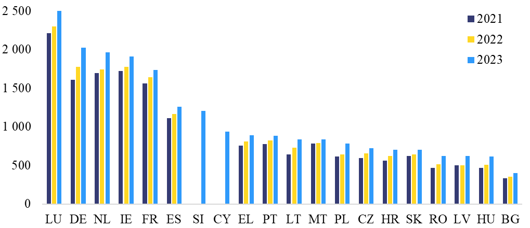
Note: Slovenia only reported data for 2023. Cyprus introduced a statutory minimum wage in 2023.
Source: Member State submissions, converted into EUR and into average monthly wage levels.
Disparities in statutory minimum wages across Member States are considerably smaller after differences in price levels are taken into account. In nominal euro terms, the highest gross monthly minimum wage in the EU is approximately six times greater than the lowest. However, this difference shrinks to less than three times when expressed in purchasing power standards, as the price level tends to be lower in Member States with lower minimum wages. In purchasing power standards, in 2023, gross monthly minimum wages were highest in Luxembourg and Germany, followed by the Netherlands and France. The lowest statutory minimum wages were reported in Bulgaria followed by Latvia and Czechia.
Statutory minimum wages grew faster in countries with initially lower levels, supporting upward convergence. In line with the objectives set out by the Directive, the variation in nominal minimum wages across Member States declined between 2021 and 2023. This was supported by the catch-up of Member States with initially lower nominal levels, such as Hungary and Romania, which recorded the largest nominal growth over the period (40.8% and 33.7%, respectively). This upward convergence in statutory minimum wages in nominal terms has continued after the reference period.
In the period from 2021 to 2023, statutory minimum wage increases offset losses in purchasing power due to the high inflation in about half of the Member States (Graph 2). In 2023, real statutory minimum wages were higher compared to 2021 in 10 of the 18 Member States for which data was available (). The largest increases in real terms were recorded in Germany (9%) and Romania (8.7%), while gains over 2% were recorded in Hungary (4.3%), Croatia (3.5%) and Greece (3.1%). More modest increases (below 2%) were recorded in Luxembourg, Lithuania, Spain, Poland and Portugal. By contrast, small decreases of less than -1% were recorded in the Netherlands and France, while more pronounced declines between -2 and -5% occurred in Bulgaria, Ireland, Latvia and Malta. The largest losses in real statutory minimum wages were observed in Slovakia (-9.7%) and Czechia (-11.4%), where relatively high inflation was met with only limited minimum wage hikes ().
Graph 2: Statutory minimum wage developments
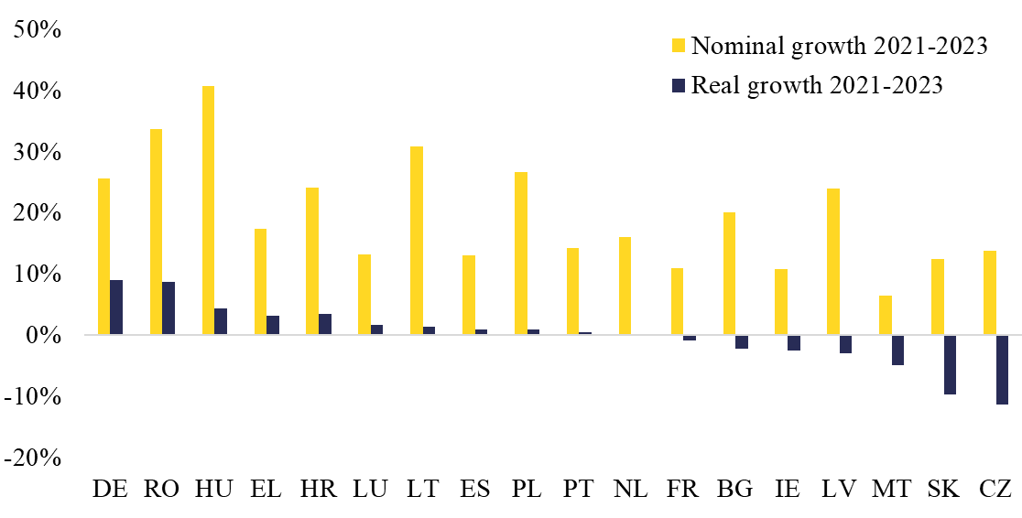
Note: Slovenia only reported data for 2023. Cyprus introduced a statutory minimum wage in 2023.
Source: Own calculations based on Member State submissions.
In 2023, statutory minimum wages were at or above 60% of the gross median wage in six Member States and above 50% of the gross average wage in four of them (Graph 3). Statutory minimum wages reached 60% of the median wage in Portugal, Slovenia, France, Poland, Germany and Greece. The Netherlands, Luxembourg, Romania, Spain, Cyprus, Hungary and Croatia were within five percentage points of the indicative reference value of 60%, while five Member States reached values between 50% and 54% of the median wage (). This index was lowest in Latvia and Malta in 2023, at less than 50%. A similar picture is observed when examining minimum wage levels relative to average wages. Statutory minimum wage levels were above 50% of the average wage in Slovenia, France, the Netherlands and Germany, while Greece, Portugal and Poland were within one percentage point of this value.
Graph 3: Ratio of statutory minimum wage to median and average wage, 2023

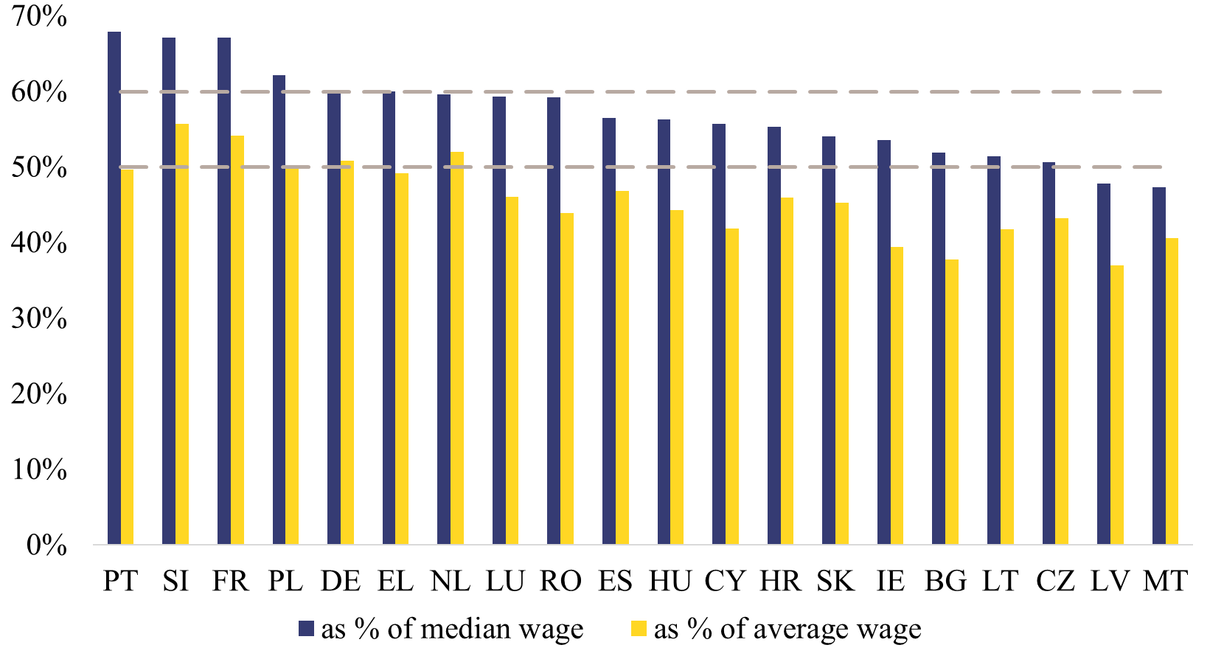
Source: Own calculations based on Member State submissions and Eurostat calculations of median and mean wages using the Structure of earnings survey (SES).
Between 2021 and 2023, statutory minimum wages rose faster than median wages in most Member States. The largest increase in the ratio of statutory minimum wages to median wages occurred in Germany, where it grew by 8.1 percentage points between 2021 and 2023. Other Member States which experienced sizeable increases in this ratio were the Netherlands, Greece, Portugal, Spain and Hungary (2 to 3 percentage points), while smaller increases were recorded in France, Czechia, Latvia, Romania, Lithuania, Ireland, Luxembourg and Poland (0.5 to 2 percentage points). Minimum wages grew more slowly than median wages only in Croatia, Malta, Slovakia and Bulgaria (-0.2 to -4.8 percentage points). These developments suggest a wage compression at the bottom of the wage distribution, as the level of statutory minimum wages approached the median in most Member States. In addition, spillover effects on wages close to the minimum following an increase in minimum wages may have further narrowed the gap between low and median wages.
The share of workers earning the statutory minimum wage varies greatly across Member States, with limited yearly changes. Member States reported shares that range from 1% to 25%, but the comparability of these shares across countries is very limited due to differences in data sources and methodologies ().The share of workers earning the minimum wage tended to be higher among younger workers, workers in smaller companies and those in the construction, hospitality, administrative and support service sectors. In most Member States which reported a comparable disaggregation, the share of minimum wage earners was higher among women. Between 2021 and 2023, the shares remained broadly stable, with changes of less than one percentage point in Hungary, Czechia, Latvia, Lithuania, the Netherlands, Luxembourg, Malta and Ireland. The share decreased by between one and two percentage points in Poland and Slovakia, and by close to three percentage points in Bulgaria, Croatia and Portugal. By contrast, it increased by slightly more than one percentage point in Spain, and between four and six percentage points in Germany, France and Romania. The larger increases in the share of minimum wage earners suggest a wage compression at the bottom of the wage distribution.
Some Member States allow employers to pay wages below the statutory minimum wage to specific groups of workers. Variations for young workers (Cyprus, France, Germany, Ireland, Luxembourg, Malta, the Netherlands), recently hired employees (Cyprus, Germany) or workers with disabilities (the Netherlands, Portugal) aim to facilitate these workers’ integration into the labour market. Variations for students, apprentices and trainees (France, the Netherlands, Portugal) have the additional aim of encouraging employers to supply vocational training.
In addition, several Member States apply variations of the statutory minimum wage for workers in specific regions, sectors or occupations. These are typically justified by the economic situation in the region (such as in Mayotte, an overseas department of France) or by the particular nature of the sector or occupation. In Cyprus, workers in the hotel industry are subject to sector- and occupation-specific minimum wages, which are based on an agreement with the social partners. In France, variations for childminders and caretakers aim to balance the interests of workers in these occupations with those of their employers, including the need for these assistance services to remain affordable. Lower minimum wages for workers engaged in public works in Hungary and for prisoners in Latvia aim, respectively, to encourage workers to seek employment in the private sector and to support their reintegration. By contrast, Malta and Romania have introduced variations requiring employees to be paid more than the statutory minimum wage in sectors affected by economic volatility or where workers have less bargaining power.
Several Member States allow employers to apply deductions, which can reduce the remuneration paid to an employee to a level below the statutory minimum wage. They can relate to employer-provided housing (Cyprus, Ireland, the Netherlands), food (Cyprus, Ireland), health insurance (the Netherlands), fines for unjustified absences and violations of health and safety regulations (Poland), compensation for damage caused to the employer (Lithuania, Poland), as well as child support payments and other administratively or judicially sanctioned deductions (Croatia, Czechia, France, Lithuania, Poland). In many cases, the extent of the deductions is limited to a specified percentage of the worker’s wage (generally ranging from 5% to 30%). Other deductions may be applied only as long as a minimum level of income for the recipient is guaranteed.

Minimum wage protection provided for only in collective agreements
The lowest pay rates in collective agreements covering low-wage earners () vary considerably across the concerned Member States (Graph 4). In 2023, Denmark recorded the highest rate (EUR 2 807 per month), followed by Belgium (EUR 1 955). Pay rates between EUR 1 600 and EUR 1 800 were reported by Sweden (EUR 1 762), Austria (EUR 1 750), Italy (EUR 1 659) () and Finland (EUR 1 642), while Estonia reported the lowest pay rate (EUR 725) (). In these Member States, workers who were not covered by a collective agreement generally earned less than those who were covered.
Graph 4: Monthly lowest pay rates provided for in collective agreements (in EUR)
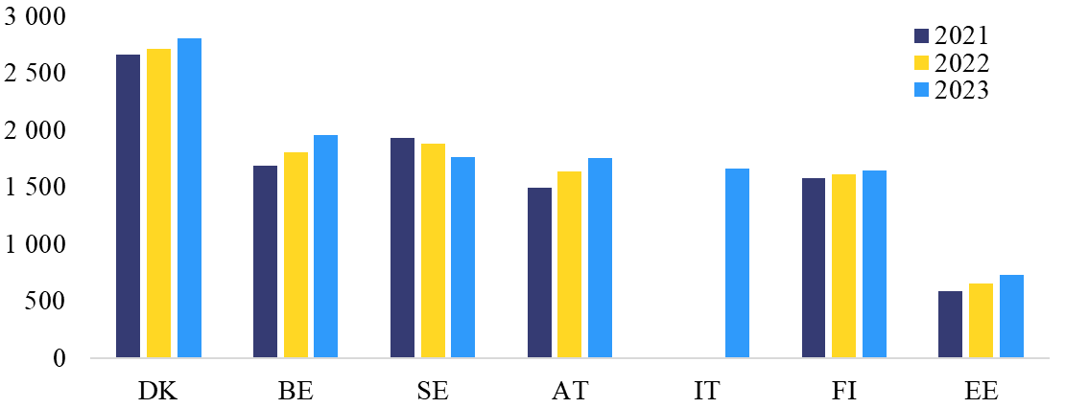
Note: In Sweden, the decrease in nominal lowest pay rates in euro is due to changes in the exchange rate. The nominal amount in the national currency increased over the period. Italy only reported data for 2023.
Source: Member State submissions, converted into EUR and into monthly wage levels.
Disparities in collectively agreed lowest pay rates across Member States are smaller after differences in price levels are taken into account. In 2023, the nominal lowest pay rates in Denmark were almost four times greater than in Estonia. When expressed in purchasing power standards to adjust for the fact that Member States with higher pay rates tend to have a higher price level, this difference decreases to less than three times. In purchasing power standards, in 2023, collectively agreed lowest pay rates were highest in Denmark, followed by Italy, Belgium, Austria, Sweden and Finland. The lowest pay rates in terms of purchasing power – by a significant margin – were recorded in Estonia.
In most Member States relying only on collective bargaining, increases in collectively agreed lowest pay rates fell short of inflation during the reference period (Graph 5). Between 2021 and 2023, the purchasing power of lowest pay rate earners fell by between -5% and -10% in all the countries except Austria and Belgium. The largest loss was recorded in Sweden (-10%). Smaller but still significant losses were recorded in Finland (-7%), Denmark (-6%) and Estonia (-5%). In Austria lowest pay rates remained relatively stable in real terms (0.2%), while in Belgium they grew by 3%.
Graph 5: Real growth in lowest pay rates, 2021-2023
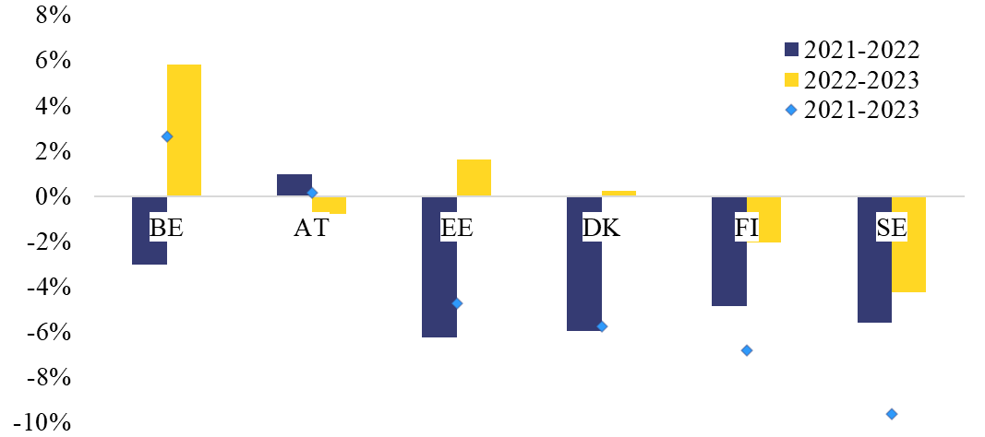
Note: Growth rates for Italy were not available as data was provided for 2023 only.
Source: Member State submissions.
The extent of purchasing power losses among minimum wage earners reflects the ability of minimum wage protection systems to adjust to high inflation in a timely manner. In several countries with minimum wage protection provided for only in collective agreements, workers earning the lowest pay rates experienced real wage losses between 2021 and 2023, while the picture is more mixed among Member States with statutory minimum wages. Where minimum wage-setting requires engaging in collective bargaining, adjustments to unforeseen circumstances such as sudden surges in inflation may take more time (). In addition, the way in which inflation expectations are accounted for in the wage-setting process differs across Member States. However, the economic and social impact was mitigated by the fact that lowest pay rates in Member States, which rely on collective agreements for minimum wage protection, tended to be relatively high compared to statutory minimum wages in other EU countries.
Collective bargaining coverage
Collective bargaining coverage rates vary widely across Member States, with collective agreements covering all workers in some and less than a fifth in others (Graph 6). Belgium and Italy had collective bargaining coverage rates of 100% in 2023, while six additional Member States had rates above the 80% threshold, namely Austria (94.9%), Spain (91.8%), Finland (88.8%), Sweden (88%), Portugal (83.3%) and Denmark (81%). Below this threshold, more than half of all workers were covered by collective agreements in the Netherlands (72.6%), Slovenia (65.3%) and Luxembourg (57.3%). Between one fifth and half of the workers were covered in Germany (49.5%), Czechia (42.4%), Latvia (31.6%), Malta (31%), Romania (28.0%), Slovakia (27%) and Cyprus (24.9%). Finally, the lowest rates of collective bargaining coverage, below 20%, were reported by Estonia (19.1%), Bulgaria (16.2%), Hungary (14.8%) and Poland (11.6%) (). Between 2021 and 2023, collective bargaining coverage rates changed relatively little, except for Cyprus, Malta and Romania ().
Graph 6: Collective bargaining coverage rates in the EU, 2021-2023
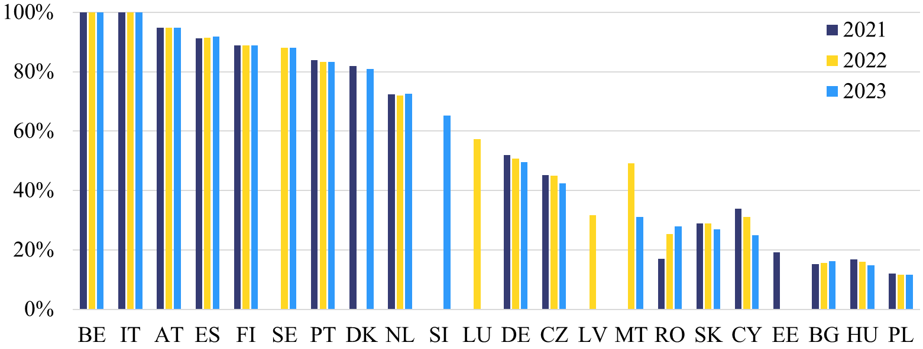
Note: Croatia, France, Greece, Ireland and Lithuania did not submit data for any of the three years. Malta used different data sources for each reported year – the Structure of earnings survey for 2022 and a study conducted by the Department of Industrial and Employment Relations for 2023. Sweden used a different method for computing collective bargaining coverage in 2021. Slovenia, Luxembourg, Latvia and Estonia provided data for specific years only.
Source: Member State submissions.

PART II: ACTION PLANS TO PROMOTE COLLECTIVE BARGAINING
There are currently 18 Member States in which the collective bargaining coverage rate is lower than the 80% threshold (). These Member States are therefore obliged to establish an action plan to promote collective bargaining in accordance with Article 4(2) of the Directive. The Directive also provides that the action plans shall be made public and notified to the Commission. While it does not specify a deadline for the establishment of the action plans, it can be inferred that it should be done without undue delay.
As of 15 June 2026, the Commission has received the action plans from 12 Member States (). The scope of the analysis is therefore limited to the action plans from these Member States. In the six remaining Member States (), the action plans are being discussed with social partners. The Commission is closely monitoring the state of play in these countries and expects them to establish their action plans in the coming months.
As required by the Directive, the received action plans have been established with the involvement of the social partners (). Most of the Member States specify in their action plans that they were established after consulting social partners () or in agreement with them (), while in the remaining cases the fact that social partners were consulted can be inferred from publicly available sources ().
They all contain a clear timeline for their full implementation. Most of the action plans transmitted to the Commission are to be implemented within five years (). This coincides with the maximum duration they should have before their mandatory update in accordance with Article 4(2) of the Directive. Some of the action plans () have a shorter timeframe of two years. In addition to the overall timeframe, most of the action plans have specific deadlines for each of the measures they contain ().
The received action plans also include concrete measures to promote collective bargaining. The Directive leaves Member States discretion to determine the best means to achieve the objective of gradually increasing the collective bargaining coverage. In this regard, Member States could take inspiration from other non-binding EU instruments, such as the Council Recommendation on strengthening social dialogue (), as well as Guideline 7 of the EU Employment Guidelines ().
The concrete measures to promote collective bargaining included in the action plans can be classified, according to their main purpose, in the following six main categories.
- Strengthening the capacity of social partners. These measures aim at enabling social partners to engage more effectively in collective bargaining at all levels. They often include training, skills development and knowledge exchange. Nine out of the 12 Member States include such measures in their action plans ().

- Improving the collective bargaining regulatory framework. Measures in this category aim at removing legal and procedural obstacles, clarifying rights and obligations of social partners, and enabling bargaining at the appropriate levels (e.g. by facilitating collective bargaining at sectoral level or in the context of new forms of work). Most of the action plans foresee this type of measures ().

- Awareness-raising and promotion of the benefits of collective bargaining. These measures seek to address informational and cultural barriers among workers, employers and the wider public. They comprise information campaigns, publications or web portals. Measures of this category are included in 10 out of the 12 action plans ().

- Improving collection, monitoring and transparency of data on collective bargaining. This category refers to measures and tools such as registers of collective agreements, coverage statistics and regular reporting of collective agreements and their coverage. 10 action plans include measures of this type ().

- Incentives and support mechanisms to encourage collective bargaining. Some examples from the different action plans under this category are the introduction of tax incentives for companies that have a collective agreement or the creation of specialized units within social partners to provide support and methodological guidance in collective agreement negotiations. Seven action plans contemplate measures that can be classified within this category ().

- Enforcement and dispute resolution mechanisms. These measures include strengthening the role of labour inspectorates in the enforcement of collective agreements and providing additional training and resources to mediators and arbitrators. Measures of this type appear in the action plans of six Member States ().
The Staff Working Document accompanying this report contains a more detailed description of the measures foreseen by the action plans under each of these categories.
Assessment of the action plans by the Commission
All the received action plans can be considered to formally comply with the legal requirements set in Article 4(2) of the Directive. They have all been established with the involvement of the social partners and contain both a clear timeline and a number of concrete measures aimed at increasing the collective bargaining coverage rate.
The effectiveness of the actions plans needs to be assessed in light of the specificities of each national collective bargaining system. In accordance with the Directive, the action plans aim to achieve a gradual increase of the collective bargaining coverage rate. However, there is no standard methodology to assess ex ante the effectiveness of measures to promote collective bargaining, as this will depend very much on how they are implemented in practice. Moreover, national traditions and practices regarding social dialogue need to be considered in each case.
Ultimately, the effectiveness of the action plans will be reflected in the evolution of collective bargaining coverage rates in the coming years. In this regard, it is still too early to draw conclusions as to whether each action plan is likely to succeed in increasing the coverage rate.
At the same time, some preliminary observations on best practices can already be made:
- Level of detail for institutional measures. Most action plans describe in concrete terms the envisaged awareness-raising and information measures (), which may contribute to creating a more favourable climate for collective bargaining. However, they are often vaguer when it comes to explaining the future institutional changes that will be introduced in the collective bargaining framework (). Given that institutional measures often have a direct positive impact on collective bargaining coverage rates, it would be preferable for all action plans to specify them in more concrete terms.
- Timeline for implementation. All the action plans include an overall timeframe for their implementation, but some of them do not set specific deadlines for each individual measure they contain (). In this regard, setting intermediate deadlines and milestones can be considered good practice, as it may help to ensure steady progress and enable a better monitoring of the implementation.
- Social partners’ involvement in monitoring implementation. While all the action plans contain references to the monitoring of their implementation (in some cases with detailed indicators), only some of them expressly foresee the involvement of social partners in this task (). This is also considered to be good practice, as social partners will usually be in a position to assess whether the measures contained in the action plan are being correctly implemented in practice.

CONCLUSION
Between 2021 and 2023, statutory minimum wages rose in all Member States. In around half of the Member States, the increases offset the loss of purchasing power caused by high inflation. Minimum wages also rose more strongly in countries where they were lower, helping to support upward minimum wage convergence, in line with the objectives of the Directive.
In Member States where minimum wage protection is provided only through collective agreements, collectively agreed lowest pay rates varied considerably. In most countries, increases in collectively agreed lowest pay rates during the reference period fell short of inflation. However, this was partly mitigated by the fact that these rates were generally relatively higher than those in countries with statutory minimum wages.
There are currently 18 Member States in which the collective bargaining coverage rate is lower than the 80% threshold. These Member States are therefore obliged to establish an action plan to promote collective bargaining in accordance with the Directive. However, as of 15 June 2026, the Commission has received the action plans from 12 Member States only.
The action plans notified to the Commission comply with the requirements set out in the Directive. They have been established with the involvement of the social partners and contain both concrete measures to promote collective bargaining and a clear timeline for their implementation. A preliminary assessment has identified some best practices, such as introducing detailed explanations of the foreseen institutional measures. Member States may wish to take these elements into consideration in the context of the future review and update of their action plans.
The Commission intends to closely monitor the impact of the action plans on the evolution of the collective bargaining coverage rate in the concerned Member States and will reassess the effectiveness of these action plans in its next periodic report to the European Parliament and the Council under Article 10(3) of the Directive.

() Directive (EU) 2022/2041 of the European Parliament and of the Council of 19 October 2022 on adequate minimum wages in the European Union, https://eur-lex.europa.eu/eli/dir/2022/2041/oj/eng
() Interinstitutional Proclamation on the European Pillar of Social Rights, (2017/C 428/09), https://employment-social-affairs.ec.europa.eu/policies-and-activities/european-pillar-social-rights-building-fairer-and-more-inclusive-european-union_en
() Eurostat publishes minimum wage statistics based on comparable and harmonised data. See: https://ec.europa.eu/eurostat/statistics-explained/index.php?title=Minimum_wage_statistics
() SWD(2026)237
() Cyprus introduced a national statutory minimum wage in 2023. In 2021 and 2022, minimum wage protection was provided for in collective agreements or, in some sectors, through a sector-specific minimum wage.
() For better comparability, reported statutory minimum wages have been converted into weighted averages of monthly minimum wages over the year.
() Croatia, Cyprus, Czechia, Greece, Lithuania, Malta, Poland, Portugal and Slovakia.
() For Cyprus and Slovenia, growth rates could not be computed as Slovenia only submitted data for 2023, and Cyprus introduced a statutory minimum wage in 2023.
() Subsequent increases which occurred outside of the reporting period have further offset the loss of purchasing power across the EU. See, for instance, European Commission, Labour market and wage developments in Europe – Annual review 2025, 2025.
() Slovakia, Ireland, Bulgaria, Lithuania and Czechia.
() Harmonised data published by Eurostat indicates that, in 2022, the share of workers earning less than 105% of the statutory minimum wage ranged from 2.6% in Czechia to 13.0% in Bulgaria.
() Eurostat defines low-wage earners as employees earning two-thirds or less of the national median gross hourly earnings. However, the Directive allows Member States to use their own definitions.
() Italy reported the pay rate at 25th percentile, rather than the lowest pay rate, of the selected collective agreements covering low-earning workers.
() Member States have identified collective agreements covering low-wage earners and submitted data on the lowest pay rates found among them.
() OECD Employment Outlook (2023).
() Due to data availability, collective bargaining coverage rates for Luxembourg and Latvia in this comparison refer to the year 2022, whereas the rate for Estonia refers to 2021.
() In Cyprus, the reported decrease is consistent with the longer-term decline in trade union density observed in the country. In Romania, the reported increase likely reflects both institutional developments such as social dialogue reforms and measurement methodology. The decline in Malta is due to the use of different data sources.
() Bulgaria, Croatia, Cyprus, Czechia, Estonia, Germany, Greece, Hungary, Ireland, Latvia, Lithuania, Luxembourg, Malta, the Netherlands, Poland, Romania, Slovakia and Slovenia.
() Bulgaria, Czechia, Estonia, Greece, Ireland, Latvia, Lithuania, Malta, the Netherlands, Poland, Romania and Slovakia.
() Croatia, Cyprus, Germany, Luxembourg, Hungary and Slovenia.
() Article 4(2) of the Directive stipulates that action plans should be established plan after consulting the social partners, by agreement with the social partners, or, following a joint request by the social partners, as agreed between the social partners.
() Bulgaria, Estonia, Greece, Ireland, Lithuania, the Netherlands, Poland and Slovakia.
() Czechia.
() Latvia, Malta and Romania.
() This is the case for the action plans of Bulgaria, Czechia, Greece, Ireland, Malta, Poland, Romania and Slovakia, which are to be implemented by 2030. The action plan of Lithuania, which was established earlier than the rest (2024) foresees a timeframe for its implementation of four years (from 2024 to 2028).
() Estonia, Latvia and the Netherlands.
() With the exception of those of Estonia, Latvia and Malta, which only set an overall timeframe.
() Council Recommendation of 12 June 2023 on strengthening social dialogue in the European Union (C/2023/1389), https://eur-lex.europa.eu/legal-content/EN/TXT/PDF/?uri=CELEX:32023H01389
() Council Decision (EU) 2024/3134 of 2 December 2024 on guidelines for the employment policies of the Member States, https://eur-lex.europa.eu/legal-content/EN/TXT/PDF/?uri=OJ:L_202403134
() Bulgaria, Czechia, Greece, Ireland, Lithuania, Malta, Poland, Romania and Slovakia.
() Bulgaria, Czechia, Estonia, Greece, Ireland, Latvia, Lithuania, Malta, the Netherlands, Poland and Slovakia.
() Bulgaria, Czechia, Estonia, Ireland, Latvia, Lithuania, the Netherlands, Poland, Romania and Slovakia.
() Bulgaria, Czechia, Estonia, Greece, Ireland, Latvia, Lithuania, the Netherlands, Romania and Slovakia.
() Bulgaria, Ireland, Latvia, Lithuania, the Netherlands, Poland and Romania.
() Bulgaria, Greece, Ireland, the Netherlands, Romania and Slovakia.
() Such as awareness campaigns, data collection initiatives, or public registers of collective agreements.
() While some Member States, such as Bulgaria and Greece, specify the content of the regulatory changes they intend to introduce, others, such as Latvia, Lithuania or Slovakia, leave it more open and do not contain any indication on the possible content of those changes or merely refer to the need for further studies and analysis.
() This is the case for the action plans of Estonia, Latvia and Malta.
() Greece, Czechia, Slovakia, Poland and Romania.

