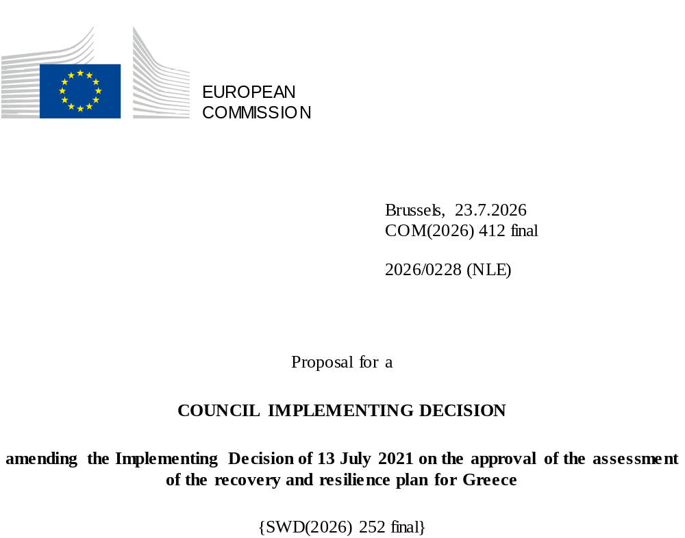

2026/0228 (NLE)
Proposal for a
COUNCIL IMPLEMENTING DECISION
amending the Implementing Decision of 13 July 2021 on the approval of the assessment of the recovery and resilience plan for Greece
THE COUNCIL OF THE EUROPEAN UNION,
Having regard to the Treaty on the Functioning of the European Union,
Having regard to Regulation (EU) 2021/241 of the European Parliament and of the Council of 12 February 2021 establishing the Recovery and Resilience Facility, and in particular Article 20(1) thereof,
Having regard to the proposal from the European Commission,
Whereas:
(1) Following the submission of the national recovery and resilience plan (‘RRP’) by Greece on 27 April 2021, the Commission proposed its positive assessment to the Council. On 13 July 2021, the Council approved the positive assessment by means of an implementing decision (‘the Council Implementing Decision of 13 July 2021’). The Council Implementing Decision of 13 July 2021 was amended by the Council Implementing Decisions of 8 December 2023, 16 July 2024, 21 January 2025, 18 July 2025, and 12 December 2025.
(2) On 8 May 2026, Greece made a reasoned request to the Commission to make a proposal to amend the Council Implementing Decision of 13 July 2021 in accordance with Article 21(1) of Regulation (EU) 2021/241 on the grounds that the RRP is partially no longer achievable because of objective circumstances. On that basis, Greece has submitted an amended RRP.
Amendments based on Article 21 of Regulation (EU) 2021/241
(3) The amendments to the RRP submitted by Greece because of objective circumstances concern 111 measures.
(4) Greece has explained that one measure is no longer achievable, because of unexpected technical challenges. This concerns measure 16892 – Upgrading suburban railway of West Attica. On this basis, Greece has requested that this measure be removed. The Council Implementing Decision of 13 July 2021 should be amended accordingly.
(5) Greece has explained that seven measures are partially no longer achievable due to unexpected delays related to public procurement procedures. This concerns measure 16955 – Upgrade of Cloud-computing infrastructure and services of the National Infrastructures for Research and Technology (GRNET), measure 16941 – Restructuring and rebranding of DYPA’s local branches for the promotion of employment (KPA2), measure 16794 – Strengthening the Apprenticeship System, measure 16795 – Health infrastructure, measure 16611 – Digital transformation of tax audits, measure 16536 – Upgrade of infrastructure and equipment of HOCRED Stores, measure 16931 – Tourism Development. On this basis, Greece has requested that those measures be amended. The Council Implementing Decision of 13 July 2021 should be amended accordingly.
(6) Greece has explained that nine measures are partially no longer achievable because of lower-than-expected demand. This concerns measure 16872 - Energy renovation on residential buildings, 16874 – Energy and entrepreneurship, measure 16755 – Reform of the Primary Health Care System, measure 16688 – Promote integration of the refugee population into the labour market, measure 16715 - Labour Reform in the Cultural Sector, measure 16922 – Social Integration, measure 16925 – Digital Transformation of the social support system, measure 16919 – Child Protection, measure 16721 – Acceleration of smart manufacturing. On this basis, Greece has requested that those measures be amended. The Council Implementing Decision of 13 July 2021 should be amended accordingly.
(7) Greece has explained that one measure is partially no longer achievable due to forced majeure. This concerns measure 16910 – Civil protection management and monitoring. On this basis, Greece has requested that this measure be amended. The Council Implementing Decision of 13 July 2021 should be amended accordingly.
(8) Greece has explained that 24 measures are partially no longer achievable due to unexpected technical challenges. This concerns measure 16831 – Produc-E Green, measure 16875 - Infrastructure development and buildings’ restoration in former royal estate in Tatoi, measure 16911 – Aerial Means for Crisis Management, measure 16742 – Digital transformation of the Ministry of Foreign Affairs, measure 16956 – Expansion of Syzefxis II, measure 16706 – Digital Transformation of SMEs, measure 16676 – Digital transformation of Education, measure 16904 – Disability, measure 16934 - Upgrading Vocational Education and Training, measure 16291 – Digital Transformation of the Tax and Customs Administration, measure 16581 – Enhanced capital market supervision and trustworthiness, measure 16630 – Cretan Northern Highway (Β.Ο.Α.Κ.), measure 16631 – Road Safety Upgrade, measure 16912 - Forest firefighting, prevention and response equipment, measure 16735 – Utilizing “arts on prescription”, promoting social cohesion, and tapping on the silver economy, measure 16624 – Creation, Expansion and Upgrade of Infrastructures of Research Centres supervised by the General Secretariat for Research and Innovation (GSRI), measure 16833 – Implementation of airport safety works, measure 16486 – Museum of underwater antiquities, measure 16851 – Biodiversity protection as a driver for sustainable growth, measure 16959 – Digital Transformation of the Hellenic Railways, measure 16960 – Smart Infrastructure with environmental and cultural focus, measure 16975 – Upgrade Interventions for Regional Ports, measure 16543 – Actions for the simplification of the business environment and its upgrading in quality and safety, measure 16626 - Economic transformation of the Agricultural and Aquaculture Sectors. On this basis, Greece has requested that those measures be amended. The Council Implementing Decision of 13 July 2021 should be amended accordingly.
(9) Greece has explained that 18 measures have been amended to implement better alternatives in order to achieve their original ambition. This concerns measure 16870 – Interventions for the electricity interconnection of islands and investments in the electricity network, measure 16285 – National Water Strategy, measure 16725 – Upgrading higher arts education, measure 16772 – Waste management law for sustainable landfilling and recycling, measure 16756 – Organisational Reforms in the Health System, measure 16400 – Affordable Housing Programme “My Home II”, measure 16402 – Social and Affordable Housing, measure 16292 – New Judicial buildings and renovations, measure 16575 – Accelerating the administration of justice, measure 16957 – Strengthening the capacity of the financial system to overcome legacy challenges and finance the real economy, measure 16618 – Basic & Applied Research, measure 16982 – Organisational reform in the railways sector, measure 16403 – Capital injection into the Hellenic Development Bank, measure 16990 - Grid and storage capacity reform measure 16993 – Roadmap for innovative energy efficiency interventions and identification of new financial instruments, measure 16994 – Energy Efficiency and promotion of RES for auto-consumption, measure 16293 – Culture as a driver of growth, measure 16824 – E-registries. On this basis, Greece has requested that those measures be amended. The Council Implementing Decision of 13 July 2021 should be amended accordingly.
(10) Greece has explained that 41 measures have been amended to implement better alternatives that allow the administrative burden to be reduced and simplify the Council Implementing Decision, while still achieving the objectives of those measures. This concerns measure 16899 - Hellenic Electricity Distribution Network Operator (HEDNO) High Voltage/Medium Voltage substations, measure 16900 - Hellenic Electricity Distribution Network Operator (HEDNO) overhead network, measure 16404 - Development Program for Local Government “Antonis Tritsis”, measure 16736 – New system for public procurements, measure 16485 – Cultural Routes at Archaeological Sites and Monuments, Measure 16792 - Labour force skilling, reskilling and upskilling through a reformed training model (Vocational Education & Training Reform), 16926 – Support of the installation of storage systems to enhance RES penetration, measure 16873 – Interventions in residential areas and in the building stock, measure 16932 – Olympic Athletic Center of Athens, measure 16924 – Electromobility, measure 16850 – Drinking Water Supply and Saving Infrastructures, measure 16854 – Smart cities, measure 16750 – Digital Transformation of Labour Systems, measure 16942 – Digital transformation of the public employment service (DYPA), measure 16933 – Upgrading Vocational Education and Training (VET): Purchase of laboratory equipment for laboratories of VET units, measure 16746 – Reform of Passive Labour Market Policies to Support Transitions to Employment, measure 16747 – Active Labour Market Policies Reform, measure 16752 – Digital transformation of health (DigHealth), measure 16753 – Establishment of Home Health Care & Hospital at Home systems, measure 16757 – Radiotherapy Centre at the “Sotiria” Thoracic Diseases Hospital of Athens, measure 16727 - Digital Transformation of Justice (E-Justice), measure 16580 - Delivery of the new unified insolvency framework for the restructuring of debt and second chance, measure 16711 – Professionalisation of the Public Procurement domain, measure 16952 – Strengthening the national anti-corruption framework, measure 16974 – Accounting Reform, measure 16972 - Reforming Public Administration, measure 16622 – HORIZON 2020 “Seal of Excellence”: financing top innovative companies, measure 16654 – TH2ORAX: Trellis Holistic & Hybrid Operational Ruggedized Autonomous eXemplary system, measure 16971 – Research – Create – Innovate, measure 16433 – Protection of cultural monuments and archaeological sites from climate change, measure 16435 – Restoration – Conservation – Enhancement of the Acropolis Monuments, measure 16634 – Industrial Parks, measure 16921 – Reskilling and Upskilling in Tourism, measure 16949 – Smart Bridges, measure 16593 – Amendment of the legal framework for the attraction of strategic investment, measure 16989 – Optimisation of land and sea space usage for the development of RES and offshore wind energy development, measure 16991 - Regulatory framework towards a smart grid, measure 16992 - Toolset to promote energy sharing, self-consumption and renewable Energy Communities, measure 16995 – Renewable Hydrogen production project. Furthermore, Greece has requested to merge measure 16827 – Data Governance strategy & policies for the Public Sector with measure 16928 – Incorporation of new technologies and trends towards Public Administration’s advanced services. On this basis, Greece has requested that those measures be amended. The Council Implementing Decision of 13 July 2021 should be amended accordingly.
(11) Following the removal/decrease in the level of implementation of measures in accordance with Article 21 of Regulation (EU) 2021/241, Greece has requested to use the resources freed up by the removal of measures and the decrease in the level of the implementation of measures to add two new measures (Measure 16880 – Contribution of DES ADMIE to IPTO’s share capital increase for the facilitation of interconnections and the upgrading of the electricity high-voltage (HV) network, Measure 16859 – Voluntary contribution to the EuroHPC Joint Undertaking for AI Gigafactory) and increase the level of implementation of 10 measures. This concerns measure 16401 – Energy Upgrade Programme “Upgrade My Home”, measure 16846 – Urban Wastewater and Sludge Management Infrastructures from Wastewater Treatment, measure 16983 – Preliminary inspection of seismic resistance of buildings, measure 16855 - “Small-satellites”, measure 16783 – Implementation of the National Public Health Prevention Program “Spiros Doxiadis” (NPP “SD”), measure 16628 - Central Greece Highway E-65: Trikala-Egnatia Section, measure 16293- Culture as a driver of growth, measure 16879 – Preparation of Urban Plans in implementation of the urban policy reform, measure 16999 – Accessibility Restoration following the devastating effects of storms "DANIEL" and "ELIAS", measure 16980 – Loan Facility. On this basis, Greece has requested that the level of implementation of eight measures be increased and that three new measures be added. The Council Implementing Decision of 13 July 2021 should be amended accordingly.
Distribution of milestones and targets
(12) The distribution of milestones and targets in instalments should be amended to take into account the amendments to the RRP and the indicative timeline presented by Greece.
Corrections of clerical errors
(13) Two clerical errors have been identified in the text of the Council Implementing Decision, affecting two milestones/targets under one component. The Council Implementing Decision should be amended to correct these clerical errors that do not reflect the content of the RRP submitted to the Commission on 27 April 2021, as agreed between the Commission and Greece. Those clerical errors relate to the descriptions of targets 157 and 158 under measure 16816 – Clawback reduction and rationalization of healthcare expenditure, under component 3.3 - Improve resilience, accessibility and sustainability of healthcare. Those corrections do not affect the implementation of the measures concerned.
Commission’s assessment
(14) The Commission has assessed the amended RRP against the assessment criteria laid down in Article 19(3) of Regulation (EU) 2021/241.
Do no significant harm
(15) In accordance with Article 19(3), point (d), of and Annex V, criterion 2.4, to Regulation (EU) 2021/241, the amended RRP is expected to ensure that no measure (rating A) for the implementation of reforms and investments projects included in the RRP does significant harm to environmental objectives within the meaning of Article 17 of Regulation (EU) 2020/852 of the European Parliament and of the Council (the principle of ‘do no significant harm’).
(16) The amended RRP assesses compliance with the ‘do no significant harm’ principle following the methodology set out in the technical guidance provided in the Commission Notice ‘Technical guidance on the application of “do no significant harm” under the Recovery and Resilience Facility Regulation’. The assessment is done systematically for each modified reform and investment following the two-step approach. The assessment concludes that for all modified measures, there is no risk of significant harm. Where needed, the requirements of the ‘do no significant harm’ assessment are enshrined in the design of a measure and specified in a milestone or target of this measure. Based on the information provided, it can be concluded that no measure does significant harm to environmental objectives within the meaning of Article 17 of Regulation (EU) 2020/852.
Contribution to the green transition including biodiversity
(17) In accordance with Article 19(3), point (e), of, and criterion 2.5 of Annex V to, Regulation (EU) 2021/241, the amended RRP contains measures that contribute to a large extent (rating A) to the green transition, including biodiversity, or to addressing the challenges resulting therefrom. The measures supporting climate objectives account for an amount which represents 39.8% of the amended RRP’s total allocation and 100% of the total estimated costs of measures in the REPowerEU chapter calculated in accordance with the methodology set out in Annex VI to Regulation (EU) 2021/241. In accordance with Article 17 of Regulation (EU) 2021/241, the amended RRP is consistent with the information included in the National Energy and Climate Plan 2021-2030.
(18) The amended RRP maintains measures supporting the green transition that contribute to achieving the 2030-2050 targets and the objective of Union’s climate neutrality by 2050, as well as to fostering biodiversity. For instance, under measure 16994 it is expected that 117 455 solar water heaters and 22 500 heat pumps will be acquired by households, including specific targets set for vulnerable households.
Contribution to the digital transition
(19) In accordance with Article 19(3), point (f), of, and criterion 2.6 of Annex V to, Regulation (EU) 2021/241, the amended RRP contains measures that contribute to a large extent (rating A) to the digital transition or to addressing the challenges resulting from it. The measures supporting digital objectives account for an amount which represents 25.2% of the amended RRP’s total allocation calculated in accordance with the methodology set out in Annex VII to that Regulation.
(20) The measures in the amended RRP continue contributing to the digital transition or helping to address the related challenges and positively address Greece’s shortcomings in the digital field as identified in the fourth State of the Digital Decade report 2026. The amended RRP continues to significantly address the digital transition challenges faced by Greece in the areas of connectivity, digital public services, human capital and digital skills, the digitalisation of businesses and the adoption of advanced digital technology.
Costing
(21) In accordance with Article 19(3), point (i), of, and criterion 2.9 of Annex V to, Regulation (EU) 2021/241, the justification provided in the amended RRP on the amount of the estimated total cost of the RRP is to a medium extent (rating B) reasonable and plausible, is in line with the principle of cost efficiency and is commensurate to the expected national economic and social impact.
(22) Greece provided sufficient information and evidence that estimated costs were not covered by existing or planned Union financing. However, in a limited number of cases, cost estimates could not be sufficiently substantiated. Overall, this warrants a rating of B under the assessment criterion of Article 19(3), point (i), of Regulation (EU) 2021/241. Finally, the amount of the estimated total costs of the RRP is in line with the principle of cost efficiency and commensurate to the expected national economic and social impact.
Any other assessment criteria
(23) The Commission considers that the amendments put forward by Greece do not affect the positive assessment of the RRP set out in the Council Implementing Decision of 13 July 2021 on the approval of the assessment of the RRP for Greece regarding the relevance, effectiveness, efficiency and coherence of the RRP against the assessment criteria laid down in Article 19(3), points (a), (b), (c), (da), (db), (g), (h), (j) and (k).
Measures supporting investment operations contributing to the objectives of the Strategic Technologies for Europe Platform (STEP)
(24) In accordance with Article 4(4) of the Regulation (EU) 2024/795, Greece considered as a matter of priority projects that have been awarded a Sovereignty Seal pursuant to Article 4(1) of the Regulation (EU) 2024/795. However, Greece considered that no project having been awarded a Sovereignty Seal was to be included in the amended RRP because their timeline goes beyond 2026.
Positive assessment
(25) Following the positive assessment by the Commission of the amended RRP, with the finding that the RRP satisfactorily complies with the criteria for assessment set out in Regulation (EU) 2021/241, in accordance with Article 20(2) of and Annex V to that Regulation, the reforms and investment projects necessary for the implementation of the amended RRP, the relevant milestones, targets and indicators, and the amount made available from the Union for the implementation of the amended RRP should be set out.
Financial contribution
(26) The estimated total costs of Greece’s amended RRP is EUR 36 113 375 270. As the amount of the estimated total cost of the amended RRP is higher than the updated maximum financial contribution available for Greece, the financial contribution determined in accordance with Article 4a of Regulation (EU) 2021/1755 of the European Parliament and of the Council, and with Article 20(4) and Article 21a(6) of Regulation (EU) 2021/241 that is allocated for Greece’s amended RRP should be equal to EUR 18 220 378 076. Therefore, the financial contribution made available to Greece remains unchanged.
Loans
(27) The loan support made available to Greece amounting to EUR 17 727 538 920 remains unchanged.
(28) The Council Implementing Decision of 13 July 2021 on the approval of the assessment of the RRP for Greece should therefore be amended accordingly. For the sake of clarity, the Annex to the Council Implementing Decision of 13 July 2021 should be replaced entirely.
(29) This Decision should be without prejudice to the outcome of any procedures relating to the award of Union funds under any Union programme other than the Facility or to procedures relating to distortions of the operation of the internal market that may be undertaken, in particular under Articles 107 and 108 of the Treaty. It does not override the requirement for Member States to notify instances of potential State aid to the Commission under Article 108 of the Treaty,
HAS ADOPTED THIS DECISION:
Article 1
Approval of the assessment of the RRP
The assessment of the amended RRP for Greece on the basis of the criteria provided for in Article 19(3) of Regulation (EU) 2021/241 is approved.

Article 2
Amendments
The Council Implementing Decision of 13 July 2021 on the approval of the assessment of the recovery and resilience plan for Greece is amended as follows:
The Annex is replaced by the text set out in the Annex to this Decision.
Article 3
Addressee
This Decision is addressed to the Hellenic Republic.
Done at Brussels,
For the Council
The President

OJ L 57, 18.2.2021, p. 17, ELI: https://eur-lex.europa.eu/eli/reg/2021/241/oj
ST 10152/21 INIT; ST 10152/21 ADD 1.
ST 15831/23 REV1; ST 15831/23 ADD 1 REV 1.
ST 11858/24 INIT; ST 151858/24 COR 1; ST 151858/24 ADD 1; ST 151858/24 ADD COR 1.
ST 17055/24 INIT; ST 17055/24 ADD 1; ST 17055/24 ADD 1 COR 1.
ST 11101/25 INIT; ST 11101/25 ADD1.
ST 15754/25 INIT; ST 15754/25 ADD1.
Regulation (EU) 2020/852 of the European Parliament and of the Council of 18 June 2020 on the establishment of a framework to facilitate sustainable investment, and amending Regulation (EU) 2019/2088 (OJ L 198, 22.6.2020, p. 13, ELI: https://eur-lex.europa.eu/eli/reg/2020/852/oj/eng).
Regulation (EU) 2021/1755 of the European Parliament and of the Council of 6 October 2021 establishing the Brexit Adjustment Reserve (OJ L 357, 8.10.2021, p. 1, ELI: http://data.europa.eu/eli/reg/2021/1755/oj).

