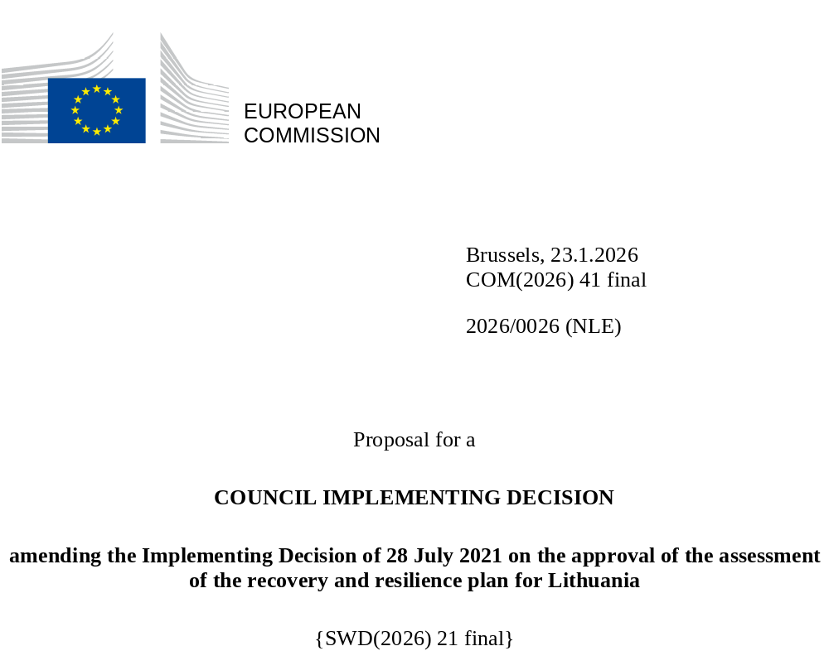

2026/0026 (NLE)
Proposal for a
COUNCIL IMPLEMENTING DECISION
amending the Implementing Decision of 28 July 2021 on the approval of the assessment of the recovery and resilience plan for Lithuania
THE COUNCIL OF THE EUROPEAN UNION,
Having regard to the Treaty on the Functioning of the European Union,
Having regard to Regulation (EU) 2021/241 of the European Parliament and of the Council of 12 February 2021 establishing the Recovery and Resilience Facility, and in particular Article 20(1) thereof,
Having regard to the proposal from the European Commission,
Whereas:
(1) Following the submission of the national recovery and resilience plan (‘RRP’) by Lithuania on 14 May 2021, the Commission proposed its positive assessment to the Council. On 28 July 2021, the Council approved the positive assessment by means of an implementing decision (‘the Council Implementing Decision of 28 July 2021). The Council Implementing Decision of 28 July 2021 was amended by the Council Implementing Decisions of 9 November 2023, 8 October 2024 and 20 June 2025.
(2) On 19 December 2025, Lithuania made a reasoned request to the Commission to make a proposal to amend the Council Implementing Decision of 28 July 2021 in accordance with Article 21(1) of Regulation (EU) 2021/241 on the grounds that the RRP is partially no longer achievable because of objective circumstances. On that basis, Lithuania has submitted an amended RRP.
Amendments based on Article 21 of Regulation (EU) 2021/241
(3) The amendments to the RRP submitted by Lithuania because of objective circumstances concern 69 (sub-)measures.
(4) Lithuania has explained that six (sub-)measures are partially no longer achievable, because of supply chain constraints and unexpected technical difficulties. This concerns (sub-)measures A.1.1.7 (Creation of Centre for Advanced Therapies), A.1.3.2 (Modernisation of infectious disease cluster centres), C.1.4.5 (ICT Centre of excellence), D.1.4.1 (National Platform for the Progress of Vocational Education and Training), E.1.2.2 (Increasing demand for innovation in Lithuania by exploiting the potential of public procurement) and G.1.2.2 (Increasing the scope and diversity of employment support measures). On this basis, Lithuania has requested that those (sub-)measures be amended. The Council Implementing Decision of 28 July 2021 should be amended accordingly.
(5) Lithuania has explained that eight (sub-)measures are partially no longer achievable because of unexpected issues related to public procurement or lower than expected demand. This concerns (sub-)measures B.1.2 (Moving without polluting the environment), B.1.2.2 (Support for the purchase of zero-emission public transport vehicles), B.1.2.3 (Installation of vehicle recharging/alternative fuel filling infrastructure), B.1.2.4 (Support to develop RES fuels sector (biomethane gas, second generation liquid biofuels for transport, and green hydrogen), B.1.3.3 (Promoting the supply of construction products and services that speed up the renovation of buildings), D.1.4.5 (More opportunities to acquire profession for school pupils), E.1.1.2 (Improving the efficiency of the higher education network by refining the missions of universities and colleges) and H.1.3.1 (Improving the investment environment for RES developers). On this basis, Lithuania has requested that those (sub-)measures be amended. The Council Implementing Decision of 28 July 2021 should be amended accordingly.
(6) Lithuania has explained that one sub-measure is partially no longer achievable because of delayed adoption of EU legislation. This concerns sub-measure F.1.7.2 (Creation of a solution to enable international e-consignments). On this basis, Lithuania has requested that this sub-measure be amended. The Council Implementing Decision of 28 July 2021 should be amended accordingly.
(7) Lithuania has explained that six (sub-)measures have been amended to implement better alternatives in order to achieve their original ambition. This concerns B.1.1.1 (Preparatory steps for the development of offshore wind infrastructure), B.1.2.1 (Support for the purchase of clean vehicles by the public sector and businesses, and for sustainable mobility), B.1.3.4 (Support for faster renovation of buildings in line with up-to-date building renovation standards), C.1.3 (Customer-oriented services), E.1.3.2 (Supporting the implementation of mission based science and innovation programmes in smart specialisation), and H.1.2 (Support for the purchase of clean inland water vehicle). On this basis, Lithuania has requested that those (sub-)measures be amended. The Council Implementing Decision of 28 July 2021 should be amended accordingly.
(8) Lithuania has explained that 44 (sub-)measures have been amended to implement a better alternative that allow the administrative burden to be reduced and simplify the Council Implementing Decision, while still achieving the objectives of those (sub-)measures. This concerns (sub-)measures A.1.1.8 (Creation of a representative collection of reference genome data within the health project “1+ Million Genomes), A.1.1.9 (Establishment of Health Professionals Competence Platform), A.1.1.10 (Development of healthcare quality assessment model), (sub-)measures A.1.1.11 (Digitalisation of the healthcare sector), A.1.2.2 (Human resources and infrastructure capacity for the provision of long-term care services), A.1.3.3 (Modernisation of emergency, resuscitation or intensive care medical units in regional hospitals), B.1.3.2 (Tools to facilitate building renovation coordination and technical assistance), B.1.4 (Maintaining and increasing GHG absorption capacity), C1.1 (Transformation of public information technology governance), C.1.1.a (Transformation of public information technology governance – Development of state cybersecurity), C.1.2 (Ensuring the effectiveness of data management and open data), C.1.4.1 (Development of Lithuanian-language technological resources), C.1.4.2 (Digitisation and accessibility of cultural resources), C.1.5.1 (5G roadmap), C.1.5.2 (Further development of very high capacity networks), C.1.5.3 (Innovation in mobility), D.1.1.3 (Millennium School programme), D.1.1.4 (Strengthening the competences of pedagogical staff), D.1.1.5 (Development of the STEAM ecosystem), D.1.2 (Access to the development of competences and the recognition of qualifications for adults), D.1.4.3 (Apprenticeship and work based learning), D.1.4.4 (Mobility programme), E.1.2.3 (Fostering the development of the start-up ecosystem), E.1.2.4 (Promoting the development of green innovation), E.3.1 (Loans to enterprises to develop green and high value-added technologies for industrial development”), E.1.3.3 (Encouraging science and business to participate in the EU research and innovation programme Horizon Europe and other international funding programmes), F.1.1.1 (Modernization of human resources management system in the public sector), F.1.1.2 (Establishment of a centralised training system for developing competences in the public sector), F.1.3.1 (Improvements to the budgetary framework), F.1.4.4 (Financially literate future taxpayers), F.1.4.5 (More transparency in the construction sector), F.1.5 (Tools available to the businesses to manage insolvency risk), F.1.6.1 (Introduction of new data analytics tools in the State Tax Inspectorate), F.1.6.2 (Improving data quality of the State Tax Inspectorate and of other institutions), F.1.6.5 (New data analysis tools and upgrading Customs’ IT systems), F.1.6.6 (Increased staff competence of the State Tax Inspectorate and the Lithuanian Customs), F.1.8 (A single window to pay fines), F.3.1 (Improving centralized public procurement), F.3.2 (Capitalisation and financial resilience of the National Promotional Institution), G.1.1.1 (Study on the minimum income scheme and related changes to the legislation), G.1.2.1 (Optimization and improvement of employment service operational processes, ensuring systematic customer orientation), G.3.1.1 (Increasing the integration of employment, social and other services), H.1.1.1 (Update and testing in practice of building renovation packages and standards), H.1.1.2 (Support for faster renovation of buildings (scaled-up)). On this basis, Lithuania has requested that those (sub-)measures be amended. The Council Implementing Decision of 28 July 2021 should be amended accordingly.
(9) Following the decrease in the level of implementation of four (sub-)measures in accordance with Article 21 of Regulation (EU) 2021/241, Lithuania has requested to use the resources freed up by the decrease in the level of their implementation to add one new sub-measure and to increase the level of implementation of four (sub-) measures. This concerns new sub-measure B.1.6. (Transparency of electricity grid connection information), (sub-)measures B.1.2 (Moving without polluting the environment), F.1.3.5 (Consolidation of the national development institutions) and H.1.3.2 (Support for the construction of RES plants (solar power). On this basis, Lithuania has requested that one sub-measure is added and that the level of implementation of these three (sub-)measures be increased. The Council Implementing Decision of 28 July 2021 should be amended accordingly.
Distribution of milestones and targets
(10) The distribution of milestones and targets in instalments should be amended to take into account the amendments to the RRP and the indicative timeline presented by Lithuania.
Commission’s assessment
(11) The Commission has assessed the amended RRP against the assessment criteria laid down in Article 19(3) of Regulation (EU) 2021/241.
Contribution to the REPowerEU objectives
(12) In accordance with Article 19(3), point (da), of, and criterion 2.12 of Annex V to, Regulation (EU) 2021/241, the REPowerEU chapter is still expected to effectively contribute to a large extent (rating A) to energy security, the diversification of the Union’s energy supply, an increase in the uptake of renewables and in energy efficiency, an increase of energy storage capacities or the necessary reduction of dependence on fossil fuels before 2030, with the ambition of sub-measure H.1.3.2. (Support for the construction of RES plants) being increased following the reallocation of the corresponding freed-up resources.
Contribution to the green transition including biodiversity
(13) In accordance with Article 19(3), point (e), of, and criterion 2.5 of Annex V to, Regulation (EU) 2021/241, the amended RRP contains (sub-)measures that contribute to a large extent (rating A) to the green transition, including biodiversity, or to addressing the challenges resulting therefrom. The (sub-)measures supporting climate objectives account for an amount which represents 38.2% of the amended RRP’s total allocation and 99.3% of the total estimated costs of (sub-)measures in the REPowerEU chapter calculated in accordance with the methodology set out in Annex VI to Regulation (EU) 2021/241. In accordance with Article 17 of Regulation (EU) 2021/241, the amended RRP is consistent with the information included in the National Energy and Climate Plan 2021-2030.
(14) Following the proposed amendments by Lithuania to the RRP, the contribution to climate objectives increased from 37.4% to 38.2%. The increase in the contribution to climate objectives mostly reflects the increase in the level of implementation of (sub-)measure F.1.3.5. (Consolidation of the national development institutions) contributing 100% to climate objectives following the reallocation of the corresponding freed-up resources.
Contribution to the digital transition
(15) In accordance with Article 19(3), point (f), of, and criterion 2.6 of Annex V to, Regulation (EU) 2021/241, the amended RRP contains (sub-)measures that contribute to a large extent (rating A) to the digital transition or to addressing the challenges resulting from it. The (sub-)measures supporting digital objectives account for an amount which represents 23.4% of the amended RRP’s total allocation calculated in accordance with the methodology set out in Annex VII to that Regulation.
(16) The contribution towards the digital transition of the modified RRP increases from 22.1% contribution to 23.4%. This increase is driven mostly by the upscaling of sub-measure B.1.1.2. (Support for the construction of individual storage facilities) which contributes at 40% to digital objectives, sub-measure B.1.3.2. (Tools to facilitate building renovation coordination and technical assistance) and sub-measure C.1.4.5. (ICT Centre of excellence) which contribute at 100% to digital objectives.
Costing
(17) In accordance with Article 19(3), point (i), of, and criterion 2.9 of Annex V to, Regulation (EU) 2021/241, the justification provided in the amended RRP on the amount of the estimated total cost of the RRP is to a medium extent (rating B) reasonable and plausible, is in line with the principle of cost efficiency and is commensurate to the expected national economic and social impact. According to the information provided, the assessment of the cost estimates for the revised investments shows that most of the costs are reasonable and plausible even though the evidence shows varying degrees of details and depth of calculations. Furthermore, the changes in the cost estimates for amended measures were justified and proportional and as such the reasonability, plausibility, and the additionality of EU funding where applicable, of these cost estimates were not altered compared to the original RRP. Finally, the amount of the estimated total costs of the RRP is in line with the principle of cost efficiency and commensurate to the expected national economic and social impact.
Any other assessment criteria
(18) The Commission considers that the amendments put forward by Lithuania do not affect the positive assessment of the RRP set out in the Council Implementing Decision of 28 July 2021 regarding the relevance, effectiveness, efficiency and coherence of the RRP against the assessment criteria laid down in Article 19(3), points (a), (b), (c), (d), (db), (g), (h), (j) and (k) .
Measures supporting investment operations contributing to the objectives of the Strategic Technologies for Europe Platform (STEP)
(19) In accordance with Article 4(4) of Regulation (EU) 2024/795 of the European Parliament and of the Council of 29 February 2024 establishing the Strategic Technologies for Europe Platform (STEP), Lithuania considered as a matter of priority projects that have been awarded a Sovereignty Seal pursuant to Article 4(1) of Regulation (EU) 2024/795. However, Lithuania considered that no project having been awarded a Sovereignty Seal was to be included in the amended RRP because, following an internal assessment, it was concluded that such projects would be more appropriately supported through Cohesion policy funds.
Positive assessment
(20) Following the positive assessment by the Commission of the amended RRP, with the finding that the RRP satisfactorily complies with the criteria for assessment set out in Regulation (EU) 2021/241, in accordance with Article 20(2) of and Annex V to that Regulation, the reforms and investment projects necessary for the implementation of the amended RRP, the relevant milestones, targets and indicators, and the amount made available from the Union for the implementation of the amended RRP should be set out.
Financial contribution
(21) The estimated total costs of Lithuania’s amended RRP is EUR 3 849 237 823. As the amount of the estimated total cost of the amended RRP is higher than the updated maximum financial contribution available for Lithuania, the financial contribution determined in accordance with Article 4a of Regulation (EU) 2021/1755 of the European Parliament and of the Council, and with Article 20(4) and Article 21a(6) of Regulation (EU) 2021/241 that is allocated for Lithuania’s amended RRP should be equal to EUR 2 297 565 464. Therefore, the financial contribution made available to Lithuania remains unchanged.
(22) The amount of the financial contribution for Lithuania should be determined in accordance with Article 20 of Regulation (EU) 2021/241. However, pursuant to Commission Implementing Decision of 6 May 2024 on the reduction of the amount of the first instalment of the non-repayable support for Lithuania, adopted in accordance with Article 24(8) of Regulation (EU) 2021/241, the financial contribution has been reduced by EUR 8 733 750 and Lithuania cannot request its disbursement from the Commission.
Loans
(23) The loan support made available to Lithuania amounting to EUR 1 551 672 358 remains unchanged.
(24) The Council Implementing Decision of 28 July 2021 should therefore be amended accordingly. For the sake of clarity, the Annex to the Council Implementing Decision of 28 July 2021 should be replaced entirely.
(25) This Decision should be without prejudice to the outcome of any procedures relating to the award of Union funds under any Union programme other than the Facility or to procedures relating to distortions of the operation of the internal market that may be undertaken, in particular under Articles 107 and 108 of the Treaty. It does not override the requirement for Member States to notify instances of potential State aid to the Commission under Article 108 of the Treaty.
HAS ADOPTED THIS DECISION:
Article 1
Approval of the assessment of the RRP
The assessment of the amended RRP for Lithuania on the basis of the criteria provided for in Article 19(3) of Regulation (EU) 2021/241 is approved.
Article 2
Amendments
The Council Implementing Decision of 28 July 2021 on the approval of the assessment of the recovery and resilience plan for Lithuania is amended as follows:
the Annex is replaced by the text set out in the Annex to this Decision.
Article 3
Addressee
This Decision is addressed to the Republic of Lithuania.
Done at Brussels,
For the Council
The President

OJ L 57, 18.2.2021, p. 17, ELI: https://eur-lex.europa.eu/eli/reg/2021/241/oj
ST 10477/21 INIT; ST 10477/21 ADD 1.
ST 14637/23 INIT; ST 14637/23 COR 1; ST 14637/23 ADD 1.
ST 13498/24 INIT; ST 13498/24 ADD 1.
ST 9588/25 INIT; ST 9588/25 ADD 1; ST 9588/25 ADD 1 COR.
Regulation (EU) 2024/795 of the European Parliament and of the Council of 29 February 2024 establishing the Strategic Technologies for Europe Platform (STEP), and amending Directive 2003/87/EC and Regulations (EU) 2021/1058, (EU) 2021/1056, (EU) 2021/1057, (EU) No 1303/2013, (EU) No 223/2014, (EU) 2021/1060, (EU) 2021/523, (EU) 2021/695, (EU) 2021/697 and (EU) 2021/241 (OJ L, 2024/795, 29.2.2024, ELI: http://data.europa.eu/eli/reg/2024/795/oj)
Regulation (EU) 2021/1755 of the European Parliament and of the Council of 6 October 2021 establishing the Brexit Adjustment Reserve (OJ L 357, 8.10.2021, p. 1, ELI: http://data.europa.eu/eli/reg/2021/1755/oj).

