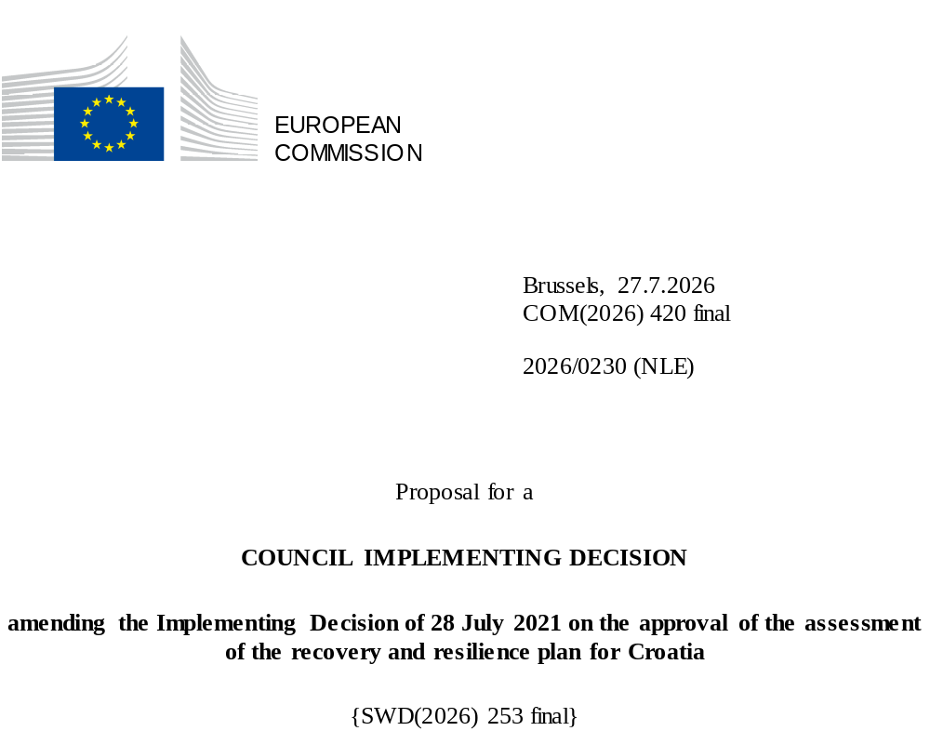

2026/0230 (NLE)
Proposal for a
COUNCIL IMPLEMENTING DECISION
amending the Implementing Decision of 28 July 2021 on the approval of the assessment of the recovery and resilience plan for Croatia
THE COUNCIL OF THE EUROPEAN UNION,
Having regard to the Treaty on the Functioning of the European Union,
Having regard to Regulation (EU) 2021/241 of the European Parliament and of the Council of 12 February 2021 establishing the Recovery and Resilience Facility, and in particular Article 20(1) thereof,
Having regard to the proposal from the European Commission,
Whereas:
(1) Following the submission of the national recovery and resilience plan (‘RRP’) by Croatia on 8 July 2021 the Commission proposed its positive assessment to the Council. On 28 July 2021, the Council approved the positive assessment by means of an implementing decision (‘the Council Implementing Decision of 28 July 2021’). The Council Implementing Decision of 28 July 2021 was amended by the Council Implementing Decisions of 8 December 2023, 20 June 2025, and 13 November 2025.
(2) On 9 July 2026, Croatia made a reasoned request to the Commission to make a proposal to amend the Council Implementing Decision of 28 July 2021 in accordance with Article 21(1) of Regulation (EU) 2021/241 on the grounds that the RRP is partially no longer achievable because of objective circumstances. On that basis, Croatia has submitted an amended RRP.
Amendments based on Article 21 of Regulation (EU) 2021/241
(3) The amendments to the RRP submitted by Croatia because of objective circumstances concern 34 measures.
(4) Croatia has explained that one measure is no longer achievable, because of the lack of demand. This concerns measure C7.1 I2 Scaled-up measure: Co-financing programme for the purchase of new alternative fuel vehicles and the development of alternative fuel infrastructures in road transport. On this basis, Croatia has requested to remove the aforementioned measure. The Council Implementing Decision of 28 July 2021 should be amended accordingly.
(5) Croatia has explained that one measure is partially no longer achievable, because of the lack of demand. This concerns measure C7.1 R1-I1 Hydrogen use and new technologies. On this basis, Croatia has requested to amend the aforementioned measure. The Council Implementing Decision of 28 July 2021 should be amended accordingly.
(6) Croatia has explained that one measure is partially no longer achievable, because of high inflation and increase of cost. This concerns measure C1.4 R3-I1 Modernisation programme for ports open to public traffic. On this basis, Croatia has requested to amend the aforementioned measure. The Council Implementing Decision of 28 July 2021 should be amended accordingly.
(7) Croatia has explained that one measure is partially no longer achievable due to bottlenecks and shortage of workers in the construction sector. This concerns measure C3.1. R1-I4 Construction, upgrading, reconstruction and equipping of primary schools for single shift full-day teaching. On this basis, Croatia has requested to amend the aforementioned measure. The Council Implementing Decision of 28 July 2021 should be amended accordingly.
(8) Croatia has explained that two measures have been amended to adjust the baseline in order to achieve their original ambition. This concerns C2.5 R1 - Increasing the efficiency of the justice system to increase citizens’ trust, C4.3.R1 Transparency and adequacy of social benefits in the social protection system. On this basis, Croatia has requested that those measures be amended. The Council Implementing Decision of 28 July 2021 should be amended accordingly.
(9) Croatia has explained that 32 measures have been amended to implement better alternatives that allow the administrative burden to be reduced and simplify the Council Implementing Decision, while still achieving the objectives of those measures. This concerns, C1.1.1. R4-I2 Financial instrument for micro, small and medium-sized enterprises, C1.1.1. R4-I3 Financial instrument for mid-cap and large enterprises, C1.1.1. R4-I4 Financial instrument for public sector entities, C1.1.1. R5-I1 Investment in equity and quasi-equity financial instruments, C1.1.1 R6-I2 Establishment of media fact-checking and public disclosure system, C1.1.2 R2-I2 Investing in the management capacity of small and medium-sized enterprises, C1.1.2 R3-I3 Grants for digitalisations, C1.2. R1-I1 Revitalising, building and digitising the energy system and supporting infrastructure to decarbonise the energy sector, C1.4. R1-I5 Monitoring of Transport of Dangerous Goods by Road (e-ADR), C1.4. R2-I3 Removing “bottlenecks” on railway infrastructure, C1.4. R2-I6 Use of green technologies in rail passenger transport, C1.4. R2-I7 Modernisation of the IT systems, C1.4. R5-I3 Programme for the purchase of new alternative fuel vehicles, C1.5 R1-I1 Construction of logistics and distribution centres for fruit and vegetables, C1.5 R1-I2 Strengthening the position and visibility of producers in the food supply chain, C1.5 R3-I2 Smart Agriculture, C2.4 R5 Optimisation of State-owned property management, C2.5 R1-I6 – Stable and resilient IT infrastructure for the Justice Information System, C2.6 R3 Improving corporate governance in majority-owned companies of local and regional government units, C3.1 R1-I2 Construction, upgrading, reconstruction and equipping of primary schools for single shift full-day teaching, C5.1. R2-I1 Purchase of equipment for the prevention, diagnosis and treatment of cancer patients, C5.1. R3-I1 Central funding for specialisations, C5.1 R4-I5 Introducing a treatment outcome monitoring system for outpatient care with a focus on chronic patients in public pharmacies, C5.1 R1-I2 Mobile outpatient care units, C5.1 R2-I2 - Acquisition and implementation of equipment for the establishment of the National Oncological Network and National Oncological Database, C6.1.R2 Developing a framework for ensuring adequate skills in the context of green jobs needed for post-earthquake reconstruction, C7.1. R1-I1 Hydrogen use and new technologies, C7.1. I1 Scaled-up measure: Procurement of alternative-fuel-powered vehicles for public urban and suburban regular transport, C7.1. R1-I4 Strengthening the use of renewable energy sources in transport and heating, C7.1. R1-I6 Strengthening the transmission and distribution capacities of the electricity network, C7.1 I3 Increasing the capacity of the LNG terminal on the island of Krk and strengthening the gas infrastructure, C7.1 I4 – Procurement of alternative-fuel-powered vehicles for public urban and suburban regular transport. On this basis, Croatia has requested that those measures be amended. The Council Implementing Decision of 28 July 2021 should be amended accordingly.
(10) Following the removal of one measure and decrease in the level of implementation of three measures in accordance with Article 21 of Regulation (EU) 2021/241, Croatia has requested to use the resources freed up by the removal of measures and decrease in the level of their implementation to add one new measure and increase the level of implementation of two measure. This concerns C1.4 R3-I1 Modernisation programme for ports open to public traffic, C2.3 R3-I18 - Voluntary contributions to the EuroHPC Joint Undertaking for AI Gigafactory or equivalent AI infrastructure, C3.1. R1-I4 Construction, upgrading, reconstruction and equipping of primary schools for single shift full-day teaching, C4.1 R3-I1 Implementation of vouchers for adult education, training and upskilling, C4.3 R3-I4 - Construction and equipping of centres for the elderly care (home and community based services and institutional services), C7.1 R1-I1 Hydrogen use and new technologies, C7.1 I2 Scaled-up measure: Co-financing programme for the purchase of new alternative fuel vehicles and the development of alternative fuel infrastructures in road transport. On this basis, Croatia has requested that the level of implementation of two measures be increased and that two new measures be added. The Council Implementing Decision of 28 July 2021 should be amended accordingly.
Corrections of clerical errors
(11) 20 clerical errors have been identified in the text of the Council Implementing Decision, affecting 15 milestones and targets and five measures under seven components. The Council Implementing Decision should be amended to correct these clerical errors that do not reflect the content of the RRP submitted to the Commission on 14 May 2021, as agreed between the Commission and Croatia. Those clerical errors relate to: targets 65 and 66 of measure C1.3 R1-I1 Public sewage development programme, target 72 of measure C1.3 R1-I2 Public water supply development programme, 79 of measure C1.3 R1-I3 Disaster risk reduction programme, targets 388 and 389 of measure C1.3 R3-I1 Further investments into the public sewage development programme, target 391 of measure C1.3 R3-I2 Further investments into the public water supply development programme under component 1.3 Improving water management and waste management, milestone 186 of measure C2.3 R3-I6 Investment in State information infrastructure network, milestone 197 of measure C2.3 R3-I13 Digital transformation of the Tax Administration, target 201 of measure C2.3 R3-I16 Digitalisation of processes in sport and recreation at local and regional level, milestone 204 of measure C2.3 R4-I1 Implementation of projects under the National Framework Programme for the Development of Broadband Infrastructure in areas where there is insufficient commercial interest, under component 2.3 digital transition of society and public administration, target 209 of measure C2.4 R3 Strengthening human capacity to monitor corporate governance in state-owned enterprises under component 2.4 improving the management of state assets, target 278 of measure C3.2 R1-I1 Development of a system of programme agreements for funding universities and research institutes focused on innovation, research and development under component 3.2 boosting research and innovation capacity, milestone 401 of measure C6.1 R2 Developing a framework for ensuring adequate skills in the context of green jobs needed for post-earthquake reconstruction under component 6.1 renovation of buildings, milestone 54 of measure C7.1 R1-I1 Hydrogen use and new technologies under component 7.1 energy and sustainable transport and the description of the following measures Investment C1.3 R3-I1 – Further investments into the public sewage development programme, Investment C2.3 R3-I15 - Setting up tourism application solutions, Investment C2.3 R4-I1 - Implementation of projects under the National Framework Programme for the Development of Broadband Infrastructure in areas where there is insufficient commercial interest in investment, Investment C2.3 R3-I17 - Establishment of the Register of Population, Family and Households, Investment C3.1 R1-I1 - Construction, upgrading, reconstruction and equipping of ECEC facilities, Reform C6.1 R2 – Developing a framework for ensuring adequate skills in the context of green jobs needed for post-earthquake reconstruction under component 1.3 Improving water management and waste management, component 2.3 digital transition of society and public administration, 3.1 reform of the education system and component 6.1 renovation of building. Those corrections do not affect the implementation of the measures concerned.
Commission’s assessment
(12) The Commission has assessed the amended RRP against the assessment criteria laid down in Article 19(3) of Regulation (EU) 2021/241.
(13) The Commission considers that the amendments put forward by Croatia do not affect the positive assessment of the RRP set out in the Council Implementing Decision of 28 July 2021 regarding the relevance, effectiveness, efficiency and coherence of the RRP against the assessment criteria laid down in Article 19(3) of Regulation (EU) 2021/241 points (a), (b), (c), (d),(da), (db), (g), (h), (j) and (k).
Contribution to the green transition including biodiversity
(14) In accordance with Article 19(3), point (e), of, and criterion 2.5 of Annex V to, Regulation (EU) 2021/241, the amended RRP contains measures that contribute to a large extent (rating A) to the green transition, including biodiversity, or to addressing the challenges resulting therefrom. The measures supporting climate objectives account for an amount which represents 37.00% of the amended RRP’s total allocation and 60.56% of the total estimated costs of measures in the REPowerEU chapter calculated in accordance with the methodology set out in Annex VI to Regulation (EU) 2021/241. In accordance with Article 17 of Regulation (EU) 2021/241, the amended RRP is consistent with the information included in the National Energy and Climate Plan 2021-2030.
(15) Target 53 of measure C7.1 R1-I2 Hydrogen use and new technologies Establishment of a hydrogen-based economy and milestone 125 of measure C7.1 I2 Scaled-up measure: Co-financing programme for the purchase of new alternative fuel vehicles and the development of alternative fuel infrastructures in road transport were removed due to lack of demand. Overall, there is a very limited reduction in the green target of the RRP.
Contribution to the digital transition
(16) In accordance with Article 19(3), point (f), of, and criterion 2.6 of Annex V to, Regulation (EU) 2021/241, the amended RRP contains measures that contribute to a large extent (rating A) to the digital transition or to addressing the challenges resulting from it. The measures supporting digital objectives account for an amount which represents 21.84% of the amended RRP’s total allocation calculated in accordance with the methodology set out in Annex VII to that Regulation.
(17) The amendments introduced do not impact the overall ambition of the plan regarding the digital transition with a slight increase in the overall contribution to the digital transition from 21.07 % to 21.84%. The modified RRP continues to significantly contribute to the digital transition, including by increasing digitalisation of the public administration and enterprises, increasing the number of digital services for citizens and business as well as investments in e-health and digitalisation of transport sector
Costing
(18) In accordance with Article 19(3), point (i), of, and criterion 2.9 of Annex V to, Regulation (EU) 2021/241, the justification provided in the amended RRP on the amount of the estimated total cost of the RRP is to a medium extent (rating B) reasonable and plausible, is in line with the principle of cost efficiency and is commensurate to the expected national economic and social impact.
(19) Croatia provided a detailed breakdown of the cost for the modified and new milestones and targets, with references to earlier similar projects and adequate explanations of the methodology used to establish total costs.
Any other assessment criteria
(20) The Commission considers that the amendments put forward by Croatia do not affect the positive assessment of the RRP set out in the Council Implementing Decision of 28 July 2021 on the approval of the assessment of the RRP for Croatia regarding the relevance, effectiveness, efficiency and coherence of the RRP against the assessment criteria laid down in Article 19(3), points (a), (b), (c), (d), (da), (db), , (g), (h), (j) and (k) .
Positive assessment
(21) Following the positive assessment by the Commission of the amended RRP, with the finding that the RRP satisfactorily complies with the criteria for assessment set out in Regulation (EU) 2021/241, in accordance with Article 20(2) of and Annex V to that Regulation, the reforms and investment projects necessary for the implementation of the amended RRP, the relevant milestones, targets and indicators, and the amount made available from the Union for the implementation of the amended RRP should be set out.
Financial contribution
(22) The estimated total costs of Croatia’s amended RRP is EUR 9 961 398 190. As the amount of the estimated total cost of the amended RRP is higher than the updated maximum financial contribution available for Croatia, the financial contribution determined in accordance with Article 4a of Regulation (EU) 2021/1755 of the European Parliament and of the Council, and with Article 20(4) and Article 21a(6) of Regulation (EU) 2021/241 that is allocated for Croatia’s amended RRP should be equal to EUR 5 786 544 628. Therefore, the financial contribution made available to Croatia remains unchanged.
Loans
(23) In order to support additional reforms and investments, a total loan support of EUR 4 254 156 972 was made available to Croatia by means of Council Implementing Decision of 21 November 2023 amending the Council Implementing Decision of 28 July 2021. Following the decrease in the level of implementation of C3.1 R1-I4 Construction, upgrading, reconstruction and equipping of primary schools for single shift full-day teaching under Article 21 of Regulation 2021/241, Croatia has not requested to use the freed up loan resources to support new measures or to increase the level of implementation of existing measures within the RRP. The amount of the estimated total costs of the RRP is lower than the combined financial contribution available for Croatia and the loan support that had been made available to Croatia by means of Council Implementing Decision of 21 November 2023 amending the Council Implementing Decision of 28 July 2021. Therefore, the total loan support made available to Croatia should be reduced to EUR 4 174 853 562.
(24) The Council Implementing Decision of 28 July 2021 should therefore be amended accordingly. For the sake of clarity, the Annex to the Council Implementing Decision of 28 July 2021 should be replaced entirely.
(25) This Decision should be without prejudice to the outcome of any procedures relating to the award of Union funds under any Union programme other than the Facility or to procedures relating to distortions of the operation of the internal market that may be undertaken, in particular under Articles 107 and 108 of the Treaty. It does not override the requirement for Member States to notify instances of potential State aid to the Commission under Article 108 of the Treaty,
HAS ADOPTED THIS DECISION:
Article 1
Approval of the assessment of the RRP
The assessment of the amended RRP for Croatia on the basis of the criteria provided for in Article 19(3) of Regulation (EU) 2021/241 is approved.
Article 2
Amendments
The Council Implementing Decision of 28 July 2021 on the approval of the assessment of the recovery and resilience plan for Croatia is amended as follows:
(1) in Article 2a, paragraph 1 is replaced by the following:
“1. The Union shall make available to Croatia a loan amounting to a maximum of EUR 4 174 853 562.”;
(2) the Annex is replaced by the text set out in the Annex to this Decision.
Article 3
Addressee
This Decision is addressed to the Republic of Croatia.
Done at Brussels,
For the Council
The President

OJ L 57, 18.2.2021, p. 17, ELI: https://eur-lex.europa.eu/eli/reg/2021/241/oj
ST 10687/21 INIT; ST 10687/21 ADD 1.
ST 15834/23 INIT; ST 15834/23 COR 1; ST 15834/23 ADD 1 REV 1.
ST 9586/25 INIT; ST 9586/25 ADD.
ST 14448/25 INIT; ST 14448/25 ADD 1.
Regulation (EU) 2021/1755 of the European Parliament and of the Council of 6 October 2021 establishing the Brexit Adjustment Reserve (OJ L 357, 8.10.2021, p. 1, ELI: http://data.europa.eu/eli/reg/2021/1755/oj).

