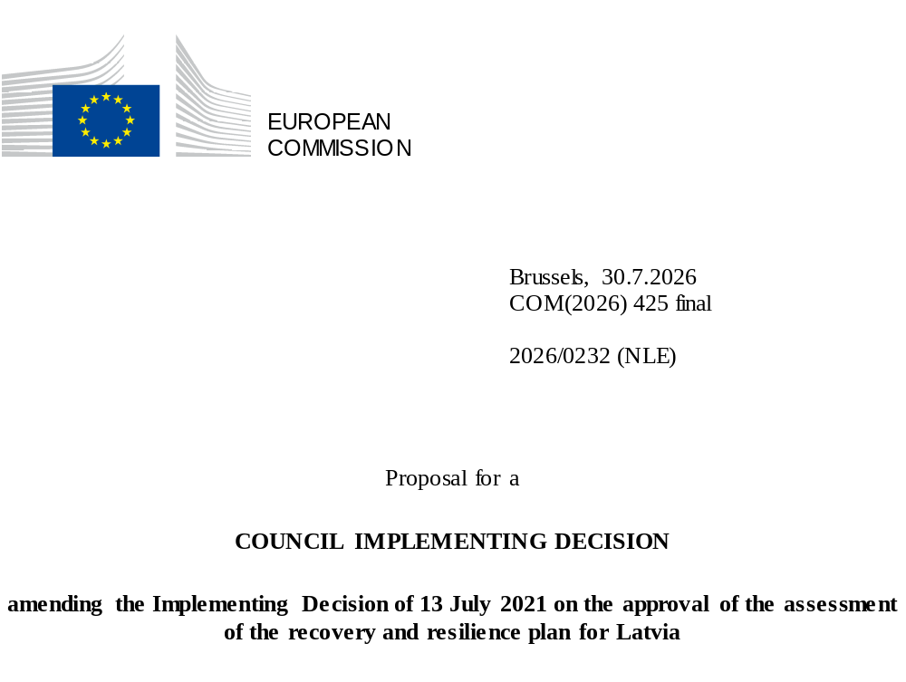

2026/0232 (NLE)
Proposal for a
COUNCIL IMPLEMENTING DECISION
amending the Implementing Decision of 13 July 2021 on the approval of the assessment of the recovery and resilience plan for Latvia
THE COUNCIL OF THE EUROPEAN UNION,
Having regard to the Treaty on the Functioning of the European Union,
Having regard to Regulation (EU) 2021/241 of the European Parliament and of the Council of 12 February 2021 establishing the Recovery and Resilience Facility, and in particular Article 20(1) thereof,
Having regard to the proposal from the European Commission,
Whereas:
(1) Following the submission of the national recovery and resilience plan (‘RRP’) by Latvia on 30 April 2021, the Commission proposed its positive assessment to the Council. On 13 July 2021, the Council approved the positive assessment by means of an implementing decision (‘the Council Implementing Decision of 13 July 2021’). The Council Implementing Decision of 13 July 2021 was amended by the Council Implementing Decisions of 8 December 2023, of 18 February 2025, of 12 December 2025 and of 10 July 2026.
(2) On 21 July 2026, Latvia made a reasoned request to the Commission to make a proposal to amend the Council Implementing Decision of 13 July 2021 in accordance with Article 21(1) of Regulation (EU) 2021/241 on the grounds that the RRP is partially no longer achievable because of objective circumstances. On that basis, Latvia has submitted an amended RRP.
Amendments based on Article 21 of Regulation (EU) 2021/241
(3) The amendments to the RRP submitted by Latvia because of objective circumstances concern two measures.
(4) Latvia has explained that one measure has been amended to implement a better alternative in order to achieve its original ambition. This concerns measure 5.2.1.r. (Reform of Higher Education and Scientific Excellence and Governance) under Component 5 (Economic Transformation and Productivity Reform). On this basis, Latvia has requested that that measure be amended. The Council Implementing Decision of 13 July 2021 should be amended accordingly.
(5) Latvia has explained that one measure has been amended to implement a better alternative that allows the administrative burden to be reduced and simplifies the Council Implementing Decision, while still achieving the objectives of the measure. This concerns measure 1.2.1.2.i. (Increasing energy efficiency in business in the form of a combined financial instrument) under Component 1 (Climate change and environmental sustainability). On this basis, Latva has requested that that measure be amended. The Council Implementing Decision of 13 July 2021 should be amended accordingly.
Commission’s assessment
(6) The Commission has assessed the amended RRP against the assessment criteria laid down in Article 19(3) of Regulation (EU) 2021/241.
(7) The Commission considers that the amendments put forward by Latvia do not affect the positive assessment of the RRP set out in the Council Implementing Decision of 13 July 2021 regarding the relevance, effectiveness, efficiency and coherence of the RRP against the assessment criteria laid down in Article 19(3) of Regulation (EU) 2021/241 points (a), (b), (c), (d), (da), (db), (e), (f), (g), (h), (i), (j) and (k).
Positive assessment
(8) Following the positive assessment by the Commission of the amended RRP, with the finding that the RRP satisfactorily complies with the criteria for assessment set out in Regulation (EU) 2021/241, in accordance with Article 20(2) of and Annex V to that Regulation, the reforms and investment projects necessary for the implementation of the amended RRP, the relevant milestones, targets and indicators, and the amount made available from the Union for the implementation of the amended RRP should be set out.
Financial contribution
(9) The estimated total costs of Latvia’s amended RRP is EUR 1 969 244 522. As the amount of the estimated total cost of the amended RRP is equal to the updated maximum financial contribution available for Latvia, the financial contribution determined in accordance with Article 4a of Regulation (EU) 2021/1755 of the European Parliament and of the Council, and with Article 20(4) and Article 21a(6) of Regulation (EU) 2021/241 that is allocated for Latvia’s amended RRP should be equal to EUR 1 969 244 522. Therefore, the financial contribution made available to Latvia remains unchanged.
(10) The Council Implementing Decision of 13 July 2021 should therefore be amended accordingly. For the sake of clarity, the Annex to the Council Implementing Decision of 13 July 2021 should be replaced entirely.
(11) This Decision should be without prejudice to the outcome of any procedures relating to the award of Union funds under any Union programme other than the Facility or to procedures relating to distortions of the operation of the internal market that may be undertaken, in particular under Articles 107 and 108 of the Treaty. It does not override the requirement for Member States to notify instances of potential State aid to the Commission under Article 108 of the Treaty,
HAS ADOPTED THIS DECISION:
Article 1
Approval of the assessment of the RRP
The assessment of the amended RRP for Latvia on the basis of the criteria provided for in Article 19(3) of Regulation (EU) 2021/241 is approved.
Article 2
Amendments
The Council Implementing Decision of 13 July 2021 on the approval of the assessment of the recovery and resilience plan for Latvia is amended as follows:
the Annex is replaced by the text set out in the Annex to this Decision.
Article 3
Addressee
This Decision is addressed to the Republic of Latvia.
Done at Brussels,
For the Council
The President

OJ L 57, 18.2.2021, p. 17, ELI: https://eur-lex.europa.eu/eli/reg/2021/241/oj.
ST 10157/21 INIT; ST 10157/21 ADD 1.
ST 15569/23 INIT; ST 15569/23 ADD 1.
ST 5730/25 INIT; ST 5730/25 ADD 1.
ST 15719/25 INIT; ST 15719/25 ADD 1; ST 15719/25 ADD1 REV 1 (el, mt); ST 15719/25 ADD1 COR 1 (lv).
ST 10641/26 INIT; ST 10641/26 ADD 1.
Regulation (EU) 2021/1755 of the European Parliament and of the Council of 6 October 2021 establishing the Brexit Adjustment Reserve (OJ L 357, 8.10.2021, p. 1, ELI: http://data.europa.eu/eli/reg/2021/1755/oj).

