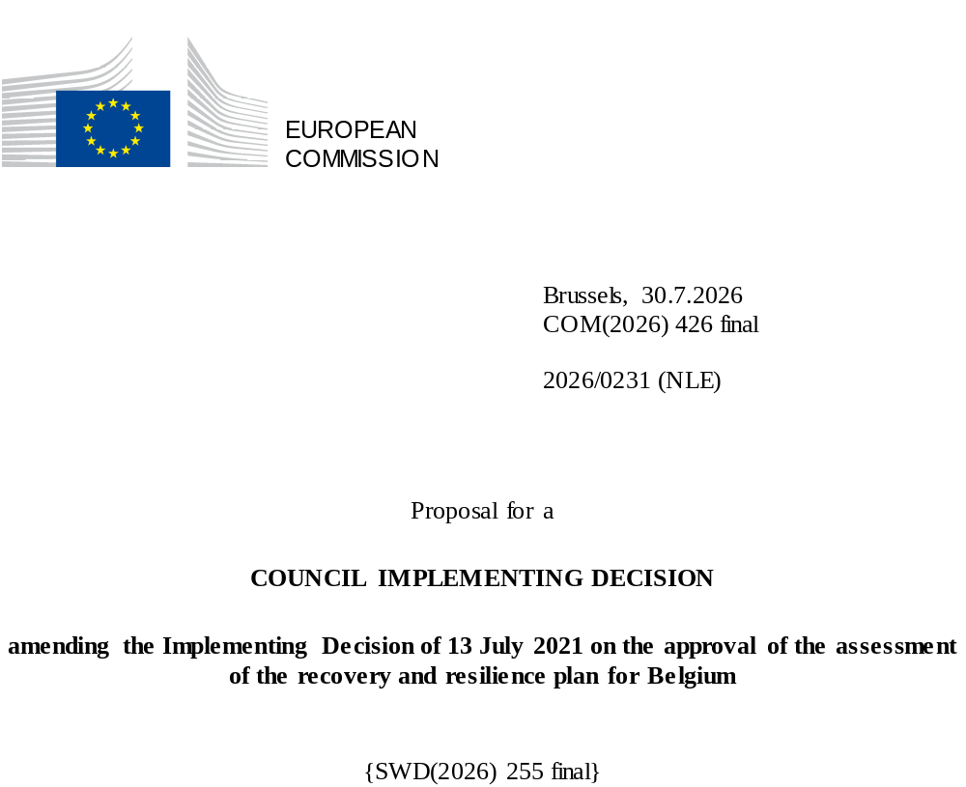

2026/0231 (NLE)
Proposal for a
COUNCIL IMPLEMENTING DECISION
amending the Implementing Decision of 13 July 2021 on the approval of the assessment of the recovery and resilience plan for Belgium
THE COUNCIL OF THE EUROPEAN UNION,
Having regard to the Treaty on the Functioning of the European Union,
Having regard to Regulation (EU) 2021/241 of the European Parliament and of the Council of 12 February 2021 establishing the Recovery and Resilience Facility, and in particular Article 20(1) thereof,
Having regard to the proposal from the European Commission,
Whereas:
(1) Following the submission of the national recovery and resilience plan (‘RRP’) by Belgium on 30 April 2021, the Commission proposed its positive assessment to the Council. On 13 July 2021, the Council approved the positive assessment by means of an implementing decision (‘the Council Implementing Decision of 13 July 2021’). The Council Implementing Decision of 13 July 2021 was amended by the Council Implementing Decisions of 8 December 2023, 10 December 2024, 18 February 2025, 11 March 2025, 20 June 2025, 8 July 2025, 13 November 2025, and 12 June 2026.
(2) On 29 May 2026, Belgium made a reasoned request to the Commission to make a proposal to amend the Council Implementing Decision of 13 July 2021 in accordance with Article 21(1) of Regulation (EU) 2021/241 on the grounds that the RRP is partially no longer achievable because of objective circumstances. On that basis, Belgium has submitted an amended RRP.
Amendments based on Article 21 of Regulation (EU) 2021/241
(3) The amendments to the RRP submitted by Belgium because of objective circumstances concern 49 measures.
(4) Belgium has explained that two measures are partially no longer achievable, because of unforeseen technical difficulties. This concerns description of investment ‘Development of social housing and housing for vulnerable persons’ (I-4.12) and target 153 of investment ‘Development of social housing and housing for vulnerable persons’ (I-4.12), description of investment ‘Enhancing public transport in Wallonia’ (I-3B) and target 101 of investment ‘Enhancing public transport in Wallonia’ (I-3B). On this basis, Belgium has requested that those measures be amended. The Council Implementing Decision of 13 July 2021 should be amended accordingly.
(5) Belgium has explained that one measure is partially no longer achievable, because of a change in compliance conditions. This concerns milestone 23 of investment ‘An industrial value chain for hydrogen transition’ (I-1.16). On this basis, Belgium has requested that this measure be amended. The Council Implementing Decision of 13 July 2021 should be amended accordingly.
(6) Belgium has explained that one measure is partially no longer achievable, because of a phased rollout. This concerns milestone 60 of investment ‘Digitalisation FPS’ (I-2.05). On this basis, Belgium has requested that this measure be amended. The Council Implementing Decision of 13 July 2021 should be amended accordingly.
(7) Belgium has explained that one measure is partially no longer achievable, because of a lack of legal framework. This concerns description of investment ‘eHealth Services and Health Data’ (I-2.06) and milestone 64 of investment ‘eHealth Services and Health Data’ (I-2.06). On this basis, Belgium has requested that this measure be amended. The Council Implementing Decision of 13 July 2021 should be amended accordingly.
(8) Belgium has explained that one measure is partially no longer achievable, because of temporary resource constraints due to overlapping priorities and the lack of a tender offer resulting in time constraints to achieve part of the measure. This concerns the description of investment ‘Marine Nature Restoration Programme’ (I-1.25) and target 252 of investment ‘Marine Nature Restoration Programme’ (I-1.25). On this basis, Belgium has requested that this measure be amended. The Council Implementing Decision of 13 July 2021 should be amended accordingly.
(9) Belgium has explained that four measures have been amended to implement better alternatives in order to achieve their original ambition. This concerns milestone 253 of investment ‘Off-shore energy project’ (I-1.26), description of investment ‘Equity injection into Participatiemaatschappij Vlaanderen (PMV) to support companies active in the field of biotechnology’ (I-5.19) and milestone 256 of investment ‘Equity injection into Participatiemaatschappij Vlaanderen (PMV) to support companies active in the field of biotechnology’ (I-5.19), description of investment ‘Capital injection into SFPIM Defence’ (I-5.20) and milestone 258 of investment ‘Capital injection into SFPIM Defence’ (I-5.20), description of investment ‘Capital injection into SFPIM Defence’ (I-5.21) and milestone 259 of investment ‘Capital injection into SFPIM Defence’ (I-5.21). On this basis, Belgium has requested that those measures be amended. The Council Implementing Decision of 13 July 2021 should be amended accordingly.
(10) Belgium has explained that 39 measures have been amended to implement better alternatives that allow the administrative burden to be reduced and simplify the Council Implementing Decision, while still achieving the objectives of those measures. This concerns description of investment ‘Building Renovations’ (I-1B) and targets 14 and 14bis of investment ‘Building renovations’ (I-1B), description of investment ‘An industrial value chain for hydrogen transition’ (I-1.17) and milestone 26 of investment ‘An industrial value chain for hydrogen transition’ (I-1.17), milestone 28 of investment ‘Developing the low-carbon industry’ (I-1.18), milestones 37 and 39 of investment ‘Biodiversity and adaptation to climate change’ (I-1.22), milestones 43 and 43bis of investment ‘Blue Deal’ (I-1.24), description of investment ‘Interception capabilities’ (I-2.02) and milestone 49 of investment ‘Interception capabilities’ (I-2.02), description of investment ‘Interception capabilities’ (I-2.03) and milestone 50 of investment ‘Interception capabilities’ (I-2.03), description of investment ‘Digitalisation’ (I-2.04) and milestones 52 and 53 of investment ‘Digitalisation’ (I-2.04), milestones 55 and 61 of investment ‘Digitalisation FPS’ (I-2.05), description of investment ‘Digitalisation projects’ (I-2.08) and milestone 66 and target 67 of ‘Digitalisation projects’ (I-2.08), description of investment ‘Digitalisation projects for asylum and immigration administrations’ (I-2.05bis) and milestone 55b of investment ‘Digitalisation projects for asylum and immigration administrations’ (I-2.05bis), description of investment ‘Coverage by fibre networks’ (I-2.13) and milestone 80 of investment ‘Coverage by fibre networks’ (I-2.13), description of investment ‘Connectivity of 35 business parks in Wallonia’ (I-2.15) and target 84 of investment ‘Connectivity of 35 business parks in Wallonia’ (I-2.15), target 96b of investment ‘Cycling infrastructure – Vélo Plus’ (I-3.03b), description of investment ‘Cycling & walking infrastructure – Schuman’ (I-3.04) and target 98 of investment ‘Cycling & walking infrastructure – Schuman’ (I-3.04), description of investment ‘Rail infrastructure and station accessibility works’ (I-3C) and target 105 of investment ‘Rail infrastructure and station accessibility works’ (I-3C), target 107 of investment ‘Canal Albert and Trilogiport’ (I-3.11), description of investment ‘Rail IT systems’ (I-3E) and target 109 of investment ‘Rail IT systems’ (I-3E), description of investment ‘Greening the bus fleet’ (I-3G) and target 115b of investment ‘Greening the bus fleet’ (I-3G), description of investment ‘Charging infrastructure for busses’ (I-3.21) and target 246 of investment ‘Charging infrastructure for busses’ (I-3.21), description of investment ‘Digital platforms for prisoners’ (I-4.09) and target 147 of investment ‘Digital platforms for prisoners’ (I-4.09), description of investment ‘Creation of Childcare places’ (I-4.13) and target 155 of investment ‘Creation of childcare places’ (I-4.13), description of investment ‘A6K/E6K Digital and Technological Innovation and Training Hub’ (I-5.01) and target 162 of investment ‘A6K/E6K Digital and Technological Innovation and Training Hub’ (I-5.01), description of investment ‘Upgrading of advanced training infrastructure’ (I-5.03) and target 163 of investment ‘Upgrading of advanced training infrastructure’ (I-5.03), description of investment ‘Digital lifelong learning’ (I-5.07) and milestone 171 of investment ‘Digital lifelong learning’ (I-5.07), description of investment ‘Nuclear medicine’ (I-5.08) and milestones 179 and 180 of investment ‘Nuclear medicine’ (I-5.08), description of investment ‘Strengthen R&D’ (I-5.11) and milestone 187 of investment ‘Strengthen R&D’ (I-5.11), description of investment ‘Relocation of food and development of logistics platforms’ (I-5.12) and target 191 of investment ‘Relocation of food and development of logistics platforms’ (I-5.12), description of target 198 of investment ‘Recycling Hub’ (I-5.14), description of milestone 200 of investment ‘Belgium Builds Back Circular’ (I-5.15), description of target 202 of investment ‘Deployment of the circular economy in Wallonia’ (I-5.16), description of investment ‘SMELD – FED’ (I-5.18) and milestone 249 of investment ‘SMELD – FED’ (I-5.18), description of investment ‘Energy efficiency measures in social housing WAL’ (I-7.04) and target 215 of investment ‘Energy efficiency measures in social housing WAL’ (I-7.04), description of investment ‘Heat pumps, insulation, solar panels or LED lights in buildings’ (I-7.10) and target 217 of investment ‘Heat pumps, insulation, solar panels or LED lights in buildings’ (I-7.10), description of investment ‘Energy measures in buildings – VLA’ (I-7) and target 218 of investment ‘Energy measures in buildings – VLA’ (I-7), description of investment Climate measures in agriculture (I-7.14) and target 225 of investment ‘Climate measures in agriculture’ (I-7.14), description of investment ‘Electrification of port infrastructure of the Flemish Region’ (I-7.18) and milestone 236 of investment ‘Electrification of port infrastructure of the Flemish Region’ (I-7.18), description of target 242 of investment ‘Greening the bus fleet –BCR’ (I-7.21), description of investment ‘Renovation of dwellings in Walloon region’ (I-7.26) and target 260 of investment ‘Renovation of dwellings in Walloon region’ (I-7.26), description of investment ‘Improved energy subsidy scheme – BCR’ (I-7.01) and target 261 of investment ‘Improved energy subsidy scheme – BCR’ (I-7.01). On this basis, Belgium has requested that those measures be amended. The Council Implementing Decision of 13 July 2021 should be amended accordingly.
(11) Following the decrease in the level of implementation of measures in accordance with Article 21 of Regulation (EU) 2021/241, Belgium has requested to use the resources freed up by the decrease in the level of their implementation to add one new measure and increase the level of implementation of three measures. This concerns, investment ‘Voluntary transfer to IRIS² satellite programme’ (I-5.22), investment ‘Smart road signals – WAL’ (I-3.08), investment ‘Equity injection into Participatiemaatschappij Vlaanderen (PMV) to support companies active in the field of biotechnology’ (I-5.19), and investment ‘Capital injection into SFPIM Defence’ (I-5.20). On this basis, Belgium has requested that the level of implementation of three measures be increased and that one new measure be added. The Council Implementing Decision of 13 July 2021 should be amended accordingly.
Corrections of clerical errors
(12) Two clerical errors have been identified in the text of the Council Implementing Decision, affecting one milestone and one target and two measures under two components. The Council Implementing Decision should be amended to correct these clerical errors that do not reflect the content of the RRP submitted to the Commission on 30 April 2021, as agreed between the Commission and Belgium. Those clerical errors relate to milestone 185 of investment ‘R&D: Minimization of waste during dismantling’ (I-5.10) of component 5.2 Supporting Economic Activity, and target 7 of investment ‘Renovation of private and social housing’ (I-1A) of component 1.1 Renovation. Those corrections do not affect the implementation of the measures concerned.
Commission’s assessment
(13) The Commission has assessed the amended RRP against the assessment criteria laid down in Article 19(3) of Regulation (EU) 2021/241.
Contribution to the green transition including biodiversity
(14) In accordance with Article 19(3), point (e), of, and criterion 2.5 of Annex V to, Regulation (EU) 2021/241, the amended RRP contains measures that contribute to a large extent (rating A) to the green transition, including biodiversity, or to addressing the challenges resulting therefrom. The measures supporting climate objectives account for an amount which represents 40% of the amended RRP’s total allocation and 65.6% of the total estimated costs of measures in the REPowerEU chapter calculated in accordance with the methodology set out in Annex VI to Regulation (EU) 2021/241. In accordance with Article 17 of Regulation (EU) 2021/241, the amended RRP is consistent with the information included in the National Energy and Climate Plan 2021-2030.
(15) The amended RRP does not alter its ambition towards the green transition, even though the total allocation for measures supporting the climate objectives has decreased by 5.1 percentage points compared with the amended assessment of 12 June 2026. This decrease is the result of the removal of the climate tagging for investment ‘Renovation of buildings’ (I-1.07), investment ‘Renovation of buildings’ (I-1.08), investment ‘Renovation of buildings’ (I-1.09), investment ‘Renovation of buildings’ (I-7.06) and investment ‘Heat pumps, insulation, solar panels or LED lights in buildings’ (I-7.10). The limited scope of those amendments does not change the overall assessment of this criterion.
Contribution to the digital transition
(16) In accordance with Article 19(3), point (f), of, and criterion 2.6 of Annex V to, Regulation (EU) 2021/241, the amended RRP contains measures that contribute to a large extent (rating A) to the digital transition or to addressing the challenges resulting from it. The measures supporting digital objectives account for an amount which represents 27.15% of the amended RRP’s total allocation calculated in accordance with the methodology set out in Annex VII to that Regulation.
(17) The amended RRP does not alter its ambition towards the digital transition, given that the total allocation for measures supporting the digital transition has slightly increased compared with the amended assessment of 12 June 2026. This increase is mainly due to the addition of investment ‘Voluntary transfer to IRIS² satellite programme’ (I-5.22). The limited scope of those amendments does not change the overall assessment of this criterion.
Costing
(18) In accordance with Article 19(3), point (i), of, and criterion 2.9 of Annex V to, Regulation (EU) 2021/241, the justification provided in the amended RRP on the amount of the estimated total cost of the RRP is to a medium extent (rating B) reasonable and plausible, is in line with the principle of cost efficiency and is commensurate to the expected national economic and social impact.
(19) Belgium has provided individual estimated costs for the new measure, as well as individual justifications for all the measures whose modifications entailed a change in the cost estimates. The cost information provided by Belgium is mostly sufficiently detailed and substantiated. For the new measure and measures where the reduction in the ambition is more than proportionate to the reduction in the financial envelope, Belgium provided estimates and information on the methodology used. The assessment of the cost estimates and supporting documents shows that the majority of the costs of the new measures are well justified, reasonable and plausible. Moreover, the changes in the cost estimates of the modified measures are sufficiently justified. Finally, the estimated total cost of the RRP is in line with the principle of cost-efficiency and commensurate with the expected national economic and social impact.
Any other assessment criteria
(20) The Commission considers that the amendments put forward by Belgium do not affect the positive assessment of the RRP set out in the Council Implementing Decision of 13 July 2021 on the approval of the assessment of the RRP for Belgium regarding the relevance, effectiveness, efficiency and coherence of the RRP against the assessment criteria laid down in Article 19(3), points (a), (b), (c), (d), (da), (db), (g), (h), (j) and (k).
Positive assessment
(21) Following the positive assessment by the Commission of the amended RRP, with the finding that the RRP satisfactorily complies with the criteria for assessment set out in Regulation (EU) 2021/241, in accordance with Article 20(2) of and Annex V to that Regulation, the reforms and investment projects necessary for the implementation of the amended RRP, the relevant milestones, targets and indicators, and the amount made available from the Union for the implementation of the amended RRP should be set out.
Financial contribution
(22) The estimated total costs of Belgium’s amended RRP is EUR 5 244 911 861. As the amount of the estimated total cost of the amended RRP is higher than the updated maximum financial contribution available for Belgium, the financial contribution determined in accordance with Article 4a of Regulation (EU) 2021/1755 of the European Parliament and of the Council, and with Article 20(4) and Article 21a(6) of Regulation (EU) 2021/241 that is allocated for Belgium’s amended RRP should be equal to EUR 5 033 950 235. Therefore, the financial contribution made available to Belgium remains unchanged.
Loans
(23) In order to support additional reforms and investments, a total loan support of EUR 230 100 000 was made available to Belgium by means of Council Implementing Decision of 13 July 2021. Following the removal of investment ‘Cycling and walking infrastructure – Schuman’ (I-3.04) and the decrease in the level of implementation of investment ‘Capital injection into SFPIM – Defence’ (I-5.21) under Article 21 of Regulation 2021/241, Belgium has not requested to use the freed up loan resources to support new measures or to increase the level of implementation of existing measures within the RRP. The amount of the estimated total costs of the RRP is lower than the combined financial contribution available for Belgium and the loan support that had been made available to Belgium by means of Council Implementing Decision of 13 July 2021. Therefore, the total loan support made available to Belgium should be reduced to EUR 209 604 000.
(24) The Council Implementing Decision of 13 July 2021 should therefore be amended accordingly. For the sake of clarity, the Annex to the Council Implementing Decision of 13 July 2021 should be replaced entirely.
(25) This Decision should be without prejudice to the outcome of any procedures relating to the award of Union funds under any Union programme other than the Facility or to procedures relating to distortions of the operation of the internal market that may be undertaken, in particular under Articles 107 and 108 of the Treaty. It does not override the requirement for Member States to notify instances of potential State aid to the Commission under Article 108 of the Treaty,
HAS ADOPTED THIS DECISION:
Article 1
Approval of the assessment of the RRP
The assessment of the amended RRP for Belgium on the basis of the criteria provided for in Article 19(3) of Regulation (EU) 2021/241 is approved.
Article 2
Amendments
The Council Implementing Decision of 13 July 2021 on the approval of the assessment of the recovery and resilience plan for Belgium is amended as follows:
(1) in Article 2a, paragraph 1 is replaced by the following:
“1. The Union shall make available to Belgium a loan amounting to a maximum of EUR 209 604 000.”;
(2) the Annex is replaced by the text set out in the Annex to this Decision.
Article 3
Addressee
This Decision is addressed to the Kingdom of Belgium.
Done at Brussels,
For the Council
The President

OJ L 57, 18.2.2021, p. 17, ELI: https://eur-lex.europa.eu/eli/reg/2021/241/oj.
ST 10161/21 INIT; ST 10161/21 ADD 1.
ST 15570/23 INIT; ST 15570/23 ADD 1.
ST 15974/24 INIT; ST 15974/24 ADD 1.
ST 5654/25 INIT; ST 5654/25 ADD 1.
ST 6545/25 INIT; ST 6545/25 ADD 1.
ST 9584/25 INIT; ST 9584/25 ADD 1.
ST 10529/25 INIT; ST 10529/25 ADD 1.
ST 14449/25 INIT; ST 14449/25 ADD 1.
ST 9517/26 INIT; ST 9517/26 ADD 1.
Regulation (EU) 2021/1755 of the European Parliament and of the Council of 6 October 2021 establishing the Brexit Adjustment Reserve (OJ L 357, 8.10.2021, p. 1, ELI: http://data.europa.eu/eli/reg/2021/1755/oj).

