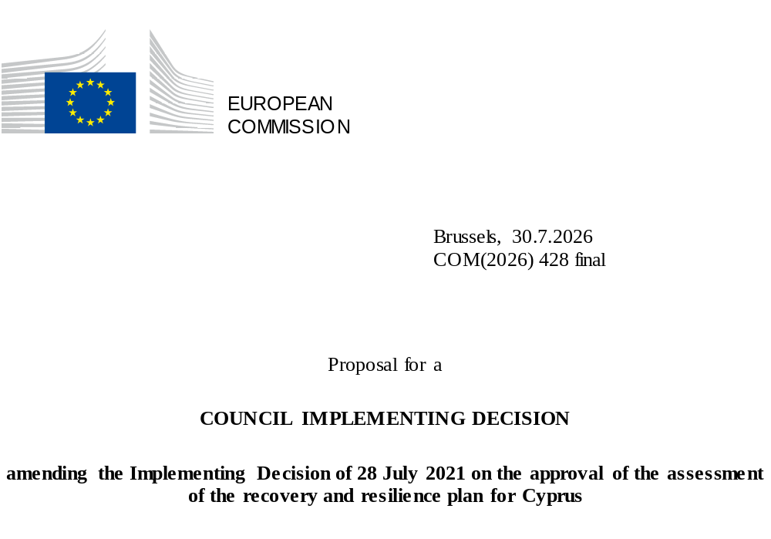

Proposal for a
COUNCIL IMPLEMENTING DECISION
amending the Implementing Decision of 28 July 2021 on the approval of the assessment of the recovery and resilience plan for Cyprus
THE COUNCIL OF THE EUROPEAN UNION,
Having regard to the Treaty on the Functioning of the European Union,
Having regard to Regulation (EU) 2021/241 of the European Parliament and of the Council of 12 February 2021 establishing the Recovery and Resilience Facility, and in particular Article 20(1) thereof,
Having regard to the proposal from the European Commission,
Whereas:
(1) Following the submission of the national recovery and resilience plan (‘RRP’) by Cyprus on 17 May 2021, the Commission proposed its positive assessment to the Council. On 28 July 2021, the Council approved the positive assessment by means of an implementing decision (‘the Council Implementing Decision of 28 July 2021’). The Council Implementing Decision of 28 July 2021 was amended by the Council Implementing Decisions of 8 December 2023, 16 July 2024, 21 January 2025, 20 June 2025, 12 December 2025 and 10 July 2026.
(2) On 17 July 2026, Cyprus made a reasoned request to the Commission to make a proposal to amend the Council Implementing Decision of 28 July 2021 in accordance with Article 21(1) of Regulation (EU) 2021/241 on the grounds that the RRP is partially no longer achievable because of objective circumstances. On that basis, Cyprus has submitted an amended RRP.
Amendments based on Article 21 of Regulation (EU) 2021/241
(3) The amendments to the RRP submitted by Cyprus because of objective circumstances concern eigth measures.
(4) Cyprus has explained that one measure is partially no longer achievable because of lack of demand. This concerns measure C3.3R2 (Supporting Fast-Track Business Activation Mechanism). On that basis, Cyprus has requested that this measure be amended. The Council Implementing Decision of 28 July 2021 should be amended accordingly.
(5) Cyprus has explained that seven measures have been amended to implement better alternatives that allow the administrative burden to be reduced and simplify the Council Implementing Decision of 28 July 2021, while still achieving the objectives of those measures. This concerns measures C1.1R1 (National Centre for Clinical Evidence and Quality Improvement); C3.1I11 (Extension of the Cyprus Green Points Network); C3.4I3 (Economic Policy Modelling Hub); C3.4I6a (Regeneration and Revitalisation of Nicosia Inner City); C3.4R9 (Digital transformation of courts); C5.1R1 (Addressing skills mismatch between education and labour market (Secondary and Higher Education) and C5.2R1 (Reform of the Social Insurance System and Restructuring of the Social Insurance Services). The Council Implementing Decision of 28 July 2021 should be amended accordingly.
Commission’s assessment
(6) The Commission has assessed the amended RRP against the assessment criteria laid down in Article 19(3) of Regulation (EU) 2021/241.
(7) The Commission considers that the amendments put forward by Cyprus do not affect the positive assessment of the RRP set out in the Council Implementing Decision of 28 July 2021 regarding the relevance, effectiveness, efficiency and coherence of the RRP against the assessment criteria laid down in Article 19(3) of Regulation (EU) 2021/241 points (a), (b), (c), (d),(da), (db), (e), (f), (g), (h), (i), (j) and (k).
Positive assessment
(8) Following the positive assessment by the Commission of the amended RRP, with the finding that the RRP satisfactorily complies with the criteria for assessment set out in Regulation (EU) 2021/241, in accordance with Article 20(2) of and Annex V to that Regulation, the reforms and investment projects necessary for the implementation of the amended RRP, the relevant milestones, targets and indicators, and the amount made available from the Union for the implementation of the amended RRP should be set out.
Financial contribution
(9) The estimated total cost of Cyprus’s amended RRP is EUR 1 022 123 510. As the amount of the estimated total cost of the amended RRP is higher than the updated maximum financial contribution available for Cyprus, the financial contribution determined in accordance with Article 4a of Regulation (EU) 2021/1755 of the European Parliament and of the Council⁸, and with Article 20(4) and Article 21a(6) of Regulation (EU) 2021/241 that is allocated for Cyprus’s amended RRP should be equal to EUR 1 020 223 681. Therefore, the financial contribution made available to Cyprus remains unchanged.
(10) The Council Implementing Decision of 28 July 2021 should therefore be amended accordingly. For the sake of clarity, the Annex to the Council Implementing Decision of 28 July 2021 should be replaced entirely.
(11) This Decision should be without prejudice to the outcome of any procedures relating to the award of Union funds under any Union programme other than the Facility or to procedures relating to distortions of the operation of the internal market that may be undertaken, in particular under Articles 107 and 108 of the Treaty. It does not override the requirement for Member States to notify instances of potential State aid to the Commission under Article 108 of the Treaty,
HAS ADOPTED THIS DECISION:
Article 1
Approval of the assessment of the RRP
The assessment of the amended RRP for Cyprus on the basis of the criteria provided for in Article 19(3) of Regulation (EU) 2021/241 is approved.
Article 2
Amendments
The Council Implementing Decision of 28 July 2021 on the approval of the assessment of the recovery and resilience plan for Cyprus is amended as follows:
the Annex is replaced by the text set out in the Annex to this Decision.
Article 3
Addressee
This Decision is addressed to the Republic of Cyprus.
Done at Brussels,
For the Council
The President

OJ L 57, 18.2.2021, p. 17, ELI: https://eur-lex.europa.eu/eli/reg/2021/241/oj.
ST 10686/21 INIT; ST 10686/21 ADD 1.
ST 15571/23 INIT; ST 15571/23 ADD 1; ST 15571/23 ADD 1 COR 1.
ST 11806/24 INIT; ST 11806/24 ADD 1.
ST 17052/24 INIT; ST 17052/24 ADD 1.
ST 9585/25 INIT; ST 9585/25 ADD 1.
ST 15743/25 INIT; ST 15743/2 ADD 1
ST 10859/26 INIT; ST 10859/26 ADD 1.

