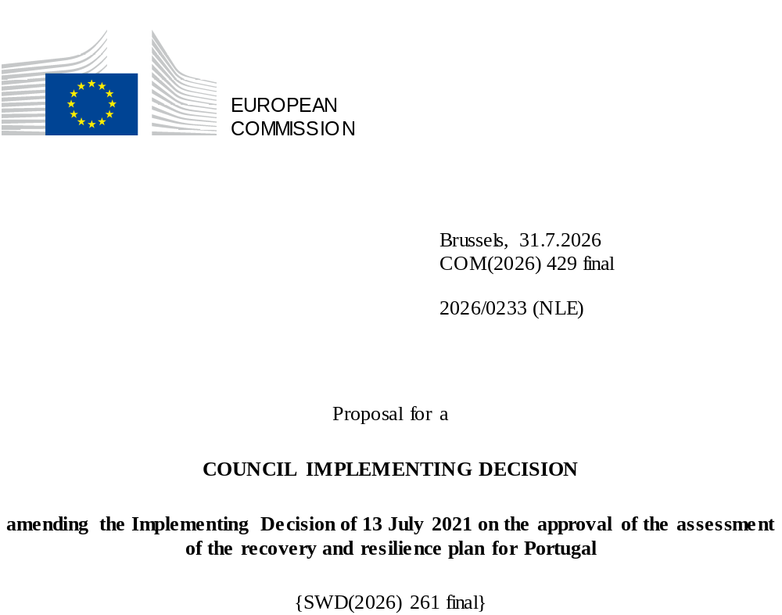

2026/0233 (NLE)
Proposal for a
COUNCIL IMPLEMENTING DECISION
amending the Implementing Decision of 13 July 2021 on the approval of the assessment of the recovery and resilience plan for Portugal
THE COUNCIL OF THE EUROPEAN UNION,
Having regard to the Treaty on the Functioning of the European Union,
Having regard to Regulation (EU) 2021/241 of the European Parliament and of the Council of 12 February 2021 establishing the Recovery and Resilience Facility, and in particular Article 20(1) thereof,
Having regard to the proposal from the European Commission,
Whereas:
(1) Following the submission of the national recovery and resilience plan (‘RRP’) by Portugal on 22 April 2021, the Commission proposed its positive assessment to the Council. On 13 July 2021, the Council approved the positive assessment by means of an implementing decision (‘Council Implementing Decision of 13 July 2021’). Council Implementing Decision of 13 July 2021 was amended by Council Implementing Decisions of 17 October 2023, 8 October 2024, 13 May 2025, 29 September 2025, 12 December 2025 and 12 June 2026.
(2) On 21 July 2026, Portugal made a reasoned request to the Commission to make a proposal to amend the Council Implementing Decision of 13 July 2021 in accordance with Article 21(1) of Regulation (EU) 2021/241 on the grounds that the RRP is partially no longer achievable because of objective circumstances. On that basis, Portugal has submitted an amended RRP.
Amendments based on Article 21 of Regulation (EU) 2021/241
(3) The amendments to the RRP submitted by Portugal because of objective circumstances concern 46 measures.
(4) Portugal has explained that five measures are partially no longer achievable because of unexpected technical difficulties or lack of demand. This concerns measures C01-i01 (Primary health care services with more answers), C01-i02 (National Network of Integrated Continuous Care and National Network of Palliative Care), C01-i03 (Support to mental health reform), C09-i01 (Algarve Water Efficiency Regional Plan) and C19-i04 (Efficient, secure and shared critical digital infrastructure),. On this basis, Portugal has requested that those measures be amended. The Council Implementing Decision of 13 July 2021 should be amended accordingly.
(5) Portugal has explained that seven measures have been amended to implement better alternatives in order to achieve their original ambition. This concerns measures C01-i05-RAM (Support to Madeira’s Regional Health Service), C02-i04-RAA (Increasing housing conditions in the housing stock of the Autonomous Region of the Azores), C02-i07-RAA (Infrastructure for parcels of land for residential housing), C04-i01 (Cultural Networks and Digital Transition), C06-i01 (Modernisation of vocational education and training institutions), C10-i02 (Green and Digital Transition and Safety in Fisheries) and C21-r48 (Simplification of the legal and regulatory framework applicable to renewable energy projects). On this basis, Portugal has requested that those measures be amended. The Council Implementing Decision of 13 July 2021 should be amended accordingly.
(6) Portugal has explained that 33 measures have been amended to implement a better alternative that allow the administrative burden to be reduced and simplify the Council Implementing Decision of 13 July 2021, while still achieving the objectives of those measures. This concerns measures C01-i11-RAA (Modernisation and requalification of the Regional Health Service), C02-i01 (Support Programme for Access to Housing), C02-i02 (National Emergency and Temporary Accommodation Grant), C02-i05 (Affordable and Social Housing), C02-i06 (Student Accommodations at Affordable Prices), C03-i01 (New generation of equipment and social responses), C03-i02 (Accessibility 360), C03-i06 (Social interventions in disadvantaged communities in the Metropolitan Areas of Lisbon and Porto), C03-r38 (Simplification of the Social Security System), C05-i01.01 (Mobilising and Green Agendas/Alliances for Business Innovation), C05-i03 (Research and innovation agenda for sustainable agriculture, food and agro-industry [Innovation Agenda for Agriculture 2030]), C05-i04-RAA (Recapitalisation of the Business System of the Azores), C05-i05-RAA (Economic Recovery of Azorean Agriculture), C05-i08 (More Digital Science), C05-i11 (Scale-up: Mobilising and Green Agendas/Alliances for Business Innovation (Loans)), C05-i13 (Scientific research units), C05-i14 (Business Innovation), C06-i07 (More Digital Impulse), C06-i09 (New or Renovated Schools), C10-i01 (Blue Hub, Network of Infrastructure for the Blue Economy), C10-i03 (Atlantic Defence Operations Centre and naval platform), C10-i04-RAA (‘Cluster do Mar dos Açores’), C13-i01 (Energy efficiency in residential buildings), C14-i03-RAA (Energy Transitions in the Azores), C15-i08 (Construction of the Porto Metro Network expansion - Casa da Música-Santo Ovídio, construction phase), C16-i02 (Digital Transition of Enterprises), C16-i04 (Industry 4.0), C16-i05-RAA (Digital Capacity and Transformation of Enterprises in the Azores), C17-r40 (Simplification of the Tax System), C19-i01 (Redesign of public and consular services), C21-i05 (Support to the Green Industry), C21-i07 (Technical studies for offshore energy potential) and C21-i12 (Scaled-up measure: Decarbonisation of Public Transport). On this basis, Portugal has requested that those measures be amended. The Council Implementing Decision of 13 July 2021 should be amended accordingly.
(7) Following the decrease in the level of implementation of measures in accordance with Article 21 of Regulation (EU) 2021/241, Portugal has requested to use the resources freed up by the decrease in the level of their implementation to increase the level of implementation of two measures. This concerns measure C01-i13 (Primary health care services) and measure C05-i01.01 (Mobilising and Green Agendas/Alliances for Business Innovation). On this basis, Portugal has requested that the level of implementation of two measures be increased. The Council Implementing Decision of 13 July 2021 should be amended accordingly.
Commission’s assessment
(8) The Commission has assessed the amended RRP against the assessment criteria laid down in Article 19(3) of Regulation (EU) 2021/241.
Contribution to the green transition including biodiversity
(9) In accordance with Article 19(3), point (e), of, and criterion 2.5 of Annex V to, Regulation (EU) 2021/241, the amended RRP contains measures that contribute to a large extent (rating A) to the green transition, including biodiversity, or to addressing the challenges resulting therefrom. The measures supporting climate objectives account for an amount which represents 37.41 % of the amended RRP’s total allocation and 99.31 % of the estimated total cost of measures in the REPowerEU chapter calculated in accordance with the methodology set out in Annex VI to Regulation (EU) 2021/241. In accordance with Article 17 of Regulation (EU) 2021/241, the amended RRP is consistent with the information included in the National Energy and Climate Plan 2021-2030.
(10) Overall, due to the differing climate tagging content of the increased measure and the decreased measures, the amendments to Portugal’s RRP entail a net decrease in the overall contribution to the climate target of the RRP by 0.52 percentage points to 37.41 % from 37.93 %. The measures of the amended RRP are expected to reduce the greenhouse gas emissions and facilitate the uptake of renewable energy and thus contribute to the attainment of the 2030 climate targets and the objective of the Union climate neutrality by 2050.
Contribution to the digital transition
(11) In accordance with Article 19(3), point (f), of and Annex V, criterion 2.6, to Regulation (EU) 2021/241, the amended RRP contains measures that contribute to a large extent (rating A) to the digital transition or to addressing the challenges resulting from it. The measures supporting digital objectives account for an amount which represents 22.26% of the amended RRP’s total allocation calculated in accordance with the methodology set out in Annex VII to that Regulation.
(12) Overall, due to the differing digital tagging content of the increased measure and the decreased measures, the amendments to Portugal’s RRP entail a net decrease in the overall contribution to the digital target of the RRP by 0.06 percentage points to 22.26% from 22.32%. The modified RRP continues to significantly contribute to the digital transition, including by increasing digitalisation of the public administration and enterprises, increasing the number of digital services for citizens and business as well as investments in e-health and digitalisation of transport sector.
Costing
(13) In accordance with Article 19(3), point (i), of, and criterion 2.9 of Annex V to, Regulation (EU) 2021/241, the justification provided in the amended RRP on the amount of the estimated total cost of the RRP is to a medium extent (rating B) reasonable and plausible, is in line with the principle of cost efficiency and is commensurate with the expected national economic and social impact.
(14) Portugal has provided individual cost estimates for the amended investments included in the amended RRP, relying on proportional reduction or increase and on several sources to justify them. The cost information provided is mostly sufficiently detailed and substantiated. Portugal has provided estimates and assumptions on costs, including descriptions and explanations of the main drivers and changes in the costs of the amended measures and their proportionality. The assessment of the cost estimates and supporting documents shows that the majority of the costs of the new and amended measures are well justified, reasonable and plausible. Portugal has also provided sufficient information and evidence that the amount of the estimated total cost is not covered by existing or planned Union financing. Finally, the estimated total cost of the RRP is in line with the principle of cost-efficiency and commensurate to the expected national economic and social impact.
Any other assessment criteria
(15) The Commission considers that the amendments put forward by Portugal do not affect the positive assessment of the RRP set out in the Council Implementing Decision of 13 July 2021 regarding the relevance, effectiveness, efficiency and coherence of the RRP against the assessment criteria laid down in Article 19(3), points (a), (b), (c), (d), (da), (db), (g), (h), (j) and (k), of Regulation (EU) 2021/241.
Measures supporting investment operations contributing to the objectives of the Strategic Technologies for Europe Platform (STEP)
(16) In accordance with Article 4(4) of Regulation (EU) 2024/795, Portugal considered as matter of priority projects that have been awarded a Sovereignty Seal pursuant to Article 4(1) of Regulation (EU) 2024/75. However, Portugal considered that no projects having been awarded a Sovereignty Seal were to be included in the amended RRP because part of those projects have already secured funding from Union sources other than the Recovery and Resilience Facility. In addition, projects with a Sovereignty Seal that have not yet secured funding could be funded under the new measure C05-i14 (Business innovation) in the amended RRP.
Positive assessment
(17) Following the positive assessment by the Commission of the amended RRP, with the finding that the RRP satisfactorily complies with the criteria for assessment set out in Regulation (EU) 2021/241, in accordance with Article 20(2) of and Annex V to that Regulation, the reforms and investment projects necessary for the implementation of the amended RRP, the relevant milestones, targets and indicators, and the amount made available from the Union for the implementation of the amended RRP should be set out.
Financial contribution
(18) The estimated total cost of Portugal’s amended RRP is EUR 21 905 333 169. As the amount of the estimated total cost of the amended RRP is higher than the updated maximum financial contribution available for Portugal, the financial contribution determined in accordance with Article 4a of Regulation (EU) 2021/1755 of the European Parliament and of the Council, and with Article 20(4) and Article 21a(6) of Regulation (EU) 2021/241 that is allocated for Portugal’s amended RRP should be equal to EUR 16 325 113 960. Therefore, the financial contribution made available to Portugal remains unchanged.
Loans
(19) The loan support made available to Portugal amounting to EUR 5 580 219 209 remains unchanged.
(20) The Council Implementing Decision of 13 July 2021 should therefore be amended accordingly. For the sake of clarity, the Annex to the Council Implementing Decision of 13 July 2021 should be replaced entirely.
(21) This Decision should be without prejudice to the outcome of any procedures relating to the award of Union funds under any Union programme other than the Facility or to procedures relating to distortions of the operation of the internal market that may be undertaken, in particular under Articles 107 and 108 of the Treaty. It does not override the requirement for Member States to notify instances of potential State aid to the Commission under Article 108 of the Treaty,
HAS ADOPTED THIS DECISION:
Article 1
Approval of the assessment of the RRP
The assessment of the amended RRP for Portugal on the basis of the criteria provided for in Article 19(3) of Regulation (EU) 2021/241 is approved.
Article 2
Amendments
The Council Implementing Decision of 13 July 2021 on the approval of the assessment of the recovery and resilience plan for Portugal is amended as follows:
the Annex is replaced by the text set out in the Annex to this Decision.
Article 3
Addressee
This Decision is addressed to the Portuguese Republic.
Done at Brussels,
For the Council
The President

OJ L 57, 18.2.2021, p. 17, ELI: https://eur-lex.europa.eu/eli/reg/2021/241/oj.
ST 10149/21 INIT; ST 10149/21 ADD 1 REV 1.
ST 13351/23 INIT; ST 13351/23 ADD 1 REV 1.
ST 13497/24 INIT; ST 13497/24 ADD 1.
ST 8055/25 INIT; ST 8055/25 ADD 1.
ST 12491/25 INIT; ST 12491/25 ADD 1.
ST 15796/25 INIT; ST 15796/25 ADD 1.
ST 9419/26 INIT; ST 9419/26 ADD 1.
Regulation (EU) 2021/1755 of the European Parliament and of the Council of 6 October 2021 establishing the Brexit Adjustment Reserve (OJ L 357, 8.10.2021, p. 1, ELI: http://data.europa.eu/eli/reg/2021/1755/oj).

