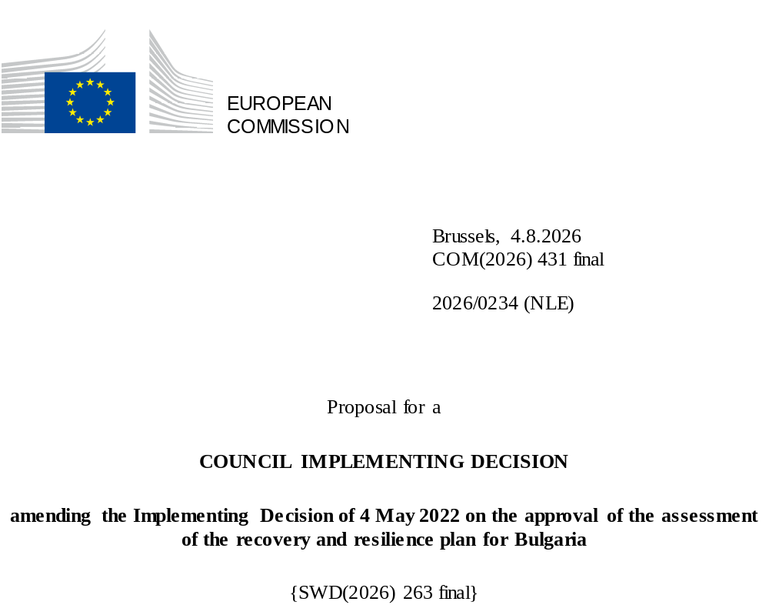

2026/0234 (NLE)
Proposal for a
COUNCIL IMPLEMENTING DECISION
amending the Implementing Decision of 4 May 2022 on the approval of the assessment of the recovery and resilience plan for Bulgaria
THE COUNCIL OF THE EUROPEAN UNION,
Having regard to the Treaty on the Functioning of the European Union,
Having regard to Regulation (EU) 2021/241 of the European Parliament and of the Council of 12 February 2021 establishing the Recovery and Resilience Facility, and in particular Article 20(1) thereof,
Having regard to the proposal from the European Commission,
Whereas:
(1) Following the submission of the national recovery and resilience plan (‘RRP’) by Bulgaria on 15 October 2021, the Commission proposed its positive assessment to the Council. On 4 May 2022, the Council approved the positive assessment by means of an implementing decision (‘the Council Implementing Decision of 4 May 2022’). The Council Implementing Decision of 4 May 2022 was amended by the Council Implementing Decisions of 8 December 2023, 18 July 2025, 27 November 2025 and 28 May 2026.
(2) On 10 June 2026, Bulgaria made a reasoned request to the Commission to make a proposal to amend the Council Implementing Decision of 4 May 2022 in accordance with Article 21(1) of Regulation (EU) 2021/241 on the grounds that the RRP is partially no longer achievable because of objective circumstances. On that basis, Bulgaria has submitted an amended RRP.
Amendments based on Article 21 of Regulation (EU) 2021/241
(3) The amendments to the RRP submitted by Bulgaria because of objective circumstances concern 47 measures.
(4) Bulgaria has explained that one measure is no longer achievable, because of unexpected delays in implementation arising from circumstances beyond Bulgaria’s control. This concerns Investment 7 Unified Information System for Spatial Planning, Investment Design and Building Permitting. On this basis, Bulgaria has requested that this measure be removed. The Council Implementing Decision of 4 May 2022 should be amended accordingly.
(5) Bulgaria has explained that six measures are partially no longer achievable, because of unexpected delays in implementation arising from circumstances beyond Bulgaria’s control. This concerns C4.I1 Support for the renovation of the building stock, C8.I5 Road safety, C10.I6 Supporting a pilot phase for the introduction of building information modelling, C11.I1 Infrastructure works in long-term care establishments, C12.I1 Modernisation of hospital facilities, C12.I4 Establishment of an air ambulance system. On this basis, Bulgaria has requested that those measures be amended. The Council Implementing Decision of 4 May 2022 should be amended accordingly.
(6) Bulgaria has explained that four measures have been amended to implement better alternatives in order to achieve their original ambition. This concerns C4.I9 Subsidy scheme – renovation of residential buildings, C4.R11 Improving corporate governance of state-owned companies in the energy sector, C8.R4 Integrated public transport, and C9.R2 Water supply and sewerage reform. On this basis, Bulgaria has requested that those measure be amended. The Council Implementing Decision of 4 May 2022 should be amended accordingly.
(7) Bulgaria has explained that 34 measures have been amended to implement better alternatives that allow the administrative burden to be reduced and simplify the Council Implementing Decision, while still achieving the objectives of those measures. This concerns C1.I1 STEM centres and innovation in education; C1.I2 Infrastructure works in educational facilities; C1.I3 Digital skills; C1.I4 Youth centres; C2.I1 Programme to support research and innovation; C2.I2 Investment in the Bulgarian Academy of Sciences; C3.I1 Programme for industrial parks and zones (“AttractInvestBG”); C4.I3 Support for energy-efficient street lighting systems; C4.I4 Digital transformation of the electricity transmission grid; C4.I8 National infrastructure for storage of electricity (RESTORE); C4.R6 Increasing electricity generation from renewable sources; C4.R10 Decarbonisation of the energy sector; C6.I1 Technological and ecological transition of agriculture; C8.I1 Railways rolling stock; C8.I7 Green mobility; C8.I8 Equipment for monitoring or maintenance of railway tracks and overhead lines; C8.I9 Renovation of railway infrastructure; C10.R2 Anti-corruption; C10.R10 Public Procurement; C10.I4 Security services; C11.I2 Provision of assisting devices to persons with permanent disabilities; C11.I5 Digital services at the Employment Agency; C11.I7 Digitisation of archives; C11.I8 Culture infrastructure; C12.I2 Centres for interventional diagnosis and endovascular treatment of cerebrovascular diseases; C12.I3 Modernization of psychiatric care; C12.I5 National digital platform for medical diagnostics; C12.I7 Development of outpatient care; C13.R2 Transparency of connection procedures for new renewable and storage capacities; C13.R3 Functioning of the balancing market and demand-response; C13.I1 Information system on energy poor households and vulnerable customers; C13.I2 National infrastructure for storage of electricity (RESTORE) (scaled-up); C13.I3 Installation of Photovoltaic Systems and Provision of Electric Vehicles for Social Services Facilities; C13.I4 Support for capacities for electricity generation from renewable sources and electricity storage. On this basis, Bulgaria has requested that those measures be amended. The Council Implementing Decision of 4 May 2022 should be amended accordingly.
(8) Following the removal and decrease in the level of implementation of measures in accordance with Article 21 of Regulation (EU) 2021/241, Bulgaria has requested to use the resources freed up by the removal of measures and the decrease in the level of their implementation to add two new measures and increase the level of implementation of one measure. This concerns C10.I12 Digitalisation of the Customs Agency and C10.I13 Digitalisation of the National Revenue Agency and C4.I9 Subsidy scheme – renovation of residential buildings. On this basis, Bulgaria has requested that the level of implementation of one measure be increased (C4.I9 Subsidy scheme – renovation of residential buildings) and that two new measures (C10.I12 Digitalisation of the Customs Agency and C10.I13 Digitalisation of the National Revenue Agency) be added. The Council Implementing Decision of 4 May 2022 should be amended accordingly.
Distribution of milestones and targets
(9) The distribution of milestones and targets in instalments should be amended to take into account the amendments to the RRP and the indicative timeline presented by Bulgaria.
Commission’s assessment
(10) The Commission has assessed the amended RRP against the assessment criteria laid down in Article 19(3) of Regulation (EU) 2021/241.
Do no significant harm
(11) In accordance with Article 19(3), point (d), of, and criterion 2.4 of Annex V to, Regulation (EU) 2021/241, the amended RRP is expected to ensure that no measure (rating A) for the implementation of reforms and investments projects included in the RRP does significant harm to environmental objectives within the meaning of Article 17 of Regulation (EU) 2020/852 of the European Parliament and of the Council (the principle of ‘do no significant harm’).
(12) The limited scope of those amendments does not change the overall assessment of this criterion. For what concerns the new investments introduced in the amended RRP (C.10.I12 Digitalisation of the Customs Agency and C.10.I13 Digitalisation of the National Revenue Agency), Bulgaria provided an assessment of the measures against the principle of ‘do no significant harm’ in line with the Do No Significant Harm Technical Guidance (C/2023/111). The information provided allows to conclude that the amended RRP is expected to ensure that no measure does significant harm within the meaning of Article 17 of Regulation (EU) 2020/852.
Contribution to the green transition including biodiversity
(13) In accordance with Article 19(3), point (e), of, and criterion 2.5 of Annex V to, Regulation (EU) 2021/241, the amended RRP contains measures that contribute to a large extent (rating A) to the green transition, including biodiversity, or to addressing the challenges resulting therefrom. The measures supporting climate objectives account for an amount which represents 48.9% of the amended RRP’s total allocation and 99.5% of the total estimated costs of measures in the REPowerEU chapter calculated in accordance with the methodology set out in Annex VI to Regulation (EU) 2021/241. In accordance with Article 17 of Regulation (EU) 2021/241, the amended RRP is consistent with the information included in the National Energy and Climate Plan 2021-2030.
(14) The limited scope of those amendments does not change the overall assessment of this criterion. The amended RRP entails a reduction in size of one investment contributing to the green transition caused by unexpected delays in implementation arising from circumstances beyond Bulgaria’s control. Nevertheless, the level of contribution to green objectives remains substantially above the climate target set out in Article 18(4)(e) of Regulation (EU) 2021/241 and the amended RRP continues to significantly contribute to the green transition, as well as to the achievement of the Union 2030 climate targets, while complying with the objective of EU climate neutrality by 2050.
Contribution to the digital transition
(15) In accordance with Article 19(3), point (f), of, and criterion 2.6 of Annex V to, Regulation (EU) 2021/241, the amended RRP contains measures that contribute to a large extent (rating A) to the digital transition or to addressing the challenges resulting from it. The measures supporting digital objectives account for an amount which represents 21.2% of the amended RRP’s total allocation calculated in accordance with the methodology set out in Annex VII to that Regulation.
(16) The limited scope of those amendments does not change the overall assessment of this criterion. The amendments to the RRP concern amendments to 17 measures contributing to the digital transition, the removal of one measure contribution to the digital transition, and the addition of two new measures that contribute to the digital transition. Despite the reduction in implementation, the inclusion of two new measures, C10.I12 Digitalisation of the Customs Agency and C10.I13 Digitalisation of the National Revenue Agency, leads to a slight increase of the RRP’s contribution to the digital transition.
Costing
(17) In accordance with Article 19(3), point (i), of, and criterion 2.9 of Annex V to, Regulation (EU) 2021/241, the justification provided in the amended RRP on the amount of the estimated total cost of the RRP is to a medium extent (rating B) reasonable and plausible, is in line with the principle of cost efficiency and is commensurate to the expected national economic and social impact.
(18) According to the information provided, the assessment of the cost estimates for the new measures and for the existing measures whose amendment entailed a new cost assessment show that most of the costs are reasonable and plausible. Only in a few cases, details on the methodology and assumptions used to make the cost estimates were limited, partly due to the novelty of the measures. This precludes an A rating for this assessment criterion. Furthermore, the changes in the cost estimates for the other amended measures were justified, proportional to the new revised targets and supported by detailed calculations and evidence, and as such the reasonability and plausibility of these cost estimates were not altered compared to the original RRP. Finally, the estimated total cost of the RRP is in line with the principle of cost-efficiency and commensurate to the expected national economic and social impact.
Protection of the financial interests of the Union
(19) In accordance with Article 19(3), point (j), of, and criterion 2.10 of Annex V to, Regulation (EU) 2021/241, the arrangements proposed in the amended RRP are adequate (rating A) to prevent, detect and correct corruption, fraud and conflicts of interests when using the funds provided under that Regulation, and the arrangements are expected to effectively avoid double funding under that Regulation and other Union programmes. This is without prejudice to the application of other instruments and tools to promote and enforce compliance with Union law, including for preventing, detecting and correcting corruption, fraud and conflicts of interest, and for protecting the Union budget in accordance with Regulation (EU, Euratom) 2020/2092 of the European Parliament and of the Council.
(20) Since the previous assessment, the Commission has had access to information on Bulgaria’s audit and control system’s actual implementation. This includes the preliminary findings of the audit on the protection of the financial interests of the Union performed by the Commission in Bulgaria.
(21) In light of this information, the Commission considers that the internal control system of the Bulgarian RRP is overall adequate.
Any other assessment criteria
(22) The Commission considers that the amendments put forward by Bulgaria do not affect the positive assessment of the RRP set out in the Council Implementing Decision of 4 May 2022 on the approval of the assessment of the RRP for Bulgaria regarding the relevance, effectiveness, efficiency and coherence of the RRP against the assessment criteria laid down in Article 19(3), points (a), (b), (c), (da), (db), (g), (h) and (k).
Positive assessment
(23) Following the positive assessment by the Commission of the amended RRP, with the finding that the RRP satisfactorily complies with the criteria for assessment set out in Regulation (EU) 2021/241, in accordance with Article 20(2) of and Annex V to that Regulation, the reforms and investment projects necessary for the implementation of the amended RRP, the relevant milestones, targets and indicators, and the amount made available from the Union for the implementation of the amended RRP should be set out.
Financial contribution
(24) The estimated total costs of Bulgaria’s amended RRP is EUR 6 174 106 145. As the amount of the estimated total cost of the amended RRP is equal to the updated maximum financial contribution available for Bulgaria, the financial contribution determined in accordance with Article 4a of Regulation (EU) 2021/1755 of the European Parliament and of the Council with Article 20(4) and Article 21a(6) of Regulation (EU) 2021/241 that is allocated for Bulgaria’s amended RRP should be equal to EUR 6 174 106 145. Therefore, the financial contribution made available to Bulgaria remains unchanged.
(25) The Council Implementing Decision of 4 May 2022 should therefore be amended accordingly. For the sake of clarity, the Annex to the Council Implementing Decision of 4 May 2022 should be replaced entirely.
(26) This Decision should be without prejudice to the outcome of any procedures relating to the award of Union funds under any Union programme other than the Facility or to procedures relating to distortions of the operation of the internal market that may be undertaken, in particular under Articles 107 and 108 of the Treaty. It does not override the requirement for Member States to notify instances of potential State aid to the Commission under Article 108 of the Treaty,
HAS ADOPTED THIS DECISION:
Article 1
Approval of the assessment of the RRP
The assessment of the amended RRP for Bulgaria on the basis of the criteria provided for in Article 19(3) of Regulation (EU) 2021/241 is approved.
Article 2
Amendments
The Council Implementing Decision of 4 May 2022 on the approval of the assessment of the recovery and resilience plan for Bulgaria is amended as follows:
the Annex is replaced by the text set out in the Annex to this Decision.
Article 3
Addressee
This Decision is addressed to the Republic of Bulgaria.
Done at Brussels,
For the Council
The President

OJ L 57, 18.2.2021, p. 17, ELI: https://eur-lex.europa.eu/eli/reg/2021/241/oj.
ST 8091/22 INIT; ST 8091/22 ADD 1.
ST 15837/23 INIT; ST 15837/23 ADD 1.
ST 11242/25 INIT; ST 11242/25 ADD 1.
ST 15108/25 INIT; ST 15108/25 ADD 1.
ST 8819/26 INIT; ST 8819/26 ADD 1.
Regulation (EU) 2020/852 of the European Parliament and of the Council of 18 June 2020 on the establishment of a framework to facilitate sustainable investment, and amending Regulation (EU) 2019/2088 (OJ L 198, 22.6.2020, p. 13, ELI: https://eur-lex.europa.eu/eli/reg/2020/852/oj/eng).
Regulation (EU, Euratom) 2020/2092 of the European Parliament and of the Council of 16 December 2020 on a general regime of conditionality for the protection of the Union budget (OJ L 433 I, 22.12.2020, p. 1, ELI: https://eur-lex.europa.eu/eli/reg/2020/2092/oj/eng).
Regulation (EU) 2021/1755 of the European Parliament and of the Council of 6 October 2021 establishing the Brexit Adjustment Reserve (OJ L 357, 8.10.2021, p. 1, ELI: http://data.europa.eu/eli/reg/2021/1755/oj).

