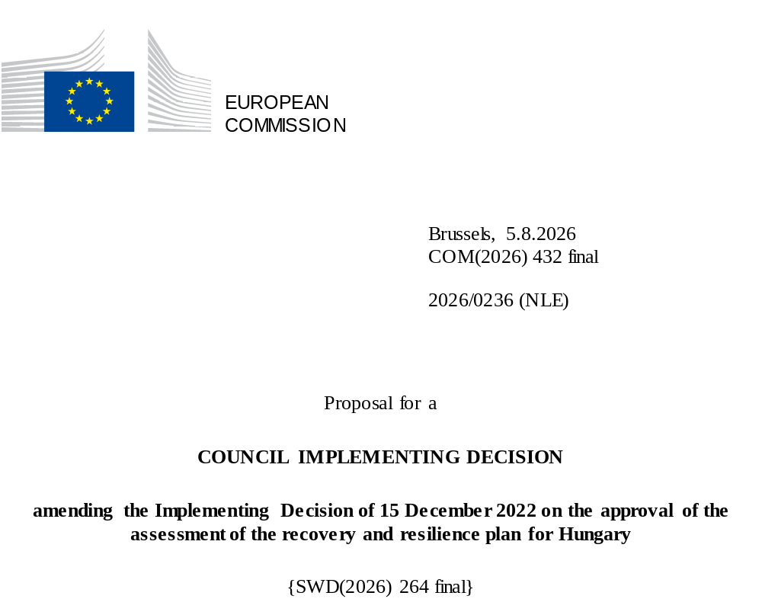

2026/0236 (NLE)
Proposal for a
COUNCIL IMPLEMENTING DECISION
amending the Implementing Decision of 15 December 2022 on the approval of the assessment of the recovery and resilience plan for Hungary
THE COUNCIL OF THE EUROPEAN UNION,
Having regard to the Treaty on the Functioning of the European Union,
Having regard to Regulation (EU) 2021/241 of the European Parliament and of the Council of 12 February 2021 establishing the Recovery and Resilience Facility, and in particular Article 20(1) thereof,
Having regard to the proposal from the European Commission,
Whereas:
(1) Following the submission of the national recovery and resilience plan (‘RRP’) by Hungary on 11 May 2021, the Commission proposed its positive assessment to the Council. On 15 December 2022, the Council approved the positive assessment by means of an implementing decision (‘the Council Implementing Decision of 15 December 2022’). The Council Implementing Decision of 15 December 2022 was amended by the Council Implementing Decisions of 8 December 2023 and 10 July 2026.
(2) On 25 July 2026, Hungary made a reasoned request to the Commission to make a proposal to amend the Council Implementing Decision of 15 December 2022 in accordance with Article 21(1) of Regulation (EU) 2021/241 on the grounds that the RRP is partially no longer achievable because of objective circumstances. On that basis, Hungary has submitted an amended RRP.
Amendments based on Article 21 of Regulation (EU) 2021/241
(3) The amendments to the RRP submitted by Hungary because of objective circumstances concern 36 measures.
(4) Hungary has explained that one measure is no longer achievable, because the investment cannot be finalised within the timeframe of the RRF. This concerns investment 2 (Supporting the education of students with special education needs) of component 1 (Demography and public education). On this basis, Hungary has requested that the measure be removed. The Council Implementing Decision of 15 December 2022 should be amended accordingly.
(5) Hungary has explained that 35 measures have been amended to implement better alternatives that allow the administrative burden to be reduced and simplify the Council Implementing Decision, while still achieving the objectives of those measures. This concerns investment 1 (Development of competitive public education using 21st century technology), reform 2 (Increasing the attractiveness of the teaching profession) and investment 3 (Modernisation of school infrastructure) of component 1 (Demography and public education); investment 1 (Institutional innovation in higher education), investment 2 (Digitalization and modernisation of higher education infrastructure) and investment 3 (Vocational education and training infrastructure for the 21st century) of component 2 (Highly qualified, competitive workforce); investment 1 (Production and use of renewable energy in disadvantaged settlements), investment 2 (Promoting employment and skills development based on local specificities) and investment 3 (Community-oriented pedagogy) of component 3 (Catching up settlements); reform 1 (Awareness raising – water) and investment 1 (Nature protection) of component 4 (Water management and circular economy); investment 3 (Development of zero-emission bus transport), investment 6 (Boosting the uptake of electric vehicles (EVs)) and reform 2 (Reform of railway services in Hungary) of component 5 (Sustainable green transport); reform 1 (Transformation of electricity regulations), reform 3 (Accelerate the connection of renewable energy projects to the grid), investment 1 (Classic and smart grid development for transmission system operator and distribution system operators), investment 3 (Installation of grid energy storage facilities), investment 4 (Dissemination of smart metering) and investment 5 (Energy efficiency and renewable energy investments in public buildings) of component 6 (Energy – green transition); investment 3 (Development of primary health care) of component 7 (Health); reform 4 (Introduction of a specific procedure in the case of special crimes related to the exercise of public authority or the management of public property (‘judicial review’)), reform 11 (Development of the Electronic Public Procurement System (EPS) to increase transparency), reform 18 (Legislative amendments strengthening the management, monitoring and audit and control mechanisms to guarantee the sound use of Union support), reform 20 (The Arachne system for Union support), reform 21 (Establishment of a Directorate of Internal Audit and Integrity to reinforce the control of conflicts of interest when implementing Union support), reform 26 (Improving the quality of law-making and effective involvement of stakeholders and social partners in decision-making) and reform 31 (Simplifying the tax system by reducing the number of taxes) of component 8 (Governance and public administration); reform 3 (Strengthening the role of aggregators), reform 5 (Opening the regulatory reserve markets to encourage competition), reform 6 (Expanding energy communities) and reform 8 (Amendment(s) to legal act(s) on geothermal energy) of component 9 (REPowerEU); reform 1 (Governance reform of Magyar Fejlesztési Bank) and investment 1 (Equity injection into Magyar Fejlesztési Bank (MFB)) of component 10 (Business environment) and investment 1 (E-government services) of component 11 (Digital innovation). On this basis, Hungary has requested that those measures be amended. The Council Implementing Decision of 15 December 2022 should be amended accordingly.
(6) Following the decrease in the level of implementation of one measure in accordance with Article 21 of Regulation (EU) 2021/241, Hungary has requested to use the resources freed up by the decrease in the level of their implementation to increase the level of implementation of one measure. This concerns investment 2 (Support for the use of residential solar panels and heating modernisation) of component 6 (Energy – green transition). On this basis, Hungary has requested that the level of implementation of one measure be increased. The Council Implementing Decision of 15 December 2022 should be amended accordingly.
Corrections of clerical errors
(7) Three clerical errors have been identified in the text of the Council Implementing Decision, affecting three milestones and three measures under one component. The Council Implementing Decision should be amended to correct these clerical errors that do not reflect the content of the RRP submitted to the Commission on 9 June 2026, as agreed between the Commission and Hungary. Those clerical errors relate to milestone 61 of reform 5 (Amendment of rules related to asset declarations), milestone 65 of reform 9 (Reducing the share of single-bid public procurement procedures), milestone 77 of reform 19 (Anti-fraud and anti-corruption strategy for the implementation, audit and control of Union support) under component 8 (Governance and public administration). Those corrections do not affect the implementation of the measures concerned.
Commission’s assessment
(8) The Commission has assessed the amended RRP against the assessment criteria laid down in Article 19(3) of Regulation (EU) 2021/241.
(9) The Commission considers that the amendments put forward by Hungary do not affect the positive assessment of the RRP set out in the Council Implementing Decision of 15 December 2022 regarding the relevance, effectiveness, efficiency and coherence of the RRP against the assessment criteria laid down in Article 19(3) of Regulation (EU) 2021/241 points (a), (b), (c), (d), (da), (db), (f), (g), (h), (i), (j) and (k).
Contribution to the green transition including biodiversity
(10) In accordance with Article 19(3), point (e), of, and criterion 2.5 of Annex V to, Regulation (EU) 2021/241, the amended RRP contains measures that contribute to a large extent (rating A) to the green transition, including biodiversity, or to addressing the challenges resulting therefrom. The measures supporting climate objectives account for an amount which represents 53.08% of the amended RRP’s total allocation and 100% of the total estimated costs of measures in the REPowerEU chapter calculated in accordance with the methodology set out in Annex VI to Regulation (EU) 2021/241. In accordance with Article 17 of Regulation (EU) 2021/241, the amended RRP is consistent with the information included in the National Energy and Climate Plan 2021-2030.
(11) The Hungarian RRP continues to substantially contribute to the green transition including biodiversity by providing support to deployment of renewable energy sources and energy storage, modernisation of transmission networks, energy efficiency measures, electrification of transport modalities and to climate mitigation and water retention interventions. The upscaling of investment 2 (Support for the use of residential solar panels and heating modernisation) of component 6 (Energy – green transition) further increased the climate ambition of the RRP, therefore, the revised RRP continues to comply with this criterion.
Positive assessment
(12) Following the positive assessment by the Commission of the amended RRP, with the finding that the RRP satisfactorily complies with the criteria for assessment set out in Regulation (EU) 2021/241, in accordance with Article 20(2) of and Annex V to that Regulation, the reforms and investment projects necessary for the implementation of the amended RRP, the relevant milestones, targets and indicators, and the amount made available from the Union for the implementation of the amended RRP should be set out.
Financial contribution
(13) The estimated total costs of Hungary’s amended RRP is EUR 10 000 000 000. As the amount of the estimated total cost of the amended RRP is higher than the updated maximum financial contribution available for Hungary, the financial contribution determined in accordance with Article 4a of Regulation (EU) 2021/1755 of the European Parliament and of the Council, and with Article 20(4) and Article 21a(6) of Regulation (EU) 2021/241 that is allocated for Hungary’s amended RRP should be equal to EUR 6 511 661 435. Therefore, the financial contribution made available to Hungary remains unchanged.
Loans
(14) The loan support made available to Hungary amounting to EUR 3 488 338 565 remains unchanged.
(15) The Council Implementing Decision of 15 December 2022 should therefore be amended accordingly. For the sake of clarity, the Annex to the Council Implementing Decision of 15 December 2022 should be replaced entirely.
(16) This Decision should be without prejudice to the outcome of any procedures relating to the award of Union funds under any Union programme other than the Facility or to procedures relating to distortions of the operation of the internal market that may be undertaken, in particular under Articles 107 and 108 of the Treaty. It does not override the requirement for Member States to notify instances of potential State aid to the Commission under Article 108 of the Treaty,
HAS ADOPTED THIS DECISION:
Article 1
Approval of the assessment of the RRP
The assessment of the amended RRP for Hungary on the basis of the criteria provided for in Article 19(3) of Regulation (EU) 2021/241 is approved.
Article 2
Amendments
The Council Implementing Decision of 15 December 2022 on the approval of the assessment of the recovery and resilience plan for Hungary is amended as follows:
the Annex is replaced by the text set out in the Annex to this Decision.
Article 3
Addressee
This Decision is addressed to Hungary.
Done at Brussels,
For the Council
The President

OJ L 57, 18.2.2021, p. 17, ELI: https://eur-lex.europa.eu/eli/reg/2021/241/oj.
ST 15447/22 INIT; ST 15447/22 ADD 1.
ST 15964/23 REV 1; ST 15964/23 REV 2 (bg); ST 15964/23 ADD 1.
ST 10914/26 INIT; ST 10914/26 ADD 1.
Regulation (EU) 2021/1755 of the European Parliament and of the Council of 6 October 2021 establishing the Brexit Adjustment Reserve (OJ L 357, 8.10.2021, p. 1, ELI: http://data.europa.eu/eli/reg/2021/1755/oj).

