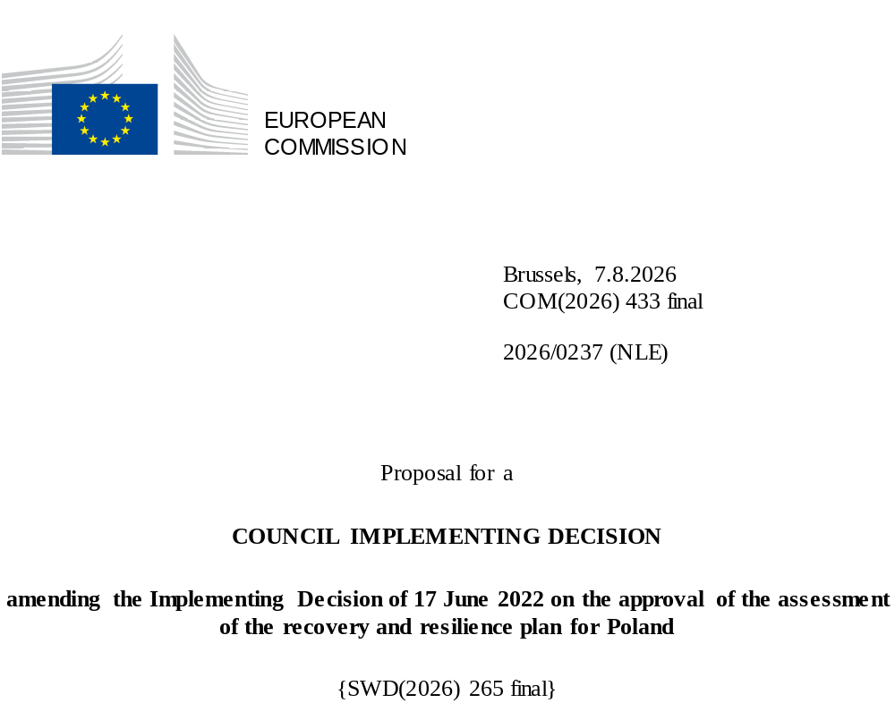

2026/0237 (NLE)
Proposal for a
COUNCIL IMPLEMENTING DECISION
amending the Implementing Decision of 17 June 2022 on the approval of the assessment of the recovery and resilience plan for Poland
THE COUNCIL OF THE EUROPEAN UNION,
Having regard to the Treaty on the Functioning of the European Union,
Having regard to Regulation (EU) 2021/241 of the European Parliament and of the Council of 12 February 2021 establishing the Recovery and Resilience Facility, and in particular Article 20(1) thereof,
Having regard to the proposal from the European Commission,
Whereas:
(1) Following the submission of the national recovery and resilience plan (‘RRP’) by Poland on 3 May 2022, the Commission proposed its positive assessment to the Council. On 17 June 2022, the Council approved the positive assessment by means of an implementing decision (‘the Council Implementing Decision of 17 June 2022’). The Council Implementing Decision of 17 June 2022 was amended by the Council Implementing Decisions of 8 December 2023, 16 July 2024, 20 June 2025, 12 December 2025 and 12 June 2026.
(2) On 15 July 2026, Poland made a reasoned request to the Commission to make a proposal to amend the Council Implementing Decision of 17 June 2022 in accordance with Article 21(1) of Regulation (EU) 2021/241 on the grounds that the RRP is partially no longer achievable because of objective circumstances. On that basis, Poland has submitted an amended RRP.
Amendments based on Article 21 of Regulation (EU) 2021/241
(3) The amendments to the RRP submitted by Poland because of objective circumstances concern 29 measures.
(4) Poland has explained that six measures are partially no longer achievable due to difficult winter weather conditions, unexpected contract cancellations, project delays and lack of demand. This concerns A1.3.1 Implementation of the land-use planning reform, B1.1.5 Investments in energy efficiency of multi-apartment residential buildings, B2.2.3 Construction works for upgrading / extending facilities in the ports of Łeba, Ustka and Darłowo, B3.5.1 Investment in housing projects, C1.1.1 Access to broadband network, E3.1.1 Facility for support of a low-carbon economy. On this basis, Poland has requested that those measures be amended. The Council Implementing Decision of 17 June 2022 should be amended accordingly.
(5) Poland has explained that two measures have been amended to implement better alternatives in order to achieve their original ambition. This concerns D1.1 Improving the effectiveness, accessibility and quality of health services, and E1.1.2 Zero and low-emission buses and trams. On this basis, Poland has requested that those measures be amended. The Council Implementing Decision of 17 June 2022 should be amended accordingly.
(6) Poland has explained that 17 measures have been amended to implement better alternatives that allow the administrative burden to be reduced and simplify the Council Implementing Decision, while still achieving the objectives of those measures. This concerns A1.2.1 Projects aimed at diversifying business activities, A1.4.1 Modernisation of infrastructure or equipment in the agricultural sector, A2.1.1 Investments supporting robotisation or digitalisation in enterprises, A2.6.1 Investment in the National Satellite Information System (NSIS) and satellites, B3.4.1 Investments in a green transformation of cities, C2.2.1 Digital technologies in teaching, C3.1.1 Cybersecurity – CyberPL, infrastructure of data processing and optimization of the infrastructure of law enforcement services, D1.1.1 Modernisation of highly specialised care centres and other healthcare providers, D1.1.2 Digital transformation of healthcare, D2.1.1 Investments related to the modernisation and retrofitting of teaching facilities and increasing admissions to medical studies, D3.1.1 Comprehensive development of research in the field of medical sciences and health sciences, E1.1 Increase in the use of environmentally friendly transport, E2.1.1 Railways lines, E2.1.3 Intermodal projects, E2.2.1 Transport safety investments, G1.1.4 Support to institutions implementing REPowerEU reforms and investments, G1.2.4 Construction or modernisation of electricity distribution networks. On this basis, Poland has requested that those measures be amended. The Council Implementing Decision of 17 June 2022 should be amended accordingly.
(7) Following the decrease in the level of implementation of measures in accordance with Article 21 of Regulation (EU) 2021/241, Poland has requested to increase the level of implementation of four measures. This concerns C2.1.1 Public e-services and IT solutions for public administration, C4.1.1 Support for advanced digital transformation, E2.1.2 Railways passenger rolling stock and G1.2.3 Transmission networks and smart electricity infrastructure. On this basis, Poland has requested that the level of implementation of four measures be increased. The Council Implementing Decision of 17 June 2022 should be amended accordingly.
Commission’s assessment
(8) The Commission has assessed the amended RRP against the assessment criteria laid down in Article 19(3) of Regulation (EU) 2021/241.
Contribution to the green transition including biodiversity
(9) In accordance with Article 19(3), point (e), of, and criterion 2.5 of Annex V to, Regulation (EU) 2021/241, the amended RRP contains measures that contribute to a large extent (rating A) to the green transition, including biodiversity, or to addressing the challenges resulting therefrom. The measures supporting climate objectives account for an amount which represents 40.29% of the amended RRP’s total allocation and 68.34% of the total estimated costs of measures in the REPowerEU chapter calculated in accordance with the methodology set out in Annex VI to Regulation (EU) 2021/241.
(10) In accordance with Article 17 of Regulation (EU) 2021/241, the amended RRP is consistent with the information set out in the recently submitted National Energy and Climate Plan for 2021–2030, notwithstanding its late submission. The modification of the amended RRP does not materially impact its ambition towards the climate transition. Despite the amendments, the amended RRP continues to significantly contribute to climate change mitigation with interventions in renewable energy production and distribution, energy efficiency, decarbonisation of buildings and zero emission transport.
(11) The measures in the amended RRP continue to significantly contribute to the green transition. The climate contribution of the amended RRP has increased from 40.05% to 40.29% compared to the previous assessment. The increase in the contribution to climate objectives reflects the increase in the level of implementation of measures E2.1.2 Railways passenger rolling stock and G1.2.3 Transmission networks and smart electricity infrastructure. The limited scope of these amendments does not change the overall assessment of this criterion.
Contribution to the digital transition
(12) In accordance with Article 19(3), point (f), of, and criterion 2.6 of Annex V to, Regulation (EU) 2021/241, the amended RRP contains measures that contribute to a large extent (rating A) to the digital transition or to addressing the challenges resulting from it. The measures supporting digital objectives account for an amount which represents 21.28% of the amended RRP’s total allocation calculated in accordance with the methodology set out in Annex VII to that Regulation.
(13) The measures in the amended RRP continue to significantly contribute to the digital transition. The digital contribution of the amended RRP has decreased from 21.30 % to 21.28% compared to the previous assessment. The decrease in the contribution to digital objectives reflects the decrease in the level of implementation of measure C1.1.1 Access to broadband network. The limited scope of these amendments does not change the overall assessment of this criterion.
Costing
(14) In accordance with Article 19(3), point (i), of, and criterion 2.9 of Annex V to, Regulation (EU) 2021/241, the justification provided in the amended RRP on the amount of the estimated total cost of the RRP is to a medium extent (rating B) reasonable and plausible, is in line with the principle of cost efficiency and is commensurate to the expected national economic and social impact.
(15) Poland has provided cost estimates for all types of measures under its amended RRP that entail a cost. Overall, the methodology and the assumptions used to reach the cost estimates are clear and understandable, very often based on previous projects financed by the cohesion policy funds. In some cases, details on the methodology and assumptions used to make the cost estimates are limited, hindering a full positive assessment of the cost estimates. Poland has also provided detailed supporting documentation for most types of interventions to underpin the justification and the evidence relating to the cost estimates. Poland has provided sufficient information and assurance that the cost of its amended RRP is not covered by other Union financing. Finally, the estimated total cost of the amended RRP is in line with the principle of cost-efficiency and is commensurate with the expected national economic and social impact.
Any other assessment criteria
(16) The Commission considers that the amendments put forward by Poland do not affect the positive assessment of the RRP set out in the Council Implementing Decision of 17 June 2022 on the approval of the assessment of the RRP for Poland regarding the relevance, effectiveness, efficiency and coherence of the RRP against the assessment criteria laid down in Article 19(3), points (a), (b), (c), (d), (da), (db), (g), (h), (j) and (k).
Measures supporting investment operations contributing to the objectives of the Strategic Technologies for Europe Platform (STEP)
(17) In accordance with Article 4(4) of Regulation (EU) 2024/795, Poland considered as a matter of priority projects that have been awarded a Sovereignty Seal pursuant to Article 4(1) of Regulation (EU) 2024/795. However, Poland considered that no project having been awarded a Sovereignty Seal was to be included in the amended RRP because of insufficient time to complete such projects before the end date of the Recovery and Resilience Facility.
Positive assessment
(18) Following the positive assessment by the Commission of the amended RRP, with the finding that the RRP satisfactorily complies with the criteria for assessment set out in Regulation (EU) 2021/241, in accordance with Article 20(2) of and Annex V to that Regulation, the reforms and investment projects necessary for the implementation of the amended RRP, the relevant milestones, targets and indicators, and the amount made available from the Union for the implementation of the amended RRP should be set out.
Financial contribution
(19) The estimated total costs of Poland’s amended RRP is EUR 54 718 157 234. As the amount of the estimated total cost of the amended RRP is higher than the updated maximum financial contribution available for Poland, the financial contribution determined in accordance with Article 4a of Regulation (EU) 2021/1755 of the European Parliament and of the Council, and with Article 20(4) and Article 21a(6) of Regulation (EU) 2021/241 that is allocated for Poland’s amended RRP should be equal to EUR 25 276 853 716. Therefore, the financial contribution made available to Poland remains unchanged.
Loans
(20) The loan support made available to Poland amounting to EUR 29 441 303 518 remains unchanged.
(21) The Council Implementing Decision of 17 June 2022 should therefore be amended accordingly. For the sake of clarity, the Annex to the Council Implementing Decision of 17 June 2022 should be replaced entirely.
(22) This Decision should be without prejudice to the outcome of any procedures relating to the award of Union funds under any Union programme other than the Facility or to procedures relating to distortions of the operation of the internal market that may be undertaken, in particular under Articles 107 and 108 of the Treaty. It does not override the requirement for Member States to notify instances of potential State aid to the Commission under Article 108 of the Treaty,
HAS ADOPTED THIS DECISION:
Article 1
Approval of the assessment of the RRP
The assessment of the amended RRP for Poland on the basis of the criteria provided for in Article 19(3) of Regulation (EU) 2021/241 is approved.
Article 2
Amendments
The Council Implementing Decision of 17 June 2022 on the approval of the assessment of the recovery and resilience plan for Poland is amended as follows:
the Annex is replaced by the text set out in the Annex to this Decision.
Article 3
Addressee
This Decision is addressed to the Republic of Poland.
Done at Brussels,
For the Council
The President

OJ L 57, 18.2.2021, p. 17, ELI: https://eur-lex.europa.eu/eli/reg/2021/241/oj.
ST 9728/22 INIT; ST 9728/22 ADD 1.
ST 15835/23 INIT; ST 15835/23 REV 1; ST 15835/23 ADD 1.
ST 11805/24 INIT; ST 11805/24 ADD 1.
ST 9590/25 INIT; ST 9590/25 ADD 1.
ST 15795/25 INIT; ST 15795/25 ADD 1; ST 15795/25 ADD 1 REV 1 (pl).
ST 9521/26 INIT; ST 9521/26 ADD 1.
Regulation (EU) 2021/1755 of the European Parliament and of the Council of 6 October 2021 establishing the Brexit Adjustment Reserve (OJ L 357, 8.10.2021, p. 1, ELI: http://data.europa.eu/eli/reg/2021/1755/oj).

