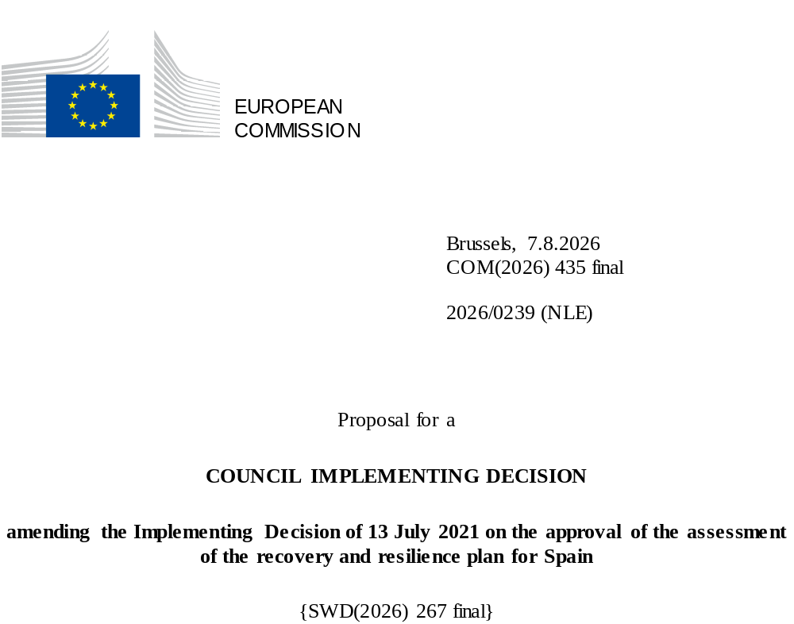

2026/0239 (NLE)
Proposal for a
COUNCIL IMPLEMENTING DECISION
amending the Implementing Decision of 13 July 2021 on the approval of the assessment of the recovery and resilience plan for Spain
THE COUNCIL OF THE EUROPEAN UNION,
Having regard to the Treaty on the Functioning of the European Union,
Having regard to Regulation (EU) 2021/241 of the European Parliament and of the Council of 12 February 2021 establishing the Recovery and Resilience Facility, and in particular Article 20(1) thereof,
Having regard to the proposal from the European Commission,
Whereas:
(1) Following the submission of the national recovery and resilience plan (‘RRP’) by Spain on 3 April 2021, the Commission proposed its positive assessment to the Council. On 13 July 2021, the Council approved the positive assessment by means of an implementing decision (‘the Council Implementing Decision of 13 July 2021’). The Council Implementing Decision of 13 July 2021 was amended by the Council Implementing Decisions of 17 October 2023, 14 May 2024, 21 January 2025, 13 May 2025, 12 June 2025, 10 October 2025, 20 January 2026, and 12 June 2026.
(2) On 11 July 2026, Spain made a reasoned request to the Commission to make a proposal to amend the Council Implementing Decision of 13 July 2021 in accordance with Article 21(1) of Regulation (EU) 2021/241 on the grounds that the RRP is partially no longer achievable because of objective circumstances. On that basis, Spain has submitted an amended RRP.
Amendments based on Article 21 of Regulation (EU) 2021/241
(3) The amendments to the RRP submitted by Spain because of objective circumstances concern 96 measures.
(4) Spain has explained that one measure is partially no longer achievable because of inflation. This concerns measure C2.I2 (Programme to support the construction of social rental housing in energy efficient buildings). On this basis, Spain has requested that this measure be amended. The Council Implementing Decision of 13 July 2021 should be amended accordingly.
(5) Spain has explained that 11 measures have been amended due to lack of demand. This concerns measures C2.I7 (ICO Loan Facility for the Promotion of Social Housing), C12.I7 (Support scheme to strategic projects in the value chain of electric cars (loans)), C13.I3 (Digitalisation and Innovation and subsidy scheme for the digitalisation of companies), C13.I7 (Next Tech Fund), C13.I13 (Regional Resilience Fund (FRA)), C14.I4 (Special actions in the field of competitiveness), C15.I9 (CHIP Financing Facility), C16.R1 (National AI Strategy), C25.I3 (Audiovisual Hub Fund), C31.I3 (Subsidy scheme to support the decarbonisation of the industrial sector and value chain of renewable energy sources and storage), and C32.I3 (Employment opportunities for working people for the reconstruction and socio-economic revitalization of the territories affected by the DANA). On this basis, Spain has requested that those measures be amended. The Council Implementing Decision of 13 July 2021 should be amended accordingly.
(6) Spain has explained that 48 measures have been amended to implement better alternatives that allow the administrative burden to be reduced and simplify the Council Implementing Decision of 13 July 2021, while still achieving the objectives of those measures. This concerns measures C1.I1 (Low-emission areas and transformation of urban and metropolitan transport), C2.I1 (Rehabilitation programme for economic and social recovery in residential environments), C2.I4 (Regeneration programme and demographic challenge), C3.I4 (Plan to boost the sustainability and competitiveness of agriculture and livestock farming (III): Investments in precision agriculture, energy efficiency or circular economy in the agriculture and livestock sector), C4.I1 (Digitalisation and Knowledge of natural heritage), C4.I2 (Conservation of terrestrial and marine biodiversity), C4.I3 (Restoration of ecosystems and green infrastructure), C4.I4 (Sustainable forest management), C5.I1 (Treatment, sanitation, efficiency, savings, re-use and infrastructure safety (DSEAR) actions), C5.I2 (Restoration of river ecosystems, water infrastructure and flood risk mitigation), C5.I3 (Digital transition in the water sector (Digital Environmental Enforcement) – Strategic project for economic recovery and transformation (PERTE) for the digitalisation of water uses), C5.I4 (Adapting the coastline to climate change), C6.I2 (Trans-European Network for Transport Program, other works), C6.I3 (Intermodality and logistics), C6.I4 (Support programme for sustainable and digital transport), C7.I1 (Development of renewable energies and storage), C7.R3 (Development of energy communities), C10.I1 (Investment in Just Transition), C11.I3 (Digital transformation and modernisation of the Ministry of Territorial Policy and Democratic Memory, Ministry of Digital Transformation and Public Service, and the regional and local administrations, as well as the National Health Service), C11.I4 (Energy transition plan in the General State Administration), C12.I2 (Programme to boost competitiveness and industrial sustainability), C12.I3 (Plan to support the implementation of waste legislation and the promotion of the circular economy), C13.I1 (Entrepreneurship), C14.I1 (Transformation of the tourism model towards sustainability), C15.I6 (5G Deployment: networks, technological change and innovation), C17.I2 (Research infrastructure), C17.I5 (Knowledge transfer), C17.I6 (Health), C17.I7 (Environment, Climate change and energy), C17.I11 (Voluntary contribution to ESA for the FutureNav, EU Secure Connectivity and European Launcher Challenge Programmes), C18.I2 (Public health campaigns and actions), C18.I3 (Increased capacities to respond to health crises), C18.I4 (Training of health professionals and improving the treatment of patients with rare diseases), C18.I5 (Plan to rationalise the consumption of pharmaceuticals and promote sustainability, and expand the portfolio of genomic services in the National Health System), C18.I6 (National Health Data Space), C19.I2 (Digital transformation of education), C19.I3 (Digital skills for employment), C20.I2 (Digital transformation of vocational training), C21.I1 (Promoting early childhood education and care (ECEC)), C23.I1 (Youth Employment), C23.I2 (Female employment and gender mainstreaming in active labour market policies), C24.I1 (Strengthening the competitiveness of cultural industries), C24.I2 (Boosting culture across the territory), C25.I1 (Program for the promotion, modernisation and digitalisation of the audio visual sector), C26.I2 (Ecological transition of sports facilities), C31.I1 (Investment promoting self-consumption (based on renewable energy and behind-the-meter storage)), C32.I1 (Green and sustainable mobility and infrastructure), and C32.I4 (Preventing and combating natural disasters: new Spanish component of the Atlantic constellation (ESCA+)). On this basis, Spain has requested that those measures be amended. The Council Implementing Decision of 13 July 2021 should be amended accordingly.
(7) Spain has explained that 30 measures have been amended due to the existence of better alternatives to implement the measures. This concerns measures C3.I1 (Plan to enhance efficiency and sustainability in irrigation), C3.I12 (Plan to enhance efficiency and sustainability in irrigation), C7.I2 (Sustainable energy in islands), C9.I1 (Scheme to support renewable hydrogen, a country project), C11.R1 (Reform for the modernisation and digitalisation of the administration), C12.I1 (Sectoral data spaces to digitise sectors and R&D&I actions), C13.I14 (Equity injection into ICO), C13.I15 (Equity injection into ICO), C15.I1 (Ultra-fast broadband extension), C15.I5 (Deployment of cross-border digital infrastructure), C15.I7 (Cybersecurity: Enhancing the capacities of citizens, SMEs and professionals; improving the sector’s ecosystem), C15.I8 (PERTE Chip: Enhancing the scientific and technological ecosystem. Increased design capabilities ), C19.I1 (Transversal digital skills), C20.I3 (Offer expansion and internationalisation of vocational training), C21.I3 (Support to vulnerable students), C22.R2 (Modernising public social services and giving them a new regulatory framework), C22.I1 (Long-term care and support plan: deinstitutionalisation, equipment and technology), C22.I2 (Plan for the Modernisation of Social Services - Technological transformation, innovation, training and strengthening childcare), C22.I4 (Plan Spain protects you from violence against women), C22.I5 (Construction, acquisition, or refurbishment of reception centres for migrants and applicants of international protection), C23.I3 (New skills for the green, digital and productive transition ), C23.I4 (Projects for rebalancing and equity), C25.I2 (PERTE “New Economy of Language”: Information in Spanish and other co official languages), C28.I1 (Tax deductions declared for the purchase of EVs or the installation of charging stations), C31.I2 (Scheme to support the production and uptake of renewable hydrogen), C31.I5 (Investment to support industrial decarbonisation (grants)), C31.I6 (Subsidy scheme for decarbonisation projects (grants)), and C31.I9 (Scheme to support the Green Transition). Additionally, Spain has identified a better alternative that is more conducive to meet the objectives of the RRF Regulation and the RRP assessment criteria. Specifically, Spain has proposed to replace one measure (C28.R2, Tax benefits reform) that addressed a CSR with one new measure (C8.R5, Entry into force of legislation contributing to green transition) and one new milestone (402a, Publication of spending review studies of the new cycle (2022-2026) in measure C29.R1 (Public spending review and evaluation process) which address two CSRs. By putting forward replacement measures that address a greater number of CSRs, the RRP ensures a greater coverage of the challenges identified in the relevant CSRs. Furthermore, the replacement of one measure with two that address CSRs contributes to the RRP representing a more a comprehensive and adequately balanced response to the economic and social situation of the Member State, ensuring that it contributes appropriately to all pillars referred to in Article 3 of the RRF Regulation. On this basis, Spain has requested that those measures be amended. The Council Implementing Decision of 13 July 2021 should be amended accordingly.
(8) Spain has explained that five measures are partially no longer achievable because of supply chain constraints and unexpected technical difficulties. This concerns measures C13.I12 (ENISA Entrepreneurship and SME Fund), C15.I3 (Connectivity vouchers for SMEs and individuals), C26.I1 (Digitalisation of the sports sector), C32.I2 (Restoration of water, environmental and agricultural infrastructure), and C32.I6 (ICO support scheme for companies affected by the change in global tariff environment). On this basis, Spain has requested that those measures be amended. The Council Implementing Decision of 13 July 2021 should be amended accordingly.
(9) Spain has explained that measure C31.I4 (Investment to support electricity network infrastructure) is no longer achievable within the timeline envisaged because of the need to follow verification procedures that are lengthier than initially planned. On this basis, Spain has requested that this measure be amended. The Council Implementing Decision of 13 July 2021 should be amended accordingly.
(10) Following the removal of one measure and the decrease in the level of implementation of 30 measures in accordance with Article 21 of Regulation (EU) 2021/241, Spain has requested to use the resources freed up by the decrease in the level of their implementation to increase the level of implementation of 11 measures and to add a new measure and a new milestone. This concerns the removal of measure C28.R2 and a decrease in measures C2.I2 (Programme to support the construction of social rental housing in energy efficient buildings), C3.I12 (Plan to enhance efficiency and sustainability in irrigation) C2.I7 (ICO Loan Facility for the Promotion of Social Housing), C9.I1 (Scheme to support renewable hydrogen, a country project), C12.I7 (Support scheme to strategic projects in the value chain of electric cars (loans)), C13.I3 (Digitalisation and Innovation and subsidy scheme for the digitalisation of companies), C13.I7 (Next Tech Fund), C13.I12 (ENISA Entrepreneurship and SME Fund), C13.I13 (Regional Resilience Fund (FRA)), C13.I15 (Equity injection into ICO), C14.I4 (Special actions in the field of competitiveness), C15.I3 (Connectivity vouchers for SMEs and individuals), C15.I7 (Cybersecurity: Enhancing the capacities of citizens, SMEs and professionals; improving the sector’s ecosystem), C15.I8 (PERTE Chip: Enhancing the scientific and technological ecosystem. Increased design capabilities), C15.I9 (CHIP Financing Facility), C16.R1 (National AI Strategy), C19.I1 (Transversal digital skills), C20.I3 (Offer expansion and internationalisation of vocational training), C21.I3 (Support to vulnerable students), C22.I2 (Plan for the Modernisation of Social Services - Technological transformation, innovation, training and strengthening childcare), C22.I5 (Construction, acquisition, or refurbishment of reception centres for migrants and applicants of international protection), C23.I4 (Projects for rebalancing and equity), C25.I3 (Audiovisual Hub Fund), C26.I1 (Digitalisation of the sports sector), C31.I3 (Subsidy scheme to support the decarbonisation of the industrial sector and value chain of renewable energy sources and storage), C31.I4 (Investment to support electricity network infrastructure), C31.I5 (Investment to support industrial decarbonisation (grants)), C32.I2 (Restoration of water, environmental and agricultural infrastructure), C32.I3 (Employment opportunities for working people for the reconstruction and socio-economic revitalization of the territories affected by the DANA), C32.I6 (ICO support scheme for companies affected by the change in global tariff environment), an increase in measures C2.I1 (Rehabilitation programme for economic and social recovery in residential environments), C3.I1 (Plan to enhance efficiency and sustainability in irrigation ), C12.I1 (Sectoral data spaces to digitise sectors and R&D&I actions), C13.I14 (Equity injection into ICO), C15.I1 (Ultra-fast broadband extension), C22.I1 (Long-term care and support plan: deinstitutionalisation, equipment and technology), C25.I2 (PERTE “New Economy of Language”: Information in Spanish and other co official languages), C28.I1 (Tax deductions declared for the purchase of EVs or the installation of charging stations), C31.I2 (Scheme to support the production and uptake of renewable hydrogen), C31.I6 (Subsidy scheme for decarbonisation projects (grants)), and C31.I9 (Scheme to support the Green Transition), the new measure C8.R5 (Entry into force of legislation contributing to green transition) and the new milestone 402a (Publication of spending review studies of the new cycle (2022-2026)). On this basis, Spain has requested that [one new measure, and one new milestone are added and that the level of implementation of 11 measures be increased. The Council Implementing Decision of 13 July 2021 should be amended accordingly.
Distribution of milestones and targets
(11) The distribution of milestones and targets in instalments should be amended to take into account the amendments to the RRP and the indicative timeline presented by Spain.
Commission’s assessment
(12) The Commission has assessed the amended RRP against the assessment criteria laid down in Article 19(3) of Regulation (EU) 2021/241.
(13) The Commission considers that the amendments put forward by Spain do not affect the positive assessment of the RRP set out in the Council Implementing Decision of 13 July 2021 regarding the relevance, effectiveness, efficiency and coherence of the RRP against the assessment criteria laid down in Article 19(3) of Regulation (EU) 2021/241 points (a), (b), (c), (d), (da), (db), (g), (j) and (k).
Contribution to the green transition including biodiversity
(14) In accordance with Article 19(3), point (e), of, and criterion 2.5 of Annex V to, Regulation (EU) 2021/241, the amended RRP contains measures that contribute to a large extent (rating A) to the green transition, including biodiversity, or to addressing the challenges resulting therefrom. The measures supporting climate objectives account for an amount which represents 37,277% of the amended RRP’s total allocation and 90,974% of the total estimated costs of measures in the REPowerEU chapter calculated in accordance with the methodology set out in Annex VI to Regulation (EU) 2021/241. In accordance with Article 17 of Regulation (EU) 2021/241, the amended RRP is consistent with the information included in the National Energy and Climate Plan 2021-2030.
(15) Overall, the climate tagging content of some measures saw their level of ambition and costing increase whereas other measures saw their level of ambition decrease. In total the amendments to Spain’s RRP entail a net balance in the overall contribution to the climate target of the RRP that remains stable at 37,277%. The measures of the plan are still expected to reduce the greenhouse gas emissions and facilitate the uptake of renewable energy and thus contribute to the attainment of the 2030 climate targets and the objective of the Union climate neutrality by 2050.
Contribution to the digital transition
(16) In accordance with Article 19(3), point (f), of, and criterion 2.6 of Annex V to, Regulation (EU) 2021/241, the amended RRP contains measures that contribute to a large extent (rating A) to the digital transition or to addressing the challenges resulting from it. The measures supporting digital objectives account for an amount which represents 22,578% of the amended RRP’s total allocation calculated in accordance with the methodology set out in Annex VII to that Regulation.
(17) Overall, taking into account the increase in the costing and ambition of some measures with a digital tagging and the decrease of other similar measures, the amendments to Spain’s RRP entail a net increase in the overall contribution to the digital target of the RRP of 1,061 percentage points to 22,578% from 21,517%. The modified RRP continues to significantly contribute to the digital transition, including by increasing digitalisation of the public administration and enterprises as well as increasing the number of digital services for citizens and business.
Monitoring and implementation
(18) In accordance with Article 19(3), point (h), of, and criterion 2.8 of Annex V to, Regulation (EU) 2021/241, the arrangements proposed in the amended RRP are adequate (rating A) to ensure effective monitoring and implementation of the RRP, including the envisaged timetable, milestones and targets, and the related indicators.
(19) In addition to the arrangements previously deemed adequate, Spain has adopted supplementary legal arrangements to ensure the sound financial management and cost-efficiency of the resources received. In particular, where the final eligible expenditure for certain projects financed by grant expenditure at national, regional or local level is lower than the amount initially granted, the resulting available amounts shall be reallocated within the same policy area of the relevant component, in compliance with applicable tagging requirements.
Costing
(20) In accordance with Article 19(3), point (i), of, and criterion 2.9 of Annex V to, Regulation (EU) 2021/241, the justification provided in the amended RRP on the amount of the estimated total cost of the RRP is to a medium extent rating B reasonable and plausible, is in line with the principle of cost efficiency and is commensurate to the expected national economic and social impact.
(21) The amount of the estimated total cost of the amended RRP is in line with the nature and type of the envisaged reforms and investments. As a result, cost estimates for most of the measures in the amended RRP are deemed reasonable and plausible. Spain has provided sufficient information and evidence that the amount of the estimated total cost is not covered by existing or planned Union financing. Finally, the estimated total cost of the amended RRP is in line with the principle of cost efficiency and commensurate with the expected national economic and social impact. Therefore, a rating B is warranted for the amended RRP.
Positive assessment
(22) Following the positive assessment by the Commission of the amended RRP, with the finding that the RRP satisfactorily complies with the criteria for assessment set out in Regulation (EU) 2021/241, in accordance with Article 20(2) of and Annex V to that Regulation, the reforms and investment projects necessary for the implementation of the amended RRP, the relevant milestones, targets and indicators, and the amount made available from the Union for the implementation of the amended RRP should be set out.
Financial contribution
(23) The estimated total costs of Spain’s amended RRP is EUR 101 318 408 928. As the amount of the estimated total cost of the amended RRP is higher than the updated maximum financial contribution available for Spain, the financial contribution determined in accordance with Article 4a of Regulation (EU) 2021/1755 of the European Parliament and of the Council, and with Article 20(4) and Article 21a(6) of Regulation (EU) 2021/241 that is allocated for Spain’s amended RRP should be equal to EUR 79 854 183 024. Therefore, the financial contribution made available to Spain remains unchanged.
Loans
(24) In order to support additional reforms and investments, a total loan support of EUR 83 160 060 000 was made available to Spain by means of Council Implementing Decision of 17 October 2023. Following the removal of C3.I12 (Plan to enhance efficiency and sustainability in irrigation) and the decrease in the level of implementation of C2.I7 (ICO Loan Facility for the Promotion of Social Housing), C12.I7 (Support scheme to strategic projects in the value chain of electric cars (loans)), C13.I7 (Next Tech Fund), C13.I12 (ENISA Entrepreneurship and SME Fund), C13.I13 (Regional Resilience Fund (FRA)), C13.I15 (Equity injection into ICO), C15.I9 (CHIP Financing Facility), and C25.I3 (Audiovisual Hub Fund) under Article 21 of Regulation 2021/241, Spain has not requested to use the freed up loan resources to support new measures or to increase the level of implementation of existing measures within the RRP. The amount of the estimated total costs of the RRP is lower than the combined financial contribution available for Spain and the loan support that had been made available to Spain by means of Council Implementing Decision of 17 October 2023. Therefore, the total loan support made available to Spain should be reduced to EUR 21 448 689 929.
(25) The amount of the financial contribution for Spain should be determined in this decision in accordance with Article 20 of Regulation (EU) 2021/241. However, pursuant to Commission Implementing Decision of 3 August 2026 on the reduction of the amount of the fifth instalment of the non-repayable support for Spain, adopted in accordance with Article 24(8) of Regulation (EU) 2021/241, the financial contribution has been reduced by EUR 197 971 828 and Spain cannot request its disbursement from the Commission.
(26) The Council Implementing Decision of 13 July 2021 should therefore be amended accordingly. For the sake of clarity, the Annex to the Council Implementing Decision of 13 July 2021 should be replaced entirely.
(27) This Decision should be without prejudice to the outcome of any procedures relating to the award of Union funds under any Union programme other than the Facility or to procedures relating to distortions of the operation of the internal market that may be undertaken, in particular under Articles 107 and 108 of the Treaty. It does not override the requirement for Member States to notify instances of potential State aid to the Commission under Article 108 of the Treaty,
HAS ADOPTED THIS DECISION:
Article 1
Approval of the assessment of the RRP
The assessment of the amended RRP for Spain on the basis of the criteria provided for in Article 19(3) of Regulation (EU) 2021/241 is approved.
Article 2
Amendments
The Council Implementing Decision of 13 July 2021 on the approval of the assessment of the recovery and resilience plan for Spain is amended as follows:
(1) in Article 2a, paragraph 1 is replaced by the following:
“1. The Union shall make available to Spain a loan amounting to a maximum of EUR 21 448 689 929.”;
(2) the Annex is replaced by the text set out in the Annex to this Decision.
Article 3
Addressee
This Decision is addressed to the Kingdom of Spain.
Done at Brussels,
For the Council
The President

OJ L 57, 18.2.2021, p. 17, ELI: https://eur-lex.europa.eu/eli/reg/2021/241/oj.
ST 10150/21 INIT; ST 10150/21 ADD 1 REV 2.
ST 13695/23 INIT; ST 13695/23 REV 1 (en); ST 13695/23 ADD 1 REV 1.
ST 9303/24 INIT; ST 9303/24 ADD 1.
ST 17099/24 INIT; ST 17099/24 ADD 1.
ST 8053/25 INIT; ST 8053/25 ADD 1.
ST 9583/25 INIT; ST 9583/25 ADD 1; ST 9583/25 ADD 1 COR 1; ST 10408/25.
ST 13075/25 INIT; ST 13075/25 ADD 1.
ST 17031/25 INIT; ST 17031/25 ADD1; ST 17031/25 ADD 1 COR1 (es).
ST 9518/26 INIT; ST 9518/26 ADD1.
Regulation (EU) 2021/1755 of the European Parliament and of the Council of 6 October 2021 establishing the Brexit Adjustment Reserve (OJ L 357, 8.10.2021, p. 1, ELI: http://data.europa.eu/eli/reg/2021/1755/oj).

