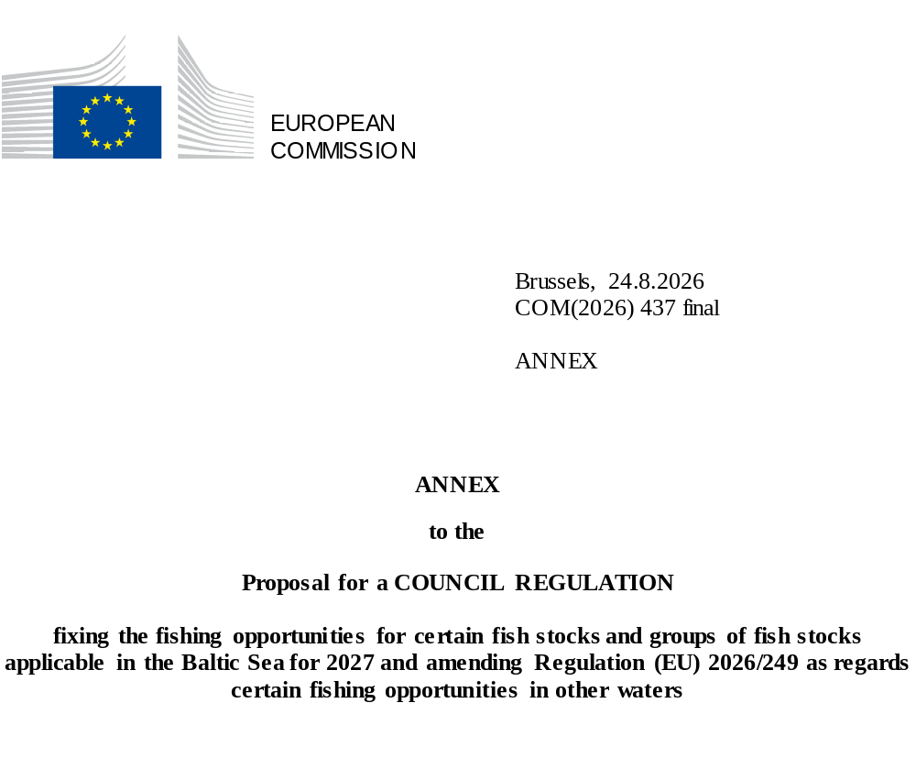

ANNEX
TACs APPLICABLE TO UNION FISHING VESSELS IN AREAS WHERE TACs EXIST BY SPECIES AND BY AREA
The following tables set out the TACs and quotas (in tonnes live weight, except where otherwise specified) by stock and measures functionally linked thereto.
Fish stocks are referred to according to the alphabetical order of the scientific names of the species.
For the purposes of this Regulation, the following comparative table of scientific names and common names is provided:
Scientific name | Alpha-3 code | Common name
Clupea harengus | HER | Herring
Gadus morhua | COD | Cod
Pleuronectes platessa | PLE | Plaice
Salmo salar | SAL | Atlantic salmon
Sprattus sprattus | SPR | Sprat

Table | 1
Species: | Herring |  |  | Zone: | Subdivisions 22-24
 | Clupea harengus |  |  |  | (HER/3BC+24)
Denmark |  | 61 | ⁽¹⁾ | Analytical TAC
Germany |  | 241 | ⁽¹⁾ | Article 3(2) and (3) of Regulation (EC) No 847/96 does not apply.
Finland |  | 0 | ⁽¹⁾ | Article 4 of Regulation (EC) No 847/96 does not apply.
Poland |  | 57 | ⁽¹⁾
Sweden |  | 78 | ⁽¹⁾
Union |  | 437 | ⁽¹⁾
TAC |  | 437 | ⁽¹⁾
⁽¹⁾ | Exclusively for by-catches. No directed fisheries are permitted under this quota.
 | By way of derogation from the first subparagraph, fishing operations conducted for the exclusive purpose of scientific investigations may be directed to herring provided that those investigations are carried out in full compliance with the conditions set out in Article 25 of Regulation (EU) 2019/1241.
Table | 2
Species: | Herring |  |  | Zone: | Union waters of subdivisions 25-27, 28.2, 29 and 32
 | Clupea harengus |  |  |  | (HER/3D-R30)
Denmark |  | 3 165 |  | Analytical TAC
Germany |  | 839 |  | Article 6 of this Regulation applies.
Estonia |  | 16 162
Finland |  | 31 548
Latvia |  | 3 989
Lithuania |  | 4 200
Poland |  | 35 842
Sweden |  | 48 115
Union |  | 143 860
TAC |  | Not relevant
Table | 3
Species: | Herring |  |  | Zone: | Subdivision 28.1
 | Clupea harengus |  |  |  | (HER/03D.RG)
Estonia |  | 17 633 |  | Analytical TAC
Latvia |  | 20 550 |  | Article 6 of this Regulation applies.
Union |  | 38 183
TAC |  | 38 183
Table | 4
Species: | Herring |  |  | Zone: | Subdivisions 30-31
 | Clupea harengus |  |  |  | (HER/30/31.)
Finland |  | 46 985 |  | Analytical TAC
Sweden |  | 10 323
Union |  | 57 308
TAC |  | 57 308
Table | 5
Species: | Cod |  |  | Zone: | Union waters of subdivisions 25-32
 | Gadus morhua |  |  |  | (COD/3DX32.)
Denmark |  | 48 | ⁽¹⁾ | Precautionary TAC
Germany |  | 19 | ⁽¹⁾ | Article 3 of Regulation (EC) No 847/96 does not apply.
Estonia |  | 5 | ⁽¹⁾
Finland |  | 4 | ⁽¹⁾
Latvia |  | 18 | ⁽¹⁾
Lithuania |  | 12 | ⁽¹⁾
Poland |  | 56 | ⁽¹⁾
Sweden |  | 49 | ⁽¹⁾
Union |  | 211 | ⁽¹⁾
TAC |  | Not relevant
⁽¹⁾ | Exclusively for by-catches. No directed fisheries are permitted under this quota.
 | By way of derogation from the first subparagraph, fishing operations conducted for the exclusive purpose of scientific investigations may be directed to herring provided that those investigations are carried out in full compliance with the conditions set out in Article 25 of Regulation (EU) 2019/1241.
Table | 6
Species: | Cod |  |  | Zone: | Subdivisions 22-24
 | Gadus morhua |  |  |  | (COD/3BC+24)
Denmark |  | 13 | ⁽¹⁾ | Precautionary TAC
Germany |  | 7 | ⁽¹⁾ | Article 3 of Regulation (EC) No 847/96 does not apply.
Estonia |  | 0 | ⁽¹⁾
Finland |  | 0 | ⁽¹⁾
Latvia |  | 1 | ⁽¹⁾
Lithuania |  | 1 | ⁽¹⁾
Poland |  | 4 | ⁽¹⁾
Sweden |  | 5 | ⁽¹⁾
Union |  | 31 | ⁽¹⁾
TAC |  | 31 | ⁽¹⁾
⁽¹⁾ | Exclusively for by-catches. No directed fisheries are permitted under this quota.
 | By way of derogation from the first subparagraph, fishing operations conducted for the exclusive purpose of scientific investigations may be directed to herring provided that those investigations are carried out in full compliance with the conditions set out in Article 25 of Regulation (EU) 2019/1241.
Table | 7
Species: | Plaice |  |  | Zone: | Union waters of subdivisions 22-32
 | Pleuronectes platessa |  |  |  | (PLE/3BCD-C)
Denmark |  | 7 861 |  | Analytical TAC
Germany |  | 873 |  | Article 6 of this Regulation applies.
Poland |  | 1 646
Sweden |  | 593
Union |  | 10 973
TAC |  | 10 973
Table | 8
Species: | Atlantic salmon |  |  | Zone: | Union waters of subdivisions 22-31
 | Salmo salar |  |  |  | (SAL/3BCD-F)
Denmark |  | 5 292 | ⁽¹⁾⁽²⁾ | Analytical TAC
Germany |  | 589 | ⁽¹⁾⁽²⁾ | Article 3(2) and (3) of Regulation (EC) No 847/96 does not apply.
Estonia |  | 538 | ⁽¹⁾⁽²⁾⁽³⁾ | Article 4 of Regulation (EC) No 847/96 does not apply.
Finland |  | 6 599 | ⁽¹⁾⁽²⁾
Latvia |  | 3 366 | ⁽¹⁾⁽²⁾
Lithuania |  | 396 | ⁽¹⁾⁽²⁾
Poland |  | 1 605 | ⁽¹⁾⁽²⁾
Sweden |  | 7 152 | ⁽¹⁾⁽²⁾
Union |  | 25 537 | ⁽¹⁾⁽²⁾
TAC |  | Not relevant
⁽¹⁾ | Expressed by number of individual fish.
⁽²⁾ | Exclusively for by-catches. No directed fisheries are permitted under this quota.
 | By way of derogation from the first subparagraph, fishing operations conducted for the exclusive purpose of scientific investigations may be directed to salmon provided that those investigations are carried out in full compliance with the conditions set out in Article 25 of Regulation (EU) 2019/1241.
 | By way of further derogation from the first subparagraph, fishing this quota is permitted for Union fishing vessels north of latitude 59° 30′ N in areas within four nautical miles measured from the baselines during the period from 1 May to 31 August.
⁽³⁾ | Special condition: no more than 450 specimens of this quota may be fished in Union waters of subdivision 32 (SAL/*3D32).
Table | 9
Species: | Atlantic salmon |  |  | Zone: | Union waters of subdivision 32
 | Salmo salar |  |  |  | (SAL/3D32.)
Estonia |  | 1 049 | ⁽¹⁾ | Precautionary TAC
Finland |  | 9 183 | ⁽¹⁾
Union |  | 10 232 | ⁽¹⁾
TAC |  | Not relevant
⁽¹⁾ | Expressed by number of individual fish.
Table | 10
Species: | Sprat |  |  | Zone: | Union waters of subdivisions 22-32
 | Sprattus sprattus |  |  |  | (SPR/3BCD-C)
Denmark |  | 28 763 |  | Analytical TAC
Germany |  | 18 222 |  | Article 6 of this Regulation applies.
Estonia |  | 33 401
Finland |  | 15 057
Latvia |  | 40 340
Lithuania |  | 14 592
Poland |  | 85 610
Sweden |  | 55 605
Union |  | 291 590
TAC |  | Not relevant

