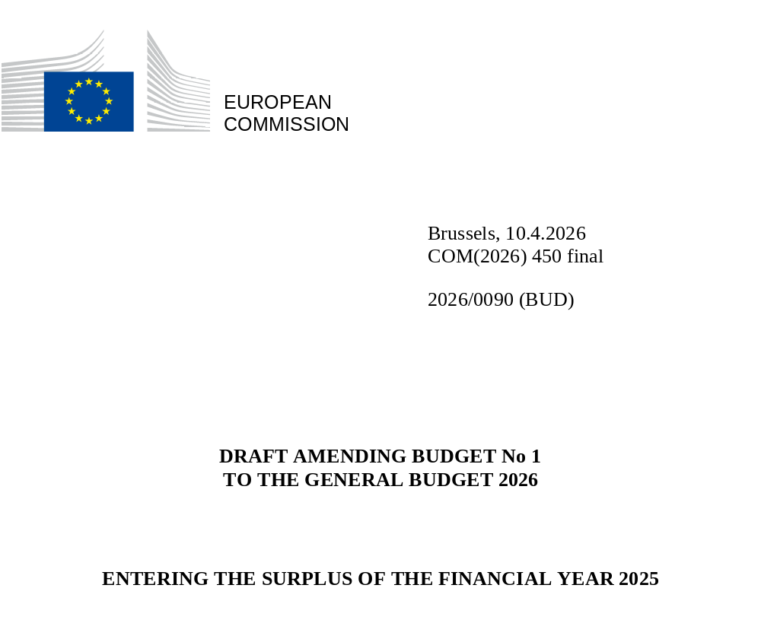

Having regard to:
- the Treaty on the Functioning of the European Union, and in particular Article 314 thereof, in conjunction with the Treaty establishing the European Atomic Energy Community, and in particular Article 106a thereof,
- Council Decision (EU, Euratom) 2020/2053 of 14 December 2020 on the system of own resources of the European Union, entered into force on 1 June 2021,
- Regulation (EU, Euratom) 2024/2509 of the European Parliament and of the Council of 23 September 2024 on the financial rules applicable to the general budget of the Union (recast), and in particular Article 44 thereof,
- the general budget of the European Union for the financial year 2026, as adopted on 26 November 2025,
The European Commission hereby presents to the European Parliament and to the Council the draft amending budget No 1 to the 2026 budget.

CHANGES TO THE STATEMENT OF REVENUE AND EXPENDITURE BY SECTION

The changes to the general statement of revenue and to the individual section III are available on EUR-Lex (https://eur-lex.europa.eu/budget/www/index-en.htm).

EXPLANATORY MEMORANDUM
Draft Amending Budget (DAB) No 1/2026 is intended to enter in the 2026 budget the surplus resulting from the implementation of the financial year 2025. As provided for in Article 18(3) of the Financial Regulation applicable to the general budget of the Union (“Financial Regulation”), the balance from 2025 is the only subject of this DAB. This DAB has to be submitted to the budgetary authority within 15 days of the submission of the provisional accounts, which happens at the end of March 2026.
- The implementation of the budget year 2025 shows a surplus of about EUR 2,1 billion, which is therefore entered as revenue in the 2026 budget.
(in EUR)
Outturn breakdown 2025
Surplus Revenue | 1 994 486 750
Surplus Expenditure | 100 751 398
Total surplus | 2 095 238 148
- Budgeting the surplus will reduce the total contribution of the Member States to the financing of the 2026 budget accordingly. The contributions by Member States will also be influenced by the revised own resources forecast, which will be available after the meeting of the Advisory Committee on Own Resources later in 2026 and which will be included in a subsequent Draft Amending Budget in accordance with Article 44(1)(b) of the Financial Regulation.
- The table below presents a breakdown of the outturn for 2025 in terms of the implementation of revenue:
(in EUR)
Outturn breakdown 2025 |  | Budget  (incl. AB1-3) | Outturn | Variation
Sub-total Revenue |  | 161 162 528 615 | 163 157 015 365 | 1 994 486 750
— | Title 1 - Own resources | 154 321 516 047 | 155 418 364 980 | 1 096 848 933
 | Levies and other duties in the sugar sector | 0 | 0 | 0
 | Custom duties | 22 178 600 000 | 23 038 328 690 | 859 728 690
 | Own resources accruing from VAT | 23 814 511 650 | 23 859 879 480 | 45 367 830
 | Own resources based on GNI | 101 480 252 237 | 101 682 108 926 | 201 856 689
 | Correction of budgetary imbalances granted to UK | 0 |  | 0
 | Gross reduction in the annual GNI-based contribution granted to some MS | 0 | -25 166 048 | -25 166 048
 | Own resources based on plastic packaging waste not recycled | 6 848 152 160 | 6 863 213 931 | 15 061 771
— | Title 2 - Surpluses, balances and adjustments | 1 344 533 139 | 1 362 014 115 | 17 480 976
— | Title 3 - Administrative revenue | 2 425 480 258 | 2 425 758 039 | 277 781
— | Title 4 - Financial revenue, default interest and fines | 1 658 657 407 | 2 499 021 068 | 840 363 661
— | Title 5 - Budgetary guarantees, borrowing and lending operations | 0 | 0 | 0
— | Title 6 - Revenue, contributions and refunds related to Union policies | 1 412 341 764 | 1 451 857 163 | 39 515 399
- The net variations in Title 1 (Own Resources) total EUR 1,1 billion. This positive difference is predominantly driven by a higher-than-expected amount of customs duties made available to the EU budget. The forecast for customs duties was revised twice during 2025 through amending budgets 2/2025 and 3/2025, to account for the actual volume of duties collected in the early part of the year. This increased the budgeted amount by a net amount of EUR 1,1 billion. The final surplus for customs duties was EUR 860 million.
- The remaining part of the surplus for this title is explained by exchange rate differences generated when paying the own resources contributions.
- Title 4 (Financial revenue, default interest and fines) comprises revenue from competition fines and default interest, other penalty payments and interest linked to fines and penalty payments. The variations in Title 4 amount to EUR 840 million; the table below presents a breakdown of these by relevant chapter/article:
(in EUR)
Outturn breakdown 2025 |  | Budget  (incl. AB1-3) | Outturn | Variation
4 0 | Revenue from investments and accounts | 76 961 995 | 135 048 176 | 58 086 181
4 1 | Default interest | 5 000 000 | 224 719 873 | 219 719 873
4 2 | Fines and penalties | 1 576 695 412 | 2 139 253 019 | 562 557 607
4 2 0 | Fines in connection with the implementation of the rules on competition | 1 063 547 301 | 1 388 818 258 | 325 270 957
4 2 1 | Penalty payments and lump sums imposed on a Member State | 563 936 638 | 741 003 723 | 177 067 085
4 2 4 | Interest connected with fines and penalty payments | 2 764 975 | 62 990 211 | 60 225 236
4 2 5 | Interest, other charges due and negative returns on cancelled or reduced fines | -53 553 502 | -53 979 331 | -425 829
4 2 9 | Other non-assigned fines and penalty payments | - | 420,158 | 420,158
Total Title 4 - Financial revenue, default interest and fines |  | 1 658 657 407 | 2 499 021 068 | 840 363 661
The overall amount for Title 4 includes amounts that have been entered as negative revenue into the 2025 budget in accordance with Article 48(2), point (b) of the Financial Regulation, for a total of EUR 54,0 million. This amount covers payments to eleven undertakings made under settlement agreements concluded and paid in 2025, in line with the judgment of the Court of Justice of the European Union of 11 June 2024 in Case C-221/22 P Deutsche Telekom v Commission. The ruling pertains to the repayment of competition fines that were either annulled or reduced by the Union Courts, as set out in the table below:
Fine case – company name | Judgment/ Case/ Settlement reference | Amount paid in 2025
AT.39523 - Slovak Telekom | C(2024)9150 - settlement | 123 205
COMP/AT.39258 - Singapore Airlines | C(2025)139 - settlement | 19 545 599
COMP/37956 - Ferriere Nord SpA | C(2025)1152 - settlement | 1 376 052
COMP/37956 - Feralpi Holding SpA | C(2025)1155 - settlement | 3 516 538
COMP/AT.39258 - BRITISH AIRWAYS | C(2025)1154 - settlement | 3 715 710
AT.39612 - PERINDOPRIL - Servier | C(2025)1833 - settlement | 5 531 677
COMP/39258 - Cathay Pacific Airways | C(2025)1997 - settlement | 16 066 155
COMP/AT.39258 - Cathay Pacific Airways | C(2025)1997 - settlement | 1 917 322
AT.39914 - Credit Agricole | T-113/17 - settlement | 1 176 130
COMP/AT.39258 - Air Canada | T-326/17 - settlement | 585 115
AT.40324 EGB - Nomura Holdings, Inc. | T-455/21- FR 2024 provisions | 199 470
AT.40324 EGB - UniCredit Bank GmbH | T-453/21- FR 2024 provisions | 226 359
Total |  | 53 979 331
- The remaining 4 titles (Titles 2, 3, 5 and 6) generate a surplus of EUR 57,3 million.
- The table below presents a breakdown of the outturn for 2025 in terms of budget implementation of expenditure for all institutions:
(in EUR)
Outturn breakdown 2025 |  | Budget  (incl. AB1-3) | Outturn | Variation
Sub-total Expenditure |  | 161 162 528 615 | 161 061 777 217 | -100 751 398
Outturn appropriations authorised in the budget |  | 161 162 528 615 | 161 051 162 355 | -111 366 260
— | European Commission | 155 913 937 424 | 155 858 594 486 | -55 342 938
 | Heading 1 - Single Market, Innovation and Digital | 20 459 264 037 | 20 235 039 247 | -20 172 862
 | Heading 2a – Economic, social and territorial cohesion | 35 960 377 346 | 35 953 975 385 | -3 032 392
 | Heading 2b - Resilience and Values | 11 186 421 091 | 11 182 882 952 | -841 351
 | Heading 3 - Natural Resources and Environment | 55 583 117 959 | 56 022 848 156 | -16 446 004
 | Heading 4 - Migration and Border Management | 3 513 087 909 | 3 562 949 705 | -1 138 204
 | Heading 5 - Security and Defence | 2 143 154 694 | 1 836 316 686 | -2 597 002
 | Heading 6 - Neighbourhood and the World | 14 426 257 975 | 15 001 919 060 | -7 871 234
 | Heading 7 - European Public Administration | 7 517 660 571 | 7 514 488 889 | -3 171 682
 | Thematic special instruments | 5 124 595 842 | 4 548 174 405 | -72 207
— | Other Institutions | 5 248 591 191 | 5 192 567 869 | -56 023 322
 | European Parliament | 2 527 491 841 | 2 517 767 307 | -9 724 534
 | Council & European Council | 714 268 858 | 691 007 559 | -23 261 299
 | Court of Justice of the European Union | 537 155 503 | 520 763 478 | -16 392 025
 | European Court of Auditors | 194 015 847 | 191 438 453 | -2 577 394
 | European Economic & Social Committee | 173 684 051 | 172 645 707 | -1 038 344
 | Committee of the Regions | 130 002 946 | 129 813 772 | -189 174
 | European Ombudsman | 15 477 918 | 14 667 882 | -810 036
 | European Data Protection Supervisor | 26 973 970 | 24 951 754 | -2 022 216
 | European External Action Service | 929 520 257 | 929 511 957 | -8 300
Cancellation of appropriations carried over from previous years |  | 0 | -137 025 591 | -137 025 591
— | European Commission | 0 | -75 505 779 | -75 505 779
 | Cancellation of unused appropriations carried over from previous years (as per art. 12(7) Financial Regulation) | 0 | -66 966 212 | -66 966 212
 | Cancellation of unused appropriations carried over from previous years (automatic and by decision) | 0 | -8 539 568 | -8 539 568
— | Other Institutions | 0 | -61 519 812 | -61 519 812
 | European Parliament | 0 | -29 894 459 | -29 894 459
 | Council & European Council | 0 | -4 479 120 | -4 479 120
 | Court of Justice of the European Union | 0 | -4 118 282 | -4 118 282
 | European Court of Auditors | 0 | -1 147 578 | -1 147 578
 | European Economic & Social Committee | 0 | -1 638 308 | -1 638 308
 | Committee of the Regions | 0 | -1 214 462 | -1 214 462
 | European Ombudsman | 0 | -57 369 | -57 369
 | European Data Protection Supervisor | 0 | -592 394 | -592 394
 | European External Action Service | 0 | -18 377 840 | -18 377 840
Exchange rate variations on expenditure |  | 0 | 147 640 454 | 147 640 454
- The amount of voted budget appropriations not implemented by all institutions combined was EUR 111,4 million. The Commission implemented 99,96 % of the authorised payment appropriations (including carry-overs to 2026). The underimplementation of the Commission concerned an amount of EUR 55,3 million of voted appropriations, as well as EUR 75,5 million of appropriations carried over from previous years.
- Similarly the under-implementation and the cancellation of appropriations of the other institutions remained low in 2025.
- Exchange rate variations on expenditure amounted to a deficit of EUR 147,6 million, of which EUR 145,8 million relating to the European Commission. This latter figure is mainly comprised of three elements: the revaluation of balance items (EUR 82,1 million); revaluations related to financial instruments (EUR 28,4 million); and the impact from the appreciation/depreciation of other currencies (EUR 35,3 million).

Council Decision (EU, Euratom) 2020/2053 of 14 December 2020 on the system of own resources of the European Union and repealing Decision 2014/335/EU, Euratom, OJ L 424, 15.12.2020.
OJ L, 2024/2509, 26.9.2024, ELI: http://data.europa.eu/eli/reg/2024/2509/oj.
OJ L, 2026/72, 26.2.2026, ELI:http://data.europa.eu/eli/budget/2026/72/oj.
OJ L, 2024/2509, 26.9.2024, ELI: http://data.europa.eu/eli/reg/2024/2509/oj.

