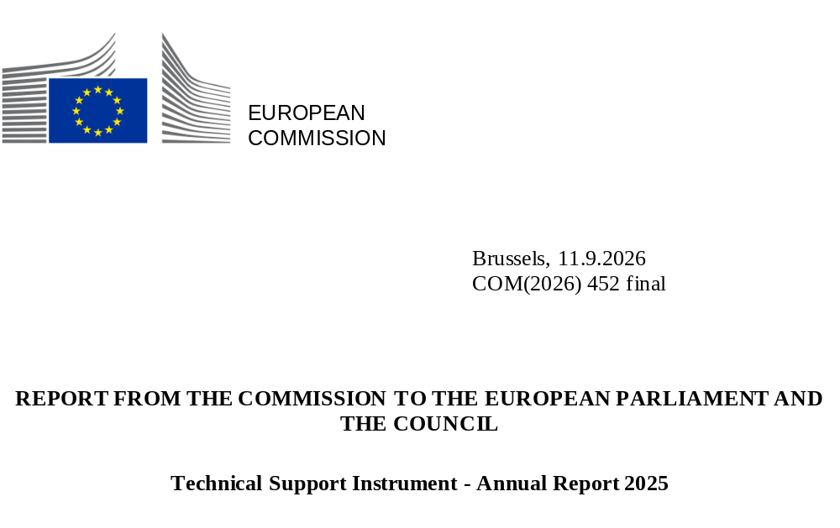

Foreword
2025 was a record year for the Technical Support Instrument (TSI) and a year of major changes.
The 2025 TSI cycle saw the highest demand from Member States, and thus the highest number of requests for support selected to date. The popularity of the TSI increased across its different features, particularly flagship and multi-country projects.
2025 marked the first year in which a majority of TSI projects were linked to flagship projects promoted by the European Commission to support Member States’ common reform needs related to EU priorities. This continues the trend of a rising proportion of both flagship and multi-country TSI projects over the years. Reforms supported by flagship or multi-country TSI projects represented a majority of supported reforms in 2025.
In 2025, the TSI provided technical support to beneficiary authorities from all Member States in a broad range of policy areas. These included public administration and governance, the financial sector and access to finance, competitiveness, the green and digital transitions and social Europe. Only one TSI 2025 project directly supported the implementation of a national recovery and resilience plan (RRP), reflecting the advanced state of implementation of the Recovery and Resilience Facility (RRF).
Member States once again positively assessed the support they received from the Reform and Investment Task Force (SG REFORM). The feedback from both beneficiary and coordinating authorities showed that Member States highly appreciated the TSI’s support.
In parallel, SG REFORM assumed responsibility for managing the TSI. SG REFORM is also responsible for implementing the Recovery and Resilience Facility (RRF), the coordination of the European Semester. It thus oversees EU support to the entire national reform and investment cycle. This change reflected the evolving priorities of the European Commission with a particular focus on the need to ensure a successful implementation of the RRF by the end of 2026.
The TSI 2026 cycle was consequently streamlined with greater emphasis placed on multi-country projects proposed by the Commission and on reforms with a stronger link to the European Semester and its country-specific recommendations.
Following the results of the mid-term evaluation of the TSI, SG REFORM further strengthened its results framework to collect and aggregate the programme’s results in a more robust way, mainly by introducing common reporting indicators across projects.
As we prepare the TSI’s last cycle in 2027, I look forward to the support provided by TSI 2027 paving the way for action under the EU’s next multiannual financial framework (MFF).
Declan Costello
Director-General SG REFORM

Table of Contents
Foreword 1
The Technical Support Instrument 3
The TSI in 2025 4
I. Highlights 4
II. The TSI 2025 cycle - facts and figures 6
Launch of the TSI 2025 cycle 6
TSI 2025 requests for support 6
TSI 2025 projects 8
Flagship projects 10
Pilot for enlargement countries as observers 11
III. Project execution 11
IV. Cooperation and support plans 13
V. Communication on the TSI 13
VI. Evaluation of the TSI 14
VII. Interinstitutional activities 15
Conclusion 17
Annex 1 – The TSI annual cycle 18
Annex 2 – 2025 TSI general call: requests by Member State 19

The Technical Support Instrument
The Technical Support Instrument (TSI) is the EU’s programme providing tailor-made technical expertise to Member States to improve their capacity to design and implement reforms, including via their national resilience and recovery plans (RRPs). Its general objective is to promote the EU’s economic, social and territorial cohesion by supporting Member States’ efforts to implement the reforms necessary to achieve economic and social recovery, resilience and upward economic and social convergence.
The TSI is managed by the European Commission’s Reform and Investment Task Force (SG REFORM). It is available to any Member State that wishes to receive support in designing and implementing reforms. This includes reforms to address challenges identified in the European Semester process of economic policy coordination, in implementing EU law or reforms at a Member State’s own initiative. The TSI does not pre-allocate funds by Member State or policy area.
The financial programming for the TSI in the 2027 draft budget has been adjusted to take account of the reduced allocation of commitment appropriations in 2025 and 2026 and the request for appropriations in the 2027 draft budget. The significant reduction in commitment appropriations in 2026 reflected SG REFORM’s need to prioritise implementing the RRF which is nearing its deadline. These changes brought the TSI’s overall budget programming for 2021-2027 to EUR 765.3 million, down from EUR 864.4 million. Member States may also request additional technical support via a direct contribution or as part of their RRPs.
2021 | 2022 | 2023 | 2024 | 2025 | 2026 | 2027 | Total
116.4 | 118.7 | 121.1 | 123.5 | 121.0 | 52.5 | 112.2 | 765.3
Figure 1 - TSI budget programming for 2021-2027 (million euro)
The TSI offers beneficiary authorities in Member States unique project-based access to technical expertise and peer-learning opportunities to help them tackle reform challenges. It is demand-driven and is organised in annual cycles (as described in Annex 1).
TSI support covers the provision of expertise related to policy advice, policy change, formulation of strategies and reform roadmaps, and support for legislative, institutional, structural and administrative reforms. It also covers institutional, administrative or sectoral capacity-building; seminars, conferences and workshops; exchange of best practice and training actions; development of common methodologies; IT capacity-building; and carrying out studies. It does not require co-financing from Member States and it does not transfer funds to Member States, but is implemented under direct and indirect management by the Commission.
To strengthen Member States’ administrative capacity, each TSI project provides unique expertise from the Commission’s in-house experts or from experts in EU Member State national administrations (e.g. via the Commission’s Technical Assistance and Information Exchange instrument, TAIEX), EU agencies, international organisations or the private sector. External expertise is contracted by SG REFORM under direct management (mainly the private sector) or indirect management. SG REFORM staff are fully involved throughout the process of implementing each project.
TSI projects may either support a single Member State (standalone projects) or multiple Member States facing a common challenge (multi-country projects). The Commission proposes TSI flagship projects to support Member States’ common reform needs related to EU priorities. Such projects focus the TSI on helping Member States to deliver on key EU political priorities.

The TSI in 2025

Highlights
The TSI 2025 cycle saw the highest demand from Member States to date. Member States submitted 885 requests for support with an estimated cost of roughly two and a half times the available funding of EUR 121 million. The TSI’s popularity increased across its distinctive features, including flagship and multi-country projects.
A record 589 requests were linked to 15 flagship projects proposed by the Commission to support Member States’ common reform needs related to EU priorities (67% of requests submitted under TSI 2025). This represented a more than 80% increase on the number of TSI 2024 flagship-related requests. Accordingly, 2025 marked the first year in which a majority of TSI projects were flagship-related projects. 66% of TSI 2025 projects were flagship-related projects (corresponding to 77% of all requests selected for funding). Both these percentages were significantly higher than in previous cycles, in part due to the higher number of flagships under TSI 2025, but also due to the spike in interest in a number of initiatives such as the Public Administration Cooperation Exchange (PACE), which roughly doubled in scale.
At the same time, the number of multi-country requests nearly doubled compared to TSI 2024, reaching 331 (38% of TSI 2025 requests submitted). This reflected the growing demand from Member States for multi-country support. On average, the quality of such requests was furthermore assessed as higher than that of standalone requests, since 56% of selected requests were for multi-country projects. Therefore, while multi-country projects represented a minority of TSI projects in 2025 – by design, since they group requests from multiple Member States into a single project - they represented a majority of TSI supported reforms in 2025 (54%), as had been the case in 2024.
In line with the higher number of submitted requests, the highest ever number of requests were selected for support under TSI 2025. The 397 selected requests were grouped into 136 projects, fewer than the 170 projects launched in 2024. This was due to an increase in the average number of Member States participating in each multi-country project, as the number of such projects remained similar to TSI 2024 (43 multi-country projects) with 41 multi-country TSI projects in 2025. The proportion of multi-country projects increased to 30% of the 136 TSI 2025 projects, up from 25% of the 170 TSI 2024 projects.
The increased uptake of multi-country and flagship projects demonstrated the TSI’s capacity to bring further EU added value and to facilitate the exchange of good practice and mutual learning opportunities between national administrations, while maintaining a strong focus on EU priorities.
As in previous years, the TSI provided technical support to beneficiary authorities from all Member States and covered many different policy areas, in line with the many different requests from national authorities selected under the TSI 2025 general call for requests. The policy areas included public administration and governance, the financial sector and access to finance, competitiveness and the green and digital transitions (see Figure 2).

Figure 2 - TSI 2025: projects by key policy priority
The TSI provided limited support to reforms and investments included in the RRPs in 2025, reflecting the advanced state of implementation of the RRF. Only one TSI 2025 project was directly linked to a national RRP (helping Poland to develop a framework for monitoring the quality of long-term care).
Major organisational changes also affected the TSI in 2025. The Commission decided to create the Reform and Investment Task Force, SG REFORM, by merging SG RECOVER and DG REFORM. On 1 February 2025, SG REFORM assumed responsibility for implementing the TSI. It is also responsible for managing the RRF. This change reflected the evolving priorities of the European Commission, with a particular focus on the need to ensure successful implementation of the RRF by the end of 2026. Consequently, the TSI 2026 cycle was streamlined to cover fewer but more impactful projects by focusing on a limited number of multi-country projects proposed by the Commission as well as requests linked to reforms to follow up the country-specific recommendations of the European Semester.
Lastly, following the results of the mid-term evaluation of the TSI, SG REFORM revised its results framework to ensure more robust collection and aggregation of the programme’s results going forward. Initial steps were taken in 2025, and work will continue in 2026.

The TSI 2025 cycle - facts and figures

Launch of the TSI 2025 cycle
The TSI 2025 cycle was launched during the TSI annual conference ‘Reforms with an impact: together we are stronger’ on 24 and 25 April 2024, hosted by the European Commissioner for Cohesion and Reforms Elisa Ferreira.
15 thematic TSI flagship technical support projects for 2025 were presented at the conference (see details below). In addition to these flagship projects, the other priorities presented were multi-country projects and support for reforms in key priority areas to strengthen Member States’ resilience and competitiveness and improve people’s lives.
Dialogues with Member States were subsequently held to help identify priorities, including policy areas where multi-country support could meet common needs. A workshop was organised on 10 September 2025 in Budapest for the coordinating authorities to finalise coordination for the submission of such multi-country projects.

TSI 2025 requests for support

General call for requests
By 31 October 2024, Member States had submitted 885 requests for technical support in response to the TSI 2025 general call, for an estimated EUR 318 million (roughly two and a half times the available funding for the TSI in 2025). Following the withdrawal of three requests, all other submitted requests were deemed eligible and 882 requests were thus assessed for selection under the general call.
The requests submitted covered a wide range of policy areas. They included strengthening the EU's competitiveness, providing a better business environment for SMEs, advancing the digital transition - with a strong focus on artificial intelligence (AI), improving the quality of public administration, and making energy systems fit for the green transition.
DG REFORM assessed the submitted requests against the assessment criteria set out in Article 9(5) of the TSI Regulation. These include the urgency, breadth and depth of the challenges identified; the support needs in respect of the policy areas concerned; analysis of socio-economic indicators; and the institutional and general administrative capacity of the Member States concerned. For requests to be selected, they need a positive assessment in all the criteria.
DG REFORM consulted other Commission departments to ensure that the technical support to be provided under the TSI 2025 was in line with EU policies. The aim was also to avoid duplicating other EU actions and funding, while complementing and building on other EU programmes.
The requests covered support for Member States’ reforms identified in different circumstances set out in the TSI Regulation. These included reforms to tackle challenges identified through the European Semester and broader economic governance process, as well as those linked to implementing EU priorities and Member States’ own reform priorities.

Figure 3 - TSI 2025: circumstances of Member States’ requests
Following the assessment and selection process outlined in Annex 1, 390 requests covering reforms related to key EU priorities were selected under the TSI 2025 call for a total of EUR 118 million. Seven additional requests were later selected in 2025 as additional funding became available. This brought the total number of requests selected under the TSI 2025 general call to 397, including:
- one request directly related to the implementation of a national RRP;
- 145 requests related to the digital transition;
- 92 requests related to the European Green Deal;
- 39 requests related to equality: support for women, people with disabilities, the Roma community, migrants, older people and the LGBTQIA+ community;
- 63 requests related to PACE, which is a multi-country flagship project aimed at promoting cooperation and cross-border exchanges among Member States.
In 2025, requests were selected covering all 27 Member States. No special measures were adopted.

TSI 2025 projects
The Financing Decision and annual work programme for 2025 was adopted on 31 March 2025. It set out the measures needed to implement the TSI in 2025. The 397 selected requests were streamlined into 136 projects, because 295 multi-country requests were merged into 41 multi-country projects to take advantage of economies of scale, promote synergies and the potential for peer learning. The 136 TSI 2025 projects supported 397 reform initiatives in all 27 Member States.
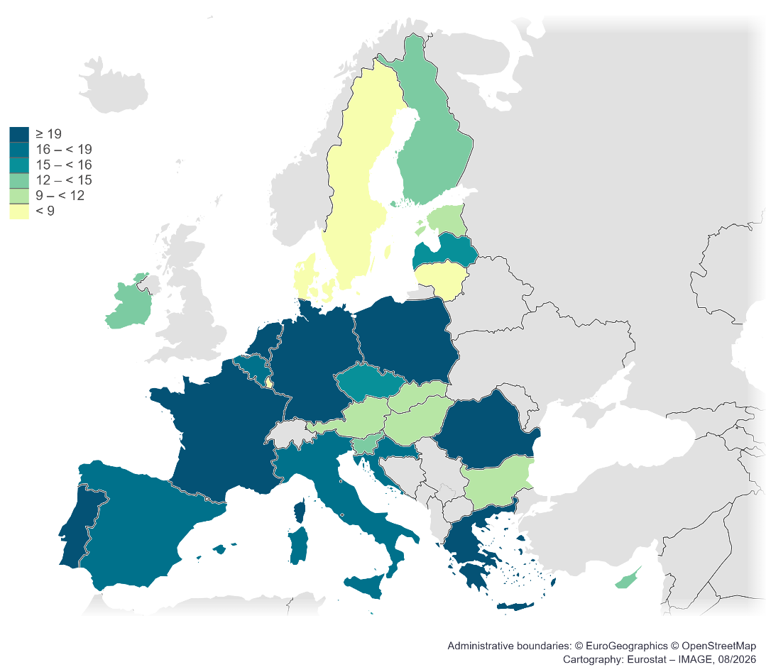

Figure 4 - TSI 2025: number of reforms supported in each Member State
41 multi-country projects were approved for launch under TSI 2025, only slightly below the record 43 under TSI 2024.
Examples of multi-country projects in TSI 2025
TSI 2025 multi-country projects included:
- 14 Member States working together to implement EU tax legislation to modernise and simplify tax and customs procedures and reduce the administrative burden for SMEs;
- the ‘FutureProof Education’ project which provides TSI support to schools in Germany, Sweden, and Ireland to develop guidance for the responsible and meaningful use of AI in schools, and set up AI literacy programmes; and
- eight Member States receiving support to implement the Carbon Border Adjustment Mechanism (CBAM) in its definitive phase by boosting national competent authorities’ expertise and resources to handle CBAM processes effectively.
With fewer projects under the TSI 2025 than the year before (136 versus 170 under TSI 2024), the proportion of multi-country projects increased to 30%, up from 25% in 2024. The average number of Member States participating in each multi-country project also increased. This reflected both the continued demand from Member States for multi-country support (38% of requests submitted were for multi-country projects), and the quality of such requests (56% of selected requests were for multi-country projects).
The 18 multi-regional TSI projects (i.e. projects covering multiple regions) in 2025 covered topics as diverse as environmental monitoring for adaptive management of coastal wetlands, futureproofing education by supporting schools in the AI evolution and gender mainstreaming in public policy and budgeting processes. There were also fewer multi-regional TSI projects in 2025 compared to previous years (38 in 2024).

Figure 5 - TSI 2021-2025: change in the number of multi-country and PACE projects
From a thematic perspective, 119 reforms supported by the TSI 2025 were to assist Member States’ public administrations in strengthening their capacity to effectively tackle current and future challenges and foster cross-country collaboration. In line with the ComPAct communication adopted in October 2023, the TSI will support action by the Member States to work together to close skills gaps, enable digital transformation, and lead the green transition.
Example of TSI 2025 public administration and governance project
The PACE multi-country flagship project aims to promote cooperation and cross-border exchanges among Member States to build administrative capacity and prepare the next generation of policymakers in the EU. In 2025, PACE was implemented using TAIEX and through indirect management.
PACE saw significant take-up with the objective of implementing 121 exchanges in 20 Member States for 477 participants, roughly double the scale of PACE in 2O24. The five Member States that received the most support from PACE are respectively Germany, Poland, Romania, Belgium, and Portugal.

Flagship projects
TSI flagships projects were introduced to focus on helping Member States to deliver on key EU political priorities.
In line with the key priority to strengthen the EU's competitiveness, the TSI 2025 supported 109 reforms to help Member States improve their business environment, close the innovation gap, build a net-zero economy, and promote the EU's economic security. For example, the TSI supported 38 reforms in 22 Member States to reduce unnecessary administrative burdens for SMEs, to promote start-ups and scale-ups and to enable them to be more productive, competitive and resilient.
More than 130 reforms linked to the digital transition were supported by TSI 2025 projects, with a strong focus on AI and innovative technologies.
The uptake of flagship technical support projects increased again in the TSI 2025 cycle compared to previous cycles. 90 of the 136 TSI 2025 projects were linked to the 15 flagship projects, i.e. 66% (up from 82 out of 170 TSI 2024 projects). This increase in the proportion of flagship projects confirmed the relevance of the 15 flagship projects put forward by DG REFORM to address reform needs in several Member States and to align funding with top EU priorities. Flagship projects covered several aims such as improving the quality of public administration, providing a better business environment for SMEs, and making energy systems fit for the green and digital transition. They are listed in the table below.
TSI 2025 flagships
- ComPAct - Pillar I - Skills for public administration systems
- ComPAct - Pillar II - Capacity for Europe's Digital Decade
- ComPAct - Pillar III - Greening Public Administration
- Economic Security in Technologies and Resources (ESTER)
- Innovative Public Financial Management
- EU Health Hub – Investing in Resilient Health System
- EU Supervisory Digital Finance Academy
- Improving Sustainability Reporting for Businesses
- Making Energy Systems Fit for the Green and Digital Transition
- PACE - Public Administration Cooperation Exchange
- Simplifying Revenue Administration for Businesses
- Single Market and Competitiveness
- Support implementation of the Migration and Asylum Pact
- Supporting the Resilience of Natural Resources
- Addressing Demographic Change Through Reforms

Pilot for enlargement countries as observers
SG REFORM and DG ENEST continued the pilot to allow countries that are candidates countries or potential candidates to join the EU to be ‘observers’ of selected TSI projects in 2025, without TSI funding. This was consistent with the Commission’s political priority of accelerating the integration of, and accession process for, candidate countries and potential candidates, and followed positive feedback from both Member States and candidate countries and potential candidates on the pilots in 2023 and 2024. This was done with the agreement of the respective beneficiary authorities in the Member States and the involvement of the candidate countries and potential candidates.
The pilot was offered to nine candidate countries and potential candidates in 2025. Of these, all except Türkiye expressed interest in participating as observers in a TSI 2025 project. This included Ukraine, which participated for the first time in the 2025 pilot. The candidate countries and potential candidates participated as observers in five projects, two of which were followed by more than one candidate country and potential candidate. For example, Albania, North Macedonia, and Serbia participated as observers in the TSI 2025 project on implementing Effective Green Budgeting Practices.

Project execution
SG REFORM’s experts were closely involved in all phases of the projects launched under TSI 2025: project design, project implementation, monitoring, and evaluation of progress and achievements.
Project design was developed by SG REFORM using the demand-driven approach of the TSI. This approach involved extensive interaction with national authorities (through outreach and high-level meetings between SG REFORM’s senior management and representatives of national authorities) to discuss needs and projects’ intended outcomes. Country coordinators (SG REFORM officers who act as the main points of contact with Member States’ coordinating authorities) played a major role in these interactions.
SG REFORM defined the methods of implementation for the 136 projects to be launched under TSI 2025. As of May 2026, 125 of the TSI 2025 projects (92%) were on the ground, while seven were under preparation and four had been cancelled. Of the four cancelled projects, three were cancelled because Member States withdrew their requests for support. The multi-country project ‘Improving Sustainability Reporting for Businesses’ was cancelled because the regulatory framework had changed following the adoption of an Omnibus simplification package and the revision of the Corporate Sustainability Reporting Directive (CSRD). Another reason was that work was already being carried out in this field through the European Financial Reporting Advisory Group (EFRAG) and related EU-funded initiatives.
Cooperation with pillar-assessed entities (PAEs) under indirect management continued to be the main method of implementing the TSI in 2025, in part due to Member States’ requests for highly specialised (and at times sensitive) technical support. Cooperation under indirect management accounted for 55% of the TSI 2025 cycle budget (below the 66% peak in 2024, but still well above the 47% in 2023).
The PAEs with which SG REFORM cooperated for TSI 2025 included international organisations (e.g. the Organisation for Economic Co-operation and Development, the Council of Europe, the World Bank, the United Nations); entities such as the United Nations International Children's Emergency Fund and the International Labour Organization; private entities with a public service mission (e.g. Expertise France); and EU bodies (e.g. the European Supervisory Authorities (ESAs)).
As indicated in the 2025 work programme for the TSI under the TSI Regulation, public procurement represented 26% of the TSI budget in the 2025 cycle (in line with 2024, and well below the 43% in 2023 and 2022).
The proportion of grants in the TSI budget in the 2025 cycle increased to 15%, well above the 4% in 2024 and the 7% in 2023. This was due to an increase in both the number and the average value of grants and to operational reasons. For example, compared to TSI 2024, this implementation mode was more often more suitable than other available modes.
SG REFORM was actively involved in the projects’ steering committees together with national authorities’ representatives. This served the purposes of: (i) safeguarding the success of the projects by monitoring their progress; (ii) steering activities towards the specific needs of the Member States involved in alignment with EU policies; and (iii) increasing the TSI’s visibility. This coordination, carried out by SG REFORM’s policy officers, proved even more essential for projects involving multiple countries and therefore a greater number of stakeholders. Multi-country projects involved several Member States pursuing a common objective. By participating in this type of project, they benefitted from improved collaboration at EU level.
Other Commission directorates-general and EU decentralised agencies (e.g. the European Securities and Markets Authority and the European Insurance and Occupational Pensions Authority), were regularly involved in the TSI by providing expertise on thematic policy areas (as they had for previous cycles). A network of representatives from competent directorates-general ensured that the projects were consistent with EU policies and created added value, avoiding overlaps with other ongoing initiatives at EU level.

Cooperation and support plans
Cooperation and support plans (CSPs) were signed with each Member State’s coordinating authority in 2025. The CSPs set out the guiding principles governing the provision of TSI support to Member States, the planned working methods, the circumstances of the requests, the intended scope of the support measures, and the indicative financing of support, in line with the TSI Regulation. They indicated the common agreement of SG REFORM and the Member States on the provision of technical support. In 2025, they were signed after the adoption of the annual TSI work programme. They were then forwarded, following approval by the Member States, to the European Parliament and the Council.
As in previous years, the CSPs described the proposed mandate of the TSI national coordinating authorities, illustrating their role at each step of the TSI cycle. The CSPs were slightly amended in 2025 to reflect the contribution of the coordinating authorities in evaluating TSI projects after their completion. The amended version of the CSPs also invited national authorities to take follow-up action and to implement the envisaged reforms.
To foster collaboration with and between coordinating authorities, the coordinating authorities network, chaired by SG REFORM, met four times in 2025 (twice online and twice in person, on 14 May and on 9-10 September in Brussels).

Communication on the TSI
SG REFORM actively promoted the TSI in 2025 (including its projects, outcomes and impact). To do so, SG REFORM worked with beneficiary authorities, support providers and the Commission’s representations in each Member State. The main communication channels were press releases, the Reform Support website, social media, publications, and various events providing targeted information to diverse audiences, including the media and the general public.
In 2025, the focus of communication on the TSI and reform support remained on presenting key priorities, results and milestones in the programme’s cycle, emphasising reforms and their broader impact on businesses and individuals.
On 31 March 2025, the Commission issued a press release to announce the adoption of the TSI 2025 work programme and financing decision. It also highlighted that the new round of reform projects would contribute to reducing the administrative burden for SMEs, boosting start-ups, and fostering productivity, resilience and competitiveness.
To launch the TSI 2026 cycle, SG REFORM organised the TSI Annual Conference on ‘Supporting reforms – Shaping the Future Together’ on 13 May 2025. High-level speakers from the European institutions and national authorities discussed how the EU supports the Member States’ reform processes and how the Commission can best keep supporting them in the future. Almost 2 000 participants attended the event, in Brussels and online.
SG REFORM also co-organised or participated in various public events locally and online, showcasing success stories and publicising TSI achievements.
The Reform Support website provided information on reforms structured by policy area and by Member State. By the end of 2025, over 687 TSI project descriptions were available online – a 25% increase on end-2024. This information was easily searchable via the TSI interactive map. Over 150 000 unique visitors accessed the site in 2025, a 21% decrease on 2024.
In line with the transparency requirement set out in Article 17 of the TSI Regulation, the Reform Support website is also a single online repository of final studies or reports produced through TSI projects. This repository is searchable by year, topic, and Member State, enabling broad access to these documents. By December 2025, 60% of completed TSI projects had their final studies or reports available online, an 11% increase compared to December 2024.
SG REFORM remained active on social media, including on X. It also set up a BlueSky account and partnered with DG ECFIN on LinkedIn. SG REFORM’s increasing internal video production capacity also enabled it to update its YouTube channel with new and original content. Three videos were produced in 2025 on topics such as electricity market reforms and the TSI’s support for managing environmental risks.
Finally, EU-wide communication campaigns and reports (such as the 2025 EU General Report) mention the TSI’s role in assisting Member States in meeting their reform goals in line with EU objectives.

Evaluation of the TSI
SG REFORM continuously assesses the technical support it provides to Member States through the TSI, at both overall programme and individual project levels. The aim of this assessment is to obtain evidence of the programme’s achievements and ensure these are in line with its objectives.
At overall programme level, the mid-term evaluation of the TSI, adopted by the Commission on 12 May 2025, analysed the early implementation of the TSI in line with Article 16 of the TSI Regulation. The evaluation followed the EU better regulation guidelines and was structured around five evaluation criteria (effectiveness, efficiency, relevance, coherence and EU added value).
The evaluation confirmed that the TSI is successfully achieving its specific objective, which is to improve all types of administrative capacity of Member States across the EU, especially the internal administrative mechanisms that are the basis for reforms. In addition, it highlighted that the success of technical support and the achievement of long-term sustainable results depend on Member States consistently and systematically following up on technical support projects. The evaluation demonstrated that continued ownership by national authorities was a crucial factor in ensuring follow-up actions and use of the outputs delivered by technical support projects. It also found that this follow-up depends on additional national factors, such as the availability of financial resources, stable staffing, and political and administrative continuity.
The evaluation highlighted four main areas of improvement for the TSI:
(i) the need for careful review of the level of ambition of TSI requests during their assessment (as Member States appreciate TSI support for smaller reforms but show less appetite for requesting expertise for major and difficult reforms);
(ii) the value of aligning TSI support with country-specific recommendations as the TSI’s areas of support broadly match these but its support is not always directly linked to the difficult reforms needed to effectively address specific country-specific recommendations;
(iii) that TSI follow-up on outcomes and impacts could be made more systematic (as Member States have no legal obligation to follow up and report on outcomes and currently only do so in 60% of cases); and
(iv) that the impact of the TSI – albeit difficult to measure – could be increased with a greater level of ambition for TSI projects.
Based on the findings and lessons learned from the mid-term evaluation, SG REFORM adapted its evaluation strategy to step up the monitoring and evaluation of technical support under the TSI and to better track the consolidated long-term results achieved after TSI projects’ closure.
At project level, SG REFORM’s results framework was also strengthened, following the mid-term evaluation. It now includes a more robust collection of more detailed results, mainly by introducing common reporting indicators across projects.
Individual TSI project monitoring continued through the TSI’s two-step ‘feedback mechanism’. The first step, shortly after project closure, assesses the level of satisfaction of the main stakeholders involved in project design and delivery. The second step, typically one year after project closure, assesses the extent to which each project has delivered its expected results.
During 2025, SG REFORM sent 189 satisfaction questionnaires to beneficiary authorities, a marginal increase on 2024. Completed satisfaction questionnaires were received for 133 TSI projects (a 70% response rate, and 9% above the rate for 2024, continuing the positive trend). Feedback from beneficiary authorities indicated an average satisfaction rating of 9.3 out of 10 for the support provided by SG REFORM and 8.8 out of 10 for the success of the projects. These ratings were both very positive and in line with the values in 2024. The average satisfaction of beneficiary authorities with their project provider (i.e. the entity providing the expertise under the TSI project) was 8.3 out of 10, only marginally below the score of 8.4 out of 10 for 2024. SG REFORM will continue efforts to further increase response rates so as to better track the long-term results achieved after TSI projects’ close.

Interinstitutional activities
At interinstitutional level, SG REFORM’s Director-General met the European Parliament’s joint Budget and Economic and Monetary Affairs Committees on 5 November 2025 for an exchange of views on implementing the TSI, in accordance with Article 15(3) of the TSI Regulation. The exchange of views mainly covered the high demand for TSI support as shown by the volume of requests received from Member States, how to increase further the share of TSI multi-country projects, how TSI projects can generate long-term results after TSI support finishes, and how the TSI supports the implementation of reforms in the recovery and resilience plans (RRPs) and country-specific recommendations.
Questions raised by the members of the Budget and Economic and Monetary Affairs Committees were answered by the Director-General who clarified the approach for the two remaining TSI cycles. The Director-General focused on completion of the RRPs and called on Member States to be strategic and specific on TSI support requested, linking this to country-specific recommendations where TSI support would have the biggest impact.
In terms of discussions with the Council, SG REFORM took part in several meetings of the Working Party of Foreign Relations Counsellors in its sanctions formation (RELEX/Sanctions) to update all Member States (alongside direct TSI beneficiaries) on the progress of TSI projects on sanctions. The findings of the multi-country TSI project on sanctions implementation concluded in September 2025 were, for instance, shared with all Member States.

Conclusion
2025 marked both a record year and a period of major changes for the TSI.
An unprecedented 882 requests for support from Member States were assessed under the TSI 2025 general call for requests, far exceeding the programme’s capacity. A rigorous assessment and selection process was carried out based on the TSI Regulation’s assessment criteria. Following this process, 390 requests were selected – alongside seven further requests selected later – for a total amount of EUR 118 million, leading to the design of 136 projects to support 397 reform initiatives in all 27 Member States.
The continued increase in the scale of multi-country projects demonstrated the TSI’s capacity to bring further EU added value and to facilitate exchanges of good practice and mutual learning opportunities between national administrations. Similarly, the increase in uptake of proposed TSI flagships confirmed the value of this approach and enabled the funding to focus on EU priorities under TSI 2025, while the TSI remained a demand-driven instrument. 2025 was the first year in which a majority of TSI projects were linked to flagship projects. The further increase in support to Member States’ reforms tackling EU priorities through both flagship and multi-country projects made it possible to maintain a broad coverage of policy areas given the high number of flagships, while maximising the added value provided.
Once again, Member States gave a positive assessment of SG REFORM’s continuous support in implementing TSI projects, including projects from previous cycles (since many TSI projects run for several years). This support ensured that project outputs remained in line with Member States’ objectives. According to feedback received from beneficiary authorities at project level and from coordinating authorities at national level, Member States highly appreciated the support provided through the TSI. They also appreciated the active role they can play in helping to design and implement projects and SG REFORM’s effective communication.
Opportunities for improvement highlighted by the mid-term evaluation of the TSI were also acted upon. SG REFORM strengthened the TSI’s results framework to ensure more robust collection and aggregation of the programme’s results, mainly by introducing common indicators across projects.
With the arrival of a new College, a more focused approach was followed for TSI 2026. Under that cycle, the Commission proposed one flagship project linked to the European Semester and its country-specific recommendations for Member State reforms, and a small number of multi-country projects. In its final 2027 cycle, the TSI will continue this more focused approach while also paving the way to the next MFF. To that end, it will provide technical support to Member States to address major national and transnational challenges, focusing on areas where both the EU added value and likely impact of EU support will be the highest over the coming years.

Annex 1 – The TSI annual cycle
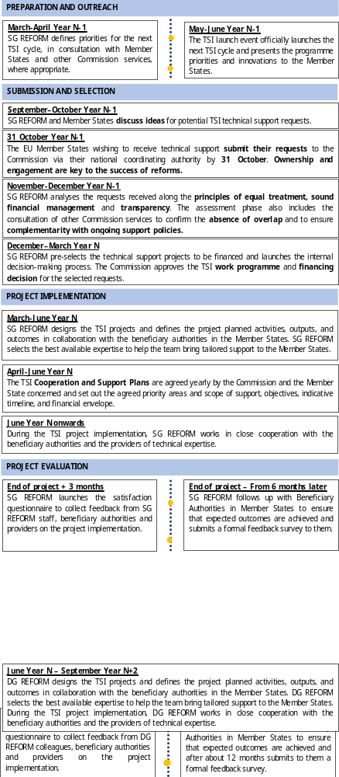

Annex 2 – 2025 TSI general call: requests by Member State
Country | Submitted | Not selected | Selected
Austria | 27 | 16 | 11
Belgium | 35 | 19 | 16
Bulgaria | 30 | 20 | 10
Croatia | 34 | 17 | 17
Cyprus | 30 | 16 | 14
Czechia | 36 | 21 | 15
Denmark | 15 | 8 | 7
Estonia | 16 | 5 | 11
Finland | 25 | 13 | 12
France | 31 | 12 | 19
Germany | 64 | 28 | 36
Greece | 47 | 28 | 19
Hungary | 19 | 10 | 9
Ireland | 25 | 11 | 14
Italy | 46 | 30 | 16
Latvia | 32 | 17 | 15
Lithuania | 20 | 12 | 8
Luxembourg | 13 | 7 | 6
Malta | 30 | 15 | 15
Netherlands | 42 | 23 | 19
Poland | 49 | 28 | 21
Portugal | 54 | 34 | 20
Romania | 59 | 35 | 24
Slovakia | 31 | 21 | 10
Slovenia | 19 | 7 | 12
Spain | 43 | 27 | 16
Sweden | 10 | 5 | 5
Total | 882 | 485 | 397

Regulation (EU) 2021/240 of the European Parliament and of the Council of 10 February 2021 establishing a Technical Support Instrument, OJ L 57, 18.2.2021, p. 1 (the TSI Regulation).
The TSI was managed by DG REFORM until it was merged with the Task Force for Recovery and Resilience on 1 February 2025. This report uses DG REFORM when referring to events and activities which took place before the merge, and SG REFORM for events and activities which took place after the merge or are still ongoing.
EUR 6.4 million of technical support was also provided in 2022 under Article 7 of the TSI Regulation.
https://enlargement.ec.europa.eu/funding-technical-assistance/taiex_en.
The list of entities implementing TSI funds under indirect management is provided on the TSI website.
The total number of reforms supported under TSI 2025 is higher than the total number of projects because multi-country projects covered multiple reforms in different Member States under TSI 2025.
Regulation (EU) 2021/241 of the European Parliament and of the Council of 12 February 2021 establishing the Recovery and Resilience Facility, OJ L 57, 18.2.2021, p. 17 (the ‘RRF Regulation’).
The amount of funding available for the TSI 2025 general call was EUR 120.4 million (as indicated in the TSI 2025 Financing Decision).
The eligibility of requests was verified against the criteria set out in Articles 8 and 9 of the TSI Regulation. The eligibility of potential beneficiaries was verified against the criteria set out in Article 2 of the TSI Regulation and Regulation (EU, Euratom) 2024/2509 of the European Parliament and of the Council of 23 September 2024 on the financial rules applicable to the general budget of the Union (‘the Financial Regulation’).
A single request for technical support may be linked to multiple circumstances hence the total does not match the total number of requests under TSI 2025.
Ibidem.
A single request for technical support may contribute to several EU priorities.
Based on the number of requests assessed by DG REFORM as having a direct link to the national RRPs. The 194 requests identified as linking to the RRPs in the circumstances set out in Figure 3 also include requests indirectly linked to RRPs as identified by Member States when submitting their requests.
Special measures may be taken under Article 12(7) of the TSI Regulation in the event of urgent needs.
Commission Implementing Decision C(2025)1860 final of 31 March 2025 on the financing of the Technical Support Instrument and the adoption of the work programme for 2025.
One project for ’Technical support to enhance the effective implementation and enforcement of EU restrictive measures (‘sanctions‘)’ resulted from the late selection of seven requests in November 2025.
The total number of reforms supported under TSI 2025 is higher than the total number of projects because multi-country projects correspond to multiple reforms in different Member States under TSI 2025.
Strengthening performance-informed budgeting and, ex ante and ex post impact assessments in Hungary, Support for effective implementation of the Energy Performance of Buildings Directive (EPBD) in Poland, and support for the transparency register for interest representation in Belgium.
As defined in Article 9(5) of the TSI Regulation.
Report from the Commission to the European Parliament, the Council, the European Economic and Social Committee and the Committee of the Regions, Mid-term evaluation of the Technical Support Instrument (2021-2027), COM/2025/198 final: EUR-Lex - 52025DC0198 - EN - EUR-Lex.
https://reforms-investments.ec.europa.eu/technical-support-instrument-0/financial-sector-and-access-finance/effective-implementation-sanctions-regime-and-enhanced-cross-border-cooperation-eu-member-states_en.
Including seven requests from late selection.
Excluding withdrawn requests.

