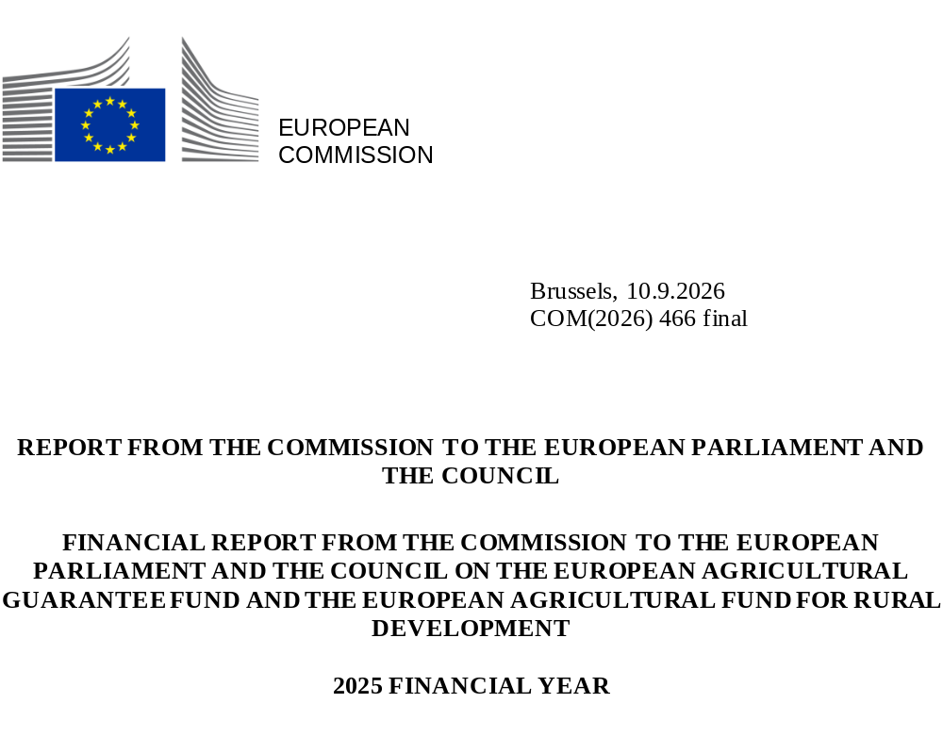

TABLE OF CONTENTS
1. BUDGET PROCEDURE 2
1.1. Financial Framework 2021-2027 2
1.2. Draft Budget 2025, Amending Letter 1/2025 and adoption of the 2025 Budget 3
2. IMPLEMENTATION OF THE 2025 BUDGET FOR EAGF AND EAFRD 4
2.1. European Agricultural Guarantee Fund (EAGF) 4
2.1.1. Monthly payments 4
2.1.2. Reductions of monthly payments 4
2.1.3. Direct management expenditure by the Commission 5
2.2. European Agricultural Fund for Rural Development (EAFRD) and European Union Recovery Instrument (EURI) 6
2.2.1. Payments 7
2.2.2. Reductions of payments 7
2.2.3. Expenditure under direct management by the Commission 7
3. THE UPTAKE OF THE EAGF AND EAFRD APPROPRIATIONS 9
3.1. European Agricultural Guarantee Fund (EAGF) 9
3.2. European Agricultural Fund for Rural Development (EAFRD) and European Union Recovery Instrument (EURI) 9
4. CONTROL MEASURES 13
4.1. Introduction 13
4.2. Integrated Administration and Control System (IACS) 13
4.3. Application Chapter III of Title IV of Regulation (EU) 2021/2116 (scrutiny of transactions) 13
5. CLEARANCE OF ACCOUNTS 14
5.1. Conformity clearance 14
5.2. Financial clearance 15
5.3. Appeals brought before the Court of Justice of the European Union against clearance decisions 16
6. RELATIONS WITH PARLIAMENT AND WITH THE EUROPEAN COURT OF AUDITORS 17
6.1. Relations with Parliament 17
6.2. Relations with the European Court of Auditors 17

1. BUDGET PROCEDURE
The reformed CAP for the period 2023-2027 introduced a strategic approach and a new delivery model focused on performance and results. It consolidates largely the two existing funds – the European Agricultural Guarantee Fund (EAGF) and the European Agricultural Fund for Rural Development (EAFRD) - under the single umbrella of the CAP Strategic Plans covering funding for income support, rural development and support for certain sectors.

1.1. Financial Framework 2021-2027
Expenditure of the Common Agricultural Policy (CAP) is funded within the multiannual financial framework for the years 2021-2027 as provided for in Council Regulation (EU, Euratom) 2020/2093. Specifically, CAP expenditure is part of the ceiling fixed for Heading 3 - Natural Resources and Environment. Within that overall ceiling, a specific sub-ceiling has been fixed for market related expenditure and direct payments financed by the EAGF.
The EAGF sub-ceiling was adjusted following the decision of some Member States to transfer certain amounts from direct payments to rural development financed by the EAFRD or to transfer from rural development to direct payments. In addition, some adjustments have been done in the framework of the MFF mid-term revision in 2024, as laid down in Council Regulation (EU, Euratom) 2024/765. Therefore, on the basis of Commission Implementing Regulation (EU) 2021/128 setting the net balance available for EAGF expenditure and its subsequent amendments, the CAP amounts included in Heading 3 of the multiannual financial framework (2021-2027) are:
Table 1 (in EUR million; current prices)
Heading 3* | 2021 | 2022 | 2023 | 2024 | 2025 | 2026 | 2027
Total | 55 713.0 | 53 365.9 | 53 626.9 | 53 757.9 | 53 890.9 | 54 021.9 | 54 000.9
of which:
- Market related expenditure and direct payments, a), b), c), d) | 40 368.0 | 40 638.2 | 40 692.2 | 40 602.1 | 40 528.9 | 40 541.2 | 40 590.5
- Rural development a), b), c) | 15 345.0 | 12 727.7 | 12 934.7 | 13 155.8 | 13 226.0 | 13 331.7 | 13 410.4
External Assigned Revenues | 2021 | 2022 | 2023 | 2024 | 2025 | 2026 | 2027
NGEU e) | 2 387.70 | 5 682.80
* Natural Resources and Environment related to the CAP
- After annual transfers from EAGF to EAFRD for the financial years 2021-2023 totaling EUR 3 463.1 million on the basis of article 14(1) of Regulation (EU) No 1307/2013, and for the financial years 2024-2027 totaling 7 076.4 million on the basis of Article 103(1)(a) and 103(2) of Regulation (EU) 2021/2115.
- After annual transfers from EAFRD to EAGF for the financial years 2021-2023 totaling EUR 1 633.4 million on the basis of article 14(2) of Regulation (EU) No 1307/2013, and for the financial years 2024-2027 totaling 2 408.1 million on the basis of Article 103(1)(b) and 103(3) of Regulation (EU) 2021/2115.
- After annual transfers from EAGF to EAFRD for the financial years 2021-2023 totaling EUR 171.9 million on the basis of Article 7(2) of Regulation (EU) No 1307/2013, and for the financial years 2024-2027 totaling 20 million on the basis of Article 17(5) of Regulation (EU) 2021/2115.
- After a reduction totalling EUR 440 million for years 2025-2027 following the MFF mid-term revision.
- Article 58(a) of Regulation (EU) No 1305/2013.

1.2. Draft Budget 2025, Amending Letter 1/2025 and adoption of the 2025 Budget
The initial Draft Budget 2025 was adopted by the European Commission and proposed to the Budgetary Authority on 19 June 2024. The Council adopted its position on the Draft Budget 2025 on 13 September 2024. The Commission presented the Letter of Amendment No 1/2025 to the draft general budget of the European Union on 10 October 2024, whereas the European Parliament adopted its position on 23 October 2024.
The President of the Council convened the Conciliation Committee on 28 October 2024. The Conciliation Committee agreed on a joint text that was approved by the Council on 25 November 2024 and by the European Parliament on 27 November 2024.
The voted budget's total commitment appropriations for the EAGF amounted to EUR 39 975.9 million and its payment appropriations amounted to EUR 40 030.7 million.
The voted budget's total commitment appropriations for the EAFRD amounted to EUR 13 226 million and its payment appropriations amounted to EUR 10 497 million.
Further details on the amounts related to the Commission’s Draft Budget 2025 as well as the Council’s and European Parliament’s positions, the Amending Letter and the approved budget are provided in annex 1.
As regards assigned revenue, at the time of establishing the 2025 budget, the amount expected to be collected in the course of the 2025 budget year was estimated at EUR 395 million for the EAGF and EUR 225 million for the EAFRD.
The estimated assigned revenue from EAGF was taken into account for the financing needs of the basic income support for sustainability when the Budgetary Authority adopted the 2025 budget. For details on the cashing, use and eventual carryover of the assigned revenue please consult annexes 2 and 3.
On 27 November 2025, Amending Budget No 2/2025 was adopted. It included, among others, a reinforcement of payment appropriations for the EAFRD, following an acceleration of payment needs. A total reinforcement of EUR 3 514 million was approved for the EAFRD, of which EUR 1 784 million for rural development types of interventions under the CAP Strategic Plans and EUR 1 730 million for rural development types of interventions under the 2014-2022 programmes.

2. IMPLEMENTATION OF THE 2025 BUDGET FOR EAGF AND EAFRD

2.1. European Agricultural Guarantee Fund (EAGF)
Article 21(1) of Regulation (EU) 2021/2116 states that monthly payments shall be made by the Commission for expenditure effected by Member States' accredited paying agencies during the reference month. Monthly payments shall be made to each Member State at the latest on the third working day of the second month following that in which the expenditure is effected.
The monthly payments are a reimbursement of net expenditure (after deduction of revenue) which has already been carried out and are made available on the basis of the monthly declarations submitted by the Member States. The monthly booking of expenditure and revenue is subject to checks and corrections on the basis of these declarations. Moreover, these payments become final following the Commission's verifications under the clearance of accounts procedure.
Payments made by the Member States from 16 October 2024 to 15 October 2025 are covered by the system for monthly payments.
For the whole financial year, the total of the decided amounts of monthly payments was EUR 40 524.4 million. Taking into account recovered amounts from clearance decisions, declared assigned revenue and negative expenditure, a total of EUR 40 292.3 million has effectively been paid to Member States.

2.1.1. Monthly payments
The Commission adopted a payment decision for each of the twelve periods of the financial year.
For details, see annex 4.

2.1.2. Reductions of monthly payments
For some measures financed by the EAGF, financial ceilings are determined in the Union legislation. Expenditure exceeding these ceilings is considered non-eligible and results in reductions of the monthly payments. Where it is established based on the declaration of expenditure that a ceiling has been exceeded, the amount in excess of that ceiling is deducted from the monthly payment. In 2025, such reductions totalled a net amount of EUR 6.6 million.

2.1.3. Direct management expenditure by the Commission
The Commission makes payments under direct management for certain measures. These are mainly related to operational technical assistance and promotion measures implemented through multi programmes and other actions. For details, see tables 2 and 3. Details concerning voted appropriations implemented under direct management by the Commission during financial year 2025 for operational and administrative expenditures are presented in annexes 5 and 6.

Table 2 (in EUR; current prices)
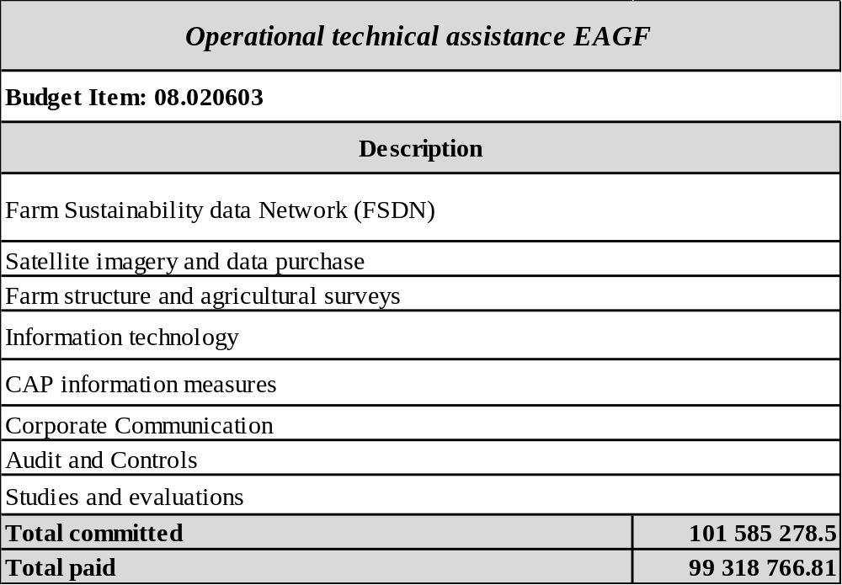

Table 3 (in EUR; current prices)
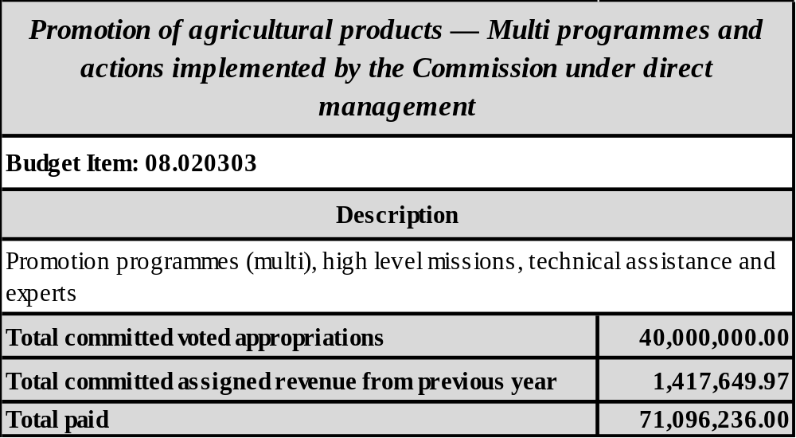

2.2. European Agricultural Fund for Rural Development (EAFRD) and European Union Recovery Instrument (EURI)
Article 31(1) of Regulation (EU) 2021/2116 states that following its implementing decision approving the CAP Strategic Plan, the Commission shall pay an initial prefinancing amount to the Member State for the entire duration of the CAP Strategic Plan. Article 32 of Regulation (EU) 2021/2116 also provides for interim payments to be made for each CAP Strategic Plan in order to reimburse the expenditure effected by the accredited paying agencies in implementing the CAP Strategic Plans.
With regard to the completion of rural development programs approved under Regulation (EU) No 1306/2013, Article 34(2) of that Regulation states that the combined total of prefinancing and interim payments may not exceed 95% of the EAFRD's contribution to each rural development program. Pursuant to Article 36(2) of Regulation (EU) No 1306/2013 and subject to the availability of resources, the Commission shall, taking account of reductions or suspensions applied under Article 41, make interim payments in order to reimburse the expenditure effected by accredited paying agencies in implementing the programmes.
As referred to in Article 37(1) of Regulation (EU) No 1306/2013, after receiving the last annual progress report on the implementation of a rural development programme, the Commission shall pay the balance, subject to the availability of resources, on the basis of the financial plan in force, the annual accounts for the last execution year for the relevant rural development program and of the corresponding clearance decision.

2.2.1. Payments
The Commission proceeds with reimbursement for each quarterly declaration of expenditure of the financial year.
For details, see annex 7.

2.2.2. Reductions of payments
For measures financed by the EAFRD, financial ceilings are determined in accordance with the Union legislation. Expenditure exceeding these ceilings is considered non-eligible and results in reductions of the payments. In 2025, reductions for a net amount of EUR 57.5 million were applied to the payments effected to the Member States based on the quarterly declarations of expenditure for 2025.

2.2.3. Expenditure under direct management by the Commission
The Commission implements certain measures and actions under direct management, mainly related to operational technical assistance. For details, please see tables 4 and 5. Details concerning voted appropriations implemented under direct management by the Commission during financial year 2025 for operational expenditure are presented in annexes 5 and 6.

Table 4 (in EUR; current prices)
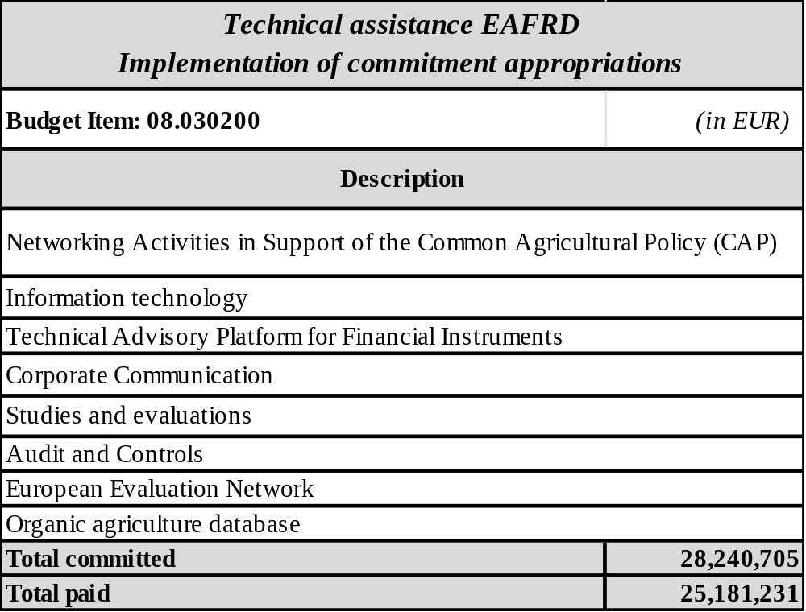

Table 5 (in EUR; current prices)
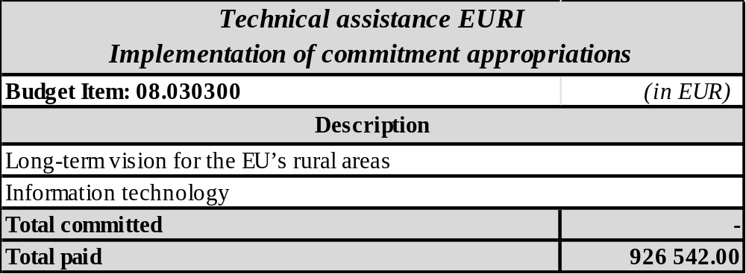

3. THE UPTAKE OF THE EAGF AND EAFRD APPROPRIATIONS

3.1. European Agricultural Guarantee Fund (EAGF)
The implementation of the EAGF appropriations amounted to EUR 40 875.4 million. This expenditure was funded by the budget's initial appropriations and by using revenue assigned to the EAGF. From the EUR 995.3 million revenue assigned to the EAGF, collected in 2025 and carried over from 2024 (of which EUR 983.6 million from shared management), EUR 924.6 million was used to cover payment needs.
Within chapter 08 01, the EAGF commitments for administrative support expenditure under article 08 01 01, amounted to EUR 12.4 million (including EUR 9.7 million of assigned revenue carried over from financial year 2024).
EUR 255.3 million was used from the agricultural reserve to finance various exceptional support measures.
Within chapter 08 02, the overall EAGF expenditure for market-related interventions, under the CAP Plans (budget article 08 02 02) and outside the CAP Plans (budget article 08 02 03) amounted to EUR 2 802.7 million.
Direct payments in financial year 2025 were implemented under the CAP Plans (budget article 08 02 04) in accordance with the rules provided for in Regulation (EU) 2021/2115, and outside the CAP plans (budget article 08 02 05), in accordance with the rules provided for in Regulation (EU) No 1307/2013. The related total expenditure amounted to EUR 37 683.3 million.
Finally, EUR 119.1 million were committed under articles 08 02 06 – Policy strategy, coordination and audit (of which EUR 101.6 million for technical assistance) and EUR 2.7 million under 08 02 99 – Completion of previous programmes and activities.
The under-execution for the EAGF was EUR 70.7 million in assigned revenue appropriations (of which 70.2 million from shared management), which were carried over to year 2026. Furthermore, the unused appropriations from the agricultural reserve amounted to EUR 391.4 million. The full amount was carried over to the 2026 agricultural reserve, in accordance with Article 16(2) of Regulation 2021/2116, partially for financing the remaining expenditure related to the exceptional measures adopted in 2025.
For details of the budget implementation by policy area as well as on the use of the assigned revenue please consult annex 8, annex 9, annex 10, annex 11 and annex 12.

3.2. European Agricultural Fund for Rural Development (EAFRD) and European Union Recovery Instrument (EURI)
The implementation of the EAFRD commitment appropriations amounted to EUR 13 226.7 million (annex 13), using the voted budget's initial appropriations and the EAFRD internal and external assigned revenues.
Within chapter 08 01, the EAFRD committed amount was EUR 2.4 million for administrative support to the program.
Within chapter 08 03, beside the committed amount related to the implementation of types of intervention under the CAP Strategic Plans (EUR 13 195.7 million) :
- EUR 28.2 million was committed for operational technical assistance
- EUR 0.3 million was committed for payback operations for rural development programmes in the previous periods (prior to 2023).
The implementation of the EAFRD payment appropriations amounted to EUR 15 852.4 million (annex 13). This payment was funded by the voted budget's appropriations and by using the EAFRD internal and external assigned revenues.
Within chapter 08 01, the EAFRD paid amount was EUR 2.2 million for administrative support to the program.
Within chapter 08 03, payments amounted to:
- EUR 7 969.8 million for the types of intervention under the CAP Strategic Plans
- EUR 7 854.3 million for operations for rural development programmes in the previous periods (prior to 2023)
- EUR 26.1 million for operational technical assistance.
The majority of EAFRD expenditure is implemented under shared management, while a small proportion is implemented under direct management.
Shared management : absorption rate of EAFRD 2014-2022 and EAFRD 2023-2027 by Member State (Graphs 1a-d):

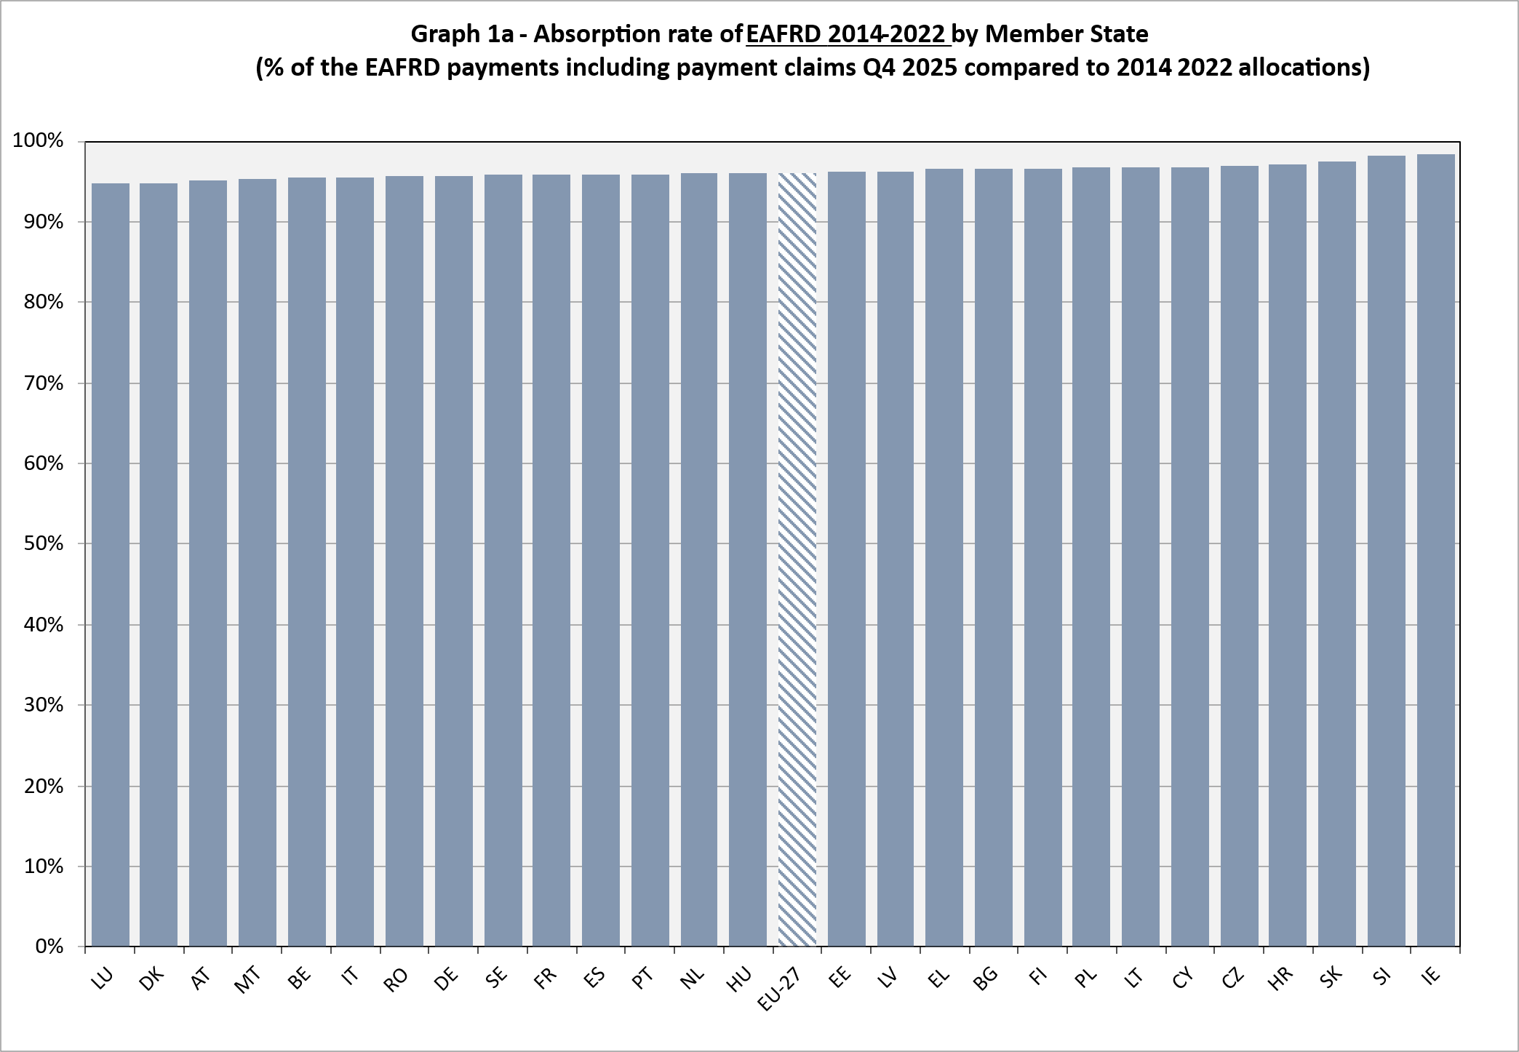

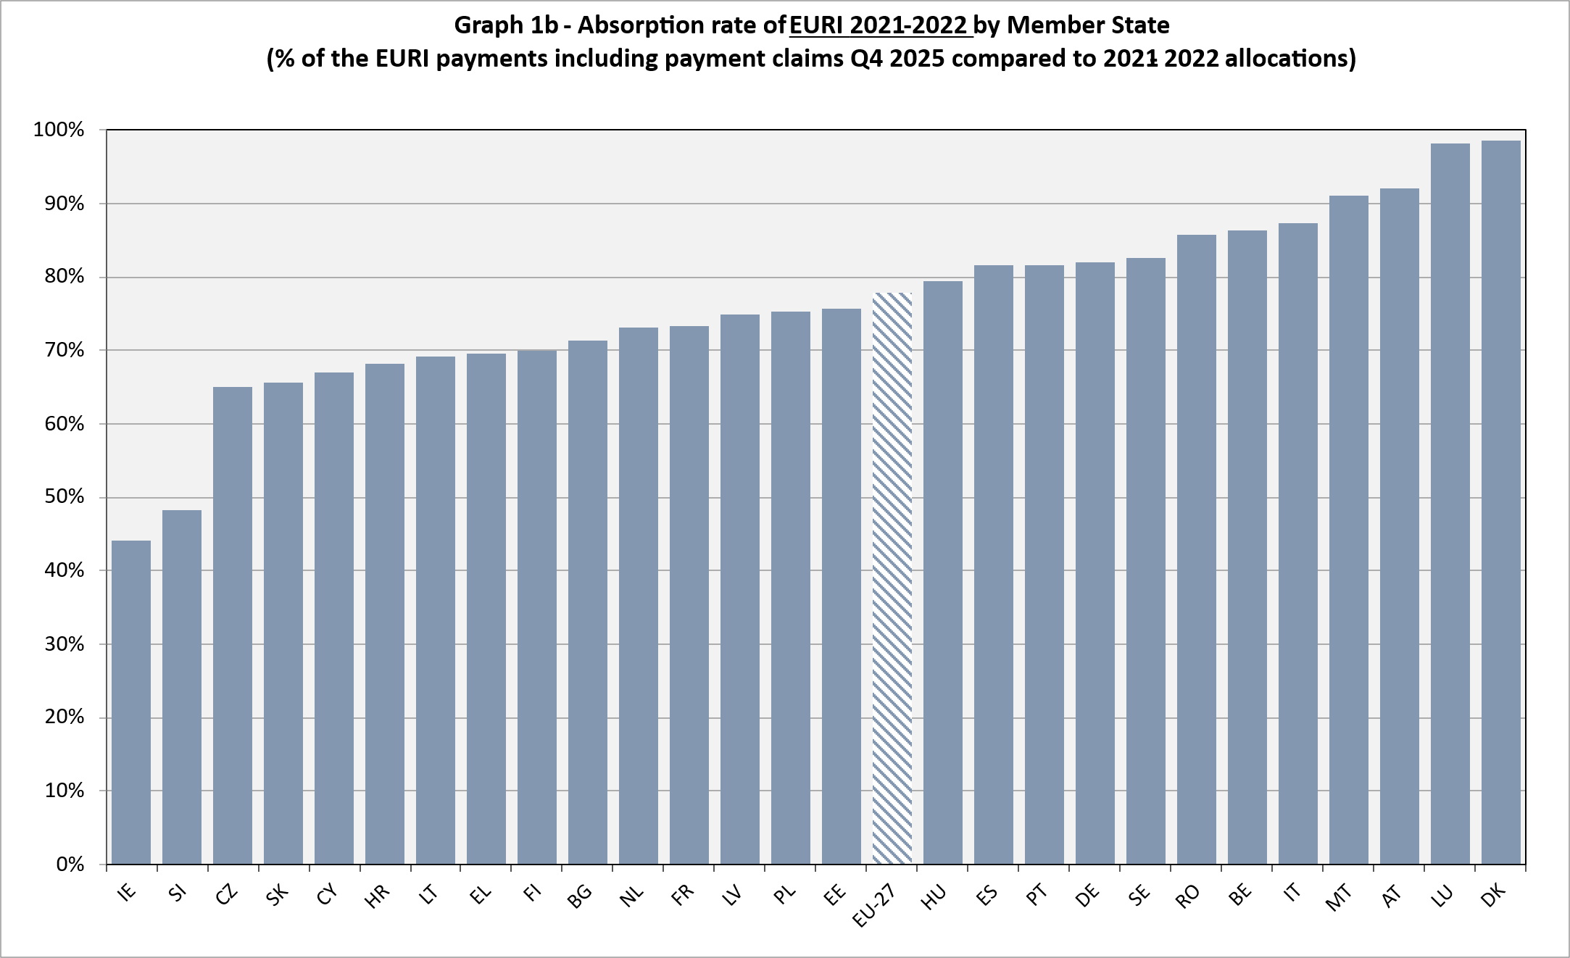

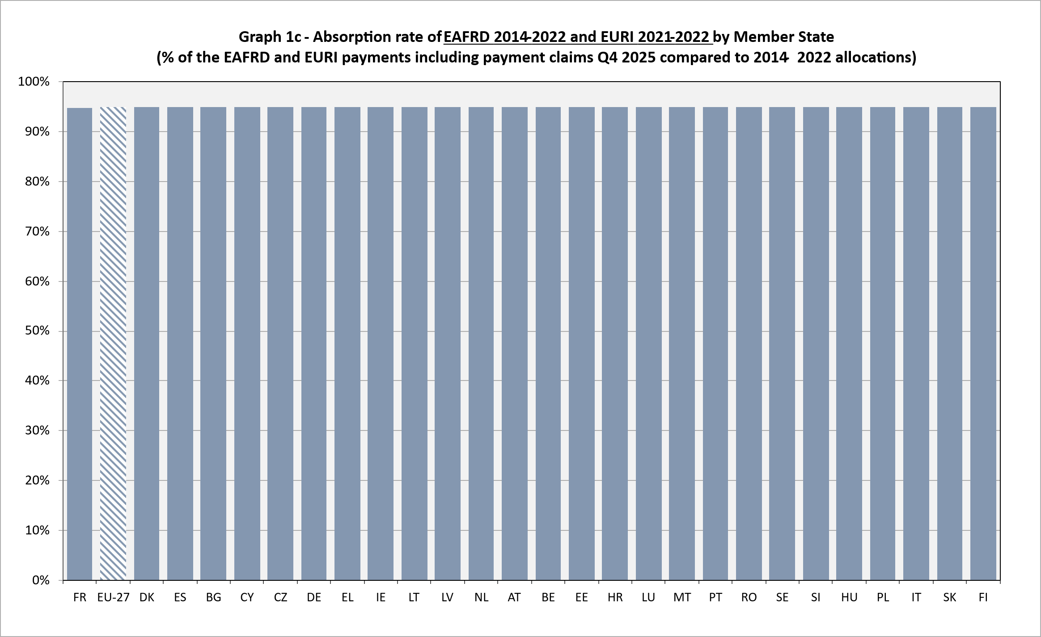

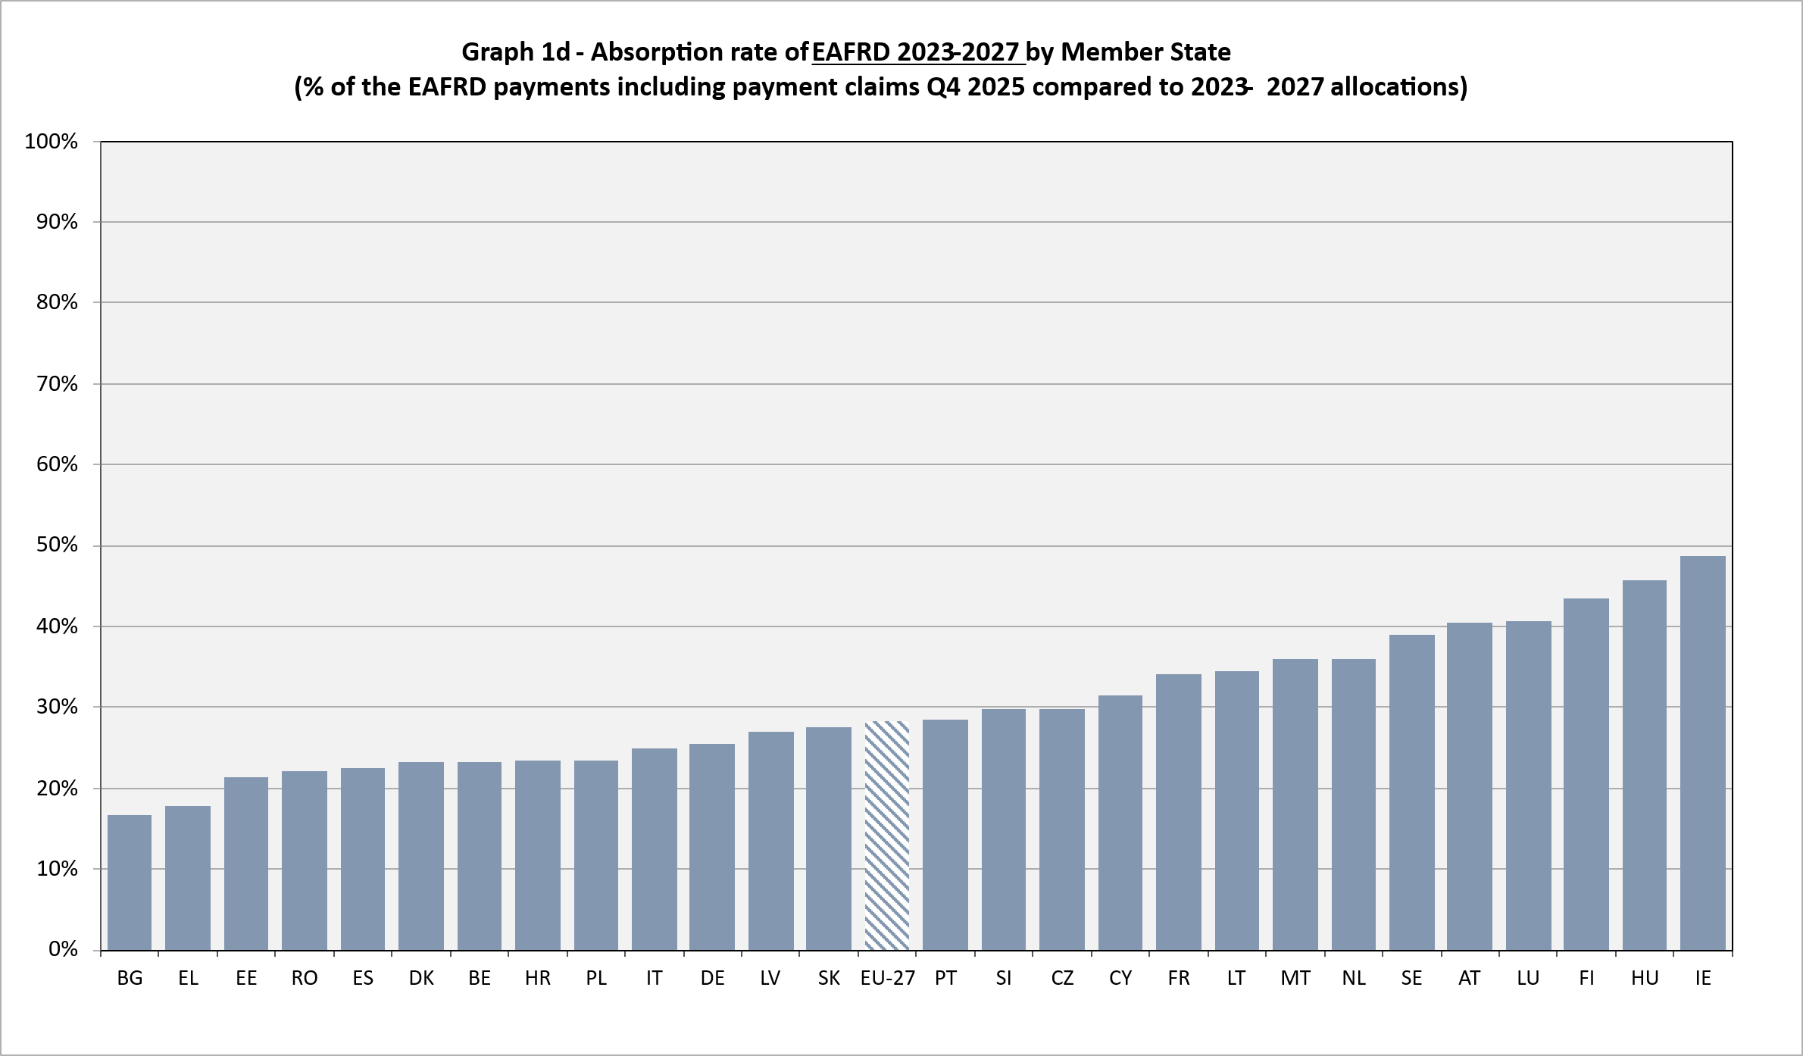
For details of the budget implementation by Member State and by policy area as well as on the use of the assigned revenue please consult annexes 14 to 17.

4. CONTROL MEASURES

4.1. Introduction
In accordance with the EU legislation and as in previous years, the 2025 agricultural expenditure was submitted to a comprehensive system of control measures.
The controls are carried out by the paying agencies or by delegated bodies operating under their supervision and effective, dissuasive and proportionate sanctions are imposed if the controls reveal non-compliance with EU rules. In addition, for most regimes which are not subject to the Integrated Administration and Control System, on top of the primary and secondary control levels, ex-post controls must be carried out.

4.2. Integrated Administration and Control System (IACS)
Regulation (EU) No 1306/2013, Commission Delegated Regulation (EU) No 640/2014 and Commission Implementing Regulation (EU) No 809/2014 as well as Regulation (EU) 2021/2116, Commission Delegated Regulation (EU) 2022/1172 and Commission Implementing Regulation (EU) 2022/1173 contain the rules on the IACS.
The DG AGRI Annual Activity Report (AAR) for 2025 contains detailed information on expenditure covered by IACS in Annex 7, Part 2, A.2.3.a). The relevant components of the IACS are also applicable to the rural development measures that are based on area or number of animals. Such measures include, inter alia, agri-environment and animal welfare measures, less-favoured areas and areas with environmental restrictions, and afforestation of agricultural land.

4.3. Application Chapter III of Title IV of Regulation (EU) 2021/2116 (scrutiny of transactions)
In 2025, the scrutiny of transactions control system provided for under Chapter III of Title IV of Regulation (EU) 2021/2116 applied. It comprised an ex-post control system complementing the sectorial control systems described above.
In 2025, Member States’ scrutiny services completed controls in respect of operations to which payments were made in financial year 2023. The annual reports in respect of the respective scrutiny period (July 2024 - June 2025) show that Member States completed 89 % of the planned scrutinies at the end of the scrutiny reporting period. The rate of irregularities from those completed scrutinies is below 1 %.

5. CLEARANCE OF ACCOUNTS

5.1. Conformity clearance
It is primarily the Member States' responsibility to ensure that transactions are carried out and executed correctly via a system of control and dissuasive sanctions. Where Member States fail to meet this requirement, the Commission applies financial corrections to protect the financial interests of the EU.
The conformity clearance under the CAP applicable in financial year 2025 relates to the legality and regularity of transactions. It is designed to exclude expenditure from EU financing which has not been effected in compliance with EU rules.
Details on audits carried out in 2025 can be found in the AAR, table 2.1.2a).1-2.
Conformity clearance decisions adopted in 2025, including financial corrections in a number of sectors, are listed in the AAR, table Annex 7 – Part 3 A.b.1)-1.
The following conformity clearance decisions had a financial impact on the 2025 budget:
- Decision (EU) 2024/2879 of 13 November 2024 – ad hoc decision 74 , with a net decided amount of EUR 178.8 million in favour of the EAGF and EUR 39.9 million in favour of the EAFRD.
- Decision (EU) EU 2025/209 of 5 February 2025 – ad hoc decision 75 (UK only), with a net decided amount of EUR 3.7 million in favour of the EAFRD.
- Decision (EU) EU 2025/1147 of 11 June 2025 – ad-hoc decision 76 , with a net decided amount of EUR 475.3 million in favour of the EAGF and EUR 46 million in favour of the EAFRD.
After accounting for the execution of a number of judgements of the Court of Justice of the European Union in favour of Member States and the release of payment suspensions, the overall financial impact of those decisions for the funds was EUR 653.1 million in favour of the EAGF and EUR 89.4 million in favour of the EAFRD.
The financial corrections in conformity clearance decisions up to 2025 are detailed in Annex 18.
For Commission Implementing Decision (EU) 2024/2879 and Commission Implementing Decision (EU) 2025/1147, due to the relative magnitude of corrections compared to certain Member States’ gross domestic product, upon requests of the Member States concerned, the Commission decided that the following corrections could be paid in 3 equal annual instalments.

Table 6 (in EUR million; current prices)
Decision number | Member State | Amount to be paid in instalments
Decision number | Member State | EAGF | EAFRD
74 | Greece | 57.1 | 13.2
74 | Romania | 40.4 | 5.6
75 | Greece | 411.0 | 3.9
75 | Portugal | 35.0 | 27.0

On 15 February 2025, Member States reported the information from outstanding amounts to be recovered at the end of financial year 2024. These amount to EUR 414.004 million for the EAGF, EAFRD, and the Temporary Rural Development Instrument (TRDI), and are presented in the AAR, table Annex 7 – Part 3 A.b.2)-1.
The outstanding amount still to be recovered from beneficiaries at the end of the financial year 2025 was EUR 2 014 million for all the funds. The financial consequences for Member States for non-recovery of EAGF, EAFRD and TRDI cases within 4 years from the date of the recovery request (for new cases) or Primary administrative or judicial finding – PACA - (for old cases), or within 8 years where recovery is taken to the national courts, amounted to EUR 31.1 million. During financial year 2025, around EUR 11.6 million was borne at 100% by the EU budget for EAGF, EAFRD and TRDI.

5.2. Financial clearance
An overview of the financial clearance decisions adopted in 2025 can be found in table 7.

Table 7 (in EUR million; current prices)
Fund | Decision Number | Adoption Date | Financial Year | Declared expenditure cleared | PA concerned
EAGF | Decision (EU) 2025/972 | 23.05.2025 | 2024 | 40 408.76 | All MS PAs
EAFRD 2014-2022 | Decision (EU) 2025/971 | 23.05.2025 | 2024 | 10 078.76 | All MS PAs
EAFRD 2023-2027 | Decision (EU) 2025/997 | 23.05.2025 | 2024 | 4 943.68 | All MS PAs

5.3. Appeals brought before the Court of Justice of the European Union against clearance decisions
A summary of cases lodged to the General Court and the Court of Justice can be found in Annex 19.

6. RELATIONS WITH PARLIAMENT AND WITH THE EUROPEAN COURT OF AUDITORS

6.1. Relations with Parliament
The European Parliament (EP) is, together with the Council, part of the EU’s Budgetary Authority. It is, thus, one of the most important discussion partners of the Commission on budgetary matters and, therefore, on the EAGF and EAFRD.
Three EP committees are involved in the discussions and the preparation for the plenary on agricultural budgetary matters. These are the Committee on Agriculture and Rural Development, the Committee on Budgets and the Committee on Budgetary Control.
Since 2014 the Committee on Agriculture and Rural Development provides an opinion on the discharge procedure to the Committee on Budgetary Control.
The Committee on Budgetary Control (CONT) controls the correct implementation of the budget and drafts the report proposing to the Parliament to grant the discharge and making recommendations to the Commission or to Member States.
The European Parliament granted discharge to the Commission, in respect to the implementation of the general budget of the European Union for the 2024 financial year, by a vote in plenary on a Parliamentary Decision, which took place on 29 April 2026.

6.2. Relations with the European Court of Auditors
The European Court of Auditors (ECA) is the external independent auditor of the European Union. A summary of the findings and conclusions of the ECA for financial year 2023 is provided in the AAR, point 2.2.

OJ L 433I, 22.12.2020, p. 11, ELI: http://data.europa.eu/eli/reg/2020/2093/oj.
OJ L, 2024/765, 29.2.2024, ELI: http://data.europa.eu/eli/reg/2024/765/oj.
OJ L 40, 4.2.2021, p. 8, ELI: http://data.europa.eu/eli/reg_impl/2021/128/oj.
OJ L 435, 6.12.2021, p. 187, ELI: http://data.europa.eu/eli/reg/2021/2116/oj.
These monthly declarations of expenditure are transmitted by the Member States by the 7th day of the month following the month in which the expenditure was incurred.
OJ L 347, 20.12.2013, p. 549, ELI: http://data.europa.eu/eli/reg/2013/1306/oj.
OJ L 347, 20.12.2013, p. 608, ELI: http://data.europa.eu/eli/reg/2013/1307/oj.
OJ L 181, 20.6.2014, p. 48, ELI: http://data.europa.eu/eli/reg_del/2014/640/oj.
OJ L 227, 31.7.2014, p. 69, ELI: http://data.europa.eu/eli/reg_impl/2014/809/oj.
OJ L 183, 8.7.2022, p. 12, ELI: http://data.europa.eu/eli/reg_del/2022/1172/oj.
OJ L 183, 8.7.2022, p. 23, ELI: http://data.europa.eu/eli/reg_impl/2022/1173/oj.
The DG AGRI Annual Activity Reports can be found at: https://commission.europa.eu/publications/annual-activity-report-2025-agriculture-and-rural-development_en.
Irregularities cases for which primary administrative or juridical finding (PACA) was not established before 16 October 2014. In case the PACA was established before that date, the cases are to be classified as “old cases”.
Cases declared irrecoverable as per provision of Article 54(3) of Regulation (EU) No 1306/2013.

