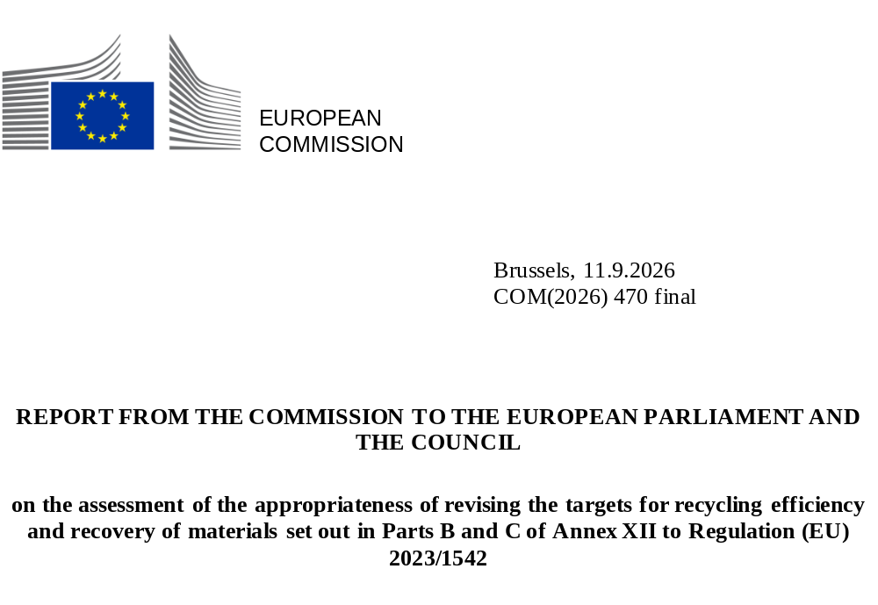

- Introduction
Batteries are one of the key enablers of sustainable development, green mobility, clean energy and climate neutrality. The Regulation on Batteries and Waste Batteries (Regulation (EU) 2023/1542 or the Batteries Regulation) introduced a harmonised regulatory framework for the entire life cycle of batteries placed on the market in the EU. This includes requirements on recycling efficiency and recovery of materials from waste batteries.
To address the scarcity of primary raw materials and reduce its dependency on non-EU countries for critical supplies, the EU must strengthen its strategic autonomy, including by developing a more circular economy. The Letta and Draghi reports and the Competitiveness Compass all emphasise the role of circularity in promoting innovation and resilience.
The RESourceEU action plan includes batteries and their raw materials among the value chains that require immediate focus to boost EU industry and support competitiveness, the green and digital transitions and defence readiness.
The targets for recycling of waste batteries and recovery of their materials are mentioned in Article 71 and set out in Annex XII to the Batteries Regulation. These targets increase over time, contributing primarily to a more circular economy and thereby increasing the availability of critical raw materials for the EU economy. They also support industrial competitiveness and encourage innovation.
Under Article 71(5) of the Batteries Regulation, by 18 August 2026 and at least every five years after that date, the Commission must assess whether it is appropriate to revise the targets for recycling efficiency and recovery of materials, taking into account:
- market developments, particularly changes in battery technologies that affect the types of material recovered;
- the current and projected availability of cobalt, copper, lead, lithium and nickel, or the lack thereof;
- technical and scientific progress.
Where justified and appropriate based on that assessment, the Commission may adopt a delegated act in accordance with Article 89 of Regulation (EU) 2023/1542 to amend the targets for recycling efficiency and recovery of materials set out in Parts B and C of Annex XII to Regulation (EU) 2023/1542.
While this assessment covers recycling efficiency for all battery chemistries and recovery of all materials subject to recovery requirements, it is focused in particular on lithium-based batteries, given recent market developments and the rapidly evolving technologies in this area.

- background
The targets for recycling efficiency and recovery of materials are laid down in Parts B and C of Annex XII to Regulation (EU) 2023/1542 as summarised below.
- No later than 31 December 2025, recycling must have reached at least the following recycling efficiency targets, by average weight: 75% for lead-acid batteries, 65% for lithium-based batteries, 80% for nickel-cadmium batteries and 50% for other waste batteries.
- No later than 31 December 2030, recycling must have reached at least the following recycling efficiency targets, by average weight: 80% for lead-acid batteries and 70% for lithium-based batteries.
- No later than 31 December 2027, all recycling must have reached at least the following targets for recovery of materials: 90% for cobalt, copper, lead and nickel and 50% for lithium.
- No later than 31 December 2031, all recycling must have reached at least the following targets for recovery of materials: 95% for cobalt, copper, lead and nickel and 80% for lithium.
The assessment covers all battery chemistries, including lead-acid and nickel-cadmium batteries. It also covers the main chemistries, by market share, in the group of ‘other’ batteries, including alkaline-saline and nickel-metal-hydride batteries.
Lithium-based batteries are now classified as a distinct chemistry under the Batteries Regulation, whereas under the repealed Directive 2006/66 (EC) they were categorised as ‘other waste batteries’. The ‘lithium-based chemistry’ category includes batteries with different levels of recyclability, depending on their composition (e.g. high or low content of valuable raw materials) and size (e.g. pack or cell level).
These differences were taken into account in the methodology for calculating and verifying the rates of recycling efficiency and recovery of materials laid down in Delegated Regulation (EU) 2025/606 . The methodology provides an appropriate degree of flexibility in the calculation rules by making the inclusion of certain substances, such as iron, phosphorous and graphite, optional until the end of 2029. This helps ensure that the targets are reachable. This calculation methodology must be taken into account when assessing the targets, as it strikes a balance between ambition and flexibility to reflect both the current state of waste battery recycling in the EU and the intended direction of travel.
The assessment was supported by a technical assessment carried out by the European Commission’s Joint Research Centre (JRC).
In September 2025, the JRC launched an EU-wide survey to collect data, targeting a broad range of battery associations, industry stakeholders involved in waste battery management (e.g. recyclers, refiners), non-governmental organisations and independent experts. The participants covered all relevant battery chemistries – i.e. lead-acid, lithium-based, nickel-cadmium and other batteries – and all battery categories – i.e. portable batteries, light means of transport (LMT) batteries, electric vehicle batteries, industrial batteries, and starting, lighting and ignition (SLI) batteries.
Most stakeholder engagement came from the lithium-based battery industry. This may be due in part to lithium-based batteries being newly classified as a distinct chemistry under the Batteries Regulation, with new specific recycling efficiency and recovery of materials targets. It may also reflect the recent significant expansion of and innovation in the lithium-based battery industry and the related recycling industry. Most of the data submitted by industry to the JRC was provided confidentially. At a JRC stakeholder workshop in January 2026, the JRC specifically invited experts on lead-acid, nickel-cadmium and other batteries to comment on its findings and suggestions relating to their specific fields of expertise.
To complement stakeholder responses to the EU survey, the JRC analysed achievable recycling efficiency by modelling the supply and demand of battery raw materials,.
A joint analysis was then carried out using the stakeholder data and the data derived from the JRC’s modelling. The results of this joint analysis were presented during the JRC stakeholder workshop in January 2026 to obtain feedback. The feedback and final conclusions from the stakeholders’ consultation conducted by the JRC have been taken into account in the present report.
Many stakeholders indicated in their feedback to the JRC that they considered this assessment of the targets to be premature. They pointed out that there was a time lag between this first assessment and the first reporting of data from recyclers to the competent authorities by mid-2027, followed by reporting from Member States to the Commission by mid-2028 (under Articles 75(7) and 76(1) of Regulation (EU) 2023/1542).
The Expert Group on Waste (Batteries) held back-to-back meetings on 22 May 2026 – one with external stakeholders and one with Member States only. Written feedback could be submitted until 19 June 2026. No requests were made to change the report’s conclusions.

- Assessment of recycling efficiency targets in Part B of Annex XII

3.1 Stakeholder input on recycling efficiency targets
Stakeholder feedback indicated that the recycling efficiency targets for lithium-based batteries for 2025 and, in particular, for 2030 are perceived by the recycling industry as challenging and in some specific cases even unreachable. This is not due to the numerical value of the targets as such, but to the way the targets are structured. The recycling efficiency targets for lithium-based batteries group together batteries that could be treated differently due to their size (e.g. portable vs electric vehicle batteries), functionality (rechargeable vs non-rechargeable batteries) and chemistry (e.g. nickel-manganese-cobalt (NMC) batteries, which are rich in high-value materials, vs lithium-iron-phosphate (LFP) batteries, which are relatively poor in high-value materials). These batteries do not offer the same results when recycled.
Similar issues arise when comparing different battery categories. Specifically, electric vehicle battery packs can achieve higher recycling efficiency than portable batteries. Electric vehicle battery packs allow a significant part of the battery (e.g. the casing) to be recovered with minimal losses, making any losses from the treatment of the cells proportionately less significant. This is not the case for portable batteries, which often consist of one cell only or have minimal casing, making losses from cell treatment proportionately more significant.
The calculation methodology laid down in Commission Delegated Regulation (EU) 2025/606 addresses this discrepancy by giving recyclers the option, until the end of 2029, to include in their calculations certain materials that currently are not commonly recovered. This approach allows recyclers to adjust the calculation of recycling efficiency rates according to the input fractions they process while maintaining harmonised calculation rules for all types of batteries – including lithium-based batteries, despite the heterogeneous composition of different lithium-based batteries.
The JRC analysis confirms that the methodology in Delegated Regulation (EU) 2025/606 is robust and gives recyclers the flexibility they need to adapt to the targets.
Some stakeholders also mentioned that some emerging battery chemistries, such as solid-state batteries (SSBs), might not be adequately covered by the targets. For such batteries it might be difficult to reach the recycling efficiency target for lithium-based batteries. However, no specific suggestions or data on possible rates of recycling efficiency for SSBs were made during the consultations.

3.2 JRC analysis based on recycling efficiency modelling
Stakeholder feedback to the EU survey lacked significant quantitative data in some areas. The JRC therefore carried out an analysis of achievable recycling efficiency using its model on the supply of and demand for battery raw materials. The analysis focused on recycling efficiency for lithium-based batteries, for which a target was introduced in Regulation (EU) 2023/1542, and for which an assessment could be considered particularly relevant, given that the recycling industry is at a relatively early stage of development in this area.
The JRC determined the average recycling efficiency rates achieved using the following three calculation models.
  - No exclusion of any fraction: no input or output fractions were excluded from the calculations.
  - Exclusion of oxygen: oxygen was excluded from the input and output fractions used in the calculations, while graphite and solvents were considered to be recovered.
- Exclusion of oxygen, solvents and graphite: oxygen, solvents and graphite were excluded from the input and output fractions used in the calculations. According to the methodology set out in Delegated Regulation (EU) 2025/606, from 1 January 2030 it will no longer be possible to exclude solvents and graphite (and more generally carbon fractions) from the calculations.
Figure 1 provides a general overview based on the assumption that the input into recycling is representative of waste batteries collected in the EU and covers all applications and all chemistries. The following observations can be made.
- If no fraction is excluded from the calculations (calculation model 1: no exclusions), reaching the target would be very difficult in the case of all lithium-based batteries, unless additional fractions are recovered (e.g. graphite).
- If the recovery of graphite and solvents is progressively implemented in recycling processes and this is combined with the exclusion of oxygen from the calculations (calculation model 2: graphite and solvents recovery – oxygen exclusion), for lithium-based batteries, the targets may still not be reached by 2025, since graphite and solvents are counted in the input received but in practise not yet recycled at a sufficiently high rate. By contrast, by 2030, when the rate of recovery of graphite and solvents will be assumed to have reached 50%, the lithium battery recycling efficiency target of 70% will also have been reached.
- Finally, excluding graphite, oxygen and solvents from the calculation (calculation model 3: graphite, oxygen and solvent exclusion) would make it possible to reach the 2025 and 2030 targets for lithium-based batteries.

Figure 1. Weighted average recycling efficiency obtainable for lithium-based batteries using three different calculation methods, compared to the targets for the years 2025 and 2030
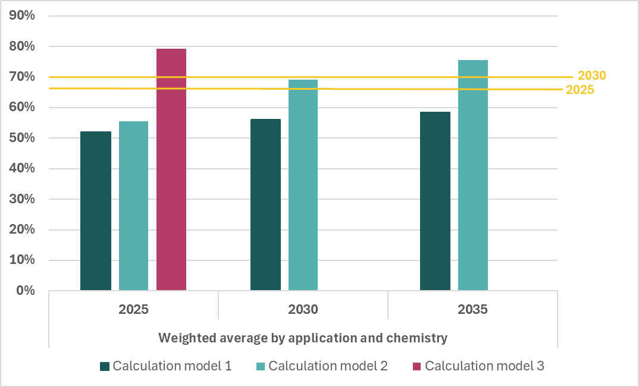
Source: JRC own calculations. (© European Union, 2026)

This analysis has its limitations. It is based on the JRC’s forward-looking modelling, which, although underpinned by solid and annually updated dataset development, relies on assumptions and estimations, as is the case with any modelling activity. The composition of waste batteries available for recycling was estimated on the basis of historical and expected data on the types of batteries used in relevant applications (e.g. electric vehicles, industrial, light means of transport, portable) and their characteristics (mainly lifetime and chemistry), using a statistical distribution (Weibull). The same applies to the historical and expected collection rates for the different batteries. The data was obtained from scientific literature, reports, private data providers and directly from battery recyclers. The expected recycling efficiency in Figure 1 reflects a weighted average based on the expected composition of the material input into recycling and the recycling efficiency for the different types of applications and chemistries, as provided by recyclers.

3.3 Results of the analysis
The analysis shows that, although the targets may be difficult to reach in some cases, Delegated Regulation (EU) 2025/606 allows recyclers to mitigate the limitations of their input by temporarily excluding fractions that are not recovered from the calculation of their recycling efficiency rate. This enables them to reach and even exceed the targets for lithium-based batteries until 31 December 2029. After 1 January 2030, recyclers will still be able to exclude oxygen, chlorine and sulphur. However, graphite, iron and phosphorous will have to be included in the calculations, which will provide an additional incentive to recycle those materials.
The analysis concludes that a revision of the targets for lithium-based batteries is not required, as no data or information from the EU survey and the JRC report identified significant changes in terms of market development or technical and scientific progress that would justify revising the current recycling efficiency targets for lithium-based batteries. The targets for lead-acid, nickel-cadmium and other batteries also do not require revision, as the analysis yielded similar results.

- Assessment of the targets for recovery of materials in Part C of Annex XII

4.1 Stakeholder feedback on targets for recovery of materials
Some stakeholders expressed concern about the 2031 target of 95% for nickel and cobalt, which they considered to be close to the technical limit, especially for large-scale, continuous processes.
Responses to the EU survey indicated that, at the end of 2025, very few recyclers were able to recover lithium from batteries, although new lithium recovery processes are expected to be introduced in the coming years. The lack of feedback on the targets from most stakeholders may indicate that there are no particular issues with the current targets and that recyclers, although under pressure, seem confident they will reach the targets on time. A few stakeholders indicated that the increase in the lithium targets from 50% in 2027 to 80% in 2031 may be too steep. By contrast, a small number of stakeholders suggested that the lithium targets could be more ambitious. However, they provided neither quantitative suggestions nor clear evidence to justify an increase.
Some stakeholders expressed concerns that start-ups and operators using new processes might not be able to reach the targets. They noted that these operators may have difficulties controlling their processes in the first one to three years, and pointed out that plants are being ramped up before material recovery rates have been optimised.

4.2 JRC analysis based on modelling of the recovery of lithium
Given the rapid growth of the battery market, the availability of material is considered a relevant factor to investigate. Lithium is technically recoverable at high rates, but in the EU many processes are currently at a pilot stage. Moreover, there are no economies of scale, and some recyclers claim that the investment security required to scale up is inadequate. This can partly be linked to the higher cost of recycling in the EU compared to non-EU countries (e.g. cost of energy and labour).
The targets for recovery of lithium are the only targets that may still leave room for being adjusted. Raising them could potentially contribute to greater lithium availability in the EU.
The JRC has assessed the effects of raising or lowering the targets for recovery of lithium on the EU’s overall lithium supply.
The following three scenarios were considered in order to estimate the total potential secondary lithium supply:
- base recycling, with targets for recovery of lithium of 50% for 2027 and 80% for 2031;
- high recycling, with a 10 percentage point increase in the targets for recovery of lithium, i.e. from 50% to 60% for 2027 and from 80% to 90% for 2031;
- low recycling, with a 10 percentage point decrease in the targets for recovery of lithium, i.e. from 50% to 40% for 2027 and from 80% to 70% for 2031.
As Figure 2 shows, when the target for recovery of lithium is 50% for 2027 and 80% for 2035, primary and secondary lithium supply from the EU is estimated to meet 18% of total EU demand in 2027, rising to 39% in 2031 and 42% in 2035. The potential effect of raising or lowering the targets would be between ±2 percentage points in 2027 and ±3 percentage points in 2035.
Figure 2. Total EU supply of lithium, as the sum of primary production and secondary production from waste batteries and manufacturing waste, over total EU demand for lithium contained in lithium-based batteries placed on the EU market, not taking into consideration treatment capacity
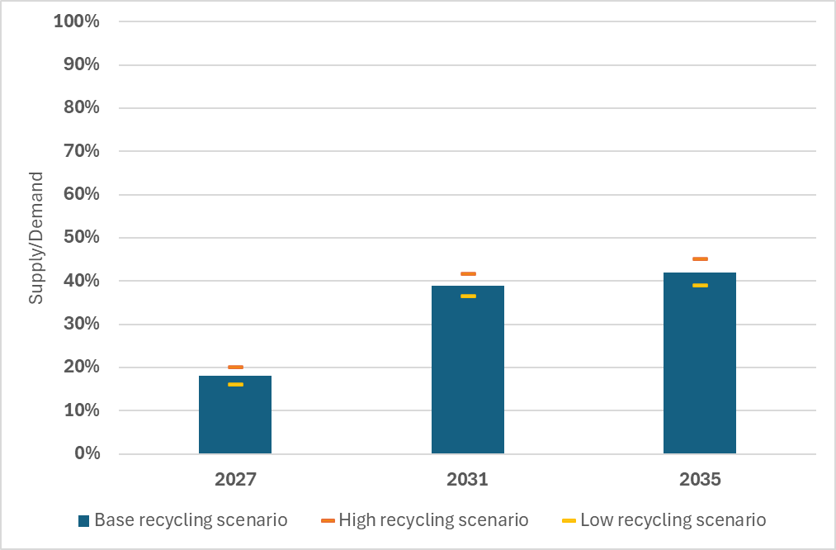
In the image above 100% represents total EU demand for lithium in batteries.
Source: JRC own calculations. (© European Union, 2026)
The analysis shows that, although an adjustment of the target would lead to an increase or decrease in supply, the impact in terms of the availability of materials to meet EU demand would be rather limited. The challenge facing the EU is more to do with the total treatment capacity available in the EU than with the efficiency of individual treatment plants.
This analysis has its limitations. It is based on the JRC’s forward-looking modelling, which, although underpinned by solid and annually updated dataset development, relies on assumptions and estimations, as is the case with any modelling activity. In this analysis, the modelling approach described in Section 3.2 was used, but for the recovery rates the analysis was further refined at the level of materials. Additional aspects, such as the material intensity specific to each battery application and chemistry, therefore had to be taken into account, and an adjustment of the analysed overall battery flows to the material content was required. Historical and expected data on refined primary raw material production was used to quantify the total supply of material. The data used for both historical and expected parameters was obtained from scientific literature, reports, private data providers and directly from recyclers.

4.3 Results of the analysis
No data or information from the EU survey and the JRC report indicate significant changes in terms of market development or technical and scientific progress that would justify revising the current targets for recovery of materials.
The JRC report shows that the 2027 target for recovery of lithium was set at 50% not because of the limited technical feasibility of the extraction processes (since very high extraction efficiencies can, in principle, be obtained with all commonly used recycling technologies), but to allow for a progressive ramp-up of the technology, given the time needed for optimisation and for overcoming any initial engineering obstacles.
Raising the targets would complicate the situation for recyclers, with no significant effect on the availability of materials, and could hamper new recyclers’ efforts to start their recycling processes. Conversely, lowering the target could benefit recyclers, but undermine circular economy objectives and worsen the already challenging lithium supply situation.
As regards cobalt, nickel, copper and lead, recyclers already recover these materials at high rates, and the targets are already very ambitious, with the 2031 target (95% recovery of materials) approaching the limit of what is technically feasible. For these materials, raising the targets would therefore merely put additional pressure on recyclers, while having a limited impact on the EU’s capacity for supplying raw materials. Conversely, lowering the targets is not considered necessary, as no technological or circularity failure has been identified related to the recovery processes.

- conclusions
The current targets set out in Parts B and C of Annex XII to Regulation (EU) 2023/1542 strike an appropriate balance between ambition and feasibility. They support the transition to a circular economy and encourage innovation and investment in the crucial area of battery recycling without overburdening a developing and growing industry.
As regards the recycling efficiency targets, the existing calculation methodology under Delegated Regulation (EU) 2025/606 provides recyclers with sufficient flexibility to adjust their calculations according to their input and to reach the targets using a technology-agnostic approach.
The targets for recovery of materials are in line with the technological feasibility of recovering cobalt, nickel, copper and lead. For lithium, the 50% recovery target, rather than being the maximum currently reachable in terms of technological feasibility and economic profitability, is considered well balanced, as it gives industry the time necessary to optimise and scale up processes.
Lowering the recovery targets would have only a limited effect on the current overall supply situation but could delay necessary investments in battery recycling. Lowering the recycling efficiency targets would also deter industry from investing in development and innovation and would not increase the competitiveness of the EU’s recycling industry. Any decrease in targets would also apply to recycling in non-EU countries following Article 72(3) of Regulation (EU) 2023/1542.
Lowering the targets might therefore undermine the achievement of circular economy objectives, especially in relation to critical raw materials and the EU’s strategic autonomy in a world characterised by increasing uncertainty around global trade and secure access to critical and strategic raw materials.
Raising the targets would also have only a limited effect on the current overall supply situation, while potentially putting additional pressure on EU recyclers without ensuring that the necessary changes could be made in the short timeline required, even with a sustained effort to improve matters and the expected impact of ongoing investments.
Rising demand for critical raw materials is driving a geopolitical scramble for access to resources. In recent years, some non-EU countries have adopted a series of export control measures covering critical raw materials and final products such as batteries.
Maintaining the targets for recycling efficiency and recovery of materials at their current levels would support the achievement of the objectives of the RESourceEU action plan, including by helping the EU reduce its dependence on a single country of origin by 30% to 50% by 2029 for battery-related raw material value chains. Keeping the targets unchanged would also complement action on primary raw materials through meaningful contributions to the circular economy and the secondary raw materials sector.
Having assessed all the information and data available on market developments, in particular on the impact of battery technologies on the type of materials recovered and the existing and forecasted availability of cobalt, copper, lead, lithium or nickel or the lack thereof, and taking into consideration technical and scientific progress, it is not considered appropriate to revise the targets for recycling efficiency and recovery of materials set out in Parts B and C of Annex XII.
On the basis of this assessment, the Commission sees no grounds for adopting a delegated act under Article 71(5) of Regulation (EU) 2023/1542 to amend the targets for recycling efficiency and recovery of materials set out in Parts B and C of Annex XII to Regulation (EU) 2023/1542.
However, continued monitoring with a view to assessing scientific progress and market developments is recommended, as required by Article 71(5), which states that the Commission must assess the appropriateness of revising the targets for recycling efficiency and recovery of materials at least every five years. The next assessment is therefore due by 18 August 2031 at the latest.

Regulation (EU) 2023/1542 of the European Parliament and of the Council of 12 July 2023 concerning batteries and waste batteries, amending Directive 2008/98/EC and Regulation (EU) 2019/1020 and repealing Directive 2006/66/EC.
Letta, E., ‘Much more than a market – Speed, Security, Solidarity. Empowering the Single Market to deliver a sustainable future and prosperity for all EU Citizens’, 2024, https://www.consilium.europa.eu/media/ny3j24sm/much-more-than-a-market-report-by-enrico-letta.pdf.
Draghi, M. ‘The future of European competitiveness’, 2024, https://doi.org/10.2872/1823372.
COM(2025) 30 Communication from the Commission to the European Parliament, the European Council, the Council, the European Economic and Social Committee and the Committee of the Regions.
COM 945, 2025. RESourceEU Action Plan Accelerating our critical raw materials strategy to adapt to a new reality.
Directive 2006/66/EC of the European Parliament and of the Council of 6 September 2006 on batteries and accumulators and waste batteries and accumulators and repealing Directive 91/157/EEC (OJ L 266, 26.9.2006, p. 1).
Commission Delegated Regulation (EU) 2025/606 of 21 March 2025 supplementing Regulation (EU) 2023/1542 of the European Parliament and of the Council by establishing the methodology for calculation and verification of rates for recycling efficiency and recovery of materials from waste batteries, and the format for the documentation.
JRC technical assessment in relation to the Article 71(5) of the Batteries Regulation, 2026.
JRC technical assessment in relation to the Article 71(5) of the Batteries Regulation, 2026.
Orefice, M., Manni, F.M., Pierri, E., Bobba, S., Gaudillat, P., Vaccari, M., Mathieux, F., 2024. Technical suggestions for the rules for calculation and verification of rates for recycling efficiency and recovery of materials of waste batteries. https://doi.org/10.2760/9393862.
Commission Delegated Regulation (EU) 2025/606 of 21 March 2025 supplementing Regulation (EU) 2023/1542 of the European Parliament and of the Council by establishing the methodology for calculation and verification of rates for recycling efficiency and recovery of materials from waste batteries, and the format for the documentation.
JRC technical assessment in relation to the Article 71(5) of the Batteries Regulation, 2026, Section 3.1. Analysis of current levels of RE targets for Li-based batteries.
This is why Delegated Regulation (EU) 2025/606 allows those substances to be excluded from the calculations of the recycling efficiency rates at least until 31 December 2029.
Orefice, M., Manni, F.M., Pierri, E., Bobba, S., Gaudillat, P., Vaccari, M., Mathieux, F., 2024. Technical suggestions for the rules for calculation and verification of rates for recycling efficiency and recovery of materials of waste batteries. https://doi.org/10.2760/9393862.
JRC technical assessment in relation to the Article 71(5) of the Batteries Regulation, 2026.
JRC technical assessment in relation to the Article 71(5) of the Batteries Regulation, 2026.

