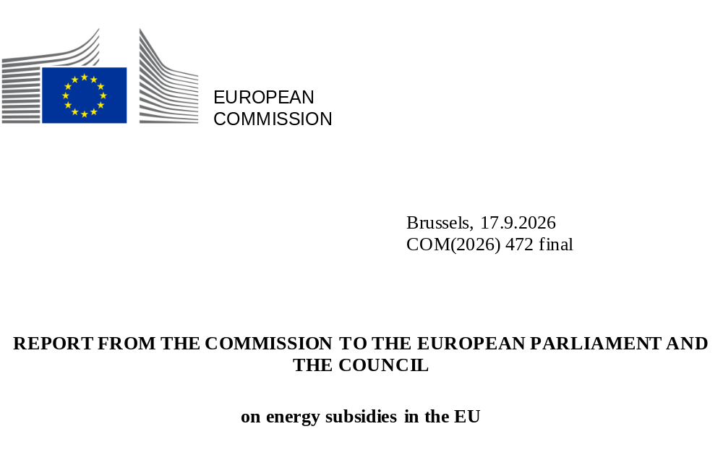

Introduction
Energy subsidies represent a fiscal burden and a cost to public budgets. It is therefore essential that energy subsidies are well designed, well-spent, and fit in coherently with EU policy goals to achieve a competitive and just carbon-neutral economy alongside a secure, clean energy supply by 2050.
This report, which covers the year 2024, is the seventh annual report on energy subsidies and progress towards phasing out fossil-fuel subsidies. It confirms a significant decline in temporary subsidies for combating the high energy prices which resulted from the 2022 energy crisis, a rebound in renewable energy subsidies, increased support for energy efficiency and infrastructure and an overall reduction in fossil fuel subsidies compared to 2023. Nevertheless, Member State spending on energy subsidies, including on fossil fuels, remains high compared to the situation prior to the 2022 crisis.
The data in this report does not cover more recent developments from 2025 and 2026, including Member State responses to the conflict in the Middle East.
Key findings:
Total energy subsidies in the EU in 2024 were worth EUR 340 billion, a slight decrease (-5%) compared to 2023 (EUR 360 billion) and significantly lower (-25%) than 2022, at the height of the crisis (EUR 457 billion). However, they remained considerably above the historical average (EUR 190 billion in 2015-2019).
The share of non-targeted energy subsidies, benefiting the use of all energy carriers across all end-users in a cross-sectoral way, remained high at almost half of all energy subsidies (48%) and more than twice the historic average (21% in 2015-2019).
Temporary measures aimed at addressing high energy prices decreased in value by 38% (to EUR 98 billion) in 2024 compared with 2023 and were below half their value (-55%) compared with 2022 (EUR 219 billion), as Member States terminated many such support measures in response to energy prices coming down after their historic peaks in 2022 and 2023. However, this still fell short of the objective set by the Council to wind down energy crisis-related subsidies completely by 2024.
Renewable energy subsidies rebounded to EUR 76 billion in 2024, representing an increase in value of 39% compared to 2023 (EUR 55 billion), while remaining around 12% below the average for the period 2015-2021 (EUR 87 billion).
In 2024, fossil fuel subsidies (FFS) were worth EUR 97 billion, well in excess of the average for the period 2015-2019 of EUR 60 billion. However, in 2024, due to the phase-out of many temporary crisis measures, FFSs declined by 20% compared to 2023 (EUR 121 billion) and were down by 42% from their peak in 2022 (EUR 168 billion).
The purpose of energy subsidies remained first and foremost to support energy consumption (70% of total energy subsidies or EUR 238 billion in 2024), and then to support energy production (24% or EUR 82 billion).
In 2024, environmentally harmful subsidies fell by 26% to EUR 110 billion (32% of the total), while non-environmentally harmful energy subsidies rose by 10% to EUR 230 billion (68%). The largest share of environmentally harmful subsidies (EUR 89 billion or 81%) was accounted for by fossil fuels subsidies.
According to the national phase-out plans communicated by Member States in 2023 and 2024, fewer than half (39% or EUR 38 billion) of all fossil fuel subsidies had a planned end-date before 2025, another 8% (EUR 8 billion) had a planned end-date between 2026 and 2030, while the remaining 52% (EUR 50 billion) had either no end-date or an end-date set for after 2030.

Energy subsidy trends in the EU
In 2024, the total value of energy subsidies in the EU-27 declined by 5% to EUR 340 billion compared to EUR 358 billion in 2023. This was the second year in a row in which the total value of energy subsidies had fallen, taking them 25% below their historic peak of EUR 457 billion reached in 2022. This decrease reflects decisions by several Member States to discontinue temporary measures for protecting households and economic activity from rising energy prices (Figure 1). However, the total value of energy subsidies remained well above the historic average (EUR 190 billion, 2015-2019).

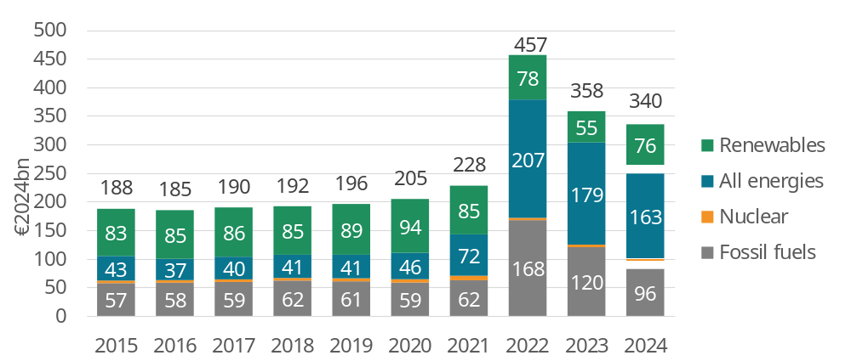
Figure 1: Total energy subsidies in the EU-27 by energy source
Source: Enerdata, Trinomics, 2025. NB: 2024 estimates are represented with hatching

In 2024, fossil fuel subsidies (EUR 96 billion) declined by 20% compared to 2023 (EUR 120 billion) and were down by 42% compared to their record high in 2022 (EUR 168 billion). Nevertheless, they remained 62% above the 5-year historic average (EUR 59 billion in 2015-2019).
Renewable energy subsidies rebounded to EUR 76 billion (+39%) in 2024. Implementation of EU programmes notably the Recovery and Resilience Facility, with a 27 dedicated REPowerEU chapters, has been incentivising Member States to accelerate the roll-out of renewables. However, renewable energy subsidies were still 12% below their historic average (EUR 86 billion in 2015-2019). Subsidies for certain renewable energy carriers rose considerably, while subsidies for all fossil fuel carriers decreased substantially. Subsidies for hydrogen were up three-fold compared to 2023 and up four-fold compared to 2022, while bioenergy subsidies were worth almost twice that of 2023.
Subsidies for coal saw the biggest decrease (-37%), followed by natural gas (-23%) then oil (-10%).
Non-targeted energy subsidies (‘all energies’) allocating financial support to all- or multi-energy sources accounted for almost half of all energy subsidies (48%) in 2024 (Figure 2). While year-on-year the share of non-targeted subsidies declined moderately (-2 percentage points from 50% in 2023), it was still above twice the historic average (21%), reflecting the still high value of temporary subsidies being granted by Member States to mitigate the impact of the 2022 crisis across most energy sources, categories of consumers, and sectors.
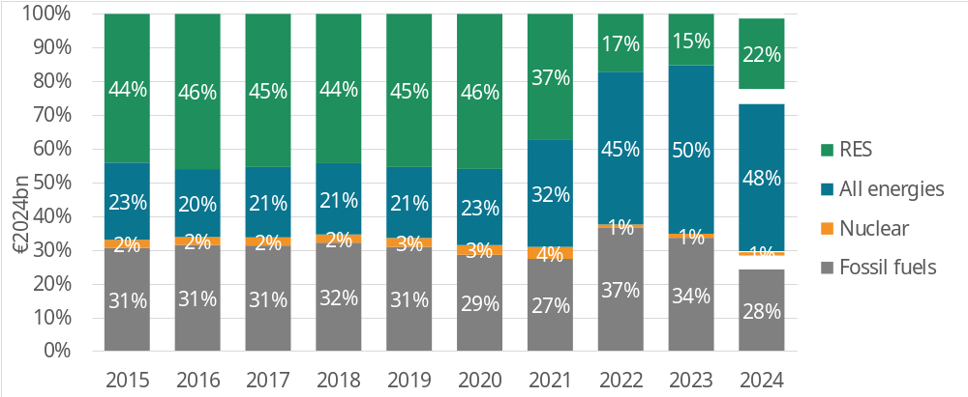
Figure 2: Main energy sources as a share of total energy subsidies in the EU-27
Source: Enerdata, Trinomics, 2025. NB: 2024 estimates are represented with hatching
Subsidies specifically aim to support fossil fuels accounted for 28% of total energy subsidies in 2024, down from 34% in 2023 and 37% in 2022, and below the historic average of 31%. (Figure 3). Renewable energy sources received 22% of energy subsidies in 2024 (up from 15% in 2023 and 17% in 2023) as falling market prices increased the need for financial support from dynamic market-based instruments.
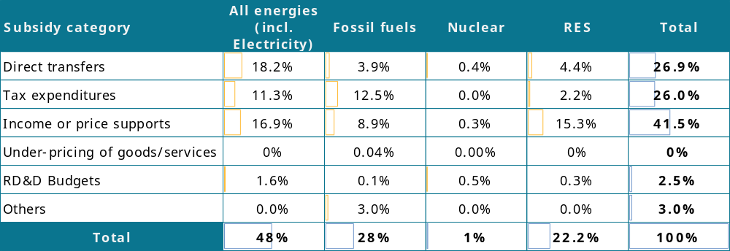
In terms of instruments for providing energy subsidies, income and price support measures remained the most common category of subsidy, accounting for 41.5% of the total (Figure 3), followed by direct transfers (26.9%) then tax measures (26%).
Figure 3: Subsidy distribution by category (2024)
Source: Enerdata, Trinomics, 2025

Subsidies by energy carrier
In 2024, electricity remained the most heavily subsidised energy carrier accounting for EUR 166 billion (close to 45%) of total energy subsides. Support for ‘all energies’ and gas subsidies fell in 2024 to EUR 59 billion and EUR 42 billion (17% and 12% of total subsidies), respectively. Support for oil was stable compared with 2023 (i.e. EUR 27 billion or 8%), while support for heat – which almost doubled in 2023 – decreased slightly in 2024 to EUR 21 billion (7%). Support for hydrogen has grown considerably since 2022, with a record EUR 13.5 billion allocated in 2024 (3%).
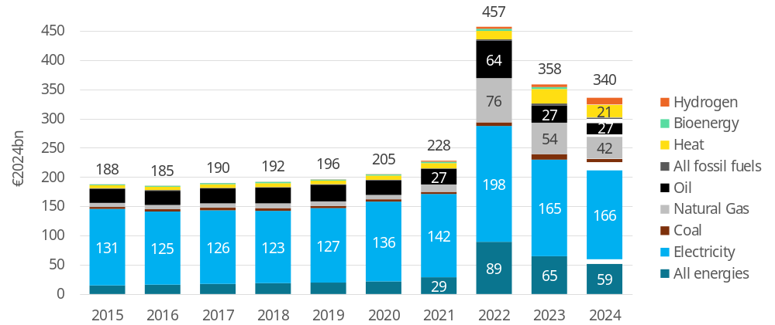
Figure 4: Energy subsidies by main energy carriers in the EU-27 in 2015-2024 (EUR₂₀₂₄ billion)
Source: Enerdata, 2025. 2024 estimates are represented with hatching

The downward trend in fossil fuel subsidies continued (Figure 5), but they were still 64% above the historic pre-crisis average (EUR 60 billion).
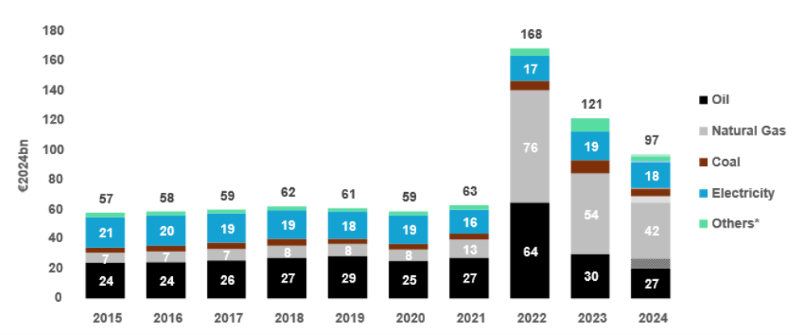
Figure 5: Fossil fuel subsidies by energy vector (EUR₂₀₂₄ billion)
Source: Enerdata, Trinomics, 2024. *‘Others’ includes subsidies directed to all fossil fuels, and heat from fossil sources. The figures in the graph include tax expenditures that cannot be directly compared across countries.
Fossil fuel subsidies excluding ‘tax expenditure’ (EUR 43 billion) and ‘government ownership’ and ‘equity infusion’ (EUR 10 billion) accounted for 45% of the total or EUR 44 billion in 2024.
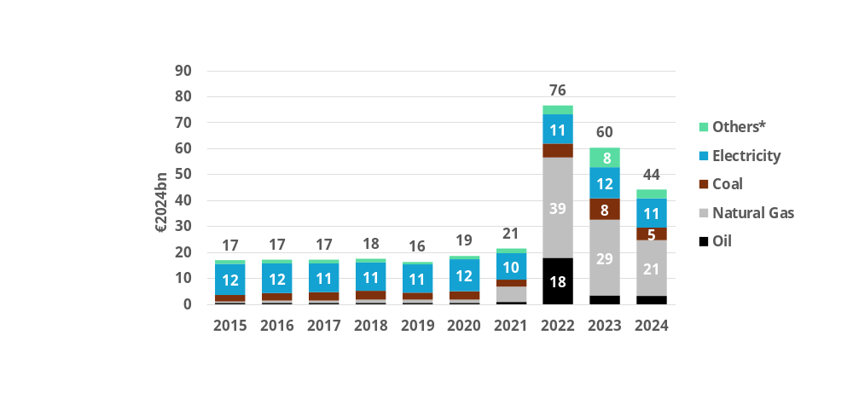
Figure 6: Fossil fuel subsidies excluding tax expenditures, government ownership/equity infusion by energy sources (EUR₂₀₂₄ billion)
Source: Enerdata, Trinomics, 2025. *‘Others’ includes subsidies directed to all fossil fuels, and heat from fossil sources. The figures in the graph include tax expenditures that cannot be directly compared across countries.
Fossil fuel subsidies addressing energy poverty decreased to EUR 1.3 billion in 2024 but remained above the historic average of around EUR 980 million annually.
Fossil fuel subsidies aimed at enhancing supply security – which fell to EUR 15 billion in 2023 – declined again in 2024, to EUR 11 billion. Nevertheless, they remained far above pre-crisis levels of around EUR 1 billion.
In 2024, subsidies for renewable energy sources rebounded to EUR 76 billion, an increase of 39% compared with 2023 when they reached their lowest level since 2015 (EUR 55 billion). However, they were still 12% below the historic average for the period 2015-2019 of around EUR 86 billion per year.

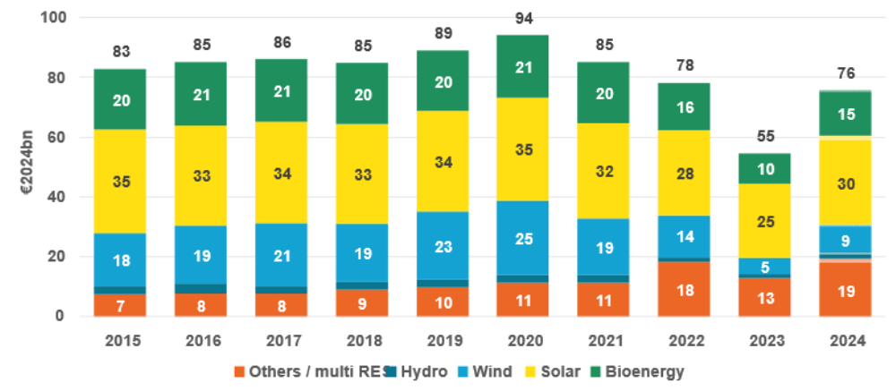
Figure 7: Renewable subsidies by technology (EUR₂₀₂₄ billion)
Source: Enerdata, 2025. NB: 2024 estimates are represented with light colour

Solar energy received by far the largest share of subsidies in 2024 (39% or an estimated EUR 30 billion), followed by bioenergy (20% or an estimated EUR 15 billion) and wind (12% or an estimated EUR 9 billion) (Figure 8). In 2024, subsidies for all major renewable energy sources increased: by 75% for wind, 19% for solar and 51% for all other sources (bioenergy, hydro, others/multi-RES). Compared to the historic 5-year average (2015-2019), subsidies for all renewables were down by between 12% (solar) and 53% (wind) with the exception of multi-renewable subsidies (+132%).
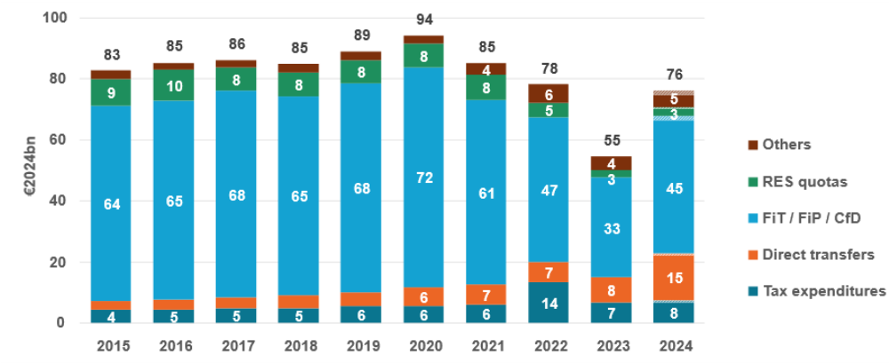
Figure 8: Renewable subsidies by instrument (EUR₂₀₂₄ billion)
Source: Enerdata, 2025. NB: 2024 estimates are represented with light colour

Support for different renewable technologies varied significantly between Member States, reflecting different energy policy priorities and local renewables potential (Figure 10). Countries with high solar irradiation, such as Malta, Greece, Cyprus, Italy and Spain, preferred to grant support for solar energy, while countries with more forest cover, such as Croatia, Finland and Sweden, granted more support for bioenergy. Wind (offshore) accounted for a substantial proportion of renewable subsidies in Poland and Belgium. Balanced technology-neutral spending across various renewables was the preferred approach in countries such as Germany, France, Slovakia, Czechia, Slovenia and Latvia.
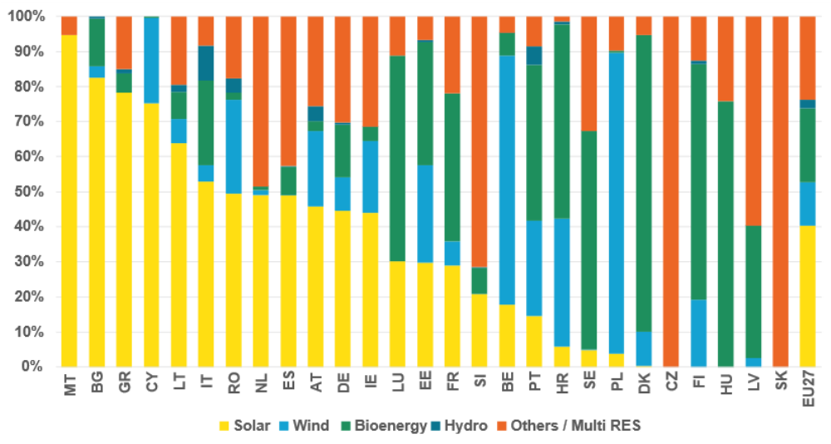
Figure 9: Share of RES subsidies by technology and Member State (%)
Source: Enerdata, Trinomics, 2025

Subsidies by economic purpose
Subsidies supporting energy demand have been the main economic purpose for granting subsidies since 2021, accounting for EUR 163 billion (48% of the total) in 2024. Such subsidies are aimed at reducing the cost of energy consumption by means of, for example, lower tax rates on energy products or direct price support.
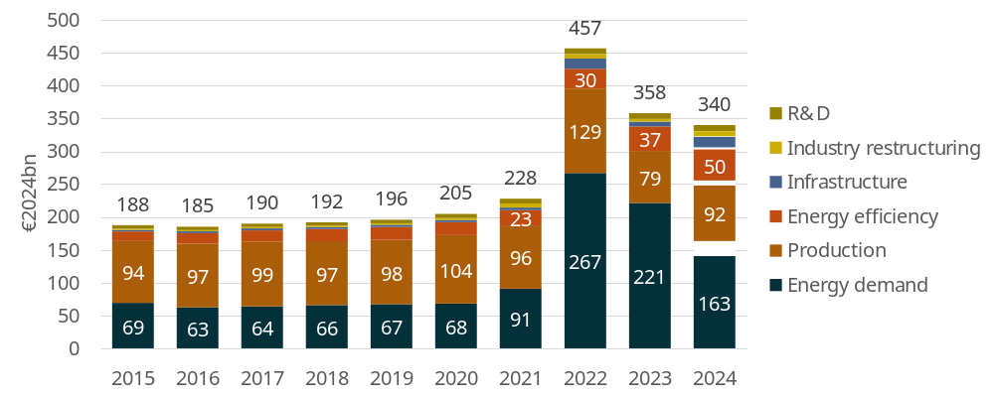
Figure 1016: Energy subsidies by economic purpose (EUR₂₀₂₄ billion)
Source: Enerdata, Trinomics, 2025. NB: 2024 estimates are represented with hatching

Fossil fuel subsidies supporting energy demand accounted for a share of between 63-75% of the total value of fossil fuel subsidies over the period 2015-2024 (Figure 11).

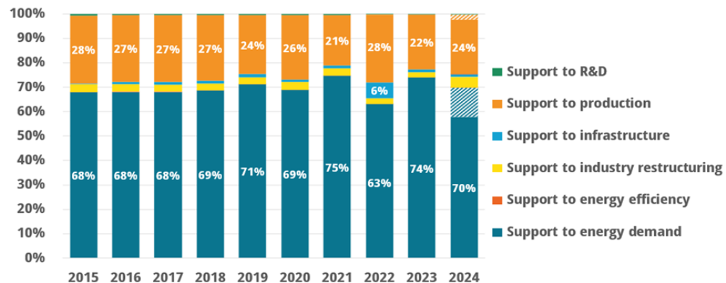
Figure 11: Fossil fuel subsidies in the EU-27 by purpose
Source: Enerdata, Trinomics, 2025. NB: 2023 estimates are represented with hatching.

Subsidies linked to the energy crisis in 2022
Energy price rises caused by the short-lived economic recovery following the COVID-19 pandemic in 2021 and the energy crisis which resulted from Russia’s full-scale invasion of Ukraine in 2022 led the Commission and Member States to take action. In addition to EU-level policies, each Member State adopted specific national measures to shield their citizens and their economy from the effects of the energy price rises and price volatility. Since prices began falling in 2023 and 2024, crisis support has decreased significantly (to EUR 98 billion, -38%), with most crisis measures now phased out.
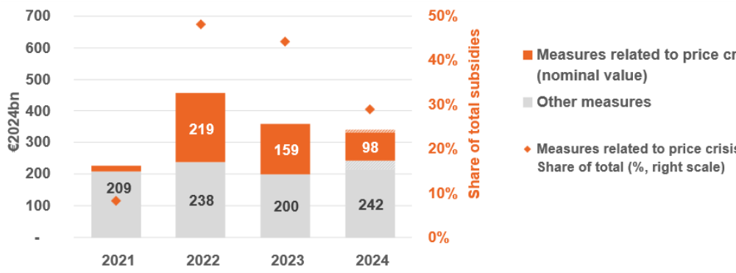
Figure 12: Structural and energy crisis-related subsidies; share of crisis subsidies in total energy subsidies
Source: Enerdata, Trinomics, 2025.

Subsidies by economic sector
In 2024, the energy industry became the sector which received the highest levels of targeted subsidies, worth EUR 114 billion (33% of the total), followed by households (EUR 64 billion, 19%) (Figure 15). Since 2021, subsidies targeting multiple sectors or not targeted at any specific sectors (i.e. cross-sector subsidies) have jumped, reaching EUR 88 billion (26% of the total) in 2024. Subsidies were lower for industrial sectors and transport, at EUR 40 billion (12%) and EUR 19 billion (6%), respectively, while the tertiary sector and agriculture received the least, at EUR 9 billion (3%) and EUR 7 billion (2%), respectively.
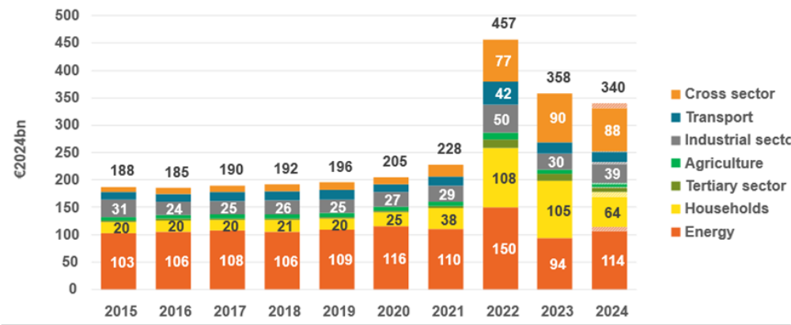
Figure 13: Energy subsidies by economic sector (EUR₂₀₂₄ billion)
Source: Enerdata, 2025. NB: 2024 estimates are represented with light colour

Subsidies by environmental impact
A further aim of this report is to provide a comprehensive assessment of the environmental impact of energy subsidies in the EU. In this context, the following definition was used:
Energy subsidies are environmentally harmful if the price or cost reduction that they bring about incentivises maintaining or increasing the availability of energy sources and/or using energy sources that cause significantly increased negative environmental impacts.
Most energy subsidies in 2024 (EUR 230 billion or 68% of the total) were classified as non-environmentally harmful. Meanwhile, the share of environmentally harmful energy subsidies was estimated at EUR 110 billion (or 32% of the total) (Figure 14). The share of non-environmentally harmful energy subsidies increased by 10% in 2024 compared to 2023. By contrast, the total share of environmentally harmful energy subsidies decreased by 26% in 2024 compared to 2023, i.e. at a faster rate than total energy subsidies, which decreased by 5% in 2024 compared to 2023.
The largest share of environmentally harmful energy subsidies (81%, EUR 89 billion) was granted for fossil fuels, followed by ‘all energies’ (15%) (), while 3% was granted for electricity and less than 1% for heat generation.
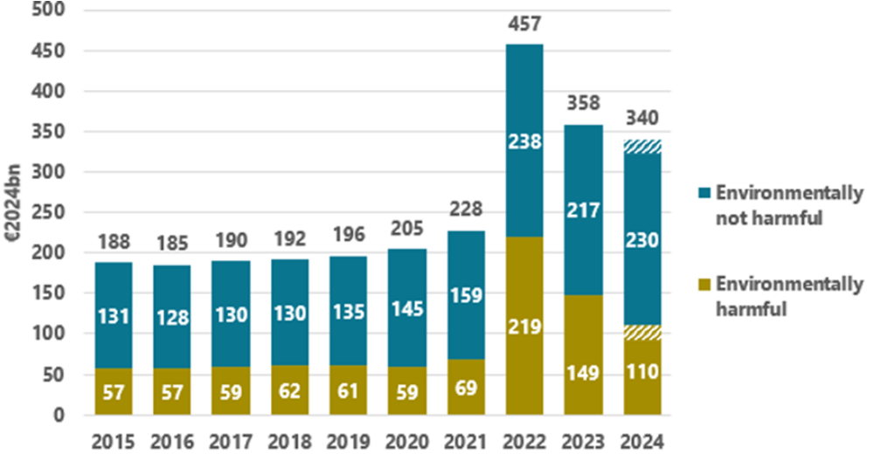
Figure 14: Energy subsidies by environmental impact (EUR₂₀₂₄ billion)
Source: Enerdata, Trinomics, 2025. NB: 2024 estimates are represented with hatching

National plans on fossil fuel subsidies
In 2024, the value of fossil fuel subsidies in the EU-27 reached EUR 97 billion or 0.5% of EU GDP. Of those subsidies, 39% (EUR 38 billion) have a planned end-date in 2025, 8% (EUR 8 billion) have an end-date between 2026 and 2030, and the remaining 52% (EUR 50 billion) have either no end-date yet or an end-date set for after the year 2030 (Figure 15).

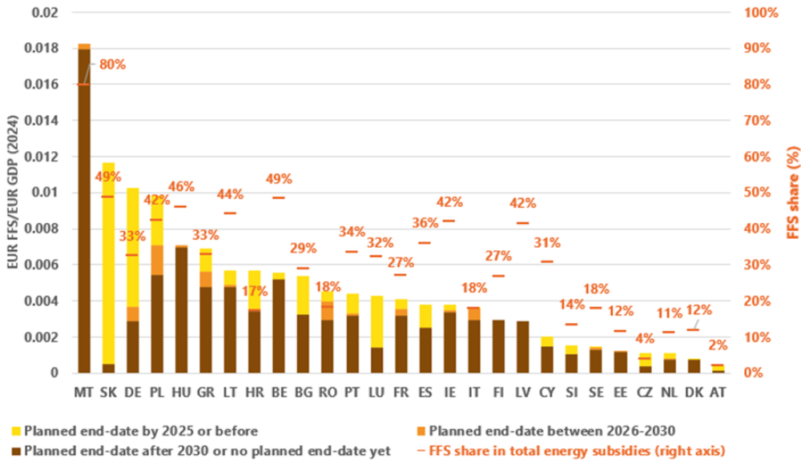
Figure 15: Weight of FFS by end-date per unit of GDP and share of FFS in total energy subsidies
Source: Enerdata, Trinomics, 2025
Almost all EU Member States intend to move away from fossil fuels. However, only eight Member States have expressed an intention or made plans to phase out FFS from their economy entirely. Concrete end-dates, policies and measures remain absent, as confirmed by the Commission’s analysis of the Member States’ most recent National Energy and Climate Progress Reports in 2025.

Conclusions
In 2024, energy subsidies, including for fossil fuels, decreased moderately compared to 2023 but were down considerably from 2022, the height of the energy crisis. Nevertheless, they remained high when compared to historic levels.
The share of overall subsidies corresponding to renewables support increased while remaining significantly below the historic average, indicating an increase in the competitiveness of renewables. In addition, there were fewer temporary subsidies for tackling the 2022 crisis, while half of fossil fuel subsidies had a planned end date in 2025 or by 2030. Subsidies for transport and oil began to fall again in 2024, almost reaching their levels from 2021. The share of environmentally harmful energy subsidies decreased, while the share of non-environmentally harmful energy subsidies increased.
Despite some positive trends, fossil fuel subsidies remained considerably above the historic average, while the share of non-targeted subsidies was also still high. Furthermore, fossil fuel subsidies to support energy consumption, which account for the majority of fossil fuel subsidies, were not specifically used to address energy poverty, supply security or competitiveness.
Importantly, no progress was observed regarding national fossil fuel phase-out plans in 2024. The number of countries committed to phasing out fossil fuel subsidies remained unchanged compared to 2023. Concrete final end-dates, policies and measures were missing even for Member States committed to phasing out fossil fuels. Therefore, much more still needs to be done by Member States in this regard if the EU is to meet its political aim to phase out fossil fuel subsidies and make Europe climate neutral by 2050.
Reforming, reducing and ultimately eliminating fossil fuel subsidies is a priority for the European Commission in accordance with the EU’s commitments under the Paris Agreement, the European Climate Law and the 8th Environmental Action Programme. In President von der Leyen’s mission letters to both the Energy and Housing Commissioner and the Climate, Net Zero and Clean Growth Commissioner, she issued a mandate for creating a framework to further scale down and phase out the use of fossil fuel subsidies.
As mentioned in the AccelerateEU communication, the 2026 conflict in the Middle East may call for further timely, targeted and temporary measures to protect the most vulnerable consumers, to accelerate the clean energy transition and electrification, and to safeguard the competitiveness of European industry. However, any short-term relief measures must not detract from the long-term objective of phasing out fossil fuel subsidies.
Accordingly, the Commission intends to adopt by the end of 2026 a proposal to update the Governance of the Energy Union and Climate Action, which will cover the phase-out of fossil fuels subsidies.

Article 35, point (n), of Regulation (EU) 2018/1999 of the European Parliament and of the Council of 11 December 2018 on the Governance of the Energy Union and Climate Action (OJ L 328, 21.12.2018, p. 1, ELI: http://data.europa.eu/eli/reg/2018/1999/oj).
The methodology applied to data collection and analysis is outlined in the Annex to this report.
Council Recommendation of 12 April 2024 on the economic policy of the euro area, ST/6316/2024/INIT (OJ C, C/2024/2807, 23.4.2024. ELI: http://data.europa.eu/eli/C/2024/2807/oj).
These figures include tax expenditure (EUR 43 billion in 2024) that cannot be directly compared across countries, as well as government ownership/equity infusion measures (EUR 10 billion in 2024) which have grown in significance since the energy crisis in 2022.
Examples of subsidies that are not qualified as environmentally harmful include subsidies for renewable energy sources, electrification and investments in the energy transition, supply security or the protection of vulnerable consumers, even if given over to fossil fuels. Examples of environmentally harmful subsidies not attributed to fossil fuels include subsidies for hydrogen, heat and electricity not produced from RES or not targeting energy efficiency and non-targeted subsidies, where the renewable share could not be identified.
Plans to phase out fossil fuel subsidies from 2024 onward.
All monetary values in this study are expressed in 2024-euro prices. Figures from previous editions were adjusted for inflation.
RD&D: Research, Development and Demonstration.
If ‘all fossil fuels’ are counted, the amount and proportion is higher.
Historic (pre-crisis) level refers to the average for 2015-2019.
2015-2019.
In 2015-2017, annual expenditures were stable at around EUR 300 million. They increased to around EUR 1.1 billion in 2018-2021.
Industrial sectors cover industry, mining and construction.
Tertiary sector covers services, public and business sectors.
The term ‘significantly increased negative environmental impacts’ is aligned with the EU Taxonomy Regulation and adapted to the energy sector by focusing on two environmental objectives of that Regulation which are related to climate, namely (i) climate change mitigation, and (ii) climate change adaptation. The focus of the background study was on energy subsidies, although it was not deemed possible to assess the environmental impact of energy subsidies on all six environmental objectives as this would require a case-by-case assessment.
Of which EUR 17 billion are estimates based on 2023 data.
For energy subsidies not targeting any specific energy carrier (i.e. ‘all energies’), the weight of fossil fuels in each Member States’ energy mix, expressed as a % and based on Eurostat data for 2022 (from dataset [nrg_bal_c]), was used to determine the environmentally harmful share.
The majority of subsidies for electricity are not considered harmful. The exception is where subsidies are clearly linked to electricity generated from fossil fuel sources.
Including subsidies for which no data was available and estimated to be worth EUR 3 billion based on 2023 levels.
The analysis is based on Annexes VIII and XV of the 2025 NECPRs and publicly available updates or announcements.
Belgium, France, Germany, Italy, Latvia, Lithuania, Luxembourg and Portugal.
Commission Implementing Regulation (EU) 2022/2299 requires Member States to report every two years on the progress achieved towards the implementation of the integrated national energy and climate plans in national energy and climate progress reports (NECPRs). NECPRs were due by 15 March 2025.
EU-wide assessment of the final updated national energy and climate plans Delivering the Union's 2030 energy and climate objective, Brussels, 27.5.2025 COM(2025) 274 final.
Average for 2015-2019, i.e. before the COVID-19 pandemic and Russia’s war of aggression against Ukraine which affected energy prices in atypical ways making them less representative for analysis.
Mission letter to Dan Jørgensen, Commissioner for Energy and Housing; eab354d1-64d2-450f-8ed4-eb3d42661974_en.
COM (2026) 370 final, 22.4.2026.
See recommendations in 2025 European Semester - Spring package, Brussels, 4.6.2025 COM(2025) 200 final.
2026 Work Programme of the European Commission, Annex I, New Initiatives, initiative 8. Commission work programme 2026 - European Commission.

