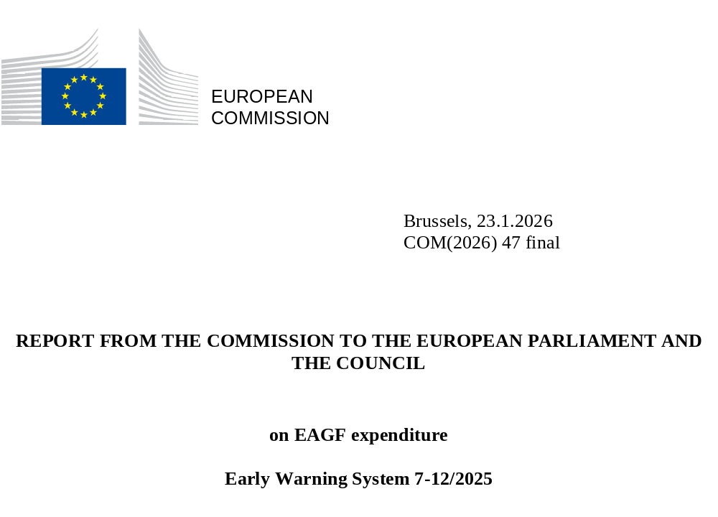

Table provisional consumption on 31/12/2025
This report presents the provisional implementation of the 2025 budget for the European Agricultural Guarantee Fund (EAGF) on 31/12/2025, with details given in the below table. A comparison is made between the implementation level and the corresponding appropriations included in the 2025 budget.
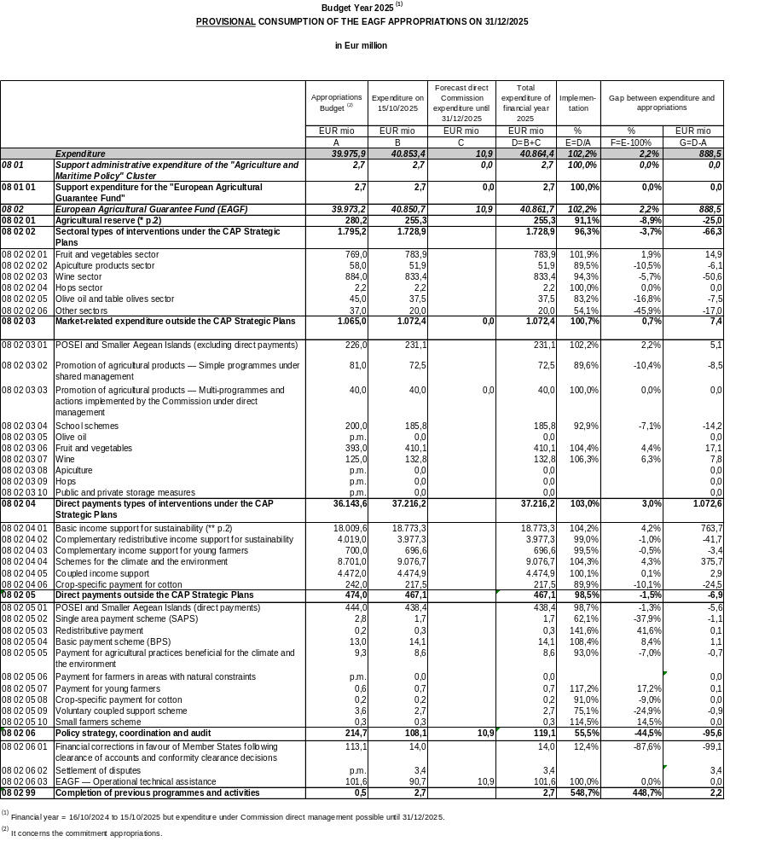
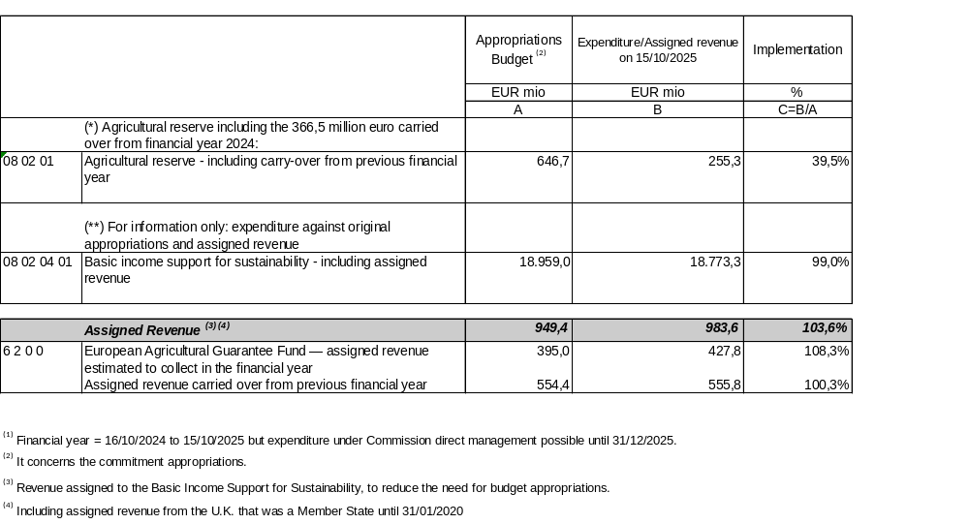

Comments on the implementation of the 2025 agricultural reserve
In 2025, the agricultural reserve amounted to EUR 646.7 million, including a carry-over of EUR 366.5 million from Budget 2024. Five measures, totaling EUR 177.5 million, were adopted. A total of EUR 255.3 million of payments have been declared under Budget 2025. These payments covered remaining expenditure from the exceptional measures adopted in 2024 as well as the declared amounts (EUR 63.5 million) related to the emergency financial support for the agricultural sectors affected by adverse climatic events and natural disasters in Spain, Croatia, Cyprus, Latvia and Hungary, adopted in 2025.
The payments for the other four measures adopted in 2025, representing a total amount of EUR 78.9 million, will be financed under the 2026 agricultural reserve. The remaining appropriations of EUR 391.4 million shall thus be carried over to Budget 2026.

Comments on the provisional implementation of the 2025 EAGF budget
The final implementation of the sectoral types of interventions under the CAP Strategic Plans (08 02 02) is lower than budgeted (-3.7 %), but significantly improved compared to the previous financial year (-18.6 % end of 2024).
On the other hand, the market-related expenditure outside the CAP Strategic Plans (08 02 03) is slightly higher than the budgeted amount (0.7 %), partially compensating the under-implementation under the Plans.
The overall under-execution of EUR 58.9 million for sectoral interventions and market-related expenditure reflects, amongst others, Member States’ need for time to adapt to the policy in place since 2023, a cumulation of crises in past years, as well as changing demand patterns (on the interior and exterior markets).
The direct payments interventions under the CAP plans (08 02 04) show an excellent implementation, slightly exceeding the budget (103 % of the voted appropriations and 100.3 % of the budgeted appropriations and assigned revenue).
The provisional expenditure of the 2025 EAGF budget, including estimated, fully implemented actions under direct management by the Commission until 31 December 2025, results in an over-execution of EUR 888.5 million (2.2 %) compared to the budget's voted appropriations. Considering the available assigned revenue of EUR 983.6 million as well as the carry-over of EUR 366.5 million from the 2024 agricultural reserve, the total EAGF under-implementation amounts to EUR 461.6 million.
This overall EAGF surplus includes EUR 391.4 million from the agricultural reserve, which in accordance with Article 16(2), third subparagraph, of Regulation (EU) 2021/2116 will be carried over to the 2026 agricultural reserve.
The remaining surplus of EUR 70.2 million translates into additional revenue assigned to the EAGF to be automatically carried over from 2025 to 2026 in accordance with Article 12(4)(b) of Regulation (EU, Euratom) 2024/2509, reducing the amount of appropriations needed in the Budget 2026.

Commission Implementing Regulation (EU) 2025/441 of 6 March 2025 providing for emergency financial support for the agricultural sectors affected by adverse climatic events and natural disasters in Spain, Croatia, Cyprus, Latvia and Hungary, in accordance with Regulation (EU) No 1308/2013 of the European Parliament and of the Council. (OJ L, 2025/441, 10.3.2025 ELI: http://data.europa.eu/eli/reg_impl/2025/441/oj) Commission Implementing Regulation (EU) 2025/1137 of 10 June 2025 providing for emergency financial support for the agricultural sectors affected by adverse climatic events and natural disasters in Czechia and Slovenia, in accordance with Regulation (EU) No 1308/2013 of the European Parliament and of the Council.(OJ L, 2025/1137, 11.6.2025 ELI: http://data.europa.eu/eli/reg_impl/2025/1137/oj); Commission Implementing Regulation (EU) 2025/1145 of 10 June 2025 on exceptional support measures for the milk and pigmeat sectors in Germany (OJ L, 2025/1145, 11.6.2025 ELI: http://data.europa.eu/eli/reg_impl/2025/1145/oj); Commission Implementing Regulation (EU) 2025/1485 of 24 July 2025 on exceptional market measures for the eggs and poultrymeat sectors in Poland (OJ L, 2025/1485, 25.7.2025, ELI: http://data.europa.eu/eli/reg_impl/2025/1485/oj); Commission Implementing Regulation (EU) 2025/2061 of 10 October 2025 providing for emergency financial support for the agricultural sectors affected by adverse climatic events in Bulgaria, Latvia, Lithuania, Hungary, Poland and Romania, in accordance with Regulation (EU) No 1308/2013 of the European Parliament and of the Council (OJ L, 2025/2061, 13.10.2025, ELI: http://data.europa.eu/eli/reg_impl/2025/2061/oj).

